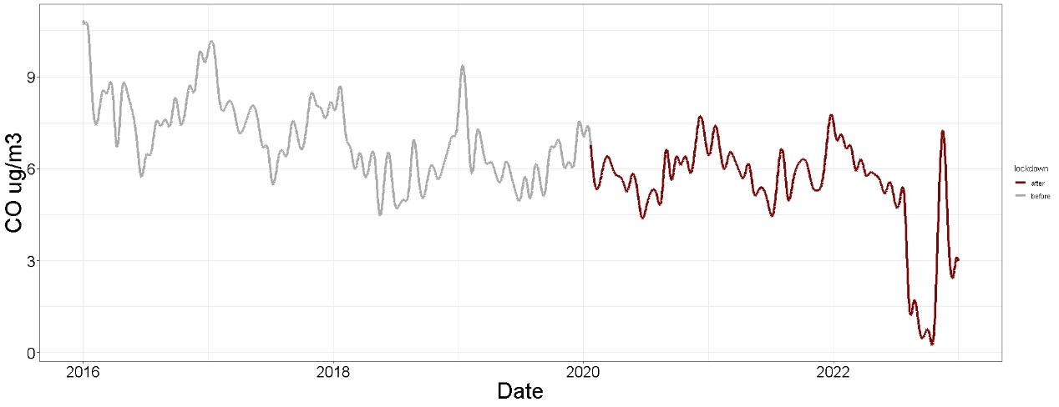
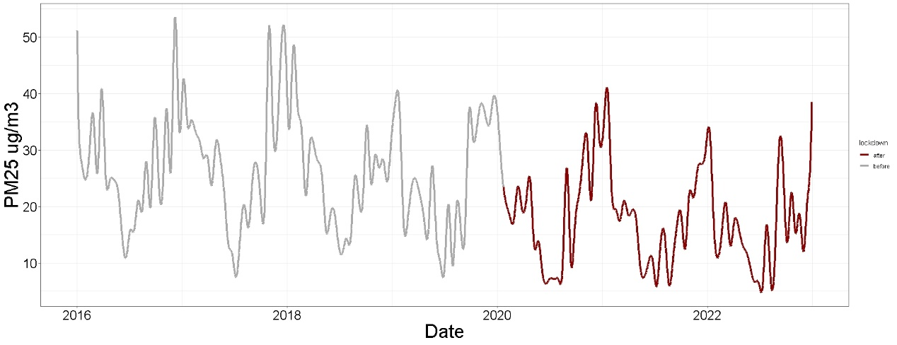
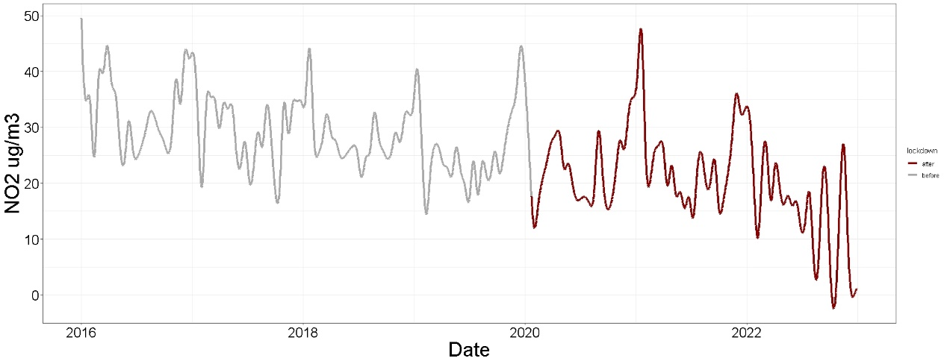
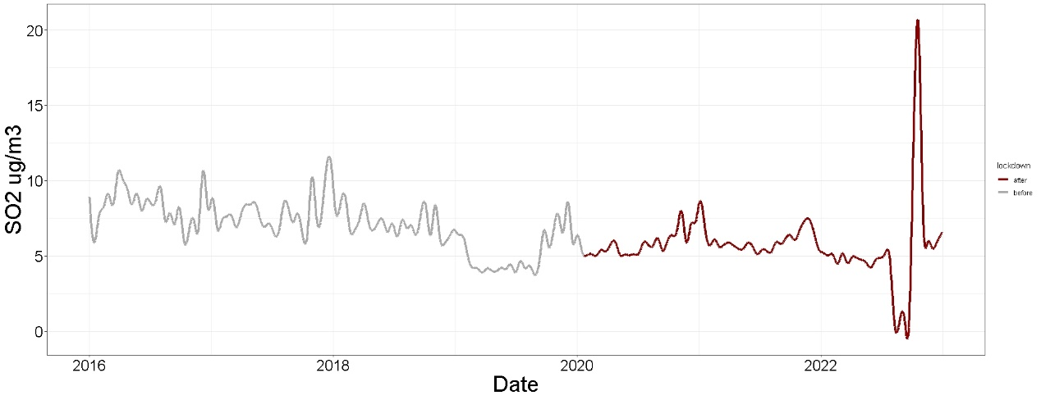
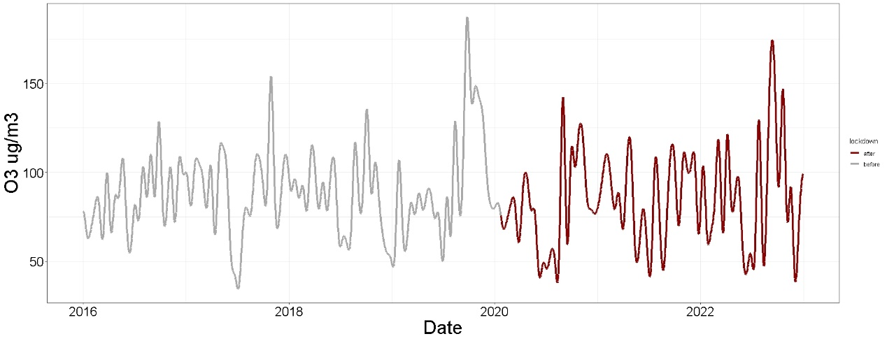
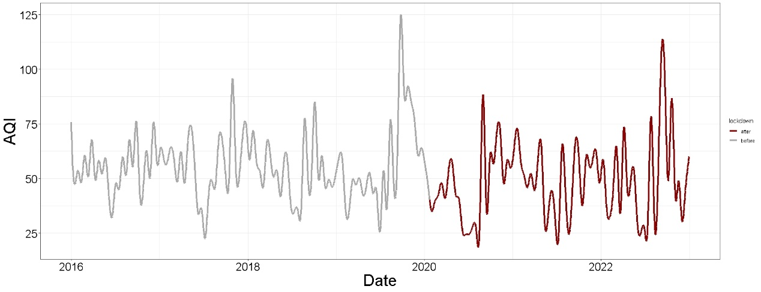
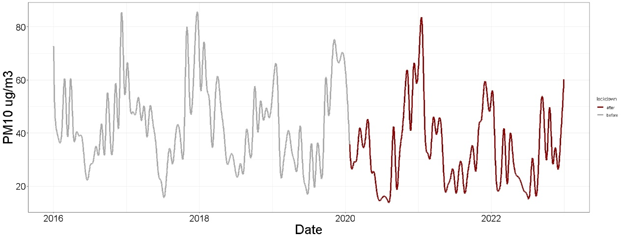
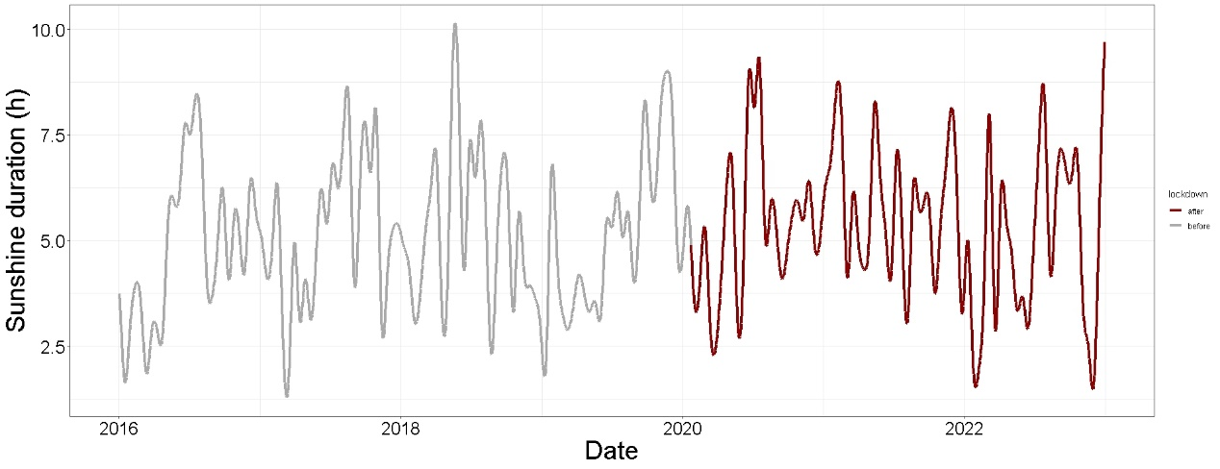
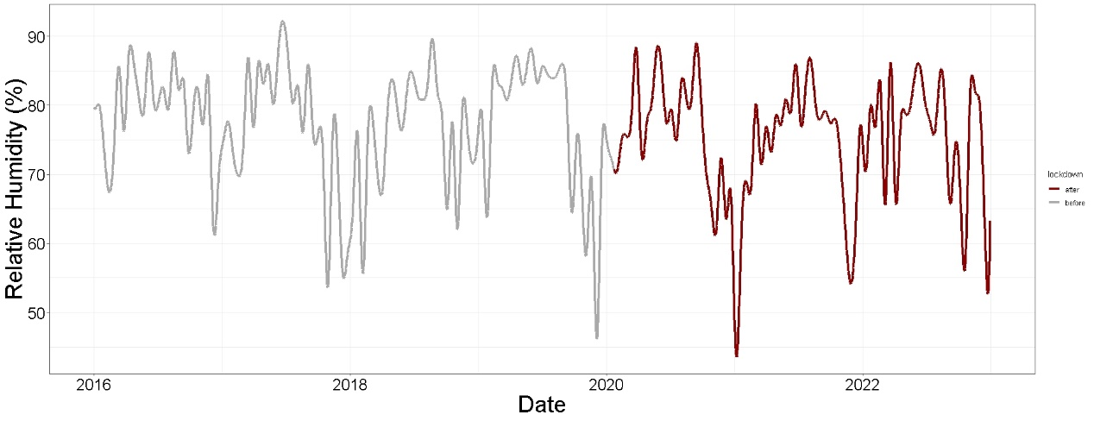
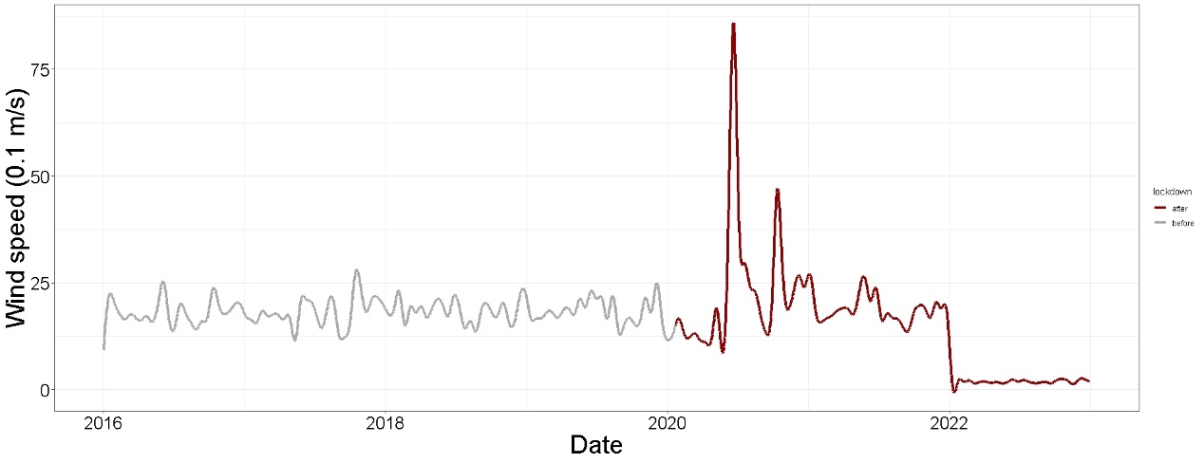
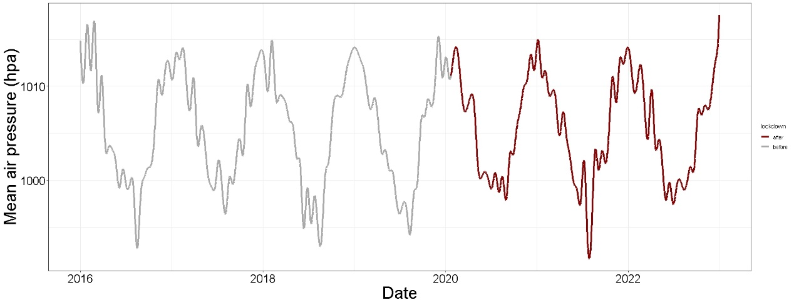
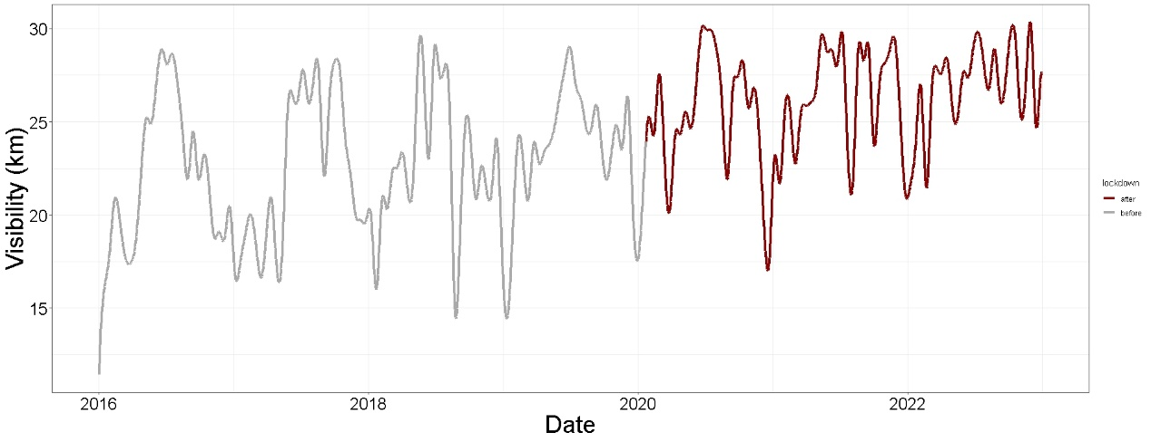
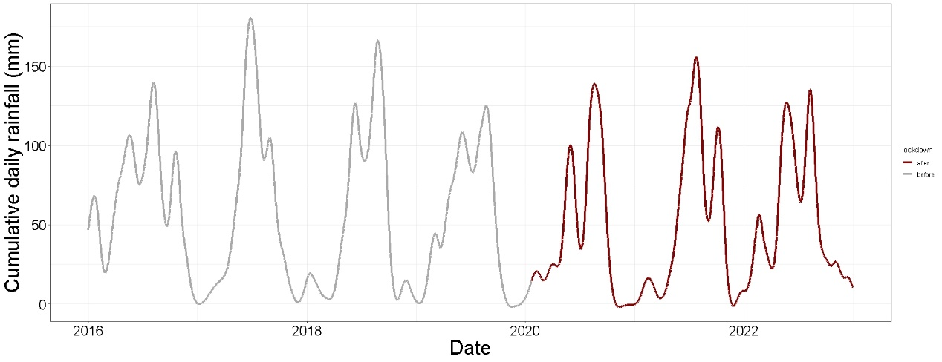
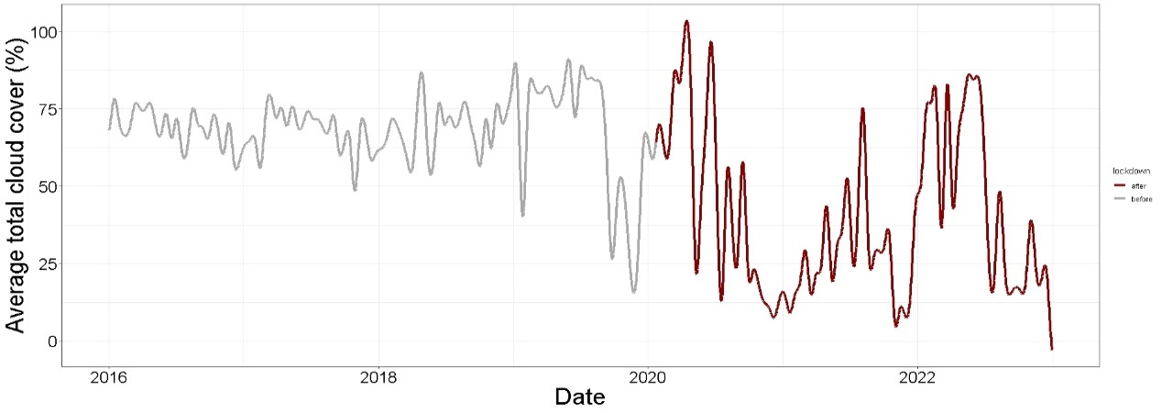
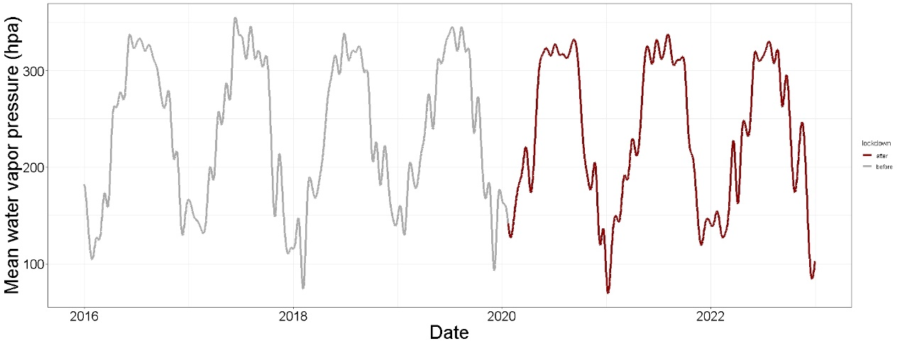
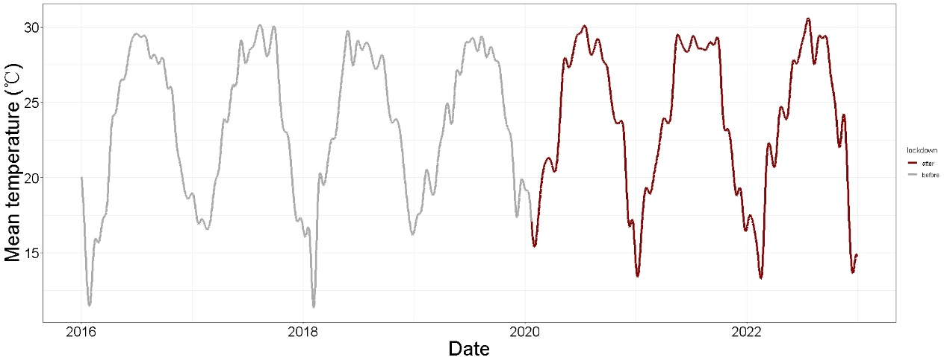
Fig.S1 Time series plots of all meteorological factors in Shenzhen from 2016 to 2022.
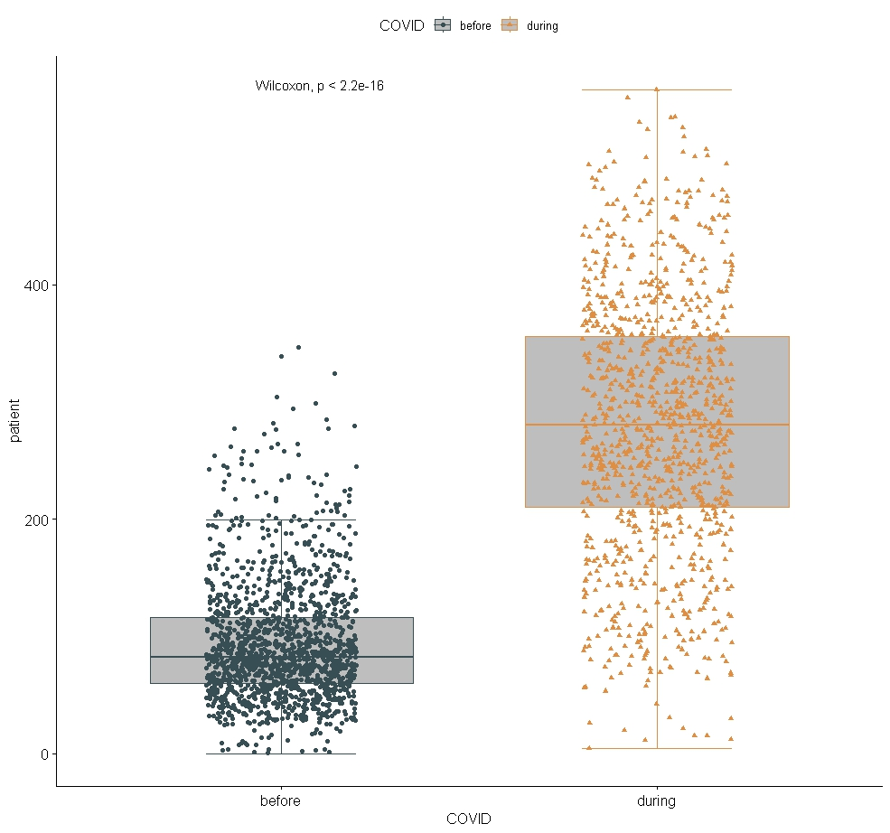

Fig S2. The Wilcoxon test result of CAPC visits before and during COVID-19 lockdown in Shenzhen.

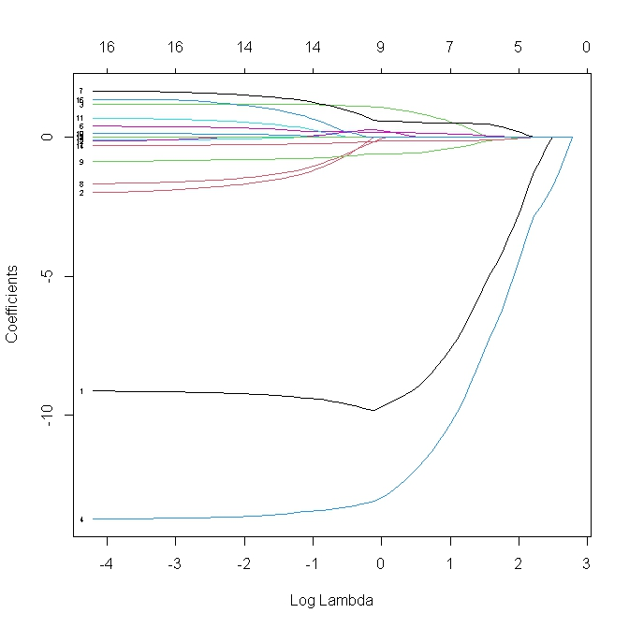
(a)
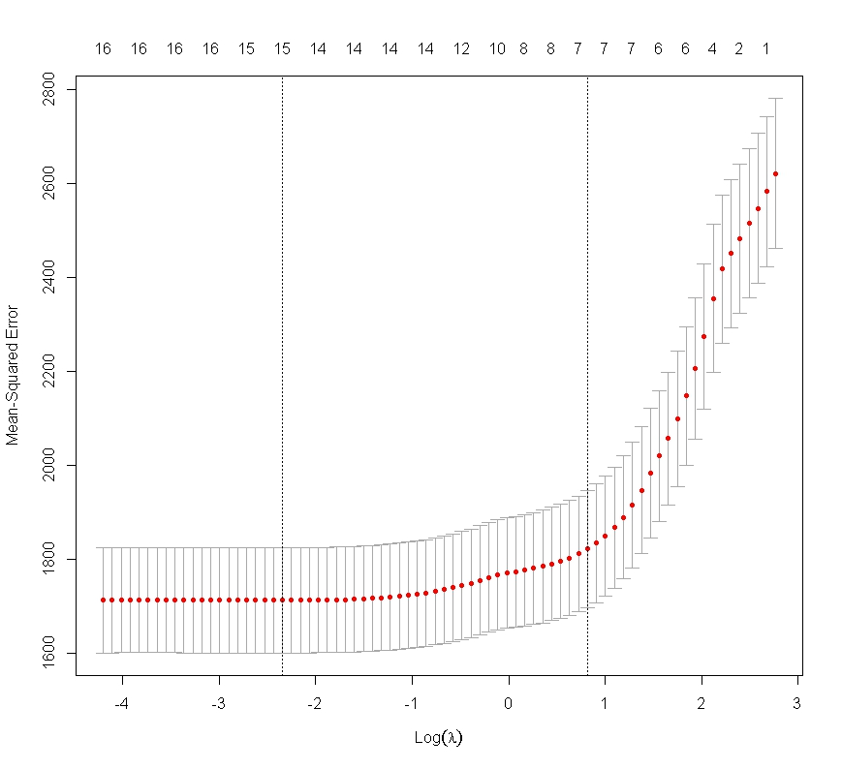
(b)
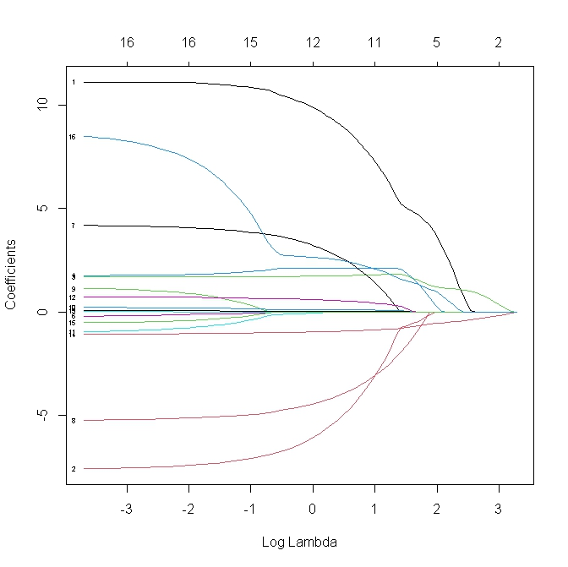
(c)
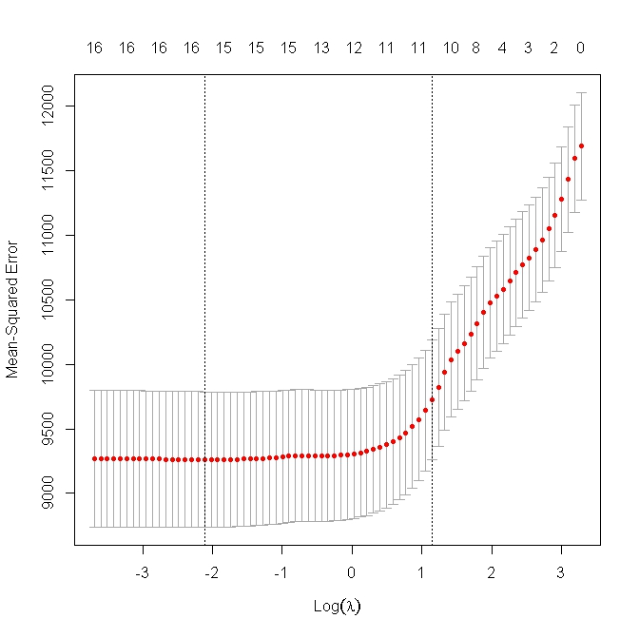
(d)
Fig.S 3 The fitting plot of λ. (a) The fitting process of λ in 2016.1.1-2020.1.22 (b) the plot of cross-validation curve in 2016.1.1-2020.1.22 (c) The fitting process of λ in 2020.1.23-2022.12.31 (d) the plot of cross-validation curve in 2020.1.23-2022.12.31.
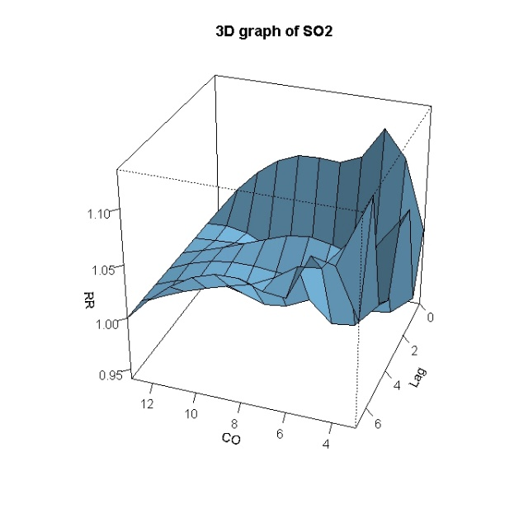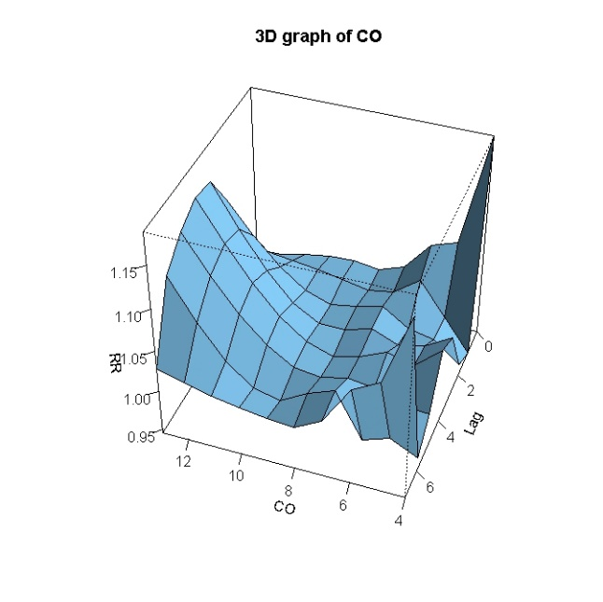
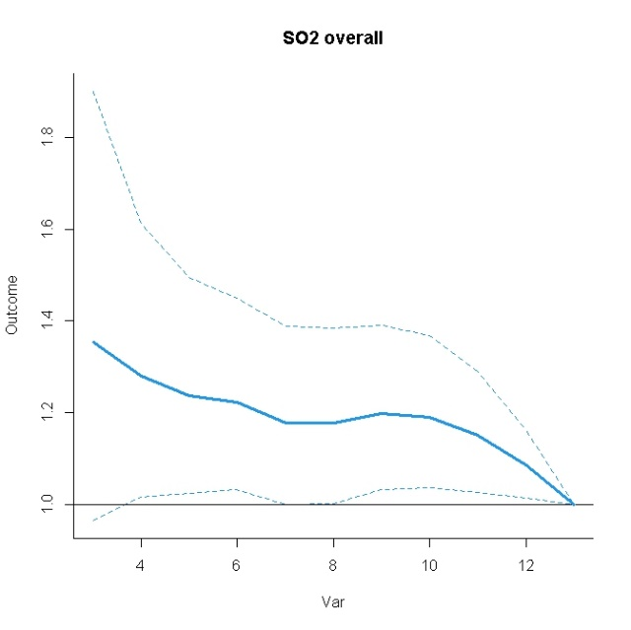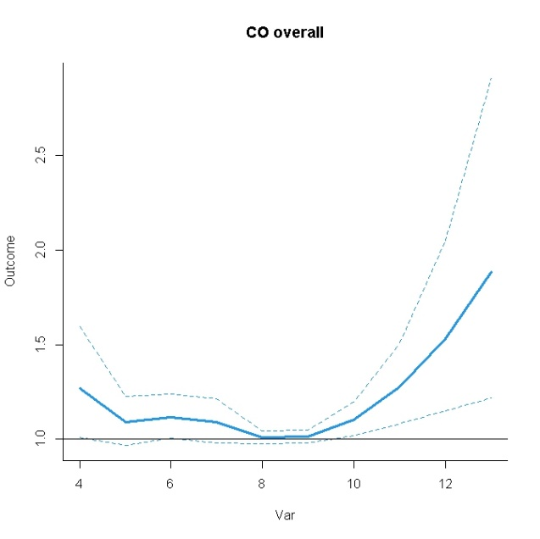
Fig. S4 The 3-D graphs and and two-dimensional graphs of SO2 and CO overall effect on CAPC visits in Shenzhen from 2016.1.1 to 2020.1.22.

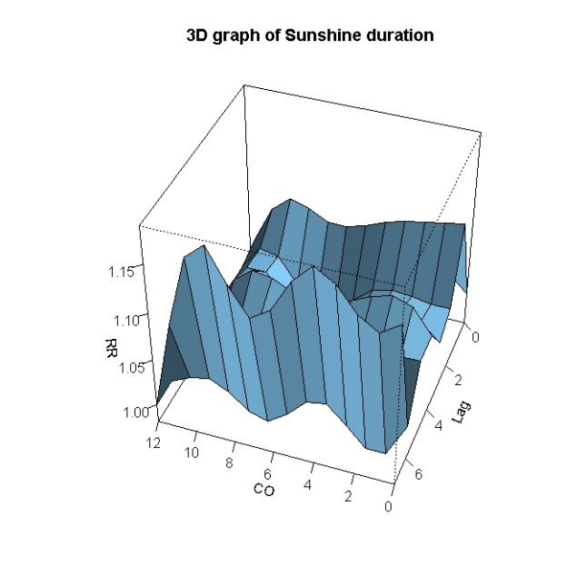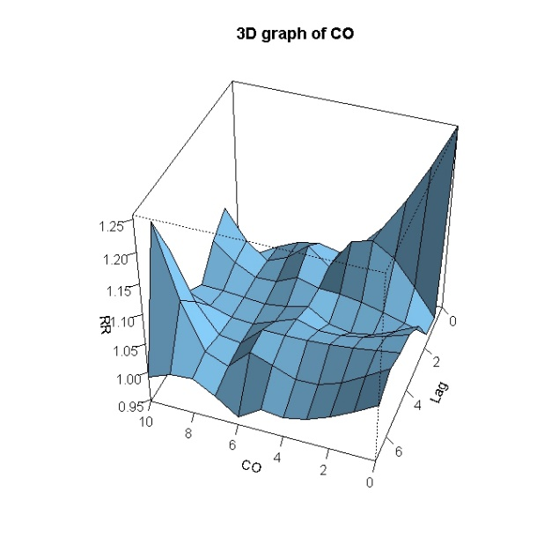
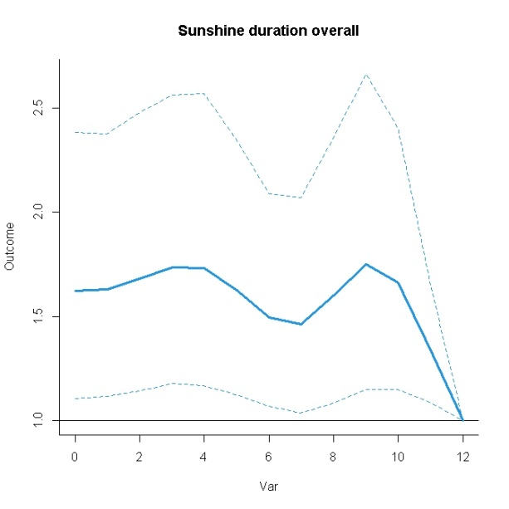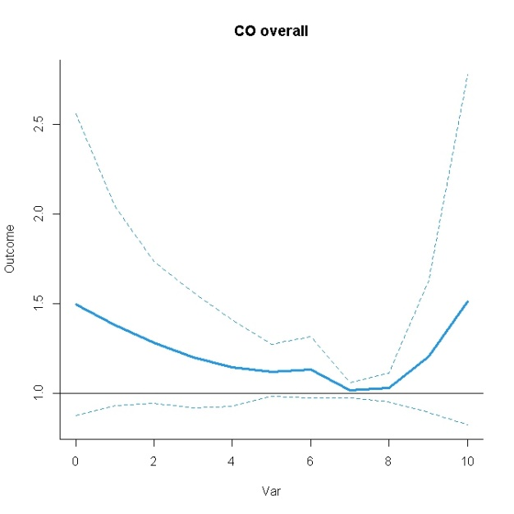
Fig S5 The 3-D graphs and and two-dimensional graphs of sunshine duration and CO overall effect on CAPC visits in Shenzhen from 2020.1.23 to 2022.12.31.

Table S1. The summary and comparison of all air pollutants before and during COVID-19 lockdown.
Factors | COVID-19 | P0 | P25 | P50 | P75 | P100 | N±S | Z | P
CO(mg/m³) | Before | 4 | 6 | 7 | 8 | 13 | 7.02±1.66 | -20.19 | <0.01
 | During | 0.4 | 5 | 6 | 7 | 10 | 5.41±1.80
PM_{2.5} (ug/m³) | Before | 5 | 16 | 25 | 35 | 103 | 26.39±13.61 | -17.30 | <0.01
 | During | 2 | 9 | 16 | 24 | 62 | 17.62±10.73
NO₂ (ug/m³) | Before | 7 | 22 | 28 | 34 | 95 | 29.15±10.56 | -20.26 | <0.01
 | During | 0 | 14 | 20 | 26 | 79 | 20.53±10.68
SO₂ (ug/m³) | Before | 3 | 6 | 7 | 8 | 19 | 7.09±2.20 | -18.41 | <0.01
 | During | 1 | 5 | 6 | 6 | 28 | 5.73±2.57
O₃ (ug/m³) | Before | 10 | 58 | 83 | 114 | 245 | 89.02±39.61 | -3.15 | <0.01
 | During | 15 | 51 | 78 | 110 | 250 | 84.51±39.15
Air Quality Index (AQI) | Before | 19 | 38 | 50 | 67 | 180 | 55.63±25.12 | -8.43 | <0.01
 | During | 17 | 29 | 44 | 61 | 185 | 48.96±25.30
PM₁₀(ug/m³) | Before | 9 | 27 | 39 | 56 | 146 | 43.51±20.85 | -12.22 | <0.01
 | During | 3 | 19 | 31 | 45 | 124 | 34.02±18.26
Sunshine duration (h) | Before | 0 | 1.3 | 5.1 | 8.6 | 12.2 | 5.10±3.79 | -1.95 | 0.05
 | During | 0 | 1.5 | 5.7 | 9.0 | 11.8 | 5.36±3.74
Relative Humidity (%) | Before | 23 | 72 | 80 | 86 | 100 | 77.36±12.58 | -5.94 | <0.01
 | During | 28 | 70 | 77 | 83 | 98 | 75.16±11.94
Wind speed (0.1 m/s) | Before | 0 | 13 | 16 | 21 | 61 | 18.17±7.68 | -13.11 | <0.01
 | During | 0 | 2 | 13 | 19 | 98 | 14.67±15.34
Mean air pressure (hpa) | Before | 983.1 | 1000.8 | 1005.7 | 1010.3 | 1027.3 | 1005.54±6.57 | -0.66 | 0.51
 | During | 988.7 | 1000.60 | 1005.20 | 1010.00 | 1020.3 | 1005.43±5.94
Visibility (km) | Before | 2.7 | 18.1 | 23.8 | 28.7 | 39.3 | 22.62±6.63 | -14.41 | <0.01
 | During | 4.6 | 23.9 | 28.7 | 30.0 | 70.4 | 26.20±5.26
Cumulative daily rainfall (mm) | Before | 0 | 0 | 0 | 16 | 1735 | 55.93±163.41 | 0.62 | 0.54
 | During | 0 | 0 | 0 | 13.25 | 1774 | 50.00±153.38
Average total cloud cover (%) | Before | 0 | 57 | 73 | 81 | 100 | 68.01±21.32 | -19.47 | <0.01
 | During | 0 | 8 | 30 | 72 | 100 | 40.24±34.80
Mean water vapor pressure (hpa) | Before | 31 | 168 | 239 | 313 | 391 | 234.76±82.68 | -0.85 | 0.39
 | During | 32 | 164.0 | 239.5 | 312.0 | 354 | 232.94±81.55
Mean temperature (℃) | Before | 3.5 | 19.6 | 24.5 | 28.0 | 32.4 | 23.50±5.27 | -1.74 | 0.08
 | During | 7 | 20 | 24.9 | 28.5 | 31.7 | 23.82±5.26

Table S2 Sparse Matrix of covariates coefficients
Factors | 2016.1.1-2020.1.22 | 2020.1.23-2022.12.31
(Intercept) | 227.1884592 | 191.7535524
CO(mg/m³) | -8.2194518 | 6.64847782
PM_{2.5} (ug/m³) |  | -2.35865771
NO₂ (ug/m³) | 0.6875006 | 1.81574429
SO₂ (ug/m³) | -11.0060895 | 2.12051586
O₃ (ug/m³)
Air Quality Index (AQI) | 0.1269796
PM₁₀(ug/m³) | 0.5129354 | 0.97686083
Sunshine duration (h) |  | -2.73830184
Relative Humidity (%) | -0.4857699
Wind speed (0.1 m/s) |  | 0.08647159
Mean air pressure (hpa)
Visibility (km) |  | 0.3919367
Cumulative daily rainfall (mm) |  | 0.02734445
Average total cloud cover (%) | -0.1373754 | -0.84181006
Mean water vapor pressure (hpa)
Mean temperature (℃) |  | 1.9362141

Table S3 the sensitive analysis of single pollutant model in Shenzhen from 2016.1.1 to 2020.1.22.
lag--cumulative effects | SO2=6 (ug/m3) | CO=6(mg/m³)
lag0 | 1.077(0.963-1.205) | 1.038(0.984-1.095)
lag1 | 1.034(0.919-1.163) | 1.059(1.001-1.120)
lag2 | 1.039(0.919-1.173) | 1.048(0.986-1.114)
lag3 | 1.072(0.937-1.226) | 1.047(0.975-1.123)
lag4 | 1.094(0.950-1.260) | 1.063(0.984-1.148)
lag5 | 1.117(0.960-1.299) | 1.063(0.976-1.157)
lag6 | 1.180(1.002-1.391) | 1.030 (0.937-1.132)
lag7 | 1.229(1.040-1.451) | 1.105(0.999-1.223)
Table S4 the sensitive analysis of single pollutant model in Shenzhen from 2020.1.23 to 2022.12.31.
lag--cumulative effects | Sunshine duration=0 (h) | CO=5(mg/m³)
lag0 | 1.032(0.885-1.203) | 1.001(0.938-1.069)
lag1 | 1.150(0.953-1.387) | 1.011(0.942-1.086)
lag2 | 1.201(0.962-1.498) | 1.022(0.947-1.103)
lag3 | 1.247(0.963-1.615) | 1.041(0.955-1.135)
lag4 | 1.344(1.011-1.788) | 1.073(0.978-1.178)
lag5 | 1.441(1.052-1.974) | 1.111(1.004-1.229)
lag6 | 1.467(1.037-2.077) | 1.132(1.013-1.266)
lag7 | 1.702(1.176-2.463) | 1.117(0.990-1.260)

Table S5 the sensitive analysis of df value of time at 6 from 2016.1.1 to 2020.1.22.
lag--cumulative effects | SO2=6 (ug/m3) | CO=6(mg/m³)
lag0 | 1.090(0.974-1.221) | 1.040(0.984-1.099)
lag1 | 1.039 (0.921 -1.172) | 1.060(1.001-1.123)
lag2 | 1.047(0.925-1.185) | 1.047 (0.983-1.114)
lag3 | 1.085 (0.948-1.242) | 1.043(0.970-1.121)
lag4 | 1.104(0.958 -1.271) | 1.060(0.980-1.147)
lag5 | 1.118(0.961-1.302) | 1.062(0.973-1.158)
lag6 | 1.186(1.006-1.398) | 1.026(0.932-1.130)
lag7 | 1.237 (1.049-1.459) | 1.086(0.981-1.204)
Table S6 the sensitive analysis of df value of time at 6 from 2020.1.23 to 2022.12.31.
lag--cumulative effects | Sunshine duration=0 (h) | CO=5(mg/m³)
lag0 | 1.069(0.916-1.249) | 0.990(0.926-1.059)
lag1 | 1.236(1.022-1.494) | 1.000(0.930-1.076)
lag2 | 1.348(1.079-1.683) | 1.008(0.931-1.092)
lag3 | 1.448(1.117-1.876) | 1.021(0.932-1.118)
lag4 | 1.589(1.194-2.116) | 1.048(0.951-1.156)
lag5 | 1.729(1.261-2.370) | 1.088(0.979-1.209)
lag6 | 1.799(1.272-2.545) | 1.116(0.994-1.254)
lag7 | 2.074(1.432-3.005) | 1.100(0.971-1.246)

Table S7 the sensitive analysis of df value of time at 8 from 2016.1.1 to 2020.1.22.
lag--cumulative effects | SO2=6 (ug/m3) | CO=6(mg/m³)
lag0 | 1.069(0.954-1.198) | 1.041(0.985-1.101)
lag1 | 1.017(0.901-1.148) | 1.069(1.008-1.133)
lag2 | 1.024(0.904-1.161) | 1.060(0.995-1.130)
lag3 | 1.060(0.924-1.217) | 1.060(0.985-1.141)
lag4 | 1.079 (0.933-1.248) | 1.081(0.997-1.173)
lag5 | 1.095(0.936-1.280) | 1.085(0.993-1.187)
lag6 | 1.163(0.982-1.377) | 1.050(0.950-1.160)
lag7 | 1.221(1.029-1.448) | 1.116(1.003-1.242)
Table S8 the sensitive analysis of df value of time at 8 from 2020.1.23 to 2022.12.31.
lag--cumulative effects | Sunshine duration=0 (h) | CO=5(mg/m³)
lag0 | 1.015(0.868- 1.187) | 1.005(0.939-1.075)
lag1 | 1.132(0.933-1.372) | 1.019(0.946-1.097)
lag2 | 1.183(0.943-1.485) | 1.028(0.948-1.115)
lag3 | 1.221(0.936-1.594) | 1.042(0.950-1.144)
lag4 | 1.302(0.970-1.748) | 1.071(0.969-1.185)
lag5 | 1.384(0.999-1.918) | 1.110(0.995-1.238)
lag6 | 1.410(0.984-2.019) | 1.136(1.008-1.280)
lag7 | 1.624(1.107-2.382) | 1.120(0.984-1.275)

