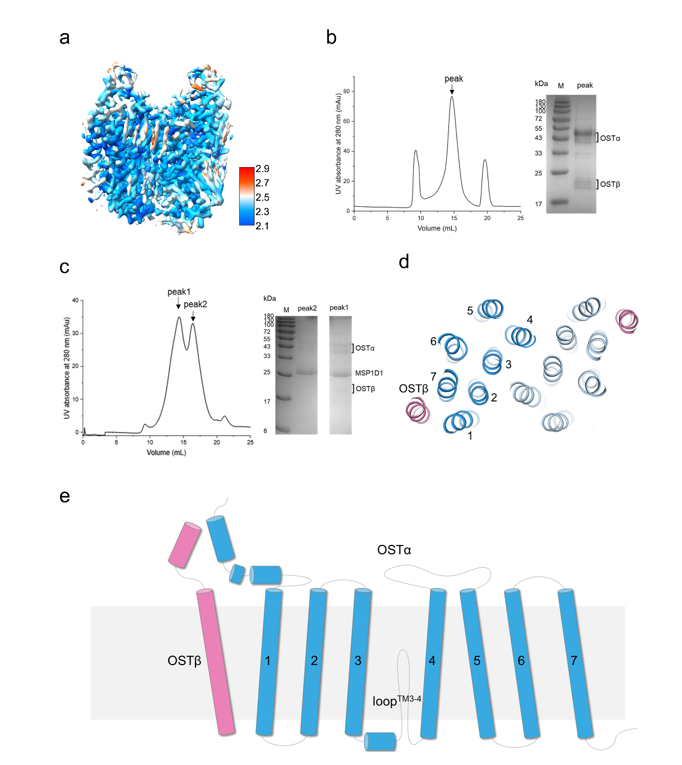Supplementary Fig. 1 Purification and structural features of OSTα/β
a. Refined cryo-EM map of OSTα/β complex structure. The cryo-EM maps are colored by UCSF ChimeraX 1.5 according to the local resolution of the cryo-EM estimated by cryoSPARC 4.7.1
b. The size exclusion chromatography profiles of human OSTα/β in the detergent LMNG and c. in nanodiscs. The peak fractions were applied to SDS-PAGE and visualized by Coomassie blue staining.
d. Top view of OSTα/β complex. Dark blue and light blue denote each OSTα monomer, OSTβ are colored pink.
e. Topology of the OSTα/β complex. OSTα is colored blue and OSTβ is colored pink.

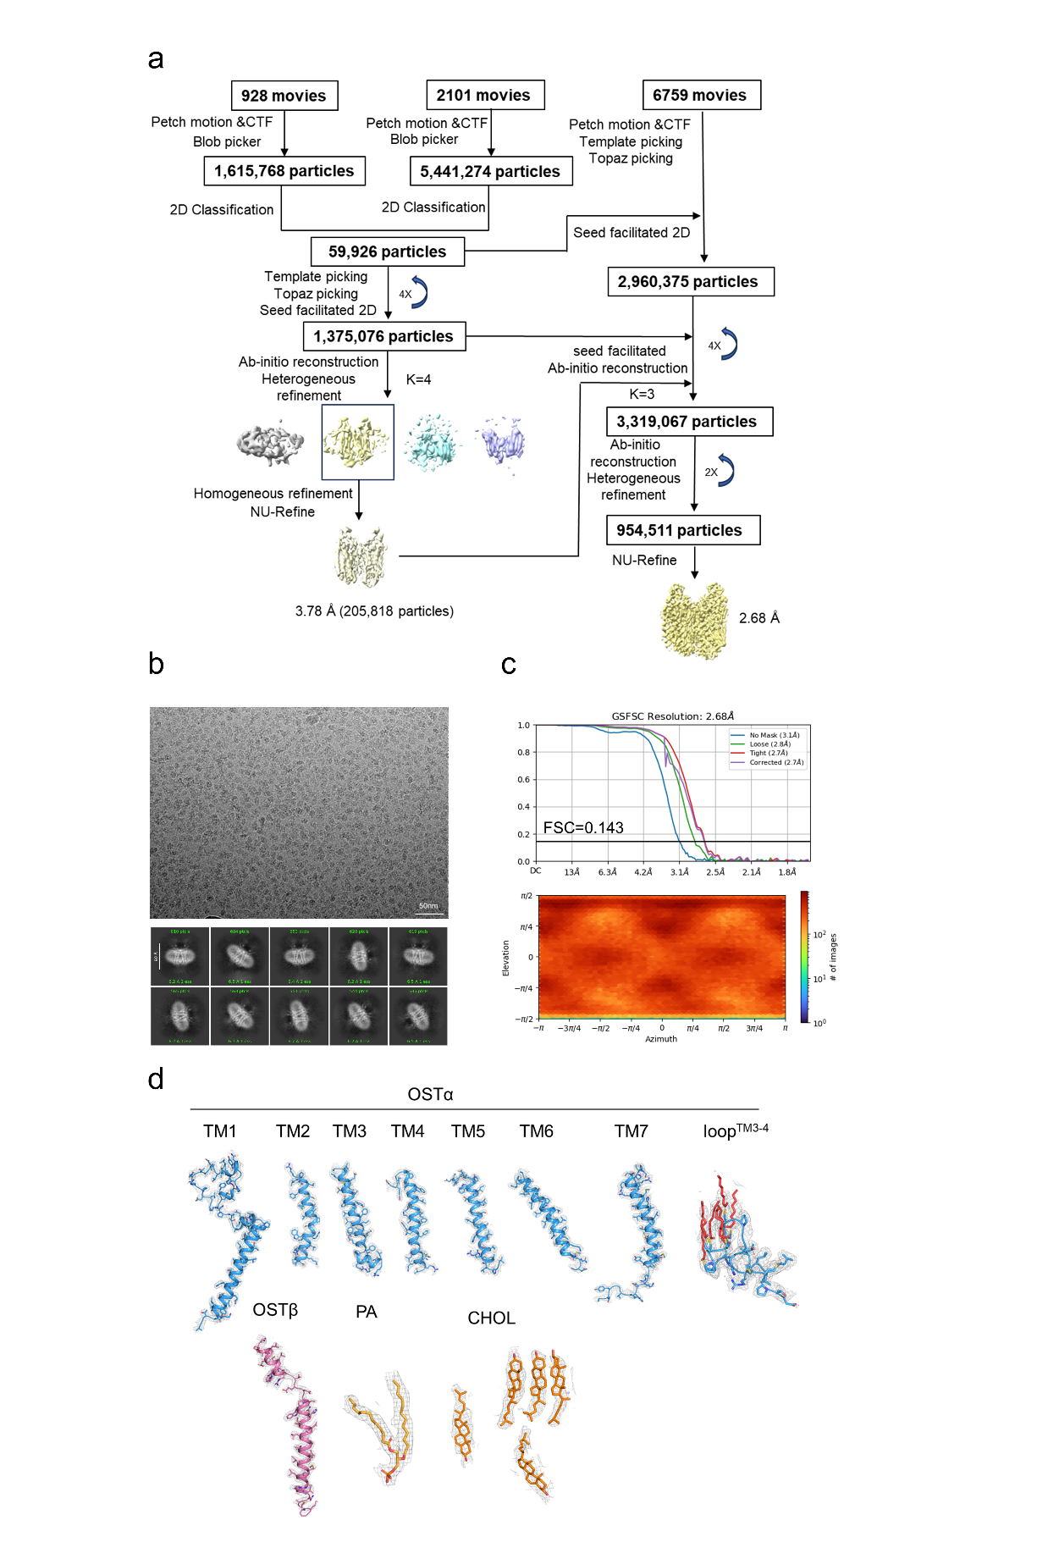
Supplementary Fig. 2 Data processing and model building of OSTα/β complex.
a. Flowchart of the cryo-EM data processing by cryoSPARC v4.7.1.
b Representative cryo-EM micrograph and 2D averages. Bar: 50 nm.
c. Fourier shell correlation (FSC) curves and Euler angle distributions of the classified particles used for the final 3D refinement of the overall maps for OSTα/β complex.
d. Cryo-EM maps for representative segments of the OSTα/β. The structure was reconstructed with C2 symmetry, and only half of the representative segments are thus presented. Contour levels are set at 5σ.

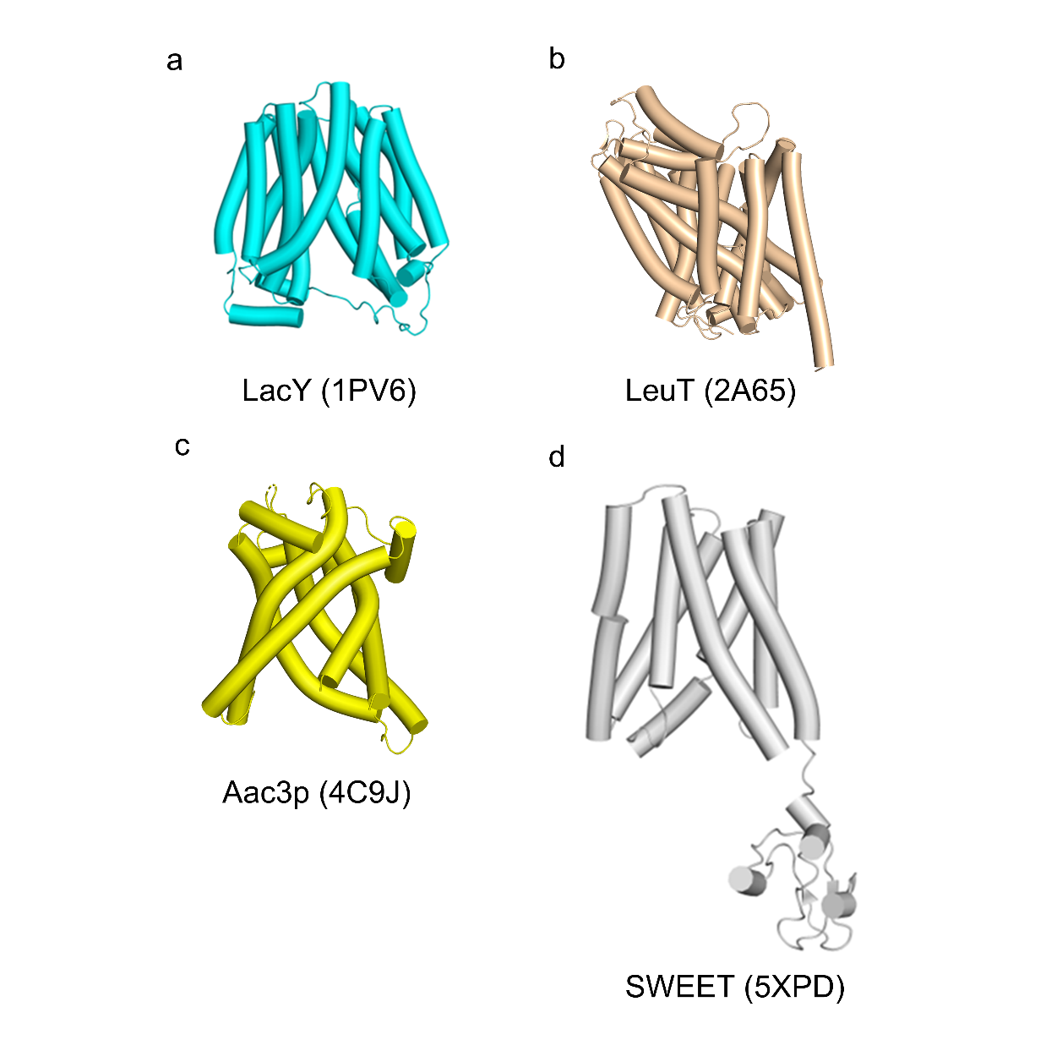
Supplementary Fig. 3 Representative structural folds of reported SLC transporters.
a. Lactose permease LacY from E. coli. LacY contains 12 TMs, with the N-terminal and C-terminal six TMs forming two distinct helical bundles connected by a long loop between TM 6 and 7. The two 6-TM domains share the same topology and exhibit an approximate two-fold symmetry¹.
b. Sodium-coupled leucine transporter LeuT from Aquifex aeolicus. LeuT contains 12 TMs, with an internal structural repeat in the first 10 TMs: TM1–TM5 and TM6–TM10 exhibit 176.5° rotational symmetry around a pseudo-two-fold axis within the membrane plane².
c. ADP/ATP carriers Aac3p from Saccharomyces cerevisiae, Aac3p contains 6 TMs, tilted at approximately 45° relative to the membrane plane. The odd-numbered TMs are kinked at proline or serine residues, forming a barrel-like structure with threefold pseudosymmetry³.
d. Sugar transporter SWEET from Arabidopsis thaliana. Each SWEET comprises 7 TMs. The N-terminal and C-terminal 3 TMs form 6-TM THB domains, as an inversion linker, TM4 spans the membrane and orients THB2 parallel to THB1⁴.

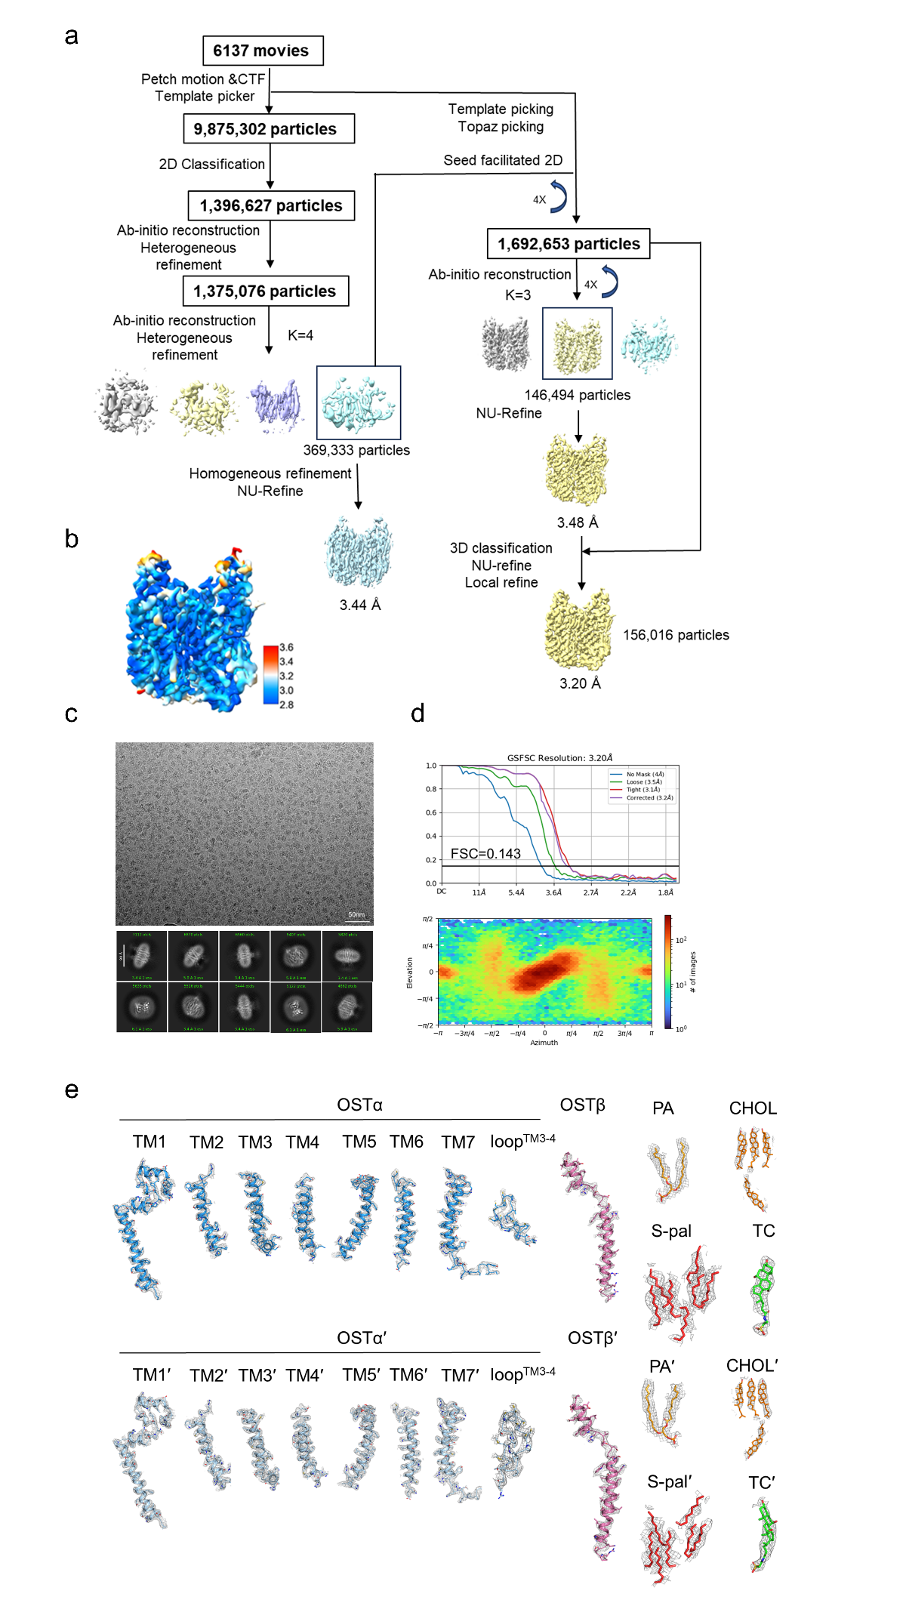
Supplementary Fig. 4 Data processing and model building of TC bound OSTα/β complex.
a. Flowchart of the cryo-EM data processing by cryoSPARC v4.7.1.
b Refined cryo-EM map of OSTα/β complex structure. The cryo-EM maps are colored by UCSF ChimeraX 1.5 according to the local resolution of the cryo-EM estimated by cryoSPARC 4.7.1
c. Representative cryo-EM micrograph and 2D averages. Bar: 50 nm.
d. Fourier shell correlation (FSC) curves and Euler angle distributions of the classified particles used for the final 3D refinement of the overall maps for TC bound OSTα/β complex.
e. Cryo-EM maps for representative segments of the TC bound OSTα/β complex. The structure was reconstructed with C1 symmetry, and all the representative segments are thus presented. Contour levels are set at 5σ except S-palmitoyl modification on the cysteine side chain which is at 3σ.

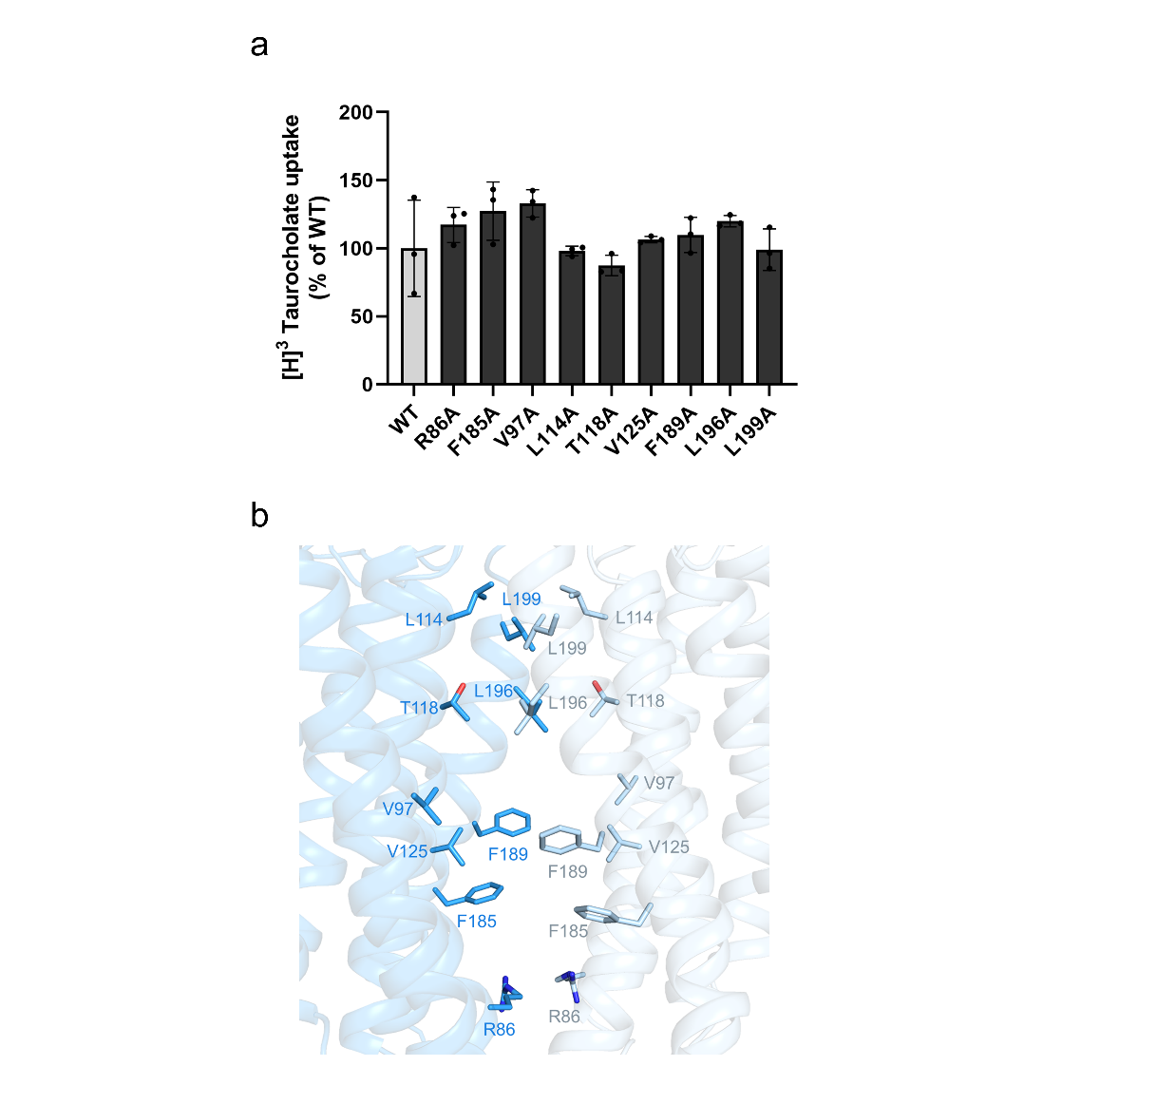
Supplementary Fig. 5 Transport activities of wild-type OSTα/β complex and OSTα/β mutants at central channel residues.
a. Transport activities of [³H] taurocholic acid mediated by the wild-type OSTα/β complex and OSTα/β mutants at central channel residues. The activity of the wild type was set to 100%. One‐way analysis of variance (ANOVA) is used for the comparison of statistical significance of wild-type OSTα/β (WT) with its mutants. The P values of < 0.05, 0.01, and 0.001 are indicated with *, **, and ***, respectively. b. Residue positions in the central cavity chosen for site-directed mutagenesis and functional transport assays.

References:
1. Abramson, J. et al. Structure and mechanism of the lactose permease of Escherichia coli. Science 301, 610-5 (2003).
2. Yamashita, A., Singh, S.K., Kawate, T., Jin, Y. & Gouaux, E. Crystal structure of a bacterial homologue of Na+/Cl--dependent neurotransmitter transporters. Nature 437, 215-223 (2005).
3. Ruprecht, J.J. et al. Structures of yeast mitochondrial ADP/ATP carriers support a domain-based alternating-access transport mechanism. Proc Natl Acad Sci U S A 111, E426-34 (2014).
4. Han, L. et al. Molecular mechanism of substrate recognition and transport by the AtSWEET13 sugar transporter. Proc Natl Acad Sci U S A 114, 10089-10094 (2017).

