Profiling Decision-Making Mechanisms in Binge Eating Disorder

Supplementary Materials

Authors
Emily Colton^{1,2} https://orcid.org/0000-0001-5873-3301
Chanel Agosta^{1,2} https://orcid.org/0009-0001-0650-7940
Holly Carey^{1,2} https://orcid.org/0009-0003-9285-2576
Emily Giddens^{1,2} https://orcid.org/0000-0002-5405-0164
Brittany Noy^{1,2} https://orcid.org/0000-0002-5405-0164
Kayla Flannagan^{1,2} https://orcid.org/0009-0005-2971-5397
Leonie Tsyrlin¹ https://orcid.org/0009-0003-8989-5890
Kira-Elise Wilson^{1,2} https://orcid.org/0000-0002-7614-9368
Dr Luiza Bonfim-Pacheco^{1,2} https://orcid.org/0009-0002-9481-8198
Dr Justin Mahlberg^{1,2} https://orcid.org/0000-0003-3974-2362
A/Prof Trevor T-J. Chong^{1,2,3,4} https://orcid.org/0000-0001-7764-3811
Prof Antonio Verdejo-Garcia^{1,2} https://orcid.org/0000-0001-8874-9339

Affiliations
¹ School of Psychological Sciences, Monash University, Clayton, VIC, Australia
² Turner Institute of Brain and Mental Health, Monash University, Clayton, VIC, Australia
³ Department of Neurology, Alfred Health, Melbourne, Victoria 3004, Australia
⁴ Department of Clinical Neurosciences, St Vincent’s Hospital, Melbourne, Victoria 3065, Australia

Correspondence

Emily Colton
Monash University
School of Psychological Sciences
Level 6, 18 Innovation Walk
Clayton, VIC 3800
AUSTRALIA
(03) 9905 4000
emily.colton@monash.edu

S1. DSM-5-TR Diagnostic Criteria for Binge Eating Disorder
Table S1. DSM-5-TR Diagnostic criteria for Binge Eating Disorder (APA, 2022)
Binge Eating Disorder (BED)
Recurrent episodes of binge eating, characterized by both of the following: | Eating, in a discrete period of time (e.g., within any 2-hour period), an amount of food that is definitely larger than most people would eat in a similar period of time under similar circumstances  The sense of lack of control overeating during the episode (e.g., a feeling that one cannot stop eating or control what or how much one is eating)
Binge-eating episodes are associated with three (or more) of the following: | Eating much more rapidly than normal  Eating until feeling uncomfortably full  Eating large amounts of food when not feeling physically hungry  Eating alone because of being embarrassed by how much one is eating  Feeling disgusted with oneself, depressed, or very guilty after overeating
Additionally: | Marked distress regarding binge eating is present.  The binge eating occurs, on average, at least 1 day a week for 3 months  The binge eating is not associated with the regular use of inappropriate compensatory behavior (e.g., purging, fasting, excessive exercise) and does not occur exclusively during anorexia nervosa or bulimia nervosa.
Other Specified Feeding or Eating Disorder (OSFED): Subthreshold BED
Binge-eating disorder of low frequency and/or limited duration | All the criteria for binge-eating disorder are met, except that the binge occurs, on average, less than once a week and/or for less than 3 months

S2. Supplementary Methods
S2.1 Decision-making stages, domains, tasks, and outcomes
Table S2 Summary of decision-making stages, domains, tasks, and outcomes
Decision-Making Domain | Task | Task Outcome(s) - Operationalisation | Task Outcomes(s) -Description | Behavioural dysfunction
Preference Formation Stage
Uncertainty Evaluation | Cognitive Impulsivity Suite (Verdejo-Garcia et al., 2021) Information Accumulation Task | Computed score (accuracy & response time) | Ability to effectively evaluate choice alternatives under conditions of uncertainty | Excessive over- or under-valuation of certainty during formation of preferences
Choice Implementation Stage
Cognitive Inhibition | Cognitive Impulsivity Suite (Verdejo-Garcia et al., 2021) Attentional Energisation Task | Attentional Inhibition  D-prime d’  Response Control Criterion c | Ability to effectively discriminate targets from distractors  Ability to implement an unbiased choice strategy | Actions are taken without due consideration
Delay Discounting | Monetary Choice Questionnaire (Kirby et al., 1999) | Geomean ln(k) | The extent to which monetary rewards are devalued as time to receiving them increases | Excessive tendency to choose smaller-sooner over larger-later rewards
Feedback Processing Stage
Reinforcement Learning | Cognitive Impulsivity Suite (Verdejo-Garcia et al., 2021) Monitoring of Feedback task | Win-stay minus lose-shift | Ability to monitor positive and negative feedback | Enhanced learning from reward and reduced learning from punishment
Consistency | Cognitive Impulsivity Suite (Verdejo-Garcia et al., 2021) Monitoring of Feedback task | Total score | Ability to use feedback to maintain an effective choice strategy | Behaviour that is random, inconsistent, or insensitive to consequences
Cognitive Flexibility / Set-Shifting | NIH Toolbox Dimensional Card Sort test (Gershon et al., 2010) | Computed score (accuracy & response time) | Ability to switch efficiently between target dimensions | Perseverative behaviour that is unresponsive to changing contingencies

To measure the Uncertainty Evaluation domain in the Preference Formation stage of decision-making, we quantified participants’ ability to optimise their choice behaviour under conditions of uncertainty in the information accumulation task. Higher scores indicated the optimal trade-off of speed and accuracy as follows:
Uncertainty evaluation = Proportion of correct responses
Mean rt of correct responses

Signal detection theory (Green & Swets, 1966) was used to calculate the behavioural outcomes to assess the Cognitive Inhibition domain in the Choice Implementation stage of decision-making. Signal detection theory uses all potential participant responses in the cued go/no-go task (correct responses [hits], incorrect non-responses [omission errors or misses], incorrect responses [commission errors or false alarms], and correct non-responses) to parse out two key contributors to task performance – namely, attentional and action control. As such, they provide more nuanced information than single go/no-go task performance outcomes such as commission errors. D-prime d’ quantifies the ability to accurately discern targets from distractors, with higher scores indicating a high rate of correct responses (hits), combined with a low rate of incorrect responses (commission errors or false alarms), and thus quantified the attentional control component. Criterion c describes decision-making bias, with scores <0 indicating liberal or impulsive responding, or a bias toward action (resulting in higher hits but also higher commission errors), and scores >0 indicating conservative or cautious responding, or a bias toward inaction (resulting in more correct rejections but also more misses, or omission errors), and thus quantified the response control component. These outcomes were calculated for each participant from AE task data as follows:
d’ = z(hits) – z(false alarms)
c = -[ z(hits) + z(false alarms)]
2

To quantify capabilities in the Feedback Processing stage of decision-making, first a general measure was included as total score on the probabilistic reversal learning task. Higher total scores indicate that participants were overall more consistent in learning and enacting an advantageous choice strategy and were more responsive to reversals in choice outcomes. To examine the specific hypothesis that individuals with BED may exhibit enhanced learning from rewarding feedback (greater tendencies to stay after a win) combined with reduced learning from punishing feedback (lesser tendencies to shift after a loss), we also defined reinforcement learning as this ‘reward bias’ (Schaefer & Steinglass, 2021; Voon et al., 2015; Waltmann et al., 2024). Win/stay was calculated as the total proportion of trials in which the same choice was made as the prior choice following a reward (+50 or +200 points) and lose/shift was calculated as the total proportion of trials in which the opposing choice was made to the prior choice following a loss (0 or -100 points). Thus win/stay and lose/shift can range from 0 to 1, with higher scores indicating greater tendencies to stay following a win or to shift following a loss. Reinforcement learning was then calculated as win/stay – lose/shift. As higher values indicate greater reward bias, this outcome was reversed (x -1) before being included in the profile analysis.
Delay Discounting and Cognitive Flexibility / Set-Shifting outcomes are operationalised according to the published guidelines for the MCQ and NIH tasks (Gershon et al., 2010; Kaplan et al., 2016; Kirby et al., 1999).
S2.2 CIS Task Data Pre-processing
CIS data cleaning procedures were conducted as reported in Eisenberg et al. (2019) and in Voigt et al. (2021). In all tasks, data was removed if participant response latency averaged <200ms on each trial or more than 3000s to complete the task. In the IA task, data was removed if the proportion of non-responses was >25%, if the proportion of correct responses was <59% (z-score = 2.5), of if the same response key (A-left or L-right) was used in over 95% of trials. In the AE task, data was removed if the proportion of correct go-trial responses was <25%, or if the proportion of total correct responses was <66% (z-score = 2.5). In the MoF task, data was removed if the participant used the same response key (A-left or L-right) for >95% trials, or if the proportion of total correct responses was <39% (z-score = 2.5).

S3. Data & Software

De-identified research data and analysis materials are available on reasonable request to the corresponding author.
Study data were collected and managed using REDCap (Research Electronic Data Capture) hosted at Monash University (Harris et al., 2019; Harris et al., 2009). REDCap is a secure, web-based software platform designed to support data capture for research studies, providing 1) an intuitive interface for validated data capture; 2) audit trails for tracking data manipulation and export procedures; 3) automated export procedures for seamless data downloads to common statistical packages; and 4) procedures for data integration and interoperability with external sources. Unless otherwise stated, all data analyses were completed using R Studio version 2025.05.0+496 (Posit Software, 2025). Packages, version, and citations are provided in Table S3.

Table S3. R packages, versions, and citations.

Package | Version | Citation
dplyr | 1.1.4 | Wickham et al. (2023)
ggcorrplot | 0.1.4.1 | Kassambara (2023a)
ggplot2 | 3.5.2 | Wickham (2016)
ggpubr | 0.6.0 | Kassambara (2023b)
heplots | 1.7.8 | Friendly et al. (2025)
Jmv | 2.7.0 | Selker et al. (2025)
JWileymisc | 1.4.3 | Wiley (2023)
knitr | 1.50 | Xie (2024)
MVN | 5.9 | Korkmaz et al. (2014)
nnet | 7.3-20 | Venables and Ripley (2002)
pastecs | 1.4.2 | Grosjean (2024)
profileR | 0.3-5 | Bulut and Desjardins (2020)
psych | 2.5.3 | Revelle (2024)
readxl | 1.4.5 | Wickham and Bryan (2022)
semTools | 0.5-7 | Jorgensen et al. (2022)
tidyverse | 2.0.0 | Wickham et al. (2019)

S4. Supplementary Results
S4.1 Assumption checks for profile analyses
The assumptions of multivariate normality, absence of multicollinearity, and homogeneity of variance-covariance matrices were examined using the car, MVN, and heplots packages in Rstudio (Fox et al., 2024; Friendly et al., 2025; Korkmaz et al., 2014).
Assumption checks for the decision-making profile showed VIF <10 (1.03-1.56) and Tolerance >0.1 (0.64-0.97), and Box’s m-test was non-significant (Chi Sq = 62, df = 56, p = 0.3), indicating absence of multicollinearity between variables and homogeneity of covariance matrices between groups were supported. However, the test of multivariate normality indicated this assumption was violated (Mardia skewness = 158.55, p < .001; Mardia kurtosis = 4.62, p < .001). To account for this, we used median and median absolute deviation (MAD) values as a robust alternative to z-scores to standardise variables for the profile analysis (Kappal, 2019).
Assumption checks for the psychological trait profile showed VIF <10 (1.13-2.97) and Tolerance >0.1 (0.34-0.89) indicating absence of multicollinearity between variables was supported. However, Box’s m-test of homogeneity of covariance matrices (Chi Sq = 205, df = 132, p < .001) and tests of multivariate normality (Mardia skewness = 524.76, p < .001; Mardia kurtosis = 4.22, p < .001) were significant, indicating these assumptions were violated. To account for this, we used median and median absolute deviation (MAD) values as a robust alternative to z-scores to standardise variables for the profile analysis and interpreted Pillai’s Trace robust alternative to the Wilks’ Lambda test of parallelism (Ateş et al., 2019).

S4.2 Post-Hoc & Exploratory Analyses
Table S4.2.1 Decision-Making Profile Tukey’s HSD pairwise comparisons
 | Mean difference | CI | p
LWC-BED | 0.294 | [0.080, 0.508] | 0.004
HWC-BED | 0.121 | [-0.092, 0.335] | 0.373
LWC-HWC | 0.173 | [-0.044, 0.389] | 0.147

Table S4.2.2 Decision-Making Profile exploratory linear models
Predictor | F | p | Adj R² | AIC
Group | 5.33 (2, 162) | .006 | .050 | 228
BMI | 6.78 (1, 163) | .010 | .034 | 230
Group + BMI | 3.46 (3, 131) | .016 | .045 | 230
Waist-hip ratio | 2.90 (1,163) | .090 | .011 | 234
Group + waist-hip ratio | 3.80 (3, 161) | .011 | .049 | 230

Table S4.2.3 Psychological Profile Tukey’s HSD pairwise comparisons
 | Mean difference | CI | p
LWC-BED | -0.661 | [-0.875, -0.448] | < .0001
HWC-BED | -0.652 | [-0.865, -0.448] | < .0001
LWC-HWC | -0.010 | [-0.226, 0.207] | .994

Table S4.2.4 Psychological Profile MANCOVA model - multivariate outcomes
 | Pillai’s Trace | F | df | p
Group | 0.714 | 6.058 | 22, 240 | < .001
Race | 0.328 | 2.144 | 33, 363 | .003
Mood diagnoses | 0.546 | 2.450 | 33, 363 | < .001
BE symptoms | 0.374 | 6.462 | 11, 119 | < .001

Table S4.2.5 Psychological Profile MANCOVA model - univariate outcomes
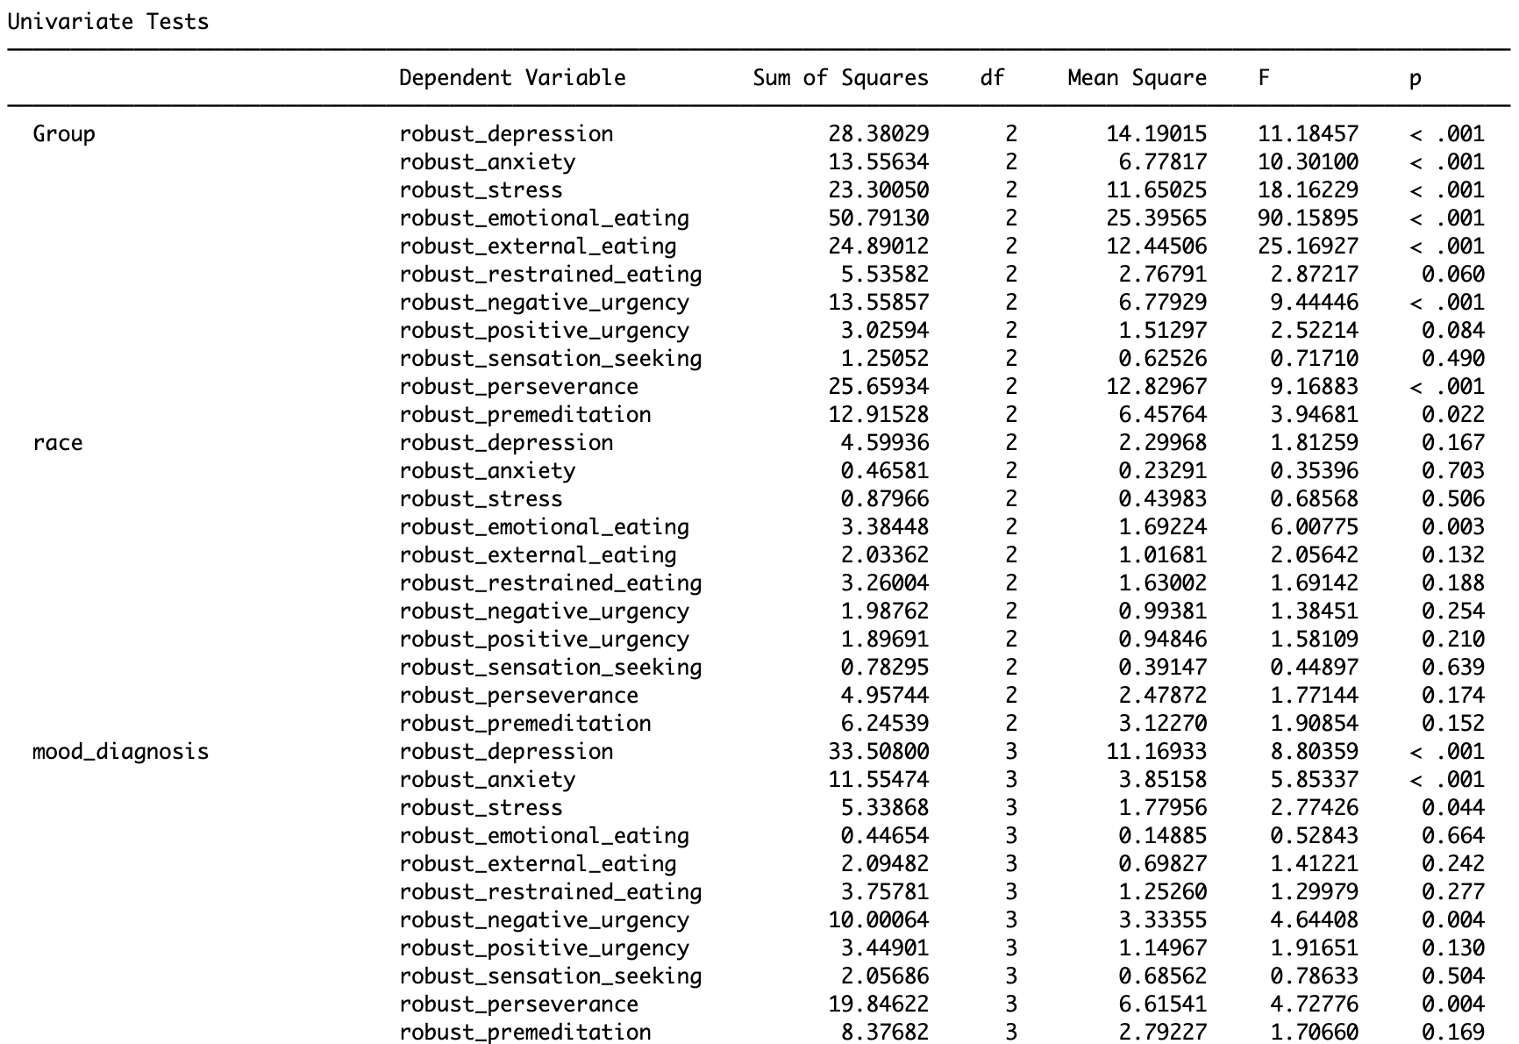
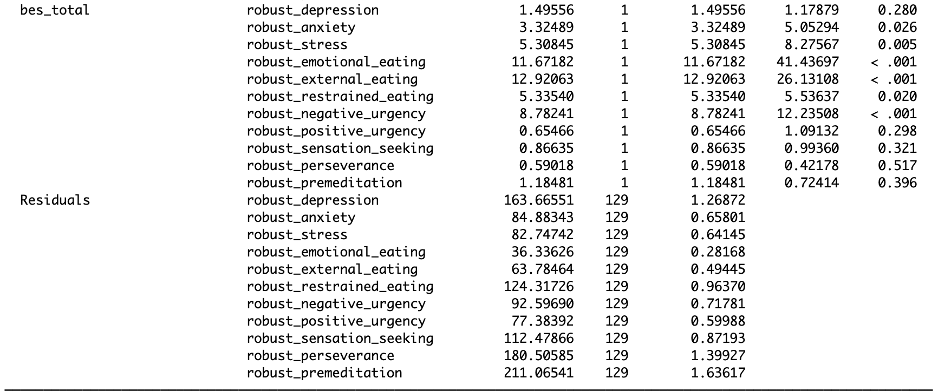

Table S4.2.6 Psychological Profile - significant pairwise comparisons (Bonferroni-adjusted t-tests) between variables within groups

Depression | t | df | p (adj)
Emotional eating | 3.73 | 164 | .014
External eating | 3.57 | 164 | .026
Negative urgency | 4.17 | 164 | .003
Lack of Premeditation | 3.43 | 164 | .042

Supplementary References

APA. (2022). Diagnostic and statistical manual of mental health disorders (5th Edition, Text Revision (DSM-5-TR) ed.). American Psychiatric Association. https://doi.org/book/10.1176/appi.books.9780890425787
Ateş, C., Kaymaz, Ö., Kale, H. E., & Tekindal, M. A. (2019). Comparison of Test Statistics of Nonnormal and Unbalanced Samples for Multivariate Analysis of Variance in terms of Type-I Error Rates. Comput Math Methods Med, 2019, 2173638. https://doi.org/10.1155/2019/2173638
Bulut, O., & Desjardins, C. D. (2020). Profile analysis of multivariate data: a brief introduction to the profileR package [Preprint]. https://doi.org/10.31234/osf.io/sgy8m
Eisenberg, I. W., Bissett, P. G., Zeynep Enkavi, A., Li, J., MacKinnon, D. P., Marsch, L. A., & Poldrack, R. A. (2019). Uncovering the structure of self-regulation through data-driven ontology discovery. Nature Communications, 10(1), 2319. https://doi.org/10.1038/s41467-019-10301-1
Fox, J., Weisberg, S., & Price, B. (2024). car: Companion to Applied Regression. In (Version 3.1-3) CRAN.
Friendly, M., Fox, J., Monette, G., Chalmers, P., & Murdoch, D. (2025). heplots: Visualizing Hypothesis Tests in Multivariate Linear Models. In (Version 1.7.8) Cran.
Gershon, R. C., Cella, D., Fox, N. A., Havlik, R. J., Hendrie, H. C., & Wagster, M. V. (2010). Assessment of neurological and behavioural function: The NIH Toolbox. The Lancet Neurology, 9(2), 138-139. https://doi.org/10.1016/S1474-4422(09)70335-7
Green, D. M., & Swets, J. A. (1966). Signal detection theory and psychophysics (Vol. 1). Wiley New York.
Grosjean, P. (2024). Pastecs: Package for analysis of space-time ecological series. In (Version 1.4.2) R-project.org. https://github.com/SciViews/pastecs
Harris, P. A., Taylor, R., Minor, B. L., Elliott, V., Fernandez, M., O'Neal, L., McLeod, L., Delacqua, G., Delacqua, F., Kirby, J., & Duda, S. N. (2019). The REDCap consortium: Building an international community of software platform partners. Journal of Biomedical Informatics, 95, 103208. https://doi.org/10.1016/j.jbi.2019.103208
Harris, P. A., Taylor, R., Thielke, R., Payne, J., Gonzalez, N., & Conde, J. G. (2009). Research electronic data capture (REDCap)—A metadata-driven methodology and workflow process for providing translational research informatics support. Journal of Biomedical Informatics, 42(2), 377-381. https://doi.org/10.1016/j.jbi.2008.08.010
Jorgensen, T. D., Pornprasertmanit, S., Schoemann, A. M., & Rosseel, Y. (2022). semTools: Useful tools for structural equation modeling. (R package version 0.5-6). In R-project.org. https://CRAN.R-project.org/package=semTools
Kaplan, B. A., Amlung, M., Reed, D. D., Jarmolowicz, D. P., McKerchar, T. L., & Lemley, S. M. (2016). Automating scoring of Delay Discounting for the 21- and 27-item Monetary Choice Questionnaires. Behav Anal, 39(2), 293-304. https://doi.org/10.1007/s40614-016-0070-9
Kappal, S. (2019). Data Normalization Using Median & Median Absolute Deviation (MMAD) based Z-Score for Robust Predictions vs. Min-Max Normalization. https://doi.org/10.13140/RG.2.2.32799.82088
Kassambara, A. (2023a). ggcorrplot: Visualization of a Correlation Matrix using 'ggplot2'. In (Version 0.1.4.1) CRAN. http://www.sthda.com/english/wiki/ggcorrplot-visualization-of-a-correlation-matrix-using-ggplot2
Kassambara, A. (2023b). ggpubr: ggplot2 based publication ready plots. In CRAN. https://CRAN.R-project.org/package=ggpubr
Kirby, K. N., Petry, N. M., & Bickel, W. K. (1999). Heroin addicts have higher discount rates for delayed rewards than non-drug-using controls. Journal of Experimental Psychology: General, 128(1), 78-87. https://doi.org/10.1037/0096-3445.128.1.78
Korkmaz, S., Goksuluk, D., & Zararsiz, G. (2014). MVN: an R package for assessing multivariate normality. In (Version 6.151) R-project.org. https://CRAN.R-project.org/package=MVN
Posit Software. (2025). RStudio: Integrated development environment for R. In Posit Software, PBC. http://www.posit.co/
Revelle, W. (2024). psych: Procedures for Psychological, Psychometric, and Personality Research. In (Version 2.4.3) https://CRAN.R-project.org/package=psych
Schaefer, L. M., & Steinglass, J. E. (2021). Reward learning through the lens of RDoC: A review of theory, assessment, and empirical findings in the eating disorders. Current Psychiatry Reports, 23(1), 2. https://doi.org/10.1007/s11920-020-01213-9
Selker, R., Love, J., & Dropmann, D. (2025). jmv: the jamovi analyses. In (Version 2.7.0) Cran.
Venables, W. N., & Ripley, B. D. (2002). Modern Applied Statistics with S (Fourth Ed. ed.). Springer. https://www.stats.ox.ac.uk/pub/MASS4/.
Verdejo-Garcia, A., Tiego, J., Kakoschke, N., Moskovsky, N., Voigt, K., Anderson, A., Koutoulogenis, J., Lubman, D. I., & Bellgrove, M. A. (2021). A unified online test battery for cognitive impulsivity reveals relationships with real-world impulsive behaviours. Nature Human Behaviour, 5(11), 1562-1577. https://doi.org/10.1038/s41562-021-01127-3
Voigt, K., Giddens, E., Stark, R., Frisch, E., Moskovsky, N., Kakoschke, N., Stout, J. C., Bellgrove, M. A., Andrews, Z. B., & Verdejo-Garcia, A. (2021). The hunger games: Homeostatic state-dependent fluctuations in disinhibition measured with a novel gamified test battery. Nutrients, 13(6), 2001. https://www.mdpi.com/2072-6643/13/6/2001
Voon, V., Derbyshire, K., Ruck, C., Irvine, M., Worbe, Y., Enander, J., Schreiber, L., Gillan, C., Fineberg, N., Sahakian, B., Robbins, T., Harrison, N., Wood, J., Daw, N., Dayan, P., Grant, J., & Bullmore, E. (2015). Disorders of compulsivity: A common bias towards learning habits. Molecular Psychiatry, 20(3), 345-352. https://doi.org/10.1038/mp.2014.44
Waltmann, M., Herzog, N., Reiter, A. M. F., Villringer, A., Horstmann, A., & Deserno, L. (2024). Neurocomputational mechanisms underlying differential reinforcement learning from wins and losses in obesity with and without binge eating. Biological Psychiatry: Cognitive Neuroscience and Neuroimaging. https://doi.org/https://doi.org/10.1016/j.bpsc.2024.06.002
Wickham, H. (2016). ggplot2: Elegant graphics for data analysis. In Springer-Verlag https://ggplot2.tidyverse.org
Wickham, H., Averick, M., Bryan, J., Chang, W., McGowan, L. D. A., François, R., Grolemund, G., Hayes, A., Henry, L., & Hester, J. (2019). Welcome to the Tidyverse. Journal of open source software, 4(43), 1686. https://doi.org/10.21105/joss.01686
Wickham, H., & Bryan, J. (2022). readxl: Read Excel Files. In https://github.com/tidyverse/readxl
Wickham, H., François, R., Henry, L., Müller, K., & Vaughn, D. (2023). dplyr: A grammar of data manipulation. In https://dplyr.tidyverse.org
Wiley, J. (2023). JWileymisc: Miscellaneous utilities and functions. In (Version 1.4.1) CRAN. https://CRAN.R-project.org/package=JWileymisc
Xie, Y. (2024). knitr: A General-Purpose Package for Dynamic Report Generation in R. In (Version 1.47) CRAN. https://CRAN.R-project.org/package=knitr

