>F5_12PFR4
GMMRGGGTTTTCCGTAGGTGAACCTGCGGAAGGATCATTACCGAGTTCTCGGGCTTCGGCTCGAATCTCCCACCCTTTGT
GAACATACCTCTGTTGCTTTGGCGGCTCTTTGCCGCGAGGAGCCACAACTTCTCGCGCGCTTTCCGCCAGAGGACCTTCA
AACTCCAGTCAGTGAACGTCGACGTCTGATAAACAAGTTAATAAACTAAAACTTTCAACAACGGATCTCTTGGTTCTGGC
ATCGATGAAGAACGCAGCSA
>F9_22PFR4
GGTTTYYSGTTKGGTGAACCWGCGGARGGATCATTACCGAGTGTAARARCTCCCAAACCATTGTGAACCTACCACTGTTG
CTTCSGCKGCCTCKCCCCGGGCGCGTTCGCGCGGCCCGGACCCAGGYGTCCGCCGGAGGCTCCAAACTCTTGTCTTTTAS
TGTATTTCTGARTGGCATAAGCAAATAAATCAAAACTTTCARCAACGGATCTCTTGGTTCTGGCATCAATGAAGAACGCA
GCGAWTAACSCASCGATCTCTTGGTTCTGGCATCGATGAAGAACGCAGCCACA
>F21_06SFR4
CKTYAGGATCTCGTTGGTGACCAGCGGAGGGATCATTACCGAGTTTACAACTCCCAAACCCCTGTGAACATACCAATTGT
TGCCTCGGCGGATCAGCCCGCTCCCGGTAAAACGGGACGGCCCGCCAGAGGACCCCTAAACTCTGTTTCTATATGTAACT
TCTGAGTAAAACCATAAATAAATCAAAACTTTCAACAACGGATCTCTTGGTTCTGGCATCGATGAAGAACGCAGCCAGA
>F23_12PFR1
TMMWGGGTTTTCGGTAGGTGACCTGCGGAAGGATCATTAAAGAGTAAGGGTGCTCAGCGCCCGACCTCCAACCCTTTGTT
GTTAAAACTACCTTGTTGCTTTGGCGGGACCGCTCGGTCTCGAGCCGCTGGGGATTCGTCCCAGGCGAGCGCCCGCCAGA
GTTAAACCAAACTCTTGTTATTTAACCGGTCGTCTGAGTTAAAATTTTGAATAAATCAAAACTTTCAACAACGGATCTCT
TGGTTCTCGCATCGATGAAGAACGCAGCSA

Supplemental data S1 – ITS-1 DNA sequences.

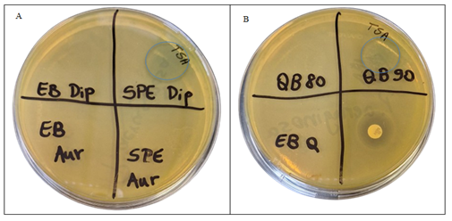
Supplemental data S2 - Inhibition zones of SPE fraction from Diplodia (20 µL of a 5 mg/mL solution, A), and QB-90 (20 µL of a 50 mg/mL, B) and norfloxacin (30 µg/mL, B) against P. aeruginosa ATCC 23893. Blue circles indicate intermediate intensity inhibition zones from direct pipetting extracts on the TSA containing the spread inoculum
A
B
Supplemental data S3 – Growth inhibitory activity of SPE fraction from Diplodia (max. 2,5mg/mL, A), QB-90 (max. 25 mg/mL, B) and chloramphenicol (max. 320 µg/mL, C) against P. aeruginosa ATCC 23893.

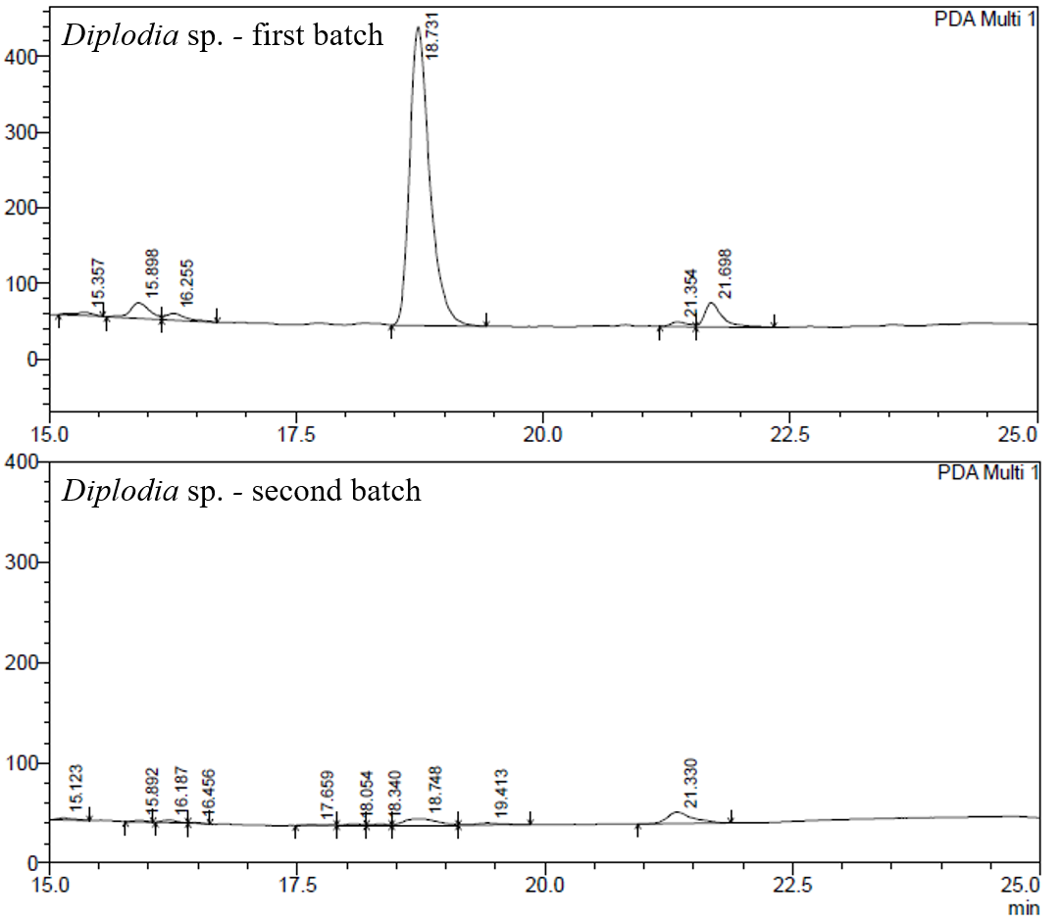
Supplemental data S4 - Comparative HPLC chromatograms of Diplodia sp. SPE-purified fractions from two independent batches.

