Table 2: Brief description of selected DRM applications
Mobile application |  | Country | Downloads (Google Play Data) | Description
 | AlertSwiss | Switzerland | 500K + | The official emergency app from the Swiss Federal Office for Civil Protection, delivering real-time alerts, warnings, and safety instructions.
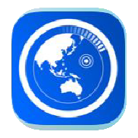 | Disaster Alert | Global | 500K + | A global emergency app powered by the PDC’s DisasterAWARE platform. It provides near real-time updates on 18 types of natural hazards worldwide, helping users stay informed and safe.
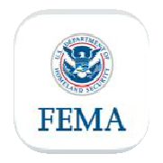 | FEMA | United States | 1M + | The official app of the Federal Emergency Management Agency offers real-time alerts, emergency shelter locations, preparedness tips, and recovery resources.
 | Info BMKG | Indonesia | 5M + | Indonesia’s official weather and disaster app, offering real-time information on weather, air quality, climate conditions, and earthquakes, all provided by the national meteorological agency, BMKG.
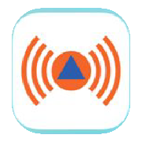 | NINA | Germany | 5M + | Germany’s official warning app from the Federal Office for Civil Protection and Disaster Relief (BBK), delivering nationwide alerts and safety information tailored to the users’ location to keep them informed and prepared.
 | NERV | Japan | 1M + | Alerts for earthquakes, tsunamis, severe weather, and more. Powered by real-time data from the Japan Meteorological Agency and an advanced in-house system, it ensures accurate, location-based warnings.
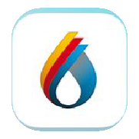 | Vic  Emergency | Australia (Victoria State) | 1M + | Official app from the Victorian Government, offering real-time emergency alerts, incident maps, fire danger ratings, and others, with location-based warnings across Victoria.

