Supplementary Information

Selective Lysosomal H₂O₂ – ROS Imaging with a Naphthalimide Probe Forming Hydroxylamine without Overoxidation
Ricardo Flores-Cruz, Nitzya Ruiz-Robledo,^{[a]} Adriana Romo-Pérez,^{[a]} and Arturo Jiménez-Sánchez*^{[a]}

ª Instituto de Química, Universidad Nacional Autónoma de México, México D.F. No. 04510, México. * arturo.jimenez@iquimica.unam.mx

Graphical Abstract

A novel lysosome-targeted fluorescent probe, LysoH₂O₂, enables real-time, high-fidelity imaging of hydrogen peroxide dynamics within the lysosomal compartment of living cells, offering a powerful tool for redox biology.

METHODS
General Probe Synthesis
Synthesis of 6-(2-morpholinoethyl)-1H-benzo[de]isoquinoline-1,3(2H)-dione (LysoH₂O₂). General Methods: All commercial reagents were used as received. NMR spectra were recorded on a 300 MHz spectrometer. Chemical shifts (δ) are reported in ppm relative to residual solvent peaks. High-resolution mass spectrometry (HRMS) was performed using electrospray ionization (ESI).
Procedure: A mixture of 4-bromo-1, 8-naphthalic anhydride, 1 mmol, 0.278 g and sodium azide NaN₃ (0.195 g, 3 mmol) were dissolved in N,N-dimethylformamide (DMF) / H₂O (v/v, 10/1, 20 mL) and stirred at 80 °C for 4 h. Then, the solvent was poured into ice water (10 ml), and the precipitated solid was filtered.Then, the solid was dissolved in DMF (20 ml), added with 2ml of aquous NaHS (0.224 g, 4 mmol) and further stirred at 90 °C for 1h. Next, the reaction solution was added with ice water and adjusted to weak acidity. Subsequently, a solid was filtered and added 10 mL DMF containing 4-(2-aminoethyl)morpholine (1.3 mmol, 0.75 mL) and heated at 120 °C under controlled pressure for 8 hours with vigorous stirring. After cooling to room temperature, the crude material was dissolved in acetone (~25 mL) and purified by flash column chromatography on silica gel (eluent: DCM/MeOH 95:5). The product was isolated as a yellow solid. Yield: 67% (0.225 g). ¹H NMR (300 MHz, CDCl₃) δ: 8.61 (dd, J = 26.60 Hz, 1H), 8.42 (dd, J = 12.87 Hz, 1H), 8.12 (dd, J = 21.45 Hz, 1H), 7.68 (m, J = 22.32 Hz, 1H), 6.90 (d, J = 13.73 Hz, 1H), 4.97 (s, 2H), 4.34 (t, J = 21.45 Hz, 2H), 3.71 (m, J = 21.45 Hz, 4H), 2.72 (t, J = 26.60 Hz, 2H), 2.63 (s, 4H). ¹³C NMR (75 MHz, CDCl₃) δ 154.2, 147.1, 133.7, 129.3, 127.2, 124.8, 122.1, 119.5, 117.21, 109.4, 107.81, 67.25, 57.16, 55.18, 36.41. HRMS (ESI+) m/z: Calculated for C₁₈H₂₀N₃O₃ [M+H]⁺: 326.1499. Found: 326.14.
Figure S1. ¹H NMR spectrum (300 MHz, CDCl₃) of LysoH₂O₂.
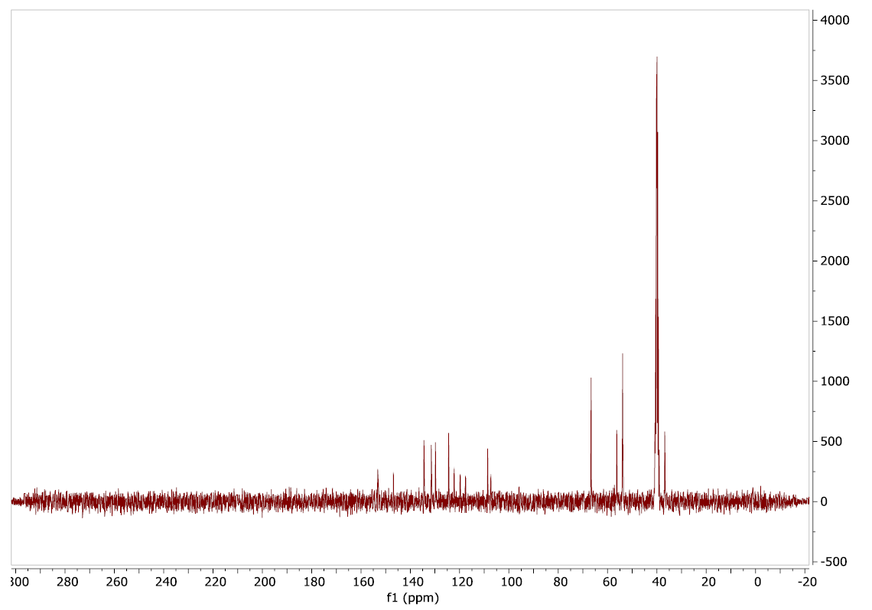
Figure S2. ¹³C NMR spectrum (75 MHz, CDCl₃) of LysoH₂O₂.
Figure S3. ¹H-¹H COSY NMR spectrum (300 MHz, CDCl₃) of LysoH₂O₂.

Figure S4. ¹H-NMR spectra (300 MHz, CDCl₃) of LysoH₂O₂ (above) and after adding 1 equiv H₂O₂ 14 % (below, δ: 10.15 (s, 1H, -OH signal) and 11.05 (s, 1H, -NH- signal).

Figure S5. HRMS (ESI-TOF+) spectra of LysoH₂O₂ (m/z: Calculated for C₁₈H₂₀N₃O₃ [M+H]⁺: 326.14, found: 326.1498).

Figure S6. HRMS (ESI-TOF+) spectra of LysoH₂O₂ after adding 1 equiv H₂O₂ 14 % (m/z: Calculated for hydroxylamine derivative C₁₈H₂₀N₃O₄ [M+H]⁺: 342.14, found: 342.1406). Also, the nitro-oxidized derivative was seen, m/z: C₁₈H₁₈N₃O₅ [M+H]⁺: 356.12, found: 356.1215).

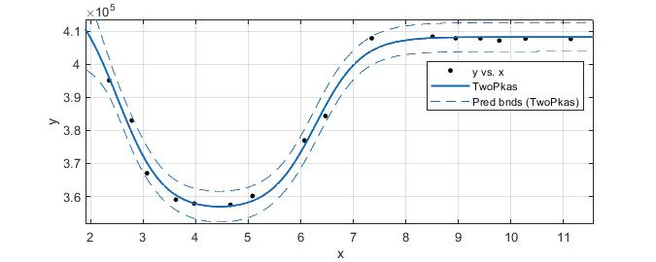

Coefficients with extrapolation (with 95% confidence bounds):
P1 = 4.083e+05 (4.063e+05, 4.102e+05)
P2 = 3.554e+05 (3.522e+05, 3.586e+05)
P3 = pKa’s = (2.509, 6.285)
P4 = 4.241e+05 (3.962e+05, 4.519e+05)

Goodness of fit:
SSE: 5.641e+07
R-square: 0.9918
Adjusted R-square: 0.9888
RMSE: 2264

Figure S7. Acid-base profiles and pK_{a} analysis for LysoH₂O₂

Table S1. LysoH₂O₂ HOMO – LUMO interactions obtained at the PBE/6-31G(d,p) level of theory, showing frontier orbital distributions HOMO-1 (H-1), HOMO (H), LUMO (L), LUMO+1 (L1) and corresponding lateral views (b). Below are show selected natural bond orbital (NBO) distributions.
H-1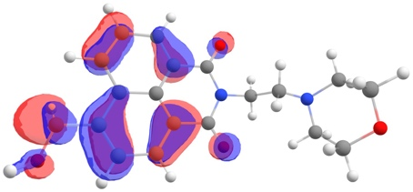 | H-1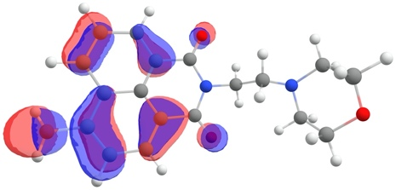
H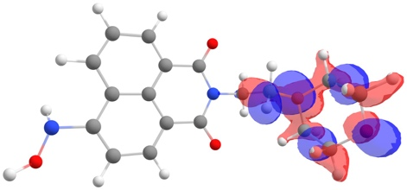 | H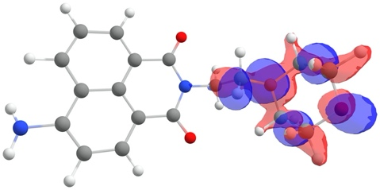
L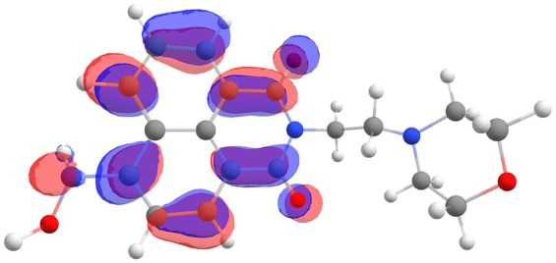 | L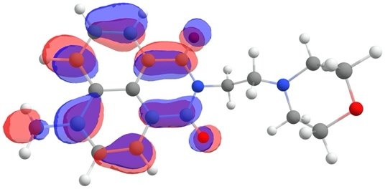
L1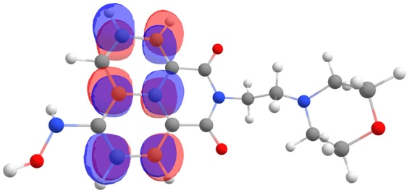 | L1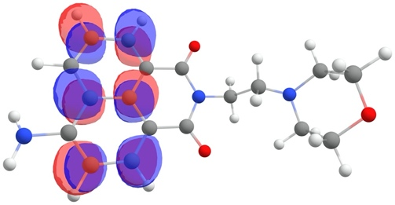
H-1b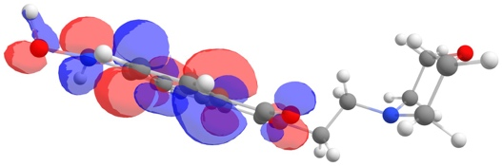 | H-1b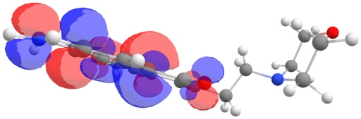
Hb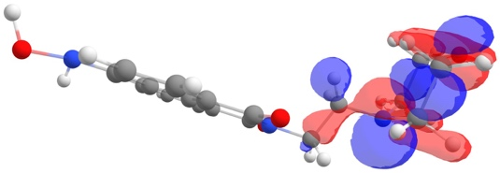 | Hb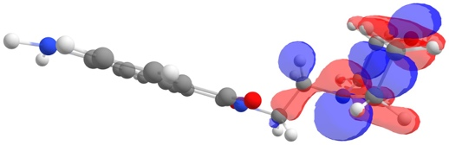
Lb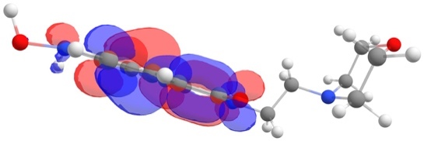 | Lb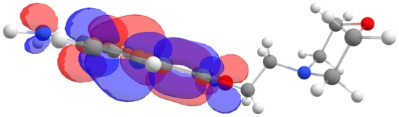
L1b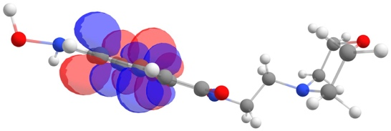 | L1b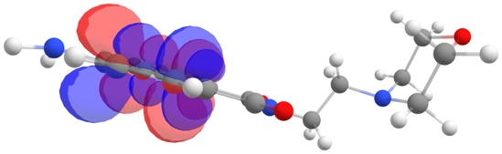

NBO Interactions:
16 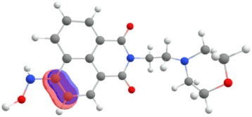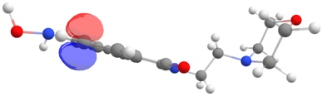 | 11 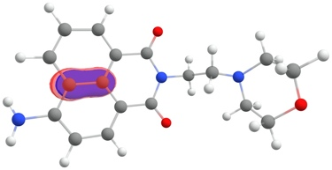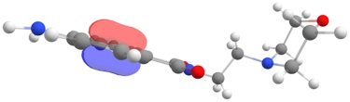
17 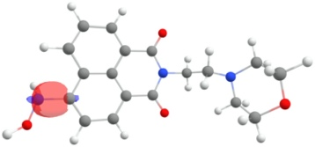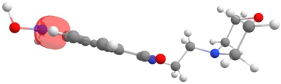 | 17 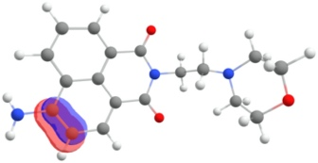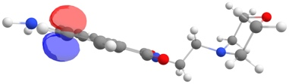
24 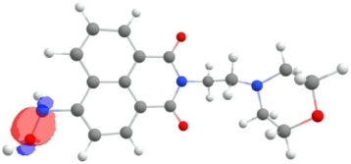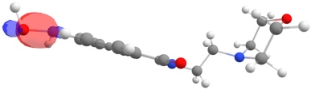 | 25 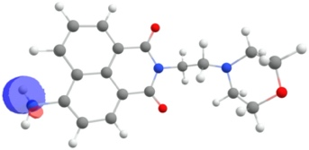
25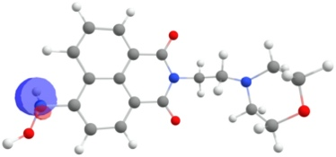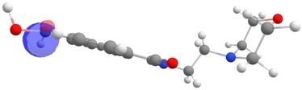 | 26 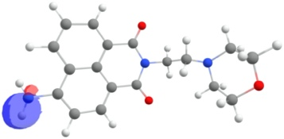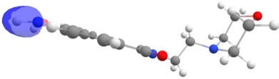
26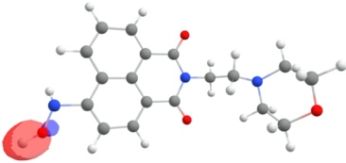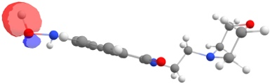 | 78 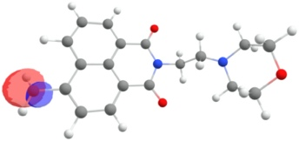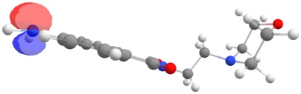
79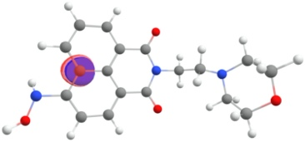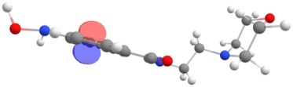
81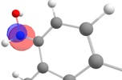 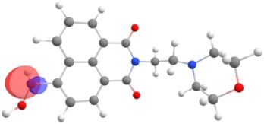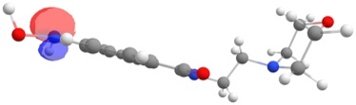
82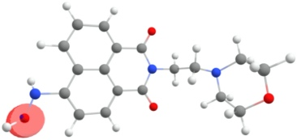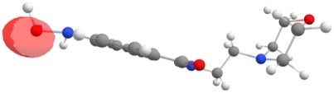
83