Table 1
Results of autumn migration and spring migration for 1st years juveniles, listing each animal, distances covered, and dates, as well as how many days each animal would stop along the way, and total days spent migrating.

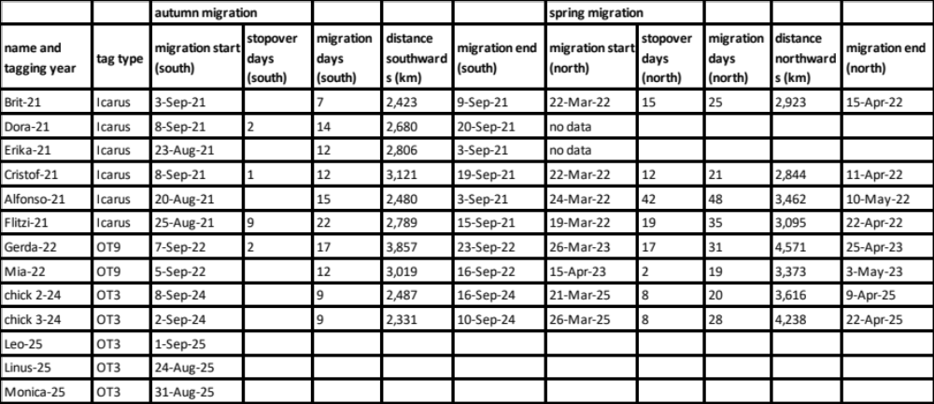

Table 2
Dispersion of birds tagged as chicks: distances of their nesting attempts relative to their birth site.
Nine juveniles returned to Spain in their second year. At least five of them started breeding; for Mia we did not have enough fixes to ensure or reject a breeding attempt. Two males tagged in 2024 did not breed in 2025, but stayed around their natal place in La Serena.

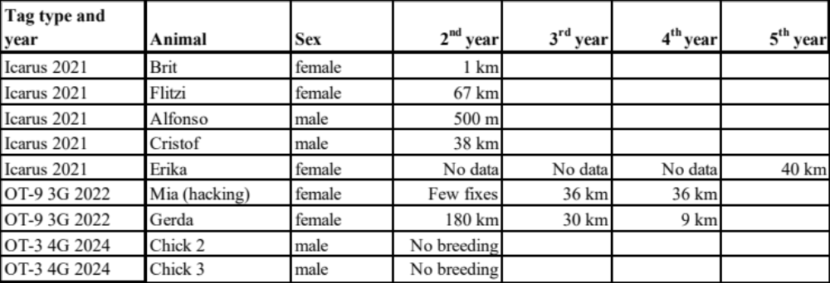

Table 3
Autumn and spring migration compared across the years for Mia and Gerda listing distances covered and dates, as well as how many days each animal would stop along the way, and total days spent migrating.

