Supplementary Information for

Environmental stress drives plasticity in sexual bimaturism in the black soldier fly (Hermetia illucens)

Table of Contents:

Figure S1. Black soldier fly larvae growth curves. | Page 2
Figure S2. Correlations between Δt and PC1. | Page 3
Figure S3. Dharma Q-Qplot for protandry modelling. | Page 4
Figure S4. Dharma Q-Qplot for dry adult weight modelling. | Page 5
Table S1. Estimation of peak larval weight. | Page 6
Table S2. Measurements of fitness related traits per sample. | Page 11

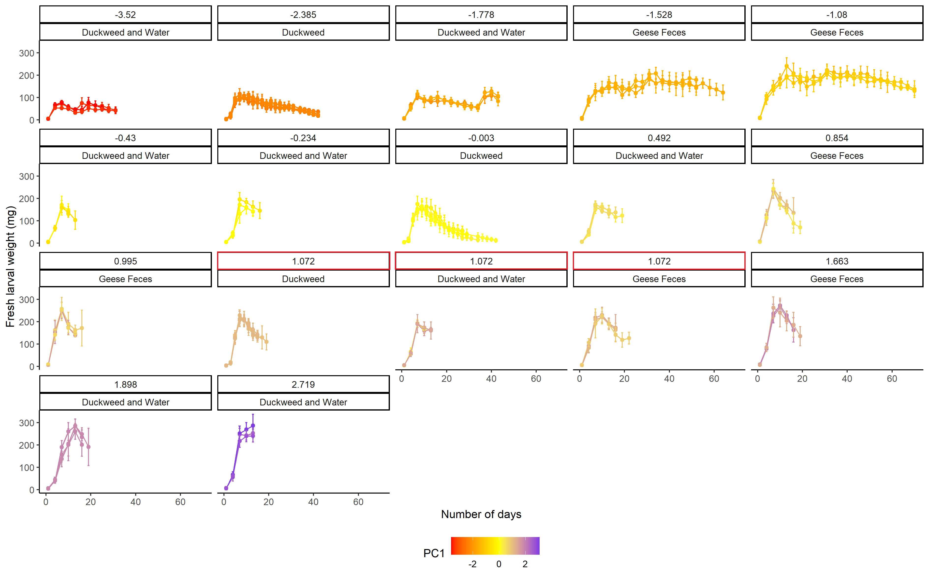
Figure S1. Fresh black soldier fly larvae weight across time per experimental treatment. Color gradient shows the PC1 value per replicate. Values at the top of each plot show the average PC1 value per treatment (red boxes show the controls per experiment).
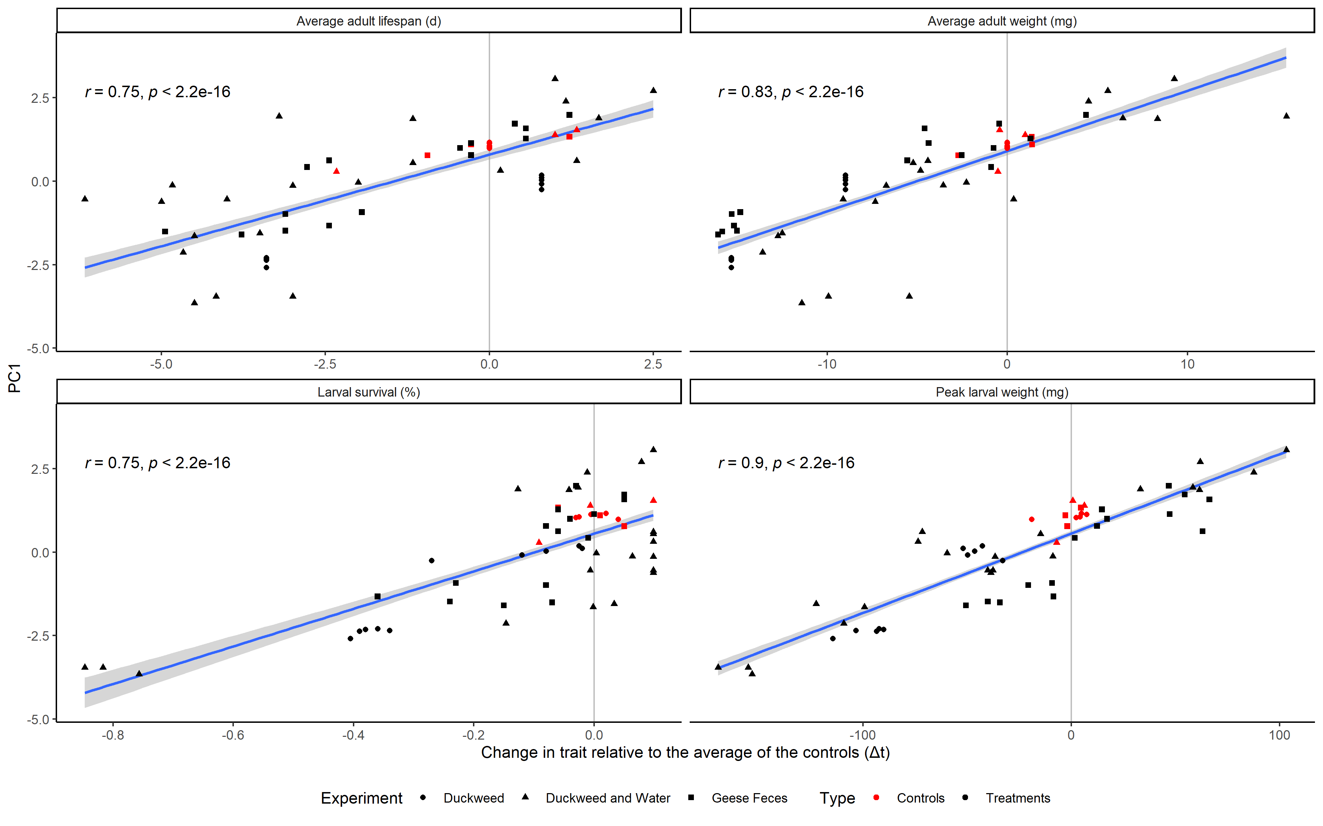
Figure S2. Correlations between the changes in fitness-related traits relative to the average of the controls of each experiment (Δt) and larval environmental quality (PC1). Values show the Pearson correlation coefficient and the associated P-value. Blue lines show the linear models with the model standard error as the shaded area.
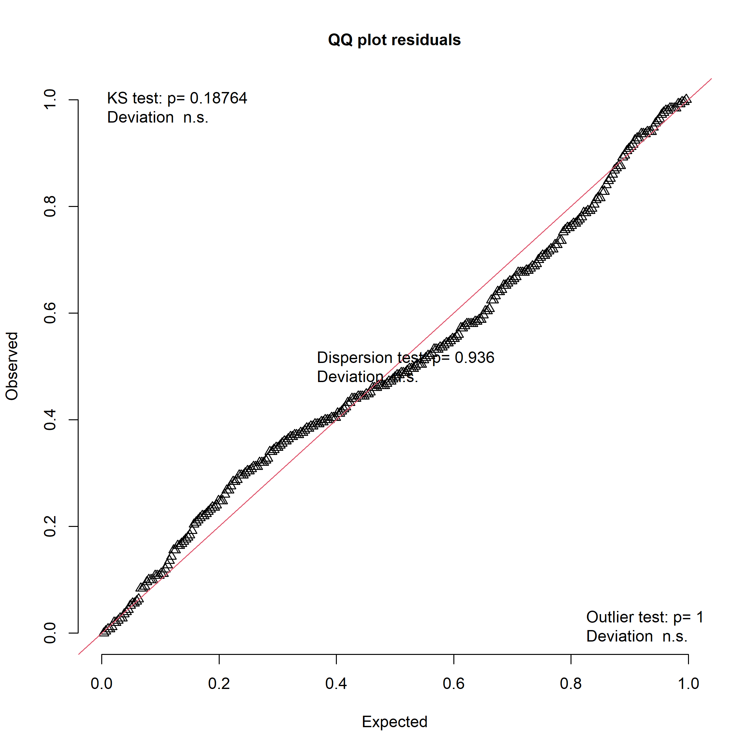
Figure S3. Dharma Q-Qplot for the modelling of the hyperbolic arcsine of degree of protandry (ΔQ) as predicted by the interaction between larval environmental quality (PC1) and quantiles.

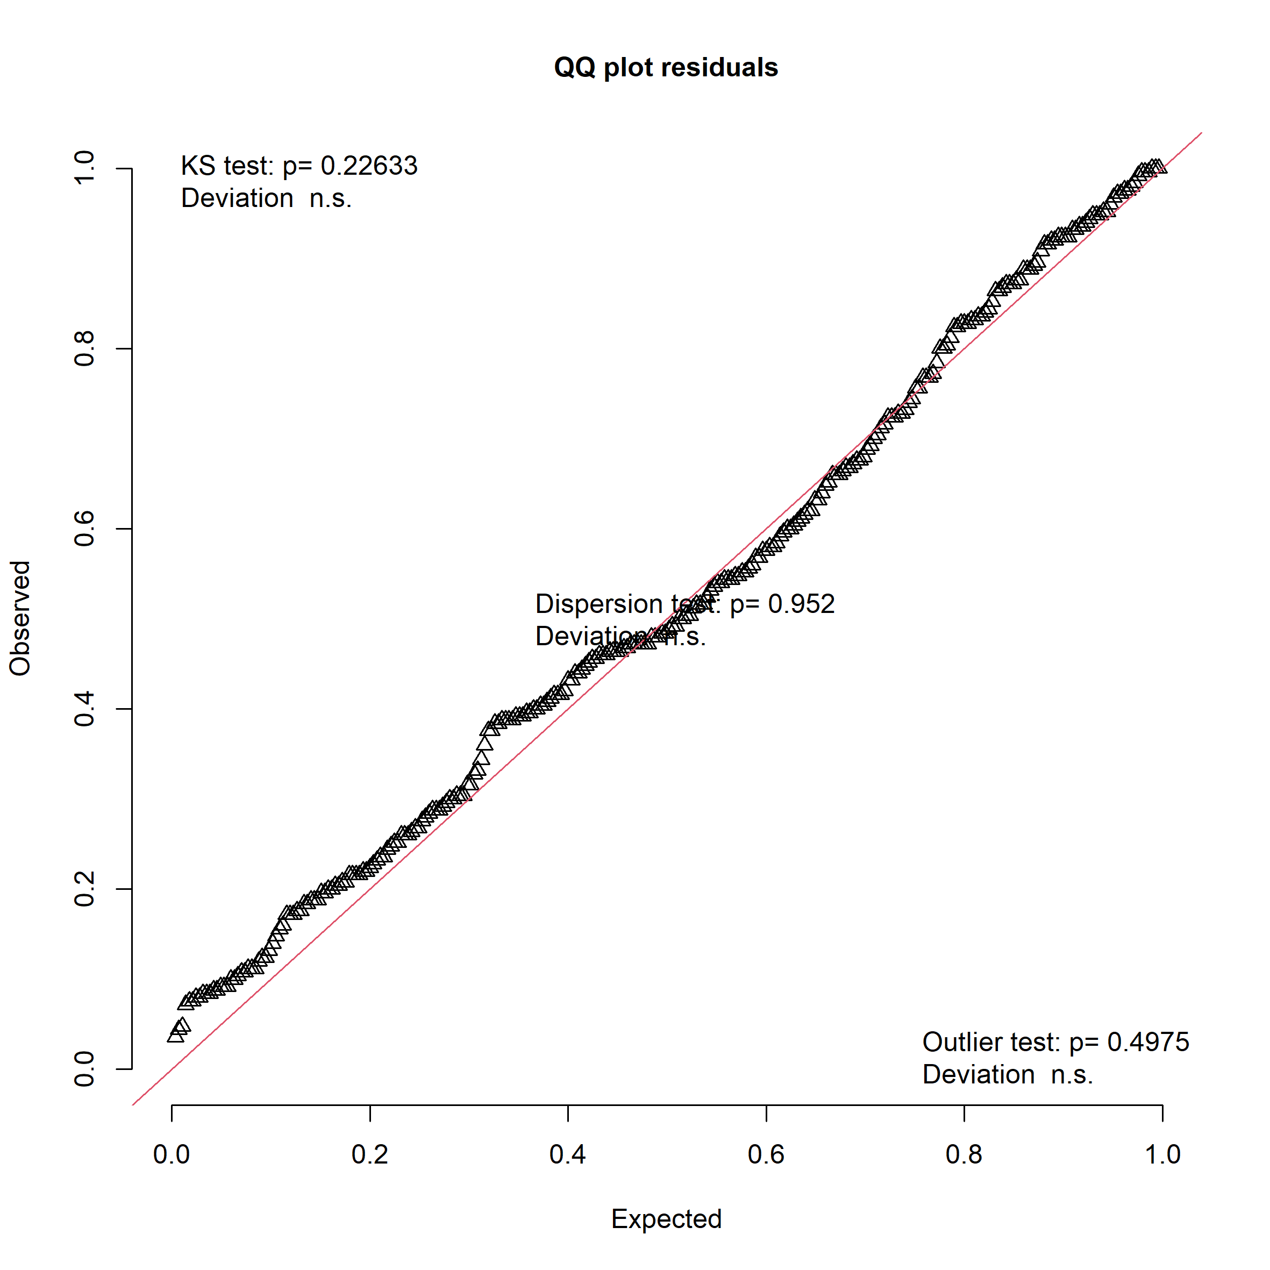
Figure S4. Dharma Q-Qplot for the modelling of the square root transformed dry adult weight mass as predicted by the interaction between larval environmental quality (PC1) and sex.

Table S1. Estimation of peak larval growth per sample. Each plot shows the fitting of the most parsimonious rTPC model (shown in the bottom right corner of each plot), as well as the predicted maximum larval weight.
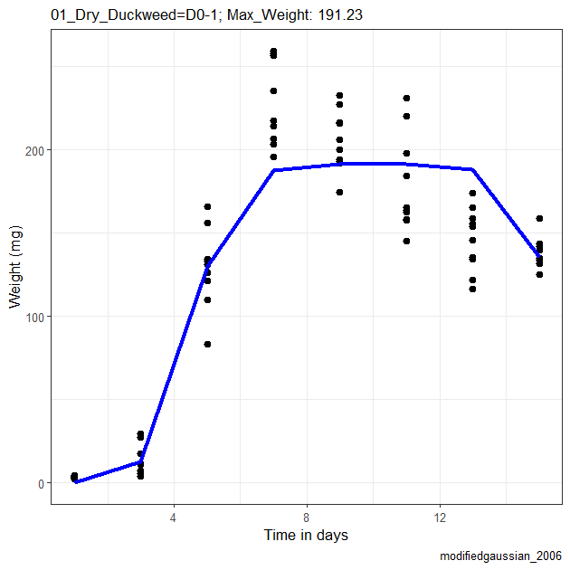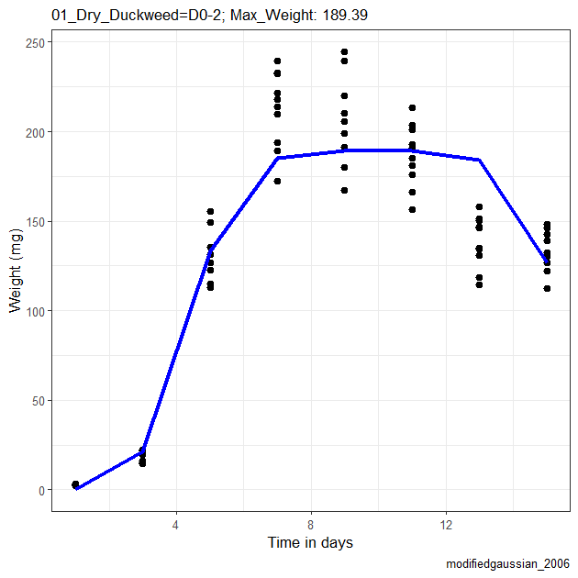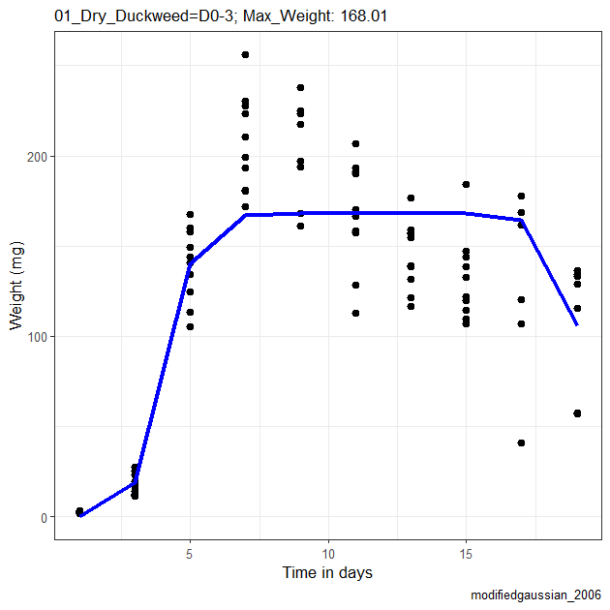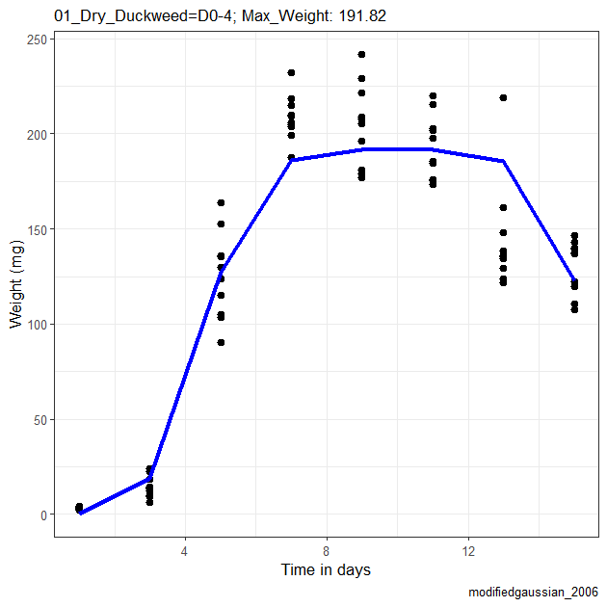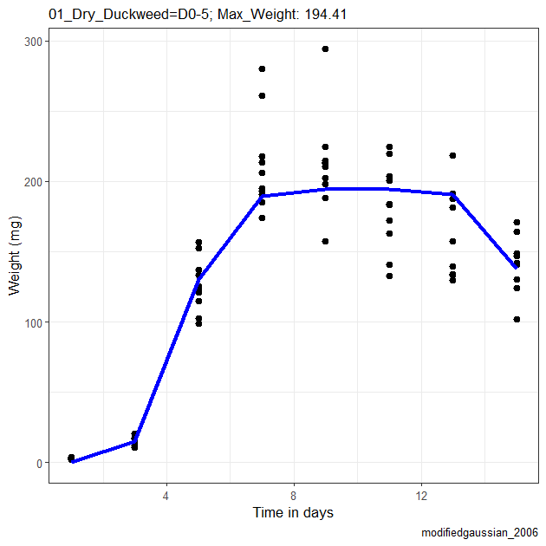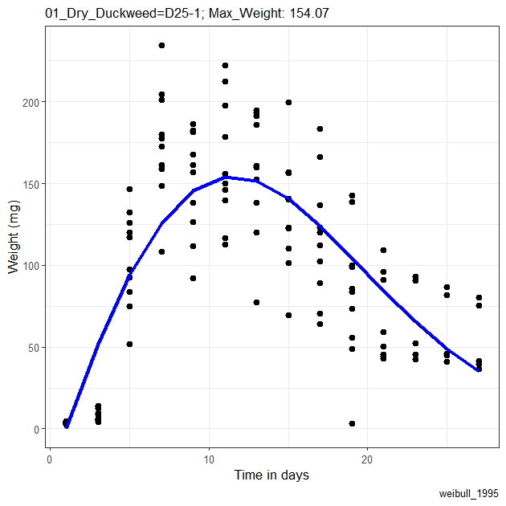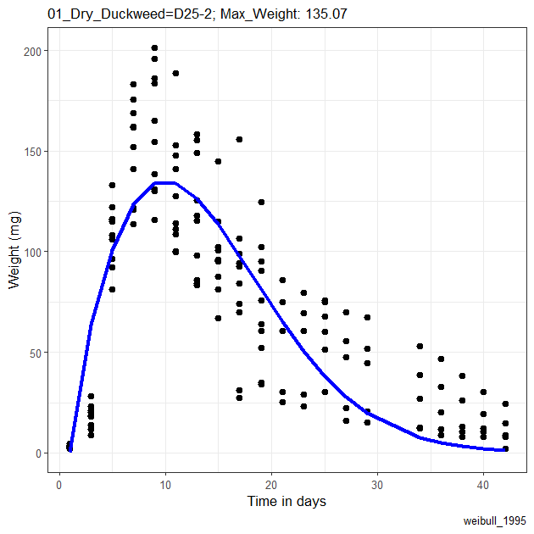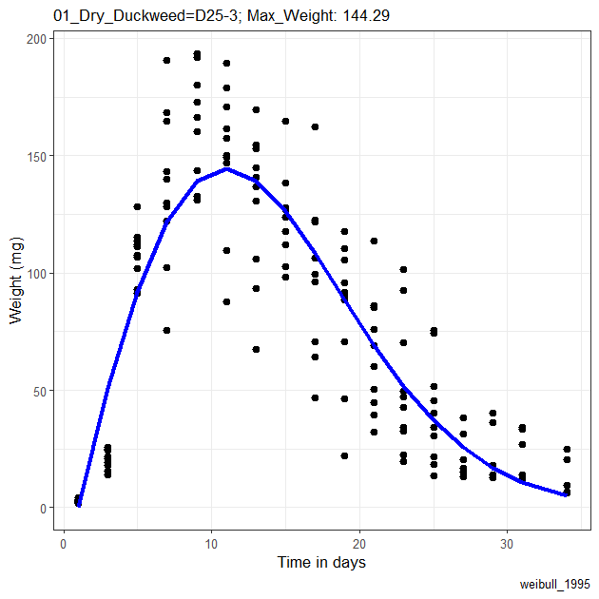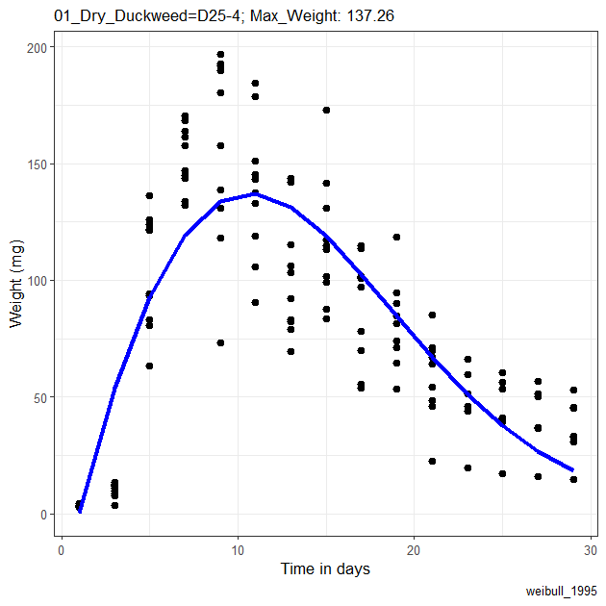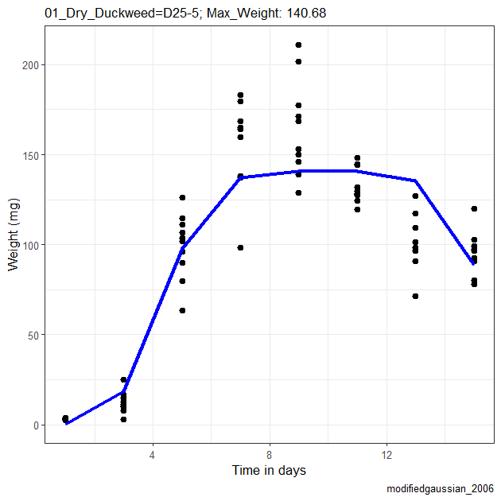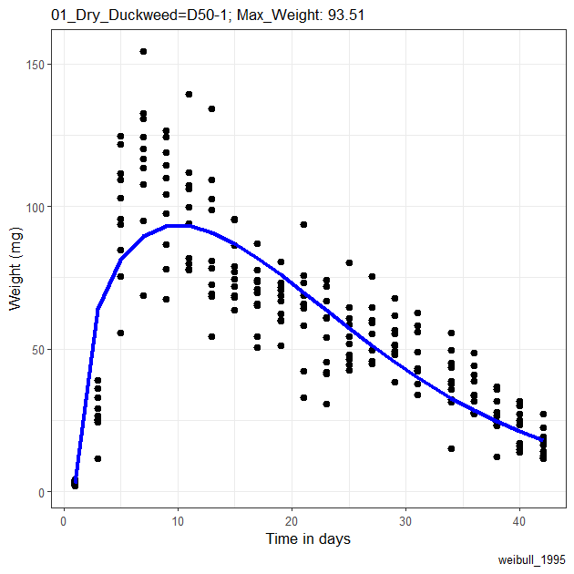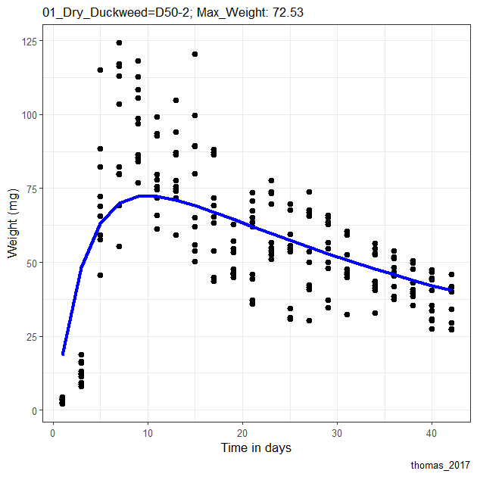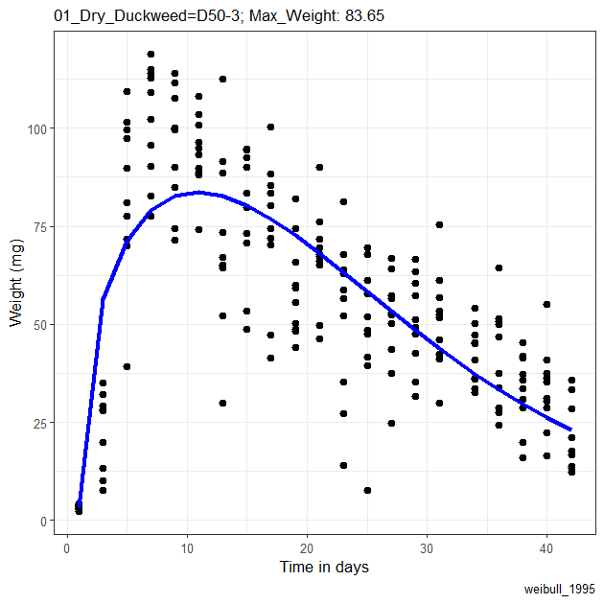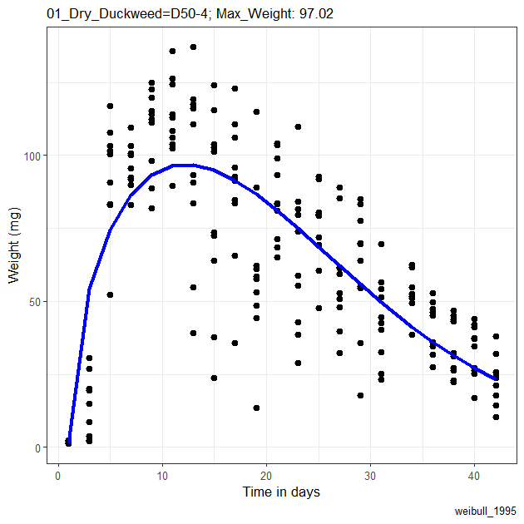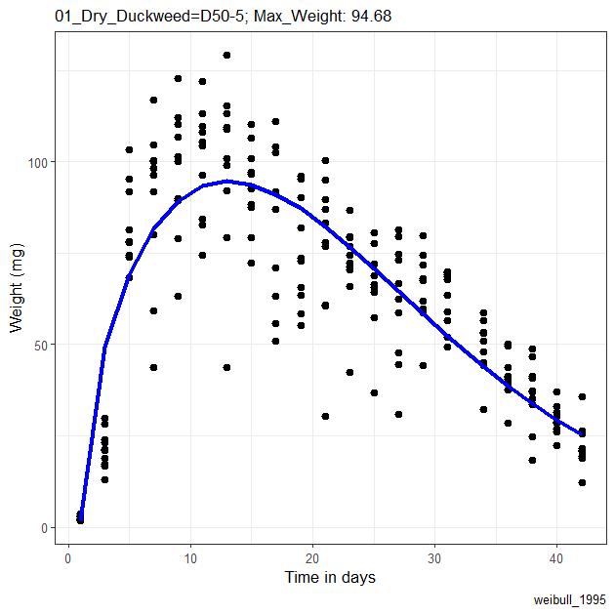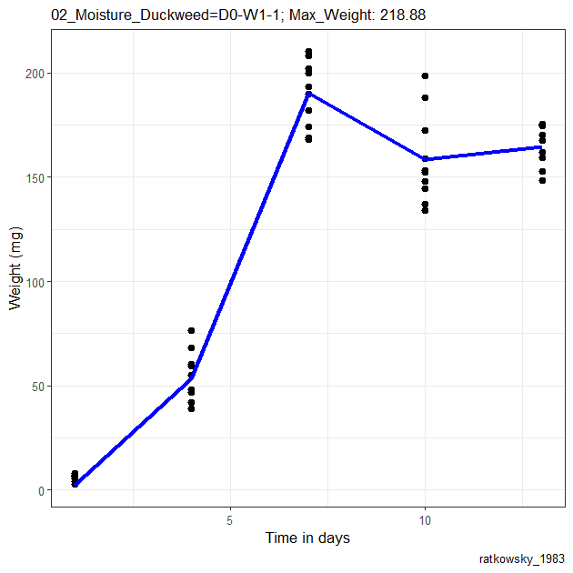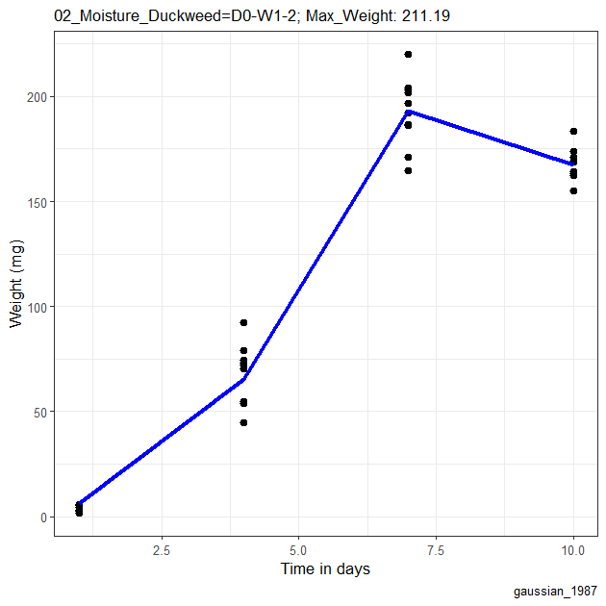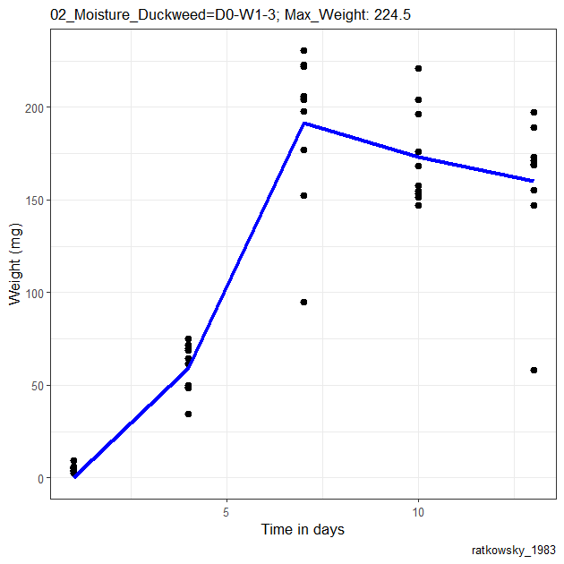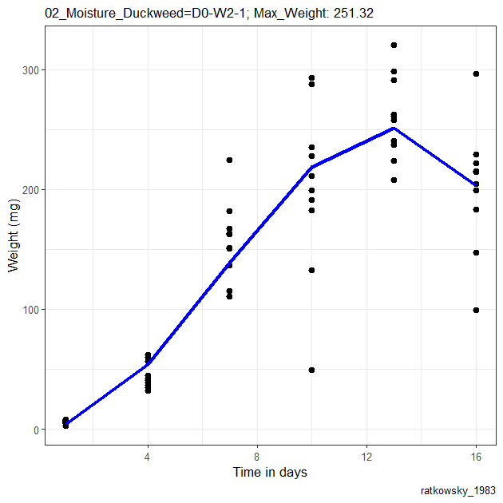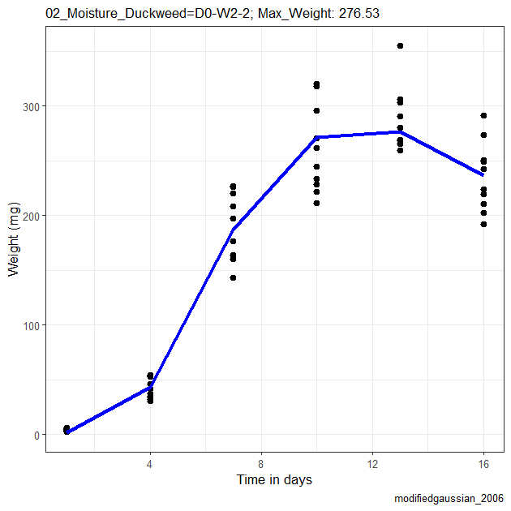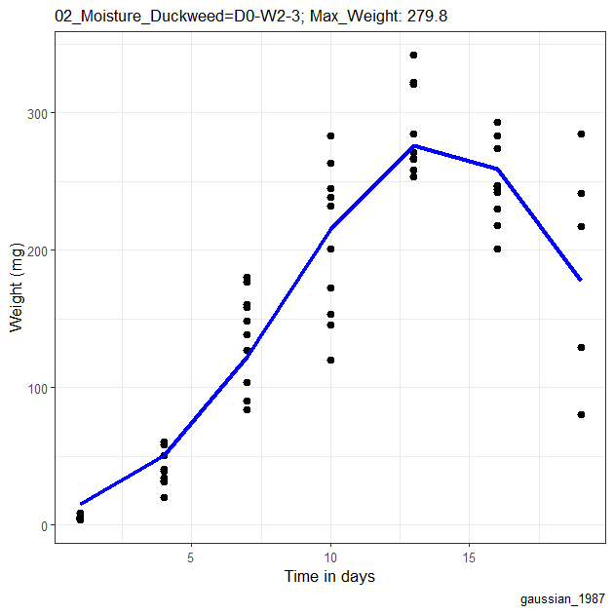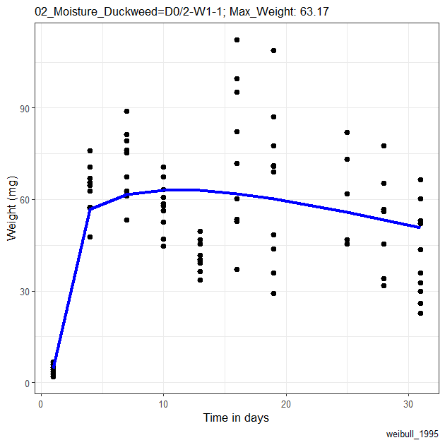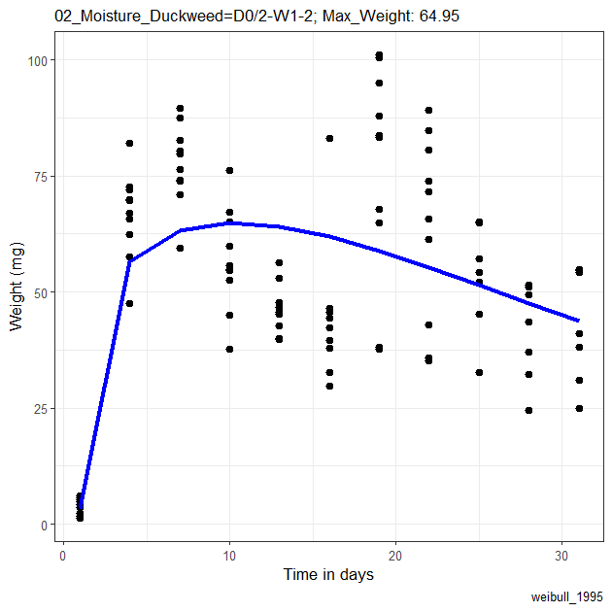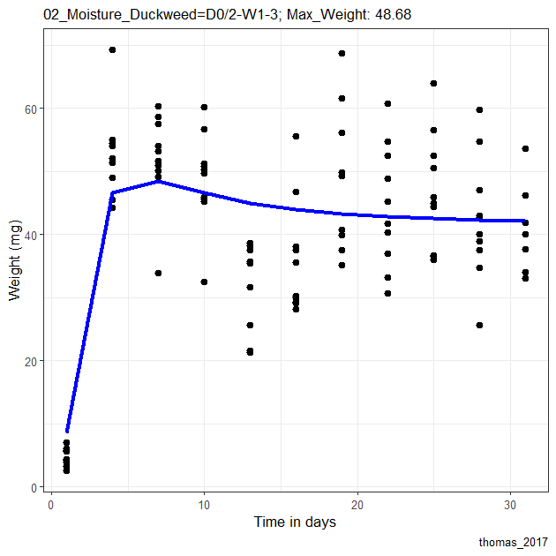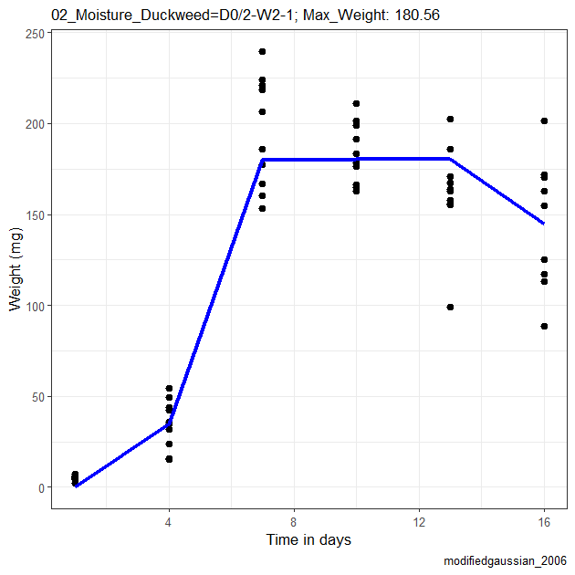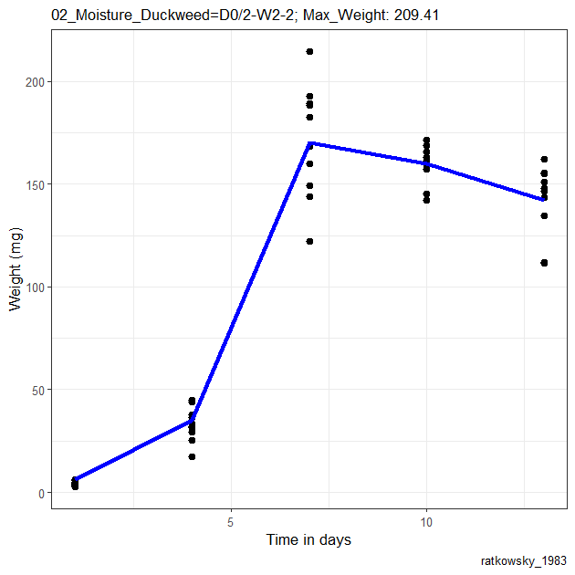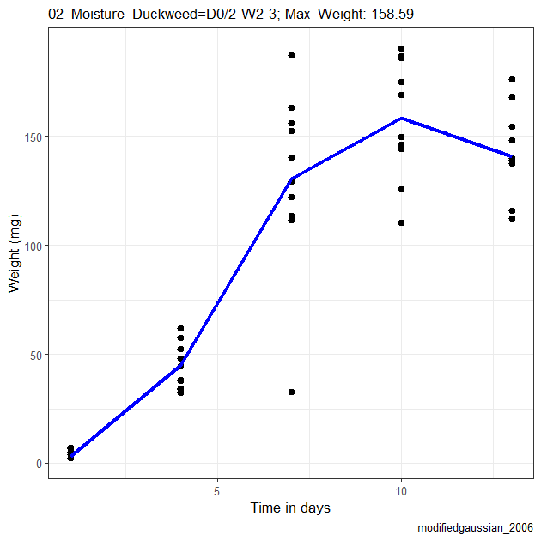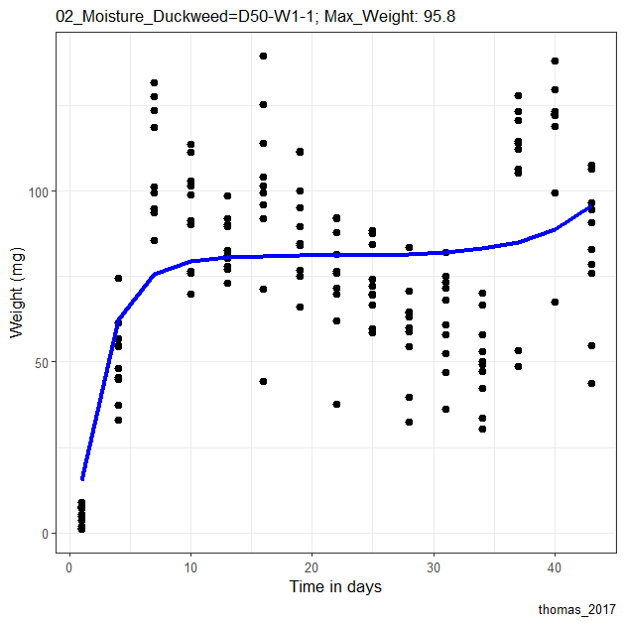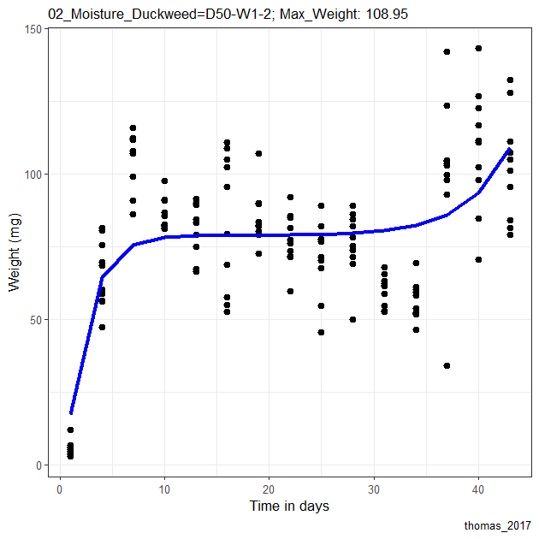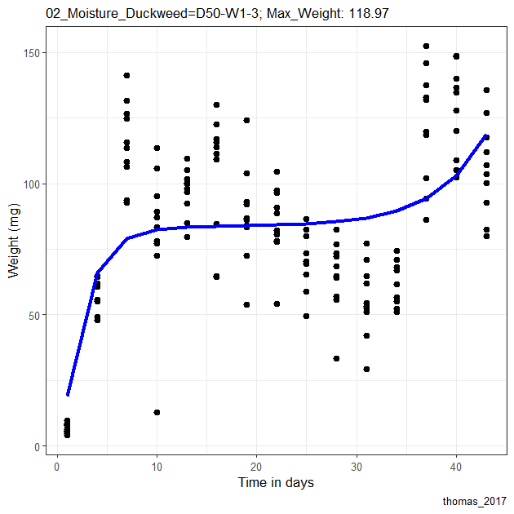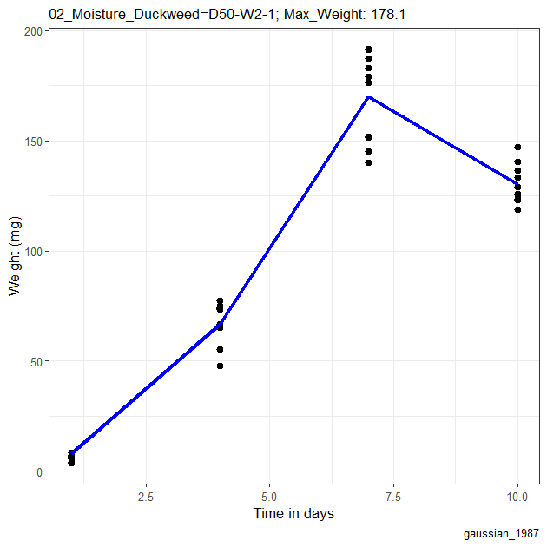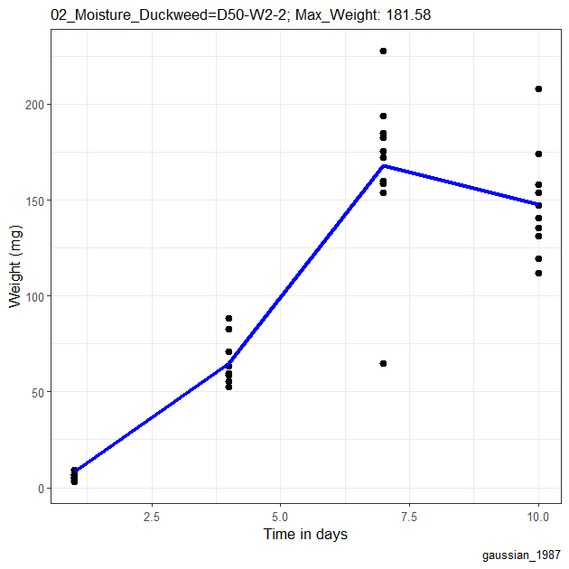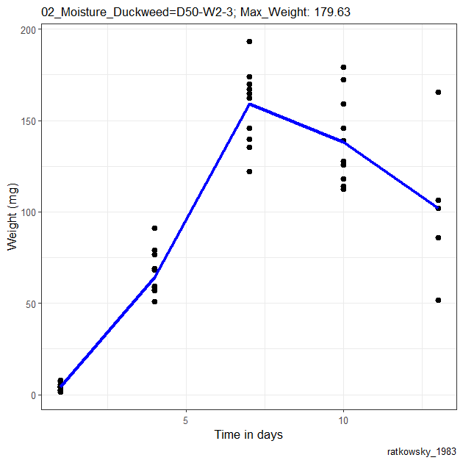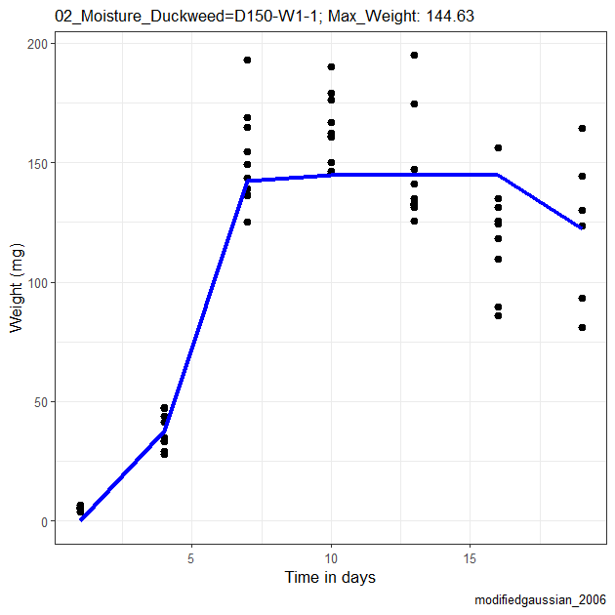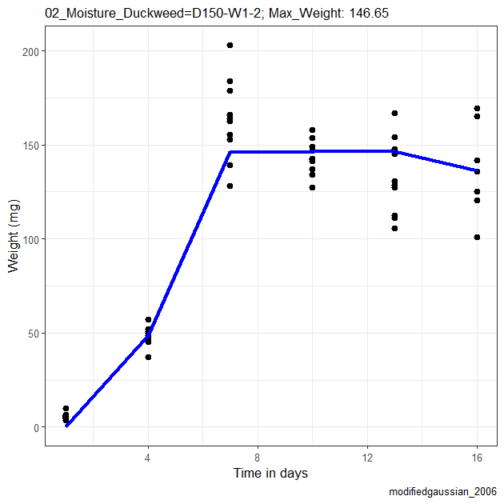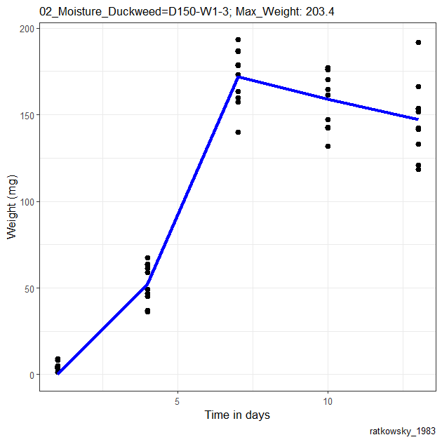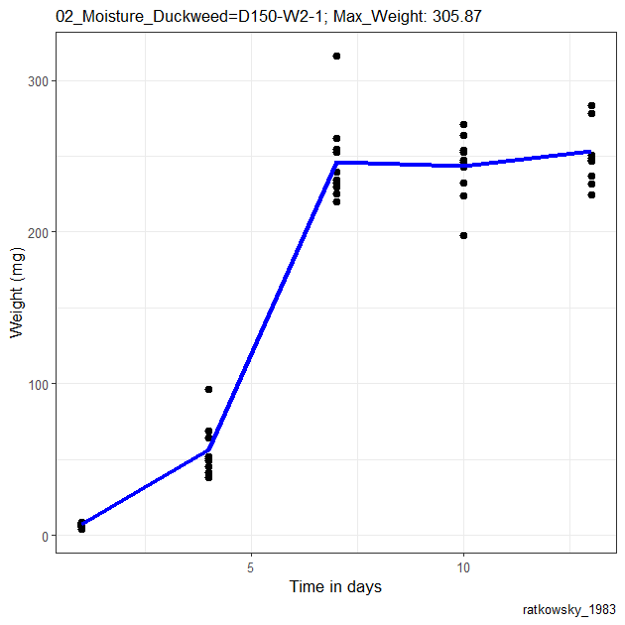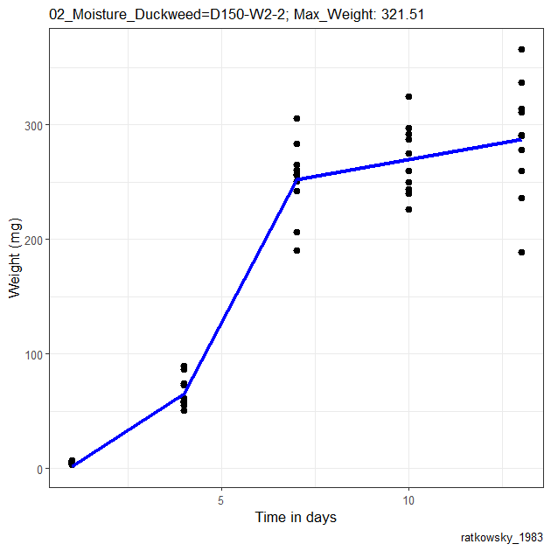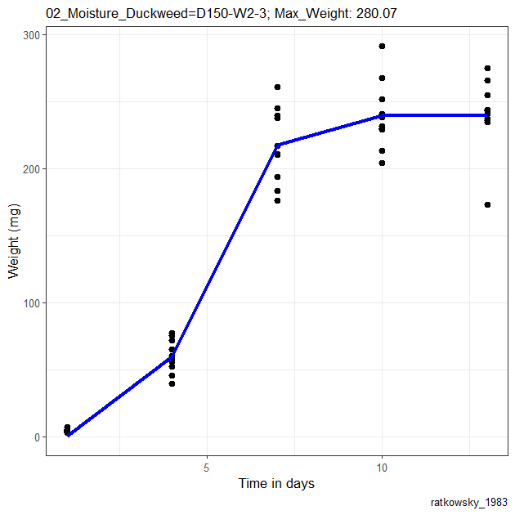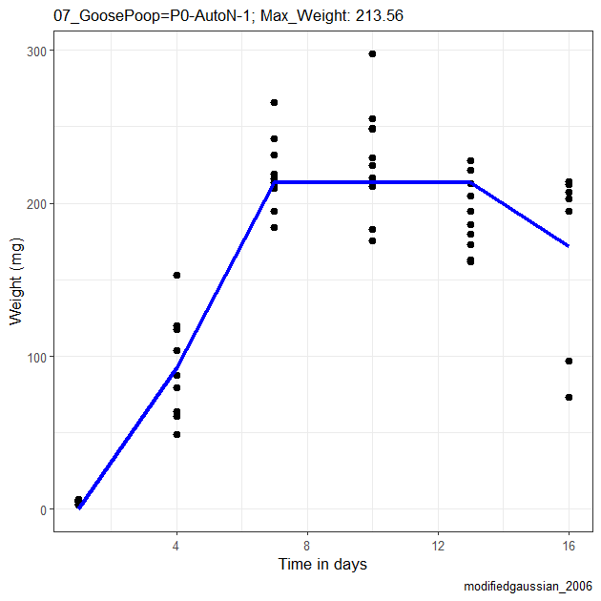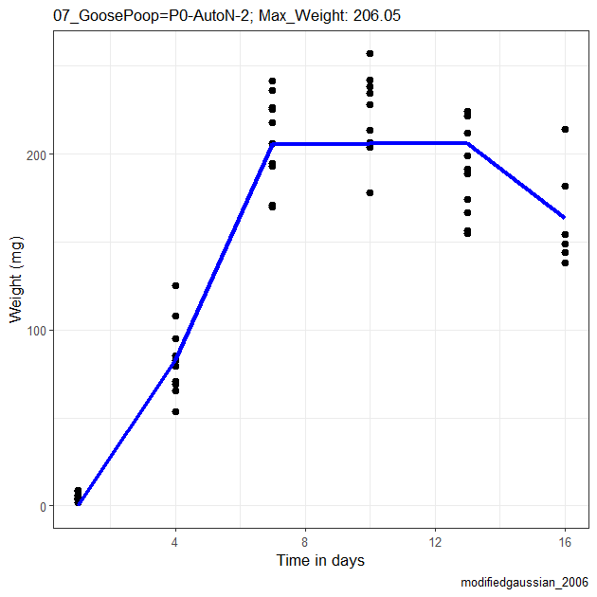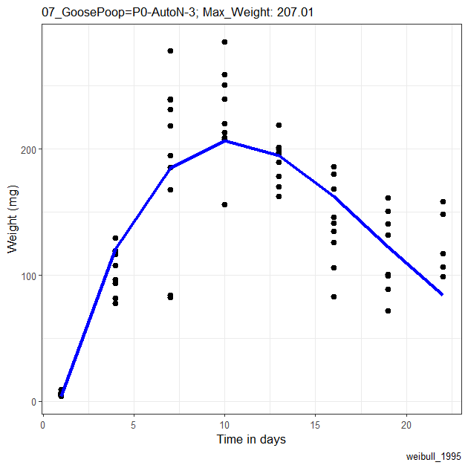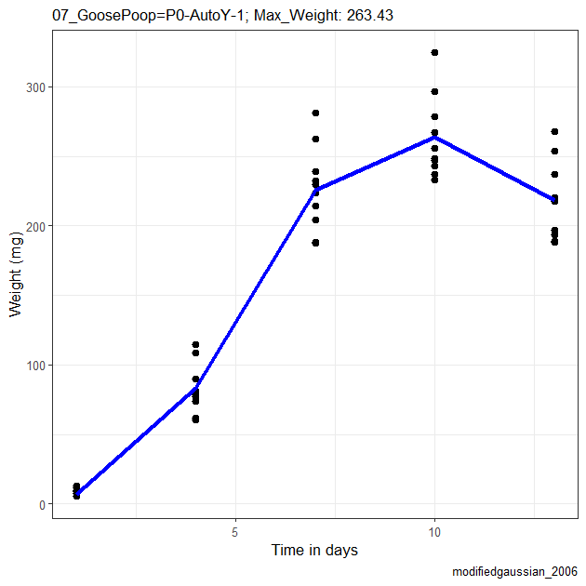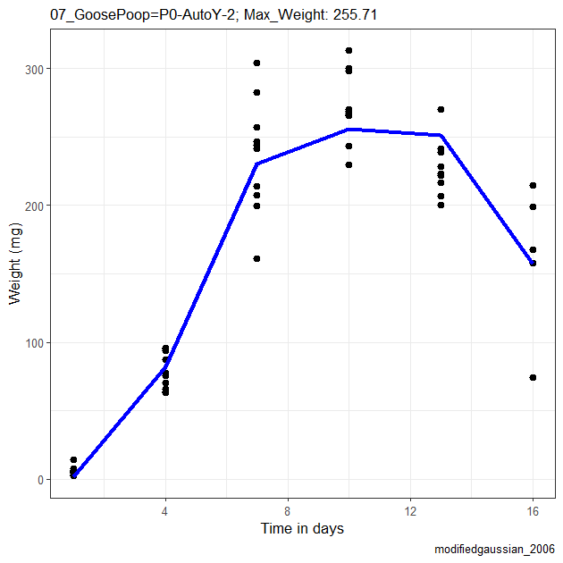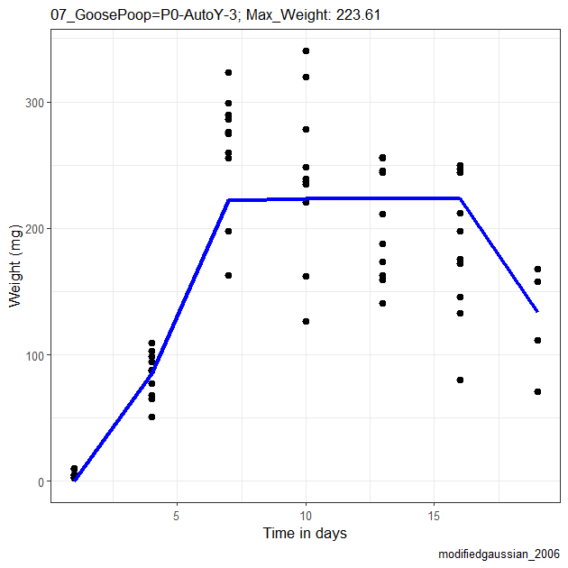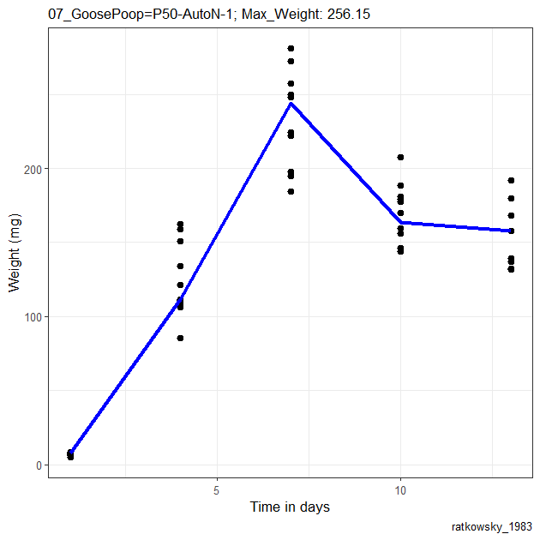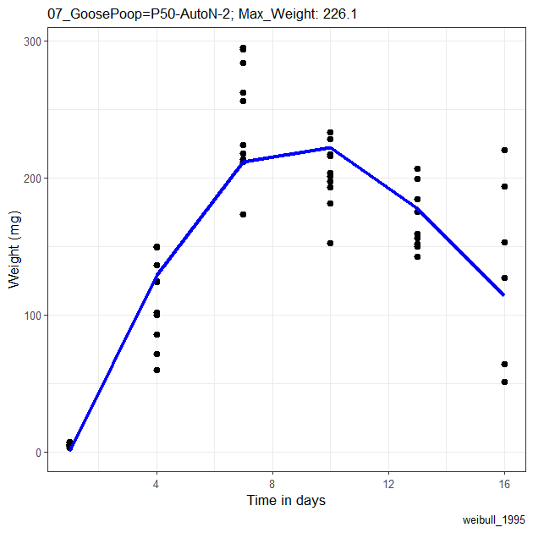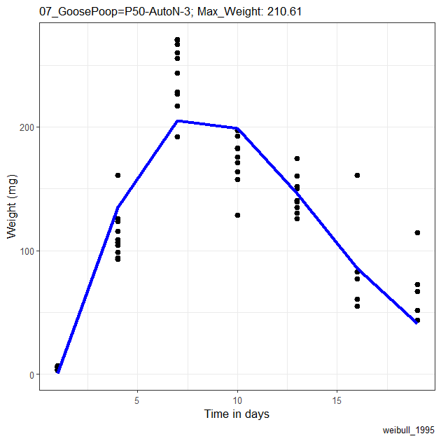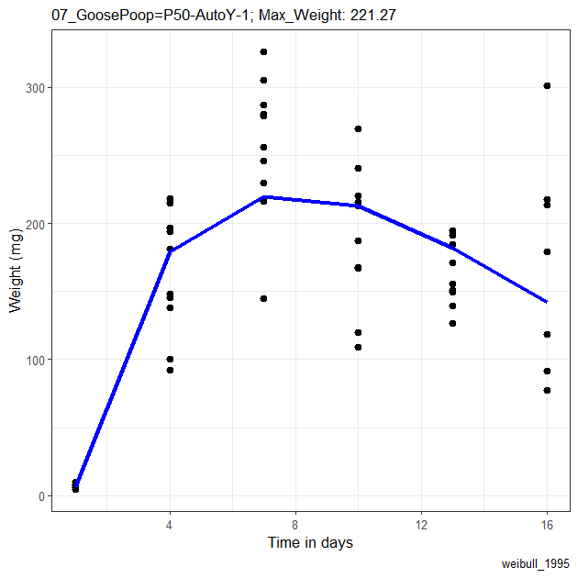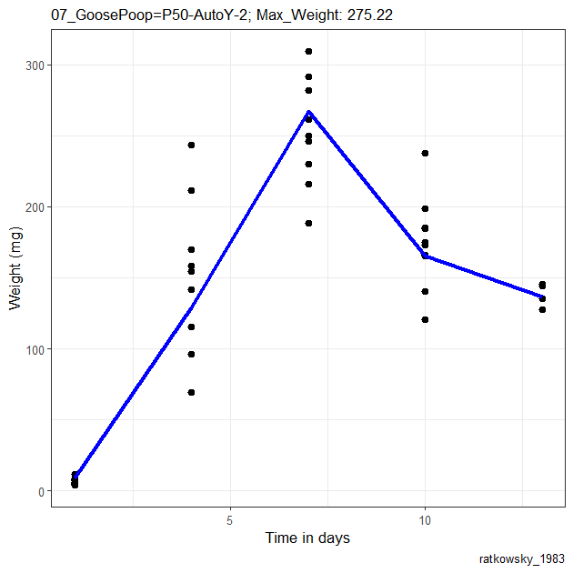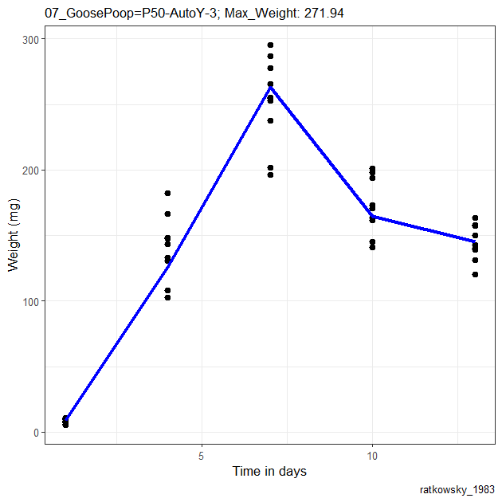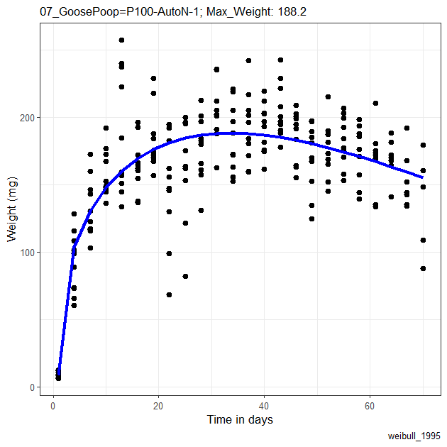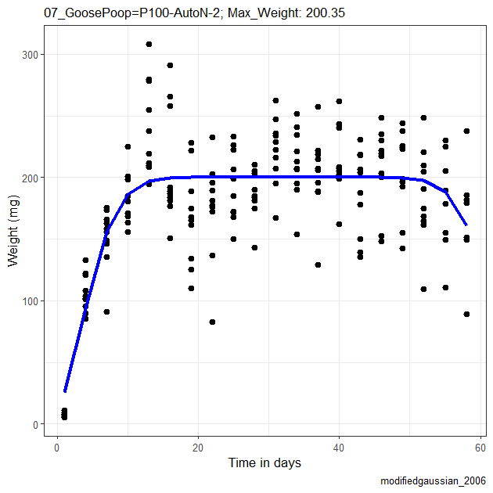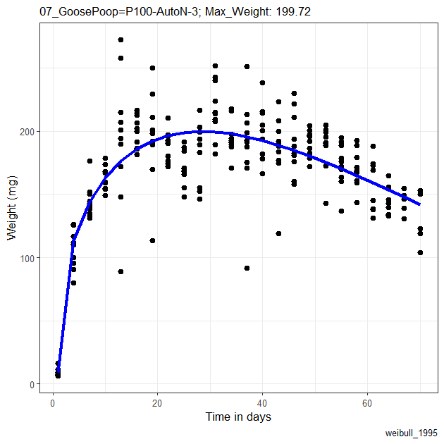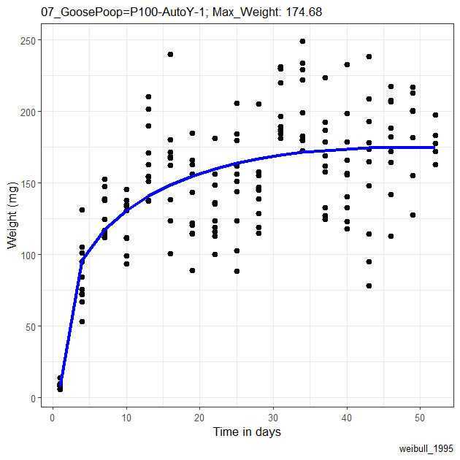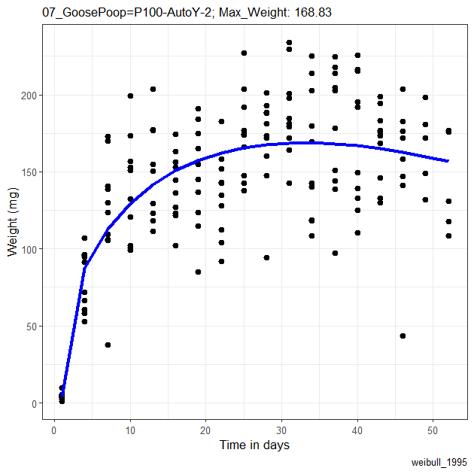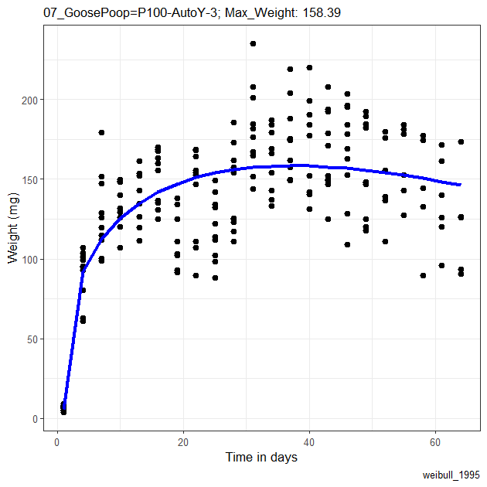

Table S2. Average adult lifespan in days (L), average adult dry weight in mg (W), percentage of larval survival (S) and peak larval weight in mg (P) per sample. Columns with “c” represent the average value of those traits in the controls of each experiment (*) and columns with “Δ” show the difference between the measured trait in each sample and the average value of the controls. PC1 shows the final measurement of larval environmental quality per sample.
Experiment | Sample | L | Lc | ΔL | W | Wc | ΔW | S | Sc | ΔS | P | Pc | ΔP | PC1
Duckweed | D0-1* | 9.1 | 9.1 | 0.0 | 19.4 | 19.4 | 0.0 | 0.85 | 0.87 | -0.03 | 191.2 | 187.0 | 4.3 | 1.057
Duckweed | D0-2* | 9.1 | 9.1 | 0.0 | 19.4 | 19.4 | 0.0 | 0.84 | 0.87 | -0.03 | 189.4 | 187.0 | 2.4 | 1.029
Duckweed | D0-3* | 9.1 | 9.1 | 0.0 | 19.4 | 19.4 | 0.0 | 0.91 | 0.87 | 0.04 | 168.0 | 187.0 | -19.0 | 0.986
Duckweed | D0-4* | 9.1 | 9.1 | 0.0 | 19.4 | 19.4 | 0.0 | 0.89 | 0.87 | 0.02 | 191.8 | 187.0 | 4.8 | 1.158
Duckweed | D0-5* | 9.1 | 9.1 | 0.0 | 19.4 | 19.4 | 0.0 | 0.87 | 0.87 | -0.01 | 194.4 | 187.0 | 7.4 | 1.128
Duckweed | D25-1 | 9.9 | 9.1 | 0.8 | 10.4 | 19.4 | -9.0 | 0.60 | 0.87 | -0.27 | 154.1 | 187.0 | -32.9 | -0.254
Duckweed | D25-2 | 9.9 | 9.1 | 0.8 | 10.4 | 19.4 | -9.0 | 0.85 | 0.87 | -0.02 | 135.1 | 187.0 | -51.9 | 0.109
Duckweed | D25-3 | 9.9 | 9.1 | 0.8 | 10.4 | 19.4 | -9.0 | 0.85 | 0.87 | -0.03 | 144.3 | 187.0 | -42.7 | 0.182
Duckweed | D25-4 | 9.9 | 9.1 | 0.8 | 10.4 | 19.4 | -9.0 | 0.75 | 0.87 | -0.12 | 137.3 | 187.0 | -49.7 | -0.085
Duckweed | D25-5 | 9.9 | 9.1 | 0.8 | 10.4 | 19.4 | -9.0 | 0.79 | 0.87 | -0.08 | 140.7 | 187.0 | -46.3 | 0.032
Duckweed | D50-1 | 5.7 | 9.1 | -3.4 | 4.1 | 19.4 | -15.3 | 0.48 | 0.87 | -0.39 | 93.5 | 187.0 | -93.5 | -2.370
Duckweed | D50-2 | 5.7 | 9.1 | -3.4 | 4.1 | 19.4 | -15.3 | 0.47 | 0.87 | -0.41 | 72.5 | 187.0 | -114.4 | -2.591
Duckweed | D50-3 | 5.7 | 9.1 | -3.4 | 4.1 | 19.4 | -15.3 | 0.53 | 0.87 | -0.34 | 83.7 | 187.0 | -103.3 | -2.352
Duckweed | D50-4 | 5.7 | 9.1 | -3.4 | 4.1 | 19.4 | -15.3 | 0.49 | 0.87 | -0.38 | 97.0 | 187.0 | -90.0 | -2.316
Duckweed | D50-5 | 5.7 | 9.1 | -3.4 | 4.1 | 19.4 | -15.3 | 0.51 | 0.87 | -0.36 | 94.7 | 187.0 | -92.3 | -2.295
Duckweed and Water | D0-W1-1* | 11.7 | 10.3 | 1.3 | 19.4 | 19.8 | -0.4 | 1.00 | 0.90 | 0.10 | 218.9 | 218.2 | 0.7 | 1.536
Duckweed and Water | D0-W1-2* | 8.0 | 10.3 | -2.3 | 19.3 | 19.8 | -0.5 | 0.81 | 0.90 | -0.09 | 211.2 | 218.2 | -7.0 | 0.289
Duckweed and Water | D0-W1-3* | 11.3 | 10.3 | 1.0 | 20.8 | 19.8 | 1.0 | 0.90 | 0.90 | -0.01 | 224.5 | 218.2 | 6.3 | 1.390
Duckweed and Water | D0-W2-1 | 12.0 | 10.3 | 1.7 | 26.3 | 19.8 | 6.4 | 0.78 | 0.90 | -0.13 | 251.3 | 218.2 | 33.1 | 1.888
Duckweed and Water | D0-W2-2 | 7.1 | 10.3 | -3.2 | 35.3 | 19.8 | 15.5 | 0.88 | 0.90 | -0.03 | 276.5 | 218.2 | 58.3 | 1.937
Duckweed and Water | D0-W2-3 | 9.2 | 10.3 | -1.2 | 28.2 | 19.8 | 8.3 | 0.86 | 0.90 | -0.04 | 279.8 | 218.2 | 61.6 | 1.869
Duckweed and Water | D0/2-W1-1 | 7.3 | 10.3 | -3.0 | 9.9 | 19.8 | -9.9 | 0.06 | 0.90 | -0.85 | 63.2 | 218.2 | -155.0 | -3.452
Duckweed and Water | D0/2-W1-2 | 5.8 | 10.3 | -4.5 | 8.4 | 19.8 | -11.4 | 0.15 | 0.90 | -0.76 | 65.0 | 218.2 | -153.2 | -3.656
Duckweed and Water | D0/2-W1-3 | 6.2 | 10.3 | -4.2 | 14.4 | 19.8 | -5.4 | 0.09 | 0.90 | -0.82 | 48.7 | 218.2 | -169.5 | -3.453
Duckweed and Water | D0/2-W2-1 | 4.2 | 10.3 | -6.2 | 20.2 | 19.8 | 0.3 | 0.90 | 0.90 | -0.01 | 180.6 | 218.2 | -37.6 | -0.545
Duckweed and Water | D0/2-W2-2 | 5.5 | 10.3 | -4.8 | 16.3 | 19.8 | -3.6 | 0.97 | 0.90 | 0.06 | 209.4 | 218.2 | -8.8 | -0.124
Duckweed and Water | D0/2-W2-3 | 8.3 | 10.3 | -2.0 | 17.6 | 19.8 | -2.3 | 0.91 | 0.90 | 0.00 | 158.6 | 218.2 | -59.6 | -0.034
Duckweed and Water | D150-W1-1 | 10.5 | 10.3 | 0.2 | 15.0 | 19.8 | -4.8 | 1.00 | 0.90 | 0.10 | 144.6 | 218.2 | -73.6 | 0.320
Duckweed and Water | D150-W1-2 | 11.7 | 10.3 | 1.3 | 15.4 | 19.8 | -4.4 | 1.00 | 0.90 | 0.10 | 146.7 | 218.2 | -71.5 | 0.609
Duckweed and Water | D150-W1-3 | 9.2 | 10.3 | -1.2 | 14.6 | 19.8 | -5.2 | 1.00 | 0.90 | 0.10 | 203.4 | 218.2 | -14.8 | 0.545
Duckweed and Water | D150-W2-1 | 11.5 | 10.3 | 1.2 | 24.3 | 19.8 | 4.5 | 0.89 | 0.90 | -0.01 | 305.9 | 218.2 | 87.7 | 2.392
Duckweed and Water | D150-W2-2 | 11.3 | 10.3 | 1.0 | 29.1 | 19.8 | 9.3 | 1.00 | 0.90 | 0.10 | 321.5 | 218.2 | 103.3 | 3.062
Duckweed and Water | D150-W2-3 | 12.8 | 10.3 | 2.5 | 25.4 | 19.8 | 5.6 | 0.98 | 0.90 | 0.08 | 280.1 | 218.2 | 61.9 | 2.704
Duckweed and Water | D50-W1-1 | 6.8 | 10.3 | -3.5 | 7.4 | 19.8 | -12.5 | 0.94 | 0.90 | 0.03 | 95.8 | 218.2 | -122.4 | -1.552
Duckweed and Water | D50-W1-2 | 5.7 | 10.3 | -4.7 | 6.3 | 19.8 | -13.6 | 0.76 | 0.90 | -0.15 | 109.0 | 218.2 | -109.2 | -2.137
Duckweed and Water | D50-W1-3 | 5.8 | 10.3 | -4.5 | 7.1 | 19.8 | -12.7 | 0.90 | 0.90 | 0.00 | 119.0 | 218.2 | -99.2 | -1.643
Duckweed and Water | D50-W2-1 | 6.3 | 10.3 | -4.0 | 10.7 | 19.8 | -9.1 | 1.00 | 0.90 | 0.10 | 178.1 | 218.2 | -40.1 | -0.541
Duckweed and Water | D50-W2-2 | 7.3 | 10.3 | -3.0 | 13.1 | 19.8 | -6.7 | 1.00 | 0.90 | 0.10 | 181.6 | 218.2 | -36.6 | -0.136
Duckweed and Water | D50-W2-3 | 5.3 | 10.3 | -5.0 | 12.5 | 19.8 | -7.3 | 1.00 | 0.90 | 0.10 | 179.6 | 218.2 | -38.6 | -0.614
Geese feces | P0-AutoN-1* | 9.8 | 8.6 | 1.2 | 22.6 | 21.3 | 1.4 | 0.89 | 0.95 | -0.06 | 213.6 | 208.9 | 4.7 | 1.333
Geese feces | P0-AutoN-2* | 8.3 | 8.6 | -0.3 | 22.6 | 21.3 | 1.4 | 0.96 | 0.95 | 0.01 | 206.1 | 208.9 | -2.8 | 1.104
Geese feces | P0-AutoN-3* | 7.7 | 8.6 | -0.9 | 18.6 | 21.3 | -2.7 | 1.00 | 0.95 | 0.05 | 207.0 | 208.9 | -1.9 | 0.778
Geese feces | P0-AutoY-1 | 9.0 | 8.6 | 0.4 | 20.8 | 21.3 | -0.4 | 1.00 | 0.95 | 0.05 | 263.4 | 208.9 | 54.6 | 1.723
Geese feces | P0-AutoY-2 | 9.8 | 8.6 | 1.2 | 25.6 | 21.3 | 4.4 | 0.92 | 0.95 | -0.03 | 255.7 | 208.9 | 46.8 | 1.986
Geese feces | P0-AutoY-3 | 9.2 | 8.6 | 0.6 | 22.6 | 21.3 | 1.3 | 0.89 | 0.95 | -0.06 | 223.6 | 208.9 | 14.7 | 1.281
Geese feces | P100-AutoN-1 | 5.5 | 8.6 | -3.1 | 6.0 | 21.3 | -15.3 | 0.87 | 0.95 | -0.08 | 188.2 | 208.9 | -20.7 | -0.986
Geese feces | P100-AutoN-2 | 6.2 | 8.6 | -2.4 | 6.1 | 21.3 | -15.2 | 0.59 | 0.95 | -0.36 | 200.4 | 208.9 | -8.5 | -1.328
Geese feces | P100-AutoN-3 | 6.7 | 8.6 | -1.9 | 6.5 | 21.3 | -14.8 | 0.72 | 0.95 | -0.23 | 199.7 | 208.9 | -9.2 | -0.927
Geese feces | P100-AutoY-1 | 3.7 | 8.6 | -4.9 | 5.5 | 21.3 | -15.8 | 0.88 | 0.95 | -0.07 | 174.7 | 208.9 | -34.2 | -1.505
Geese feces | P100-AutoY-2 | 5.5 | 8.6 | -3.1 | 6.3 | 21.3 | -15.0 | 0.71 | 0.95 | -0.24 | 168.8 | 208.9 | -40.0 | -1.484
Geese feces | P100-AutoY-3 | 4.8 | 8.6 | -3.8 | 5.2 | 21.3 | -16.1 | 0.80 | 0.95 | -0.15 | 158.4 | 208.9 | -50.5 | -1.597
Geese feces | P50-AutoN-1 | 8.3 | 8.6 | -0.3 | 16.9 | 21.3 | -4.4 | 0.95 | 0.95 | 0.00 | 256.2 | 208.9 | 47.3 | 1.142
Geese feces | P50-AutoN-2 | 8.2 | 8.6 | -0.4 | 20.5 | 21.3 | -0.8 | 0.91 | 0.95 | -0.04 | 226.1 | 208.9 | 17.2 | 0.997
Geese feces | P50-AutoN-3 | 5.8 | 8.6 | -2.8 | 20.4 | 21.3 | -0.9 | 0.94 | 0.95 | -0.01 | 210.6 | 208.9 | 1.7 | 0.425
Geese feces | P50-AutoY-1 | 8.3 | 8.6 | -0.3 | 18.7 | 21.3 | -2.5 | 0.87 | 0.95 | -0.08 | 221.3 | 208.9 | 12.4 | 0.781
Geese feces | P50-AutoY-2 | 9.2 | 8.6 | 0.6 | 16.7 | 21.3 | -4.6 | 1.00 | 0.95 | 0.05 | 275.2 | 208.9 | 66.3 | 1.580
Geese feces | P50-AutoY-3 | 6.2 | 8.6 | -2.4 | 15.7 | 21.3 | -5.6 | 0.89 | 0.95 | -0.06 | 271.9 | 208.9 | 63.1 | 0.623

