Supplementary Material
Supplementary Table 1: ATC-5 Codes
A. APM medication for inclusion criteria

ATC Group name | ATC code | Generic name | Mechanism of action
Dopa and dopa derivatives | N04BA01 | Duodopa pump/levopar/ Dopicar
 | N04BA02 | Levodopa, Benserazide | Dopamine precursor + inhibitor of dopa Decarboxylase  Dopamine precursor + peripheral dopa  decarboxylase inhibitor + COMT inhibitor
 | N04BA02 | Levodopa, Carbidopa
 | N04BA03 | Levodopa, Carbidopa, Entacapone, Stavelo
 | N04BA07 | Pro-duodopa sub cutaneous pump *
Amantadine derivatives | N04BB01 | Amantadine | Dopaminergic, anti-viral
Dopamine agonists | N04BC01 | Bromocriptine | Dopamine agonist
Dopamine agonists | N04BC02 | Pergolide | Dopamine agonist
Dopamine agonists | N04BC04 | Ropinirole | Dopamine agonist
Dopamine agonists | N04BC05 | Pramipexole | Dopamine agonist
Dopamine agonists | N04BC06 | Cabergoline/ Cabaser/Cabotrim | Dopamine agonist
Dopamine agonists | N04BC07 | Apomorphine
Dopamine agonists | N04BC09 | Rotigotine *
Monoamine oxidase B inhibitors | N04BD01 | Selegiline | MAO B inhibitor
Monoamine oxidase B inhibitors | N04BD02 | Rasagiline | MAO B inhibitor
Monoamine oxidase B inhibitors | N04BD03 | Xadago /Safinamide | MAO B inhibitor
Other dopaminergic agents | N04BX01 | Tolcapone * | COMT inhibitor
Other dopaminergic agents | N04BX02 | Entacapone | COMT inhibitor
Other dopaminergic agents | N04BX04 | Opicapone * | COMT inhibitor
(*) Not found Clalit’s database
B. Anticholinergic medication
ATC code | Generic name | Medication Name
N04AA02 | Biperiden | Dekinet/Akineton/Biperdien
N04AA01 | Trihexphenidyl | Rodenal/Partane/Artane
N04AA03 | Metixene | Tremaril/Tremoquil/Tremarit
N04AA04 | Procyclidine | Kemadrin/Procyclidine

C. Anti-psychotic medication
ATC code | Generic name
N05AL05 | Amisulpride
N05AX12 | Aripiprazole
N05AH05 | Asenapine
N05AX16 | Brexpiprazole
N05AX15 | Cariprazine
N05AA01 | Chlorpromazine
N05AF03 | Chlorprothixen
N05AH06 | Clotiapine
N05AH02 | Clozapine
N05AF01 | Flupentixol
N05AB02 | Fluphenazine
N05AD01 | Haloperidol
N05AX14 | Iloperidone
N05AA02 | Levomepromazine
N05AH03 | Olanzapine
N05AX13 | Paliperidone
N05AG03 | Penfluridol
N05AC01 | Periciazine
N05AB03 | Perphenazine
N05AG02 | Pimozide
N05AH04 | Quetiapine (50 mg and above) *
N05AX08 | Risperidone
N05AE03 | Sertindole
N05AL01 | Sulpiride
N05AB08 | Thioproperazine
N05AC02 | Thioridazine
N05AL03 | Tiapride
N05AB06 | Trifluoperazine
N05AE04 | Ziprasidone
N05AF05 | Zuclopenthixol
N05AE05 | Lurasidone *
N05AG01 | Fluspirilene *
(*) Not found in Clalit’s database

TABLE 2. Possible criteria distribution: The number of PD patients that met each specific criterion.
Criterion for Possible PD | Male | Female | Total | Total sole criterion
Never received a PD diagnosis | 1,913 | 1,930 | 3,843 | 1,464
Diagnosed with dementia with Lewy bodies | 529 | 347 | 876 | 603
Less than 2 years have passed from FPD to death date/left the HMO/data extraction date | 4,110 | 2,755 | 6,865 | 4,399
Purchased APM over 3 years, and more than 2 years have passed since their last APM purchase | 937 | 1,246 | 2,183 | 1,444
Diagnosed with PD and purchased at least one purchase of anti-psychotic prescription during the year before FPD and at least one purchase of Dopa and dopa derivatives medications. | 1,167 | 1,449 | 2,616 | 1,836
Total number meeting 3 possible criteria | 32 | 15 | 47 | -
Total number meeting only 2 possible criteria | 1,631 | 1,617 | 3,248 | -
Total number meeting only 1 possible criterion | 5,298 | 4,448 | 9,746 | 9,746
Total Possible | 6,961 | 6,080 | 13,041

Abbreviations: APM: anti-Parkinson medication; FDP- first purchase date.

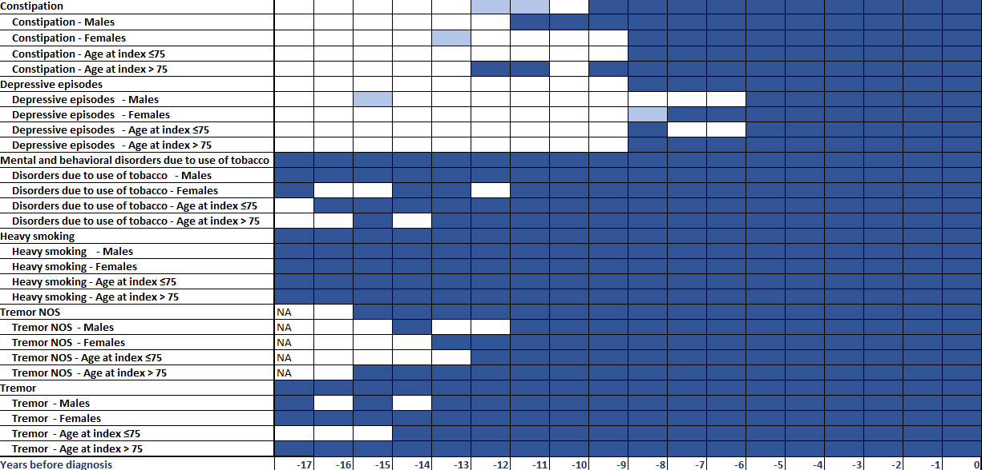
Supplementary Fig. S1: Statistical analysis results of the comparison between the prevalence of diagnoses between PD patients and controls for each year before the index date, up to 18 years (-17) before index date. For all the population and segmentized by sex (Male/Female) and age at index (age at index ≤ 75 and age at index > 75). Colors denote significance levels: FDR-adjusted P<0.05 (dark blue), P<0.05 but FDR-adjusted P≥0.05 (light blue), and not significant (white).

