Bayesian correction of satellite-derived pCO₂ reveals the biogeochemical impact of hurricanes on ocean–atmosphere CO₂ fluxes

Climatic Change

Coronado-Álvarez Luz de Lourdes Aurora¹ , Cervantes-Díaz Gabriela Y.¹ , Espinosa-Carreón T. Leticia²

¹ Instituto of Investigaciones Oceanológicas, Universidad Autónoma de Baja California, Carretera Transpeninsular Tijuana-Ensenada 3917, Fraccionamiento Playitas, CP, 22860, Ensenada, Baja California, México
² Sinaloa, 81101 Guasave, Sinaloa, México.

Correspondence to: cervantes.gabriela@uabc.edu.mx

Supplementary
According to Avila (2017), Lidia reached a peak intensity of 55 kt at 1800 UTC 31 August, as determined from Dvorak estimates. At that time, the cloud system was at its most organized, even suggesting the presence of an eye feature. As the center of Lidia moved near Cabo San Lucas, an elevated station near that site reported sustained winds of 54 kt. Lidia was notably large, with tropical-storm-force winds extending well east of the center and affecting coastal towns such as Los Mochis and Topolobambo on mainland Mexico.

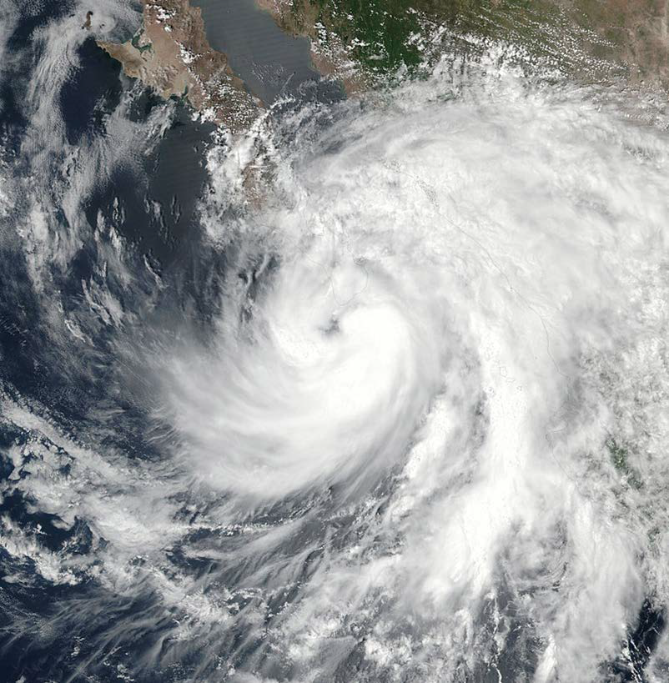
Figure S1. NASA-NOAA’S SUOMI NPP SATELLITE IMAGE AT 2024 UTC 31 AUGUST WHEN TROPICAL STORM LIDIA WAS LOCATED TO SOUTHWEST OF THE SOUTHERN TIP OF BAJA CALIFORNIA (Information and figure taken from the National Hurricane Center report (Avila, 2017))

Lidia was a large cyclone that spread tropical-storm-force winds and heavy rains across a portion of the Baja California peninsula and mainland Mexico (Avila, 2017).
Figures S2 and S3 show the effects of Tropical Storm Ileana between 12 and 15 September 2024. Satellite-derived variable maps were observed to underestimate both pCO₂ values and CO₂ fluxes compared to data corrected using the Bayesian algorithm, a behavior similar to that recorded during Hurricane John.
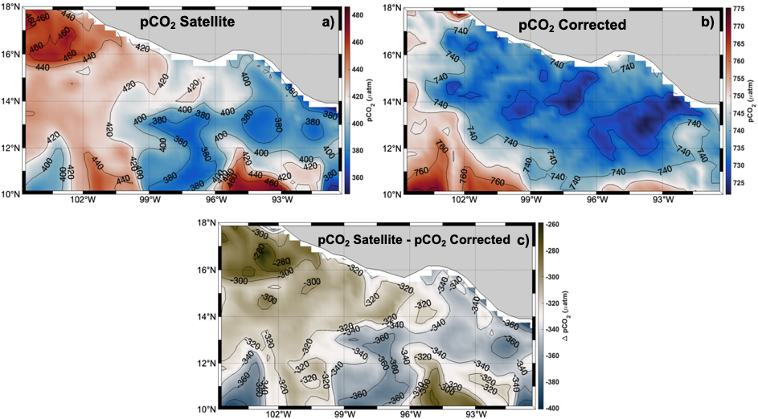
Figure S2. Surface distribution maps of partial pressure of CO₂ (pCO₂): satellite-estimated values (panel a), corrected estimates produced by the Bayesian neural network (panel b), and the difference between both products (satellite minus corrected; panel c). Maps correspond to the average of the days with the greatest variation (September 12–15).
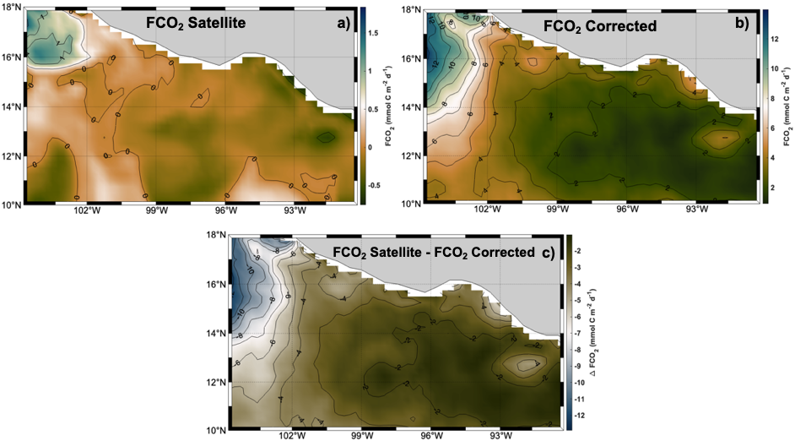
Figure S3. Surface distribution maps of air–sea CO₂ fluxes (FCO₂): satellite-estimated (panel a), corrected (panel b), and the difference between both products (panel c). Maps represent the average of the most variable days (September 12–15).
Figures S4 and S5 show the effects of Tropical Storm Eleven-E between 1 and 3 October 2024. Satellite-derived variable maps were observed to underestimate both pCO₂ values and CO₂ fluxes compared to data corrected using the Bayesian algorithm, a behavior similar to that recorded during Hurricane John and Ileana.
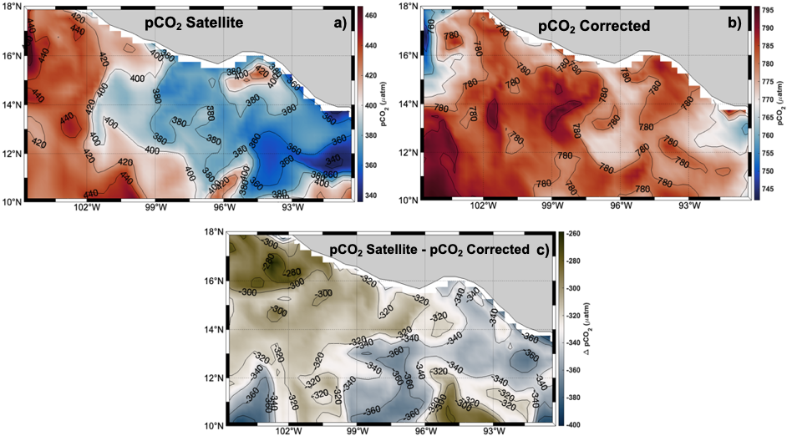
Figure S4. Surface distribution maps of partial pressure of CO₂ (pCO₂): satellite-estimated values (panel a), corrected estimates produced by the Bayesian neural network (panel b), and the difference between both products (satellite minus corrected; panel c). Maps correspond to the average of the days with the greatest variation (October 4–6).
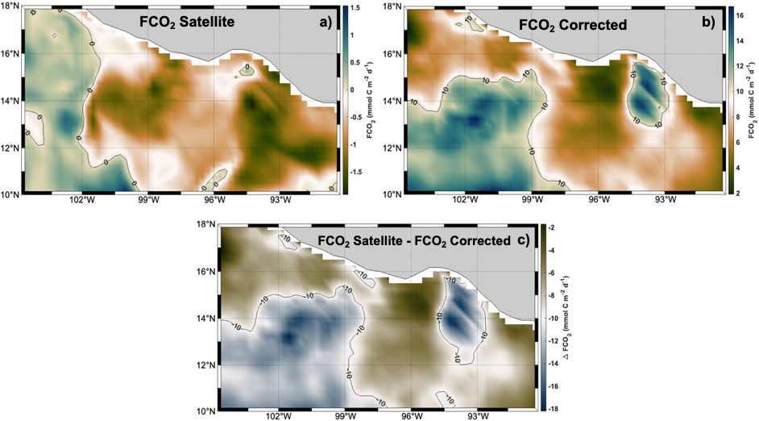
Figure S5. Surface distribution maps of air–sea CO₂ fluxes (FCO₂): satellite-estimated (panel a), corrected (panel b), and the difference between both products (panel c). Maps represent the average of the most variable days (October 4–6).

