Additional Information

Additional File 1. Figure S1. Nanopore sequencing output for sample 26 using the rapid sequencing kit. A) Pore availability and sequencing and B) cumulative output show poor pore performance and a high proportion of reads that failed to pass the quality control filters.
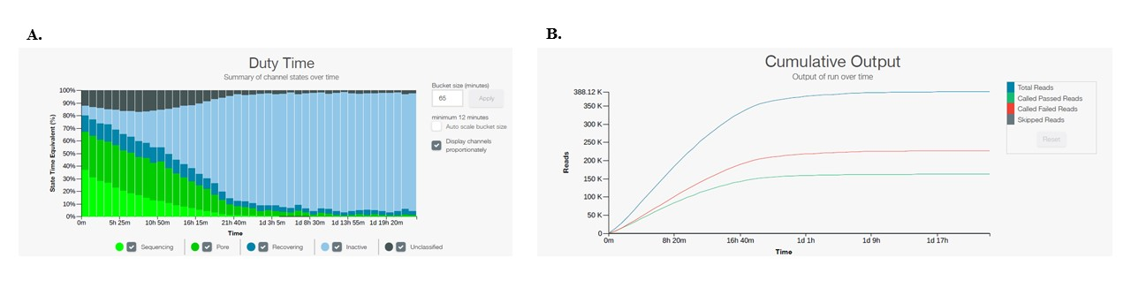

Additional File 2. Supplementary Table 1. Oxford Nanopore run output statistics.
Sample Site | Kit | Total Reads | Reads analyzed (>5000bp) | Reads Classified | Average Sequence Length | Total Yield (Gbases)
9 | Ligation  (SQK-LSK109) | 2,210,000 | 559,835 | 395,718 | 3,933 | 7.3
10 | Ligation  (SQK-LSK109) | 2,150,000 | 479,658 | 315,027 | 3,808 | 6.6
11 | Ligation  (SQK-LSK109) | 2,695,570 | 922,646 | 621,507 | 5,493 | 11.7
12 | Ligation  (SQK-LSK109) | 1,870,000 | 642,229 | 430,090 | 5,258 | 8.3

Additional File 3. Supplementary Table 2. Superkingdom taxa representation by number of reads for the metagenome analysis at each sample site determined by WIMP.
Sample Site | Bacteria | Eukaryota | Viruses | Archaea
9 | 362,601 (92%) | 26,494 (7%) | 4,547 (1%) | 967 (<1%)
10 | 287,858 (92%) | 19,645 (6%) | 6,046 (2%) | 596 (<1%)
11 | 552,841 (89%) | 56,173 (9%) | 8,743 (1%) | 1,277 (<1%)
12 | 394,942 (92%) | 31,468 (7%) | 484 (<1%) | 1,163 (<1%)

Additional File 4. Figure S2. Relative abundance of WIMP identified genera for each agricultural water site. DNA libraries were prepared using either the ligation kit (LSK109) for sites 9 – 12 or the rapid kit (RAD004) for sites 17 and 26. Reads were analyzed by the EPI2ME WIMP workflow. Bacterial genera contributing more than 1% of the classified reads are shown and the sum of the remaining genera identified are included as “Other.”
