Extended Data for:

Homing and Detection of Unknown Primary Head-Neck Cancer by Acid-Sensing Nanoparticles
Qiang Feng^{1,2}, Jun Chen², William Hartnett², Sindhu Voorugonda³, Brittny Tillman³, John Truelson³, Larry Myers³, Andrew Day³, Vijay Basava², Xuechun Wang², Yangyang Zhao², Oreoluwa Onabolu², Natalia Hajnas³, Haini Zhang¹, Gang Huang^{2,4}, Shao-Po Huang⁵, Isaac S. Chan⁵, Mingyi Chen⁶, Doreen Palsgrove⁶, Samuel Achilefu¹, Baran D. Sumer^{3,*}, and Jinming Gao^{1,2,3,4,*}
¹Department of Biomedical Engineering, ²Simmons Comprehensive Cancer Center, ³Department of Otolaryngology, ⁴Department of Pharmacology, ⁵Department of Internal Medicine, ⁶Department of Pathology, University of Texas Southwestern Medical Center, 6000 Harry Hines Blvd., Dallas, Texas 75390, USA
*Correspondence: jgao1@utsouthwestern.edu (J.G.); baran.sumer@utsouthwestern.edu (B.S.)

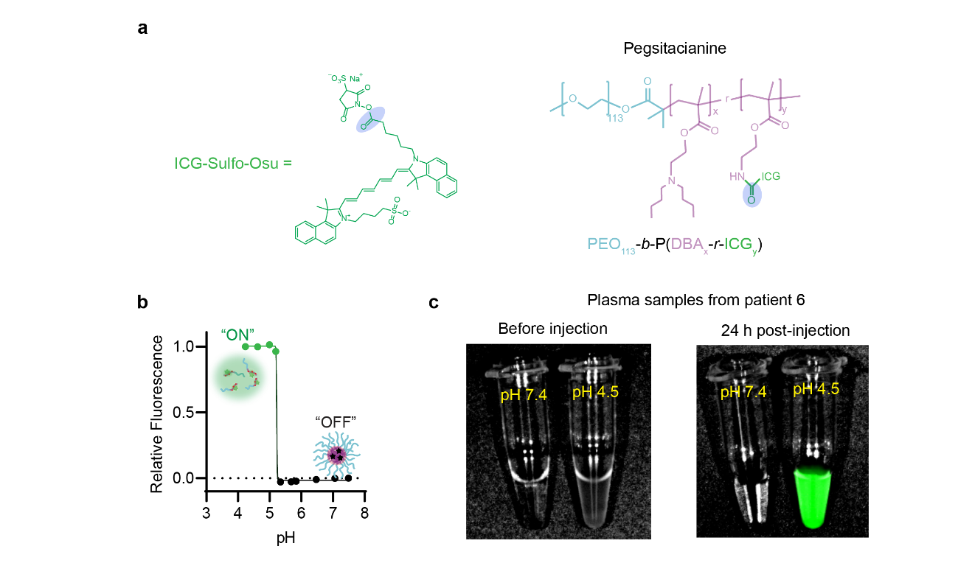
Extended Data Fig. 1: Pegsitacianine responds to acidic environments with ON/OFF fluorescence response across pH 5.3. a, Chemical structures of indocyanine green sulfosuccinimidyl ester (ICG-Sulfo-Osu) and Pegsitacianine. The purple circle indicates the conjugation site of ICG to the ultra-pH-sensitive (UPS) polymer. b, Fluorescence intensity of Pegsitacianine as a function of pH. At pH values above the transition threshold (pH>5.3), the UPS nanosensor remains in a micellar “OFF” state with quenched fluorescence. At pH<5.3, micelles dissociate into unimers, resulting in sharp fluorescence activation (ON state). c, Fluorescence overlaid with brightfield images of patient plasma samples, with or without Pegsitacianine injection, at pH 7.4 or pH 4.5. Near-infrared fluorescence imaging (λ_{ex}/λ_{em} = 780/820 nm) shows strong signal activation of plasma sample (collected 24 h post injection) after acidification to pH 4.5, but not at pH 7.4 or before injection.
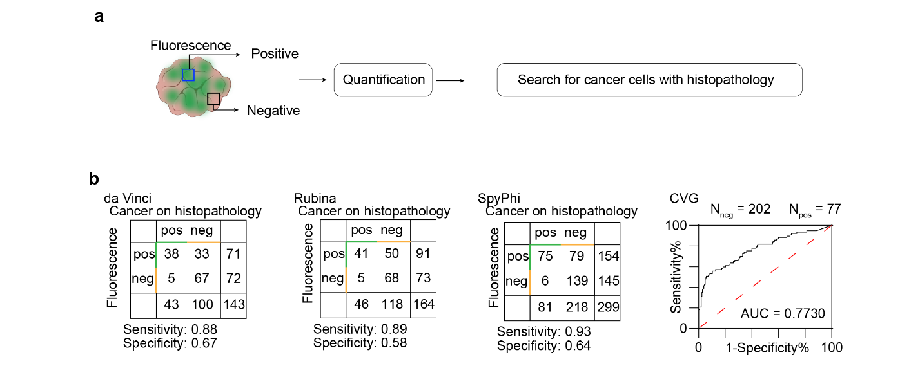
Extended Data Fig. 2: Quantitative relationship between Pegsitacianine fluorescence and cancer cell presence across imaging systems. Biopsied samples (~300) from fluorescent and non-fluorescent regions were compared with histopathology. Sensitivity for detecting regions containing identifiable cancer cells was 0.88, 0.89, and 0.93, with specificity of 0.67, 0.58, and 0.64 for the da Vinci Firefly, Rubina, and SpyPhi platforms, respectively. CancerVision™ Goggles, which provide continuous fluorescence readouts, yielded an area under the receiver operating characteristic curve (AUC) of 0.773 across 279 histopathology-verified regions (77 cancer, 202 non-cancer).

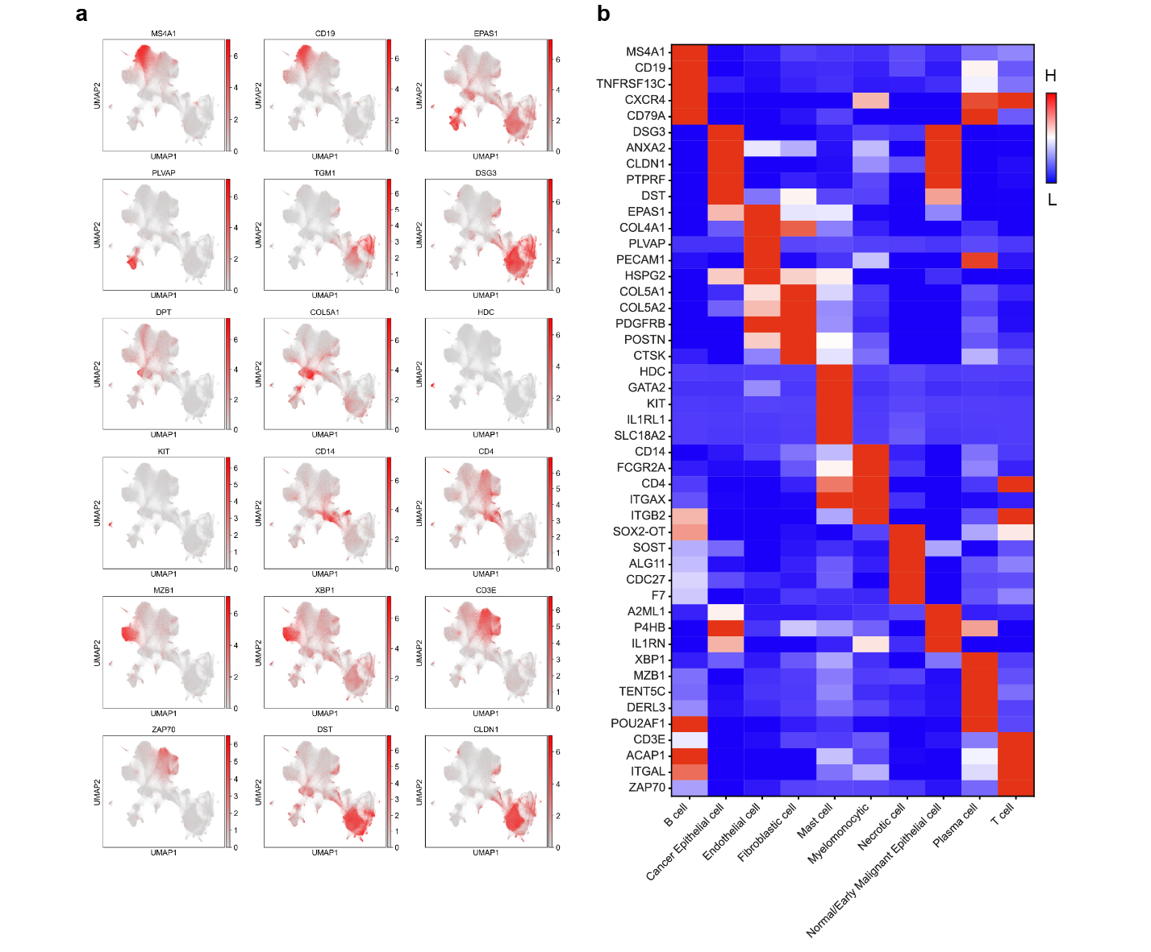
Extended Data Fig. 3: Feature plots and heatmap of gene expression for key marker genes used in cell type annotation. a, Feature plots displaying spatial distribution of individual gene expressions on UMAP coordinates. Expression patterns of representative markers demonstrate localization within specific cell populations. b, Heatmap of selected marker genes across identified cell populations, highlighting cell type-specific gene expression signatures.
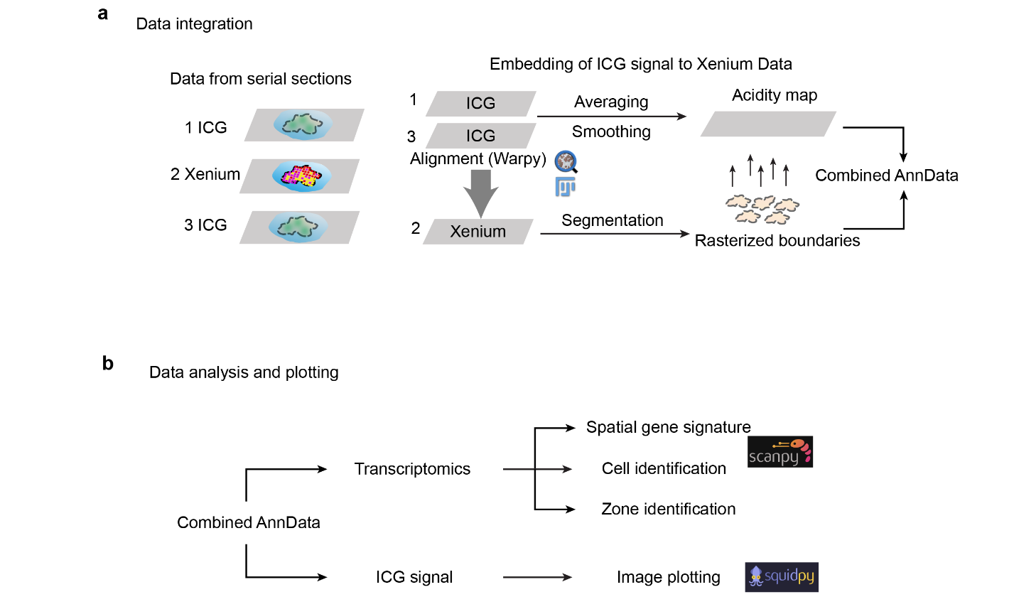
Extended Data Fig. 4: Procedures for data integration and analysis for spatially resolved ICG and transcriptomic profiling. a, Data integration workflow. Tissue sections from Pegsitacianine-guided resections were processed in serial for ICG fluorescence imaging (slides 1 and 3) and spatial transcriptomic profiling (slide 2) using the 10x Genomics Xenium platform. ICG fluorescence was acquired on the Akoya PhenoImager using the 780 nm channel and aligned to the central Xenium-analyzed section using Warpy. A composite acidity map was generated by averaging ICG signals from slides 1 and 3 and applying a Gaussian smoothing filter. Pixel-level ICG intensity was assigned to cells using rasterized cell boundaries from Xenium cell segmentation. The mean fluorescence intensity per cell was then added to the corresponding AnnData object. b, Data analysis and visualization workflow. The integrated dataset was analyzed using Squidpy for spatial gene signature mapping, cell type identification, and image plotting.
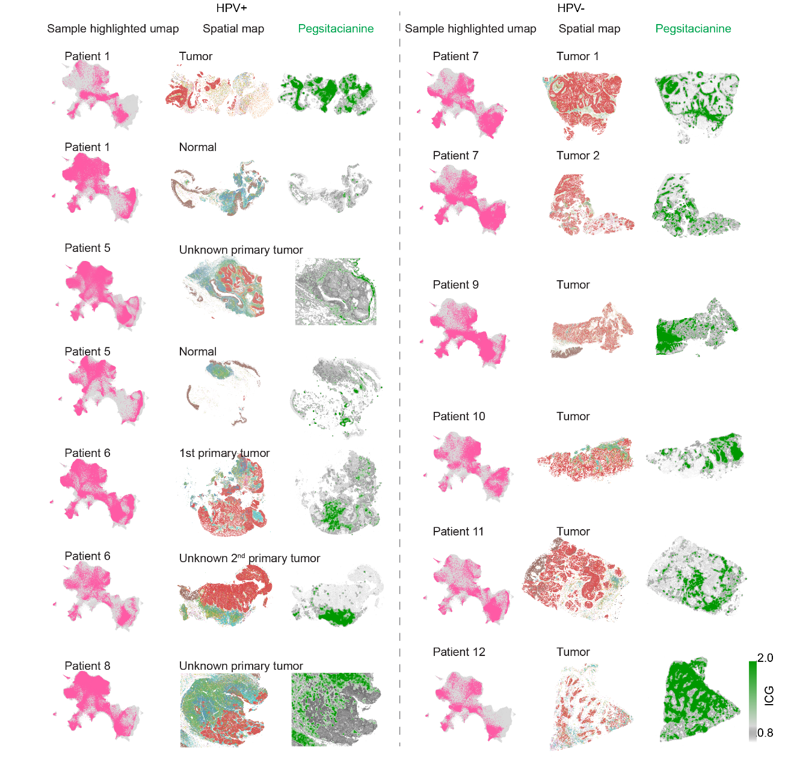
Extended Data Fig. 5: Spatial mapping of Pegsitacianine activation across HPV-positive and HPV-negative tumors. Representative UMAP projections, spatial transcriptomic maps, and Pegsitacianine (ICG) overlays from 12 tumor samples spanning HPV-positive (left) and HPV-negative (right) patients. Across both groups, Pegsitacianine signal was enriched in stromal regions adjacent to epithelial nests, consistent with compartmentalization of acidotic metabolism and endothelial localization.
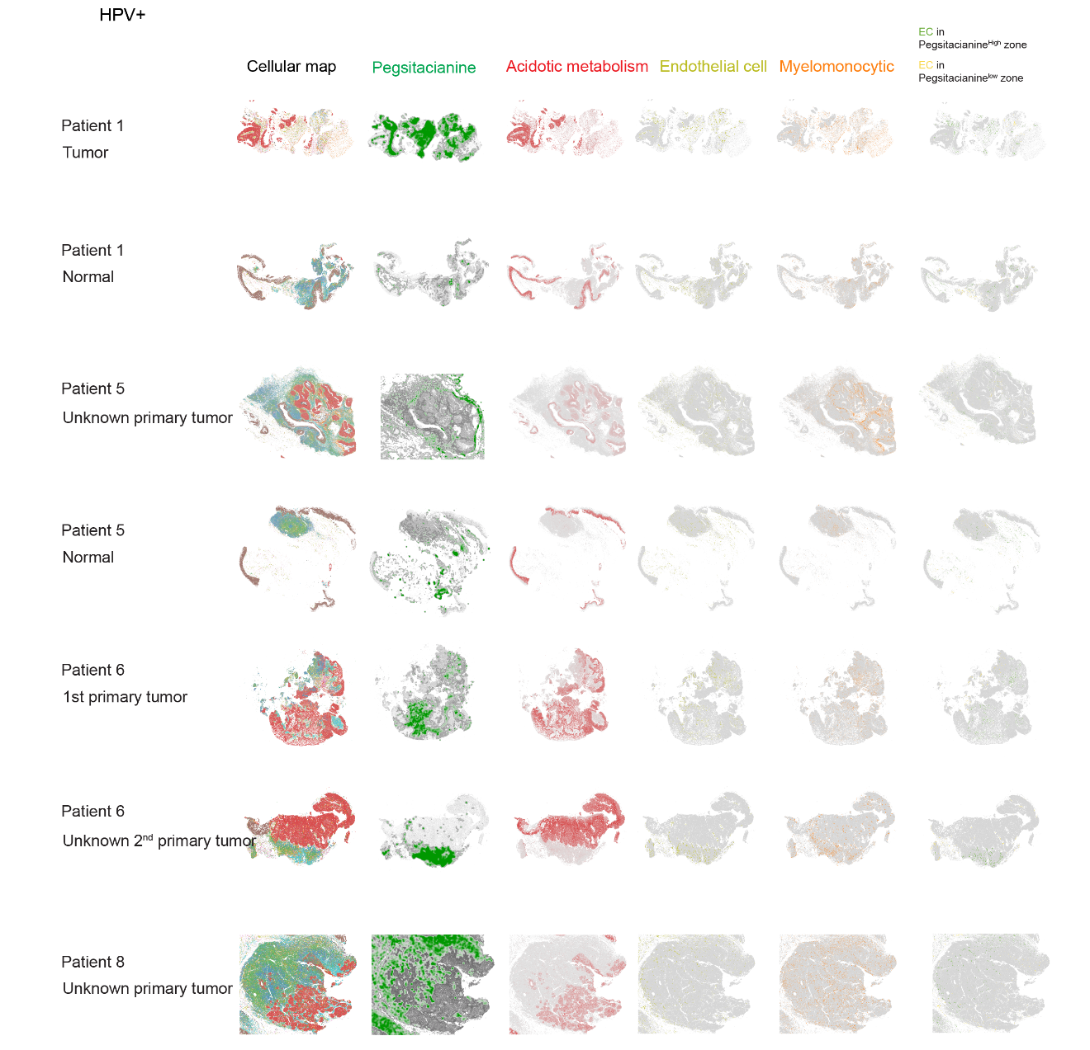
Extended Data Fig. 6: Pegsitacianine activation in HPV-positive tumors. Spatial maps from HPV-positive patients (including known and unknown primary cancers) show co-registration of Pegsitacianine (ICG) signal, acidotic metabolism, endothelial cells, and myelomonocytic compartments. Pegsitacianine consistently localized to stromal regions surrounding epithelial nests enriched in acidotic metabolism genes.
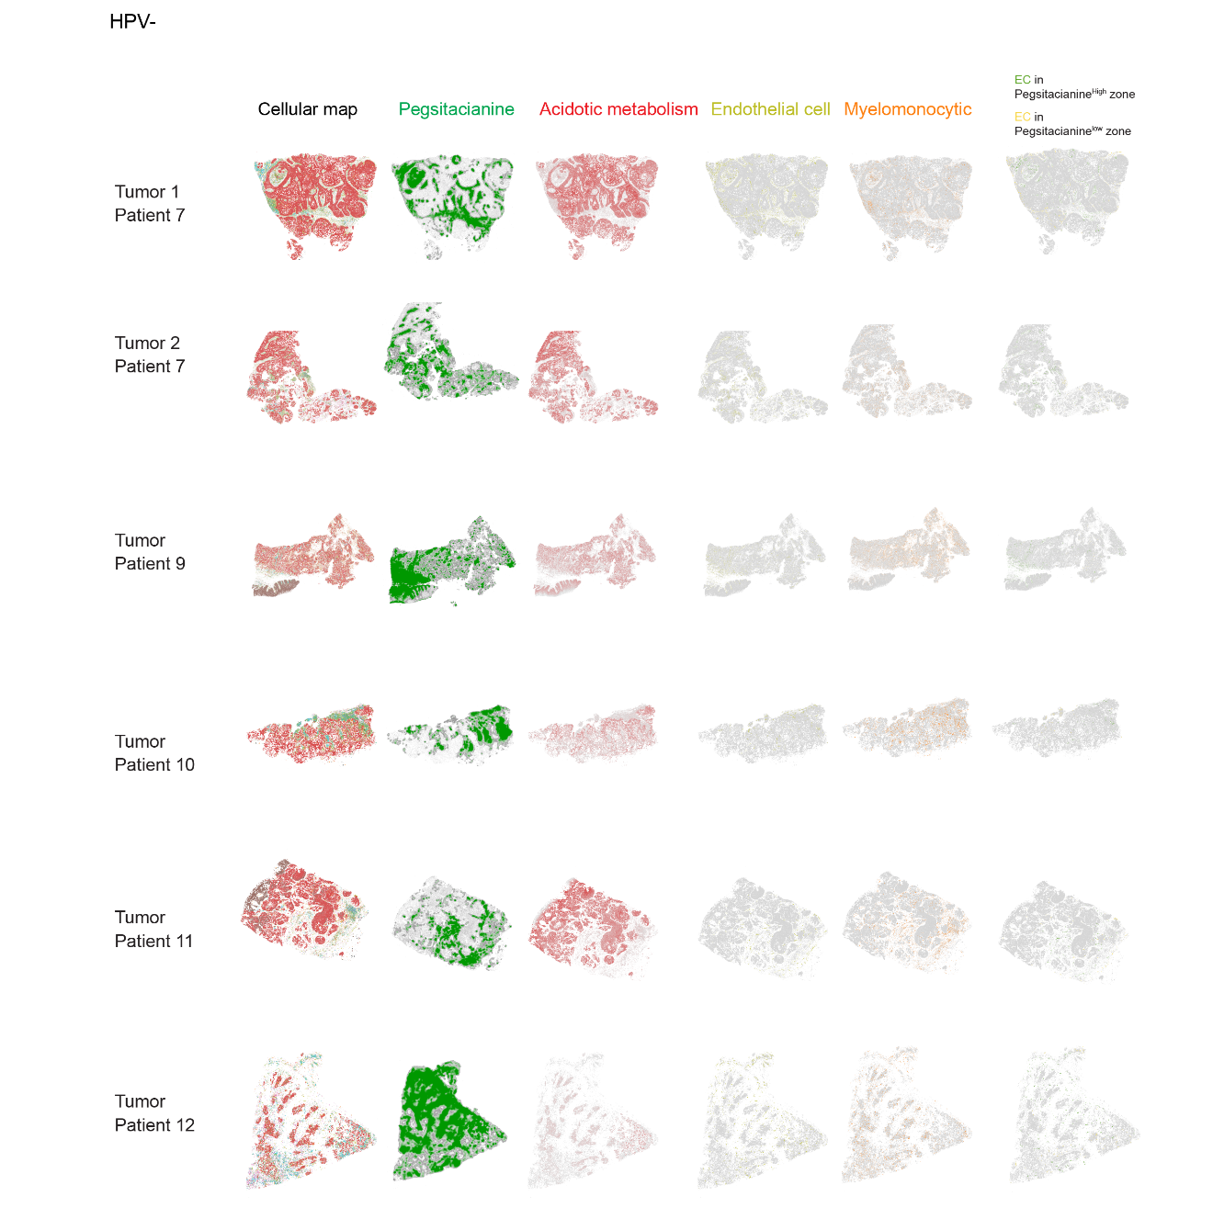
Extended Data Fig. 7: Pegsitacianine activation in HPV-negative tumors. Spatial maps from HPV-negative head and neck cancers reveal the same pattern observed in HPV-positive disease: acidotic metabolism signatures cluster within epithelial nests, while Pegsitacianine signal localizes to stromal and vascular regions. This conserved distribution underscores stromal acidity as the primary site of nanoparticle activation across tumor subtypes.
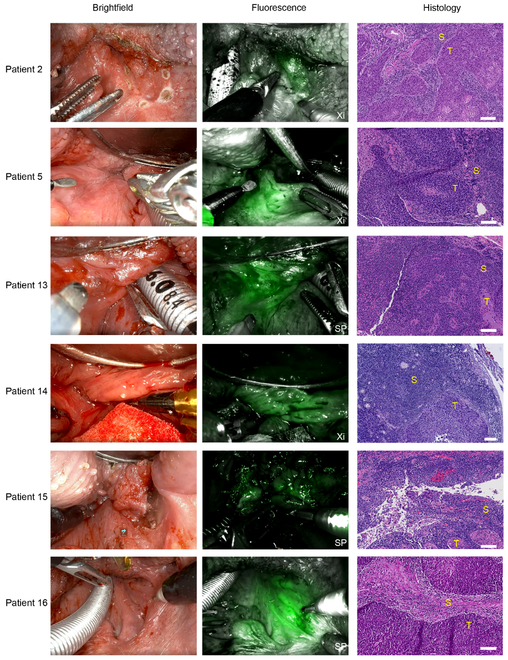
Extended Data Fig. 8: Representative intraoperative images from six additional patients injected with Pegsitacianine. Brightfield, near-infrared fluorescence, and corresponding histological images are shown for the same anatomical regions in each patient. Pegsitacianine facilitates tumor detection, confirmed by histopathological examination. S, stroma; T, tumor. Scale bar: 100 μm. See additional video clips for real-time identification and resection.
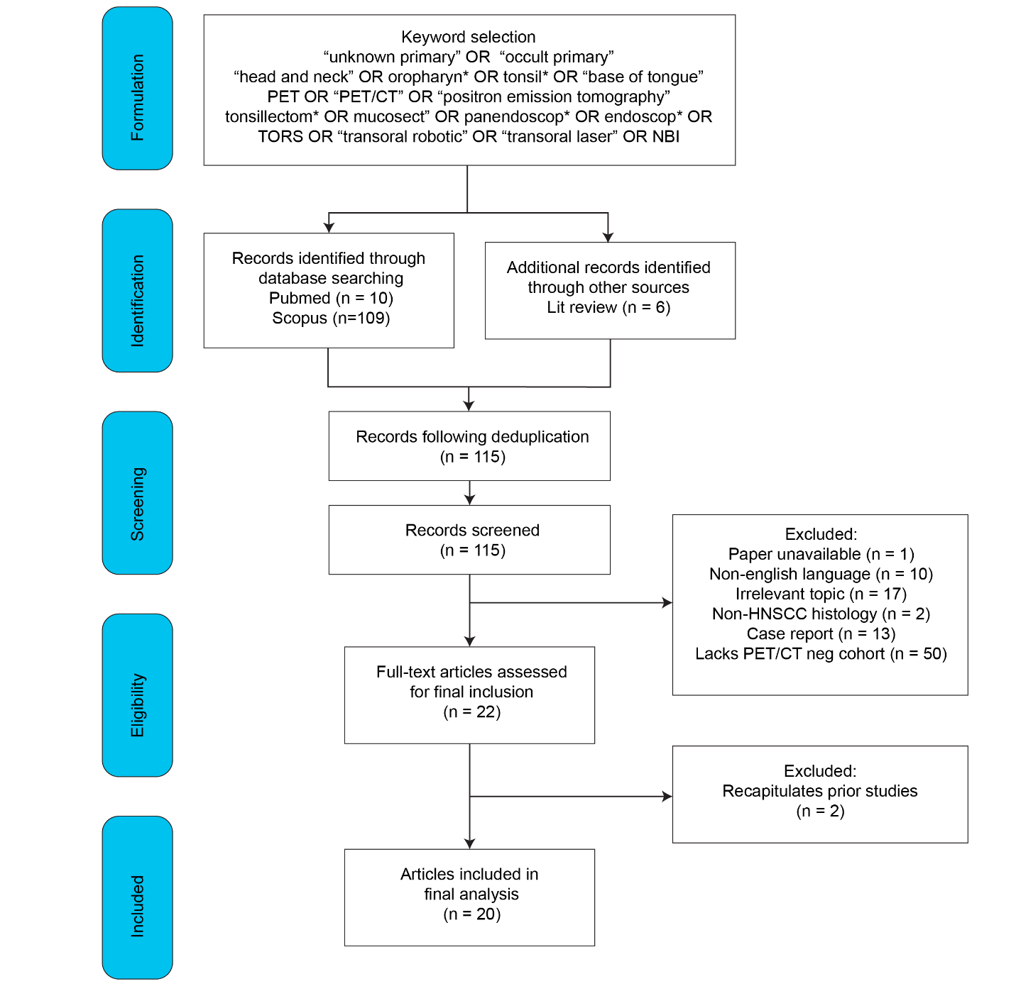
Extended Data Fig. 9: Meta analysis workflow of current clinic studies on discovery of UPC from patients.
Table S1. Patient demographics
Patient # | UPC | Tumor found | Age | Gender | TN | HPV16 | Infusion Time to Surgery | Tumor Size (cm)
1 | No | Yes | 67 | M | T2N1 | + | 46 hrs 32 mins | 2.9
2 | Yes | Yes | 60 | M | T1N1 | + | 96 hrs | 1.1
3 | No | Yes | 68 | M | T4aN3b | - | 40 hour 34 min | 8.5
4 | No | Yes | 79 | M | T1N0 | - | 56 hour 39 min | 1.7
5 | Yes | Yes | 65 | M | T1N1 | + | 47 hrs 33 min | 0.5
6 | Yes | Yes | 52 | M | T2N1 | + | 381 hrs 38 min | 8
7 | No | Yes | 83 | F | T2N1 | - | 68 hrs 2mins | 2.5
8 | Yes | Yes | 75 | M | T1N1 | + | 62 hrs47 min | 0.2
9 | No | Yes | 53 | M | T4aN3b | - | 65 hrs 23mins | 2.5
10 | No | Yes | 71 | M | T1N0 | - | 116 hrs 37mins | 4.4
11 | No | Yes | 65 | F | T2N0 | - | 95 hrs 21mins | 2.8
12 | No | Yes | 49 | M | T1N2a | - | 170 hrs 38mins | 2
13 | Yes | Yes | 70 | M | T1N1 | + | 138 hrs 41 min | 0.6
14 | Yes | Yes | 45 | M | T1N1 | + | 141 hrs 44 min | 0.4
15 | Yes | Yes | 77 | M | T1N1 | + | 171 hr 3 min | 0.4
16 | Yes | Yes | 70 | M | T1N1 | + | 23 hrs 38 mins | 0.7
17 | Yes | Yes | 52 | F | T1N1 | + | 94 hrs 22 mins | 1.5
18 | Yes | Yes | 59 | M | T1Nx | + | 91 hrs 12 mins | 0.9
19 | Yes | Yes | 58 | M | T1N1 | + | 139 hrs 9 mins | 0.2
20 | Yes | Yes | 54 | M | T1N1 | + | 195 hrs 45 mins | 0.8
21 | Yes | Yes | 63 | F | T1N1 | + | 66 hrs 22 mins | 1
22 | Yes | Yes | 75 | M | T1Nx | + | 99 hrs 32 mins | 1
23 | Yes | No | 58 | M | T0N1 | + | 145 hrs 30 mins | -
24 | Yes | No | 67 | M | TxN1 | + | 72 hrs 23 mins | -

