Fig. S1. Correlation of apoM with S1P in the HDL2 fraction before (V2) and after obicetrapib treatment (V5).

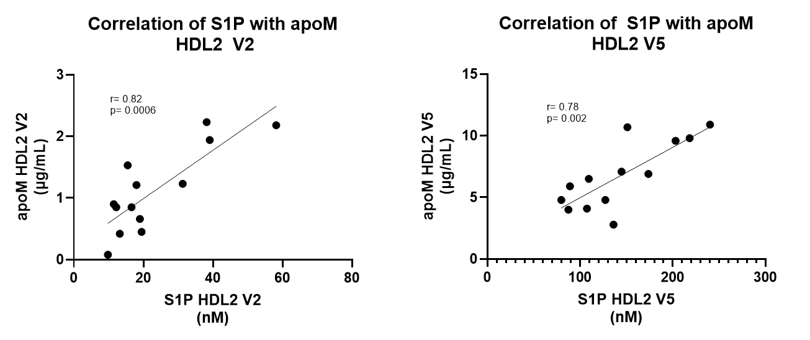
Abbreviations: apo, apolipoprotein; HDL, high-density lipoprotein; S1P, sphingosine-1-phosphate; V2, baseline; V5, week 8.

Fig. S2. Correlation of apoM with m-apoA1 in the HDL2 fraction before (V2) and after obicetrapib treatment (V5).

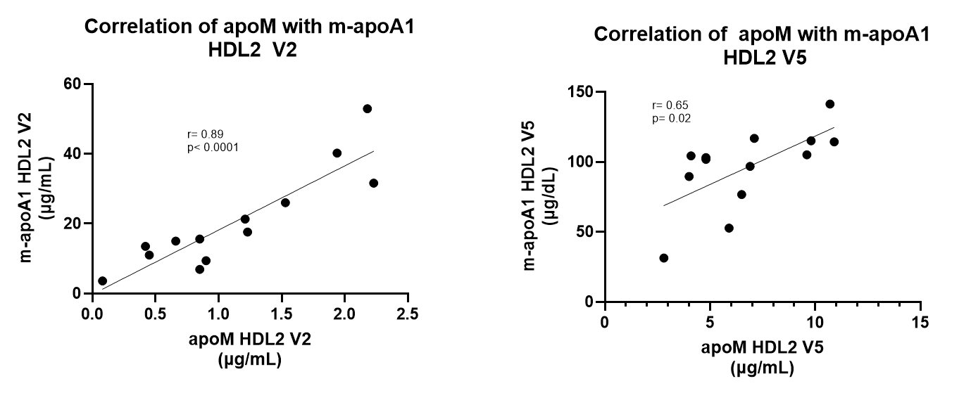
Abbreviations: apo, apolipoprotein; HDL, high-density lipoprotein; m-apoA1, monomeric apolipoprotein A1; S1P, sphingosine-1-phosphate; V2, baseline; V5, week 8.

Fig. S3. Correlation of apoM in the HDL2 fraction with m-apoA1 in the protein fraction before V2 (A) and after obicetrapib treatment V5 (B).

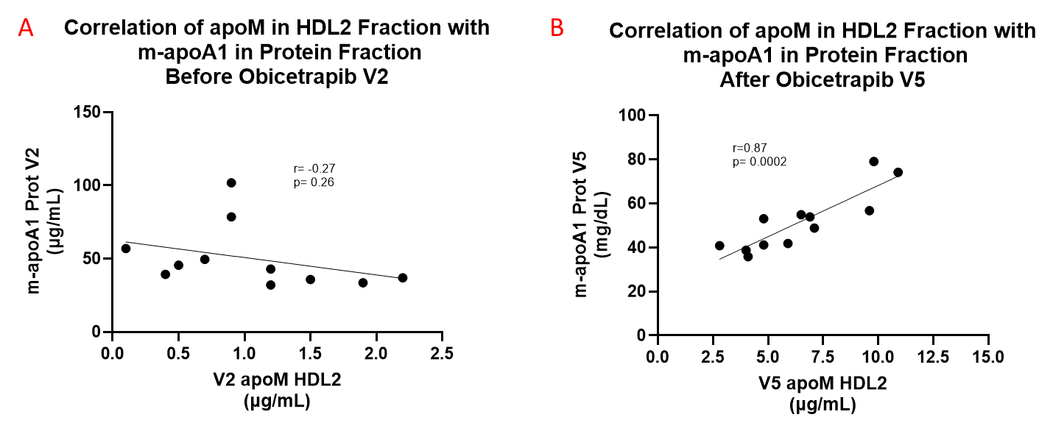
Abbreviations: apo, apolipoprotein; HDL, high-density lipoprotein; m-apoA1, monomeric apolipoprotein A1; S1P, sphingosine-1-phosphate; V2, baseline; V5, week 8.

Fig. S4. Correlation of CSF carotenoids with HDL2 carotenoids before obicetrapib treatment (V1).
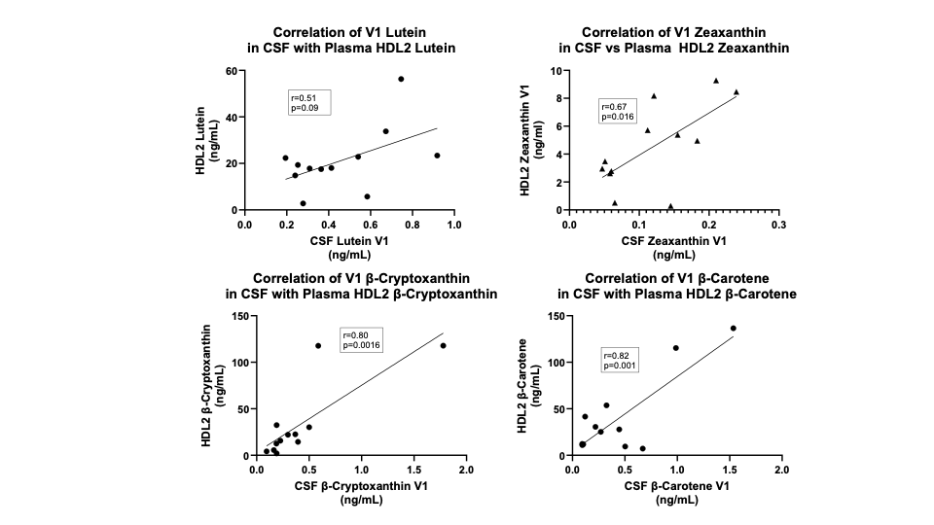
Abbreviations: CSF, cerebrospinal fluid; HDL, high-density lipoprotein; V1, screening.
Fig. S5. Correlation of CSF carotenoids with HDL2 carotenoids after obicetrapib treatment (V6).
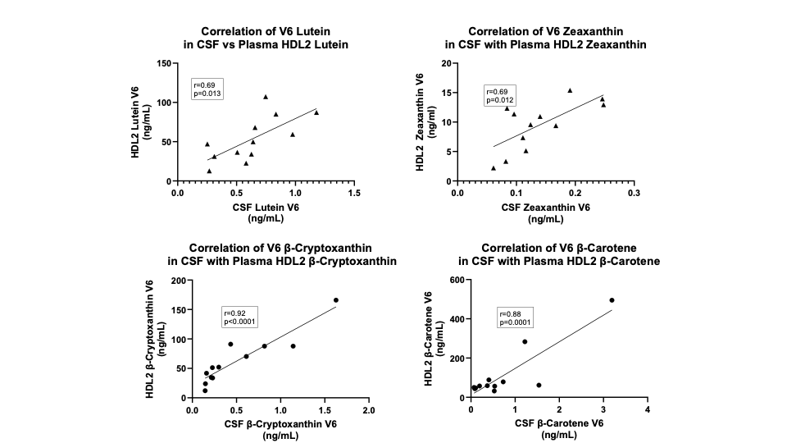
Abbreviations: CSF, cerebrospinal fluid; HDL, high-density lipoprotein; V6, week 24.

