Manuscript title, "Therapeutic potential of Diosmin against benign prostatic hyperplasia via regulation of androgen receptor and NF-κB signaling".
Abul Vafa¹, Rupali Ghosh^{1,} Nishat Afroz^{1,2}, Syed Abuzar Raza Rizvi¹, Zaid Siddiqui¹, Saima Wajid^{1,*}
Ref: Submission ID 72f406b7-c571-4e9f-89ad-9b751977d492
Full-length Western blot images corresponding to Figure 4A, showing β-actin AR, NF-κB p65, and COX-2 bands.
Western blot showing detection of β-actin (~42 kDa) used as a loading control for the corresponding experiments. (The sequence is from left to right G1, G2, G3, G4, then G5).
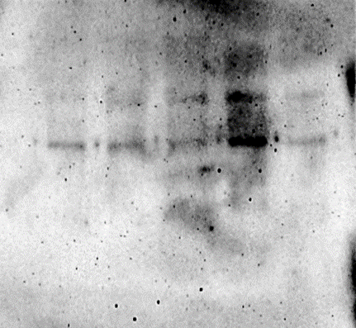
~40 kDa
Blot 1
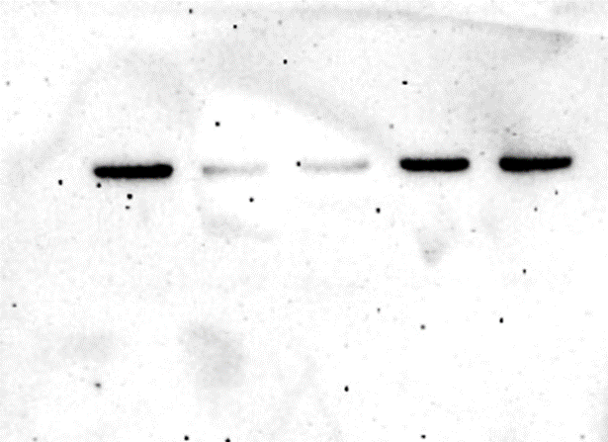
β-Actin
~40 kDa
Blot 2
G1
G2
G3
G4
G5
G1
G2
G3
G4
G5

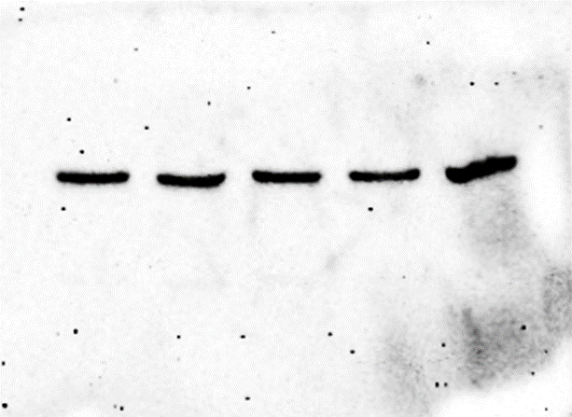
~40 kDa
Blot 3
presented in main figure

G1
G2
G3
G4
G5

Western blot showing detection of Androgen Receptor (AR, ~110 kDa) corresponding to the cropped blot presented in the main figure. (The sequence is from left to right G1, G2, G3, G4, then G5).
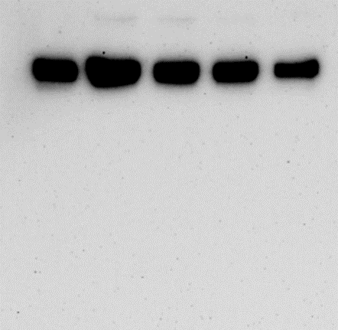
G1
G2
G3
G4
G5

~110 kDa
Blot 1
Main blot
AR
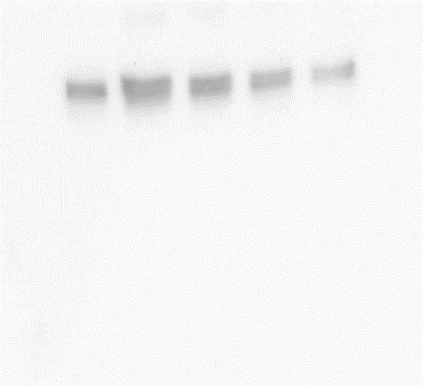
Blot 2
High contrast blot
~110 kDa

Western blot showing detection of NF-κB p65 (~65 kDa) corresponding to the cropped blot presented in the main figure. The sequence is from left to right G1, G2, G3, G4, then G5).
NF-κB
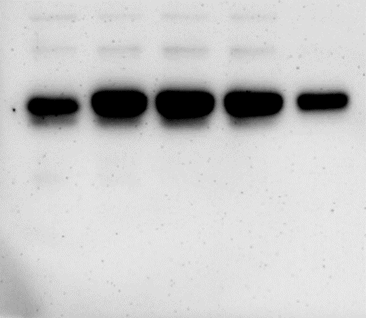
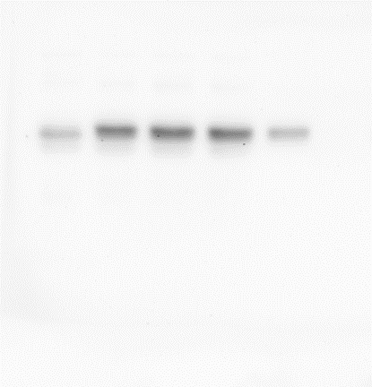

G1
G2
G3
G4
G5
~62 kDa
Blot 1
Main blot
~62 kDa
Blot 2
High contrast

Western blot showing detection of COX-2 (~72 kDa) corresponding to the cropped blot presented in the main figure.The sequence is from left to right G1, G2, G3, G4, then G5).
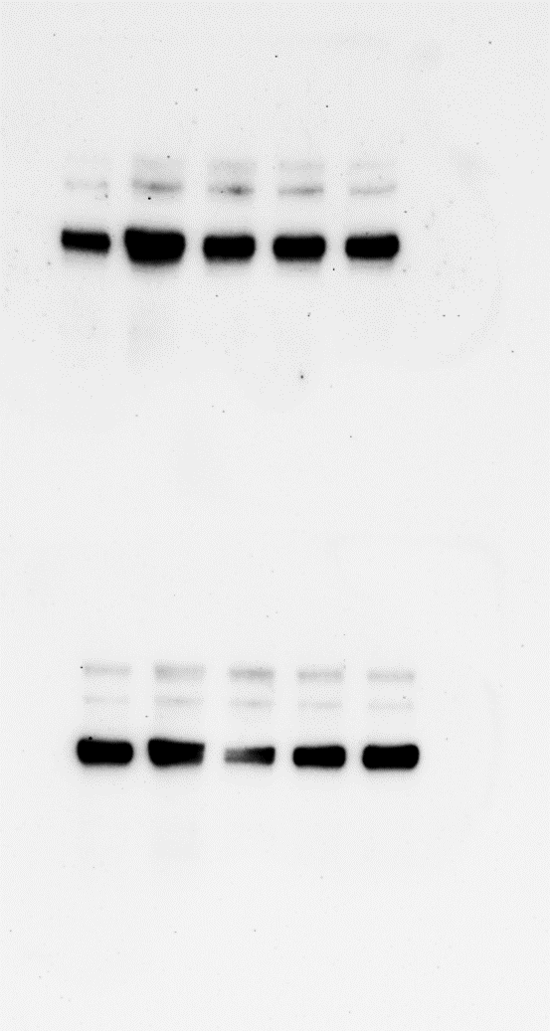

G1
G2
G3
G4
G5
~70 kDa
Blot 1
Main blot
COX-2
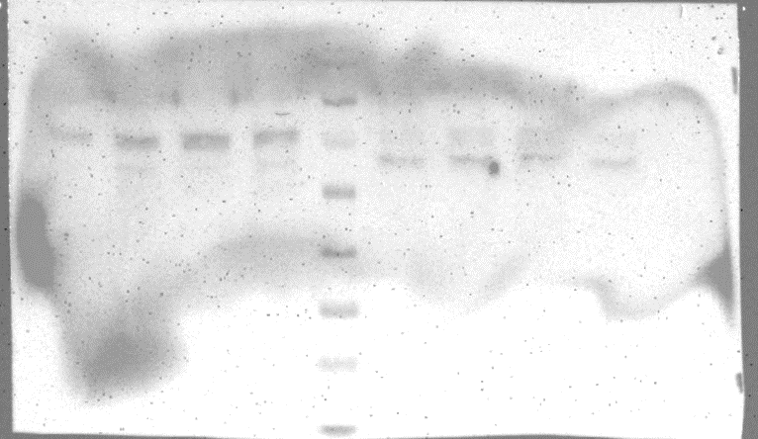
~70 kDa
Blot 2

