Supplementary Materials
Figure
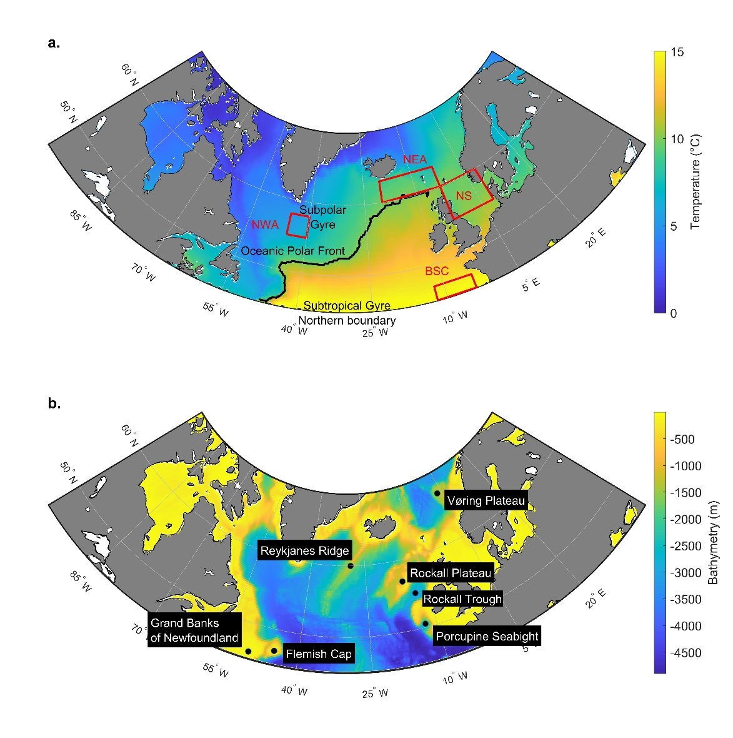
Fig. S1: (a) Mean sea-surface temperature (SST, °C; averaged over 1958-2022) with approximate regions of the Subtropical and Subpolar Gyres and the oceanic polar front (black line, computed here as the upper limit of the 10 °C SST isoline as a practical thermal marker), shown for reference to the results in Fig. 1, along with the regions (red squares) selected for this study and arranged along a thermal gradient (colder to warmer): the North-West Atlantic (NWA; Longitude 45°W-40°W, Latitude 55°N-58°N, mean temperature: 5.95 °C, bathymetry: 3302 m [2589-3493 m]); the North-East Atlantic (NEA; Longitude 20°W-3°W, Latitude 60°N-63°N, mean temperature: 9.27 °C, bathymetry: 1244 m [16-2735 m]); the North Sea (NS; Longitude 3°W-8°E, Latitude 55°N-60°N, mean temperature: 9.89 °C, bathymetry: 95 m [6-359 m]); and the Bay of Biscay (BSC; Longitude 12°W-4°W, Latitude 45°N-47°N, mean temperature: 14.97 °C, bathymetry: 4133 m [124-5032 m]). (b) Bathymetric data of the North Atlantic, showing the major bathymetric features (black dots) referenced in this study.
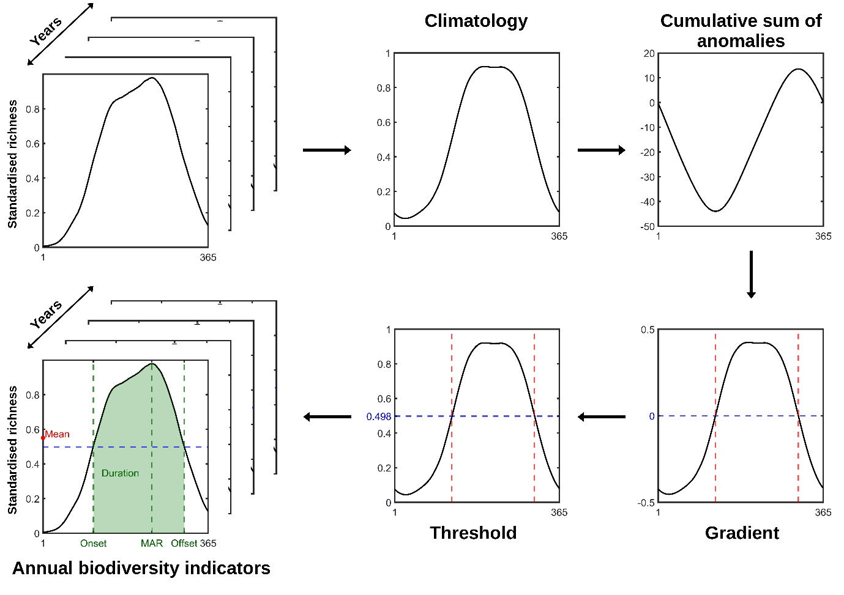Fig. S2: Schematic diagrams outlining the method used to compute five indicators to measure changes in annual biodiversity patterns observed in the four studied regions and for the three taxonomic groups. (i) Day of Maximum Annual Richness (MAR), (ii) Onset, (iii) Offset, (iv) Duration of the high-richness period, and (v) Mean annual richness.
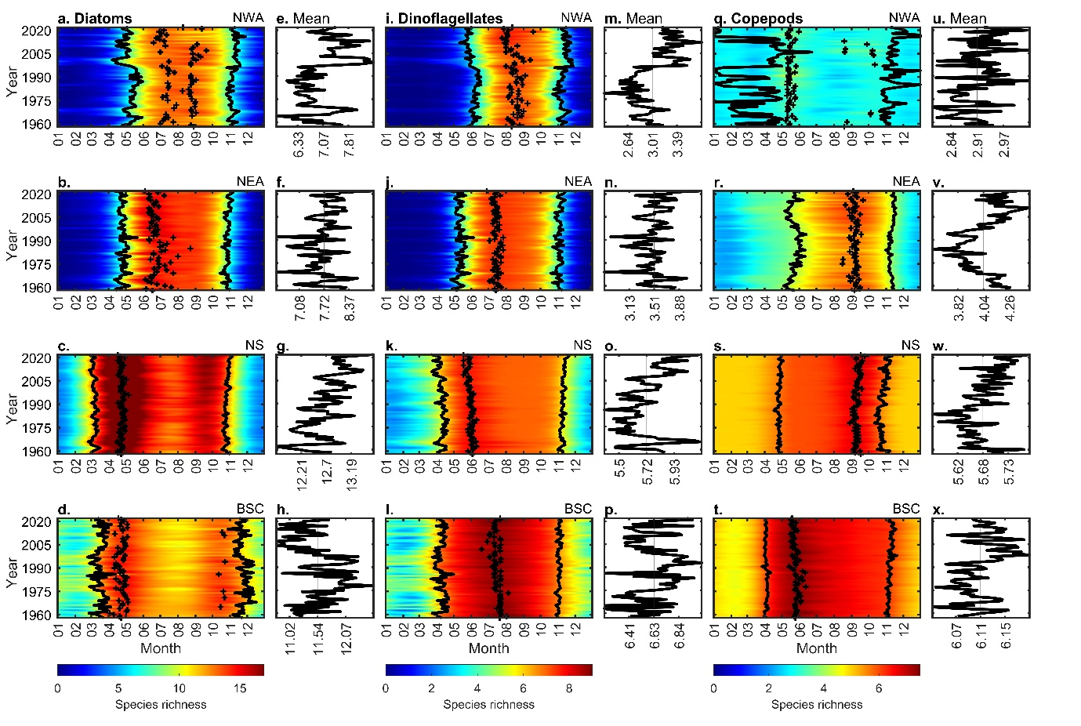Fig. S3: Reanalysed long-term changes (1958-2022) in mean daily species richness (0-10 m) and associated indicators: onset and offset of the high-biodiversity period (black lines) and day of Maximum Annual Richness (MAR, black crosses), for diatoms (a-d), dinoflagellates (i-l), and copepods (q-t). The panels to the right of each colourmap (e-h, m-p, u-x) show the corresponding yearly mean richness (black line) and the overall mean across the studied period (vertical grey line) for each group in each region: Northwest Atlantic (NWA: a, e, i, m, g, u), Northeast Atlantic (NEA: b, f, j, n, r, v), the North Sea (NS: c, g, k, o, s, w), and the Bay of Biscay (BSC: d, h, l, p, t, x). See the mapping of the selected regions in Supplementary Fig. S1 and the methods section for the assessment of the onset and offset.
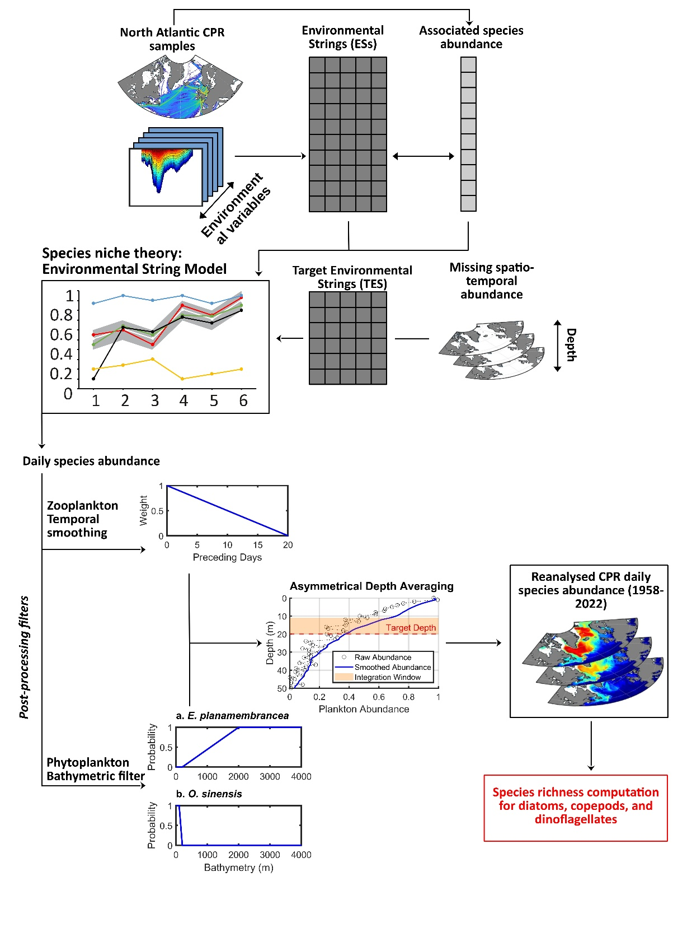
Fig. S4: Conceptual scheme summarising the methodology to compute reanalysis of North-Atlantic phytoplankton and zooplankton species abundance from the Continuous Plankton Recorder (from Castant et al. 2025)²¹.

Table
Table S1: Species names recorded in the Continuous Plankton Recorder (CPR) dataset that were selected to compute species richness for Copepods, Dinoflagellates and Diatoms
Group | Species
Copepods | Calanus finmarchicus
 | Calanus helgolandicus
 | Calanus glacialis
 | Calanus hyperboreus
 | Neocalanus gracilis
 | Nannocalanus minor
 | Calanoides carinatus
 | Rhincalanus nasutus
 | Euchirella rostrata
 | Euchaeta acuta
 | Metridia lucens
 | Metridia longa
 | Pleuromamma robusta
 | Pleuromamma abdominalis
 | Pleuromamma borealis
 | Pleuromamma gracilis
 | Candacia armata
 | Labidocera wollastoni
 | Aetideus armatus
 | Anomalocera patersoni
 | Candacia bipinnata
 | Candacia ethiopica
 | Candacia pachydactyla
 | Centropages bradyi
 | Centropages violaceus
 | Euchaeta marina
 | Heterorhabdus norvegicus
 | Heterorhabdus papilliger
 | Pleuromamma piseki
 | Pleuromamma xiphias
 | Rhincalanus cornutus
 | Scolecithrix danae
 | Undeuchaeta plumosa
 | Undinula vulgaris
 | Paracandacia simplex
 | Mesocalanus tenuicornis
 | Subeucalanus crassus
 | Paraeuchaeta hebes
 | Paraeuchaeta norvegica
 | Temora longicornis
 | Centropages typicus
 | Centropages hamatus
 | Acartia danae
 | Ctenocalanus vanus
 | Mecynocera clausi
 | Temora stylifera
Dinoflagellates | Ceratium fusus
 | Ceratium furca
 | Ceratium lineatum
 | Ceratium tripos
 | Ceratium macroceros
 | Ceratium horridum
 | Ceratium longipes
 | Ceratium arcticum
 | Ceratium arietinum
 | Ceratium azoricum
 | Ceratium bucephalum
 | Ceratium candelabrum
 | Ceratium carriense
 | Ceratium compressum
 | Ceratium declinatum
 | Ceratium extensum
 | Ceratium gibberum
 | Ceratium hexacanthum
 | Ceratium lamellicorne
 | Ceratium massiliense
 | Ceratium minutum
 | Ceratium pentagonum
 | Ceratium teres
 | Ceratium trichoceros
 | Actiniscus pentasterias
 | Goniodoma polyedricum
Diatoms | Paralia sulcata
 | Skeletonema costatum
 | Dactyliosolen antarcticus
 | Rhizosolenia styliformis
 | Rhizosolenia hebetata semispina
 | Odontella sinensis
 | Thalassiothrix longissima
 | Thalassionema nitzschioides
 | Bellerochea malleus
 | Biddulphia alternans
 | Odontella aurita
 | Odontella granulata
 | Odontella regia
 | Odontella rhombus
 | Coscinodiscus concinnus
 | Detonula confervacea
 | Ditylum brightwellii
 | Eucampia zodiacus
 | Guinardia flaccida
 | Leptocylindrus danicus
 | Cylindrotheca closterium
 | Rhaphoneis amphiceros
 | Rhizosolenia acuminata
 | Rhizosolenia bergonii
 | Rhizosolenia setigera
 | Coscinodiscus wailesii
 | Nitzschia longissima
 | Proboscia alata
 | Leptocylindrus mediterraneus
 | Proboscia inermis
 | Asterionellopsis glacialis
 | Ephemera planamembranacea
 | Pseudo-nitzschia delicatissima complex
 | Pseudo-nitzschia seriata complex
 | Podosira stelligera
 | Pseudosolenia calcar-avis
 | Guinardia delicatula
 | Dactyliosolen fragilissimus
 | Guinardia striata
 | Lauderia annulata
 | Bacillaria paxillifera
 | Corethron hystrix
 | Proboscia indica
 | Rhizosolenia imbricata

Table S2: Differences (with 95% confidence intervals) for the five indicators of annual biodiversity patterns for diatoms, dinoflagellates, and copepods across four regions; North-West Atlantic (NWA), North-East Atlantic (NEA), North Sea (NS), and Bay of Biscay (BSC); calculated between two time periods (1965-1985 vs 2002-2022): annual Duration of the high-richness period, Onset, Offset, day of Maximum Annual Richness (MAR) and mean annual richness. Significant differences between periods were assessed with a Mann-Whitney U test and highlighted in bold with an asterisk (*).
 |  | Duration | Onset | Offset | MAR | Mean
NWA | Diatoms | 18.76  [12.40; 25.33]* | -10.57  [-15.07; -6.19]* | 8.14  [4.83; 11.57]* | -9.33  [-25.60; 6.62] | 0.60  [0.31; 0.88]*
 | Dinoflagellates | 20.81  [15.05; 26.86]* | -12.00  [-15.29; -8.81]* | 8.81  [5.00; 12.67]* | -10.14  [-16.57; -2.76]* | 0.48  [0.37; 0.61]*
 | Copepods | 4.86  [-29.76; 39.5] | 7.76  [-20.86; 36.43] | 12.57  [2.14; 22.71]* | 27.76  [-2.79; 58.43] | 0.05  [0.02; 0.08]*
NEA | Diatoms | 6.67  [1.14; 12.48] | -2.81  [-6.90; 1.19] | 3.81  [1.24; 6.62]* | -13.62  [-22.62; -5.81]* | 0.32  [0.07; 0.59]
 | Dinoflagellates | 4.95  [-0.9; 11.33] | -2.33  [-6.76; 2.05] | 2.62  [-0.52; 6.05] | -3.38  [-6.57; -0.33] | 0.11  [-0.02; 0.26]
 | Copepods | 14.90  [9.48; 20.48]* | -7.62  [-12.40; -2.16]* | 7.33  [5.76; 8.90]* | -0.19  [-4.38; 4.43] | 0.3  [0.22; 0.38]*
NS | Diatoms | 7.86  [4.10; 11.33]* | -2.71  [-5.10; -0.29] | 5.10  [3.14; 7.00]* | -1.33  [-3.69; 1.07] | 0.47  [0.29; 0.66]*
 | Dinoflagellates | 12.62  [7.52; 17.43]* | -8.33  [-12.14; -4.43]* | 4.29  [2.29; 6.29]* | -8.19  [-10.57; -5.81]* | 0.19  [0.09; 0.28]*
 | Copepods | 9.29  [6.05; 12.48]* | 2.24  [0.71; 3.71]* | 11.52  [8.29; 14.71]* | 6.24  [3.71; 8.81]* | 0.07  [0.05; 0.09]*
BSC | Diatoms | -14.62  [-22.43; -6.81]* | 4.14  [-1.81; 10.19] | -10.48  [-16.24; -4.76]* | -8.43  [-42.5; 25.83] | -0.60  [-0.81; -0.38]*
 | Dinoflagellates | 2.48  [-2.33; 7.00] | -0.67  [-4.95; 3.71] | 1.76  [-0.10; 3.67] | -7.71  [-12.24; -3.67] | -0.05  [-0.17; 0.08]
 | Copepods | 8.24  [6.48; 10.05]* | -2.43  [-3.33; -1.48]* | 5.81  [4.10; 7.52]* | -8.81  [-11.43; -6.33] | 0.03  [0.01; 0.05]*

