Supplementary Information

Uniform Nanoporous Zirconia Composite Membrane Enabling High-Performance Alkaline Water Electrolysis
Zhipeng Xu^{1,2,3}, Zhihao Lin^{1,2,3}, Daohui He^{1,2,3}, Jingjing Yin^{1,2,3}, Yangke Pan^{1,2,3}, Liang Guo^{1,2,3}, Junbin Liao^{1,2,3}, Huimin Ruan^{1,2,3,*}, Congjie Gao^{1,2,3}, Jiangnan Shen^{1,2,3,*}, Young Moo Lee^{4,*}
¹ College of Chemical Engineering, Zhejiang University of Technology, Hangzhou 310014, China.
² State Key Laboratory of Advanced Separation Membrane Materials, Zhejiang University of Technology, Hangzhou 310014, China.
³ National Key Laboratory of Green Chemical Synthesis and Transformation Technology, Hangzhou 310014, China.
⁴ Department of Energy Engineering, College of Engineering, Hanyang University, Seoul 04763, Republic of Korea
*Corresponding authors: Email: ruanhm@zjut.edu.cn, shenjn@zjut.edu.cn, ymlee@hanyang.ac.kr
Contents
Supplementary Test
- Preparation of YSZs-PPS-85 membrane
- Characterization
- Hydrogen permeation test
- Computational method
- Figure S1-S61
- Tables S1-S5

- Preparation of YSZs-PPS-85 membrane
120 g of PPA, 1.66 g of TPA, and 2.14 g of DAB were added into a three-necked reaction flask under a nitrogen atmosphere. The mixture was heated to 140 °C and mechanically stirred until completely dissolved. Subsequently, the temperature was raised to 190 °C; during this process, the polymerization mixture gradually became viscous and turned dark brown. Then, 22g of YSZNPs is dispersed in a PA solution with a total volume of 50 ml. Pour the aforementioned PPA mixture onto a glass plate preheated to 60 °C. After casting the first layer, attach the PPS mesh to the first YSZs-85 layer, and let it stand for 5 min. Subsequently, cast the next layer onto the top of the mesh, then allow the composite structure to stand for hydrolysis. The final thickness of the membrane is approximately 320±20 μm.

- Characterization
The samples were thermally annealed at 200 ℃ for 24 h in an electric furnace. The intrinsic viscosity (IV) of the polymers was measured using a Cannon-Ubbelohde viscometer at 30 ℃ in concentrated sulfuric acid at a concentration of 0.2 g/dL. The intrinsic viscosity ($η_{IV}$) and corresponding viscosity-average molecular weights (M_{η}) were calculated from the following equation:
$η_{IV}=(η_{sp}+3\ln{ (1+η_{sp}})) / 4C$ (1)
$η_{IV}=KM_{η}^{a}$ (2)
where C is the polymer concentration (g mL⁻¹), η_{sp} is the specific viscosity of polymer solution, and K=1.94×10^{–4} and a=0.791.¹
Attenuated total reflectance–Fourier transform infrared (ATR–FTIR) spectroscopy (Nicolet is50 +IN10 and Thermo Nicolet IS5) of dried membranes was performed at a resolution of 4 cm⁻¹ over 500 − 4000 cm⁻¹. For solid–state 13C nuclear magnetic resonance (SSNMR, Bruker Avance Neo 400WB), the membranes were repeatedly washed in DI water, dried in a 120°C oven for 12 h, and ground into a powder.
X–ray diffraction (XRD) patterns were recorded on a Empyrean Nano diffractometer using Cu Kα radiation (λ= 0.1541 nm). The patterns were collected with a 2θ range from 10˚ to 60˚ at a step of 2˚ min⁻¹.
X-ray photoelectron spectroscopy (XPS) was performed on a Thermo Kalpha spectrometer with an X–ray source operated at 12 kV and 350 W. Samples containing residual PA was prepared by repeated washing followed by direct drying. Samples containing KOH were prepared by washing, immersion in 6M KOH, and subsquent drying.
Cryo–scanning electron microscopy (Cryo–SEM) of H₂O–doped membranes was carried out using a Hitachi Regulus 8220 instrument. Samples were rapidly frozen in liquid nitrogen slush, transferred to a cryogenic preparation chamber, fractured under cryogenic conditions, and sublimed at –80°C for 10 min. A thin gold coating was applied prior to imaging.
For field-emission SEM (Regulus 8100), samples were freeze-dried and the surface and cross-sectional morphology were examined.
Atomic force microscopy (AFM) phase images were acquired in tapping mode using a Dimension Icon instrument (Bruker).
Thermogravimetric analysis (TGA) was performed using a Netzsch thermal analyzer. Samples were heated to 100 °C for 20 min to remove residual moisture., followed by heating to 800 °C under nitrogen at 10 °C·min⁻¹.
Mechanical properties were measured using an INSTRON 5982 universal testing machine. Samples (4 cm × 5 mm) were tested at room temperature at a tensile rate of 5 mm min⁻¹.
Porosity was determined by immersing the membranes in deionized water at 25°C for 100 h to obtain the wet mass (M_{wet}) and wet volume (V_{wet}). Samples were then dried at 100°C for 12 hours to determine the dry mass (M_{dry}). Porosity was calculated using the following equation:
$$Porosity \left(\%\right)=\frac{M_{wet}-M_{dry}}{V_{wet}×ρ_{water}}×100 (3)$$
where M_{wet} is the mass of the membrane after immersion in water, M_{dry} is the mass of the dried membrane, V_{wet} is the volume of the wet membrane, and ρ_{water} is the density of water.
Bubble point pressure (BPP) was measured using a capillary flow porometer. A 3cm ×3cm EtOH-doped membrane was mounted onto a 2.5 cm test platform. Pressure was gradually increased, and the BPP was recorded when a gas flow of 1 mL min⁻¹ was detected on the low-pressure side.
Creep resistance was measured using a dynamic mechanical analyzer (DMA, TA 850). Samples were immersed in deionised water, and a constant compressive stress of 0.1 MPa was applied for 6 h. Multiple membrane layers were stacked to reach a thickness of ~3 mm and an area of 1 cm².
Static water contact angles were measured a Dataphysics OCA20 goniometer and analyzed by using Washburn method. Membranes were pre-immersed in 6M KOH for 48 h. A 3 μL water droplet was placed on the membrane surface using the sessile drop method.
Membrane samples were immersed in a 6 M KOH solution at room temperature, and the membranes intended for long-term storage were placed in sealed PTFE vials. The ionic conductivity was measured periodically to characterize the alkaline stability.
The activation energies (Ea) of the PA-doped membranes were calculated according to the Arrhenius equation:
$$lnσ=lnσ_{0}-\frac{E_{a}}{RT}$$
where E_{a} represents the activation energy, measured in kJ mol^{–1}, R stands for the gas constant, with a value of 8.314 J mol^{–1} K^{–1}, and T signifies the absolute temperature in Kelvin (K).
At 25 °C, the area resistance of the membrane was measured in a customized H-type cell. The composite membrane was mounted between two chambers equipped with Pt electrodes, and the gap was filled with a 30 wt% KOH solution. An electrochemical workstation was used to measure the resistance. The area resistance was calculated as follows:
$$AR=A×(R-R_{blank})$$
where $R$ (Ω) is the resistance of the electrodes with the membrane, $R_{blank}$ (Ω) is the resistance of the electrodes without the membrane and $A$ (cm²) represents the available cross-sectional membrane area.

- Hydrogen Permeation Test
A single cell was assembled using the membrane (pre-immersed in 6M KOH solution for 12 h), with a Pt/C (40 wt%, Johnson Matthey Hispec 4000, 0.5mg cm^{–2} Pt) as both anode and cathode. Catalyst ink was prepared by dispersing catalyst powder, ionomer (Nafion D520, 5%wt), distilled water and isopropanol, with the ionomer content in the catalytic layer being 20wt%. Before testing, both the cathode and anode chambers were purged with humidified N₂ for 1 h, followed by humidified H₂ on the cathode for 30 min. After backpressure stabilization of the two chambers for 30 m, hydrogen crossover limiting current of the membrane under different temperature conditions was obtained using linear voltammetry scanning (LSV). The linear scanning range was 0–0.8 V, and the scanning rate was 5 mV·s⁻¹. Hydrogen permeability was calculated using the following equation:
$K=\frac{i}{2FP}$(4)
where K refers to the hydrogen permeability (mol cm^{–2} s^{–1} kPa^{–1}), F represents the Faraday constant (96485 C mol^{–1}), and P stands for the hydrogen partial pressure difference (kPa).
- Computational method
Molecular dynamic (MD) simulations were performed using Materials Studio 2020 software package (BIOVIA, USA). In a cubic simulation box, a polymer chain with 25 monomer units was used as the template chain for adjacent initial packing via the Amorphous Cell module with COMPASSIII force field. For the YSZs–70/PA model, the crystal lattice contains two PBI chains (5 repeating units each), 60 ZrO₂ molecules and 200 phosphoric acid molecules. For the G–PBI/PA model, the crystal lattice contains eight PBI chains (5 repeating units each), along with 200 phosphoric acid molecules. For the YSZs–70/KOH model, the crystal lattice contains two PBI chains (5 repeating units each), along with 60 ZrO₂ molecules, 40 K⁺ ions, 40 OH⁻ ions, and 400 water molecules. For the G–PBI/KOH model, the crystal lattice contains eight PBI chains (5 repeating units each), along with 40 K⁺ ions, 40 OH⁻ ions, and 400 water molecules.
All models were built under periodic boundary conditions at 298 K with an initial density of 1.0 g·cm^{–3}. Perdew–Burke–Ernzerhof (PBE) function of generalized gradient approximation (GGA) was employed to describe the exchange–correlation energy. After obtaining the model density, the final equilibration of the packing models was carried out with the following sequence of simulation steps: 100 annealing cycles with NPT–MD annealing at 1 atm, using a time step of 1.0 fs, where the initial temperature was 433 K and the middle–cycle temperature was 633 K; Then, 2000ps MD in the NPT ensemble at 1 atm and 353K was carried out to compress the cell to reasonable density. The precise Nose–Hoover temperature control mode and Berendsen pressure control mode are used in the dynamic process.
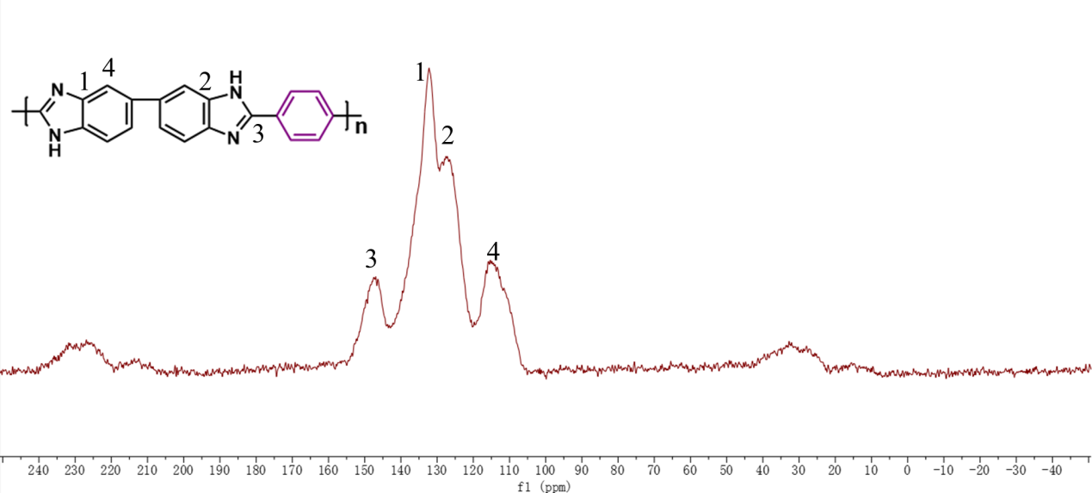
Fig. S1. | Characterization of PBI. ¹³C NMR spectra of the PBI polymer.

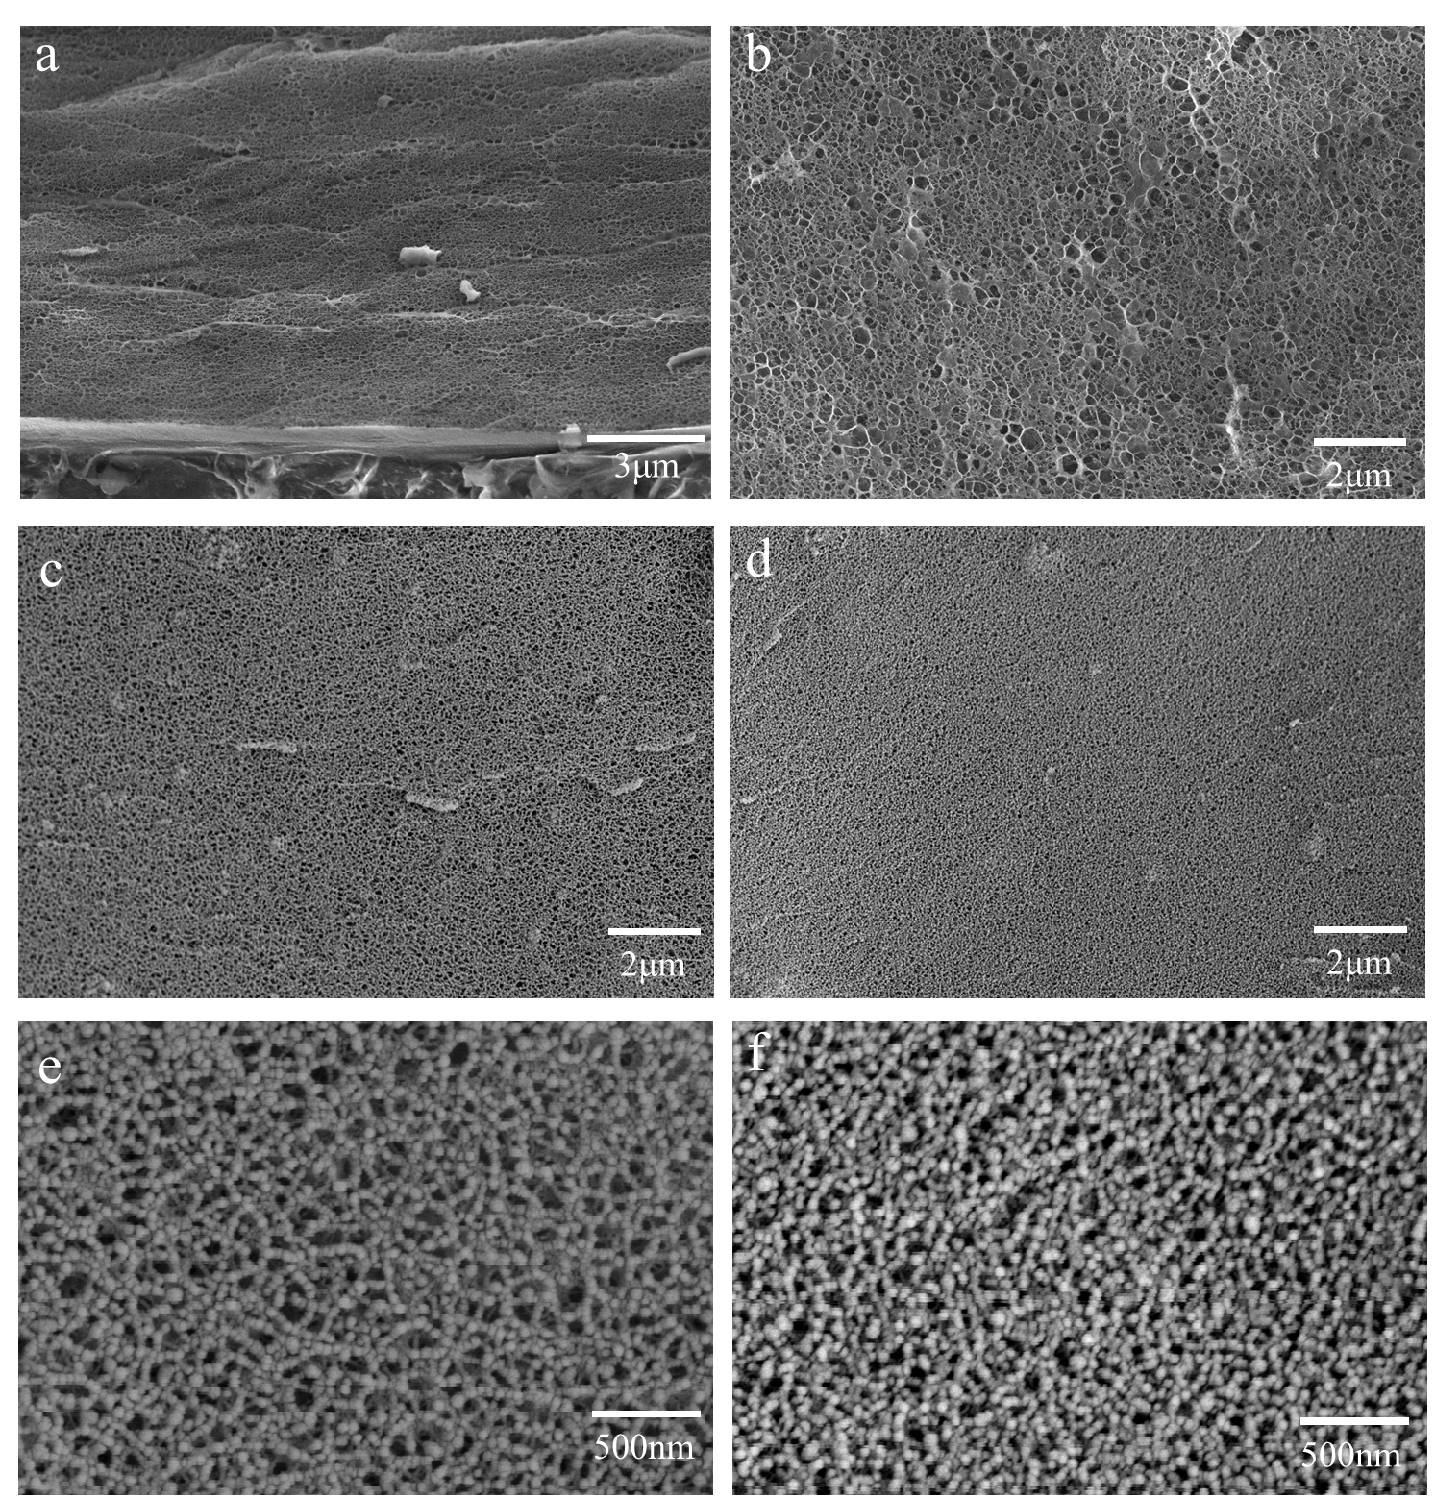
Fig. S2. | Cryo–SEM cross–sectional image of the wet membranes: (a) the skin layer of G–PBI skin layer; (b) G–PBI; (c) and (f) YSZs–40; (e) and (g) YSZs–70.
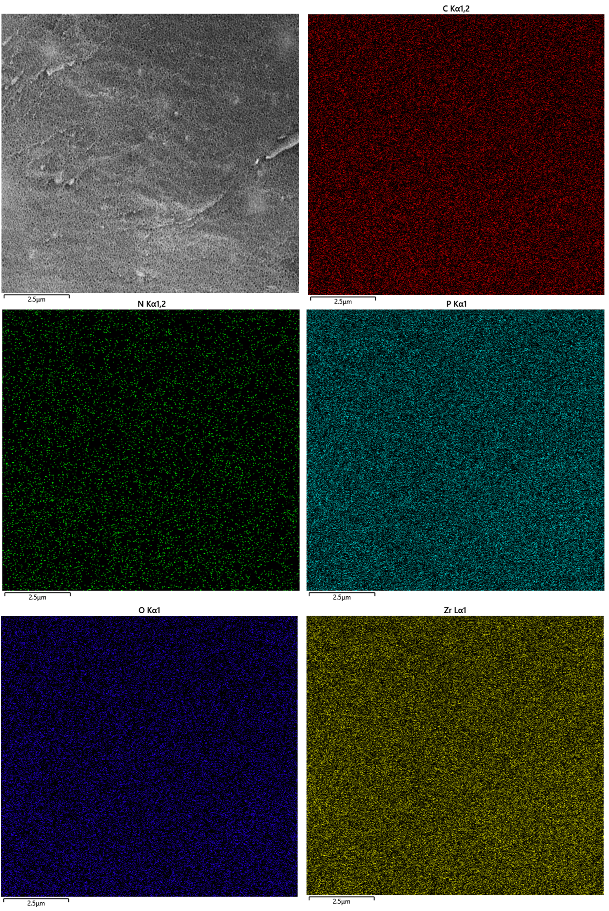
Fig. S3. | Elemental distribution map. EDS elemental distribution maps of the YSZs–70 membrane obtained under cryogenic conditions.
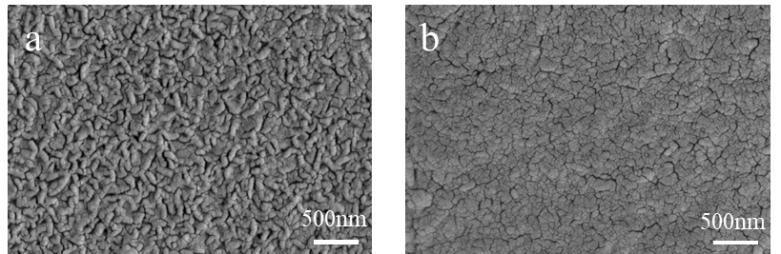
Fig. S4. | Cryo–SEM of the wet YSZs-70 membranes: (a) upper epidermal layer (air-contact side); (c) lower epidermal layer (glass-contact side).

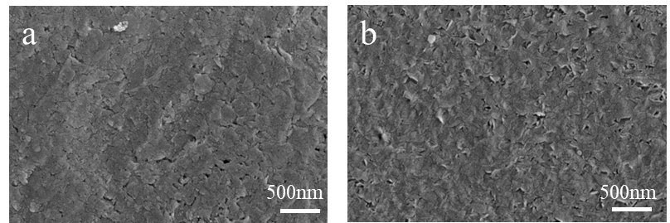
Fig. S5. | Cryo–SEM of the wet YSZs-40 membranes: (a) upper epidermal layer (air-contact side); (b) lower epidermal layer (glass-contact side).
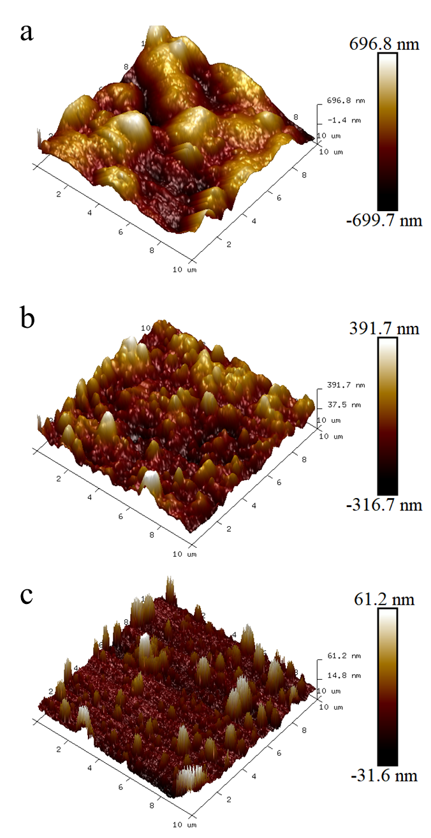
Fig. S6. | Surface images of the dried membranes: AFM image of the dried (a) YSZs-70; (b) YSZs-40; (c) G–PBI membrane.

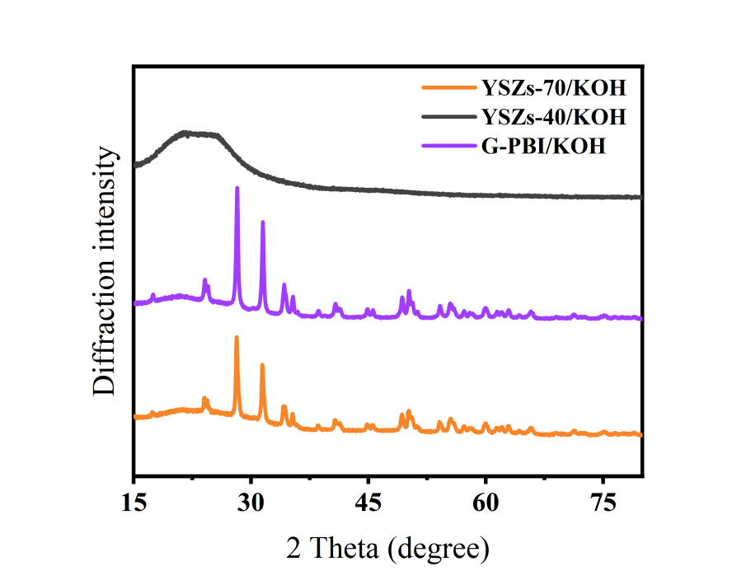
Fig. S7 | XRD patterns. XRD patterns of different dried KOH–doped membranes.

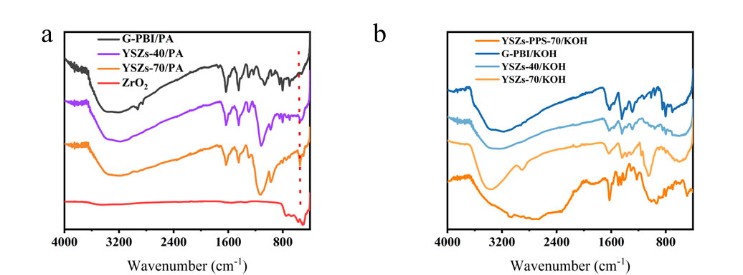
Fig. S8 | FTIR spectra|. FTIR spectra of different dried membranes and ZrO₂.

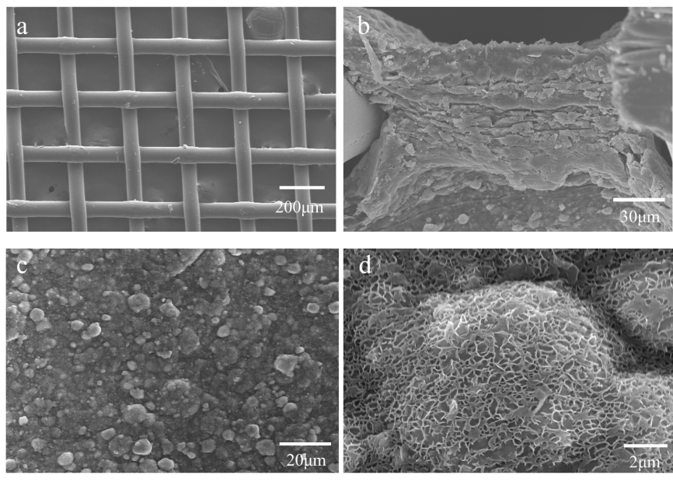
Fig. S9 | SEM of YSZs–PPS–70 membrane. SEM Image of (a) PPS mesh; (b) Cross–section of the YSZs–PPS–70 membrane after freeze–drying; and (c) and (d) the surface of the YSZs–PPS–70 membrane after freeze–drying.
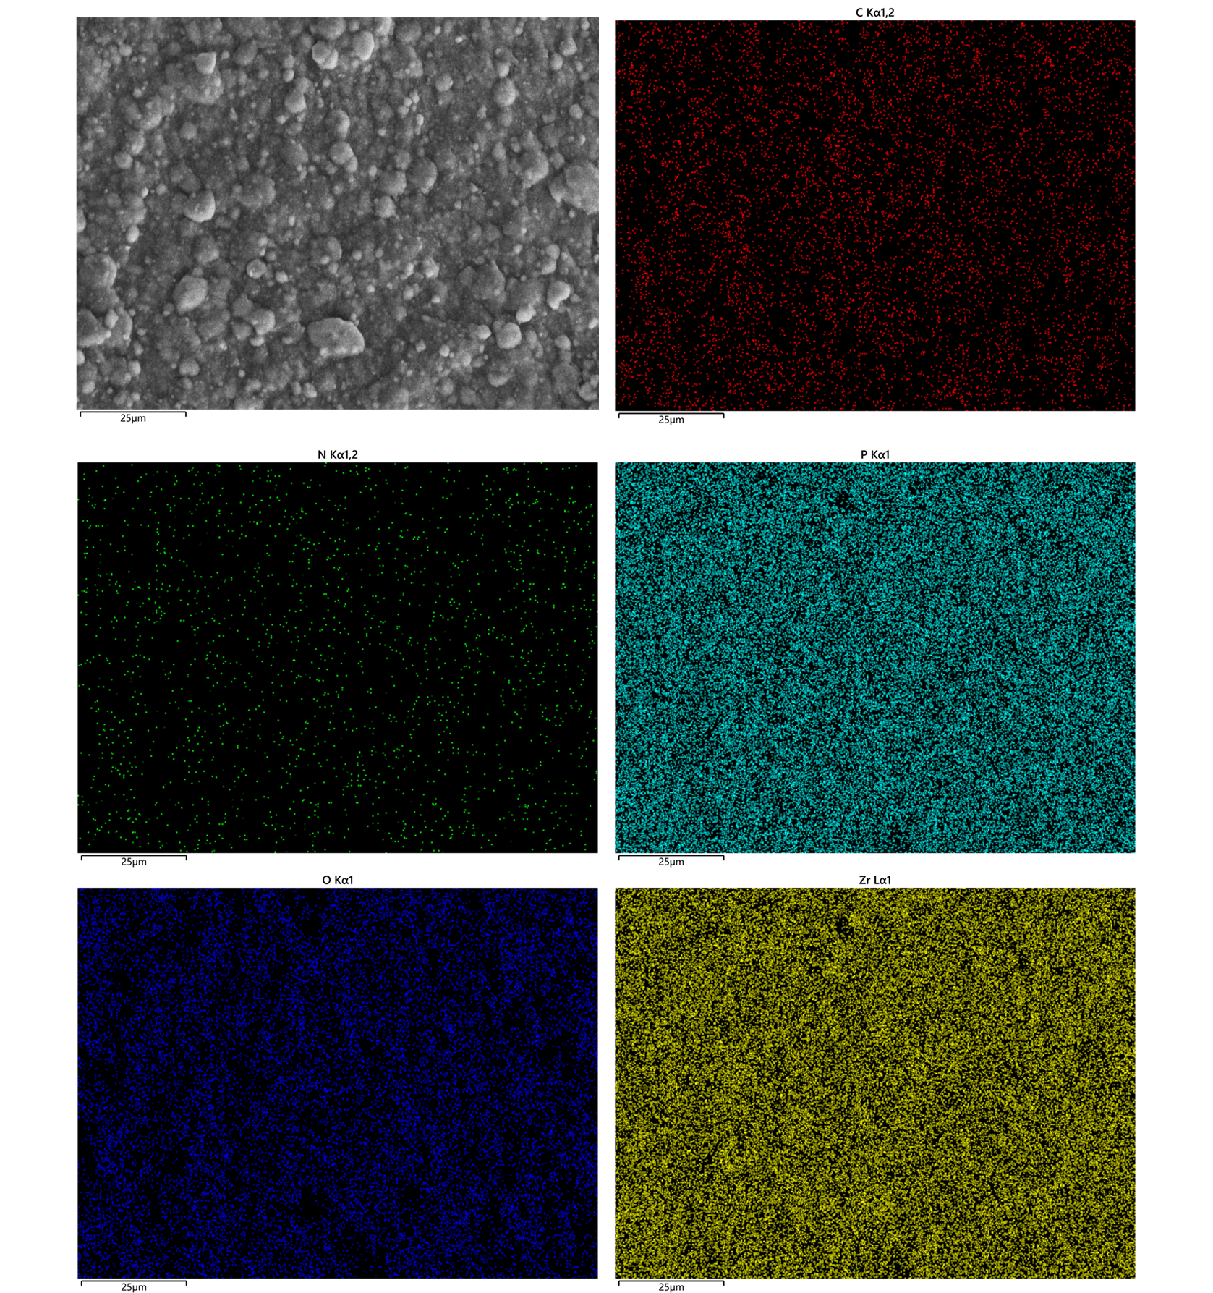
Fig. S10 | Elemental distribution. EDS elemental distribution maps of the dried YSZs–PPS–70 membrane.
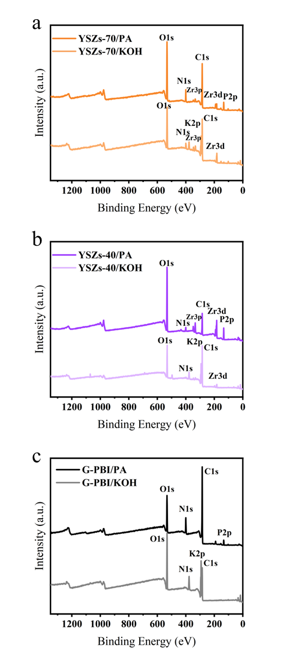
Fig. S11 | XPS survey spectra of different membranes. Samples containing PA were repeatedly washed with deionized water and then dried, whereas samples containing KOH were dried after being soaked in KOH solution.
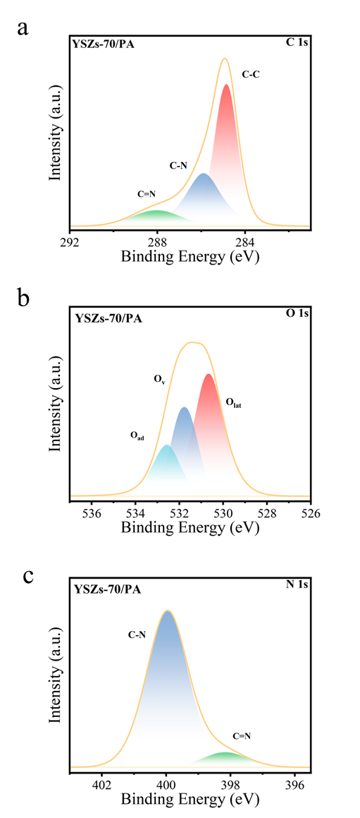
Fig. S12 | Surface characterization. XPS survey scan of the dried YSZs–70/PA (after substantial PA removal by soaking and washing)

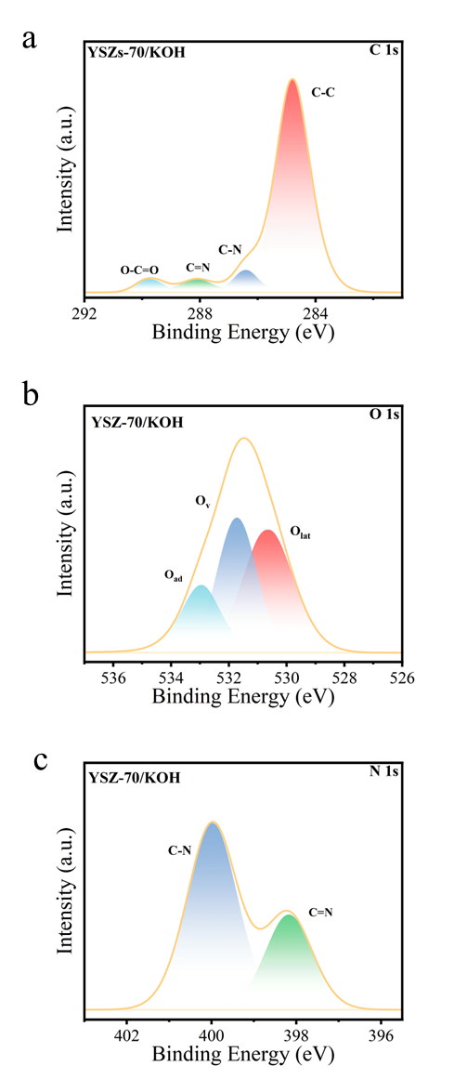
Fig. S13 | Surface characterization. XPS survey scan of the dried YSZs–70/KOH (after KOH treatment).
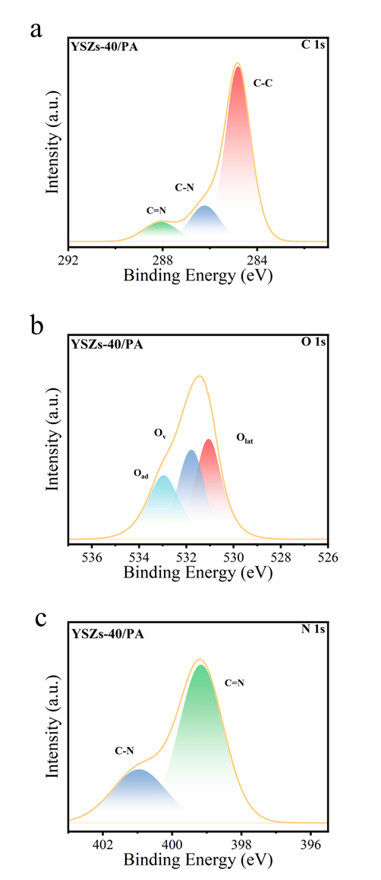
Fig. S14 | Surface characterization. XPS survey scan of the dried YSZs–40/PA (after substantial PA removal by soaking and washing).
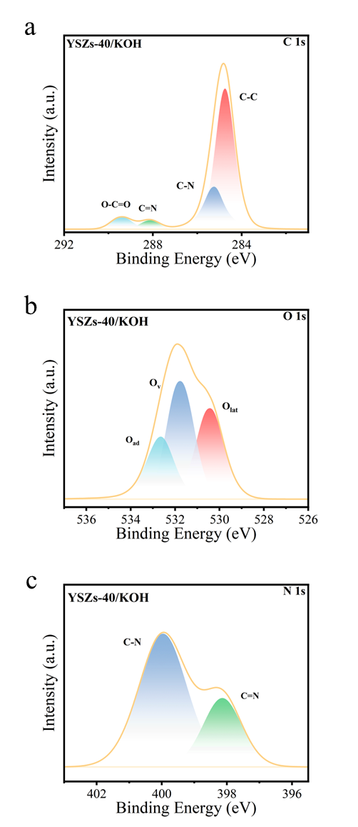
Fig. S15 | Surface characterization. XPS survey scan of the dried YSZs–40/KOH (after KOH treatment).

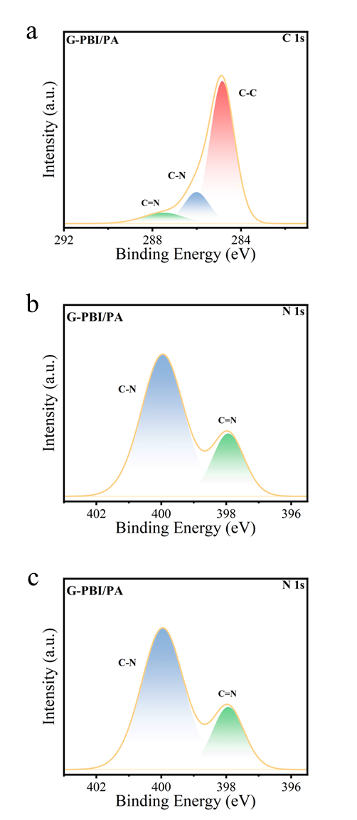
Fig. S16 | Surface characterization. XPS survey scan of the dried G–PBI/PA (after substantial PA removal by soaking and washing).
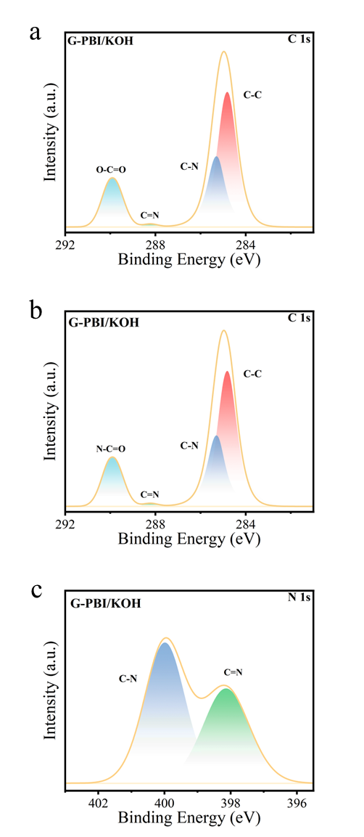
Fig. S17 | Surface characterization. XPS survey scan of the dried G–PBI/KOH (after KOH treatment).
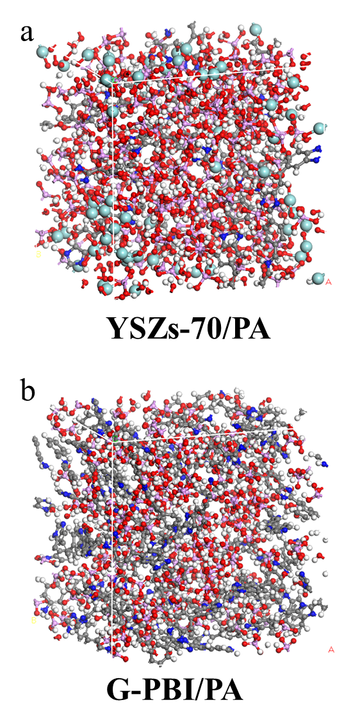
Fig. S18 | Illustration of the molecular dynamics (MD) models: (a) YSZs–70/PA; (b) G–PBI/PA.
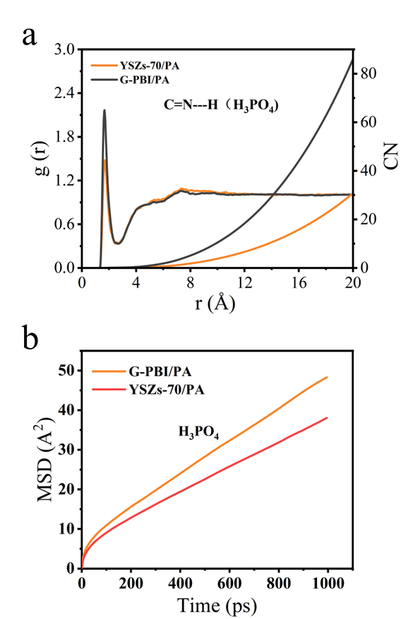
Fig. S19 | Simulation Calculation. (a) Radial distribution functions (RDF) and coordination numbers (CN) of hydrogen bonding between the C=N group of the imidazole ring and PA molecules. (b) PA diffusion coefficient of YSZs–70 and G–PBI containing PA.

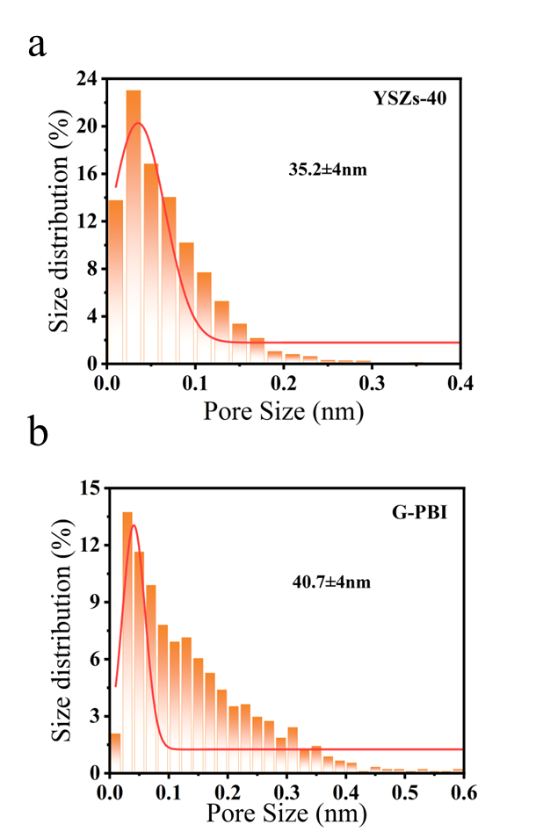
Fig. S20 | Pore size distribution analysis. Pore size distribution of the wet YSZs–40 and G–PBI membranes, determined from the Cryo–SEM images in Figure 1 using ImageJ software.

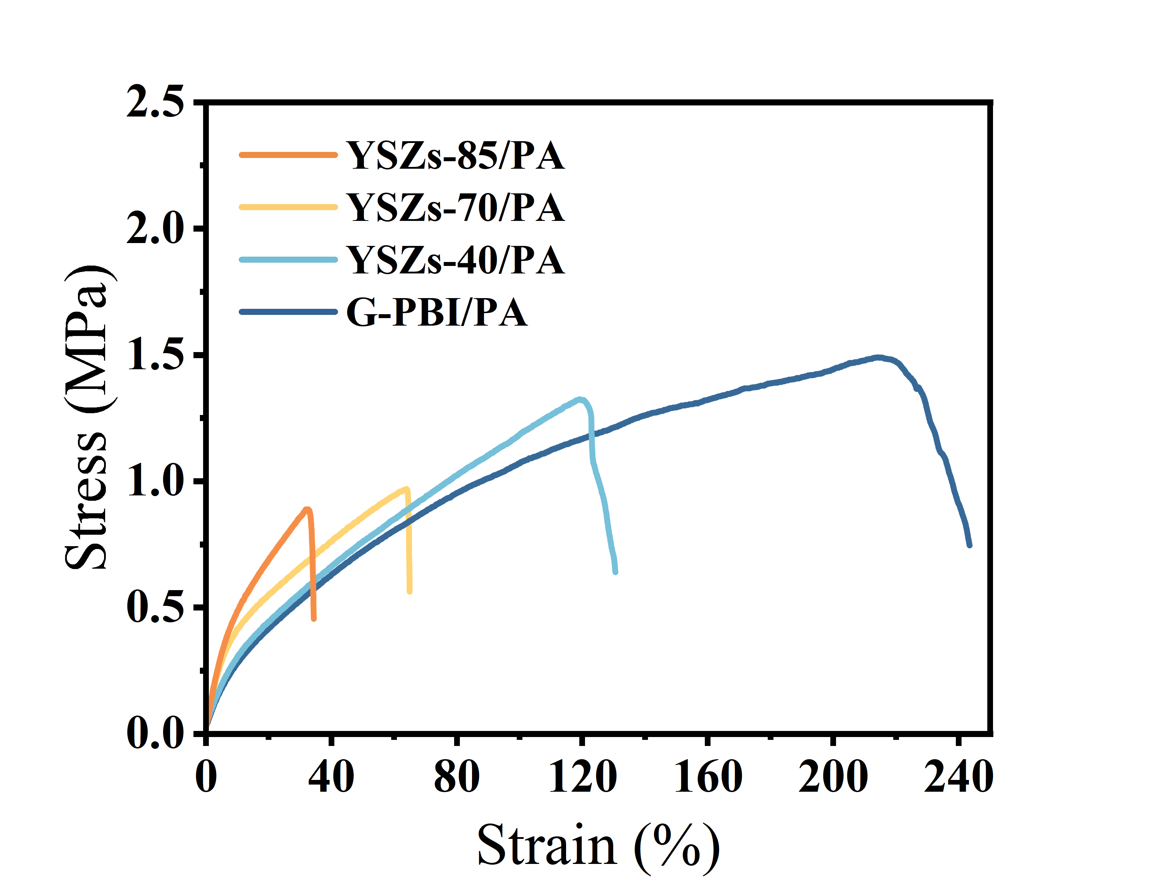
Fig. S21 | Mechanical strength. Tensile stress-strain curves of the membranes containing trace amounts of PA (after substantial PA removal by soaking and washing).

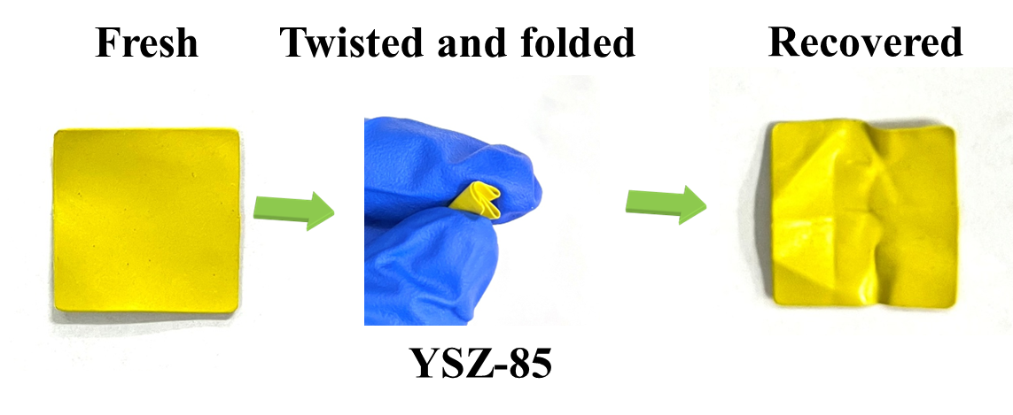
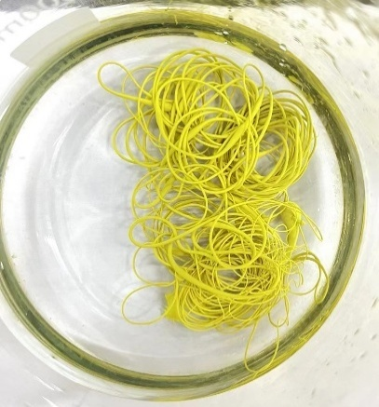
Fig. S22 | Visual images of membranes. Image of YSZs-85 membrane after twisting and folding. When the YSZs-85 casting solution is poured into water, it forms continuous filament-like strands and maintains toughness without breaking.
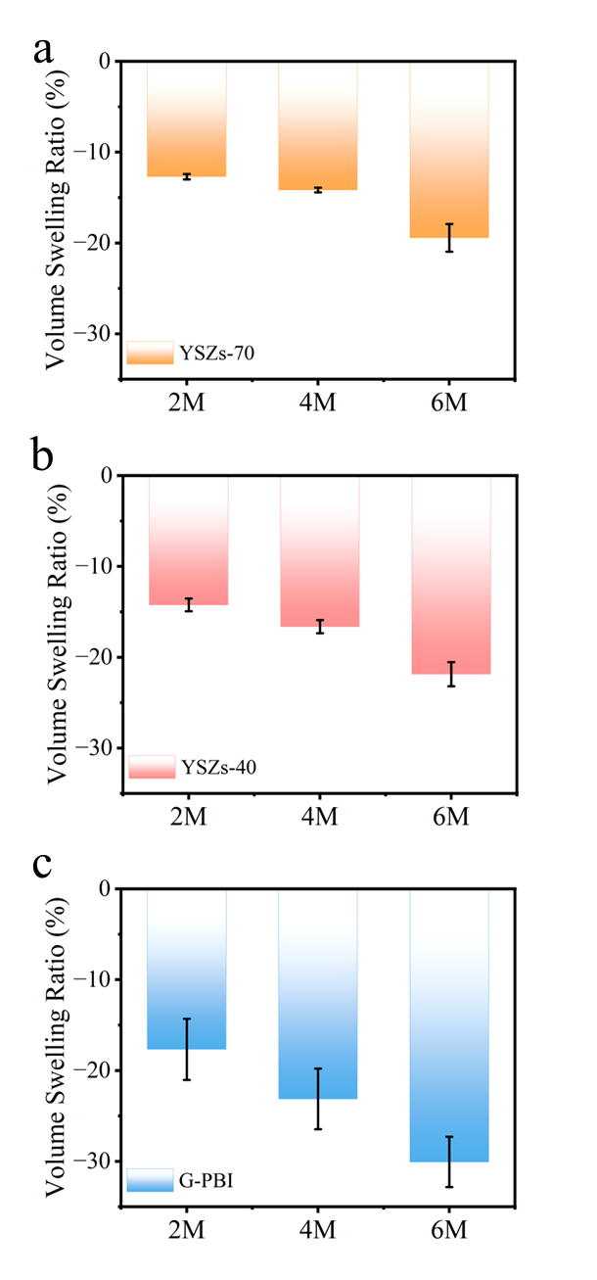
Fig. S23 | Swelling ratio. Volume swelling ratio of different membrane.

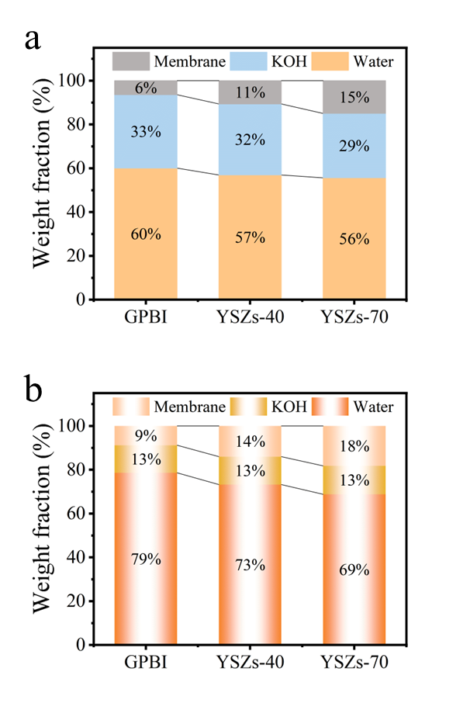
Fig. S24 | Weight fraction in alkaline environments. Weight fraction of each component after absorbing (a) 6M KOH; (b) 2M KOH.

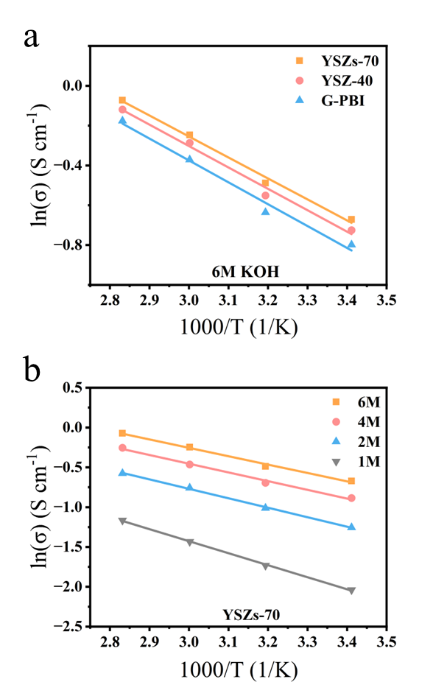
Fig. S25 | Arrhenius plots of ionic conductivity. (a) Activation energies of the membranes at 6M KOH concentrations; (b) Activation energies of the YSZs-70 membranes at different KOH concentrations, derived from Arrhenius plots.
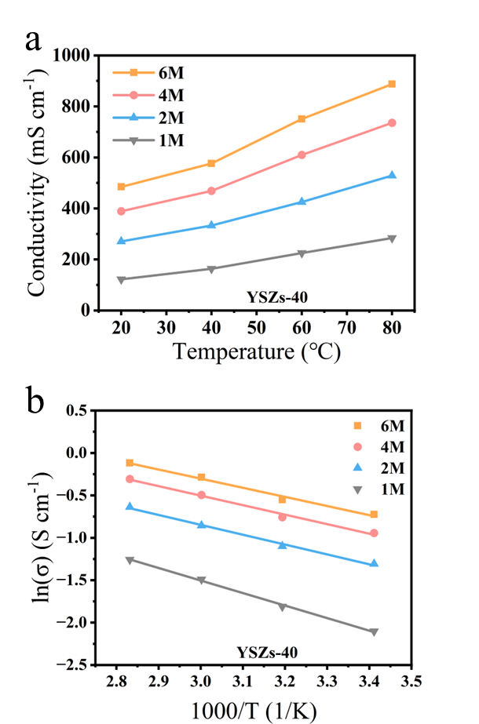
Fig. S26 | Ionic conductivity. Ionic conductivity and corresponding activation energies of YSZs–40 membranes at different KOH concentrations, derived from Arrhenius plots.
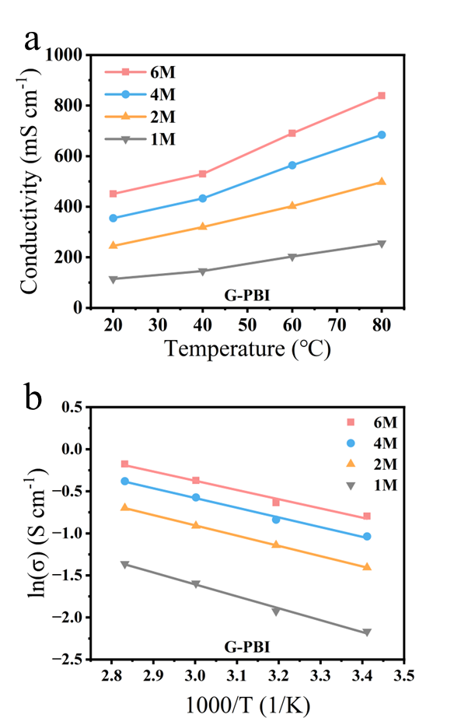
Fig. S27 | Ionic conductivity. Ionic conductivity and corresponding activation energies of G-PBI membranes at different KOH concentrations, derived from Arrhenius plots. 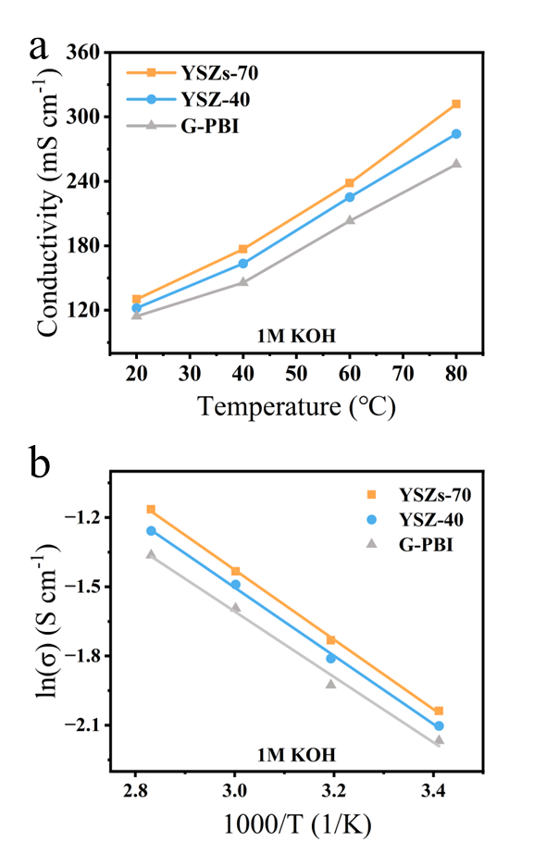
Fig. S28 | Ionic conductivity. Ionic conductivity and corresponding activation energies of the membranes at 1M KOH concentrations, derived from Arrhenius plots.
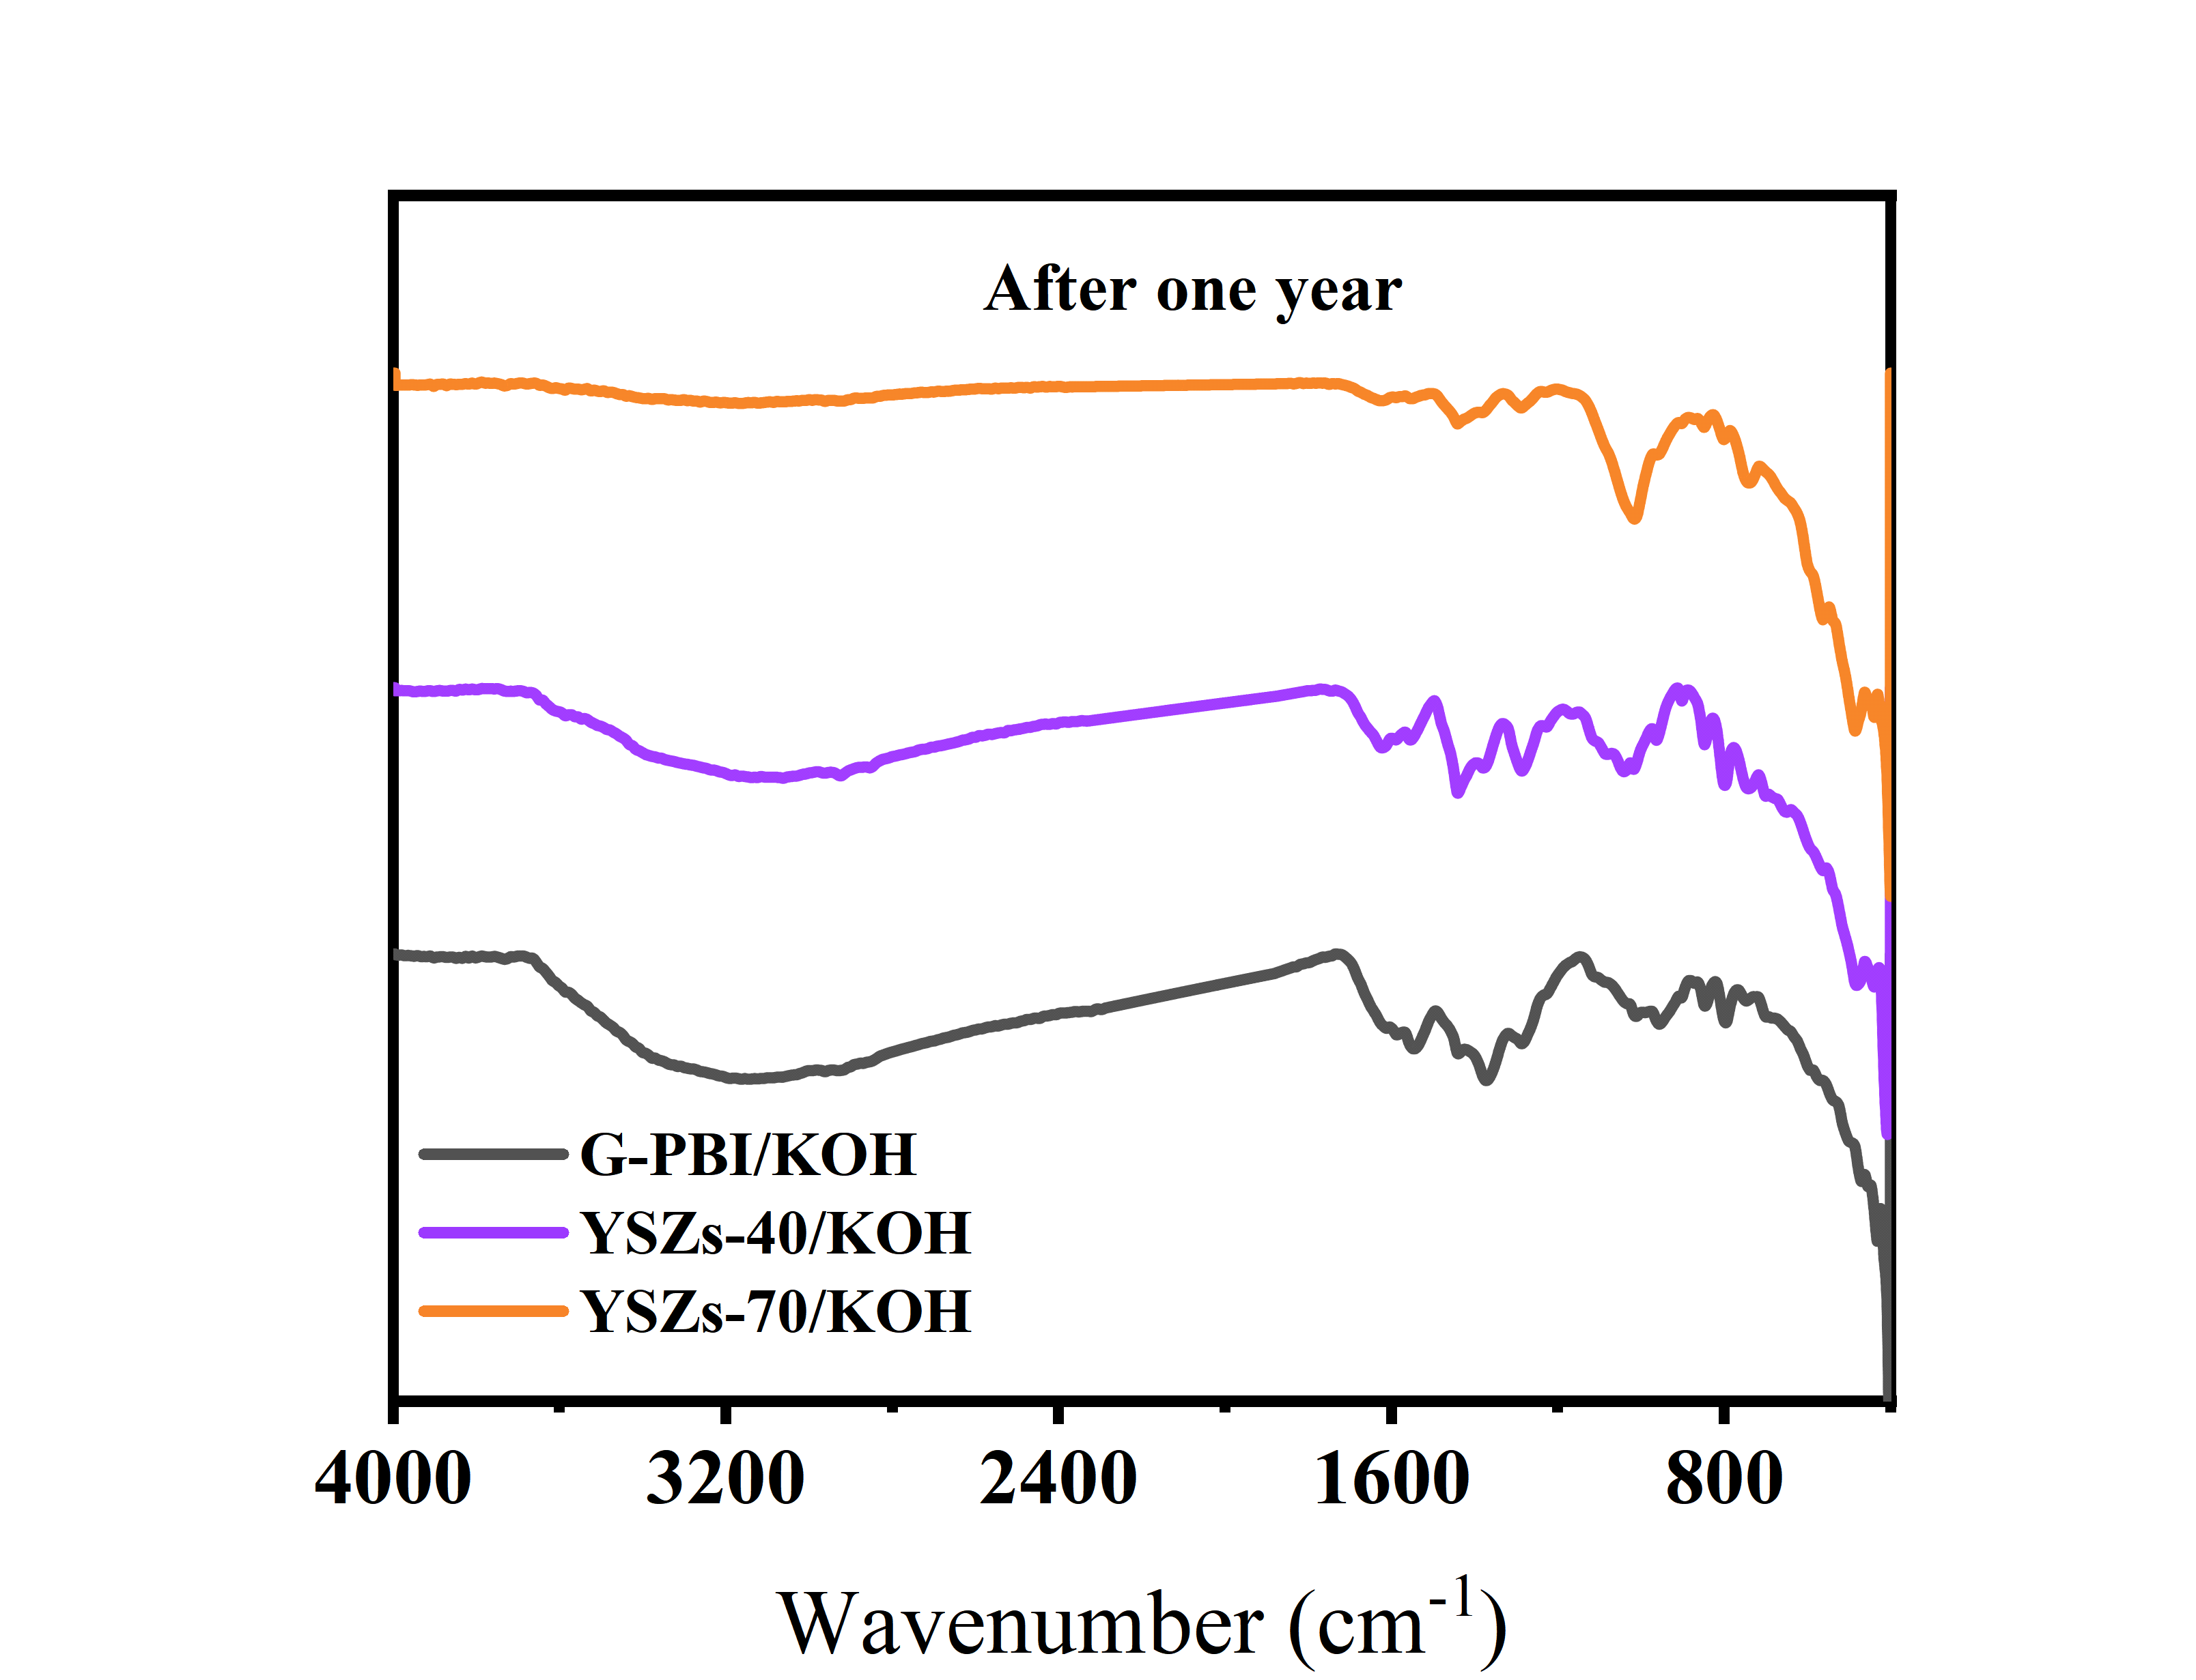
Fig. S29 | FTIR spectra. FTIR spectra of different membranes after soaking in 6M KOH for one year at room temperature.

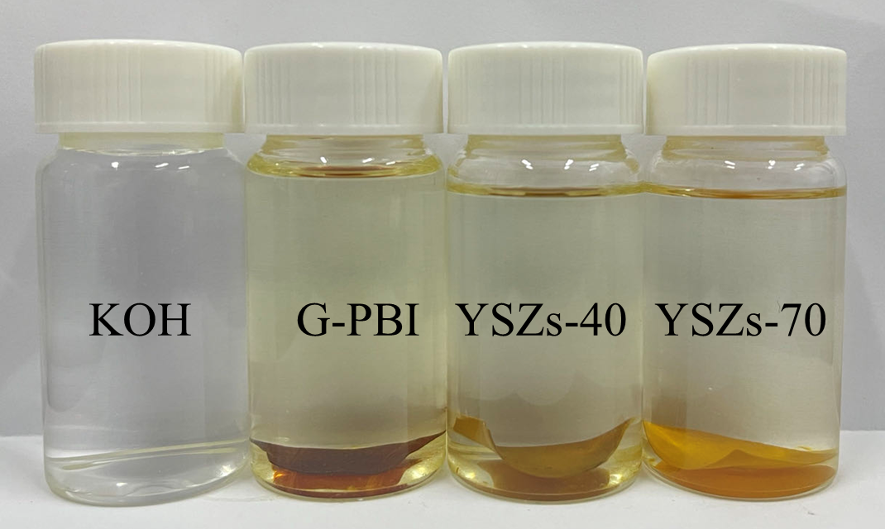
Fig. S30 | Photo of membrane. Photo of the membrane after one-year immersion in KOH solution.
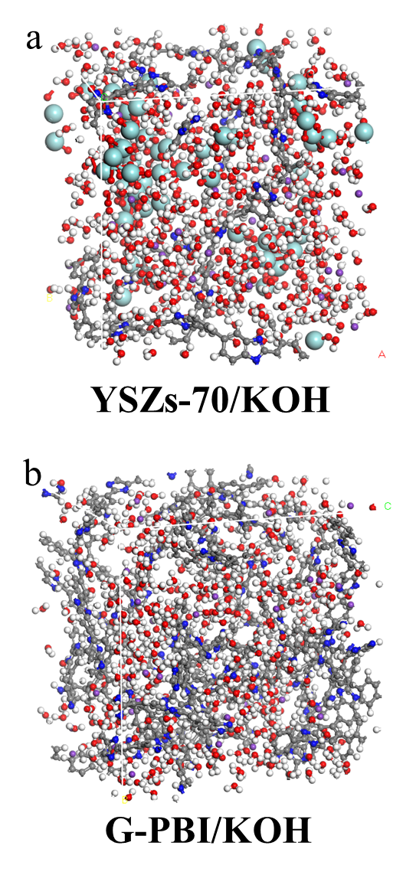
Fig. S31 | Illustration of the molecular dynamics (MD) models: a) YSZs–70/KOH; (b) G–PBI/KOH.

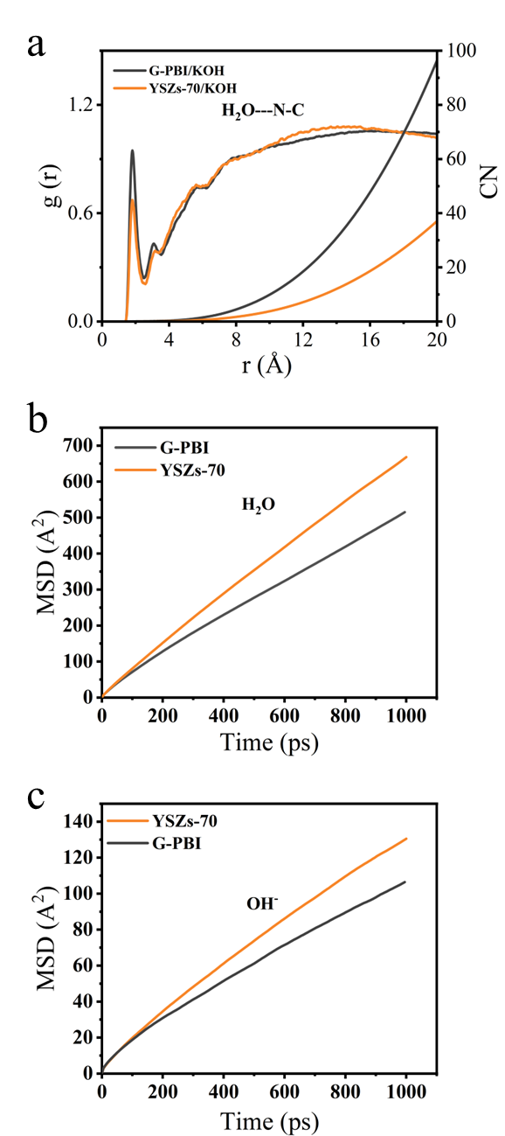
Fig. S32 | Simulation Calculation and diffusion coefficients of water and hydroxide ion. (a) Radial distribution functions (RDF) and coordination numbers (CN) of hydrogen bonds between H₂O and C–N. (b) H₂O diffusion coefficient in YSZs–70 and G–PBI Containing PA. (c) OH– diffusion coefficient of YSZs–70 and G–PBI containing PA.
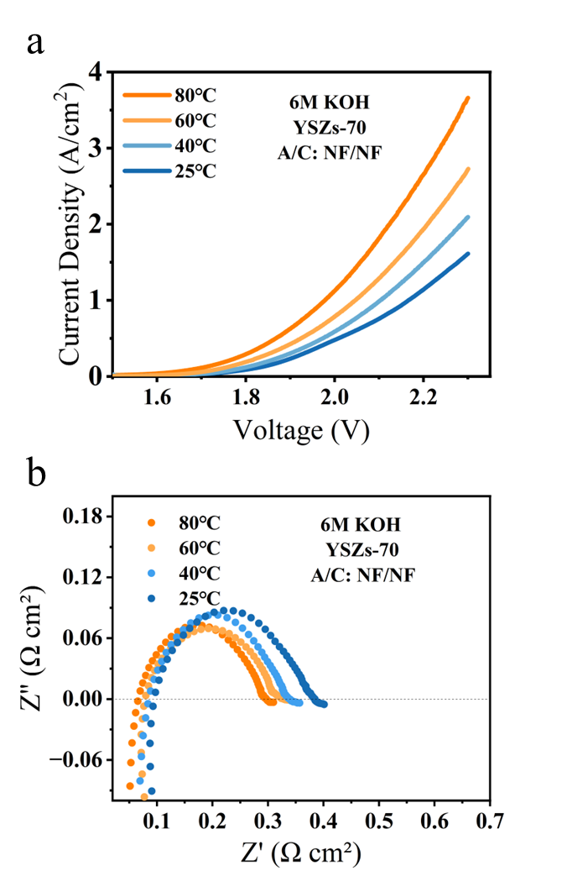
Fig. S33 | Electrochemical performance and EIS analysis. (a) Polarization curves of YSZs–70 membrane with Ni foam/Ni foam electrodes in 6 M KOH; (b) EIS of the membrane at different temperatures at a current density of 500 mA cm⁻².
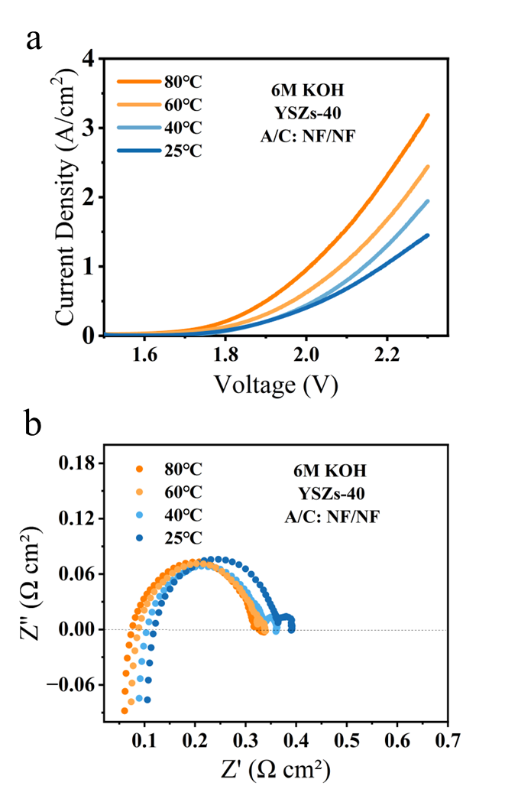
Fig. S34 | Electrochemical performance and EIS analysis. (a) Polarization curves of YSZs–40 membrane with Ni foam/Ni foam electrodes in 6 M KOH; (b) EIS of the membrane at different temperatures at a current density of 500 mA cm⁻².
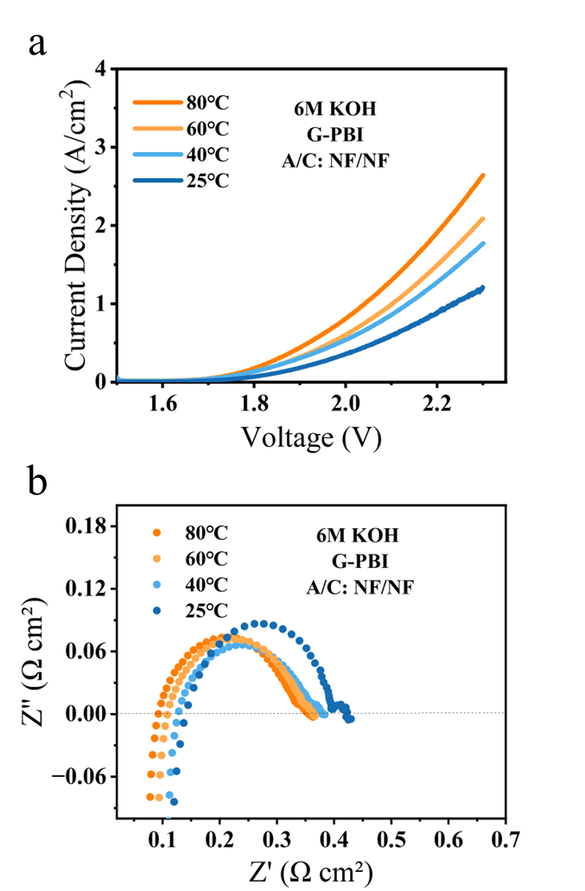
Fig. S35 | Electrochemical performance and EIS analysis. (a) Polarization curves of G–PBI membrane with Ni foam/Ni foam electrodes in 6 M KOH; (b) EIS of the membrane at different temperatures at a current density of 500 mA cm⁻².
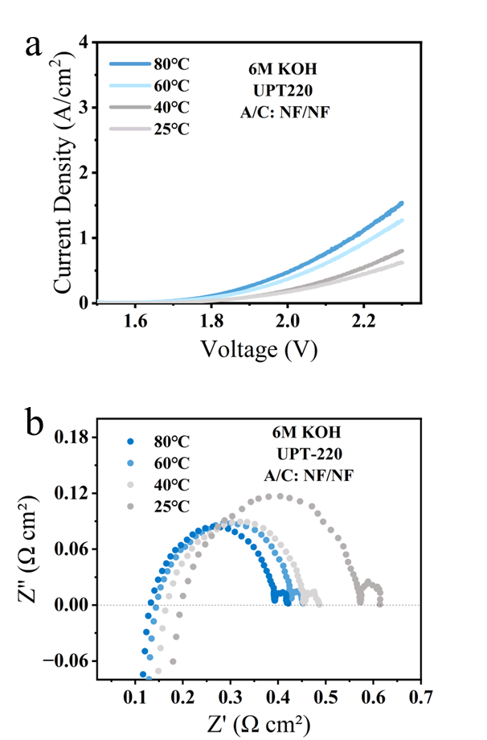
Fig. S36 | Electrochemical performance and EIS analysis. (a) Polarization curves of YSZs–PPS–70 membrane with Ni foam/Ni foam electrodes in 6 M KOH; (b) EIS of the membrane different temperatures at a current density of 500 mA cm⁻².

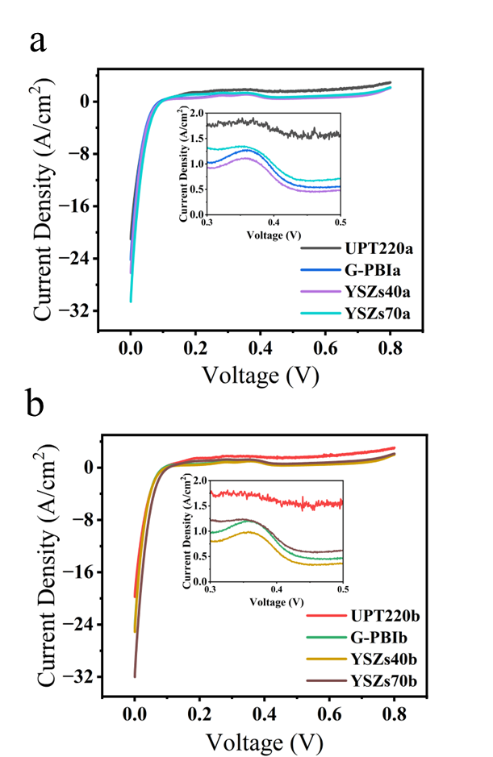
Fig. S37 | Hydrogen permeability of the membrane at different backpressures under full humidification. (a) LSV under isobaric conditions (P_{H₂} = 0.1 MPa, P_{N₂} = 0.05 MPa); (b) LSV under differential pressure conditions (P_{H₂} = P_{N₂} = 0.1 MPa).

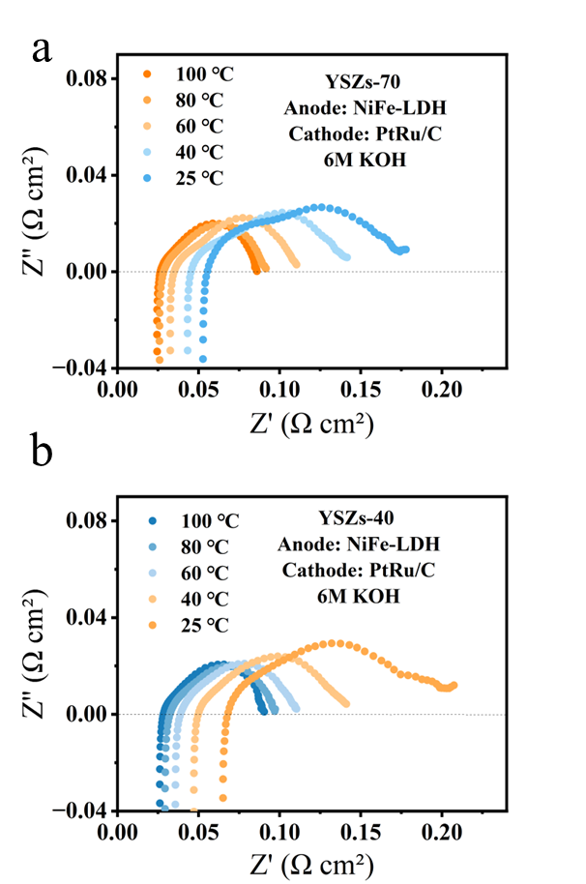
Fig. S38 | EIS analysis. EIS of YSZs–70 and YSZs–40 membranes at a current density of 500 mA cm⁻² in 6 M KOH at different temperatures.
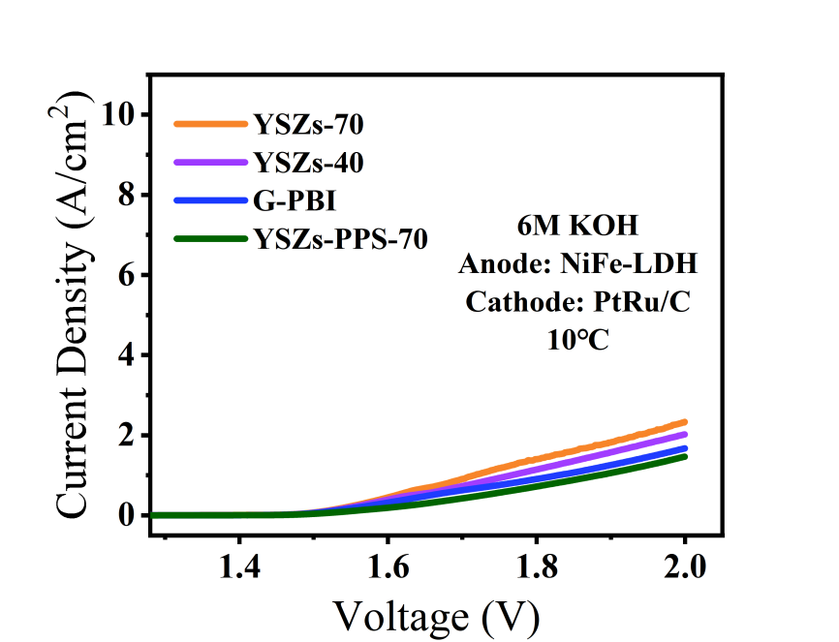
Fig. S39 | Electrochemical performance analysis. Polarization curves of different membranes with NiFe–LDH and PtRu/C electrodes in 6M KOH solutions at 10℃.

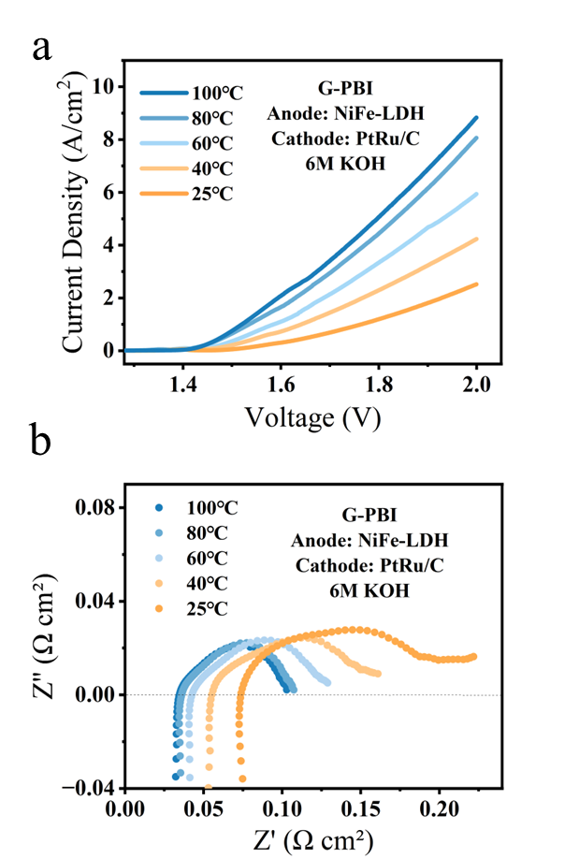
Fig. S40 | Electrochemical performance and EIS analysis. (a) Polarization curves of G–PBI membrane with NiFe–LDH and PtRu/C electrodes in 6 M KOH; (b) EIS of the membrane at different temperatures at a current density of 500 mA cm⁻².

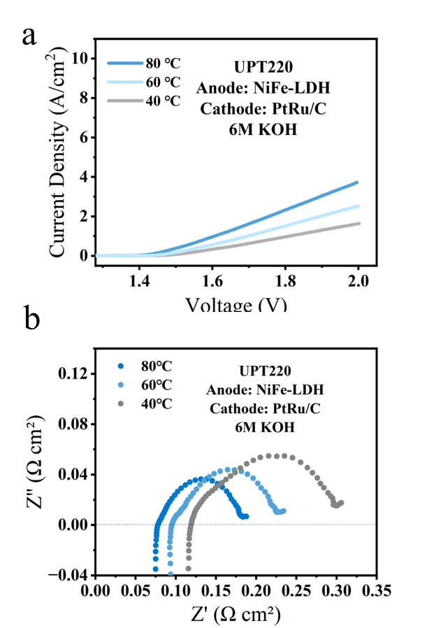
Fig. S41 | Electrochemical performance and EIS analysis. (a) Polarization curves of Zirfon UPT220 membrane with NiFe–LDH and PtRu/C electrodes in 6 M KOH; (b) EIS of the membrane at different temperatures at a current density of 500 mA cm⁻².

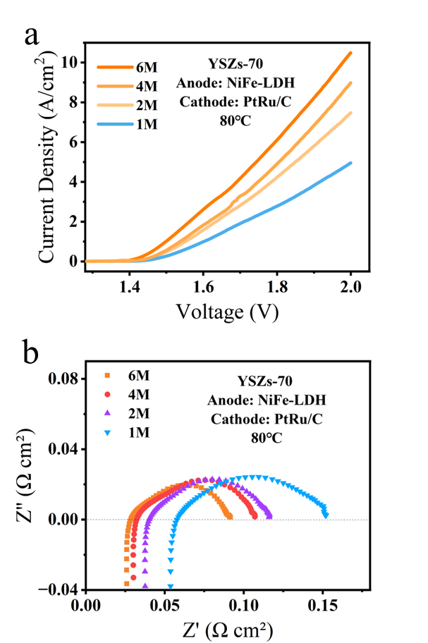
Fig. S42 | Electrochemical performance and EIS analysis. (a) Polarization curves of YSZs–70 membrane with NiFe–LDH and PtRu/C electrodes in 6 M KOH at 80°C; (b) EIS of the membrane at different temperatures at a current density of 500 mA cm⁻².

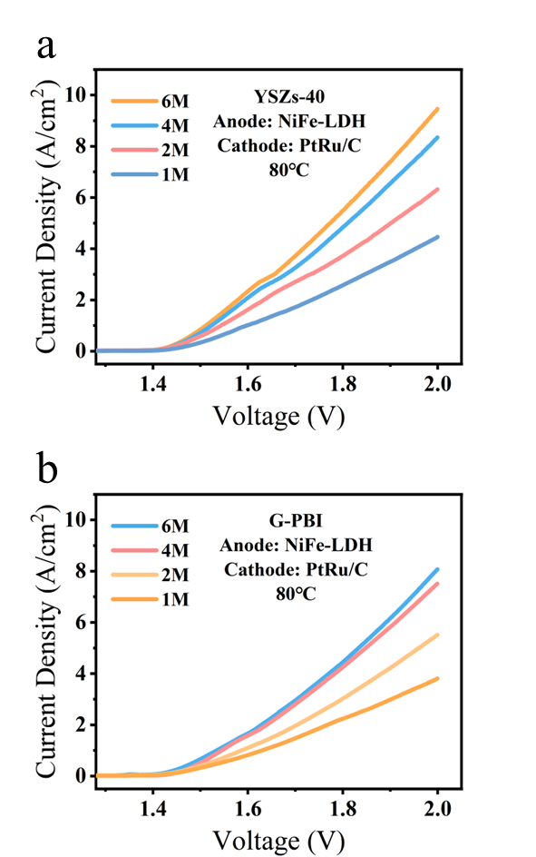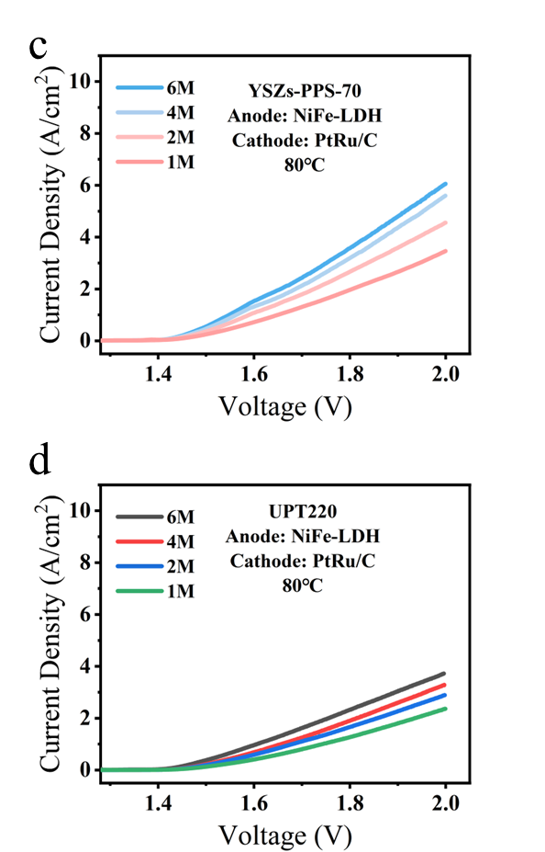
Fig. S43 | Electrochemical performance and EIS analysis. (a–d) Polarization curves of different membranes with NiFe–LDH and PtRu/C electrodes in KOH solutions of varying concentrations at 80℃.
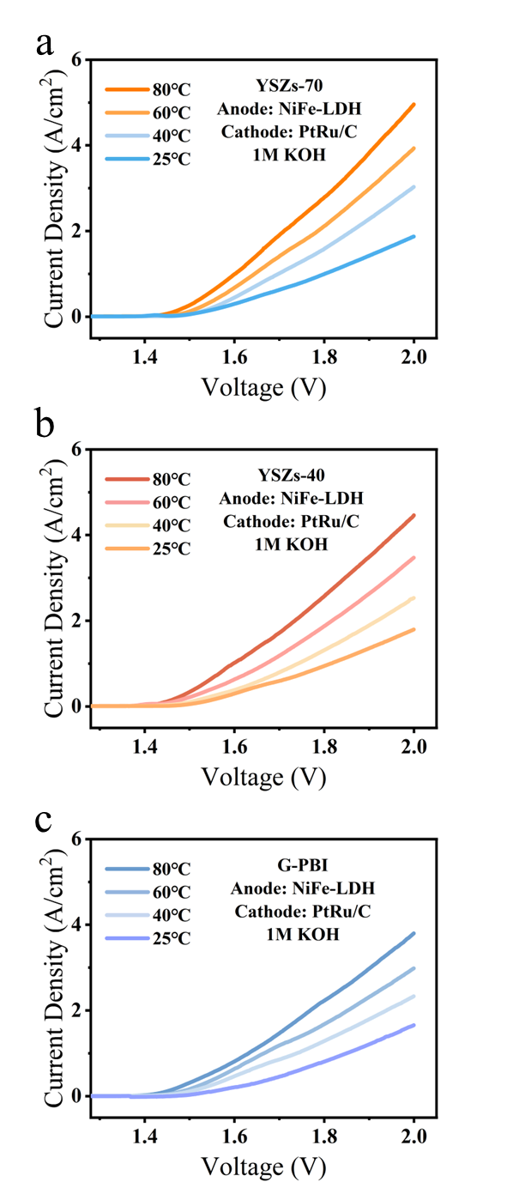
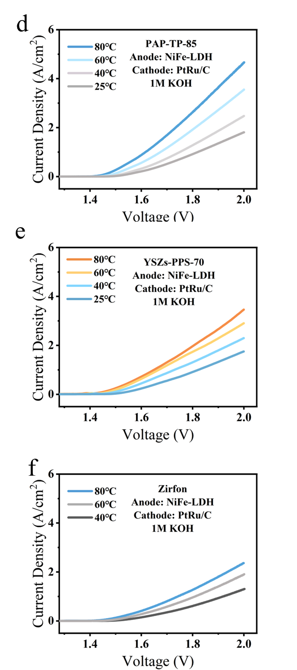
Fig. S44 | Electrochemical performance and EIS analysis. (a–e) Polarization curves of various membranes with NiFe–LDH and PtRu/C electrodes in 1 M KOH.
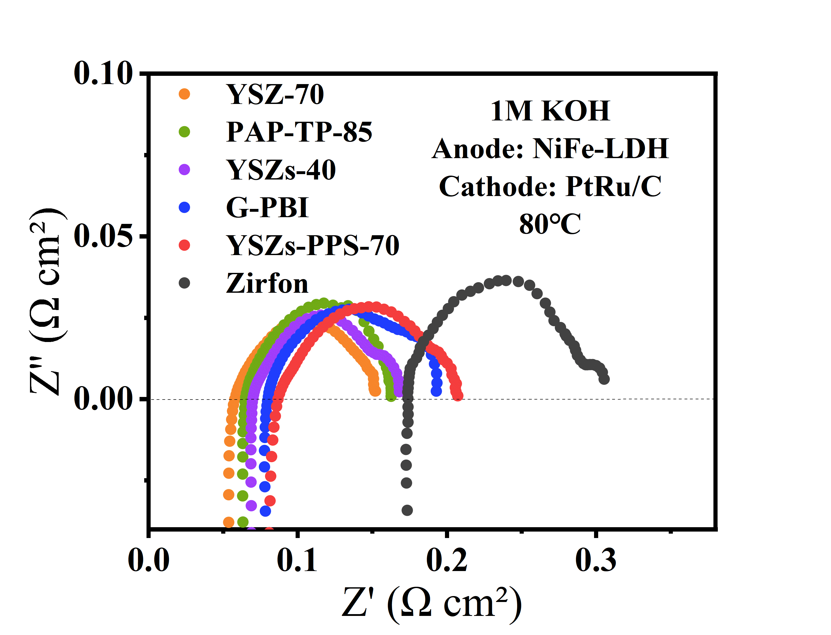
Fig. S45 | ElS analysis. EIS of different membranes with NiFe–LDH and PtRu/C electrodes in 1 M KOH at 80°C and a current density of 500 mA cm⁻².

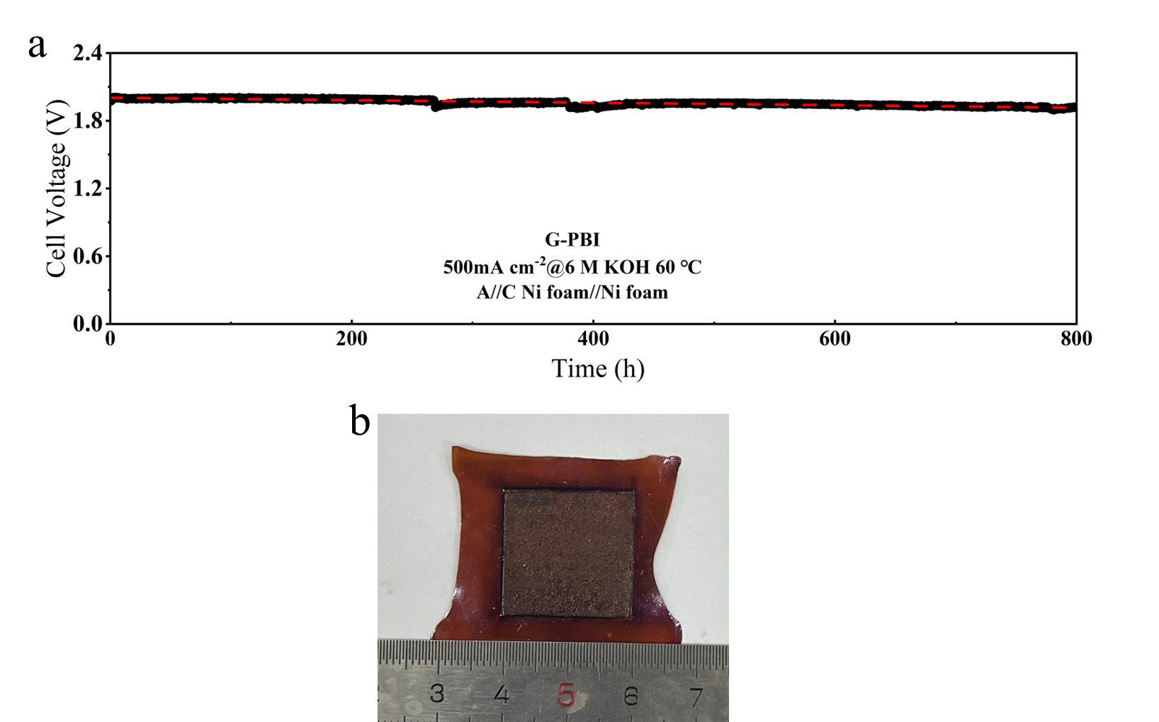
Fig. S46 | Durability and visual image after test. (a) In–situ durability of the G–PBI membrane in 6M KOH at 60°C under a constant current density of 500 mA cm⁻². (b) Photograph of the G-PBI membrane after the durability test.
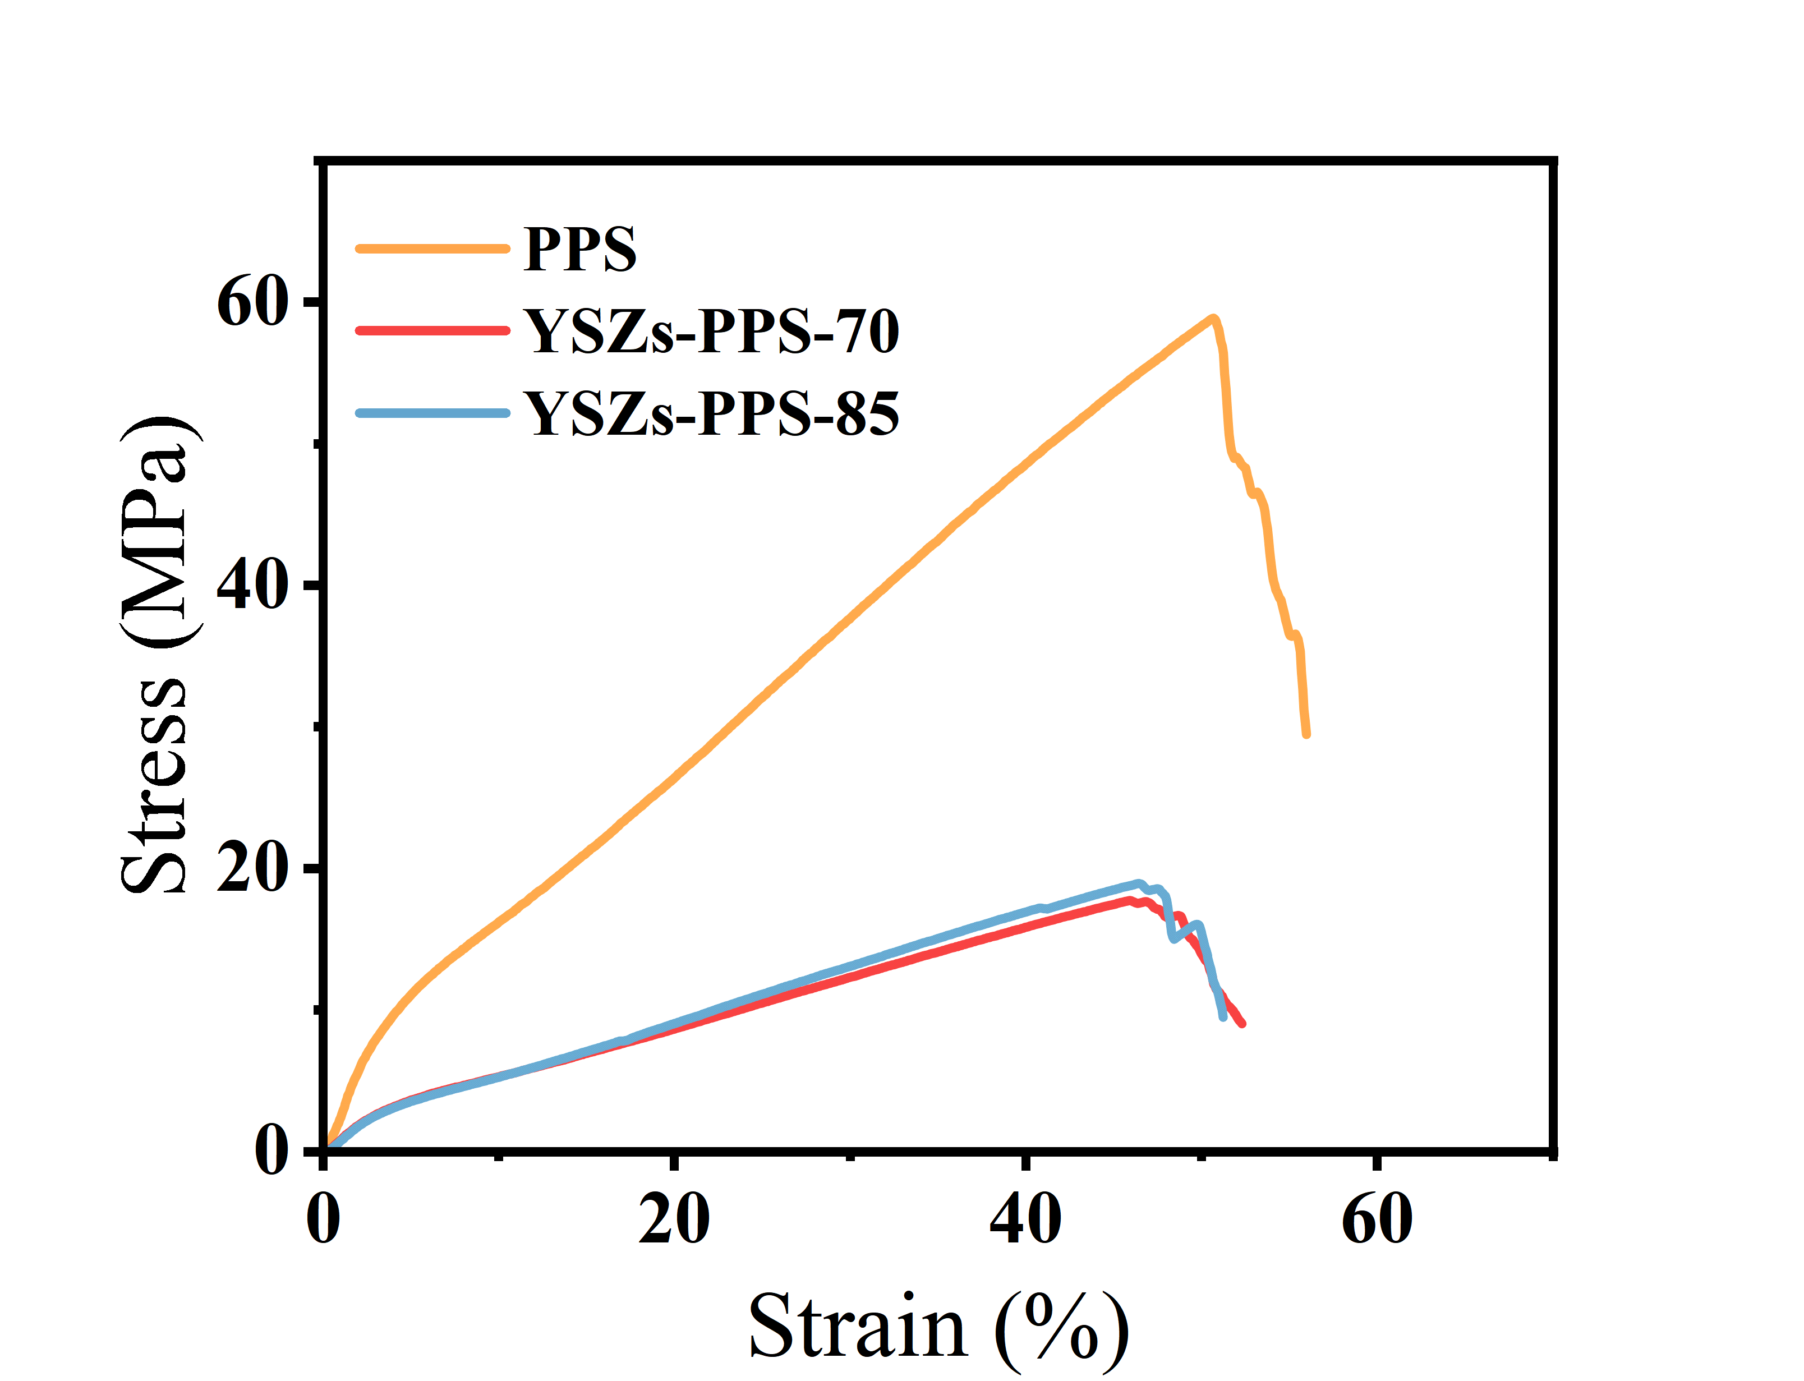
Fig. S47 | Mechanical properties. Tensile stress-strain curves of the YSZs–PPS–70 membrane and PPS mesh.

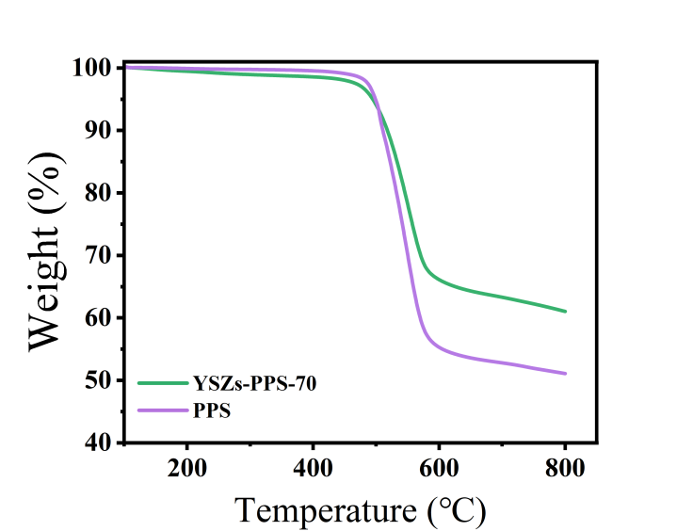
Fig. S48 | Thermal property. TGA of the membranes.

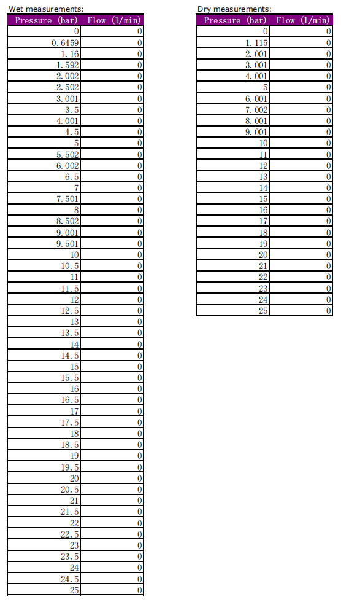
Fig. S49 | Bubble point pressure data. Graph of test data from capillary flow analyzer for YSZ-PPS-70 Membranes.
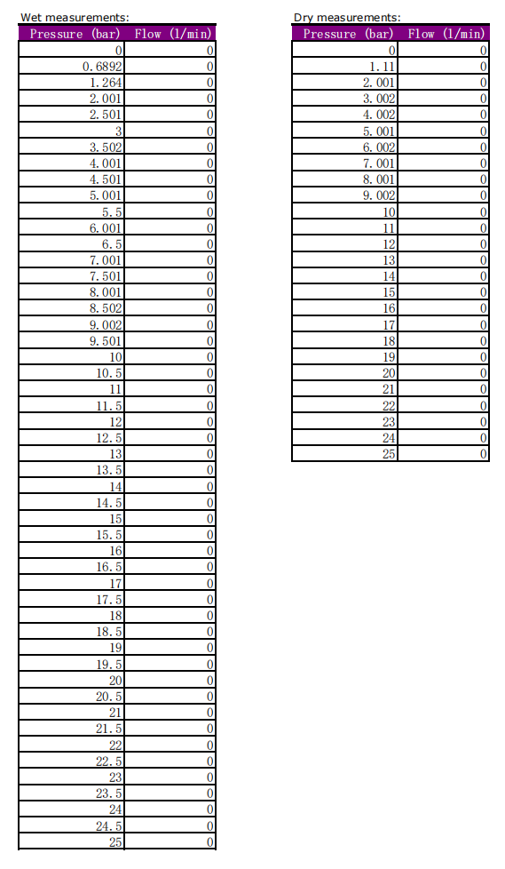
Fig. S50 | Bubble point pressure data. Graph of test data from capillary flow analyzer for YSZ-PPS-85 Membranes.
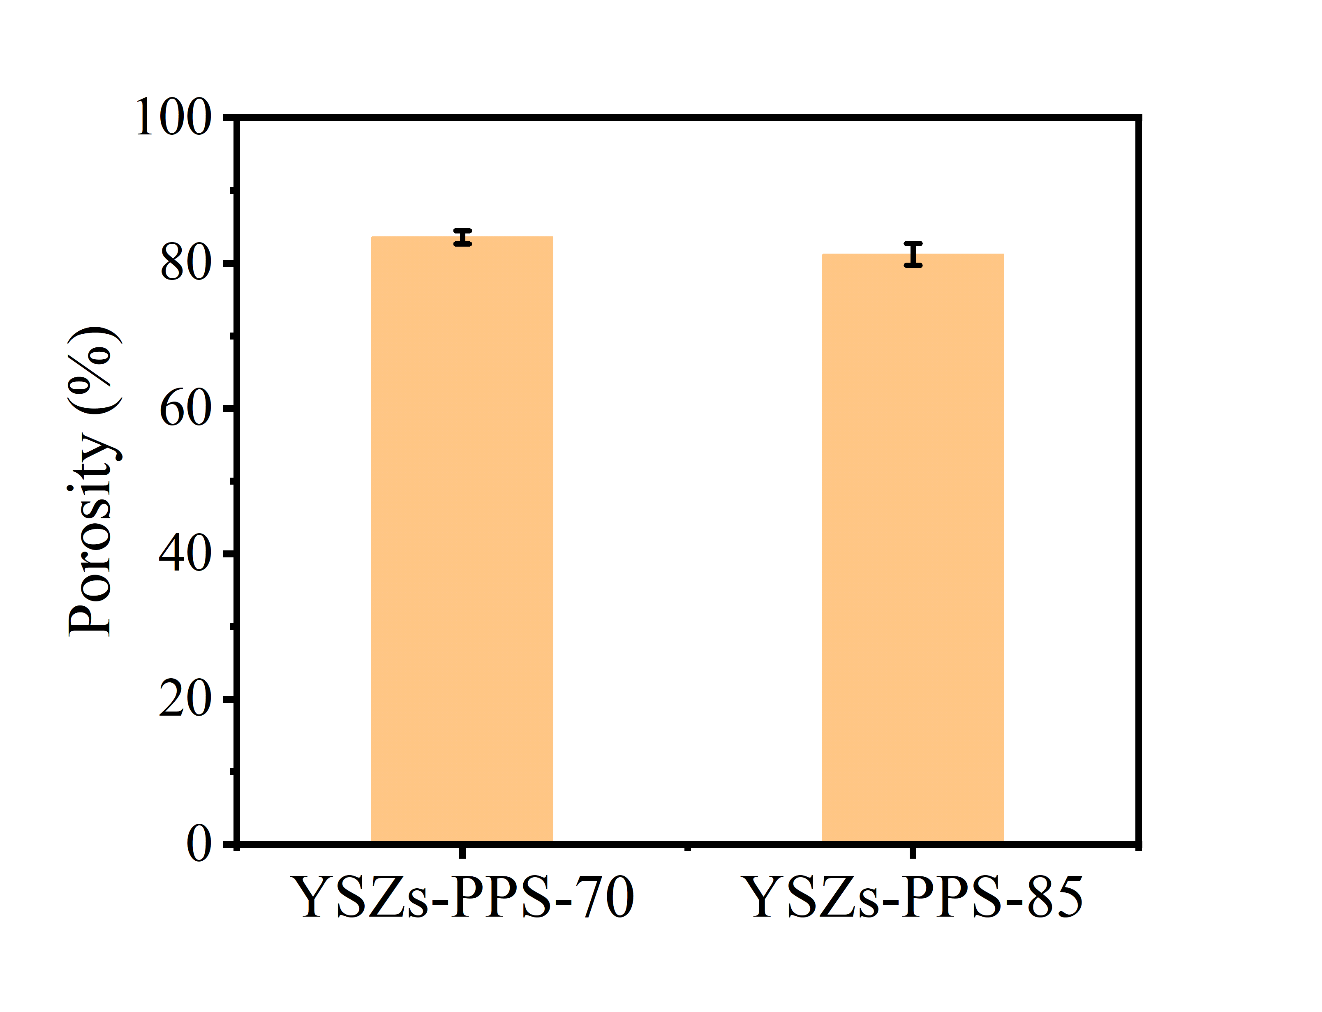
Fig. S51 | Porosity Analysis. Porosity of the YSZs–PPS–70 and YSZs–PPS–85 membrane.

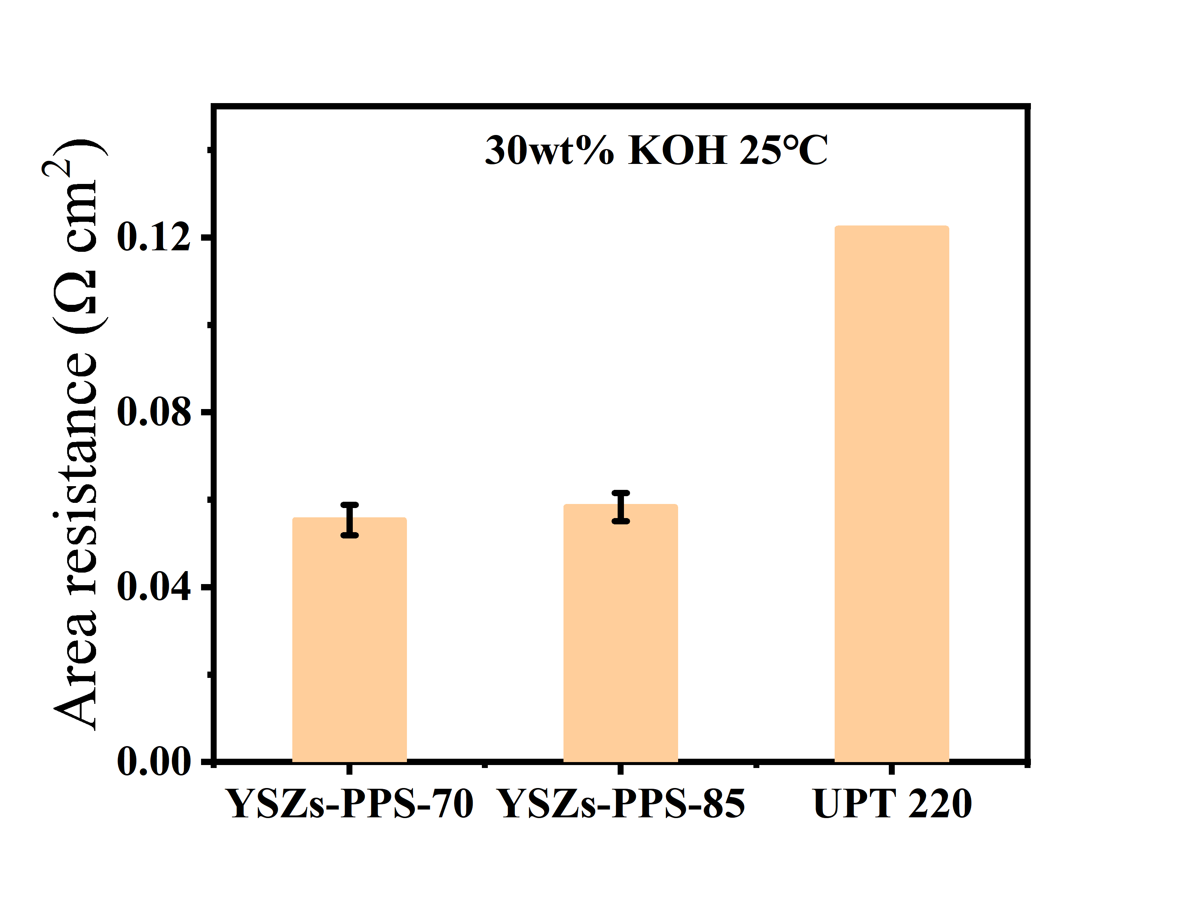
Fig. S52 | Membrane resistance. Area resistance of the membrane.
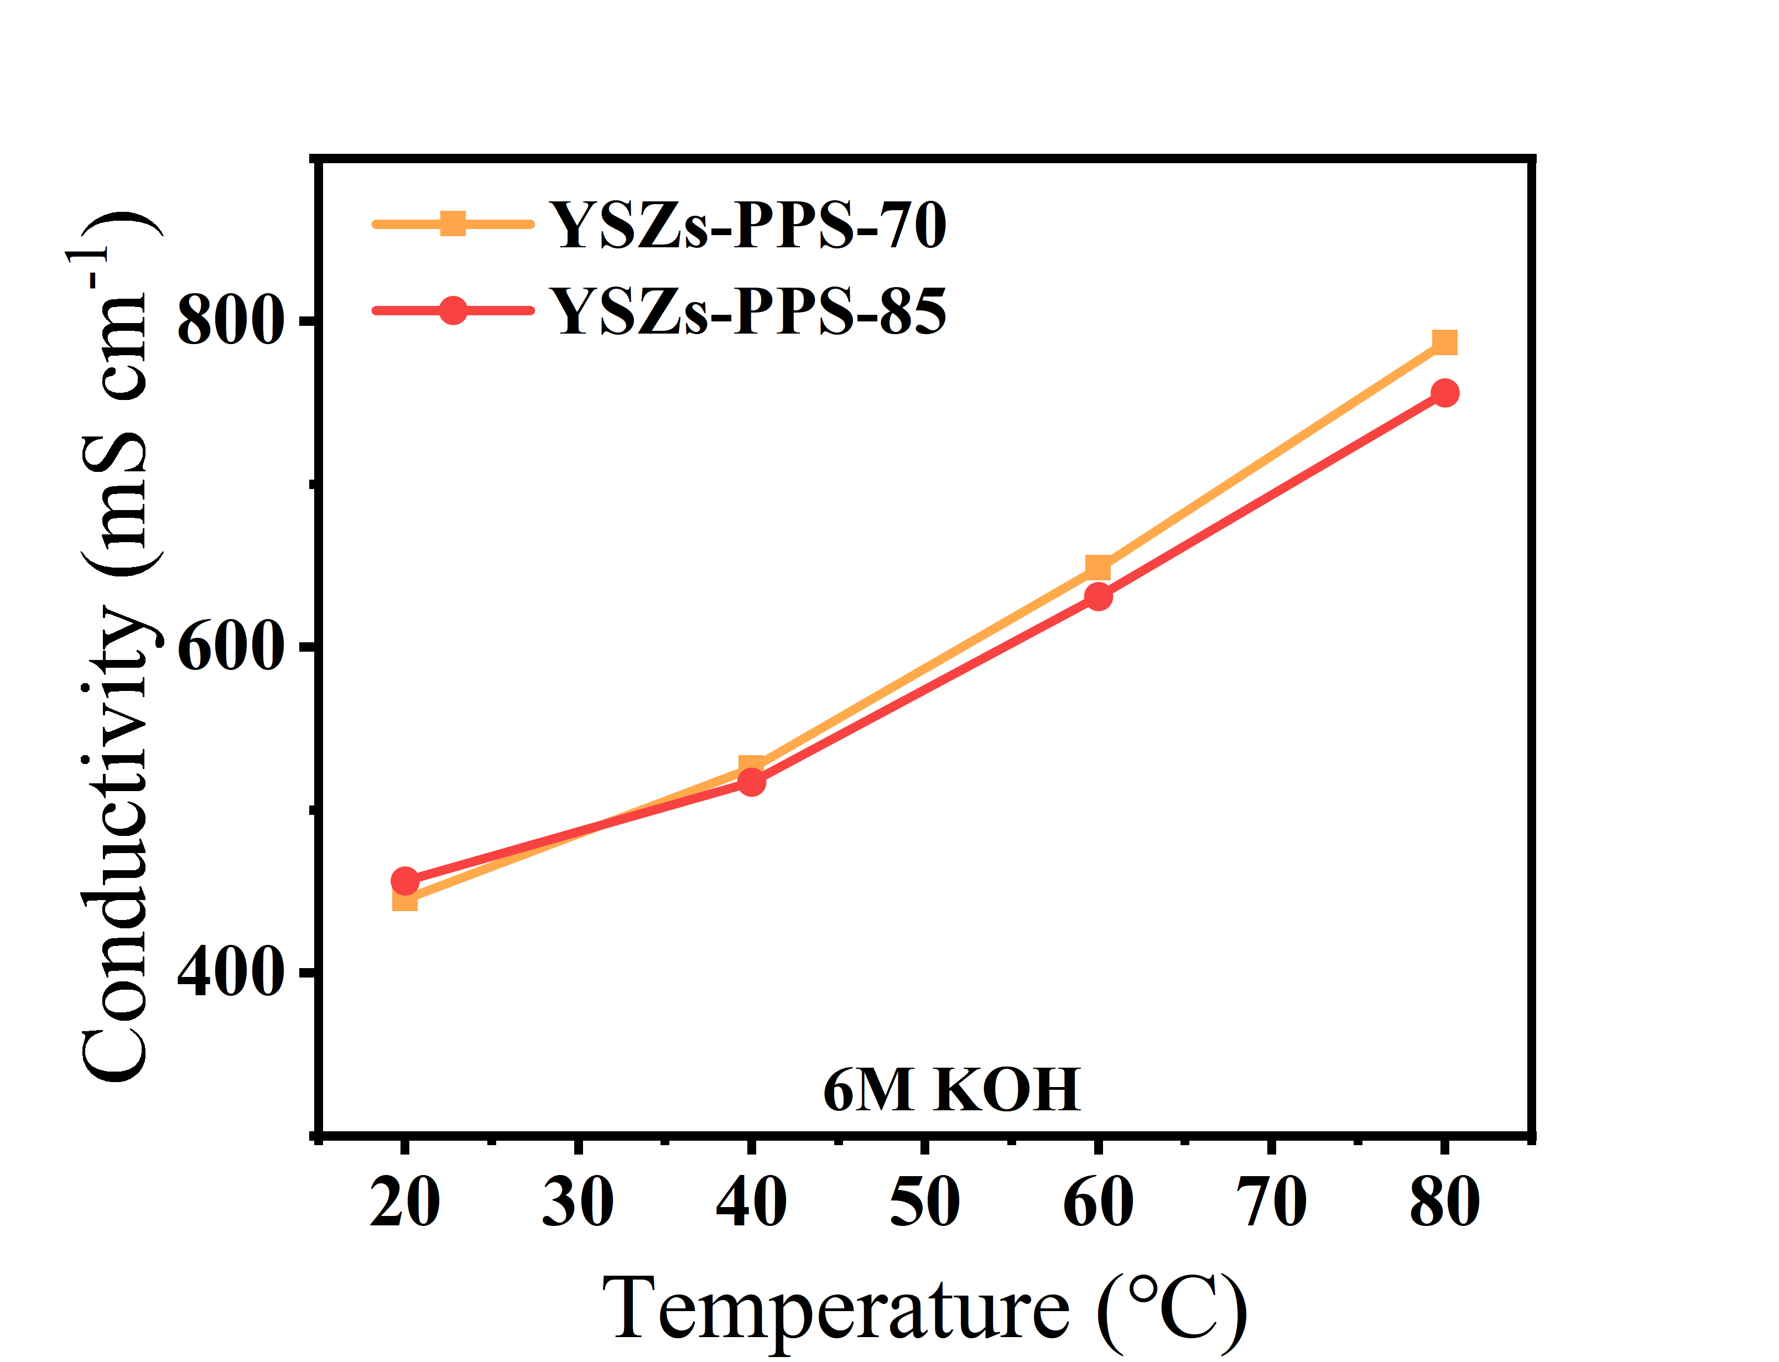
Fig. S53 | Ionic conductivity. Ionic conductivity of the YSZs–PPS–70 and YSZs–PPS–85 membrane.
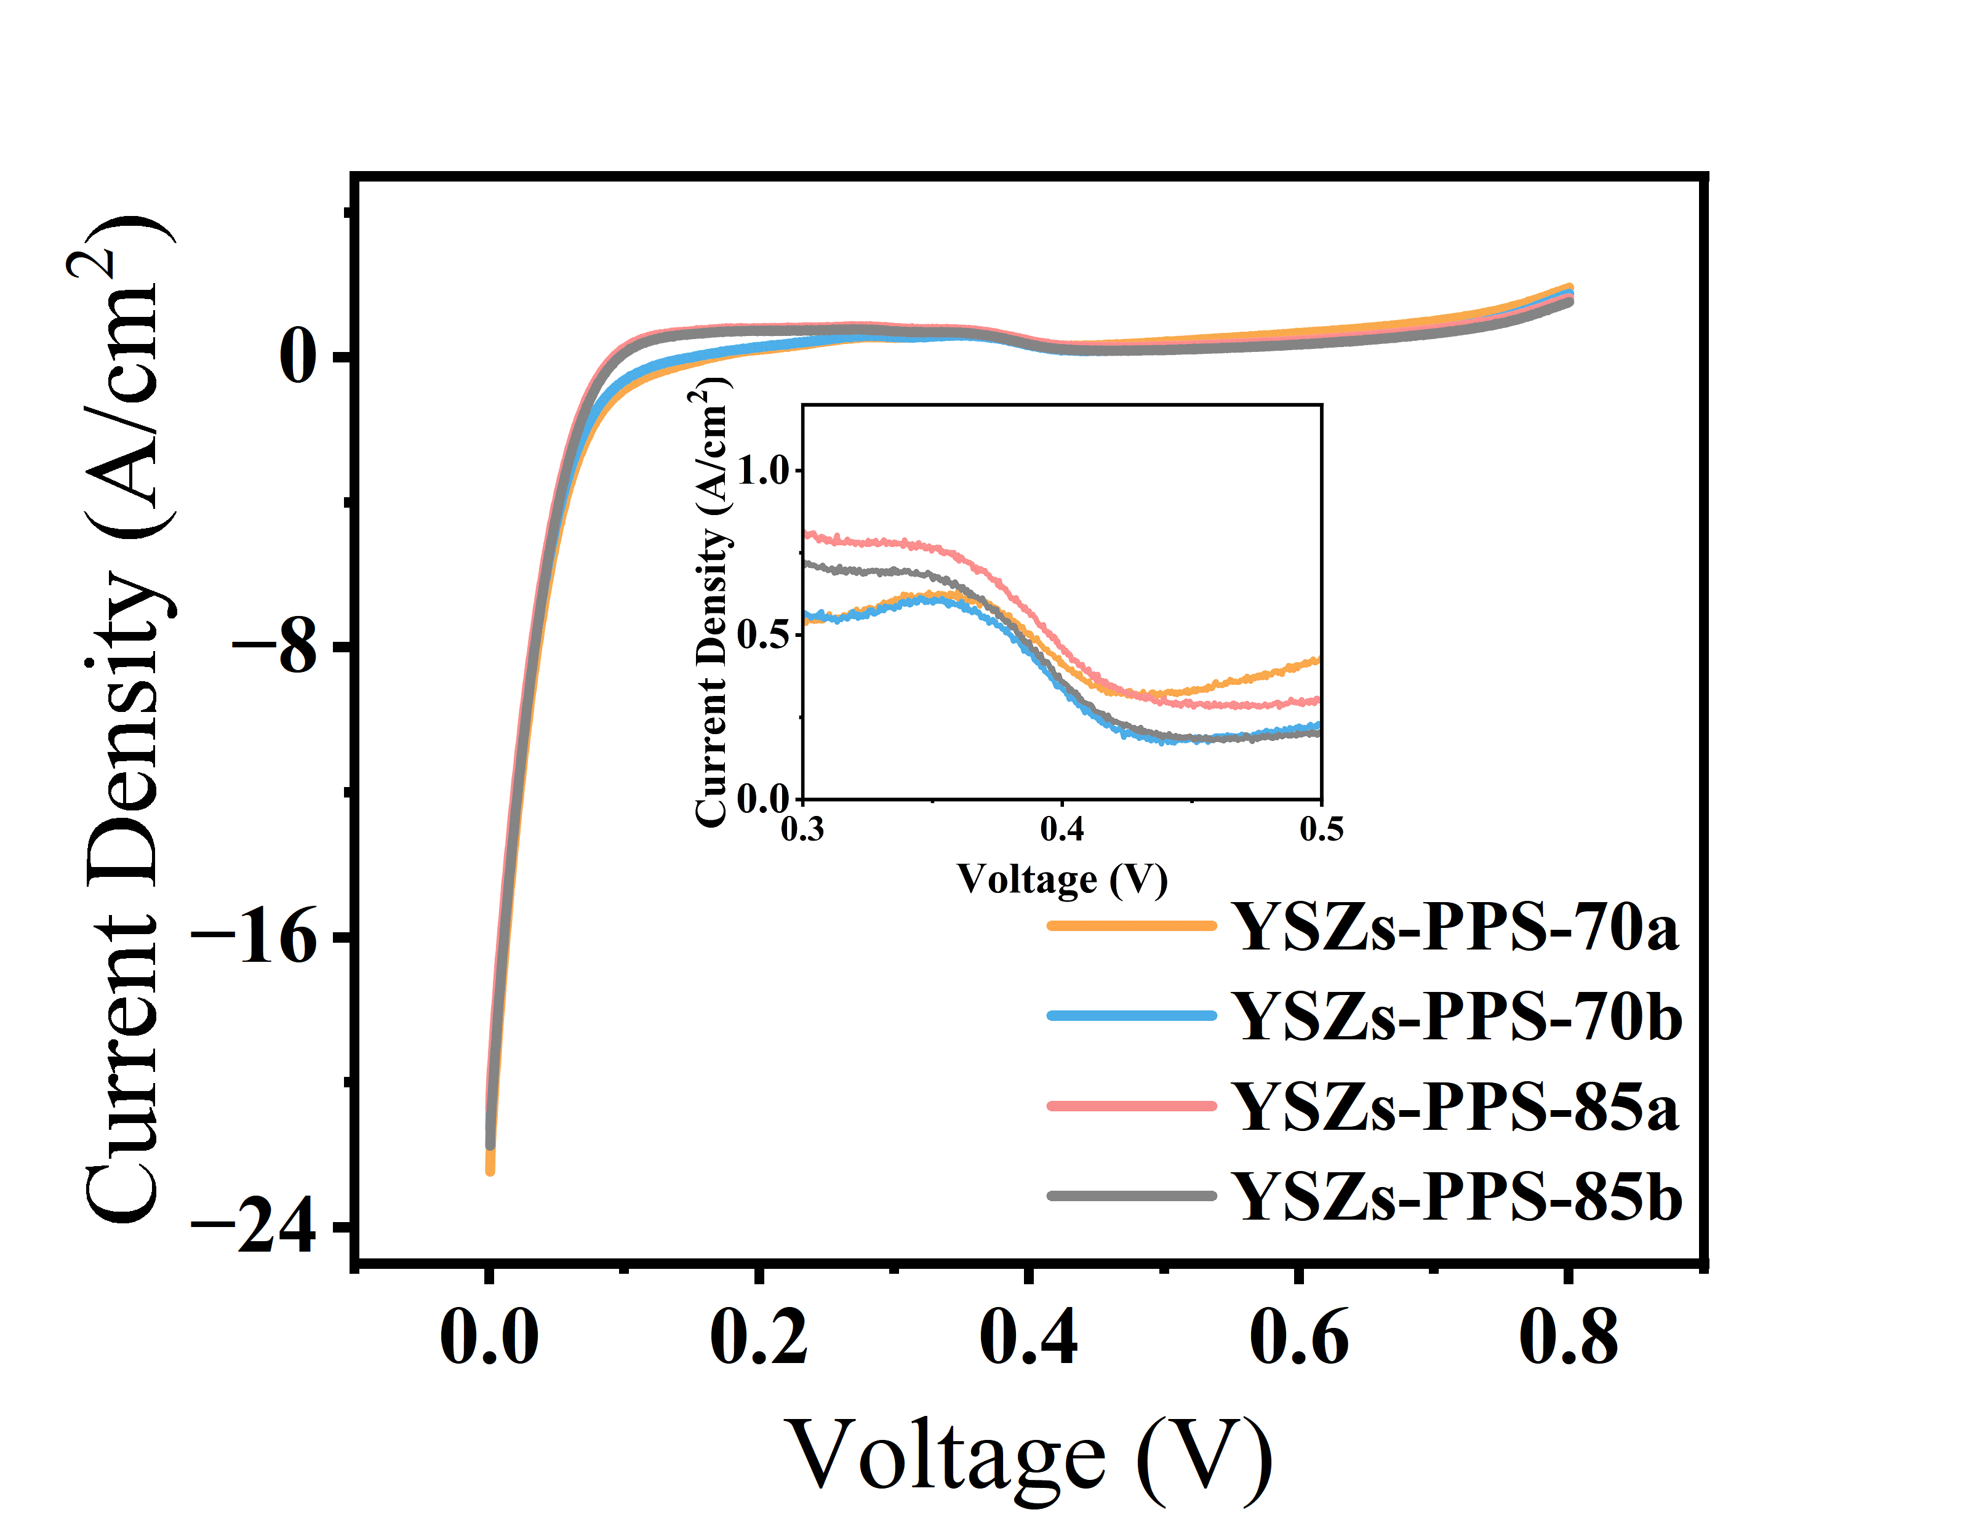
Fig. S54 | Hydrogen permeability of the YSZs-PPS-70 and YSZs-PPS-85 membrane at different backpressures under full humidification. (a) LSV under isobaric conditions (P_{H₂} = 0.1 MPa, P_{N₂} = 0.05 MPa); (b) LSV under differential pressure conditions (P_{H₂} = P_{N₂} = 0.1 MPa).

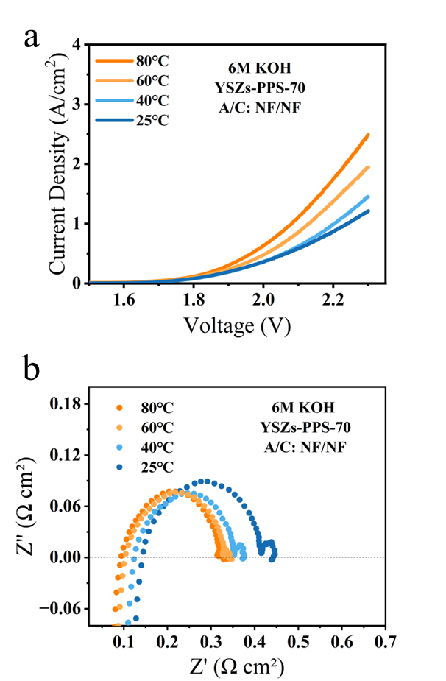
Fig. S55 | Electrochemical performance and EIS analysis. (a) Polarization curves of YSZs–PPS–70 membrane with Ni foam/Ni foam electrodes in 6 M KOH at 25°C; (b) EIS of the membrane at different temperatures at a current density of 500 mA cm⁻².
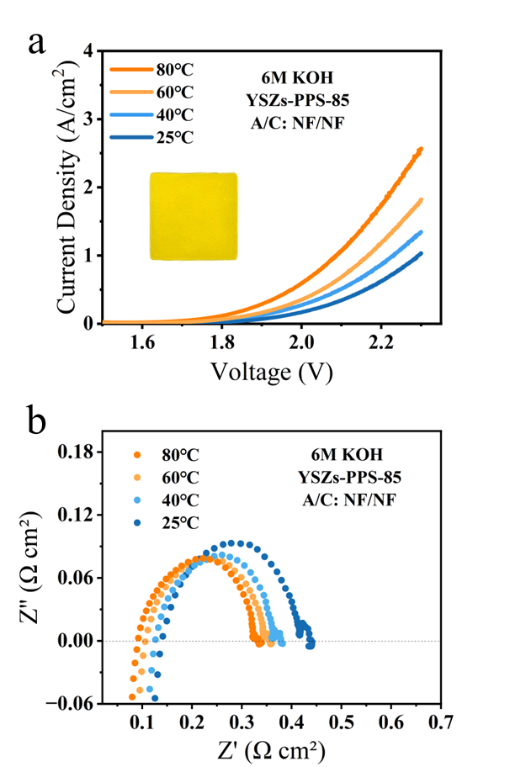
Fig. S56 | Electrochemical performance and EIS analysis. (a) Polarization curves of YSZs-PPS-85 membrane with Ni foam/Ni foam electrodes in 6 M KOH; (b) EIS of the membrane different temperatures at a current density of 500 mA cm⁻².

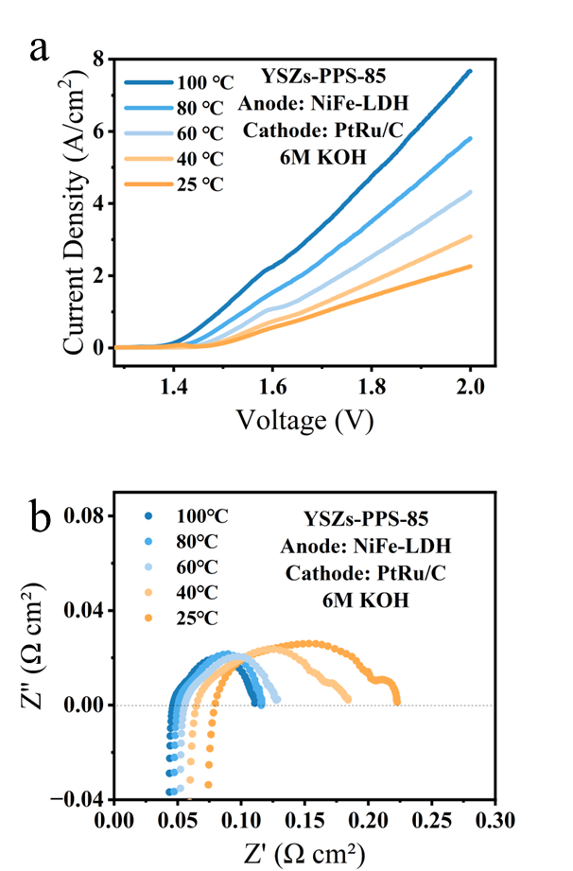
Fig. S57 | Electrochemical performance and EIS analysis. (a) Polarization curves of YSZs-PPS-85 membrane with NiFe–LDH and PtRu/C electrodes in 6 M KOH; (b) EIS of the membrane at different temperatures at a current density of 500 mA cm⁻².

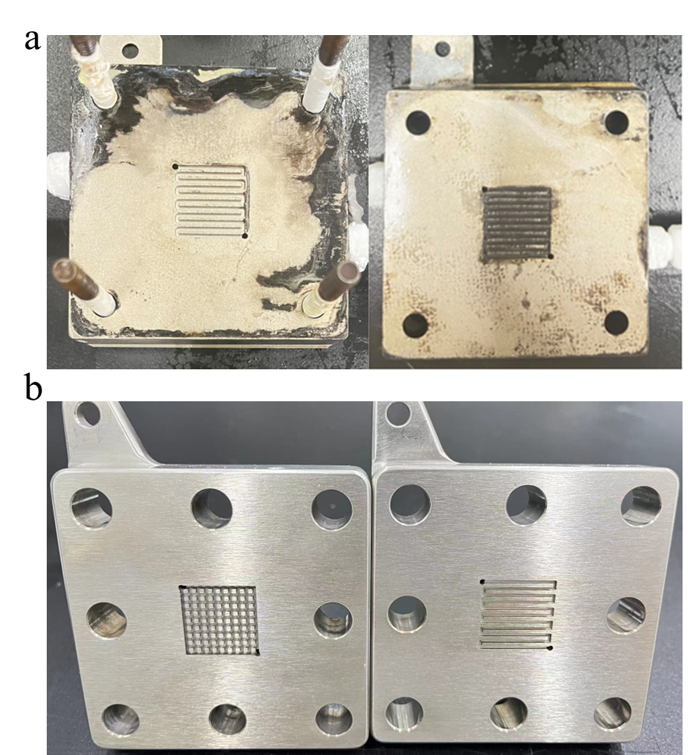
Fig. S58 | Photo image of cells. (a) After 5000h of testing; (b) New electrolytic cell replaced in the durability test of YSZs-PPS-70 membrane

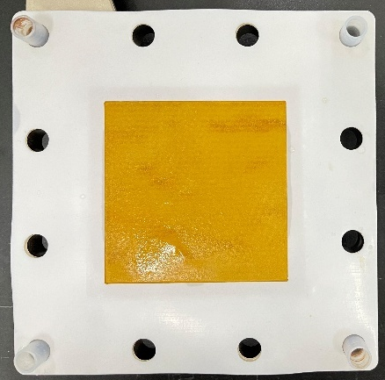
Fig. S59 | Photo image of cells. Photographss of YSZs–PPS–70 membranes and 64 cm² electrolyzer cells after durability Testing.

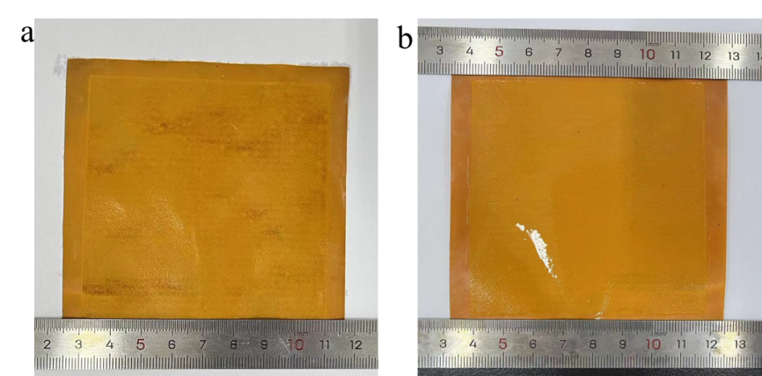
Fig. S60 | Photo image of membranes. Photographs of the (a) anode side and (b) cathode side of the YSZs–PPS–70 membrane after testing.

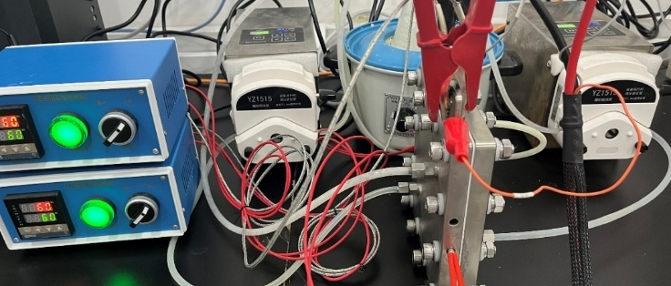
Fig. S61 | Visual image of test system. Photograph of the 64 cm² 1–cell stack.

Table S1. Inherent viscosity (IV) and estimated molecular weight (Mw) of ISM–PBI–D and ISM–PBI–FG membranes.
Membranes | η_{IV}  (dL/g) | Mη  (KDa)
G–PBI | 3.82 | 271.3
mPBIª | 1.87 | 108.6
ª NEXIONIC, China.

Table S2. Creep compliance of the wet membranes (25℃, 100%RH)
Membranes | J⁰_{S}  (10⁻⁶ Pa⁻¹) | Creep rate  (10⁻¹² Pa⁻¹ s⁻¹)
YSZs–70 | 0.69 | 32.16
YSZs–40 | 1.06 | 49.11
G-PBI | 1.87 | 72.94

Table S3 Hydrogen permeation current density of different membranes under different pressure differences at 0.4 V and 25°C.
Sample | ia  (mA cm^{–2}) | ib  (mA cm^{–2})
UPT220 | 1.6775 | 1.5765
G–PBI | 0.8627 | 0.7956
YSZs40 | 0.7343 | 0.6142
YSZs70  YSZs–PPS–70 | 0.9852  0.4081 | 0.8585  0.3352
YSZs–PPS–85 | 0.4627 | 0.3584

Table S4 Hydrogen permeability of different membranes under different pressure differences at 25℃.
Sample | Ka  (mol cm^{–2} s^{–1} kPa^{–1}) | Kb  (mol cm^{–2} s^{–1} kPa^{–1})
UPT220 | 8.69×10^{–8} | 8.17×10^{–8}
G–PBI | 4.47×10^{–8} | 4.12×10^{–8}
YSZs40 | 3.81×10^{–8} | 3.18×10^{–8}
YSZs70  YSZs–PPS–70 | 5.11×10^{–8}  2.11×10^{–8} | 4.45×10^{–8}  1.74×10^{–8}
YSZs–PPS–85 | 2.40×10^{–8} | 1.86×10^{–8}

Table S5 Performance comparison of this work with state-of-the art membranes.
Membranes | Anode | Cathode | Electrolyte | Temperature | Current density at  2.0 V (A/cm²) |  | Reference
YSZs-PPS-70 | Ni foam | Ni foam | 6 M KOH | 80 ℃ | 0.63 | This work
Zirfon UPT220 | Ni foam | Ni foam | 6 M KOH | 80 ℃ | 0.47 | This work
YSZs-70 | NiFe-LDH | PtRu/C | 6 M KOH | 80 ℃ | 10.49 | This work
YSZs-70 | NiFe-LDH | PtRu/C | 6 M KOH | 100 ℃ | 13.06 | This work
YSZs-PPS-70 | NiFe-LDH | PtRu/C | 6 M KOH | 80 ℃ | 6.06 | This work
Zirfon UPT220 | NiFe-LDH | PtRu/C | 6 M KOH | 80 ℃ | 3.72 | This work
YSZs-70 | NiFe-LDH | PtRu/C | 1 M KOH | 80 ℃ | 4.96 | This work
PAP-TP-80 A40 | NiFe-LDH | PtRu/C | 1 M KOH | 80 ℃ | 4.65 | This work
ISM-PBI-FG | NiFe | RaneyNi | 6 M KOH | 80 ℃ | 2.16 | ²
POBP-ISM | Ni foam | Nifoam | 6 M KOH | 80 ℃ | 0.25 | ³
POBP-ISM | NiAl | Ni Al | 6 M KOH | 80 ℃ | 0.61
BN-PBI | Ni foam | Nifoam | 2 M KOH | 80 ℃ | 0.25 | ⁴
BN-PBI | Ni foam | Ni foam | 4 M KOH | 80 ℃ | 0.5
BN-PBI | Ni foam | Ni foam | 6 M KOH | 80 ℃ | 0.75
3FBP-Te | NiFe | Ni foam | 15 wt% KOH | 80 ℃ | 0.13 | ⁵
PVA-C5 | Ni foam | Ni foam | 30 wt% KOH | 80 ℃ | 0.17 | ⁶
Gel-NPBI | Ni foam | Ni foam | 2 M KOH | 80 ℃ | 500 | ⁷
Gel-NPBI | Ni foam | Ni foam | 4 M KOH | 80 ℃ | 500
Gel-NPBI | Ni foam | Ni foam | 6 M KOH | 80 ℃ | 814
PB4Im | IrO₂ | Pt/C | 2 M KOH | 90 ℃ | 1.16 | ⁸
PB4Im | IrO₂ | Pt/C | 4 M KOH | 90 ℃ | 1.62
PB4Im | IrO₂ | Pt/C | 6 M KOH | 90 ℃ | 2
Mes-PBI | Ni foam | Ni foam | 25 wt% KOH | 80 ℃ | 0.2 | ⁹
PSU-PVP | NiFe | NiMo | 20 wt% KOH | 60 ℃ | 0.63 | ¹⁰
ISBP-Te100 | Ni foam | Ni foam | 30 wt% KOH | 80 ℃ | 0.17 | ¹¹
PBI80/P(IB-PEO) | Ni foam | Ni foam | 25 wt% KOH | 80 ℃ | 0.168 | ¹²
PE₁₀-L₅ | Ni foam | Ni foam | 30 wt% KOH | 80 ℃ | 0.23 | ¹³
CoNPBI-7min | Ni cloth | Nickel-bassed ternary | 6 M KOH | 60 ℃ | 2.49 | ¹⁴
POBP-ZrO₂-5 | NiAl | NiAl | 6 M KOH | 80 ℃ | 0.85 | ¹⁵
POBP-ZrO₂-5 | NiFe | Pt/C | 6 M KOH | 80 ℃ | 2.5
5′MS-PBI | Ni foam | Ni foam | 1 M KOH | 80 ℃ | 0.075 | ¹⁶
mPBI | Ni foam | Ni foam | 24 wt% KOH | 80 ℃ | 0.4 | ¹⁷
mPBI | RaneyNi | RaneyNi | 24 wt% KOH | 80 ℃ | 2.9
PBI80/P(IB-PEO₃₅₀) | RaneyNi | RaneyNi | 30 wt% KOH | 80 ℃ | 2.0 | ¹⁸
b-BOPB-2.5% | Ni | Ni | 6 M KOH | 80 ℃ | 0.3 | ¹⁹
b-BOPB-2.5% | Ni/Al | Ni/Al | 6 M KOH | 80 ℃ | 1.1
b-BOPB-2.5% | Ni/Al | Al-ternary | 6 M KOH | 80 ℃ | 1.5

1. Park J, Jeong YG. Investigation of microstructure and electric heating behavior of hybrid polymer composite films based on thermally stable polybenzimidazole and multiwalled carbon nanotube. Polymer 59, 102-109 (2015).

2. Huang Z, et al. Highly Efficient and Durable Water Electrolysis at High KOH Concentration Enabled by Cationic Group-Free Ion Solvating Membranes in Free-standing Gel Form. Small 21, 2408159 (2025).

3. Hu X, et al. An operationally broadened alkaline water electrolyser enabled by highly stable poly(oxindole biphenylene) ion-solvating membranes. Nature Energy 9, 401-410 (2024).

4. Gao R, et al. Optimization of alkaline water electrolysis performance with binaphthyl-derived polybenzimidazole ion-solvating gel membrane. Journal of Membrane Science 713, 123350 (2025).

5. Xia Y, et al. Poly(Arylene Alkylene)s with Tetrazole Pendants for Alkaline Ion-Solvating Polymer Electrolytes. ChemSusChem 17, e202400844 (2024).

6. Xia Y, Rajappan SC, Serhiichuk D, Kraglund MR, Jensen JO, Aili D. Poly(vinyl alcohol-co-vinyl acetal) gel electrolytes for alkaline water electrolysis. Journal of Membrane Science 680, 121719 (2023).

7. Hu B, et al. Highly ion conductive ion solvating membranes for durable alkaline water electrolysis at low temperature and voltage. Journal of Materials Chemistry A 12, 20449-20458 (2024).

8. Chen Q, et al. A novel ion-solvating polymer electrolyte based on imidazole-containing polymers for alkaline water electrolysis. Journal of Membrane Science 668, 121186 (2023).

9. Aili D, Wright AG, Kraglund MR, Jankova K, Holdcroft S, Jensen JO. Towards a stable ion-solvating polymer electrolyte for advanced alkaline water electrolysis. Journal of Materials Chemistry A 5, 5055-5066 (2017).

10. Aili D, Kraglund MR, Tavacoli J, Chatzichristodoulou C, Jensen JO. Polysulfone-polyvinylpyrrolidone blend membranes as electrolytes in alkaline water electrolysis. Journal of Membrane Science 598, 117674 (2020).

11. Xia Y, et al. Tetrazole-functionalized poly(oxindole biphenylene) ion-solvating membranes for alkaline water electrolysis. Journal of Power Sources 656, 238047 (2025).

12. Makrygianni M, Aivali S, Xia Y, Kraglund MR, Aili D, Deimede V. Polyisatin derived ion-solvating blend membranes for alkaline water electrolysis. Journal of Membrane Science 669, 121331 (2023).

13. Xiao W, et al. Poly(vinyl alcohol)/poly(ethylene glycol) ion-solvating membrane with NiFe-LDH for high-performance alkaline water electrolysis. Separation and Purification Technology 366, 132769 (2025).

14. Yang E, et al. Application of ion-solvating membranes regulated by Co2+ coordination in alkaline water electrolysis (AWE) for hydrogen production. Journal of Membrane Science 738, 124850 (2026).

15. Hu X, et al. Engineering antioxidant ion-solvating membranes via precise metal oxide hybridization for 3000 h-durable alkaline water electrolyzers. Chemical Engineering Journal 522, 167330 (2025).

16. Dayan A, et al. Quaternary Ammonium-Free Membranes for Water Electrolysis with 1 m KOH. Advanced Energy Materials 13, 2302966 (2023).

17. Kraglund MR, et al. Ion-solvating membranes as a new approach towards high rate alkaline electrolyzers. Energy & Environmental Science 12, 3313-3318 (2019).

18. Gjoshi S, et al. Tuning properties of PEO-functionalized ion-solvating blend membranes via PEO side chain length: Impact on alkaline water electrolysis performance. Journal of Membrane Science 733, 124368 (2025).

19. Liu M, et al. Highly durable alkaline water electrolyzer with branched poly(oxindole biphenylene) ion-solvating membrane. Chem Catalysis 5, 101199 (2025).

