APPENDICES
Appendix A. Ethics Committee Approval Letter from Aydın Adnan Menderes University
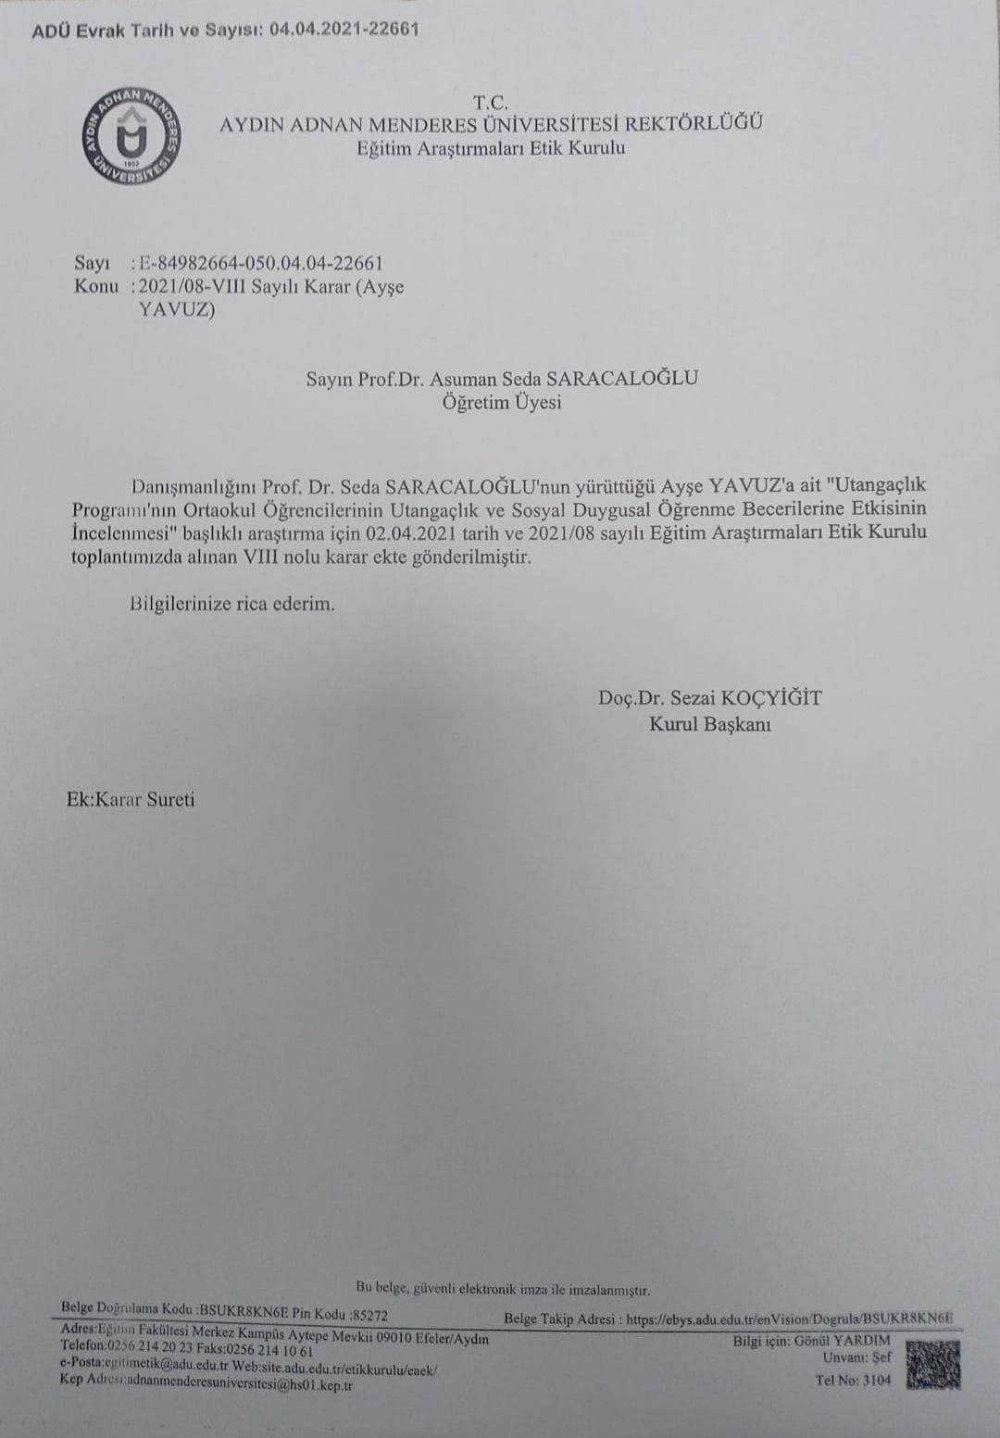

Appendix B. The SIP: Structure and Session Content
The SIP is a six-session, school-based intervention developed to reduce shyness and enhance social-emotional skills in adolescents. Informed by cognitive-behavioral therapy (A. Beck, 1976) and social learning theories (Bandura, 1977), the program focuses on the interrelation of thoughts, emotions, and behaviors in socially challenging contexts. Each session is structured around a specific psychoeducational objective and incorporates experiential activities to foster emotional awareness, self-expression, and peer interaction.
Session 1: Introduction and First Steps
The first session focused on establishing a safe, inclusive, and collaborative group environment. Its primary aims were to foster initial interpersonal connections among students, introduce the concept of shyness, and initiate the data collection process for evaluating the program’s effectiveness. The session began with the facilitator introducing themselves and presenting an overview of the program's purpose, structure, and process. To collect baseline data, two standardized assessment tools were administered: the Shyness for Children Scale (Şar et al., 2015) and the Social Emotional Learning Skills Scale (Kabakçı & Korkut-Owen, 2010). These tools served as pre-intervention measures for assessing students’ levels of shyness and social-emotional competencies. Following the assessments, a series of interactive warm-up activities were implemented to promote group cohesion and reduce initial anxiety. In the first activity, each student wrote a single word that described themselves on a piece of paper. The group then tried to guess which word belonged to which student. In the second activity, students formed a circle and passed a soft ball around, introducing themselves with their name and a favorite activity. Such icebreaker exercises are essential for building trust and facilitating early group engagement in psychoeducational settings (Yalom & Leszcz, 2005).
To further promote group ownership, students collaboratively established group rules, which were later written on the classroom board. These included principles such as respect, confidentiality, active participation, and listening without judgment. The session concluded with a brief reflective circle, where students were invited to share their initial thoughts or feelings about the group experience. This closing activity was designed to reinforce self-expression and group belonging, key components of early-stage group development (Corey et al., 2018). Overall, Session 1 laid the groundwork for subsequent sessions by creating a psychologically safe space that encouraged voluntary participation and peer support. Establishing this foundation is particularly important when working with adolescents experiencing social anxiety or shyness, as it reduces withdrawal tendencies and strengthens motivation for continued engagement (Irwin, 2021).
Session 2: Understanding the Concept of Shyness
The second session focused on deepening students’ understanding of shyness as a multidimensional construct. Drawing on cognitive-behavioral principles, the session aimed to help participants recognize how shyness manifests across emotional, physiological, behavioral, and cognitive domains. To initiate the session, the facilitator encouraged an open dialogue by posing reflective questions such as “What is shyness?”, “How does it influence your life?”, and “Can shyness ever be beneficial?”. This interactive discussion allowed students to share their perspectives, revealing both the perceived limitations and potential strengths associated with shy behavior (Crozier, 2001). To build on this exploration, students engaged in a written exercise identifying common symptoms associated with shyness. These included physical sensations such as increased heart rate and trembling, emotional experiences like anxiety and discomfort, and behavioral patterns such as avoiding eye contact and withdrawing from social situations. The activity emphasized that shyness is not merely a feeling but a complex interaction of multiple systems. In line with Beck’s (1976) cognitive model, the discussion progressed toward identifying distorted thought patterns commonly observed in shy individuals, such as “I must never make a mistake” or “People will think poorly of me.” By recognizing these internalized beliefs, students began to develop insight into how thoughts shape emotional and behavioral responses.
In the applied portion of the session, students were encouraged to recall a personal experience in which they had felt shy. One volunteer shared their memory with the group, which served as a practical case for examining the underlying cognitive and emotional processes. The facilitator guided the group in analyzing the event by asking reflective questions that encouraged self-awareness and emotional expression. The discussion then moved toward imagining alternative thought patterns and how these might lead to different behavioral outcomes. This process introduced the foundational technique of cognitive restructuring in a supportive and experiential format. To consolidate their learning, students completed a reflection worksheet that guided them in analyzing their own past experiences with shyness. They were asked to describe the situation, identify associated emotions and thoughts, and consider how alternative perspectives could lead to more constructive responses. Through this activity, students were encouraged to recognize and challenge maladaptive cognitions while exploring healthier coping strategies. The session concluded with a brief discussion in which students voluntarily shared insights gained from the reflection task. In doing so, the group reinforced the session’s key learning objective: that shyness, while common, is influenced by modifiable thought processes that can be changed through awareness and practice (Greenberger & Padesky, 2016).
Session 3: The Connection Between Thoughts and Emotions
This session focused on helping students explore the cognitive foundations of shyness and recognize how internal thought patterns influence emotional and behavioral responses. Grounded in Beck’s (1976) cognitive theory, the session emphasized that emotional reactions are often shaped not by events themselves, but by the meaning individuals assign to them. The session opened with a brief recap of the physiological and behavioral signs of shyness discussed in previous meetings. Building on this, the facilitator introduced the idea that these external manifestations often stem from automatic thoughts and internal interpretations. To illustrate this, students discussed how negative thoughts in social situations such as fearing exclusion or judgment can trigger strong emotional reactions. A sample scenario was presented: a student notices two close friends meeting without informing them. Participants were asked to reflect on how they would interpret this situation, what emotions such thoughts might evoke, and how those emotions could influence their behavior. This discussion was informed by Ellis's (1994) Rational Emotive Behavior Therapy (REBT) framework, which posits that it is not the event itself, but one’s belief about the event, that drives emotional outcomes.
The core of the session involved a semi-structured group activity in which students examined brief written statements reflecting common shy-related thoughts, for example, “They’ll think I’m boring” or “If I speak, I’ll embarrass myself.” Working in small groups, participants identified the likely emotional consequences of these thoughts and brainstormed more balanced or constructive alternatives. This process mirrored techniques from Greenberger & Padesky's (2016) “Mind Over Mood” model, which emphasizes developing cognitive flexibility and emotional regulation through guided thought restructuring. Following the group activity, students reflected on their own experiences with shyness. They were encouraged to identify a recent moment in which they felt socially anxious and to analyze the automatic thoughts they had at the time. Through this guided introspection, they worked on reframing their thoughts into more supportive and functional alternatives. Students who felt comfortable shared their insights with the group, which further reinforced learning through shared experience and social modeling. To close the session, each participant completed an individual worksheet designed to reinforce the cognitive-emotional link. They described a specific shy moment, detailed the thoughts and feelings involved, and generated new interpretations that could have changed their emotional experience. This exercise aimed to foster self-awareness, emotional insight, and cognitive agency, key components in reducing the intensity and frequency of maladaptive responses associated with shyness.
Session 4: Awareness of Positive and Negative Emotions
This session aimed to develop students’ awareness of both positive and negative emotions by helping them recognize the cognitive mechanisms that influence emotional experiences and supporting the development of adaptive emotional coping strategies. The session opened with the facilitator posing a guiding question to the group: “In what situations do you feel ashamed?” This prompt initiated an open discussion in which students reflected on moments from their lives that evoked feelings of shame. Through this exchange, participants were encouraged to identify the social triggers of emotional responses and to articulate the internal experiences associated with them. Building upon the group discussion, the facilitator introduced the concept of shame as a secondary emotion, often rooted in more primary emotions such as fear, humiliation, or guilt. Referring to Beck’s (1976) cognitive theory, it was emphasized that emotional responses are shaped not by the objective nature of events, but by the interpretations and meanings individuals assign to them. Examples of cognitive distortions frequently associated with shame such as “I’m not good enough,” “If I make a mistake, I’ll be judged,” or “They won’t accept me as I am” were shared with the group. These reflections helped students understand how distorted thinking patterns can intensify negative emotional experiences, particularly in social contexts (Greenberger & Padesky, 2016).
In the experiential phase of the session, students were invited to recall a personal memory in which they had experienced intense shame. One volunteer chose to share their story with the group. With guidance from the facilitator, the narrative was explored through reflective questioning: “What emotions did you feel?”, “What thoughts ran through your mind?”, and “Would your emotional response have changed if you had interpreted the situation differently?” These questions were intended to foster insight into the dynamic relationship between cognition and emotion. As other students shared similar experiences, the discussion evolved into a collaborative exploration of common emotional themes, encouraging peer-based emotional validation and insight. In the final segment, each student was provided with a self-reflection worksheet prompting them to analyze a recent event that elicited shame. They were asked to identify the emotions involved, the thoughts accompanying those emotions, and the behavioral outcomes that followed. In addition, students were encouraged to generate alternative interpretations and coping strategies that could have led to more constructive emotional responses. This activity was supported by Leahy's (2002) emotional schema model, which emphasizes both cognitive awareness and emotional acceptance as essential components of psychological resilience. The session closed with students offering brief written feedback and, for those who wished, a final group sharing opportunity to consolidate the session’s themes.
Session 5: Distinguishing Between Passive, Assertive, and Aggressive Behaviors
The fifth session focused on enhancing students’ understanding of different communication styles in social contexts, with particular emphasis on developing assertiveness skills. The session opened with a conceptual overview of passive, aggressive, and assertive behavior patterns. The facilitator led a discussion on how each communication style affects psychological well-being and interpersonal relationships. Through guided reflection and real-life examples, students were encouraged to identify which patterns they tend to exhibit and how these behaviors influence their interactions with others. Assertive communication was presented as the healthiest and most balanced approach, defined as expressing one’s needs and opinions openly and respectfully while also acknowledging the rights and boundaries of others (Alberti & Emmons, 2008). Core interpersonal skills such as appropriate eye contact, congruent body language, calm yet confident tone of voice, and situational awareness were discussed as essential elements of assertive behavior. In accordance with Bandura’s (1977) social learning theory, it was emphasized that these skills can be learned and strengthened through modeling, practice, and reinforcement.
During the applied phase of the session, students were presented with brief, realistic scenarios involving interpersonal conflict. For each scenario, they were asked to brainstorm three possible responses; one passive, one aggressive, and one assertive, and to evaluate the potential emotional and social consequences of each. This comparative approach allowed students to reflect critically on behavioral outcomes and identify which communication strategies are most constructive in resolving conflict. Following the group discussion, students were encouraged to recall a past social situation in which they had experienced difficulty expressing themselves. They then analyzed how they originally responded and how the situation might have evolved differently if they had employed assertive strategies. This exercise was designed to foster both behavioral self-awareness and cognitive restructuring, consistent with the assertiveness training framework proposed by Lange and Jakubowski (1976). To consolidate learning, students completed a short-written reflection on how they could apply assertiveness techniques in their daily lives, for example, during peer disagreements, group work, or classroom participation. These reflections were shared within the group in a voluntary format, offering students the opportunity to receive constructive peer feedback and social reinforcement, which further supports the internalization of new behavior patterns (Riggio, 2014). By the end of the session, students had a clearer understanding of how assertiveness functions as a key component of social competence and emotional resilience. This session also contributed to students’ broader development of effective interpersonal skills, promoting a balanced and respectful approach to communication across social settings.
Session 6: Process Evaluation and Closure
The final session was designed to facilitate reflection on the knowledge, skills, and personal growth students had achieved over the course of the program, while also encouraging them to consider how these competencies could be transferred into their daily lives. Drawing upon the core themes explored in previous sessions, including the nature of shyness, the thought-emotion-behavior cycle, emotional awareness, assertiveness, and interpersonal communication—this session served both as a consolidation of learning and a guided transition toward real-world application. The session began with a free-form group discussion led by the facilitator, in which students were invited to share recent experiences of shyness and describe the coping strategies they had employed or could envision using in similar contexts. This peer-sharing process not only validated students' personal experiences but also served as a practical demonstration of Bandura’s (1977) social learning theory, which underscores the importance of modeling, observation, and vicarious learning in behavior change.
As the session progressed, students were guided to generate actionable strategies for maintaining assertive communication and emotional regulation in the face of everyday social challenges. Each student developed a brief action plan to help sustain the gains made during the program and to reinforce the use of their newly acquired skills in a variety of settings, such as school, peer interactions, and family life. These plans were shared voluntarily and offered an opportunity for mutual encouragement and feedback, fostering a collaborative and supportive group environment. To deepen reflection and facilitate closure, students participated in a written reflection activity. They were asked to summarize what they had learned throughout the program, how their perspectives had shifted, and which strategies they found most personally meaningful. This reflective exercise was grounded in Kolb's (1984) experiential learning theory, which highlights the role of critical reflection in transforming experience into lasting learning. Additionally, students were encouraged to express emotions, affirm the progress they had made, and celebrate their efforts as part of the program’s emotional wrap-up process. For outcome evaluation, the same measurement tools used during the first session were re-administered: the Shyness for Children Scale (Şar et al., 2015) and the Social Emotional Learning Skills Scale (Kabakçı & Korkut-Owen, 2010). This pre-test/post-test structure enabled a comparative analysis of students' progress and supported the quantitative assessment of program effectiveness. Utilizing consistent instruments at both time points contributes to methodological rigor and enhances the validity of the intervention outcomes (Fraenkel et al., 2023). The session concluded with a closing ritual aimed at reinforcing the positive emotional bonds formed within the group. Students were invited to express final thoughts, share farewell messages, and acknowledge their individual and collective growth. The safe and supportive atmosphere cultivated throughout the sessions was preserved until the end, offering students a sense of closure, achievement, and continuity.

