Rapid Detection of Cr(VI) Using CuO/CN/LDH as an Oxidase Mimetic and the Construction of Paper-Based Devices

Shaohui Li¹, Sijia Hao¹, Wen li¹, Ran Meng¹, Qiang Wang¹, Yuqing Wang¹, Lei Wang¹, Xinjing Liu¹, Yuanyuan Zhou¹, Haitong Wang¹, Xibin Zhou^{1,}*, Dongxia Zhang^{1,†}

1 Key Laboratory of Resource Environment and Sustainable Development of Oasis, College of Geography and Environment Science, Northwest Normal University, Lanzhou 730070, China

E-mail address of Corresponding author:
*: zhouxb@nwnu.edu.cn (Xibin Zhou).
†: zhangdongxia@nwnu.edu.cn (Dongxia Zhang^{1,†})

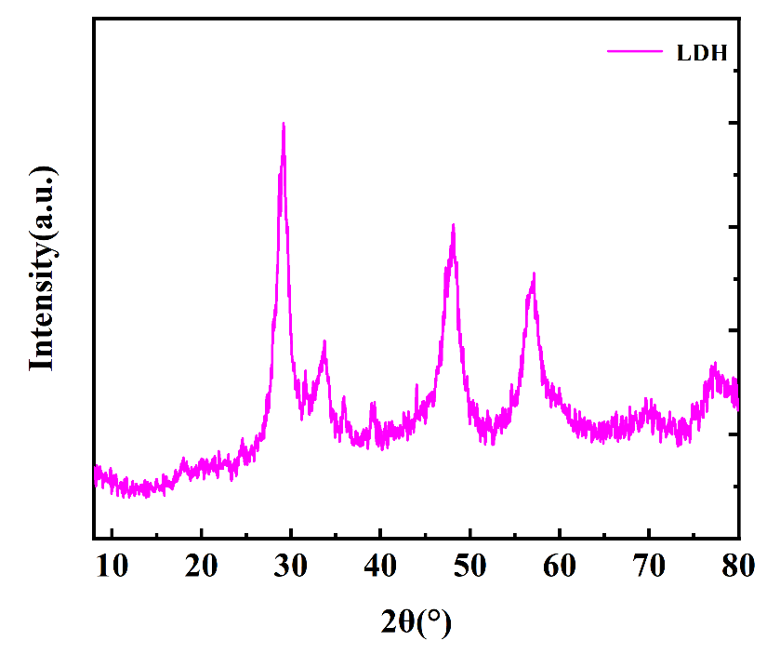
Fig. S1 XRD image of LDH
Fig. S2 Comparison of CuO/CN/LDH with intermediates and CuO-bound enzyme activities.
Fig. S3. (A) pH of the buffer; (B) concentration of TMB; (C) amount of material added; (D) reaction time (where A denotes the absorbance without HQ and A₀ denotes the absorbance when Cr(Ⅵ) is added).

Fig. S4 The anti-interference performance of CuO/CN/LDH sensors

Fig. S5 Catalytic activity of CuO/CN/LDH over 8 weeks as a function of time;

Fig. S6 (a) Optimization of Dilution Factor; (b) Optimization of Buffer Solution pH; (c) Optimization of Added TMB Volume; (d) Optimization of Development Time; (ΔG represents the difference in gray values before and after the reaction.)
Fig. S7 Experiment of anti-interference of Cr(Ⅵ) by colorimetric detection of paper-based devices - metal ion
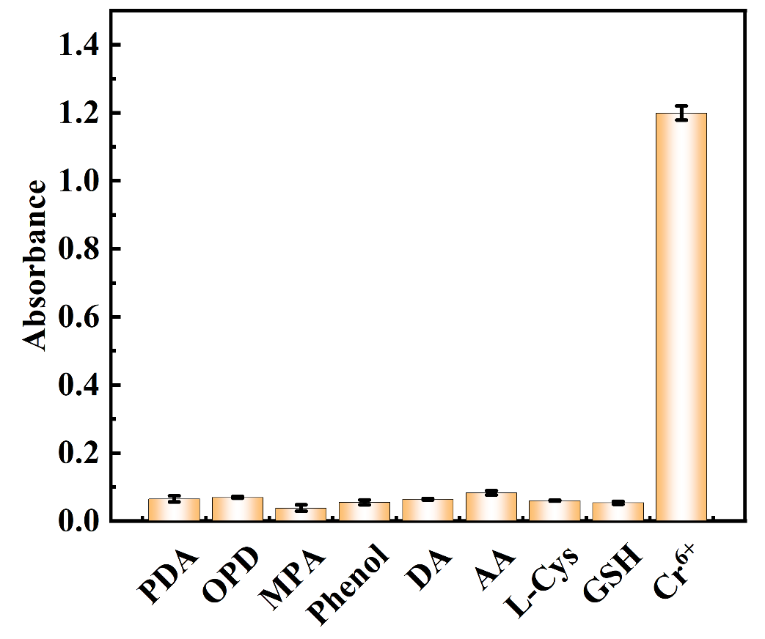
Fig. S8 Experiment of anti-interference of Cr(Ⅵ) by colorimetric detection of paper-based device - redox substances
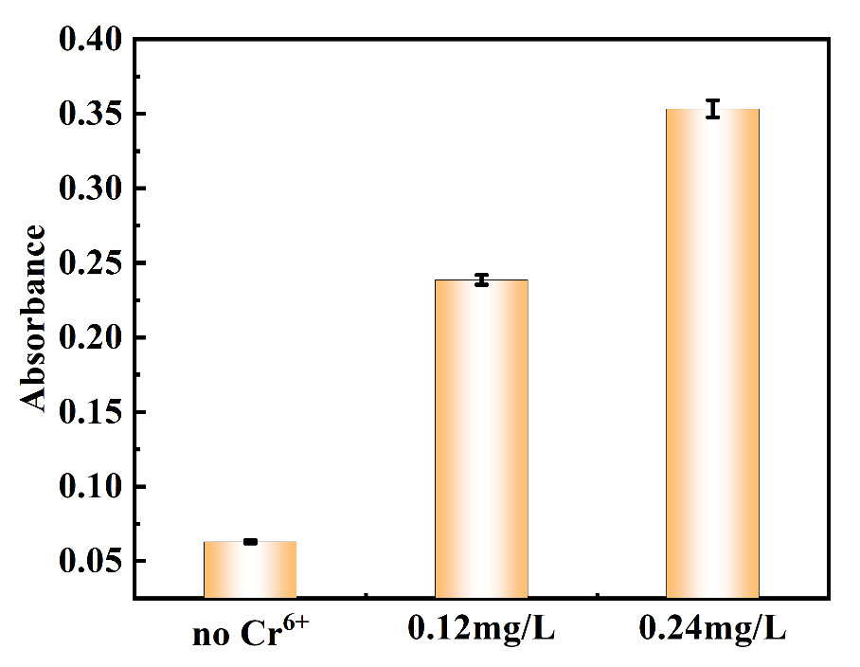
Fig. S9 Determination of Cr(Ⅵ) in standard sample(94 μg/L)
Table. S1 Comparison of reaction kinetic parameters with other nanoenzymes when CuO/CN/LDH mimics the activity of oxidase.
Catalyst | Substrate | K_{m}(mM) | V_{max}(MS⁻¹/10⁻⁸) | Ref
CuO/CN/LDH | TMB | 0.173 | 4.702 | This word
HRP | TMB | 0.275 | 1.24 | [1]
Cu FMA | TMB | 1.10 | 1.79 | [2]
Cu-N-C | TMB | 0.101 | 1.60 | [3]
Fe-Zr-MOL | TMB | 1.39 | 9.10 | [4]
Au@Pt | TMB | 0.255 | 3.2 | [5]

Table. S2 Comparison of this method with other methods for the determination of Cr(Ⅵ) in water samples.
Materials | Detection range (μM) | LOD (μM) | Reference
CuO/CN/LDH | 0~9.1 | 0.025 | This word
Cal-CS/PEG/Ag | 0.09−20 | 0.079 | [6]
Starch-capped AgNPs | 0~6 | 0.93 | [7]
CeO₂NRs-MOF | 0.03-5 | 0.02 | [8]
CuS-BSA | 0-100nM and  1-20μM | 50nm and 6.8μM | [9]
N-T/AuNPs | 0.5-2.5 | 0.07 | [10]

References：
[1] Y. Song, K. Qu, C. Zhao, J. Ren, X. Qu, Graphene Oxide: Intrinsic Peroxidase Catalytic Activity and Its Application to Glucose Detection, Advanced Materials, 22 (2010) 2206-2210.
[2] M. Ying, G. Yang, Y. Xu, H. Ye, X. Lin, Y. Lu, H. Pan, Y. Bai, M. Du, Copper fumarate with high-bifunctional nanozyme activities at different pH values for glucose and epinephrine colorimetric detection in human serum, Analyst, 147 (2022) 40-47.
[3] Z. Lin, L. Zheng, W. Yao, S. Liu, Y. Bu, Q. Zeng, X. Zhang, H. Deng, X. Lin, W. Chen, A facile route for constructing Cu–N–C peroxidase mimics, Journal of Materials Chemistry B, 8 (2020) 8599-8606.
[4] Z. Wu, J. Wen, J. Li, L. Chen, W. Li, K. Yang, The engineering design of single-site nanozyme based on metal-organic layers for the detection of antioxidant substances, Materials Today Chemistry, 30 (2023) 101598.
[5] M. Qi, Y. Ke, Y. Li, P. Li, H. Zhou, X. Zhang, J. Chen, J. Meng, Au@Pt nanozyme-based smart hydrogel for visual detection of hyaluronic acid, Sensors and Actuators B: Chemical, 427 (2025) 137144.
[6] M. Liu, S. Zhang, Y. Wang, J. Liu, W. Hu, X. Lu, Hexavalent Chromium as a Smart Switch for Peroxidase-like Activity Regulation via the Surface Electronic Redistribution of Silver Nanoparticles Anchored on Carbon Spheres, Analytical Chemistry, 94 (2022) 1669-1677.
[7] W. Sapyen, S. Toonchue, N. Praphairaksit, A. Imyim, Selective colorimetric detection of Cr(VI) using starch-stabilized silver nanoparticles and application for chromium speciation, Spectrochimica Acta Part A: Molecular and Biomolecular Spectroscopy, 274 (2022) 121094.
[8] Y. Wang, R.-P. Liang, J.-D. Qiu, Nanoceria-Templated Metal Organic Frameworks with Oxidase-Mimicking Activity Boosted by Hexavalent Chromium, Analytical Chemistry, 92 (2020) 2339-2346.
[9] A. Swaidan, P. Borthakur, P.K. Boruah, M.R. Das, A. Barras, S. Hamieh, J. Toufaily, T. Hamieh, S. Szunerits, R. Boukherroub, A facile preparation of CuS-BSA nanocomposite as enzyme mimics: Application for selective and sensitive sensing of Cr(VI) ions, Sensors and Actuators B: Chemical, 294 (2019) 253-262.
[10] J. Du, H. Ge, Q. Gu, H. Du, J. Fan, X. Peng, Gold nanoparticle-based nano-probe for the colorimetric sensing of Cr³⁺ and Cr₂O₇²⁻ by the coordination strategy, Nanoscale, 9 (2017) 19139-19144.

