Supplementary Information

Model diagnostics
Figure S1 shows the key MaxEnt model diagnostics for C. canephora. The omission–commission plot (left) illustrates how prediction accuracy changes across cumulative thresholds: the predicted omission rate closely follows the expected error curve but remains consistently lower, indicating better-than-random performance. The narrow variability around the omission and predicted area curves reflects stable model behavior across replicates. The ROC curve (right) summarizes the discriminative ability of the model, with the mean sensitivity rising well above the random-prediction line and an AUC of 0.75, demonstrating moderate predictive power.

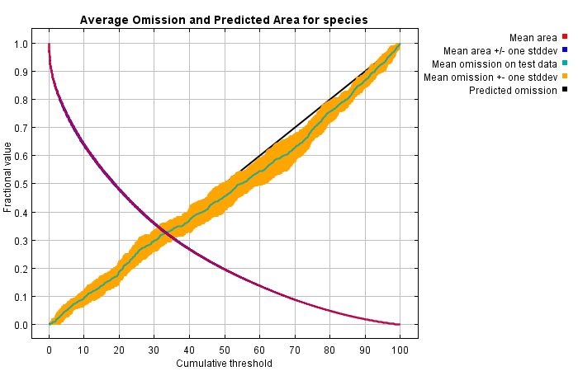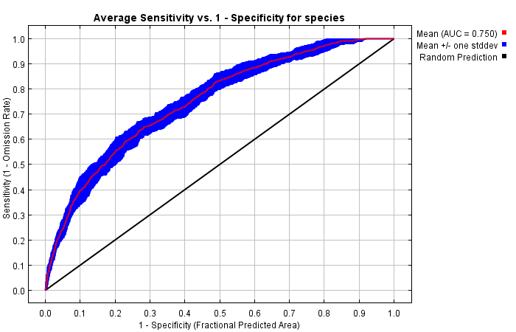
Figure S1. Left: Analysis of omission/commission. Right: AUC curve for C. canephora prediction.
Key Environmental Drivers
Figure S2 shows the jackknife test of variable importance for the MaxEnt model. The bars representing the gain when each variable is used in isolation (blue) indicate that soil type, pH, elevation (DEM), and BIO18 contribute the most unique information for predicting C. canephora suitability. The turquoise bars show the drop in gain when each variable is omitted from the full model, revealing that soils and precipitation seasonality (BIO15) remove the largest portion of explanatory power when excluded, highlighting their strong overall influence. The red bar represents the gain with all variables included, serving as a reference for comparison.
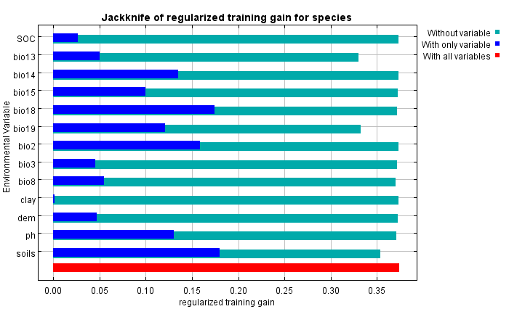
Figure S2. Jackknife test of regularized training gain for C. canephora.

Model response curves
The curves shown in Figure S3 are univariate response curves, which plot the predicted logistic probability of occurrence for C. canephora as a function of a single bioclimatic variable, while holding all other variables constant at their mean training sample value. Specifically, the graphs identify the optimal range of each variable where the probability of presence is highest, and the limiting values where suitability rapidly declines. Note that because they are univariate, these curves may oversimplify the true ecological relationship, which is often multivariate and includes complex interactions.

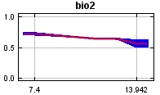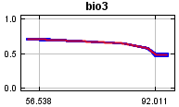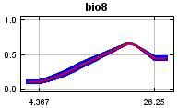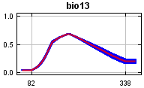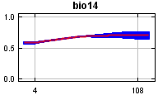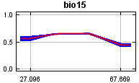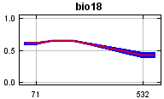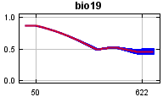
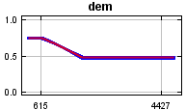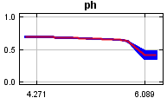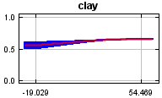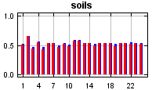
Figure S3. Response curves of C. canephora suitability along elevation, soil pH, clay content, and soil type gradients.

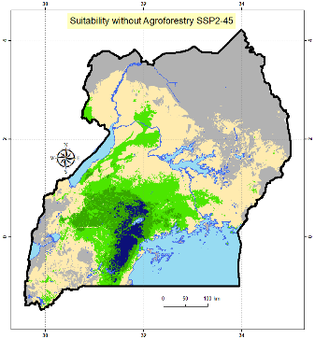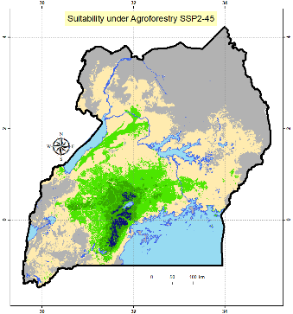
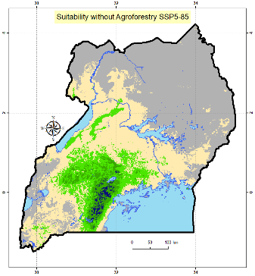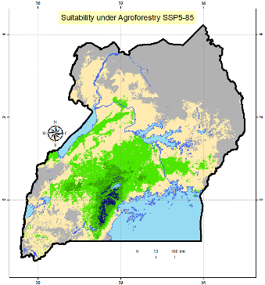
Figure S4. Predicted suitability of C. canephora in Uganda (L) with and without agroforestry for SSP2-4.5 and SSP5-8.5.

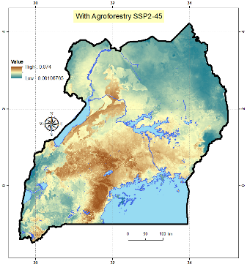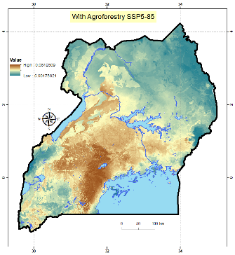
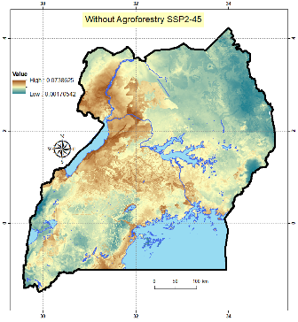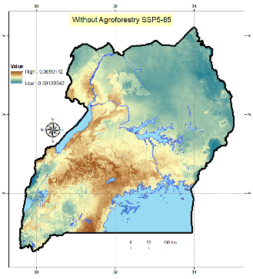
Figure S5. Corresponding uncertainty maps for predicted suitability.

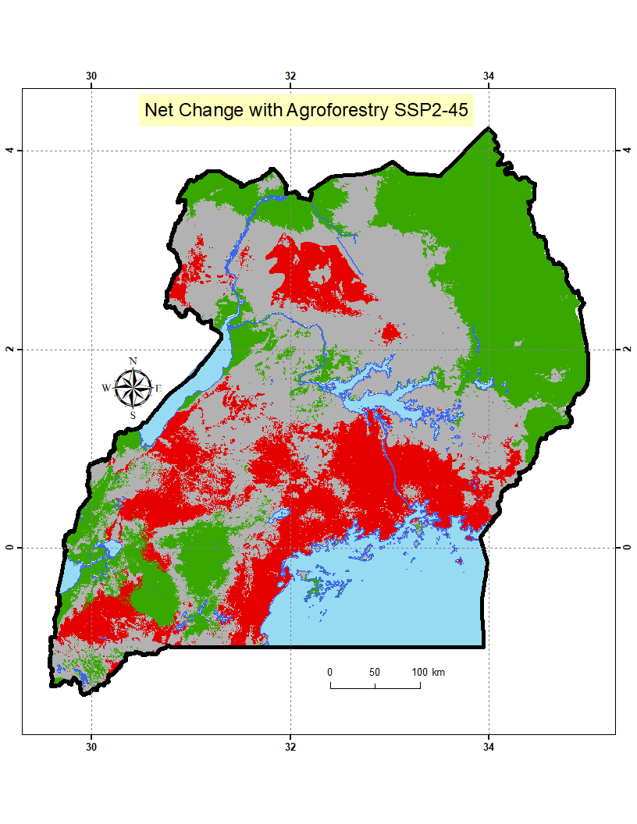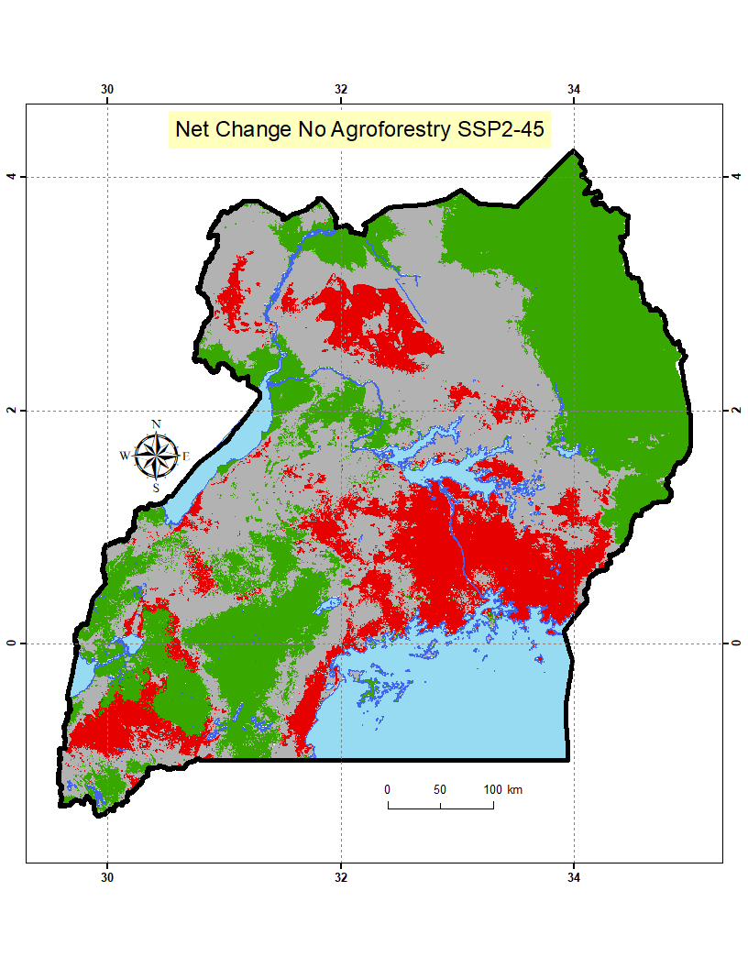
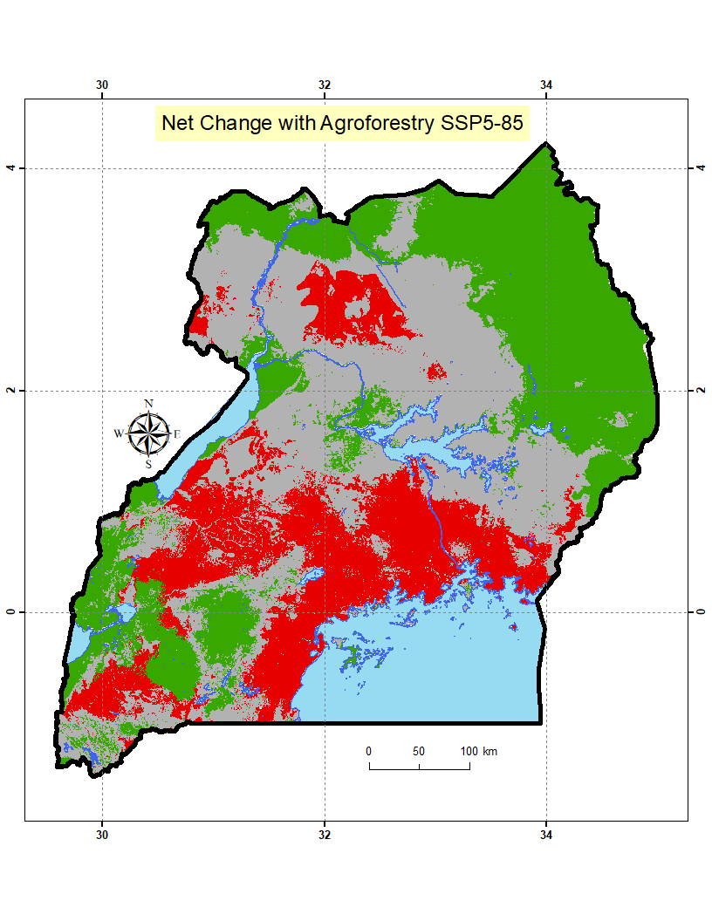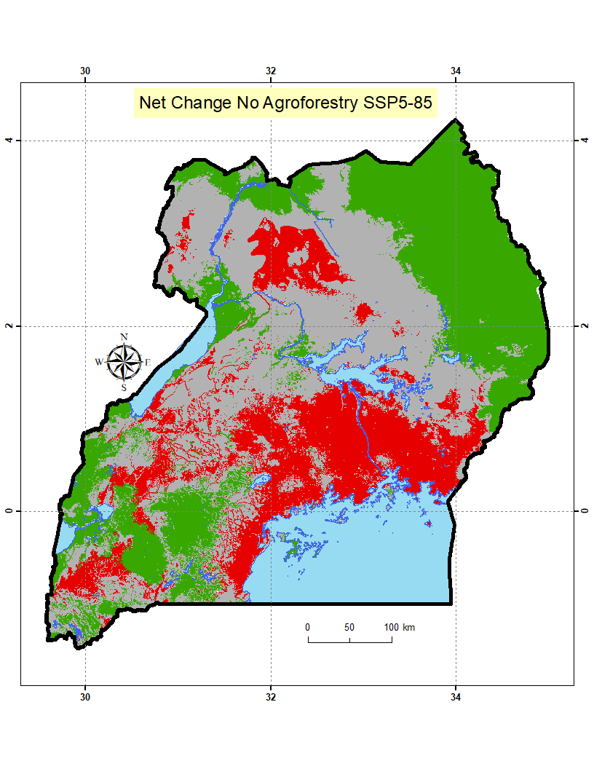

Figure S6. Changes in coffee suitability under climate change scenarios (SSP2-4.5 and SSP5-8.5) with and without agroforestry intervention across Uganda.

