Accuracy of Plasmodium falciparum genetic data for estimating parasite prevalence and malaria incidence in Uganda
Shahiid Kiyaga^{1,2,3*}, Monica Mbabazi^{1,2,3}, Thomas Katairo^{2,4}, Kisakye Diana Kabbale^{1,3,5}, Victor Asua^{2,6}, Bienvenu Nsengimaana^{2,4}, Innocent Wiringilimaana^{2,4}, Francis Ddumba. Semakuba^{2,4}, Caroline Mwubaha^{2,4}, Jackie Nakasaanya^{2,4}, Eric Watyekele², Alisen Ayitewala⁴, Stephen Tukwasibwe^{1,2,4,7}, Jerry Mulondo², Samuel Lubwama. Nsobya², Bosco Agaba^{8,9}, Catherine Maiteki-Sebuguzi⁸, Moses Robert. Kamya^{1,2}, David Patrick. Kateete¹, Joyce Nakatumba Nabende¹, Daudi Jjingo^{1,3,5}, Gerald Mboowa^{1,3,10}, Charles Batte¹, Isaac Ssewanyana^{2,4}, Andrés Aranda-Díaz¹¹, Grant Dorsey¹², Philip J. Rosenthal¹², Melissa Conrad¹², Bryan Greenhouse¹², Jessica Briggs¹²
Affiliations:
¹Makerere University, Kampala Uganda.
² Infectious Diseases Research Collaboration, Kampala, Uganda.
³The African Center of Excellence in Bioinformatics and Data Intensive Sciences, Kampala, Uganda.
⁴Central Public Health Laboratories, Kampala, Uganda.
⁵The Infectious Diseases Institute, Makerere University, Kampala, Uganda.
⁶University of Tubingen, 72074 Tubingen, Germany.
⁷Uganda Christian University, Mukono, Uganda
⁸National Malaria Elimination Division, Ministry of Health, Kampala, Uganda
⁹Mbarara University of Science and Technology, Mbarara Uganda
¹⁰Broad Institute of MIT and Harvard, 415 Main Street, Cambridge, MA 02142, USA
¹¹ISGlobal, Barcelona, Spain
¹²Division of HIV, Infectious Diseases and Global Medicine, Department of Medicine, University of California San Francisco, San Francisco, CA, United States
*Corresponding Author email: ashakykiyaga91@gmail.com

Supplementary Table 1: Genomic and epidemiologic characteristics by study sites
No. | Site | District |  |  |  | Round 1 (Jan – Mar)  mean |  |  |  |  |  |  |  |  |  | Round 2 (Jul – Sept)  mean
No. | Site |  |  |  | Sample size |  | COI | eCOI | WHR | Percent Polyclonal | Heterozygosity | %Highly related pairs (r>0.125) | Incidence (cases per 1000 PY) | Prevalence (%) |  | Sample size | COI | eCOI | WHR | Percent Polyclonal | Heterozygosity | %Highly related pairs (r>0.125) | Incidence (cases per 1000 PY)
1 | Nadunget |  | Moroto |  | 39 |  | 6.49 | 3.45 | 0.61 | 100.00 | 0.85 | 0.11 | NA | 23.50 |  | 94 | 6.43 | 3.49 | 0.59 | 75.53 | 0.86 | 0.39 | 619.71
2 | Kigandalo |  | Mayuge |  | 54 |  | 6.44 | 3.92 | 0.50 | 88.89 | 0.83 | 0.14 | 595.67 | 49.23 |  | 89 | 5.19 | 3.51 | 0.50 | 80.90 | 0.86 | 0.13 | 636.91
3 | Nawaikoke |  | Kaliro |  | 24 |  | 5.90 | 4.10 | 0.42 | 95.83 | 0.85 | 0.08 | 526.52 | 26.56 |  | 52 | 4.58 | 3.48 | 0.40 | 78.85 | 0.84 | 0.38 | 579.01
4 | Orum |  | Otuke |  | 47 |  | 5.72 | 3.51 | 0.53 | 78.72 | 0.83 | 0.09 | 360.64 | NA |  | 75 | 8.99 | 5.03 | 0.57 | 94.67 | 0.85 | 0 | 545.08
5 | Alebtong |  | Alebtong |  | 80 |  | 5.56 | 3.62 | 0.52 | 91.25 | 0.86 | 0.13 | 287.99 | NA |  | NA | NA | NA | NA | NA | NA | NA | NA
6 | Lalogi |  | Omoro |  | 51 |  | 5.31 | 3.22 | 0.57 | 76.47 | 0.85 | 0.45 | NA | 32.39 |  | 61 | 3.62 | 2.75 | 0.41 | 77.05 | 0.83 | 0.11 | NA
7 | Amolatar |  | Amolatar |  | 41 |  | 4.83 | 3.46 | 0.43 | 80.49 | 0.83 | 0.10 | 275.94 | NA |  | 67 | 5.36 | 2.96 | 0.60 | 67.16 | 0.84 | 0.18 | 266.95
8 | Lokolia |  | Kaabong |  | 44 |  | 4.73 | 3.33 | 0.44 | 79.55 | 0.82 | 0.30 | 857.52 | 43.64 |  | 88 | 4.25 | 3.11 | 0.43 | 81.82 | 0.83 | 1.02 | 790.64
9 | Budondo |  | Jinja |  | 28 |  | 4.54 | 3.38 | 0.42 | 71.43 | 0.82 | 1.85 | 160.12 | 20.27 |  | 56 | 4.25 | 2.73 | 0.56 | 76.79 | 0.84 | 0.50 | 212.56
10 | Aboke |  | Kole |  | 44 |  | 4.43 | 3.29 | 0.40 | 75.00 | 0.83 | 0.11 | 703.37 | 35.29 |  | 79 | 4.03 | 3.21 | 0.35 | 83.54 | 0.84 | 0.10 | 598.41
11 | Busitema |  | Busia |  | 50 |  | 4.20 | 2.77 | 0.44 | 90.00 | 0.85 | 0.00 | 1062.09 | 44.62 |  | 78 | 3.27 | 2.59 | 0.40 | 69.23 | 0.84 | 0.30 | 1667.15
12 | Nagongera |  | Tororo |  | 47 |  | 3.94 | 3.03 | 0.35 | 76.60 | 0.83 | 0.09 | 420.57 | NA |  | 72 | 3.78 | 2.90 | 0.40 | 73.61 | 0.84 | 0.27 | 306.16
13 | Atiak |  | Amuru |  | 69 |  | 3.86 | 2.77 | 0.47 | 81.16 | 0.84 | 0.34 | 274.29 | 30.51 |  | 97 | 4.33 | 3.20 | 0.38 | 89.69 | 0.84 | 0.54 | 337.06
14 | Kiyunga |  | Luuka |  | 51 |  | 3.73 | 2.73 | 0.42 | 72.55 | 0.83 | 0.16 | 207.81 | 15.79 |  | NA | NA | NA | NA | NA | NA | NA | NA
15 | Patongo |  | Agago |  | 76 |  | 3.66 | 2.78 | 0.42 | 78.95 | 0.84 | 0.28 | 479.27 | 19.51 |  | 97 | 5.01 | 3.61 | 0.42 | 84.54 | 0.84 | 0.11 | 598.82
16 | Metu |  | Moyo |  | 71 |  | 3.61 | 1.98 | 0.68 | 83.10 | 0.85 | 1.21 | 444.33 | 5.62 |  | 91 | 2.85 | 2.19 | 0.41 | 62.64 | 0.85 | 1.88 | 558.95
17 | Opia |  | Arua |  | 75 |  | 3.49 | 2.31 | 0.55 | 74.67 | 0.84 | 0.42 | 392.65 | 18.09 |  | 63 | 2.62 | 2.01 | 0.43 | 60.32 | 0.83 | 0.20 | 500.18
18 | Padibe |  | Lamwo |  | 67 |  | 3.18 | 2.47 | 0.46 | 67.16 | 0.83 | 0.27 | 360.98 | 5 |  | 93 | 5.04 | 3.15 | 0.53 | 87.10 | 0.85 | 0.16 | 456.67
19 | Aduku |  | Kwania |  | 64 |  | 3.17 | 2.36 | 0.51 | 68.75 | 0.84 | 0.14 | 723.28 | 23.21 |  | 76 | 5.03 | 3.49 | 0.41 | 89.47 | 0.84 | 0.28 | 593.80
20 | Kihihi |  | Kanungu |  | 72 |  | 3.06 | 1.93 | 0.59 | 70.83 | 0.85 | 1.49 | 92.41 | NA |  | 95 | 2.53 | 1.92 | 0.45 | 54.74 | 0.85 | 1.72 | 71.94
21 | Kigorobya |  | Hoima |  | 40 |  | 3.00 | 2.33 | 0.39 | 87.50 | 0.83 | 1.28 | 168.49 | 11.69 |  | 98 | 3.05 | 2.45 | 0.37 | 65.31 | 0.85 | 0.29 | 137.20
22 | Namokora |  | Kitgum |  | 91 |  | 2.92 | 2.30 | 0.41 | 69.23 | 0.84 | 0.10 | 395.28 | 18.03 |  | 93 | 7.10 | 3.48 | 0.62 | 84.95 | 0.85 | 0.02 | 646.97
23 | Kasambya |  | Mubende |  | 60 |  | 2.67 | 1.71 | 0.66 | 71.67 | 0.83 | 0.66 | 124.75 | 11.76 |  | 91 | 2.47 | 1.77 | 0.52 | 57.14 | 0.84 | 0.88 | 124.45
24 | Karambi |  | Kasese |  | 60 |  | 2.20 | 1.75 | 0.56 | 56.67 | 0.82 | 0.85 | 181.78 | NA |  | 72 | 2.76 | 1.95 | 0.54 | 62.50 | 0.83 | 0.82 | 100.30
25 | Kamwezi |  | Rukiga |  | 72 |  | 2.17 | 1.81 | 0.54 | 52.78 | 0.83 | 3.80 | 91.29 | NA |  | 62 | 1.81 | 1.52 | 0.45 | 45.16 | 0.82 | 6.66 | 33.10
26 | Awach |  | Gulu |  | NA |  | NA | NA | NA | NA | NA | NA | NA | 35.71 |  | 91 | 4.43 | 3.08 | 0.42 | 86.81 | 0.85 | 0.10 | 532.89
27 | Ayipe |  | Koboko |  | NA |  | NA | NA | NA | NA | NA | NA | NA | 33.33 |  | 73 | 3.25 | 2.49 | 0.44 | 73.97 | 0.83 | 0.27 | 1134.34
28 | Diima |  | Kiryandongo |  | NA |  | NA | NA | NA | NA | NA | NA | NA | 40.48 |  | 50 | 5.14 | 3.72 | 0.43 | 86.00 | 0.83 | 0.16 | 701.19
29 | Bikurungu |  | Rukungiri |  | 93 |  | 2.02 | 1.57 | 0.52 | 48.39 | 0.84 | 1.57 | NA | NA |  | NA | NA | NA | NA | NA | NA | NA | NA

Supplementary Table S2: Comparison of Cross-Validated Prediction Performance Across 3 months, 6 months, and 12 months Incidence Outcome Metrics
Table S2: Predictive performance of cross-validated regression models for estimating malaria incidence across 3-, 6-, and 12-month windows prior to sample collection using parasite genetic metrics. RMSE = root mean squared error; MAE = mean absolute error. Models were selected using repeated nested grouped cross-validation (10 repetitions, 5 outer folds).

Outcome | RMSE (mean) | MAE (mean) | Correlation (mean) | Top Predictors Selected
3-month incidence | 0.0799 | 0.0571 | 0.2413 | Percent polyclonal + Percentage of highly related pairs (r>0.125) + WHR
6-month incidence | 0.1368 | 0.1016 | 0.2412 | Percent polyclonal + Percentage of highly related pairs (r>0.125) + WHR
12-month incidence | 0.2850 | 0.2163 | 0.2717 | Percent polyclonal + Percentage of highly related pairs (r>0.125) + WHR

Notes: Top predictors selected reflects the combination of parasite genetic metrics most frequently chosen across repetitions.

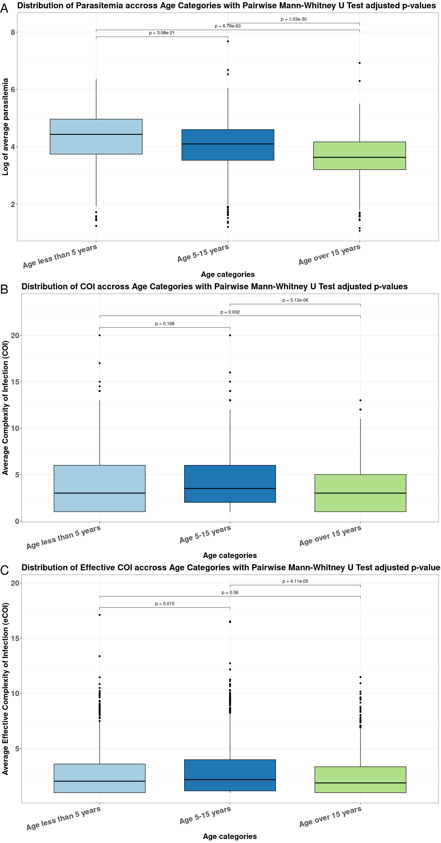

Supplementary Figure S1. Distribution of infection and parasitemia measures across age categories. (A) Log-transformed average parasitemia by age group. (B) Complexity of infection (COI) by age group. (C) Effective complexity of infection (eCOI) by age group. Age categories were defined as: children <5 years, children 5–15 years, and individuals >15 years. Boxplots display the median (horizontal line), Q1 - Q3 (box), and outliers (points). Pairwise group comparisons were performed using the Mann–Whitney U test, and adjusted p-values are shown above the comparisons.

4B

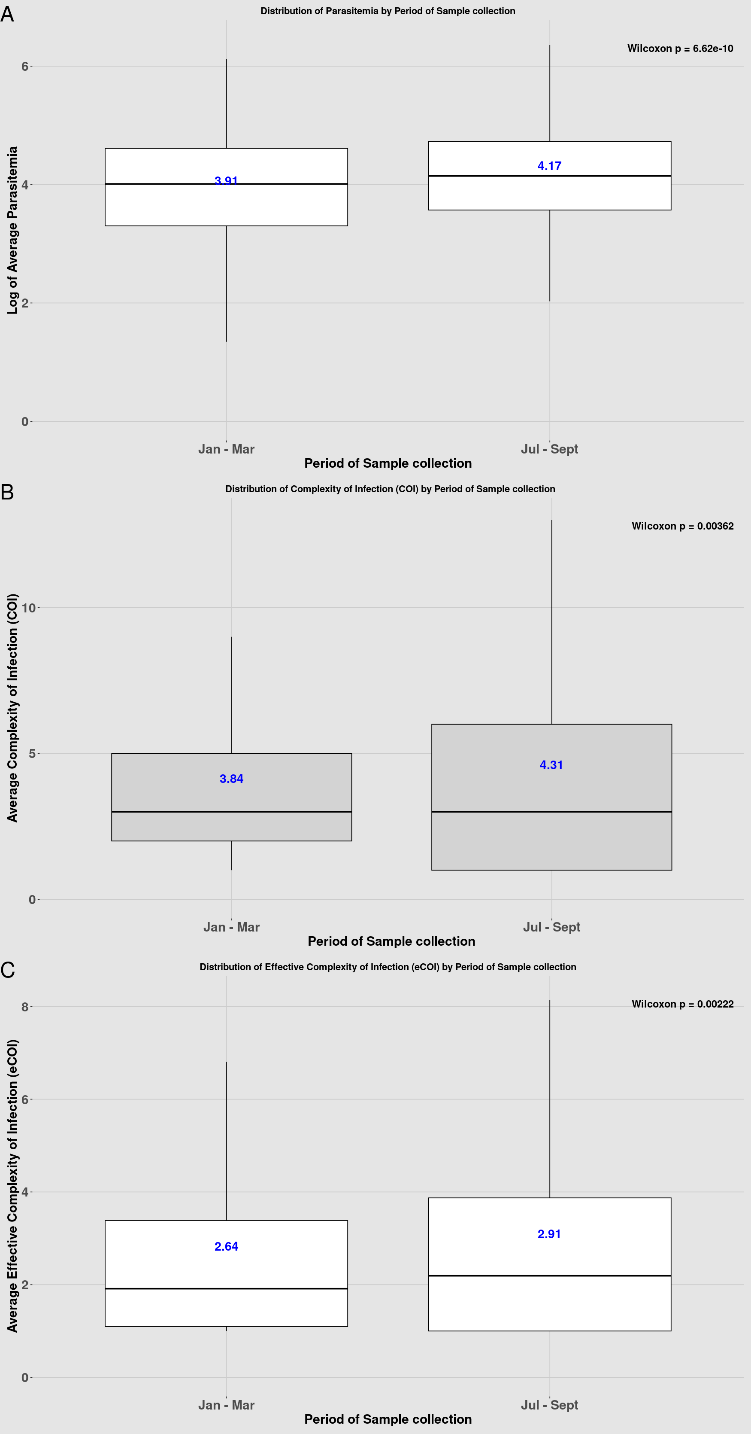

Supplementary Figure S2. Seasonal variation in parasitemia and infection complexity across collection rounds. (a) Boxplot of log-transformed parasitemia by sampling period (January–March vs June–September). (b) Boxplot of COI by sampling period, showing higher multiplicity of infection in June–September. (c) Boxplot of eCOI by sampling period, with higher values observed in June–September. The blue figures in the box plots are means. Parasitemia was significantly higher during June–September. Together, these results indicate seasonal intensification of transmission reflected in both parasite density and infection complexity.

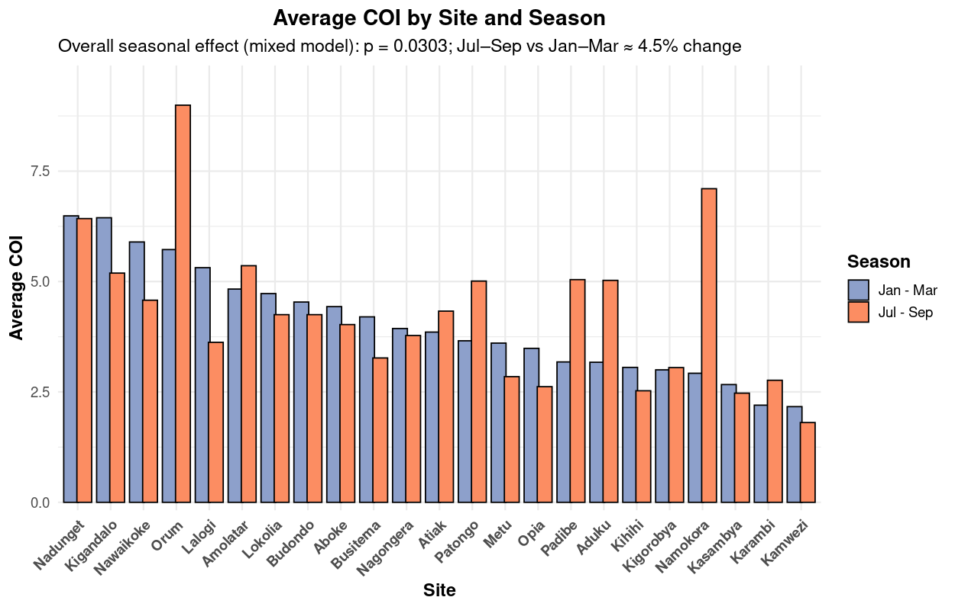
Supplementary Figure S3. Average complexity of infection (COI) by site and season. Bars show the mean COI for Round 1 (January–March 2023, blue) and Round 2 (July–September 2023, orange). Sites are arranged in descending order of Round 1 mean COI. Overall seasonal differences were assessed using a mixed-effects model adjusting for repeated sampling within sites. A modest but statistically significant reduction in COI was observed in July–September compared to January–March (p = 0.0303), corresponding to an average decrease of ~4.5%.

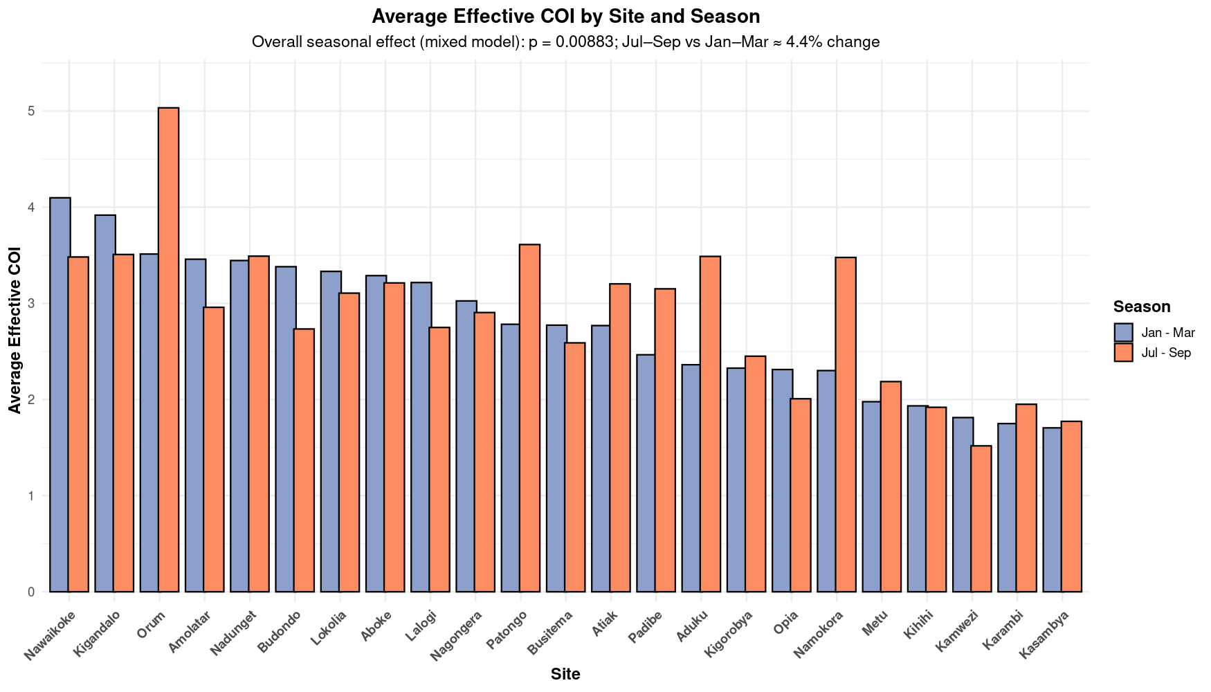
Supplementary Figure S4. Average Effective complexity of infection (eCOI) by site and season. Bars show the mean COI for Round 1 (January–March 2023, blue) and Round 2 (July–September 2023, orange). Sites are arranged in descending order of Round 1 mean eCOI. Overall seasonal differences were assessed using a mixed-effects model adjusting for repeated sampling within sites. A modest but statistically significant reduction in COI was observed in July–September compared to January–March (p = 0.0088), corresponding to an average decrease of ~4.4%.

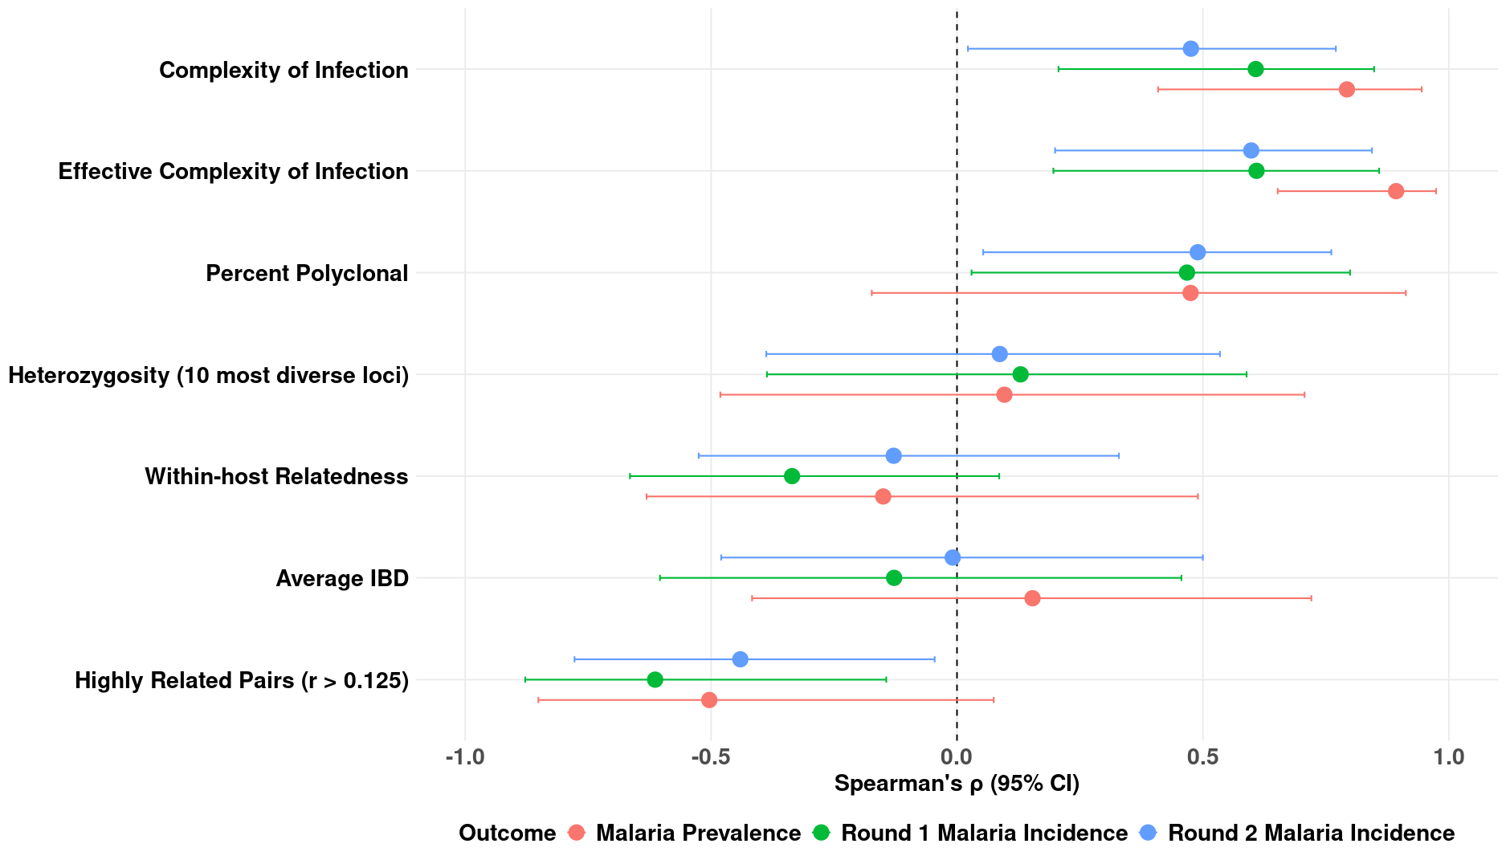

Supplementary Figure S5. Relationship between molecular diversity metrics among children <15 years and malaria transmission intensity. Analyses restricted to participants under 15 years of age demonstrated similar patterns to those observed in the full dataset, with positive associations between transmission metrics (prevalence, round 1 incidence, and round 2 incidence) and molecular diversity metrics ( COI, eCOI, percent polyclonal, heterozygosity), and negative associations with molecular diversity metrics (within-host relatedness, average IBD, and proportion of highly related pairs (r > 0.125)). These results highlight the robustness of the observed relationships across age groups, and support the use of parasite genomic diversity as a surrogate marker for transmission intensity in endemic settings.

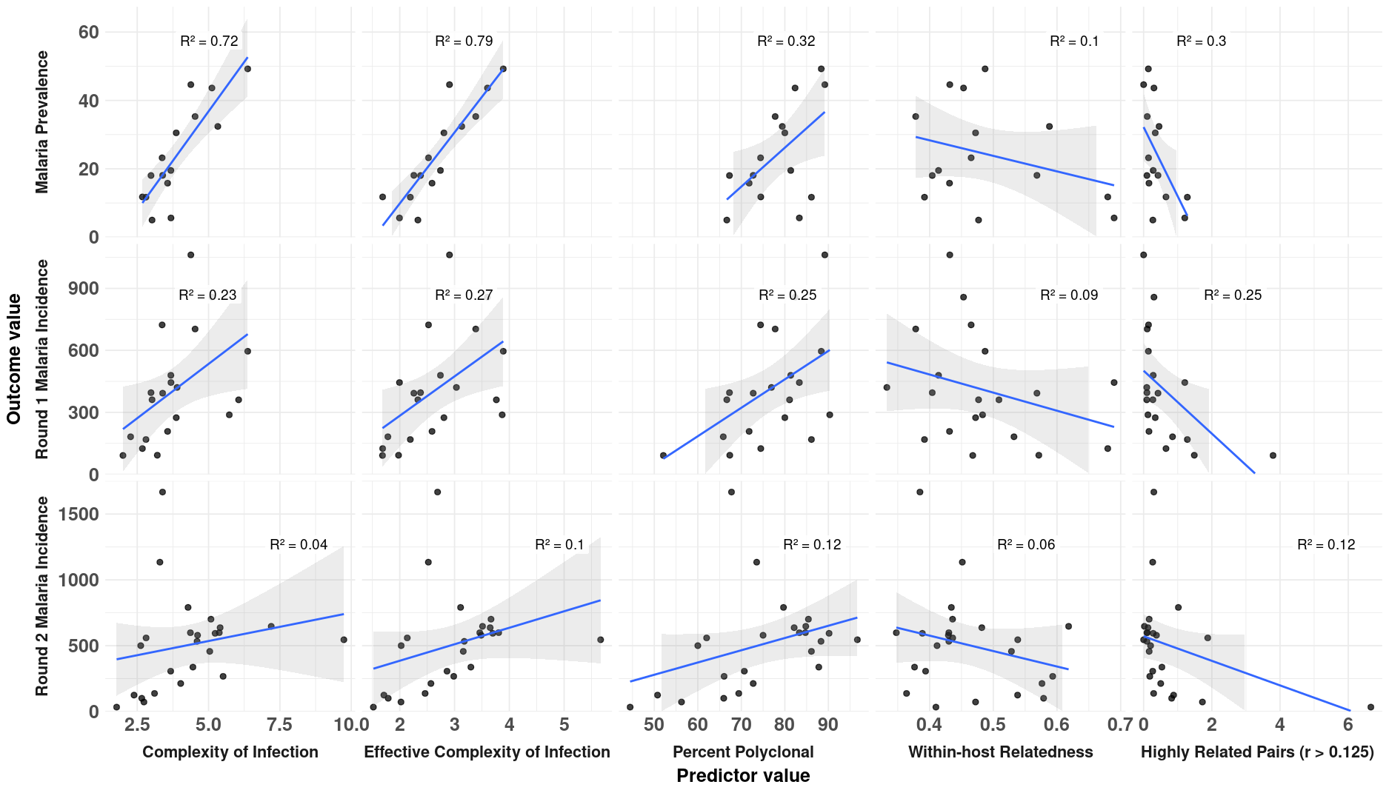

Supplementary Figure S6. Association between parasite genetic diversity metrics among children <15 years and malaria transmission intensity. Site-level regression analyses restricted to genetic diversity metrics of participants under 15 years revealed similar trends to those observed across all ages. As in the full dataset, malaria prevalence was strongly associated with COI, eCOI, and percent polyclonal infections, and inversely associated with within-host relatedness and the proportion of highly related pairs (r > 0.125). Associations with incidence were comparable to those obtained using all ages – slightly higher in Round 1 and similar in Round 2.These findings confirm that the observed molecular–epidemiological relationships are robust across age groups.

