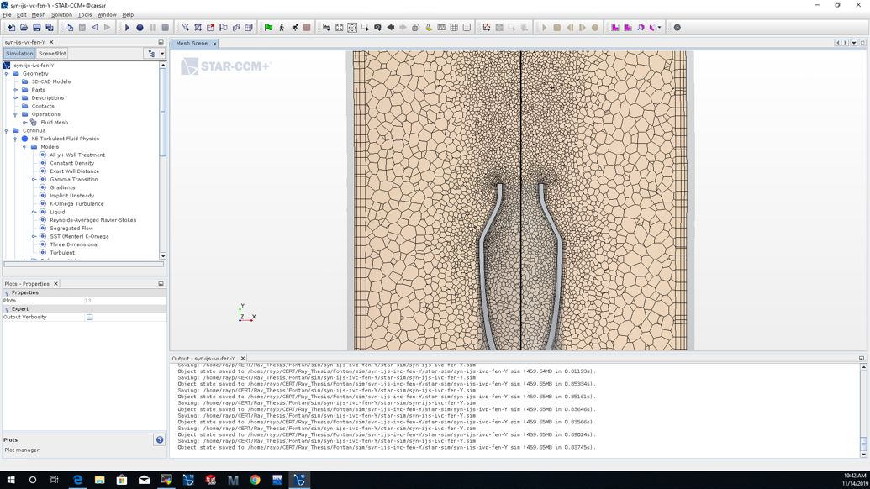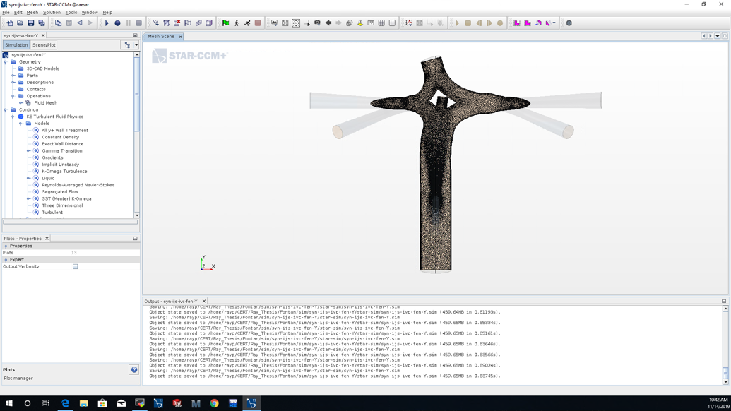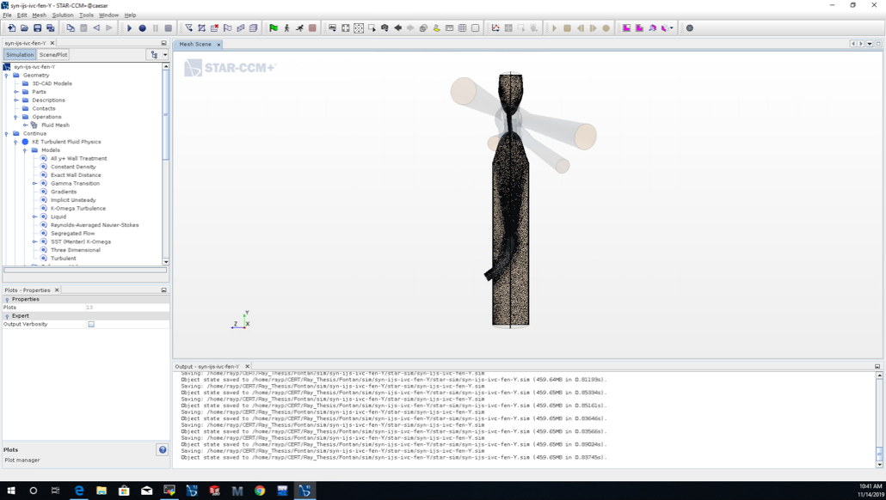

A
B
Supplementary Figure S1 - Volume mesh refinement based on shunt surface and shunt mouth wake ((A) front and side full domain view and (B) close-up to IJS outlet).
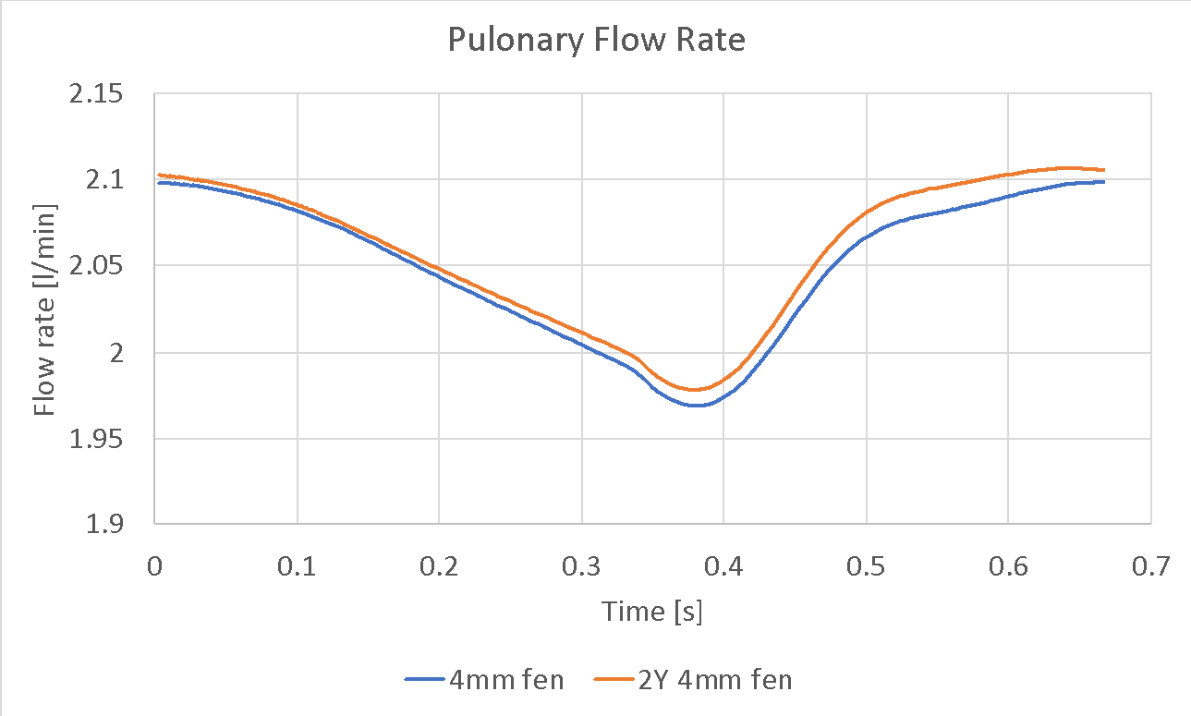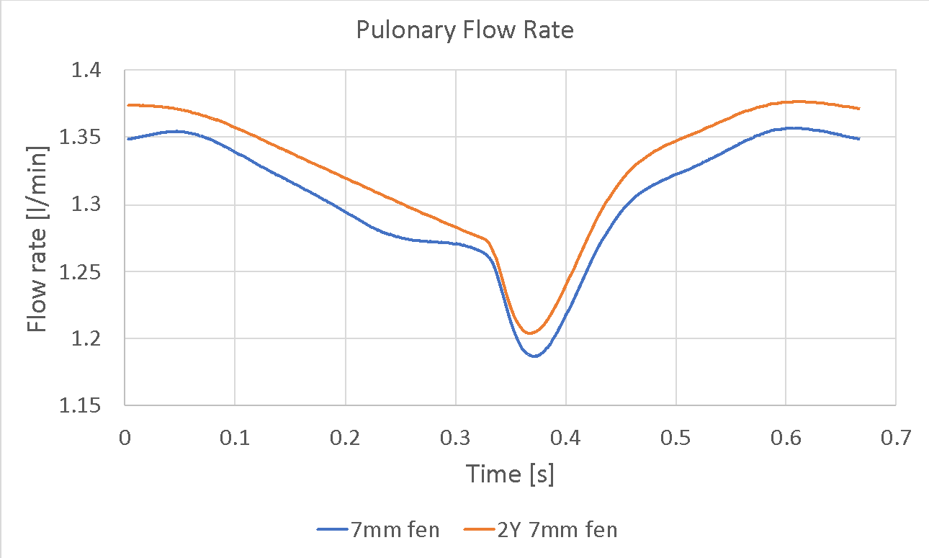

A
B
Supplementary Figure S2 - Qp for a set of fenestrated Fontan models with a standard (baseline) connection and a double Y-graft anatomic variant for (A) a 4mm fenestration and (B) a 7mm fenestration.

