Appendix 1: Survey Questions, Variable Codes, and Measurement Scales
Category | Questions | Variable Code | Scale
Attitudes towards immigrants | Is immigration bad or good for a country’s economy? | imbgeco | 0 (very bad) to 10 (very good)
Attitudes towards immigrants | Is the country’s cultural life undermined or enriched by immigrants? | imueclt | 0 (greatly undermined) to 10 (greatly enriched)
Attitudes towards immigrants | Do immigrants make the country a worse or a better place to live? | imwbcnt | 0 (much worse) to 10 (much better)
Acceptance of Immigrants | How about people of a different race or ethnic group from most [country] people? | imdfetn | 1 (Allow many) to 4 (Allow none)
Acceptance of Immigrants | How about people from the poorer countries outside Europe? | impcntr | 1 (Allow many) to 4 (Allow none)
Generalized Trust | Generally speaking, would you say that most people can be trusted or that you can’t be too careful? | ppltrst | 0 (can't be too careful) to 10 (most people can be trusted)
Generalized Trust | Do you think that most people would try to take advantage of you if they got the chance, or would they try to be fair? | pplfair | 0 (take advantage) to 10 (try to be fair)
Generalized Trust | Would you say that most of the time people try to be helpful or are they mostly looking out for themselves? | pplhlp | 0 (looking out for themselves) to 10 (try to be helpful)
Self-Transcendence Values | She/he strongly believes that people should care for nature. Looking after the environment is important to her/him. | impenv | 1 (not like me at all) to 6 (very much like me)
Self-Transcendence Values | It is important to her/him to make her/his own decisions about what she/he does. She/he likes to be free and not depend on others. | impfree | 1 (not like me at all) to 6 (very much like me)
Self-Transcendence Values | It's very important to her/him to help the people around her/him. She/he wants to care for their well-being. | iphlppl | 1 (not like me at all) to 6 (very much like me)
Self-Transcendence Values | It is important to her/him to listen to people who are different from her/him. Even when she/he disagrees with them, she/he still wants to understand them. | ipudrst | 1 (not like me at all) to 6 (very much like me)
Self-Transcendence Values | She/he likes surprises and is always looking for new things to do. She/he thinks it is important to do lots of different things in life. | impdiff | 1 (not like me at all) to 6 (very much like me)
Self-Transcendence Values | Thinking up new ideas and being creative is important to her/him. She/he likes to do things in her/his own original way. | ipcrtiv | 1 (not like me at all) to 6 (very much like me)
Self-Transcendence Values | She/he thinks it is important that every person in the world should be treated equally. She/he believes everyone should have equal opportunities in life. | ipeqopt | 1 (not like me at all) to 6 (very much like me)
Conservation Values | It is important to her/him to live in secure surroundings. She/he avoids anything that might endanger her/his safety. | impsafe | 1 (not like me at all) to 6 (very much like me)
Conservation Values | Tradition is important to her/him. She/he tries to follow the customs handed down by her/his religion or her/his family. | imptrad | 1 (not like me at all) to 6 (very much like me)
Conservation Values | It is important to her/him always to behave properly. She/he wants to avoid doing anything people would say is wrong. | ipbhprp | 1 (not like me at all) to 6 (very much like me)
Conservation Values | She/he believes that people should do what they're told. She/he thinks people should follow rules at all times, even when no-one is watching. | ipfrule | 1 (not like me at all) to 6 (very much like me)
Conservation Values | It is important to her/him to be humble and modest. She/he tries not to draw attention to herself/himself. | ipmodst | 1 (not like me at all) to 6 (very much like me)
Conservation Values | It is important to her/him that the government ensures her/his safety against all threats. She/he wants the state to be strong so it can defend its citizens. | ipstrgv | 1 (not like me at all) to 6 (very much like me)

Appendix 2: Outlier Aanalysis Report (Rows with at least one outlier: 36156 / 282662 (12.79%)
Variable | Outliers (count) | Outliers (%)
pplfair | 14272 | 5.05
ipeqopt | 7225 | 2.56
ppltrst | 4991 | 1.77
pplhlp | 4964 | 1.76
iphlppl | 4845 | 1.71
ipstrgv | 3446 | 1.22
impsafe | 3358 | 1.19
impfree | 1621 | 0.57
ipudrst | 1600 | 0.57
impenv | 1212 | 0.43
iscoco | 430 | 0.15

Appendix 3: Outlier Visualisation for Key Variables (~2% Outliers)
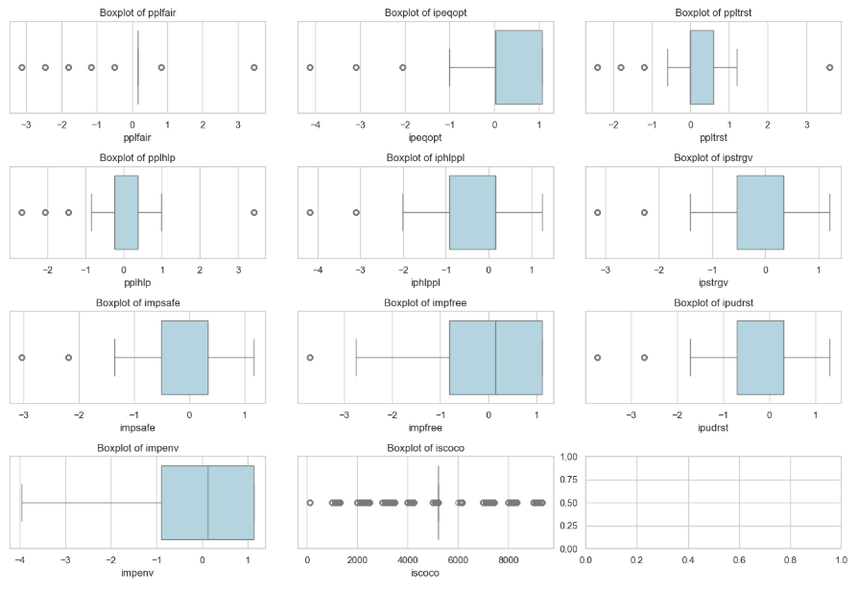
Appendix 4: Model 1 (Mixed-Effects with Fixed Country/Year and Random Trust Slope)
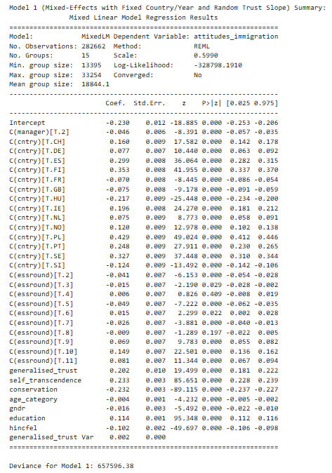

Appendix 5: Model 2 (Acceptance Composite, Mixed Effects with Country-Year Fixed Effects)
