Combined treatment of thymoquinone and embelin epigenetically attenuates epithelial-to-mesenchymal transition inducing tumor regression by efficiently suppressing stemness factors through EGFR-RAS-MAPK axis colonospheres

Supplementary files:
Supplementary Figure: 1
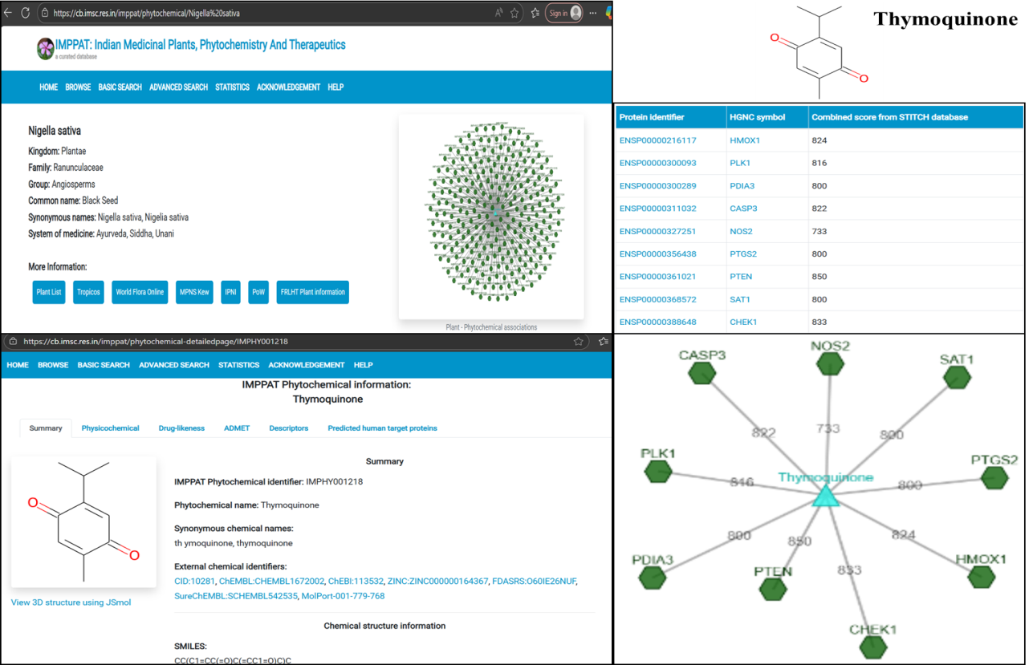
Supplementary Figure: 2
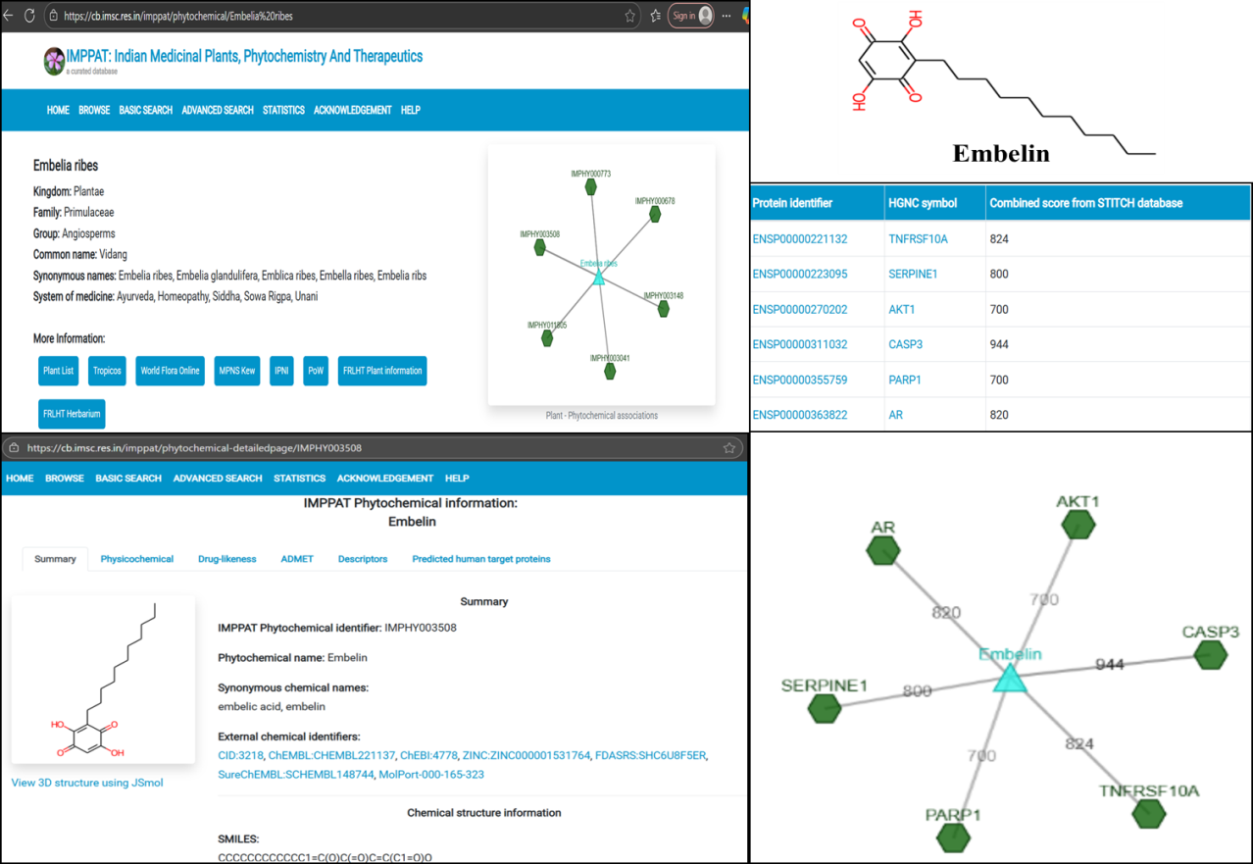

Supplementary Figure: 3
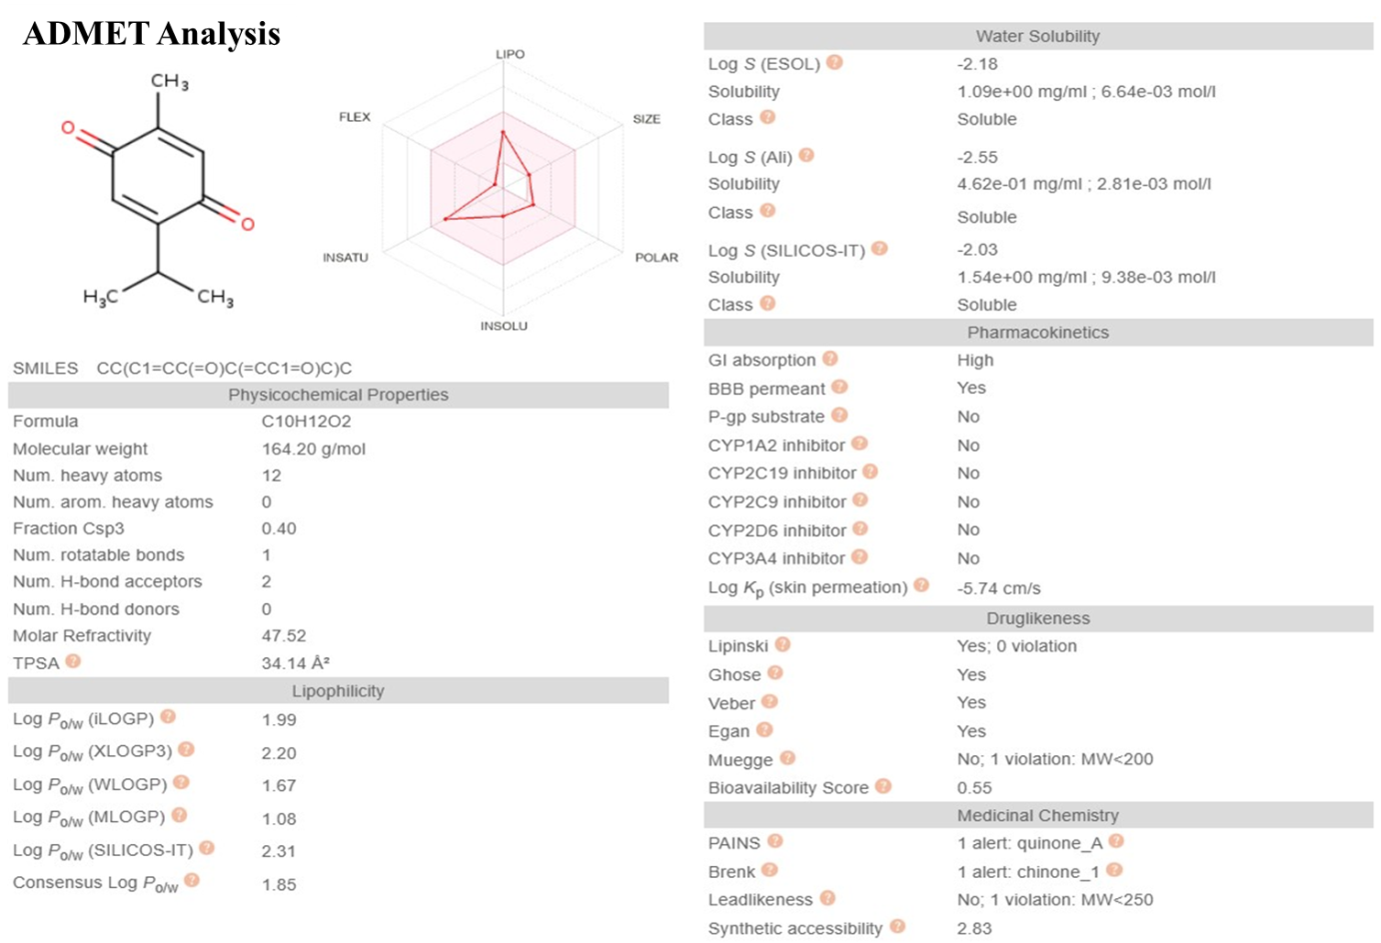
Supplementary Figure: 4

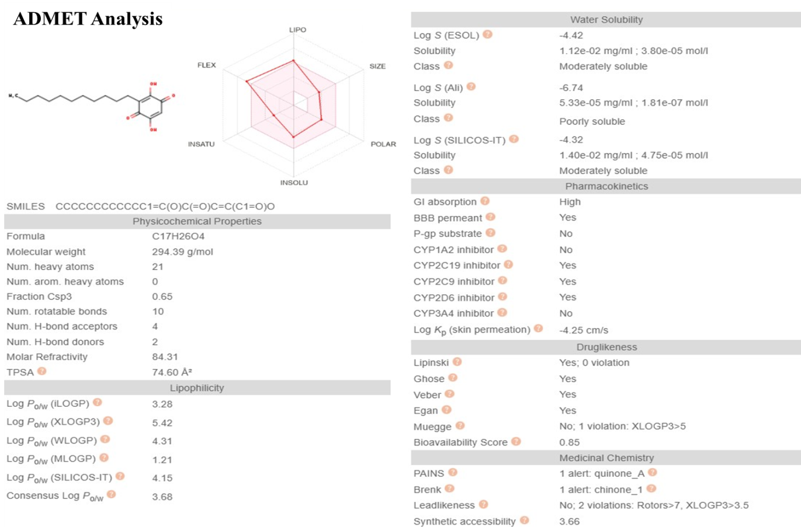

Supplementary Figure: 5
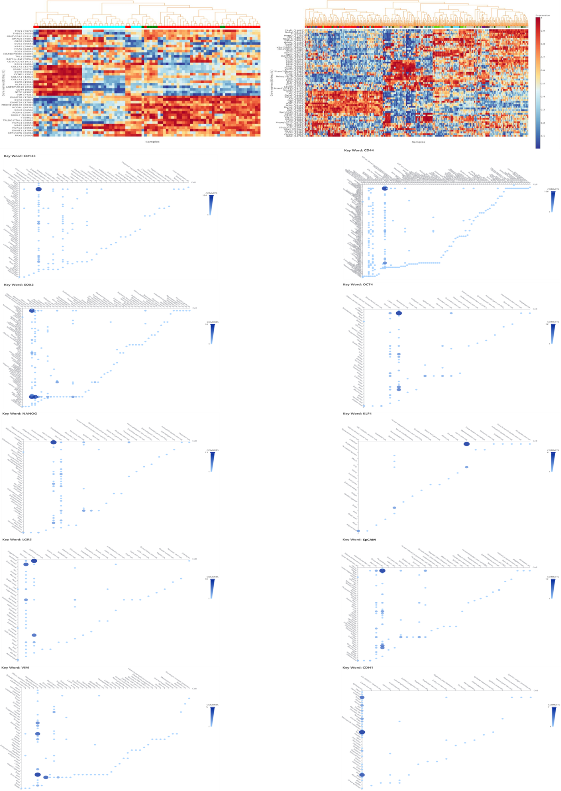

Supplementary Figure: 6
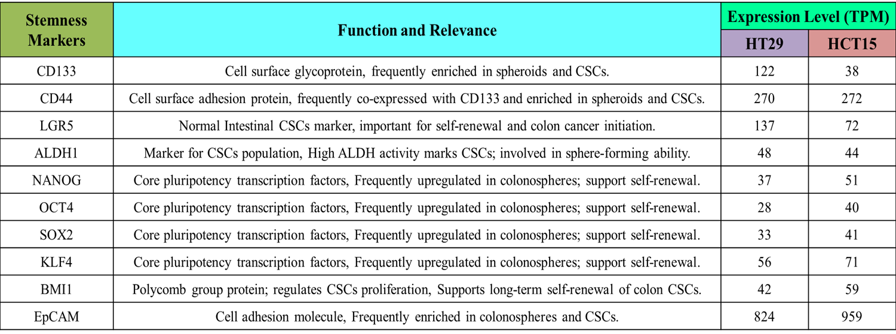
Supplementary Figure: 7
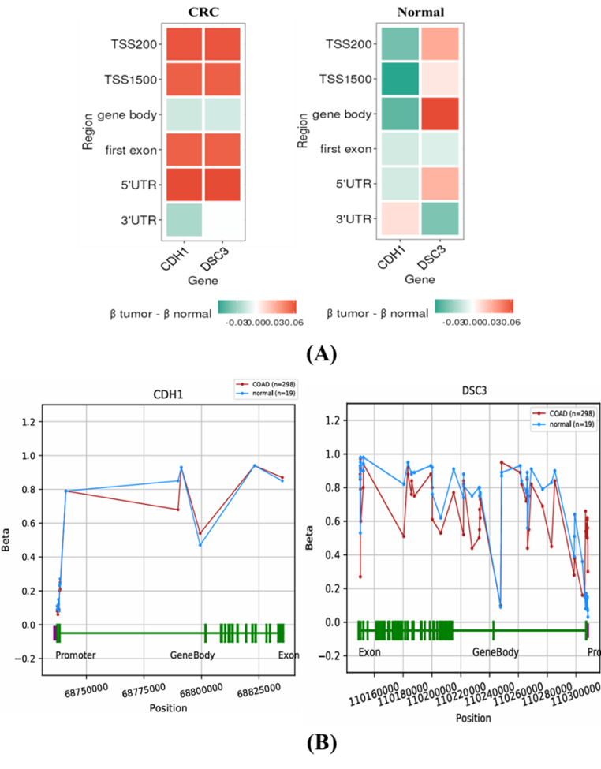

Supplementary Figure: 8

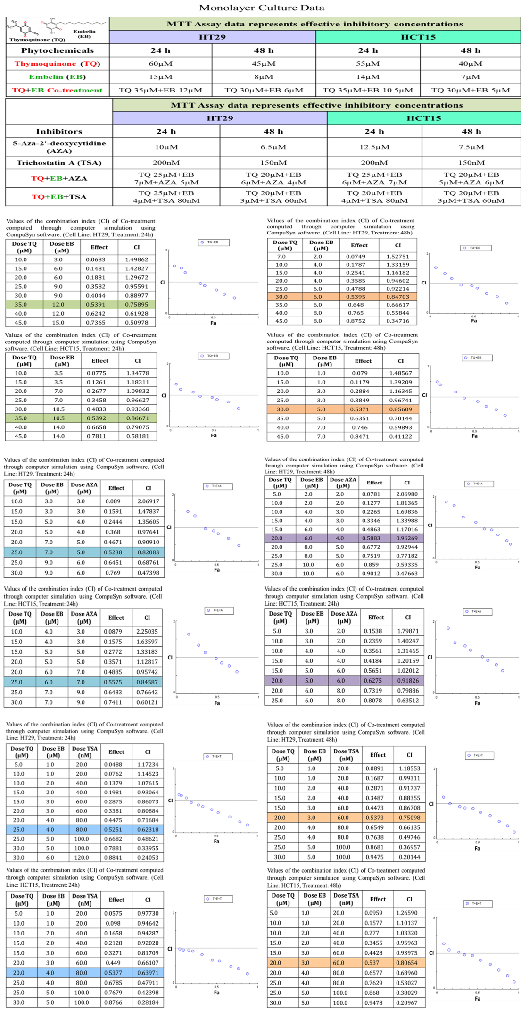

Supplementary Figure: 9
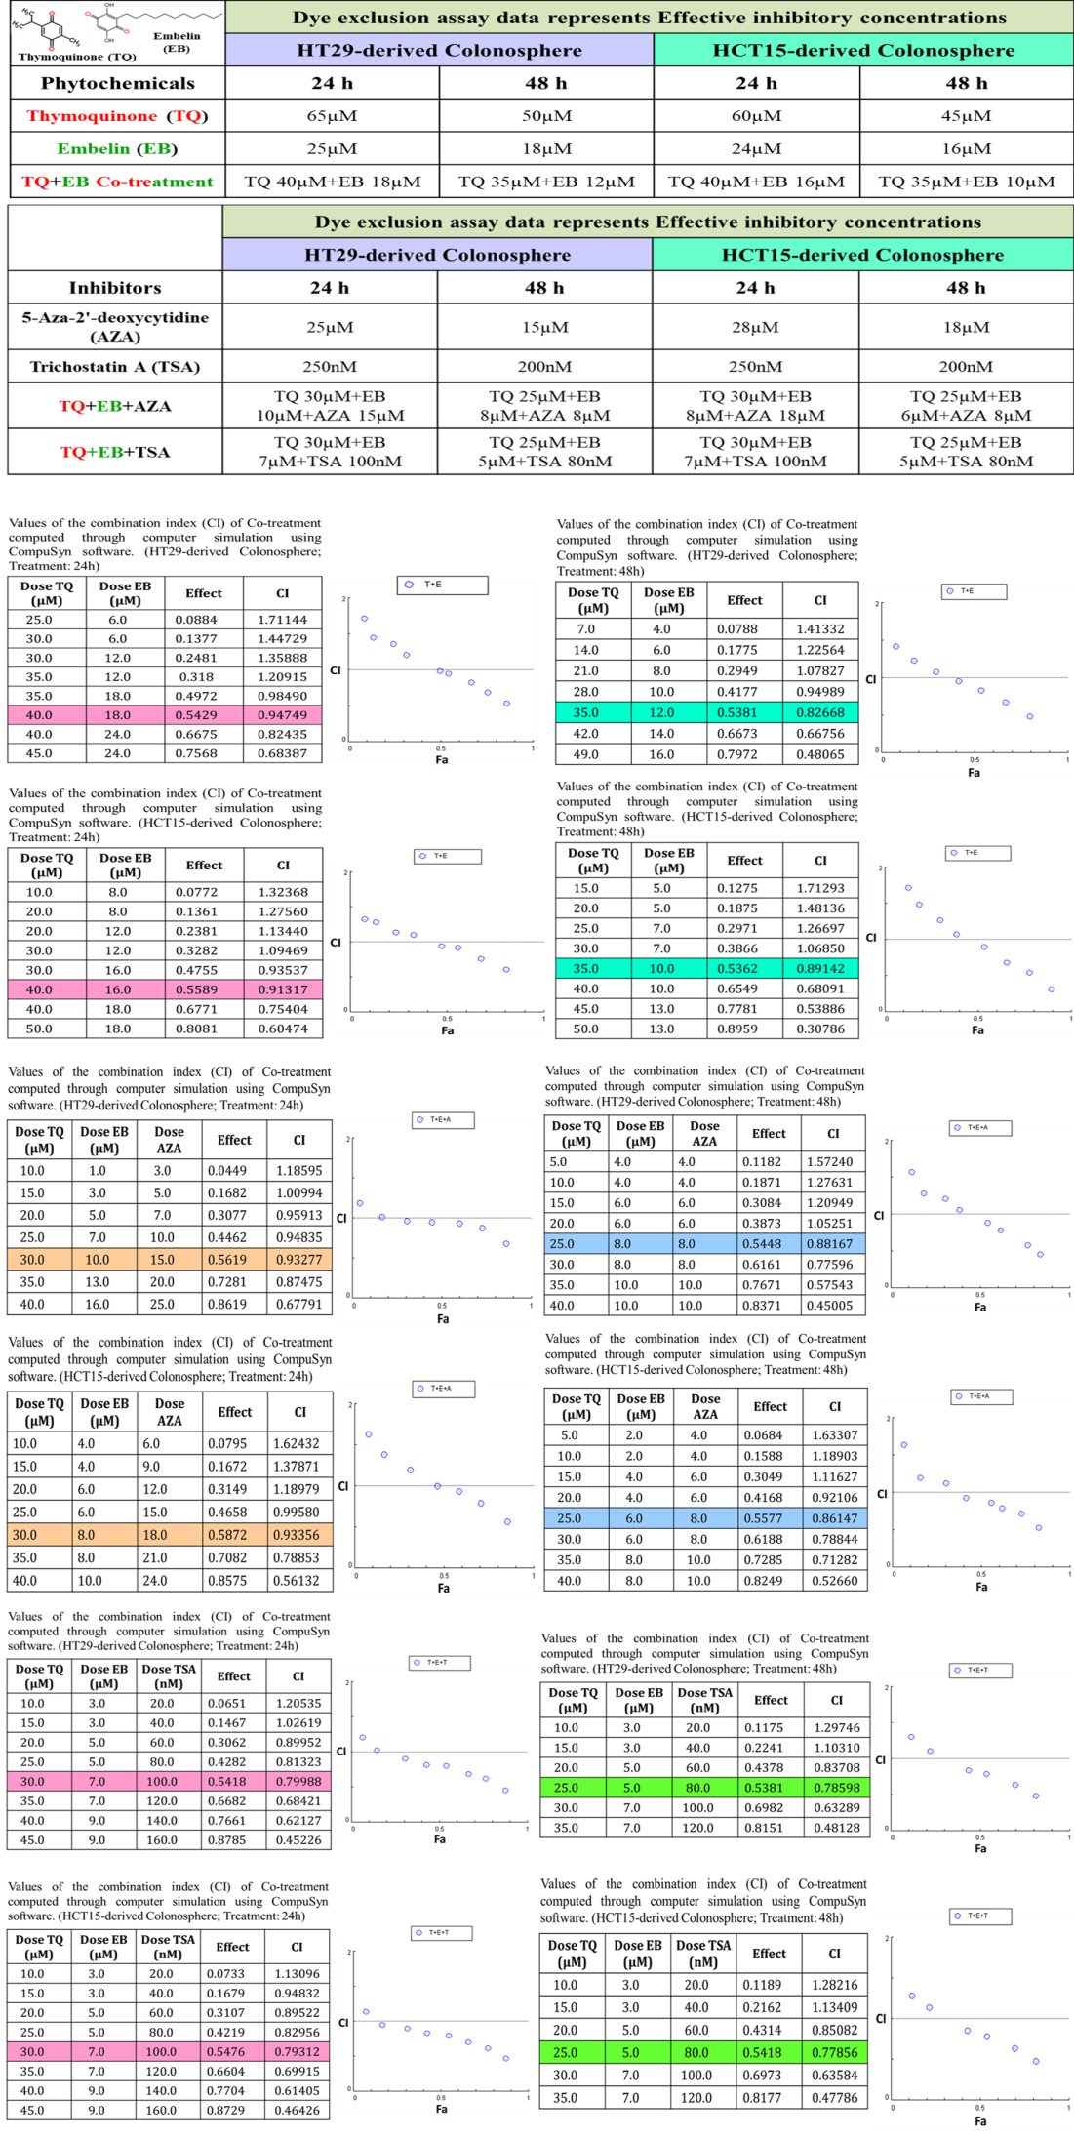

Supplementary Figure: 10
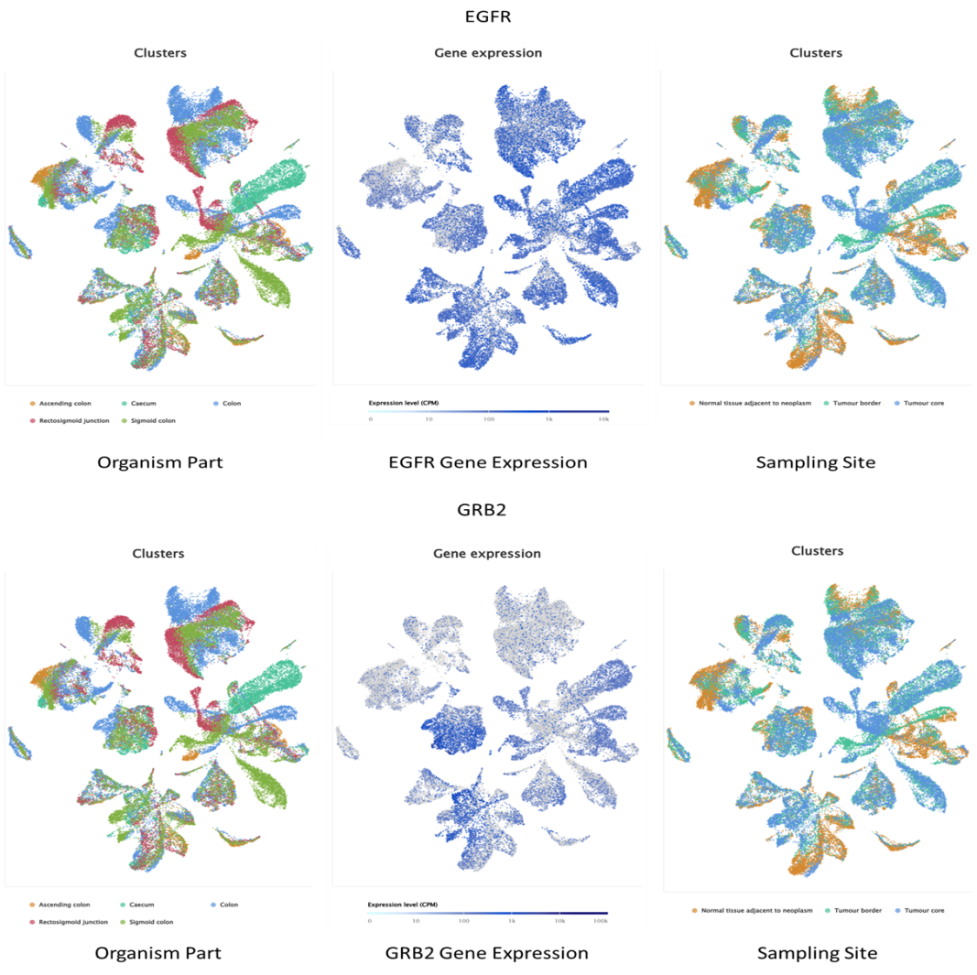
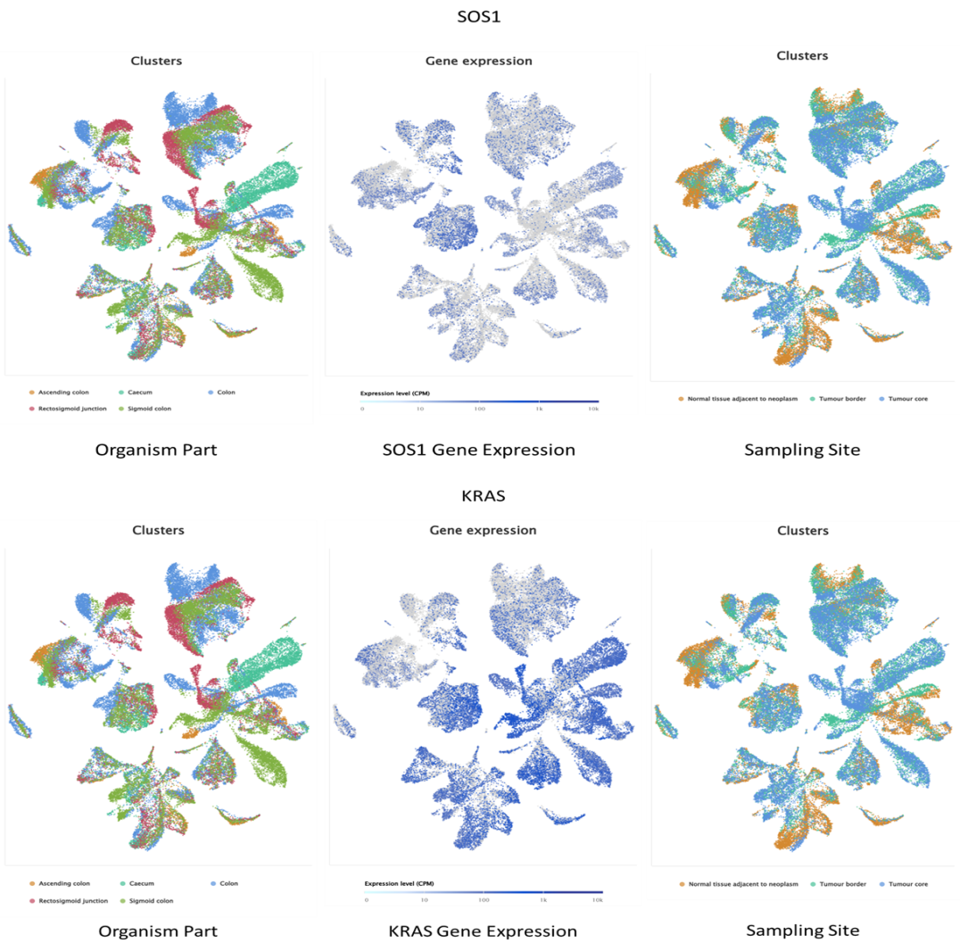

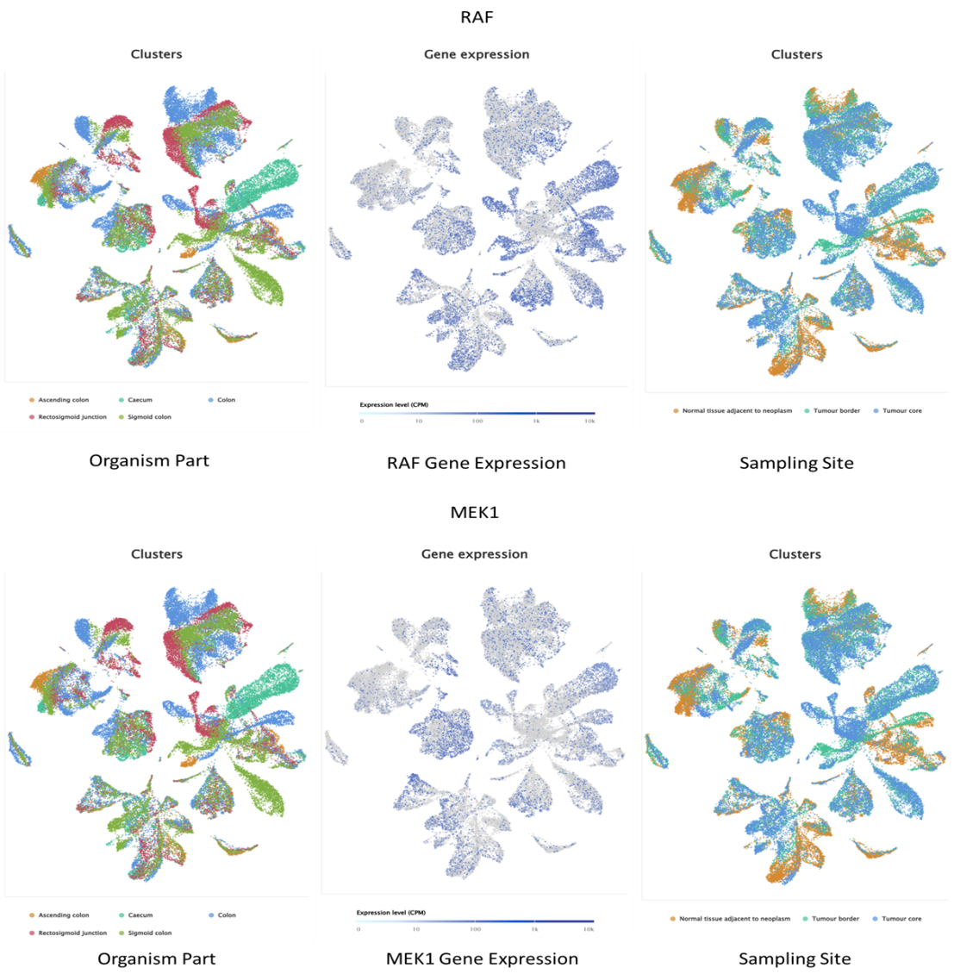
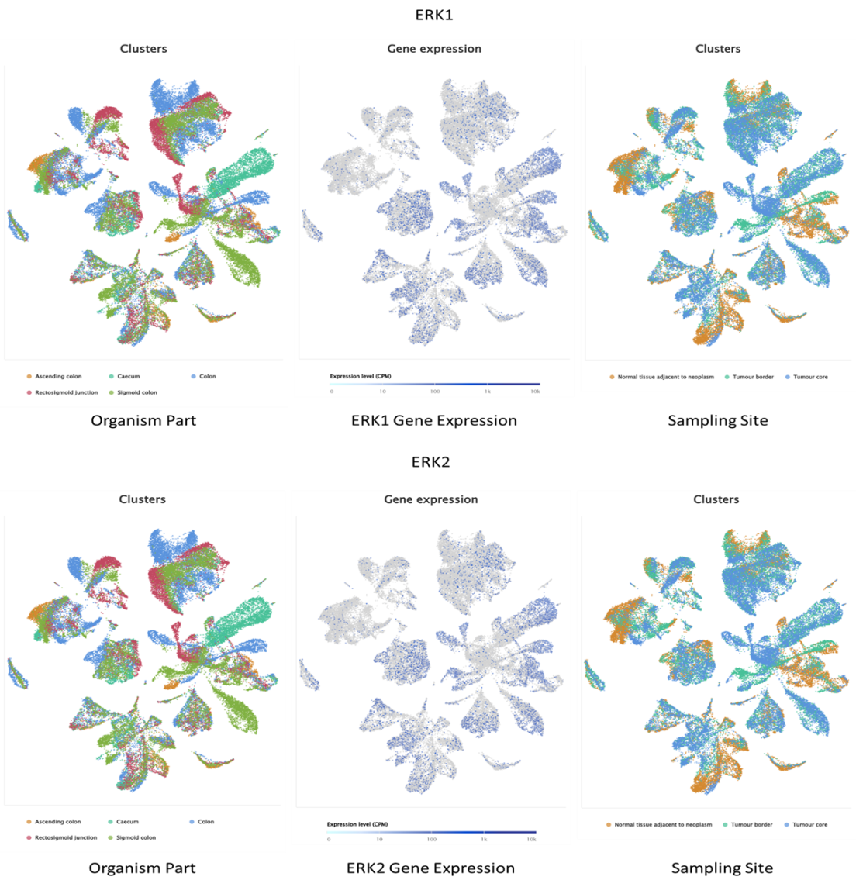
Supplementary Figure: 11
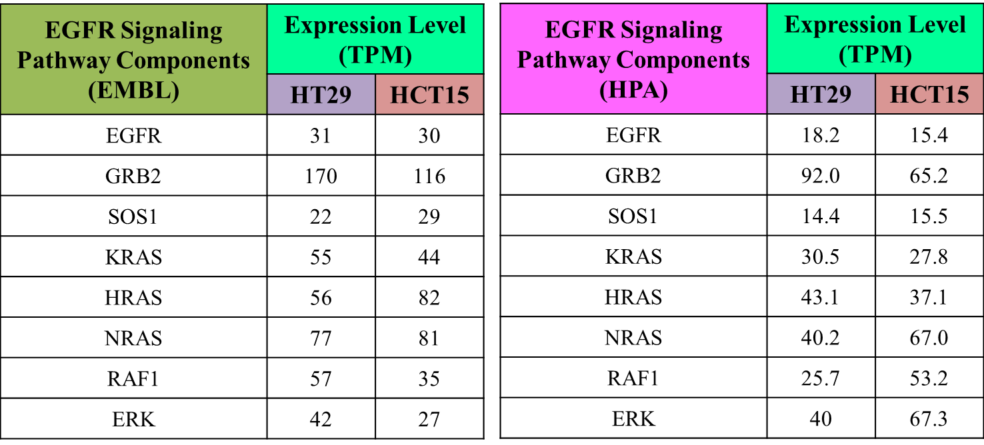

Supplementary Figure: 12
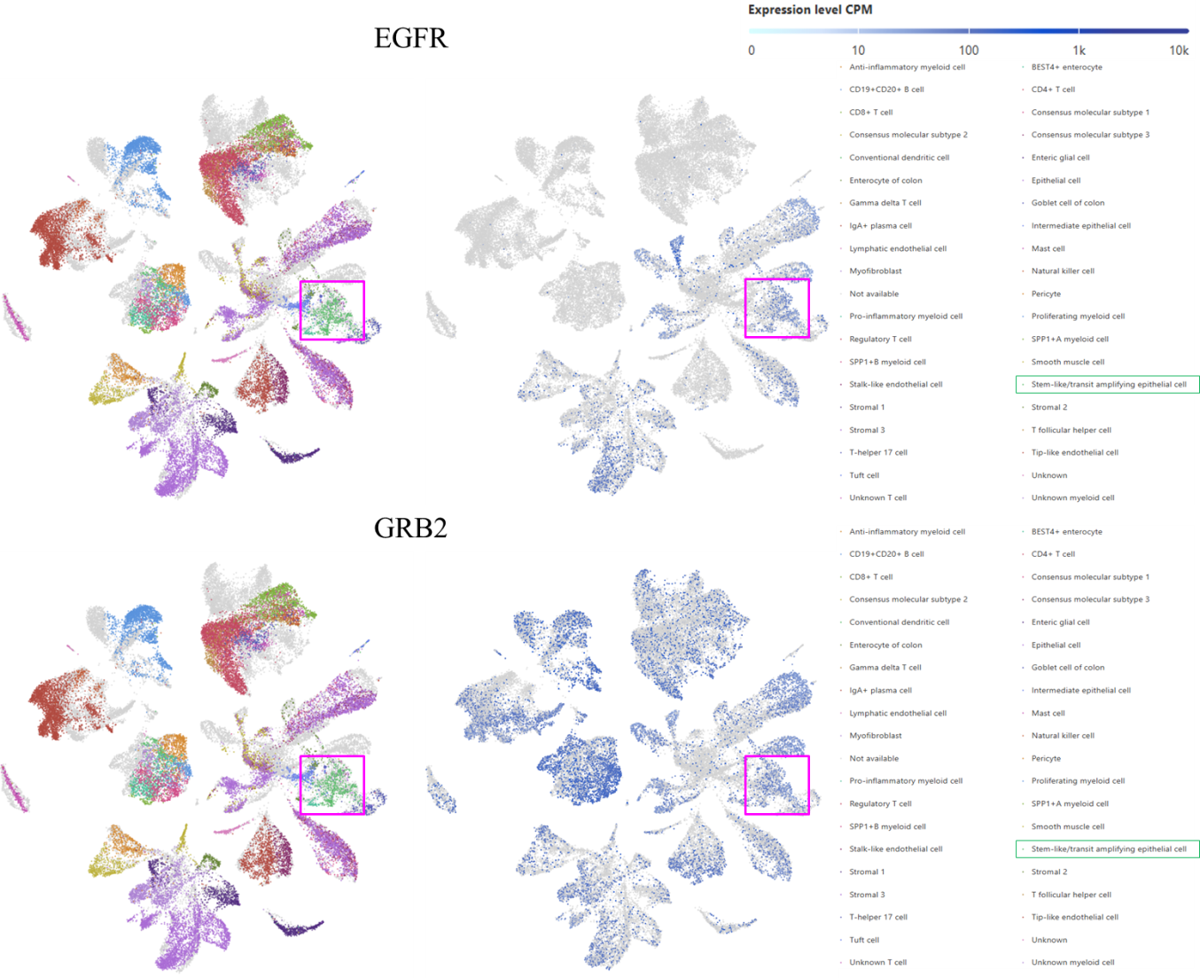
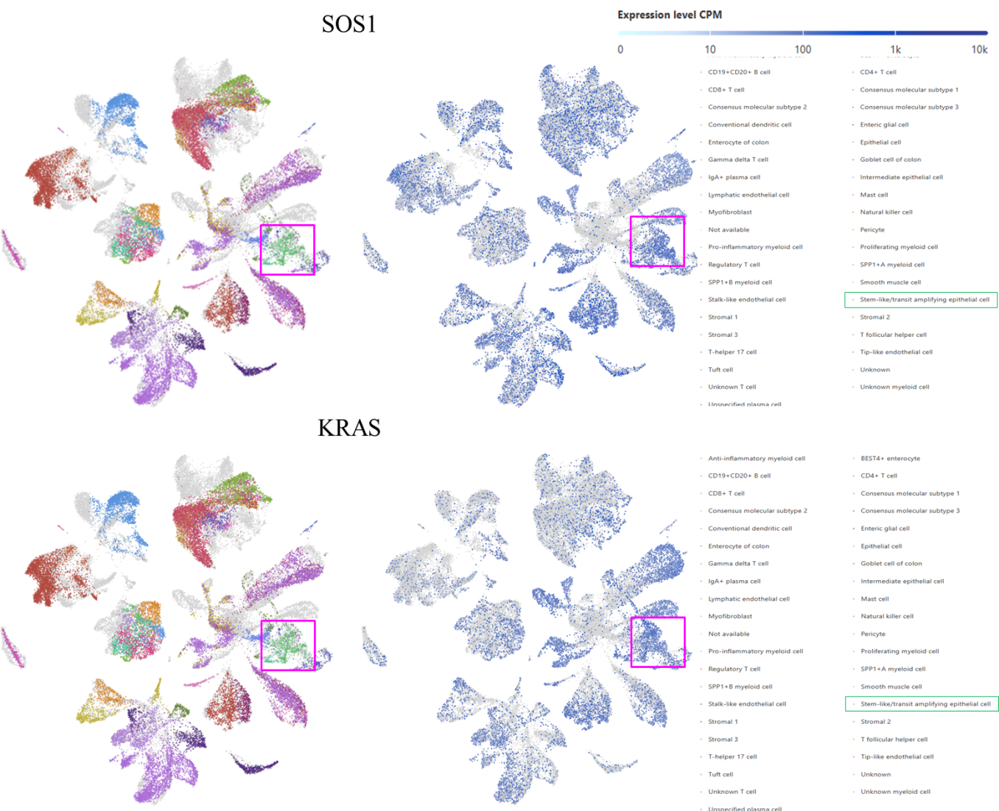
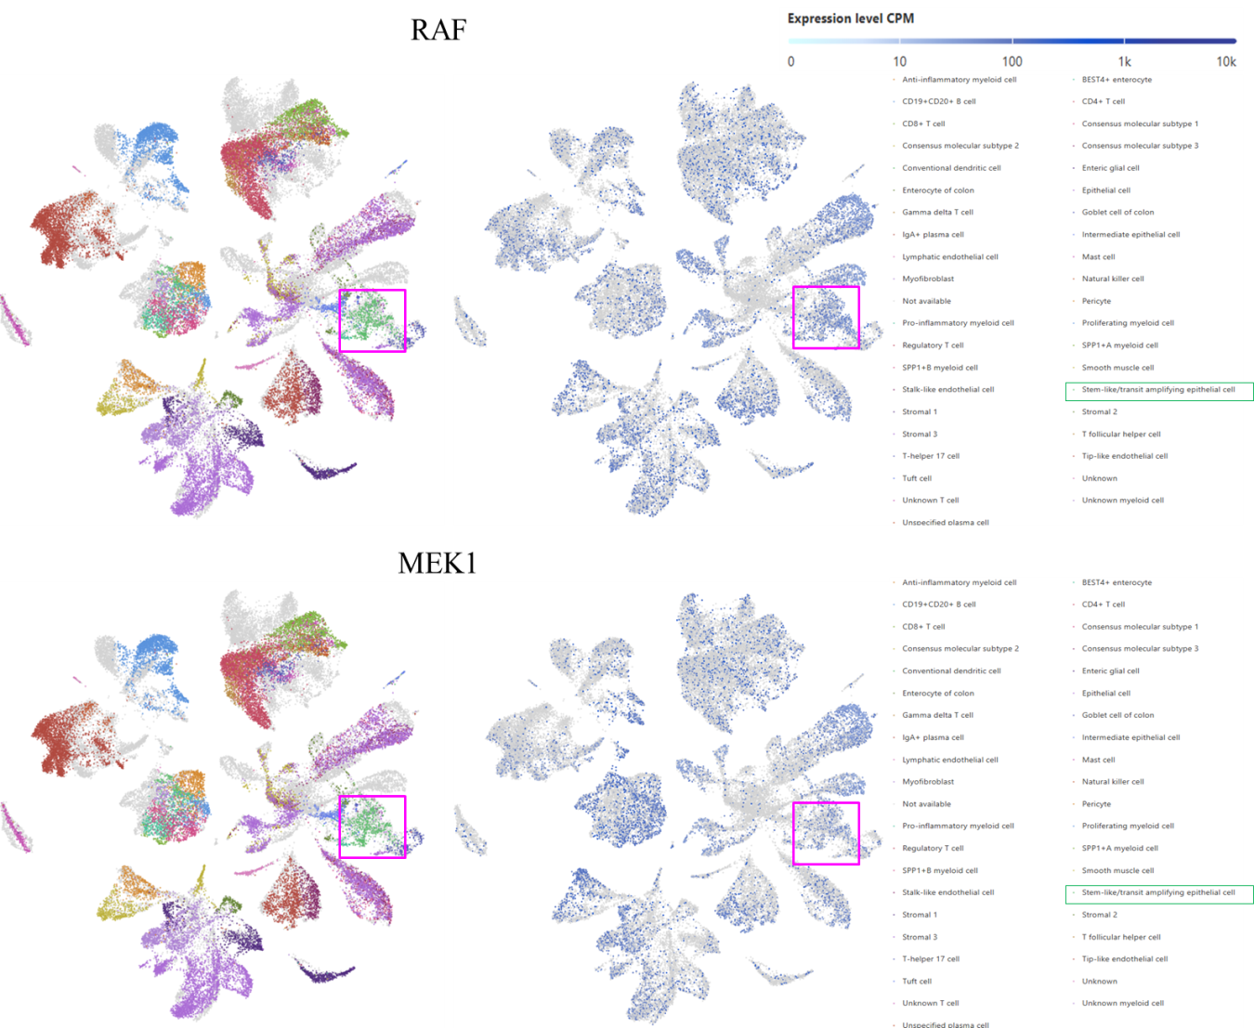
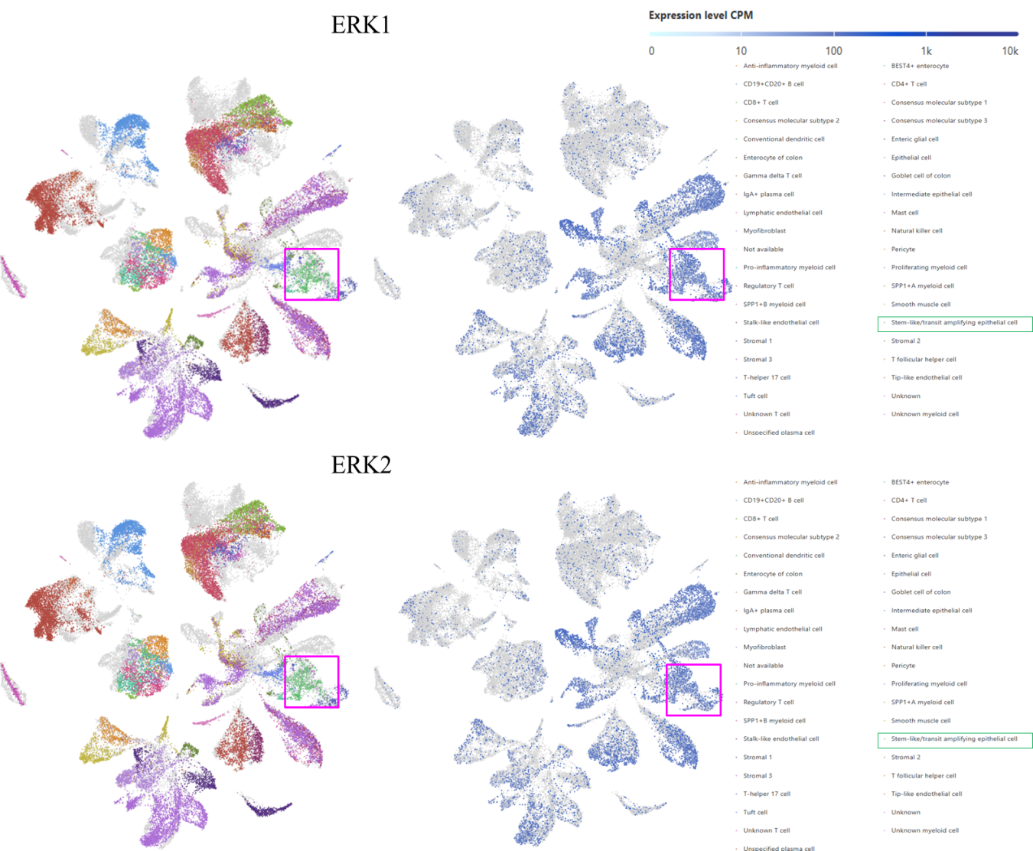

Supplementary Table: 1 Primer sequences for PCR analysis
Gene | Primer sequence
CD133 | F 5'-ACACTACCAAGGACAAGGCG-3'  R 5'-TCTCCAACGCCTCTTTGGTC-3'
CD44 | F 5'-CTGCAGGTATGGGTTCATAG-3'  R 5'-ATATGTGTCATACTGGGAGGTG-3'
OCT4 | F 5'-AGCAAAACCCGGAGGAGT-3'  R 5'-CCACATCGGCCTGTGTATATC-3'
SOX2 | F 5'-GGAAATGGAGGGGTGCAAAAGAGG-3'  R 5'-TTGCGTGAGTGTGGATGGGATTGGTG-3'
NANOG | F 5'-TCCTCCTCTTCCTCTATACTAAC-3'  R 5'-CCCACAATCACAGGCATAG-3'
KLF4 | F 5'-ACCCACACTTGTGATTACGC-3'  R 5'-CCGTGTGTTTACGGTAGTCC-3'
TWIST1 | F 5'-CCCACGCCCTGTTTCTTTGA-3'  R 5'-ACAGCCGCAGAGACCTAAAC-3'
SNAIL | F 5'-TCTAGGCCCTGGCTGCTACAA-3'  R 5'-ACATCTGAGTGGGTCTGGAGGTG-3'
SLUG | F 5'-AGTGATGGGGCTGTATGCTC-3'  R 5'-CTCCCTCCCTTTTCTTTCCCAG-3'
Vimentin | F 5'-GGTTCAGGTTTCATTCATGCCT-3'  R 5'-AGTTGGCTGTGTGTACTGCT-3'
E-cadherin | F 5'-CGAGAGCTACACGTTCACGG-3'  R 5'-GGGTGTCGAGGGAAAAATAGG-3'
ABCG2 | F 5'-ACGAACGGATTAACAGGGTCA-3'  R 5'-CTCCAGACACACCACGGAT-3'
SUV39H1 | F 5'-CCTGCCCTCGGTATCTCTAAG-3'  R 5'-ATATCCACGCCATTTCACCAG-3'
SUV39H2 | F 5'-TCTATGACAACAAGGGAATCACG-3'  R 5'-GAGACACATTGCCGTATCGAG-3'
G9a | F 5'-CCATGTAGCGACTTTCCCGGC-3'  R 5'-TGAAGCTCAAGAGGTGAC-3'
EZH2 | F 5'-TGCAGTTGCTTCAGTACCCATAAT-3'  R 5'-ATCCCCGTGTACTTTCCCATCATAAT-3'
MLL1 | F 5'-AAGAGCAGGTAAACTCTCTCCTC-3'  R 5'-TTCCTCTCCGTCGTACAATTTG-3'
MLL2 | F 5ꞌ-TTGTCCTTGGGACTCGAATCA-3ꞌ  R 5ꞌ-CCTGTCCAGATCCAACTCTTCT-3ꞌ
SMYD3 | F 5'-CGCGTCGCCAAATACTGTAGT-3'  R 5'-CAAGAAGTCGAACGGAGTCTG-3'
β-Actin | F 5'-CTGGAACGGTGAAGGTGACA-3'  R 5'-AAGGGACTTCCTGTAACAACGCA-3'
COL4A1 | F-5'-CAGGCACCCCATCTGTTGAT-3'  R-5'-CATTGCCTTGCACGTAGAGC-3'
THBS2 | F-5'-CGTGGACAATGACCTTGTTG-3'  R-5'-GCCATCGTTGTCATCATCAG-3'
SPP1 | F-5'-TGAGAGCAATGAGCATTCCGATG-3'  R-5'-CAGGGAGTTTCCATGAAGCCAC-3'
DNMT1 | F 5′-GGCTGAGATGAGGCAAAAAG-3′  R 5′-ACCAACTCGGTACAGGATGC-3′
DNMT3A | F 5′-AATGTGAATCCAGCCAGGAAAGGC-3′  R 5′-ACTGGATTACACTCCAGGAACCGT-3′
DNMT3B | F 5′TATTGATGAGCGCACAAGAGAGC-3′  R 5′-GGGTGTTCCAGGGTAACATTGAG-3′
ITGB1 | F 5′ CAAATTGTGGGTGGTGCACA 3′  R 5′ TGGAGGGCAACCCTTCTTT 3′

