Supplementary Information
Dual-Heterojunctions Enhanced High Sodium Storage Capacity and Rapid Reaction Kinetics of Na₃V₂(PO₄)₂F₃ Cathode for Sodium-Ion Batteries
Shoujie Guo¹, Zixuan Xu¹, Haixiang Mu¹, Yukun Guo¹, Qingyin Shen¹, Yi Sun¹, Qinyao Zhang¹, Bo Zhang², Ming Qin², Wenjun Fa^{1,3}*, Pinjiang Li¹* and Lijun Wu¹*
1 M.S. Shoujie Guo, Prof. Lijun Wu, Prof. Pinjiang Li, Prof. Wenjun Fa, B.S. Qingyin Shen, B.S. Zixuan Xu, B.S. Yi Sun, B.S. Yukun Guo, B.S. Haixiang Mu, B.S. Qinyao Zhang.
College of Chemistry and Chemical Engineering, Xuchang University, Xuchang 461000, China
2 B.S. Bo Zhang, B.S. Ming Qin.
College of Electrical Engineering, Xuchang University, Xuchang 461000, China
3 Institute of Laser Manufacturing, Henan Academy of Sciences, Zhengzhou 450046, China
* Prof. Lijun Wu,
wlj197908@xcu.edu.cn
Prof. Wenjun Fa
fa_wenjun@163.com
Prof. Pinjiang Li
12008012@xcu.edu.cn

Figure S1 The XRD data of V₂O₃, Na₃V₂(PO₄)₂F₃, NVPF/C, VO/NVPF and VO/NVPF/C.

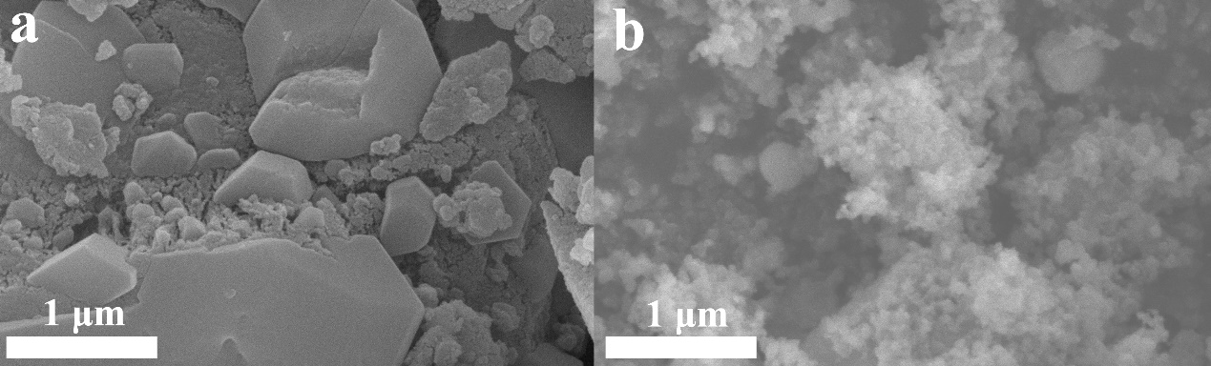
Figure S2 FESEM for a) VO/NVPF and b) NVPF/C.

Figure S3 The results of EDS for a) NVPF/C, b) VO/NVPF and VO/NVPF/C.

Figure S4 The fine spectrum of XPS for F1s.

Figure S5 Specific capacity-voltage curves at various rate density for (a) VO/NVPF/C, (b) NVPF/C and (c) VO/NVPF versus Na metal.

Figure S6 The linear fitting of charging and discharging peak currents at 3.56 V and 3.22 V versus square of scan rates for 0.2 mV s⁻¹, 0.4 mV s⁻¹, 0.6 mV s⁻¹, 0.8 mV s⁻¹, and 1.0 mV s⁻¹, (The slope is corresponding to 0.4463z^{3/2}F^{3/2}C_{Na}AR^{-1/2}T^{-1/2}D_{Na}^{1/2}).

Figure S7 The equivalent circuit diagram before 1400 cycles.

