Table 1. Ciguatera Fish Poisoning cases and mean monthly/annual incidence rate/100,000 people combined for three selected study areas on Ambae Island
 | 2015 |  | 2016 |  | 2017 |  | 2018 | 2019 | 2020 |  | 2021 |  | 2022 |  | 2023 |  | 2024 | Total | Pop | Mean Incidence
Ambae Island | 51 |  | 50 |  | 91 |  | 29 | 39 | 43 |  | 43 |  | 40 |  | 46 |  | 117 | 549 | 8,645 | 635
 | J | F |  | M |  | A | M | J | J | A |  | S |  | O | N | D |  | Total | Pop | Mean Incidence
Ambae Island | 35 | 46 |  | 33 |  | 60 | 54 | 35 | 32 | 42 |  | 30 |  | 60 | 76 | 33 |  | 536 | 8,645 | 517

TABLE 2. Ciguatera Fish Poisoning cases and mean monthly/annual incidence rate/100,000 for each study area.
Area Council | 2015 | 2016 | 2017 | 2018 | 2019 | 2020 | 2021 | 2022 | 2023 | 2024 | Total | Pop | Mean Incidence
East Ambae | 12 | 5 | 20 | 10 | 33 | 0 | 0 | 3 | 1 | 0 | 84 | 2,075 | 405
North Ambae | 18 | 14 | 54 | 7 | 0 | 2 | 10 | 0 | 2 | 47 | 154 | 3,249 | 474
West Ambae | 21 | 31 | 17 | 12 | 6 | 41 | 33 | 37 | 43 | 70 | 311 | 3,321 | 937
 | J | F | M | A | M | J | J | A | S | O | N | D | Total | Pop | Mean Incidence
East Ambae | 10 | 8 | 3 | 5 | 8 | 6 | 3 | 4 | 5 | 15 | 10 | 6 | 83 | 2,075 | 333
North Ambae | 3 | 13 | 7 | 25 | 26 | 8 | 9 | 21 | 2 | 12 | 12 | 10 | 148 | 3,249 | 380
West Ambae | 22 | 25 | 23 | 30 | 20 | 21 | 20 | 17 | 23 | 33 | 54 | 17 | 305 | 3,321 | 765

TABLE 3. Local Remedies used by local people on Ambae to treat symptoms of Ciguatera Fish Poisoning

Name |  |  | Parts Use | Preparations | Symptoms | Photo
Scientific name | Common Name | Local Name
Ageratum conyzoides | Tropical white weed | Uruten Bweta | Leaves | Gather the leaves from the plant, rub them between your palms, and squeeze the juice into a spoon or cup. Then, drink. | Relieve joint and muscle pain. Enhance strength. | 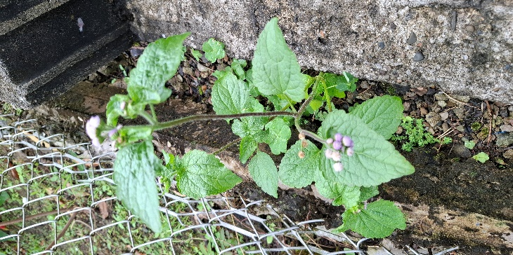
Crinum asiaticum | Seashore Lily | Seashore Lily (Tamwat maita) | Leaves/Roots | Leaves are boiled to extract the liquid, which is then strained and ready to drink. Drink one cup per day until the pain subsides. Sometimes, leaves are crushed to extract the liquid.  Roots are cleaned, boiled, and consumed. | Boost your body strength and alleviate body pain. | 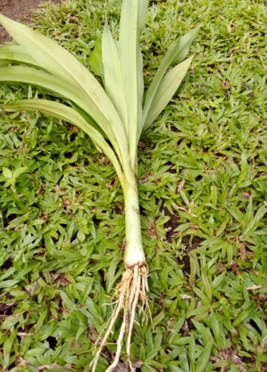
Clerodendrum inerme | Wild Jasmine | Babalau Tree | Young toppings (Leaves) | Pinch the four toppings and eat. | Relieve body pain, especially joint pain. | 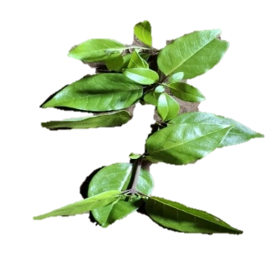
Geophila repens | Snake Pennywort | Snake Pennywort (Vasilo Vaga) | Leaves | Rub the leaves between your palms, then squeeze them into a spoon or cup, and drink. | Relieve body pain and build strength. Alleviate diarrhea and vomiting. | 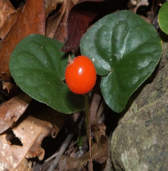
Dioscorea villosa | Wild Yam | Wild Yam | Leaves | - Boil the leaves, strain, keep warm, and drink.  - The leaves are also cooked with the fish to reduce toxins. | Relieve pain and build body strength. | 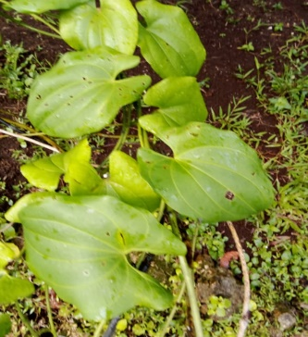
Erythrina variegata | Tiger’s Claw | Rara | Bark | Remove the inner bark, crush it, and squeeze out the juice, then drink. | Relieve muscle pain and build strength. Minimize diarrhea and vomiting. | 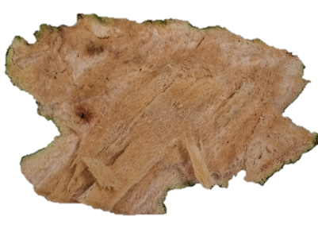
Barringtonia edulis | Cut Nut | Navele | Bark | Remove the inner bark, smash it, squeeze to extract the juice, then drink. | Relieve body pain and build strength. Alleviate diarrhea and vomiting. | 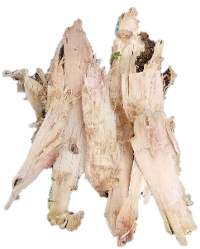
Annona muricata | Soursop | Karasol | Leaves | Boil the leaves, strain them, keep Warm, and then drink. | Relieve itchy sensations, joint pain, and overall weakness. | 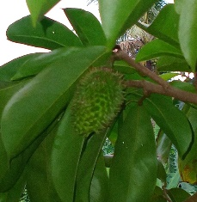
Merremia peltata | Cook’s Glory | Tabwatabwa Maita | Vines/leaves | Cut the vines and drain the milky liquid into a spoon or cup, then drink. | Joint pain, toothache, diarrhea, vomiting, body aches, and weakness. | 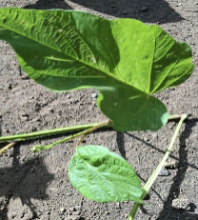
Cocos nucifera | Red Dwarf Coconut | Niu Pita | Inner part of the husk | The inner part of the coconut husk is boiled, cooled to room temperature, and drunk. | Joint pain, toothache, diarrhea, vomiting, and body weakness. | 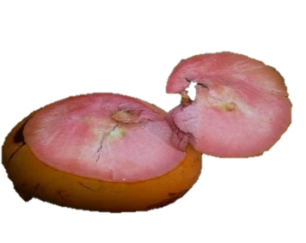
Ficuss wassa | Ripening Fruit | Vovohe | Water in the roots | The water collected by the tree roots is filtered into a cup and then drunk. | Diarrhea, joint pain, and body aches | 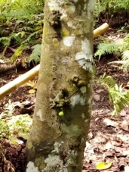
Cordia dichotoma | Glue berry tree | Gaibulu/Vwaibulu | Bark | Remove the inner part of the skin, mash it, and squeeze to extract the juice, then drink. | Diarrhea, joint pain, and body aches | 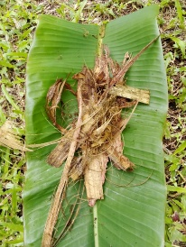
Cordia dichotoma | Glue berry tree | Gaibulu/Vwaibulu | Leaves | Leaves are boiled and drunk. | Reduce symptoms such as tinkling and itching, joint/body pain, coldness, and diarrhea. | 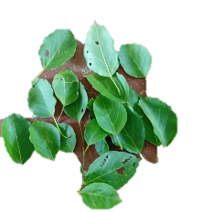
Plumeria | Frangipani | Frangipani | Leaves | Broke the leaves, collected the milky liquid in a cup, and drank it. It can also be mixed with coconut water and drunk. | Relieve muscle pain and increase strength. Reduce diarrhea and vomiting. | 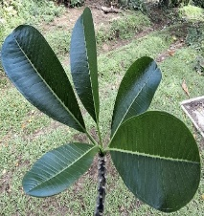
Carica papaya | Papaya | Pawpaw (Uhi Gigiri) | Fruits | Young fruits peel and eat raw | Diarrhea, joint pain, and body pain | 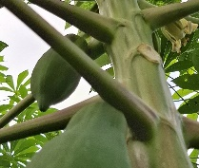
Carica papaya | Papaya | Pawpaw (Uhi Gigiri) | Roots | Roots are clean, crushed, and the juice is extracted and drunk. | Diarrhea, joint pain, and body aches | 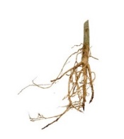
Carica papaya | Papaya | Pawpaw (Uhi Gigiri) | Leaves/flowers | Young leaves and flowers are boiled, then cooled to room temperature and consumed. Leaves can also be wrapped in other leaves and roasted over an open fire, then squeezed to extract juice. The juice is mixed with coconut water and then drunk. | Diarrhea, joint/body pain, an itchy feeling, and weakness | 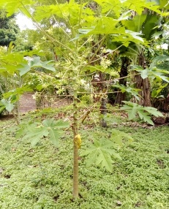
Cocos nucifera | Coconut | Coconut (Niu) | Milky juice | Dry coconut flesh is produced, and the milk is extracted and mixed with raw eggs, which are then consumed. | Reduce itchy feelings, joint pain, and body weakness. | 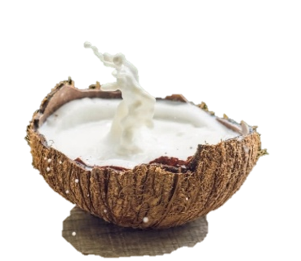
Spondias dulcis | Golden Apple | Naus | Young topping/leaves | Pinch eight toppings and eat. Leaves are also crushed | Reduce body pain and increase strength. Reduce diarrhea and vomiting. | 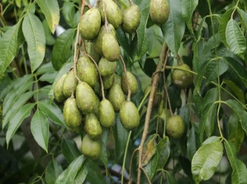
Polyscias scutellaria | Plum aralia | Nalalas (big leaf) | Leaves/young toppings | Boil the leaves and wash your body. Young toppings can be eaten as well. | Relieve the itchy feeling on your body. | 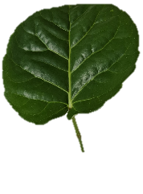
Hibiscus tiliaceus | Sea hibiscus | Burau (Bwatvae) | Leaves/toppings | Four young toppings | Reduce diarrhea and vomiting | 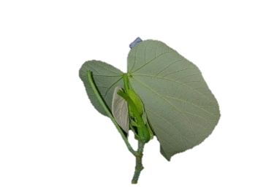
Monrinda citrifolia | Noni | Noni (Guresi) | Fruit | Fruit is crushed, liquid is extracted, and the liquid is drunk. | Reduce diarrhea and relieve joint pain and muscle pain. | 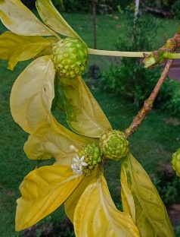
Saccharum officinarum | Red Sugarcane | Menahi Batai (Toi) | Juice from the sugarcane | Crushed to extract the juice and drink | Relieve diarrhea, joint pain, and body pain | 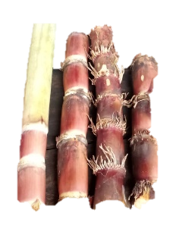
Inocarpus fagifer | Chestnut | Namabwe (Mwabwe) | Inner editable part of the Fruit | Crushed the inner part of the fruit, extracted juice, and drank | Weakness, body pain, an itchy feeling, and diarrhea | 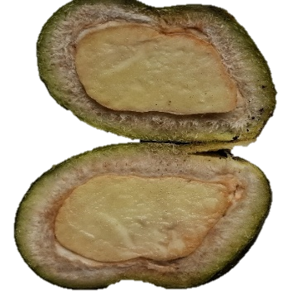
Euodia hortensis | Island musk | Bwangi | Young toppings/leaves | Pinched eight toppings and ate | Relieve cold, itchy feeling, body aches, diarrhea, and vomiting. | 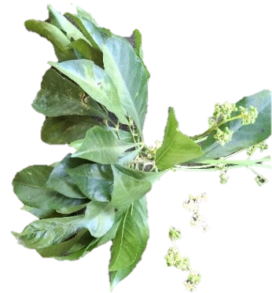
Terminalia catappa | Tropical almond | Natapoa (Tavoa) | Young toppings/leaves | Pinch 4 or 8 toppings from the Natapoa plant and eat. | Relieve joint pain, an itchy feeling, diarrhea, and vomiting. | 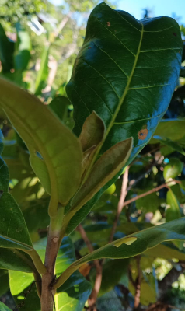
Psidium guajava | Guava | Guava | Fruits | Four young fruits chewed and swallowed the juice, then spat out the soft, crushed remains. | Relieve joint pain and reduce symptoms such as itching, diarrhea, and vomiting. | 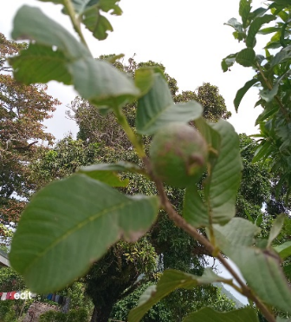
Photo: Lead author’s own

