Narcissistic Self-Sorting and Enhanced Luminescence via Catenantion in Water

Supporting Information
Table of Contents

1. General Methods 2
2. Synthetic Procedures 3
3. Characterization of (1a²⁺·2a)₂, (1a²⁺·2b)₂ and (1a²⁺·2c)₂ by NMR and HRMS 9
4. Characterization of the self-assembled products containing 1b²⁺ by NMR and HRMS 31
5. Characterization of (1a²⁺·2e) by NMR and HRMS 49
6. Self-sorting Investigations 53
7. Yields of the [2]catenanes in Solutions 81
8. Variable Temperature ¹H NMR Spectroscopy 86
9. X-ray Crystallography 96
10. UV−vis spectra 103
11. References 103

1. General Methods
All reagents and solvents were purchased from commercial sources and used without further purification. Compounds 3b¹ and 3c² were prepared by using reported procedures. Manipulations were performed under a normal laboratory atmosphere unless otherwise noted. Nuclear magnetic resonance (NMR) spectra were recorded at ambient temperature using Bruker AVANCE III 400, Bruker AVANCE III 500, or Agilent DD2 600 spectrometers, with working frequencies of 400/500/600 and 100/125/150 MHz for ¹H and ¹³C, respectively. Chemical shifts are reported in ppm relative to the residual internal non deuterated solvent signals (D2O: δ = 4.79 ppm, DMSO-d6: δ = 2.50 ppm, CD3CN: δ = 1.94 ppm). High-resolution mass spectra (HRMS) were measured by using a SHIMADZU liquid chromatograph mass spectrometry ion trap time of flight (LCMS-IT-TOF) instrument. X-ray crystallographic data were collected on a Bruker D8 Venture. UV/Vis spectra were recorded on a Agilent Cary 5000 instrument. Fluorescence spectra were recorded on a Agilent Cary eclipse instrument. The absolute photoluminescence quantum yields (PLQY) were performed on a steady state transient spectrometer FLS1000. Analytical HPLC-MS experiments were performed on an Agilent 1250 instrument equipped with a diode array detector, a InfintyLab Poroshell EC-C18 column (4.6 x 50 mm, 2.7 μm). The following acetonitrile / water (both containing 0.1% acid) gradient was used: In the beginning, 1/9 acetonitrile/water was used as the fluent phase, followed by gradually increasing the acetonitrile content from 10% to 100% over the course of 15 min. The detection wavelength was 250 nm.

2. Synthetic Procedures
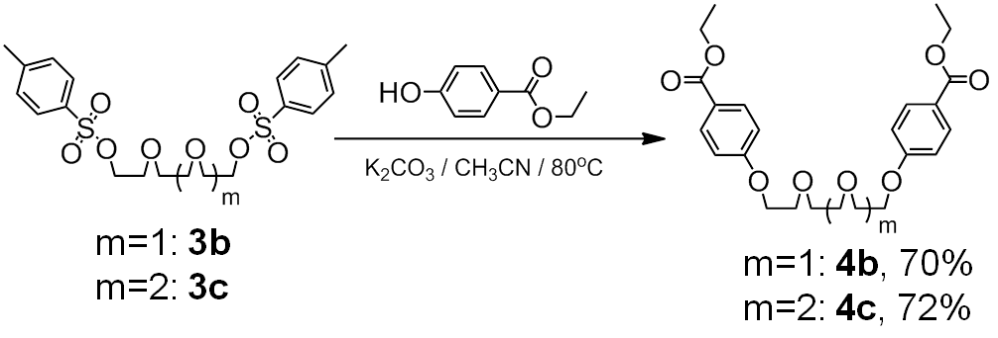
Scheme S1. Synthesis of 4b and 4c.
4c: 3c (2mmol, 1.0g) and Ethylparaben (4.4mmol, 731.1mg) were dissolved in 40ml anhydrous acetonitrile in a 100 ml round bottom flask. In a nitrogen atmosphere, K₂CO₃ (8.8mmol, 1.2g) was than added into the flask. The mixture was heated at 80 °C for 12 h. After the completion of reaction, the solution was cooled to room temperature. The precipitates were removed by filtration. The filtrate was connected and most of the solvent was removed under vacuum. The residue was poured into water, which was then extracted with ethyl acetate. The resulting organic layer was washed with water (3 x 50 mL), dried over anhydrous Na₂SO₄, and then concentrated to give the crude product. Purification by flash column chromatography (petroleum ether/ethyl acetate (4:1); silica gel, 200-300 mesh) yielded the white solid-state product 4c (686.2 mg, 70 %). ¹H NMR (400 MHz, CDCl₃): δ = 7.99 (d, 4H), 6.93 (d, 4H), 4.35 (q, 4H), 4.17 (t, 4H ), 3.88 (t, 4H), 3.72(m, 8H), 1.39 (t, 6H). ¹³C NMR (400 MHz, CDCl₃): δ = 166.3, 162.5, 131.5, 123.1, 114.1, 70.9, 70.7, 69.6, 67.5, 60.6, 14.4. HRMS: m/z calculated for C₂₄H₃₀O₈Na⁺ ([M + Na]⁺): 469.1817; found: 469.1833.
4b: 4b was obtained by using a similar procedure, whose yield is 72 %. ¹H NMR (400 MHz, CDCl₃): δ = 7.98 (d, 4H), 6.92 (d, 4H), 4.34 (q, 4H), 4.17 (t, 4H ), 3.88 (t, 4H), 3.76(s, 4H), 1.38 (t, 6H). ¹³C NMR (500 MHz, CDCl₃): δ = 166.3, 162.4, 131.5, 123.1, 114.1, 70.9, 70.0, 67.5, 60.6, 14.4. HRMS: m/z calculated for C₂₆H₃₄O₉Na⁺ ([M + Na]⁺): 513.2066; found: 513.2095.
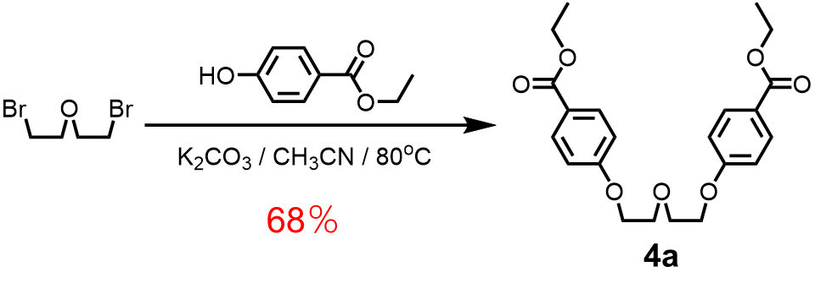
Scheme S2. Synthesis of 4a.
4a：2,2'-Dibromodiethyl ether (2mmol, 463.8mg) and Ethylparaben (4.4mmol, 731.1mg) were dissolved in 40ml anhydrous acetonitrile in a 100 ml round bottom flask. In a nitrogen atmosphere, K₂CO₃ (8.8mmol, 1.2g) was than added into the flask. The mixture was heated at 80 °C for 24 h. After the completion of reaction, the solution was cooled to room temperature. The precipitates were removed by filtration. The filtrate was connected and most of the solvent was removed under vacuum. The residue was poured into water, which was extracted with ethyl acetate. The resulting organic layer was washed with water (3 x 50 mL), dried over anhydrous Na₂SO₄, and then concentrated to give the crude product. Purification by flash column chromatography (petroleum ether/ethyl acetate (8:1); silica gel, 200-300 mesh) yielded the white solid-state product 4a (546.7 mg, 68 %). ¹H NMR (400 MHz, CDCl₃): δ = 7.98 (d, 4H), 6.93 (d, 4H), 4.34 (q, 4H), 4.21 (t, 4H), 3.96 (t, 4H), 1.38 (t, 6H). ¹³C NMR (400 MHz, CDCl₃): δ = 166.5, 162.4, 131.5, 123.1, 114.1, 69.8, 67.5, 60.7, 14.4. HRMS: m/z calculated for C₂₂H₂₆O₇Na⁺ ([M + Na]⁺): 425.1558; found: 425.1571.

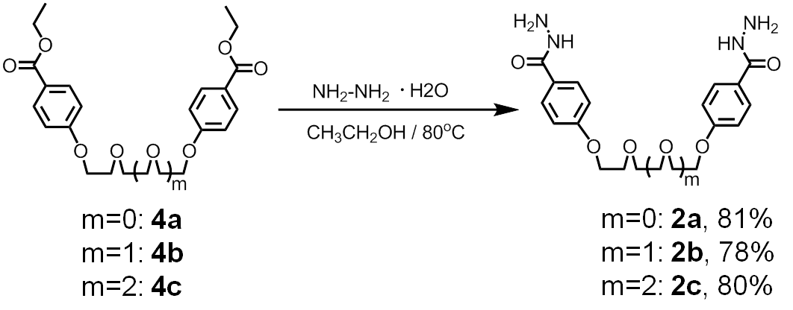
Scheme S3. Synthesis of 2a-2c.
2c: In a 50ml round bottom flask, 4c (490.2mg, 1mmol) was dissolved in 15ml ethyl alcohol. Hydrazine hydrate (1.0g, 200mmol) was then added into the flask. The mixture was refluxed for 12 h at 80 °C. After the completion of reaction, the solution was cooled to room temperature. The solvent was removed under vacuum to give the crude product. To remove residual hydrazine hydrate, the crude product was washed with ethanol for several times, yielding the orange-red solid-state product 2c (369.6 mg, 80 %). ¹H NMR (400 MHz, D₂O): δ = 7.45 (d, 4H), 6.80 (d, 4H), 4.00 (t, 4H), 3.74 (t, 4H ), 3.61(m, 8H), 3.25 (s, 6H). ¹³C NMR (400 MHz, D₂O): δ = 169.0, 160.9, 128.8, 124.3, 114.3, 69.7, 69.6, 68.8, 67.1. HRMS: m/z calculated for C₂₂H₃₀N₄O₇Na⁺ ([M + Na]⁺): 485.2012; found: 485.2000.
2b: 2b was obtained by using a similar procedure, whose yield is 78 %. ¹H NMR (500 MHz, DMSO): δ = 9.61(s, 2H), 7.79 (d, 4H), 6.98 (d, 4H), 4.14 (t, 4H), 3.76 (t, 4H), 3.62(s, 4H), 3.25 (s, 6H). ¹³C NMR (400 MHz, DMSO): δ = 165.5, 160.6, 128.6, 124.5, 114.0, 69.8, 68.8, 67.2. HRMS: m/z calculated for C₂₀H₂₆N₄O₆Na⁺ ([M + Na]⁺): 441.1750; found: 441.1741.
2a: 2a was obtained by using a similar procedure, whose yield is 81 %. ¹H NMR (500 MHz, DMSO): δ = 9.61(s, 2H), 7.79 (d, 4H), 6.99 (d, 4H), 4.17 (t, 4H), 3.83 (t, 4H), 3.62(s, 4H), 3.25 (s, 6H). ¹³C NMR (400 MHz, D₂O): δ = 165.5, 160.6, 128.7, 125.5, 114.0, 68.9, 67.2. HRMS: m/z calculated for C₁₈H₂₂N₄O₅Na⁺ ([M + Na]⁺): 397.1488; found: 397.1477.

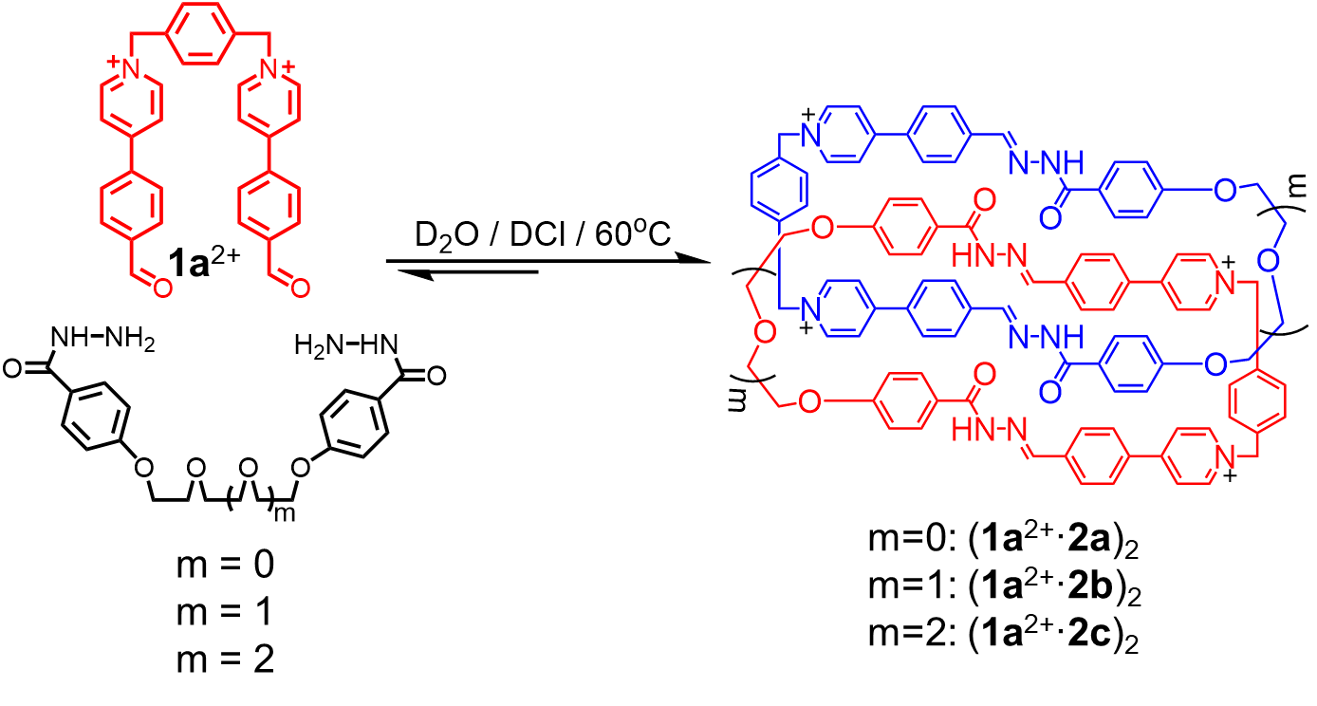
Scheme S4. Self-assembly of (1a²⁺·2a)₂, (1a²⁺·2b)₂ and (1a²⁺·2c)₂. Charges are balanced by chloride counteranions, which are omitted here for the sake of clarity.
We combined 1a²⁺·2Cl─ (5.40 mg, 0.01 mmol) with each of the dihydrazine linkers 2a-2c (0.01 mmol) in a 1:1 ratio, in D₂O (1 mL) in the presence of catalytic amount of DCl (5 μL). After heating the corresponding solutions at 60 ºC for 8 h, the ¹H NMR (Figure S3, S10 and S17) and mass spectrums (Figure S1, S8 and S15) of the corresponding solutions were recorded. To our delight, the corresponding ¹H NMR spectra indicated the formation of a set of thermodynamically stable products, including the homo [2]catenanes (1a²⁺·2a)₂·4Cl─, (1a²⁺·2b)₂·4Cl─ and (1a²⁺·2c)₂·4Cl─. The structure of (1a²⁺·2b)₂·4Cl─ and (1a²⁺·2c)₂·4Cl─ were further convinced by ¹H−¹H COSY spectra (Figure S12 and S20), ¹H−¹H NOESY spectra (Figure S13 and S21) and DOSY spectra (Figure S14 and S22). The ¹H NMR spectrum of (1a²⁺·2a)₂·4Cl─ （Figure S3A） exhibits broad resonances, which makes it difficult to assign each resonances. However, after counterion exchange, (1a²⁺·2a)₂·4PF₆─ was obtained and fully characterized in CD₃CN (Figure S3C, S5-7). (1a²⁺·2b)₂·4PF₆─ and (1a²⁺·2c)₂·4PF₆─ were obtained in a similar procedure and fully characterized (Figure S10C and S18) .
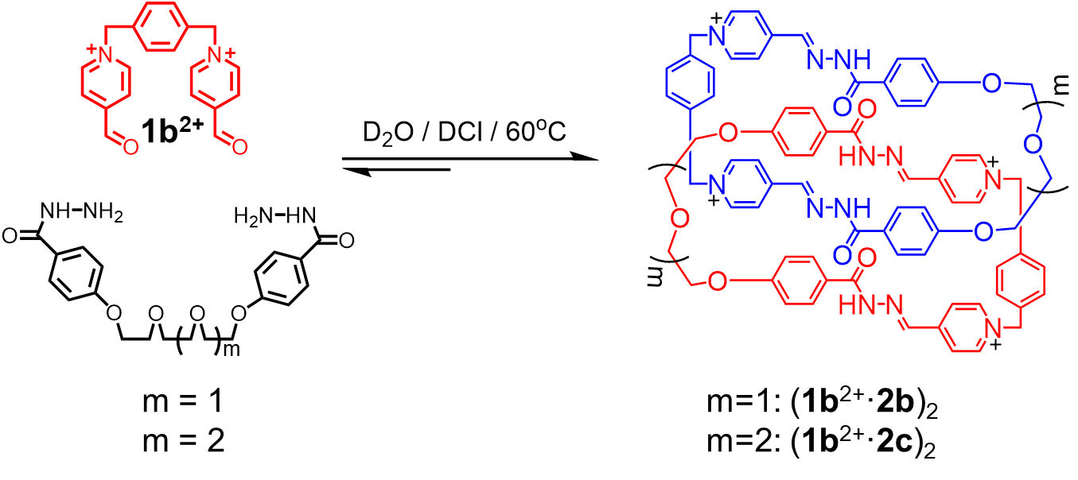
Scheme S5. Synthesis of (1b²⁺·2b)₂ and (1b²⁺·2c)₂. The positive charges on the catenanes are balanced by either Br─ or Cl─ counteranions, which are omitted here for the sake of clarity.
(1b²⁺·2b)₂ and (1b²⁺·2c)₂ were self-assembled in similar procedures as those used for (1a²⁺·2a)₂, (1a²⁺·2b)₂ and (1a²⁺·2c)₂.

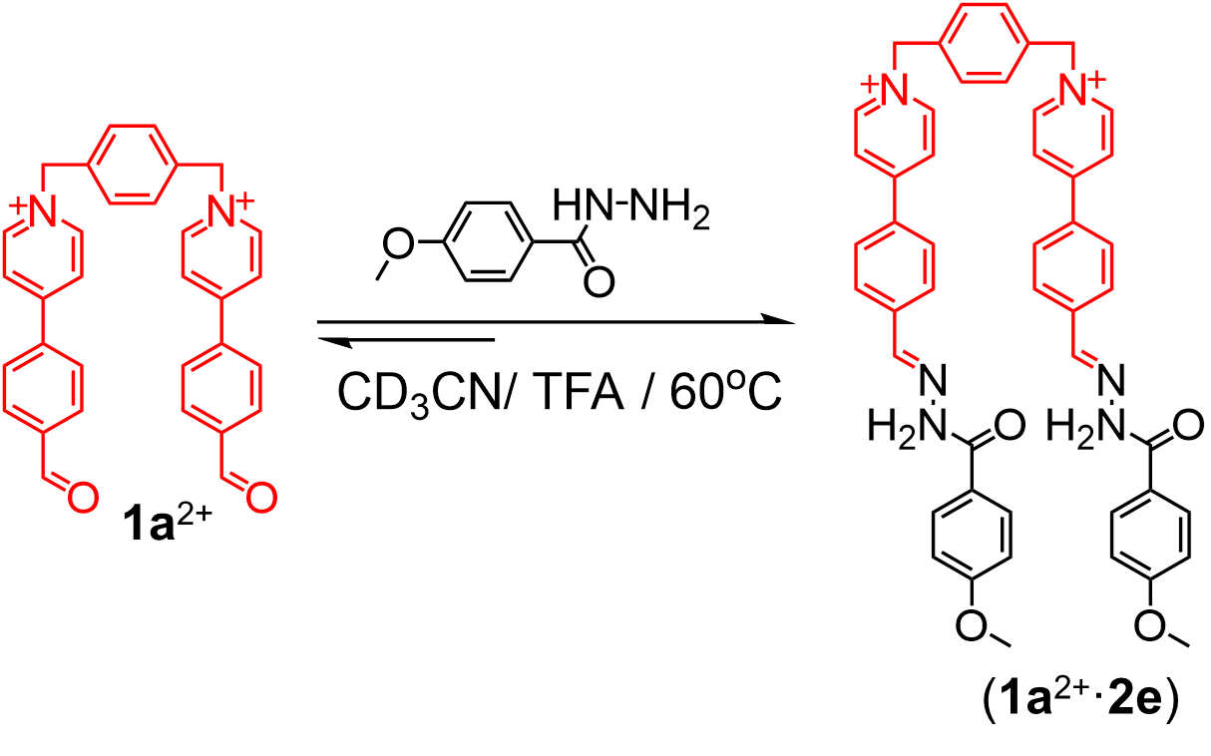
Scheme S6. Synthesis of (1b²⁺·2e). The positive charges on the catenanes are balanced by PF₆─ counteranions, which are omitted here for the sake of clarity.

We combined 1a²⁺·2PF₆─ (3.80 mg, 0.005 mmol) with 4-methoxybenzohydrazide (1.66mg, 0.01 mmol) in a 1:1 ratio, in CD₃CN (1 mL) in the presence of catalytic amount of TFA (5 μL). After heating the corresponding solutions at 60 ºC for 8 h, the ¹H NMR (Figure S41), ¹³C NMR (Figure S42), ¹H−¹H COSY spectra (Figure S43) and mass spectrums (Figure S44) of the corresponding solutions were recorded.

3. Characterization of (1a²⁺·2a)₂, (1a²⁺·2b)₂ and (1a²⁺·2c)₂ by NMR and HRMS
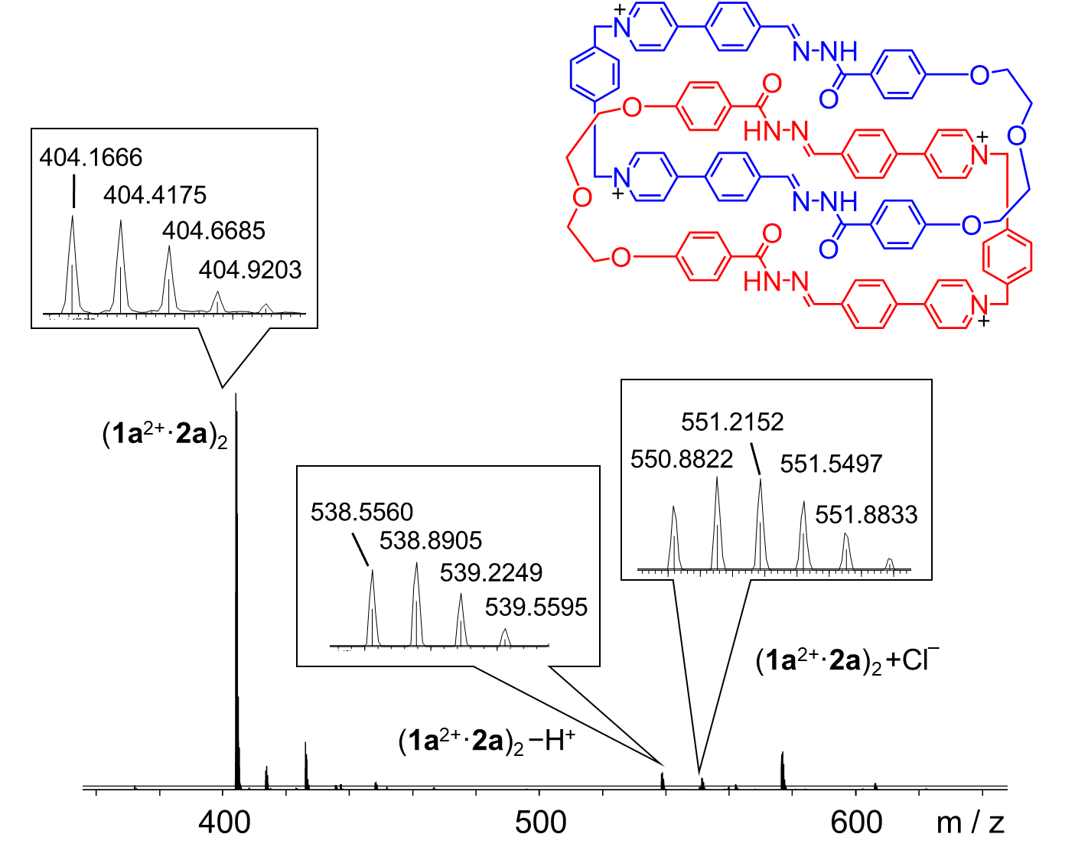
Figure S1. High-resolution LCMS-IT-TOF of (1a²⁺·2a)₂·4Cl─. The signals labeled in the spectrum correspond to molecular cations that contain four and three positive charges, respectively, by either losing proton or obtaining chloride counteranion. m/z [(1a²⁺·2a)₂]⁴⁺ calculated for C₁₀₀H₈₈N₁₂O₁₀⁴⁺: 404.4189; found: 404.4175. [(1a²⁺·2a)₂ ─ H⁺]³⁺ calculated for C₁₀₀H₈₇N₁₂O₁₀³⁺: 538.8895; found: 538.8905. [(1a²⁺·2a)₂ + Cl─]³⁺ calculated for C₁₀₀H₈₈ClN₁₂O₁₀³⁺: 550.8817; found: 550.8822.
;

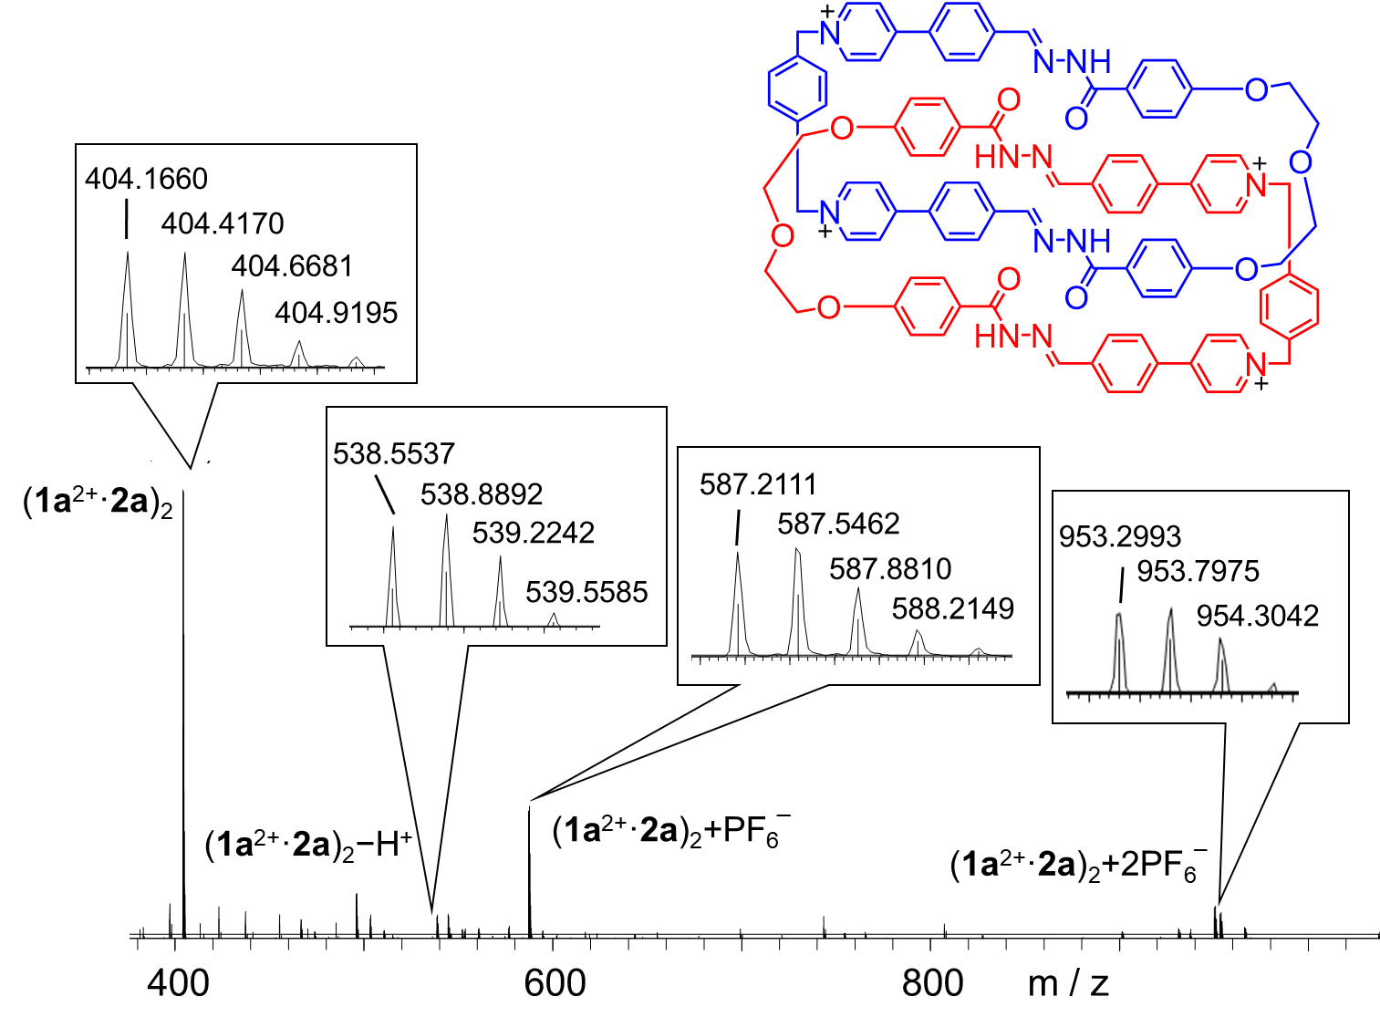
Figure S2. High-resolution LCMS-IT-TOF of (1a²⁺·2a)₂·4PF₆─. The signals labeled in the spectrum correspond to molecular cations that contain four, three and two positive charges, respectively. m/z [(1a²⁺·2a)₂]⁴⁺ calculated for C₁₀₀H₈₈N₁₂O₁₀⁴⁺: 404.4189; found: 404.4170. [(1a²⁺·2a)₂ ─ H⁺]³⁺ calculated for C₁₀₀H₈₇N₁₂O₁₀³⁺: 538.8895; found: 538.8892. [(1a²⁺·2a)₂ + PF₆─]³⁺ calculated for C₁₀₀H₈₈PF₆N₁₂O₁₀³⁺: 587.5468; found: 587.5462. [(1a²⁺·2a)₂ + 2PF₆─]²⁺ calculated for C₁₀₀H₈₈P₂F₁₂N₁₂O₁₀²⁺: 953.8026; found: 953.7975.

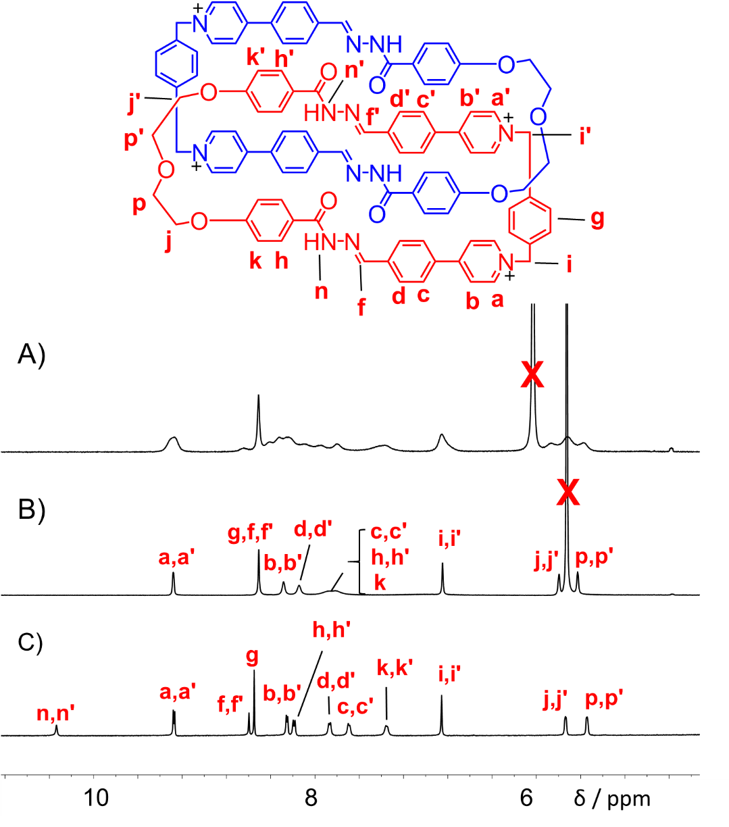
Figure S3. Partial ¹H NMR spectra of A) (1a²⁺·2a)₂·4Cl─ (600 MHz, D₂O, 298 K), B) (1a²⁺·2a)₂·4Cl─ (600 MHz, D₂O, 333 K), and C) (1a²⁺·2a)₂·4PF₆─ (500 MHz, CD₃CN, 298 K).
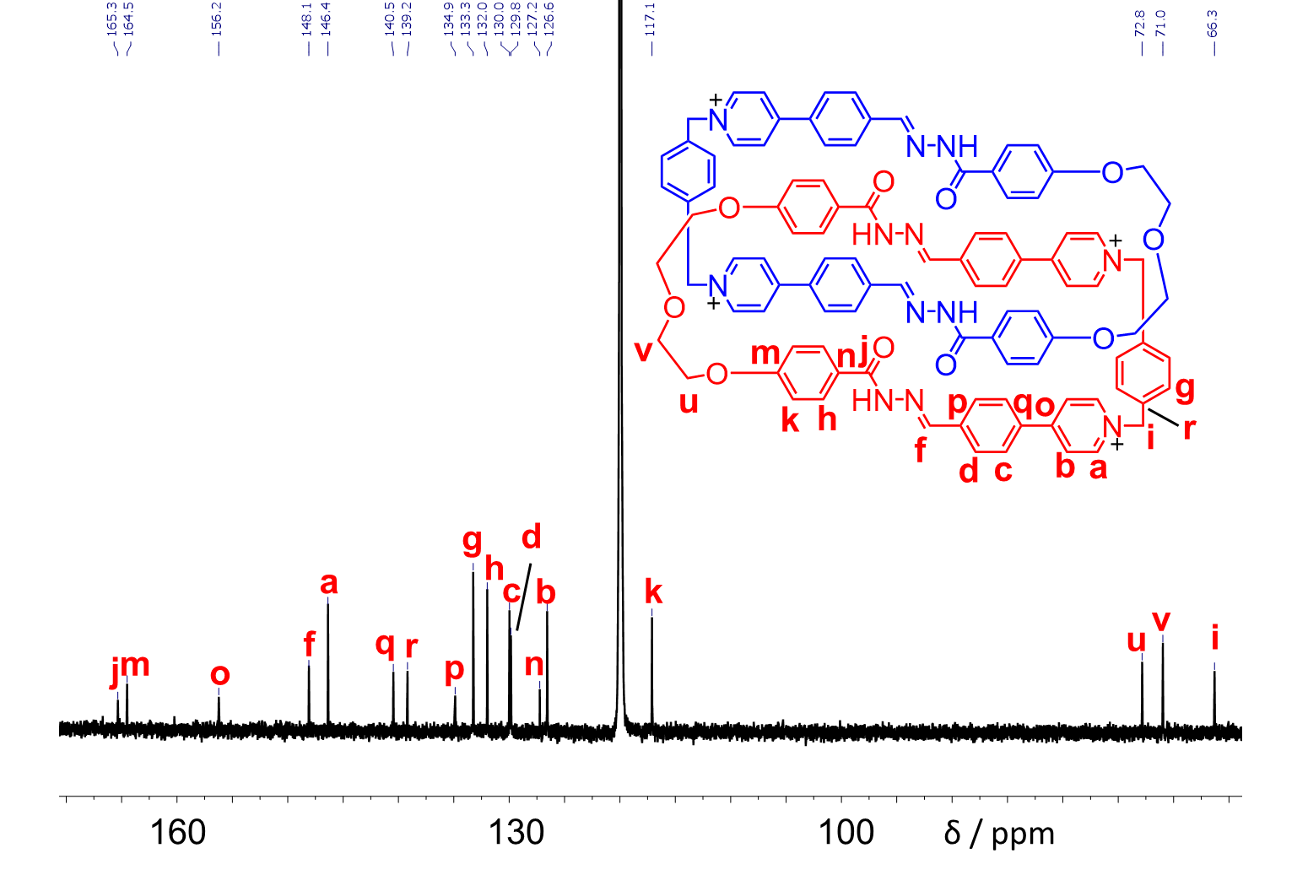
Figure S4. ¹³C NMR spectrum (150 M Hz, 298 K, CD₃CN) of (1a²⁺·2a)₂·4PF₆─.

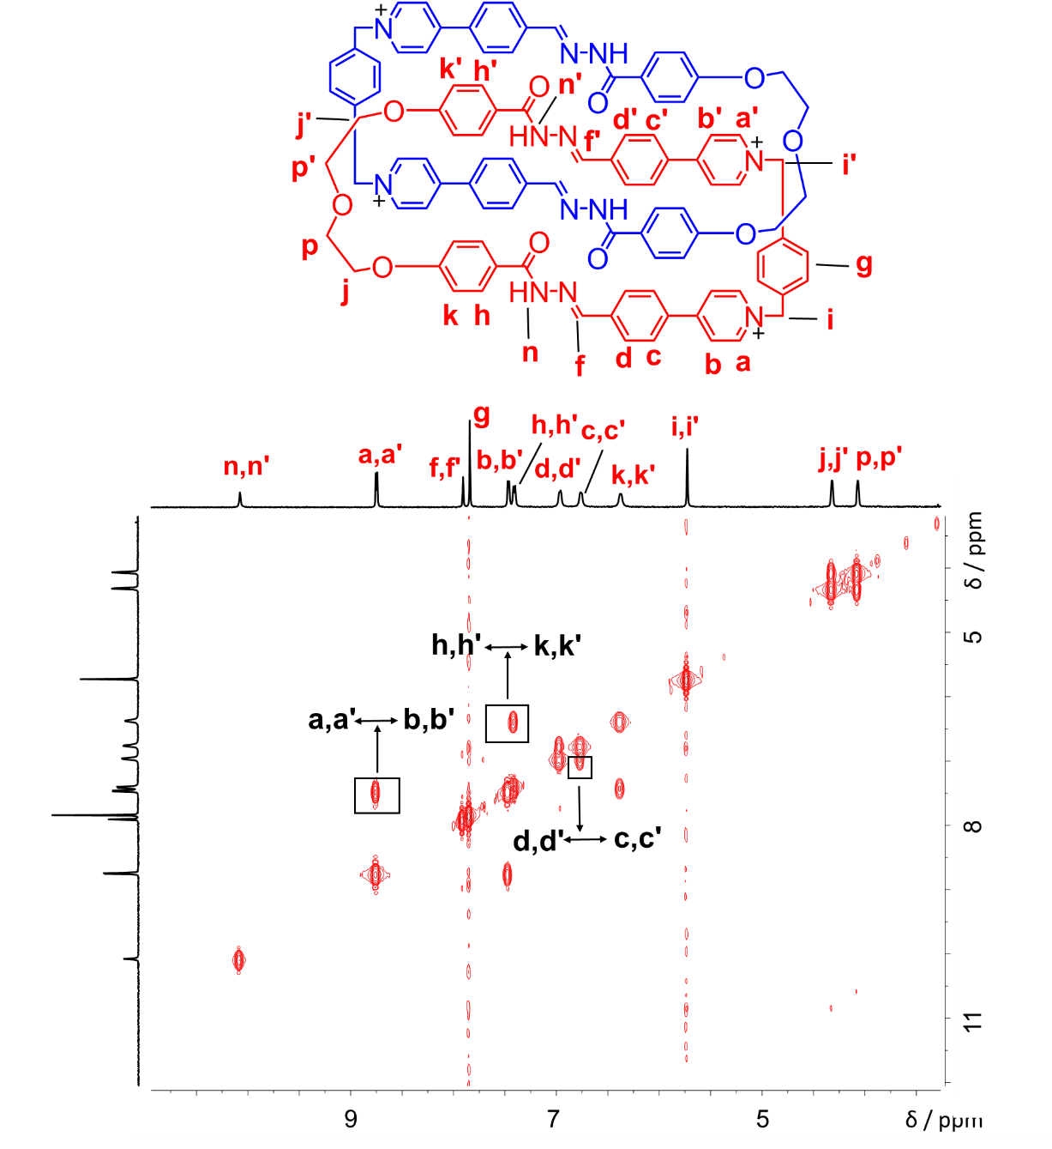
Figure S5. ¹H−¹H COSY spectrum (500 MHz, CD₃CN, 298 K) of (1a²⁺·2a)₂·4PF₆─. Key correlation peaks are labeled in the spectrum.

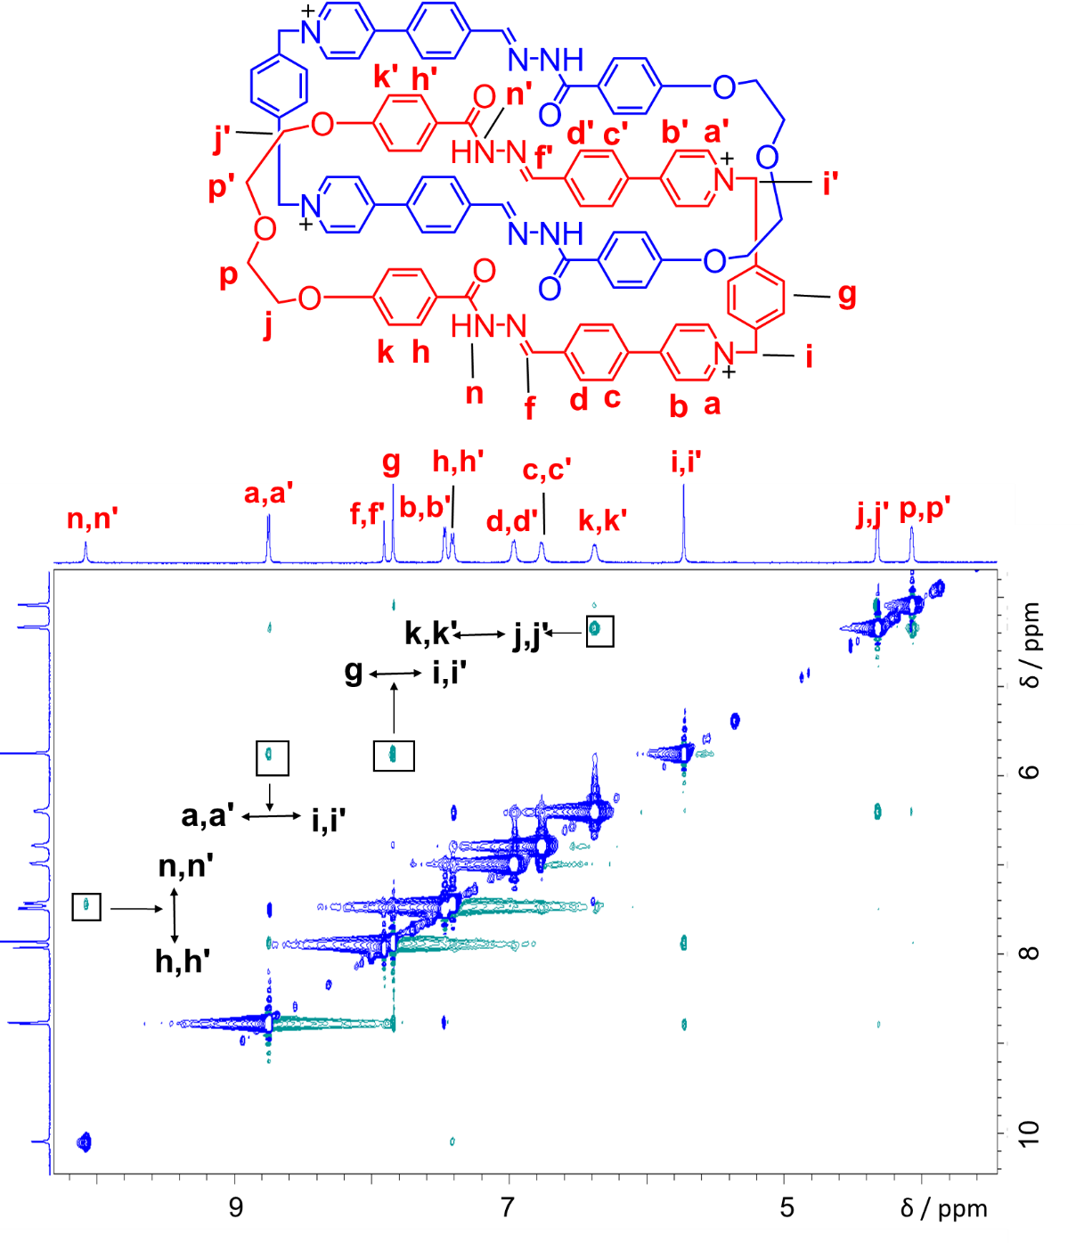
Figure S6. ¹H−¹H NOESY spectrum (500 MHz, CD₃CN, 298 K) of (1a²⁺·2a)₂·4PF₆─. Key correlation peaks are labeled in the spectrum.

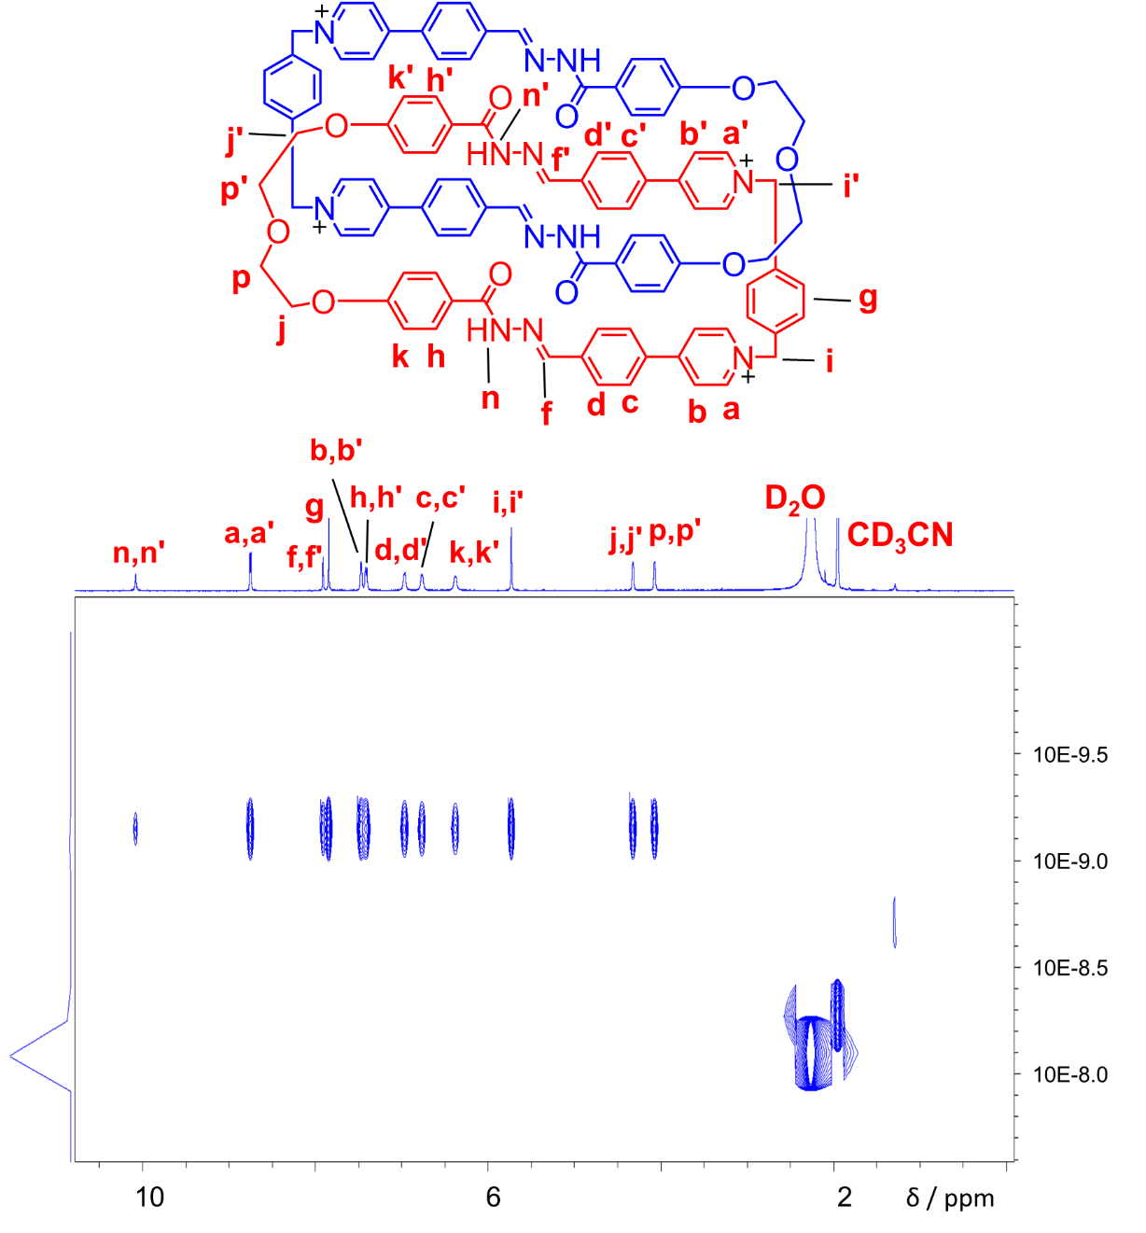
Figure S7. DOSY spectrum (500 MHz, CD₃CN, 298 K) of (1a²⁺·2a)₂·4PF₆─.
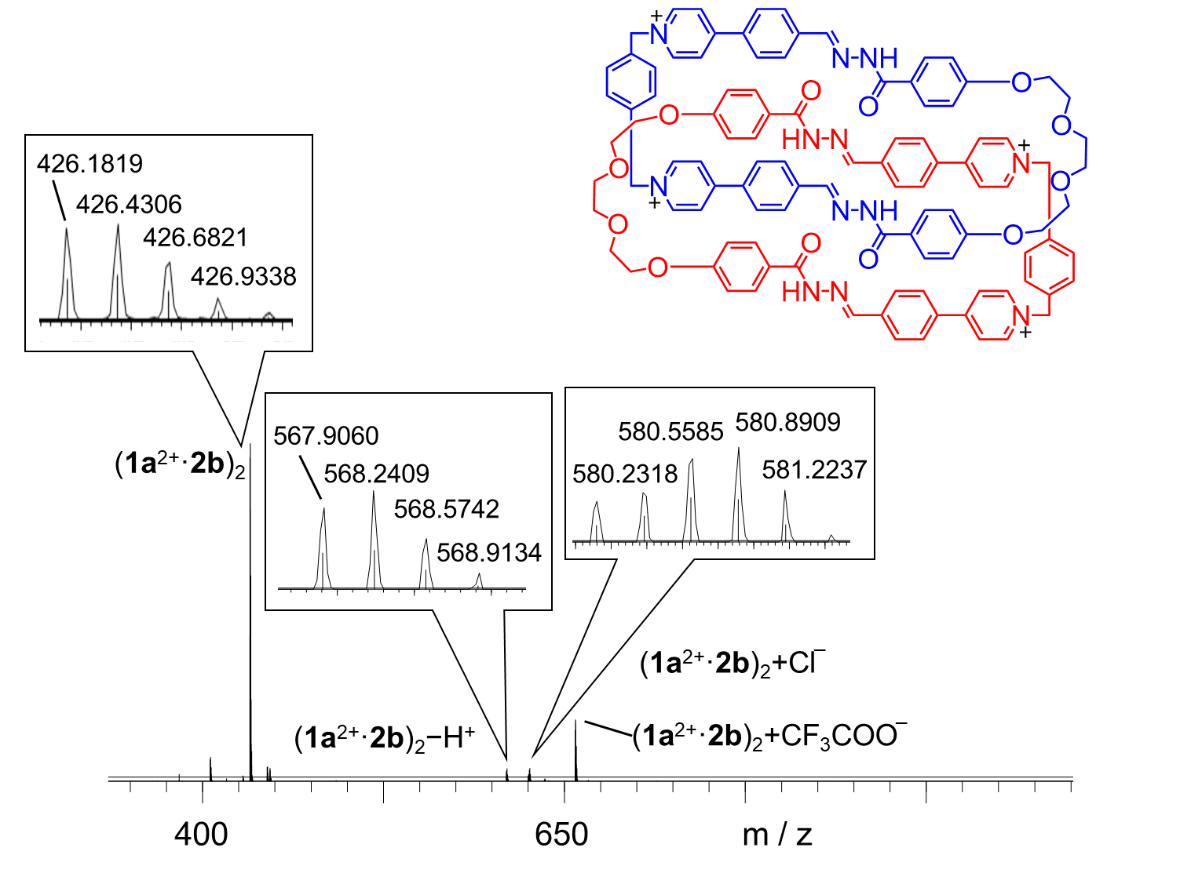
Figure S8. High-resolution LCMS-IT-TOF of (1a²⁺·2b)₂·4Cl─. The signals labeled in the spectrum correspond to molecular cations that contain four and three positive charges, respectively. m/z [(1a²⁺·2b)₂]⁴⁺ calculated for C₁₀₄H₉₆N₁₂O₁₂⁴⁺: 426.4321; found: 426.4306. [(1a²⁺·2b)₂ ─ H⁺]³⁺ calculated for C₁₀₄H₉₅N₁₂O₁₂³⁺: 568.2403; found: 568.2409. [(1a²⁺·2b)₂ + Cl─]³⁺ calculated for C₁₀₄H₉₆ClN₁₂O₁₂³⁺: 580.2325; found: 580.2318.

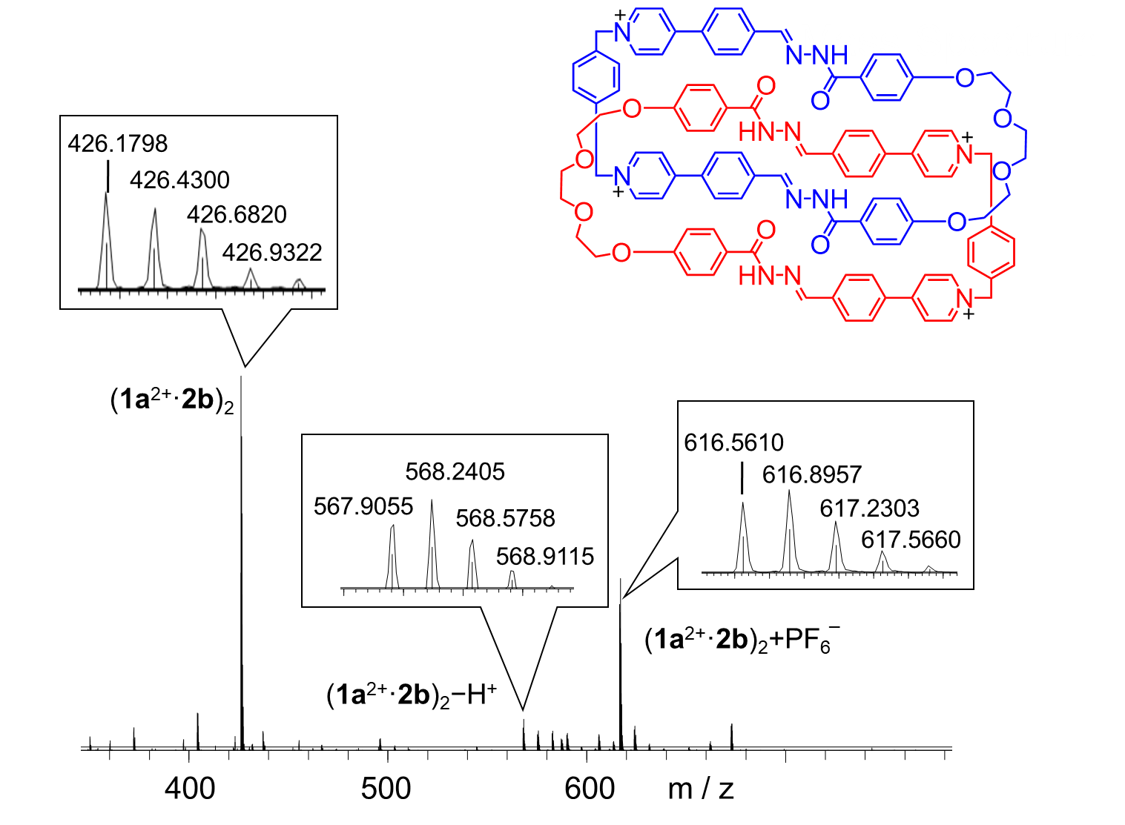
Figure S9. High-resolution LCMS-IT-TOF of (1a²⁺·2b)₂·4PF₆─. The signals labeled in the spectrum correspond to molecular cations that contain four and three positive charges, respectively. m/z [(1a²⁺·2b)₂]⁴⁺ calculated for C₁₀₄H₉₆N₁₂O₁₂⁴⁺: 426.4321; found: 426.4300. [(1a²⁺·2b)₂ ─ H⁺]³⁺ calculated for C₁₀₄H₉₅N₁₂O₁₂³⁺: 568.2403; found: 568.2405. [(1a²⁺·2b)₂ + PF₆─] calculated for C₁₀₄H₉₆PF₆N₁₂O₁₂³⁺: 616.8977; found: 616.8957.

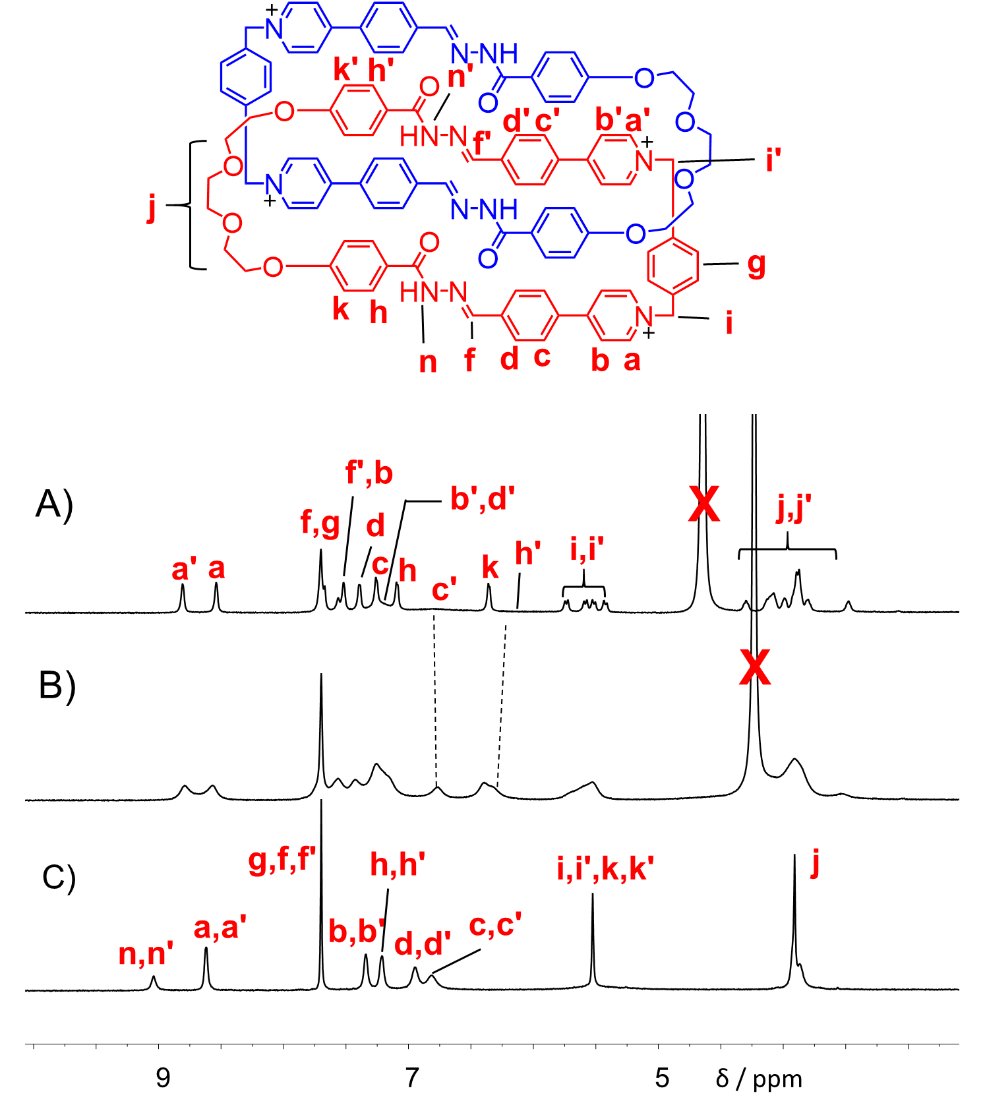
Figure S10. Partial ¹H NMR spectra of A) (1a²⁺·2b)₂·4Cl─ (600 MHz, D₂O, 298 K), B) (1a²⁺·2b)₂·4Cl─ (600 MHz, D₂O, 333 K) and C) (1a²⁺·2b)₂·4PF₆─ (500 MHz, D₂O, 298 K).

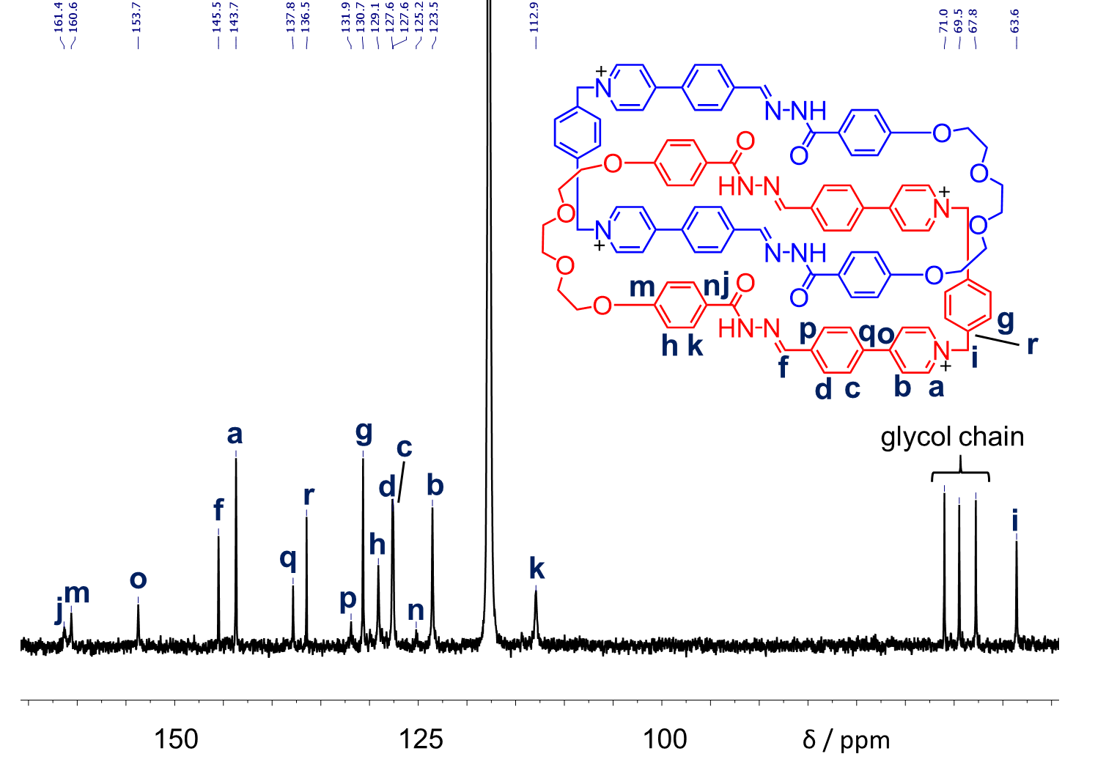
Figure S11. ¹³C NMR spectrum (125 M Hz, 298 K, CD₃CN:DMSO = 5:1) of (1a²⁺·2b)₂·4PF₆─.
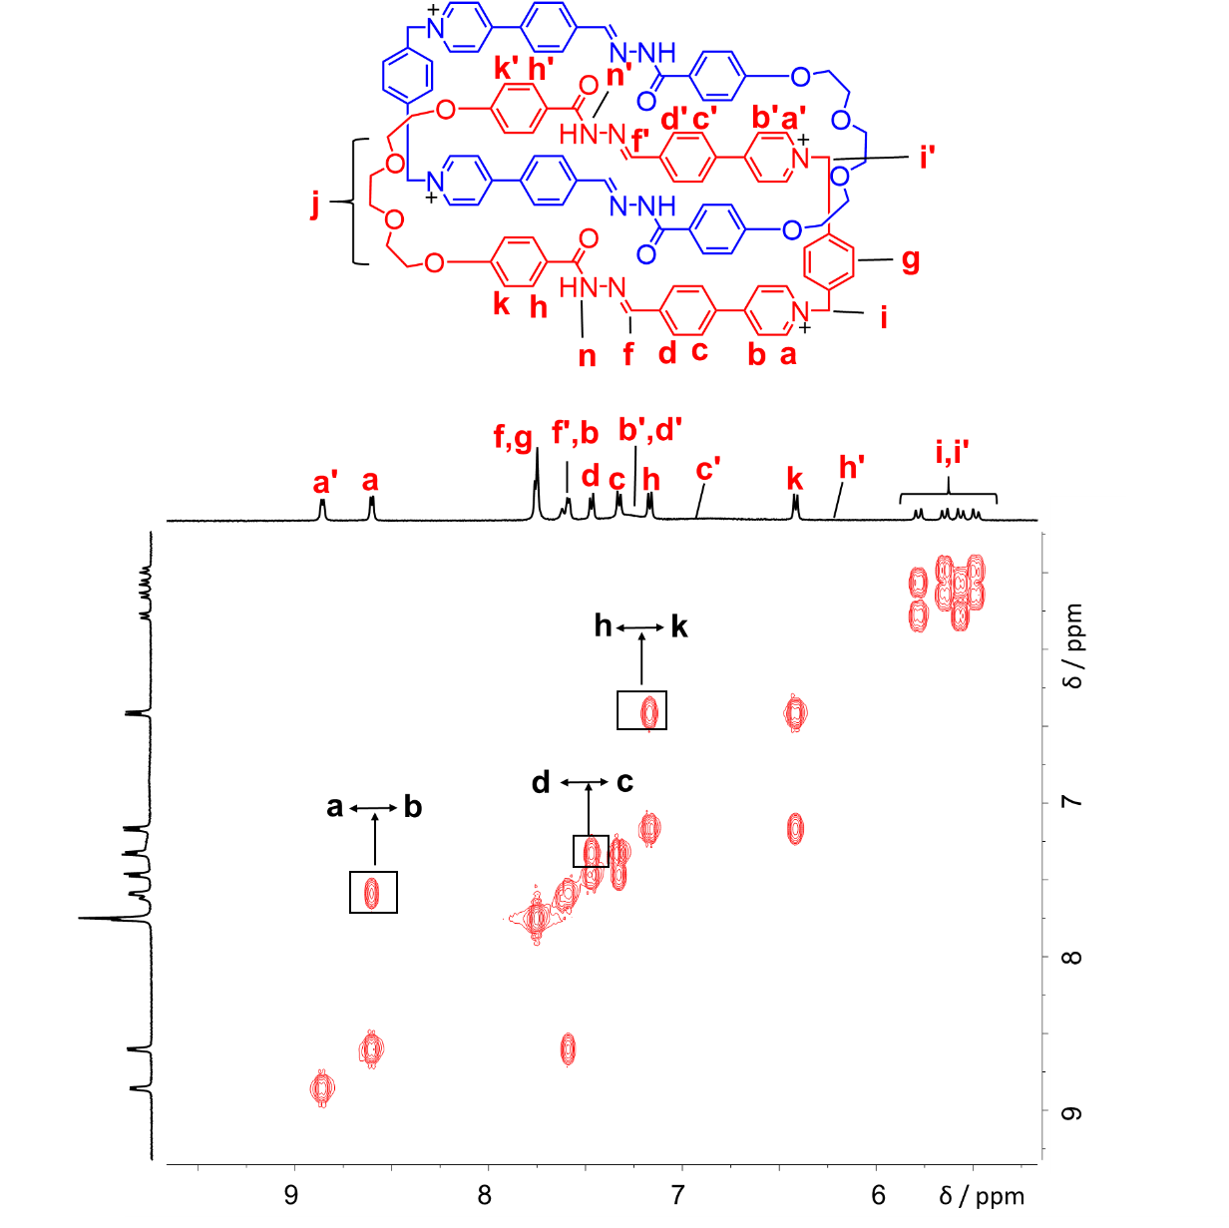
Figure S12. ¹H−¹H COSY spectrum (500 MHz, D₂O, 298 K) of (1a²⁺·2b)₂·4Cl─. Key correlation peaks are labeled in the spectrum.

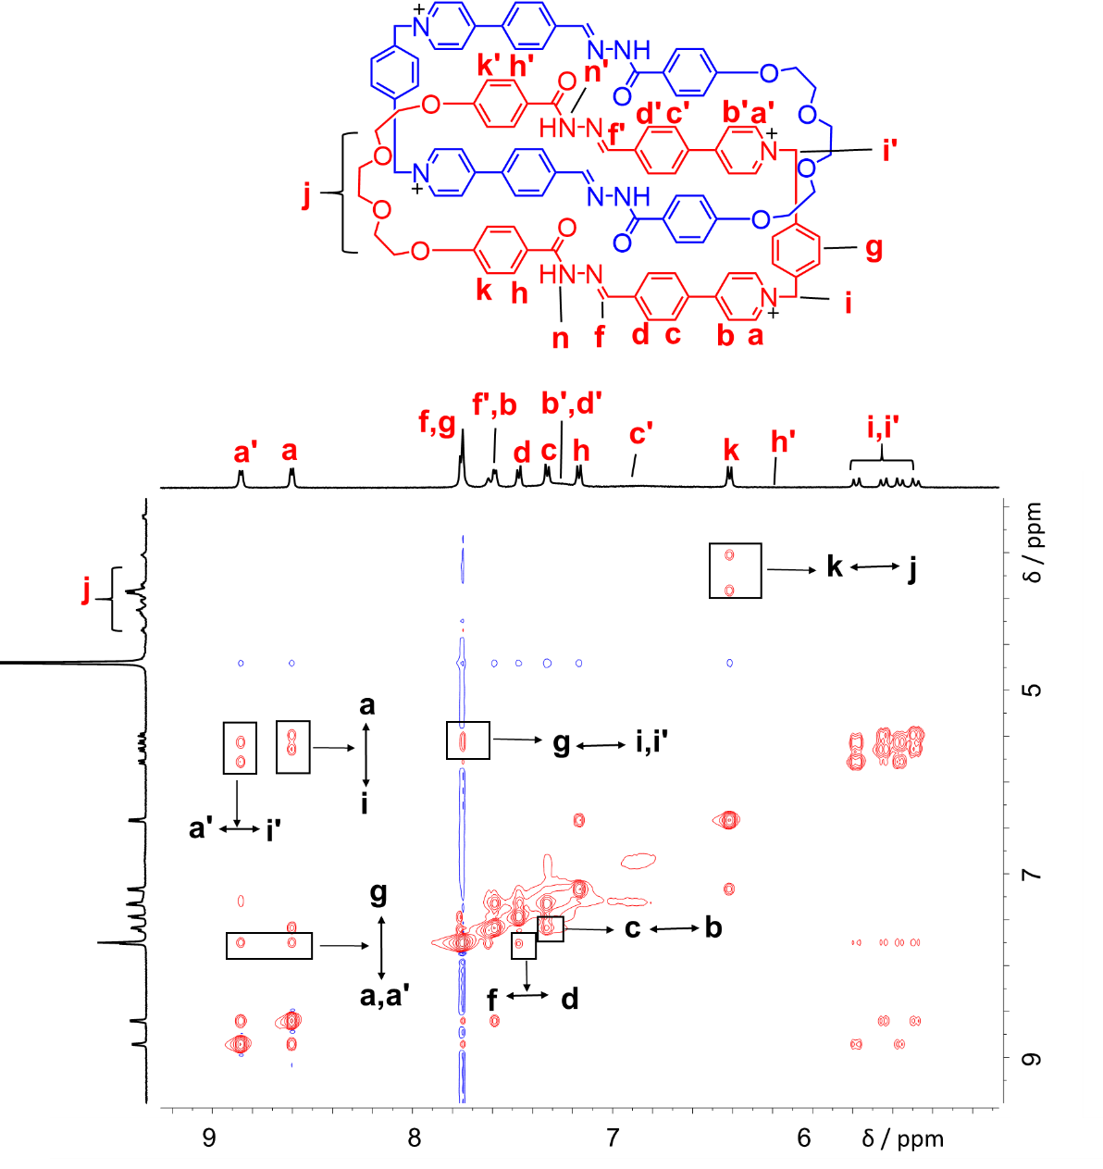
Figure S13. ¹H−¹H NOESY spectrum (500 MHz, D₂O, 298 K) of (1a²⁺·2b)₂·4Cl─. Key correlation peaks are labeled in the spectrum.

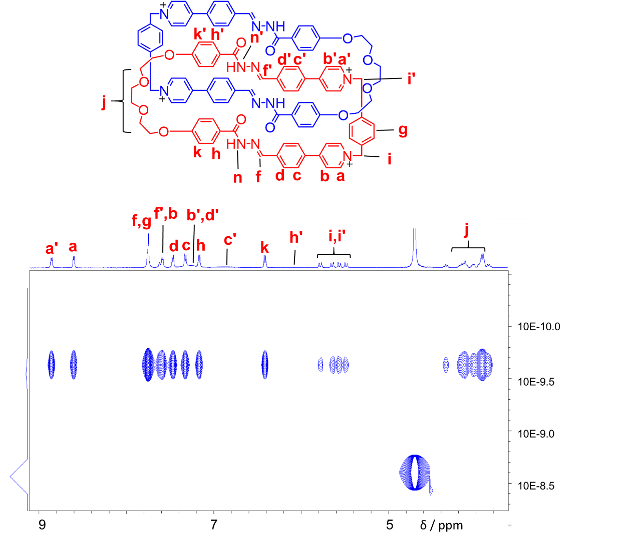
Figure S14. DOSY spectrum (500 MHz, D₂O, 298 K) of (1a²⁺·2b)₂·4Cl─.

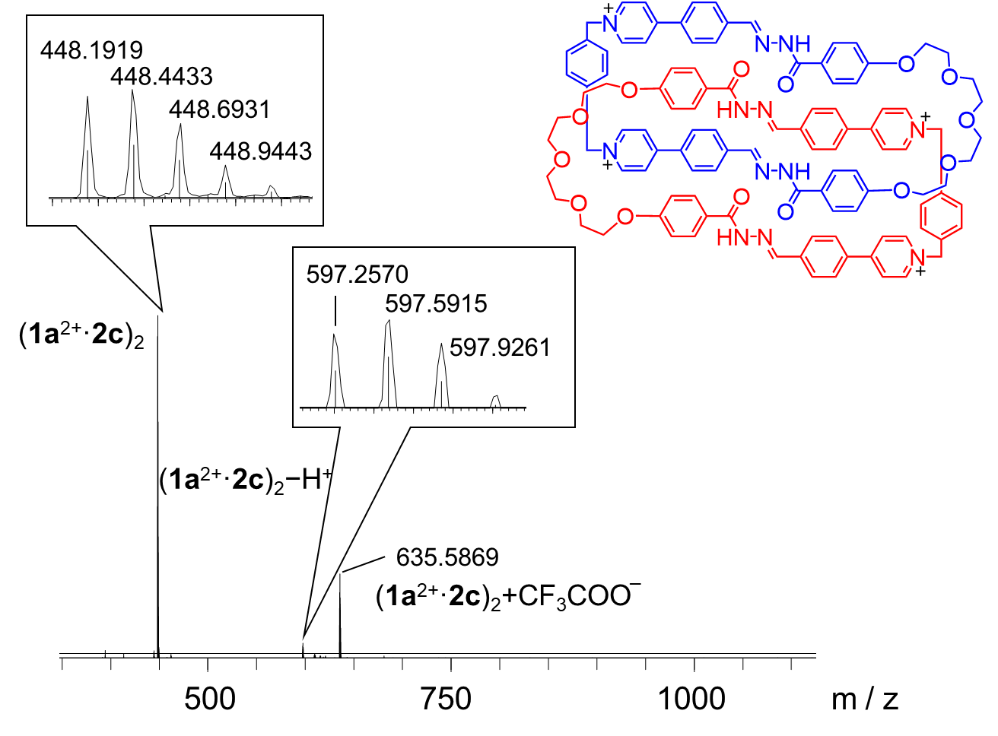
Figure S15. High-resolution LCMS-IT-TOF of (1a²⁺·2c)₂·4Cl─. The signals labeled in the spectrum correspond to molecular cations that contain four and three positive charges, respectively. m/z [(1a²⁺·2c)₂]⁴⁺ calculated for C₁₀₈H₁₀₄N₁₂O₁₄⁴⁺: 448.4452; found: 448.4433. [(1a²⁺·2c)₂ ─ H⁺]³⁺ calculated for C₁₀₈H₁₀₃N₁₂O₁₄³⁺: 597.5911; found: 597.5915.

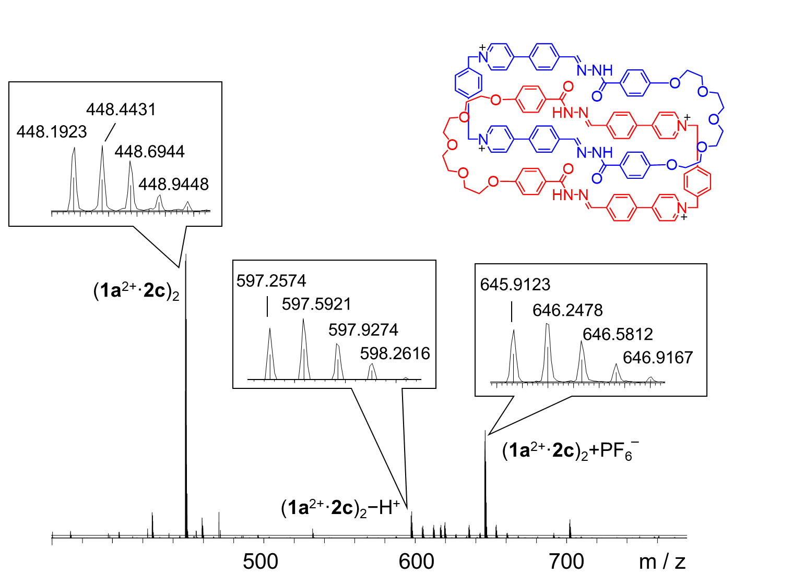
Figure S16. High-resolution LCMS-IT-TOF of (1a²⁺·2c)₂·4PF₆─. The signals labeled in the spectrum correspond to molecular cations that contain four and three positive charges, respectively. m/z [(1a²⁺·2c)₂]⁴⁺ calculated for C₁₀₈H₁₀₄N₁₂O₁₄⁴⁺: 448.4452; found: 448.4431. [(1a²⁺·2c)₂ ─ H⁺]³⁺ calculated for C₁₀₈H₁₀₃N₁₂O₁₄³⁺: 597.5911; found: 597.5921. [(1a²⁺·2c)₂ + PF₆─]³⁺ calculated for C₁₀₈H₁₀₄PF₆N₁₂O₁₄³⁺: 646.2485; found: 646.2478.

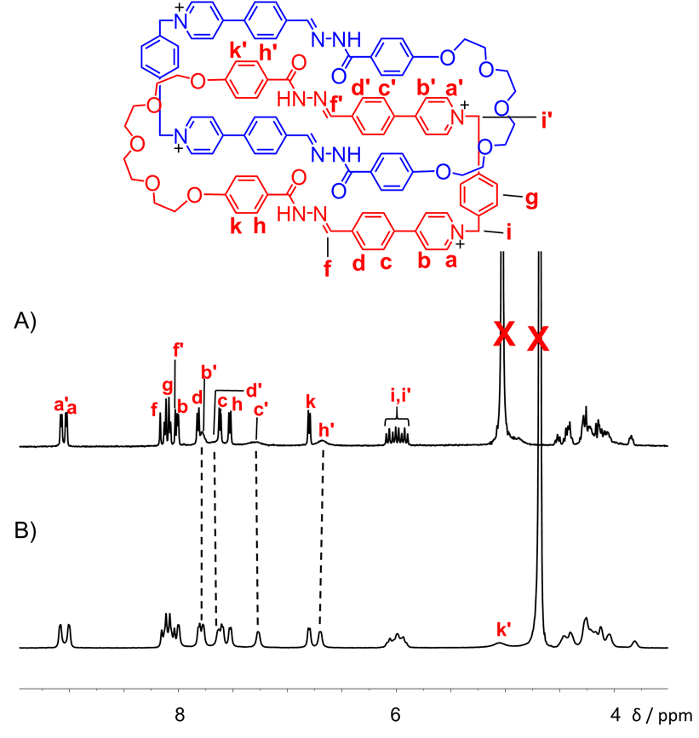
Figure S17. Partial ¹H NMR spectra of A) (1a²⁺·2c)₂·4Cl─ (500 MHz, D₂O, 298 K), B) (1a²⁺·2c)₂·4Cl─ (500 MHz, D₂O, 333 K).
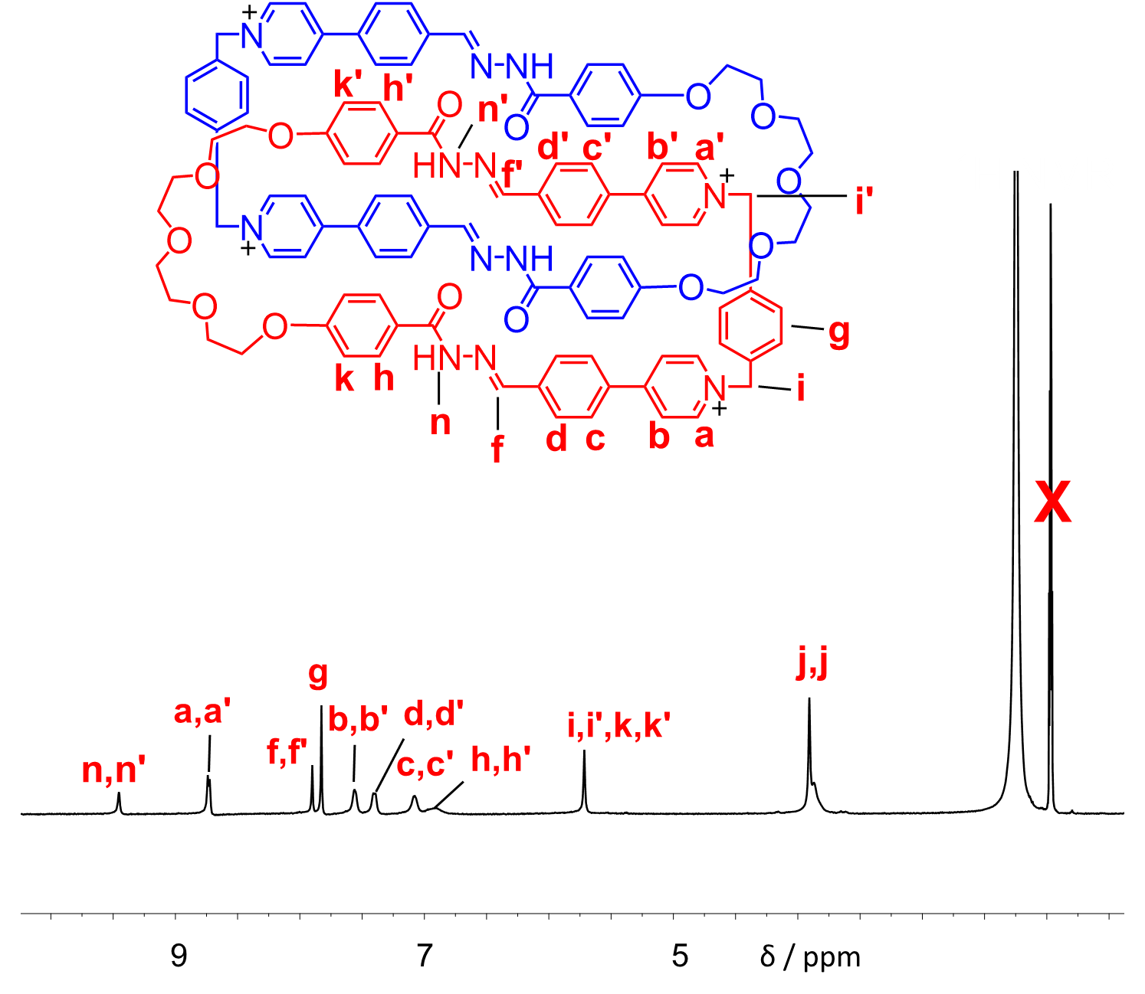
Figure S18. Partial ¹H NMR spectra of (1a²⁺·2c)₂·4PF₆─ (500 MHz, CD₃CN, 298 K).

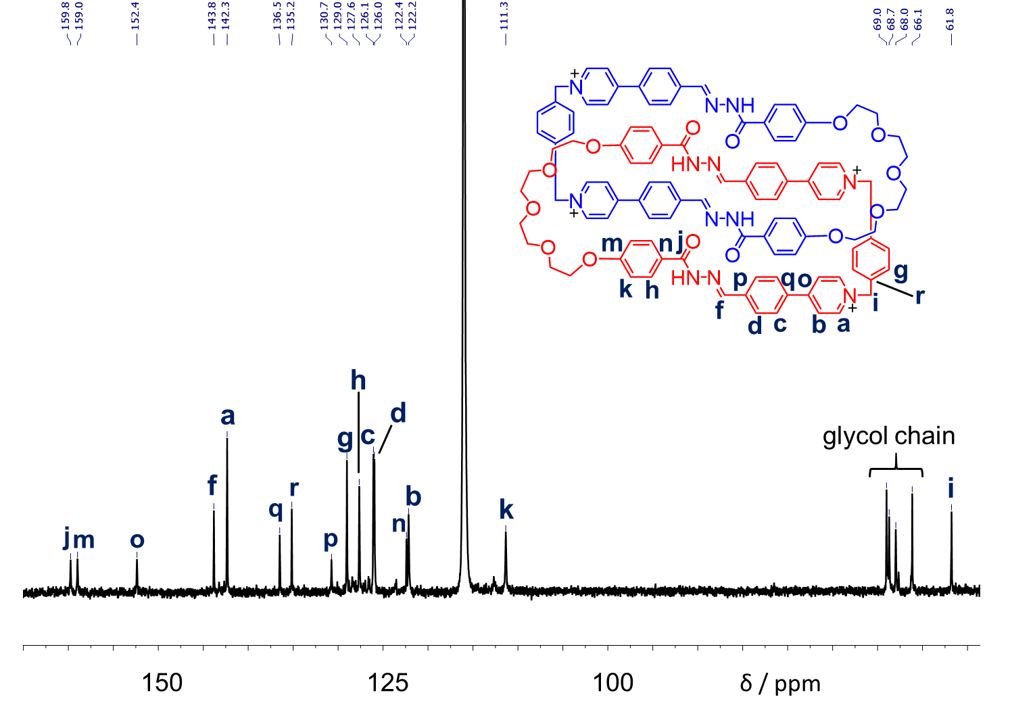
Figure S19. ¹³C NMR spectrum (125 M Hz, 298 K, CD₃CN:DMSO = 5:1) of (1a²⁺·2c)₂·4PF₆─.

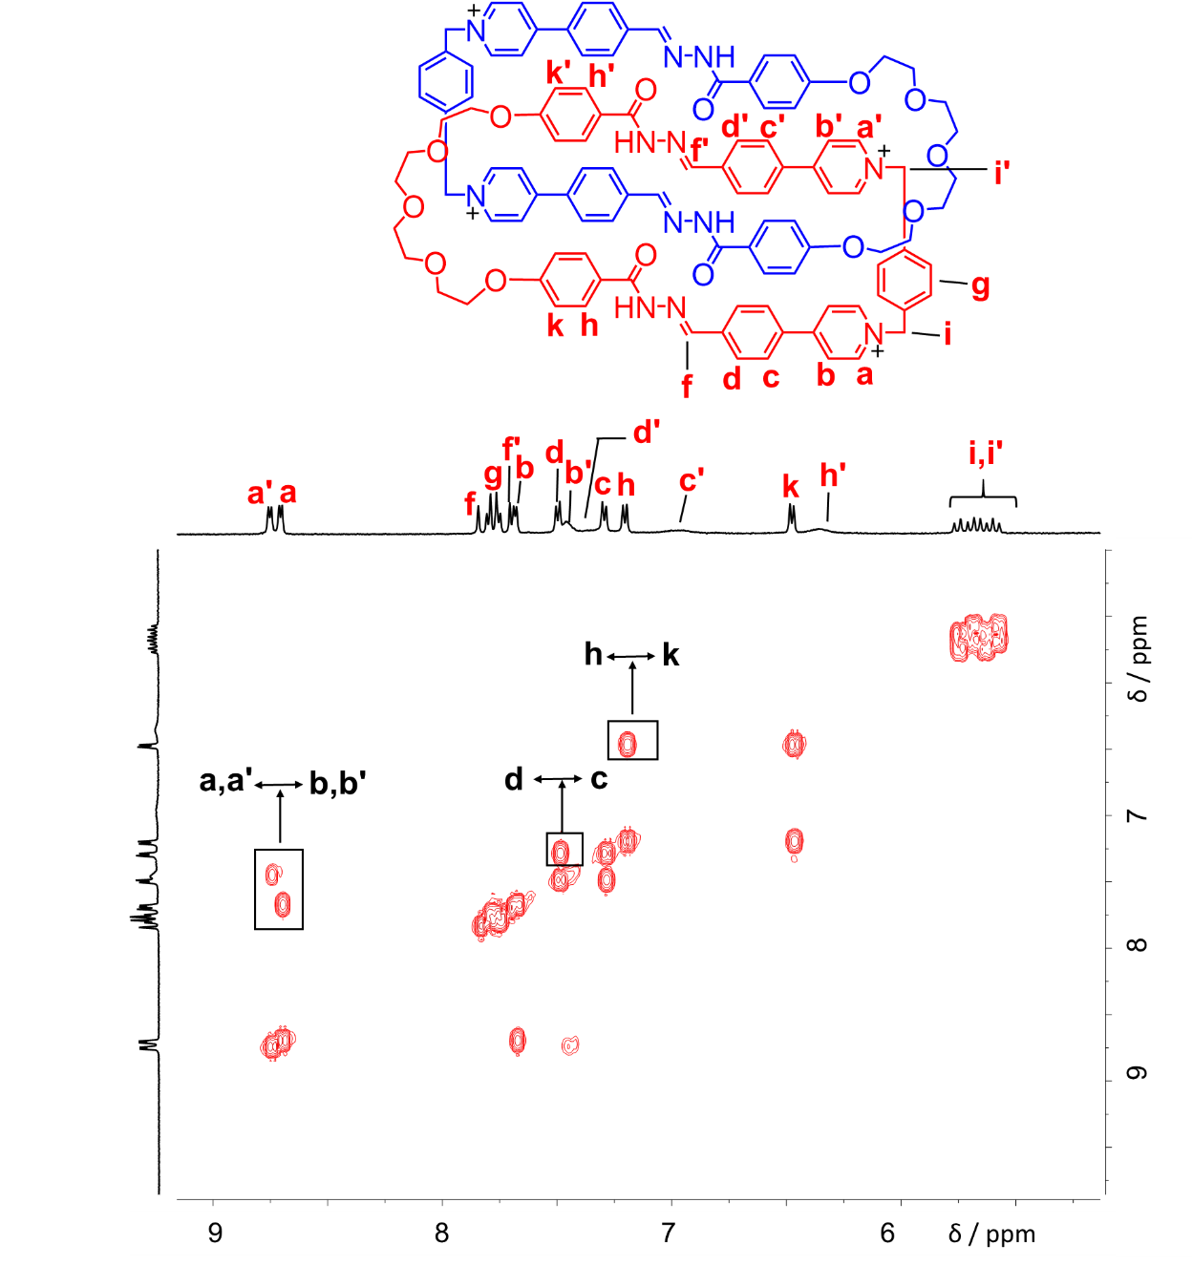
Figure S20. ¹H−¹H COSY spectrum (500 MHz, D₂O, 298 K) of (1a²⁺·2c)₂·4Cl─. Key correlation peaks are labeled in the spectrum.

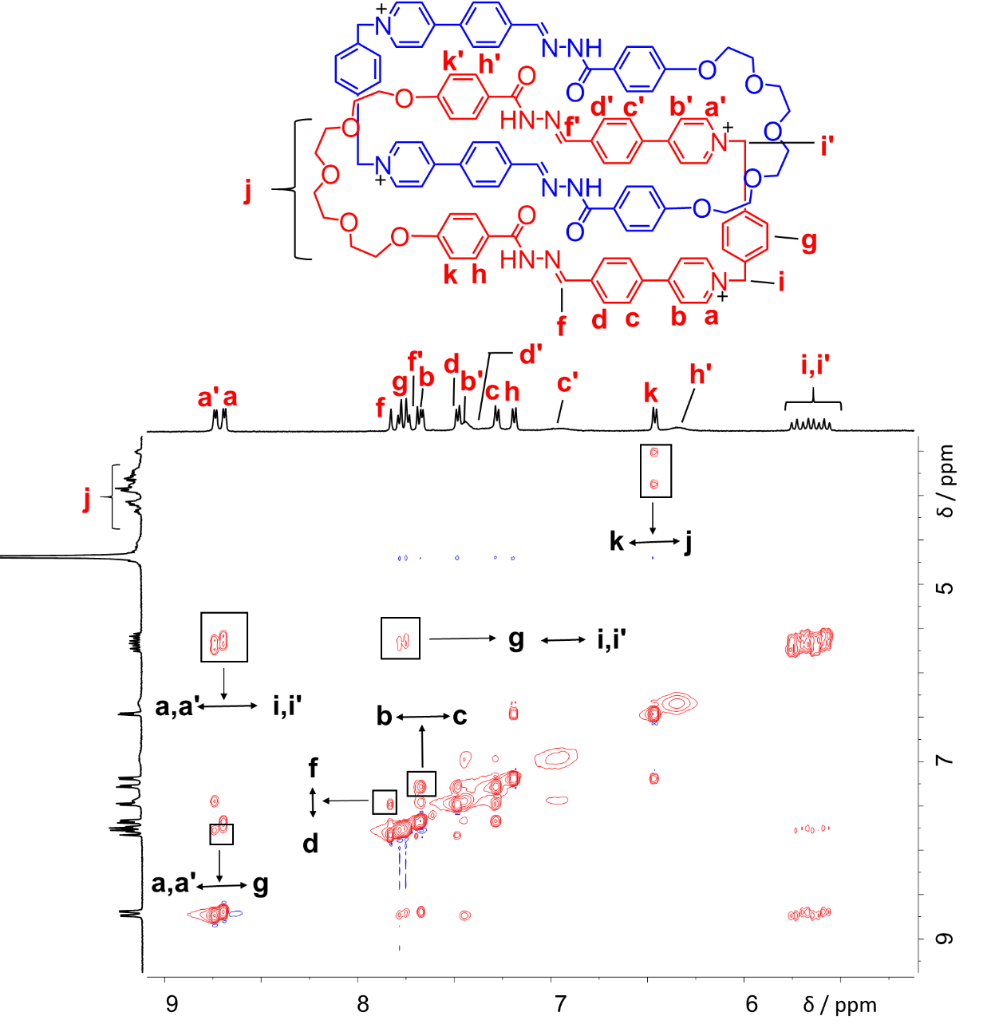
Figure S21. ¹H−¹H NOESY spectrum (500 MHz, D₂O, 298 K) of (1a²⁺·2c)₂·4Cl─. Key correlation peaks are labeled in the spectrum.

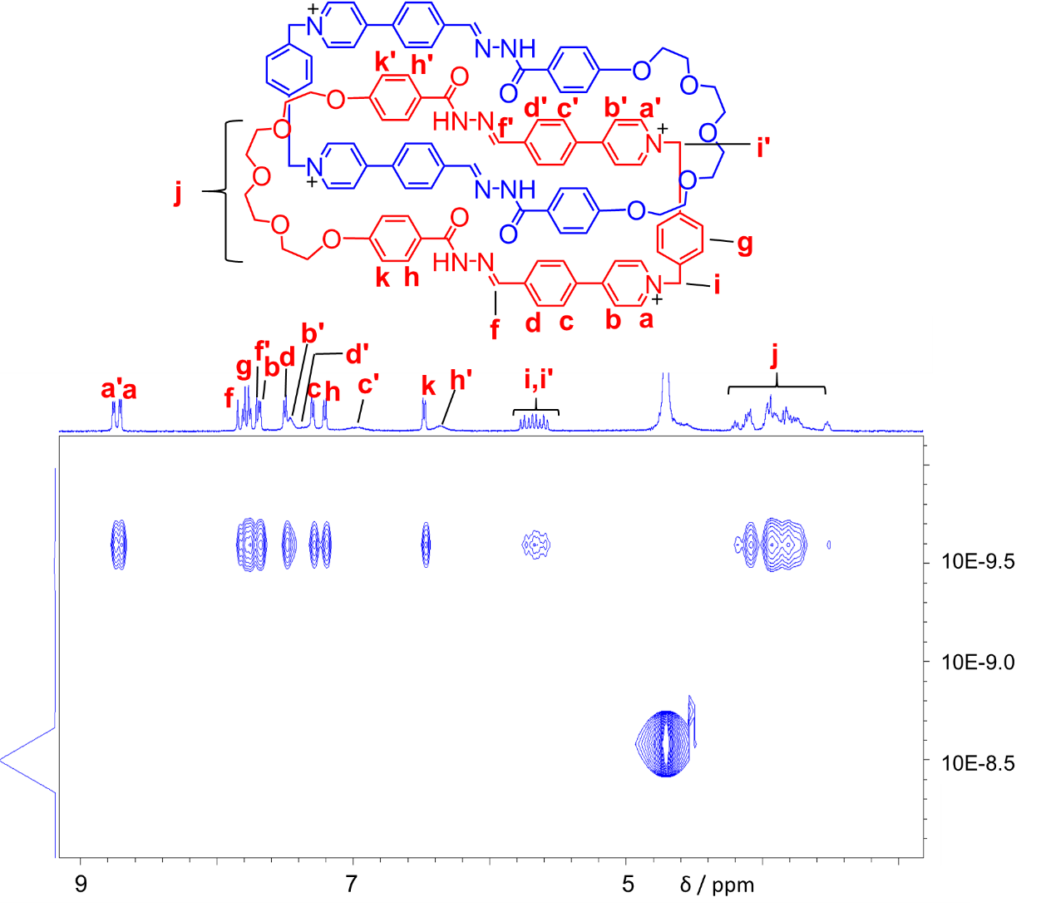
Figure S22. DOSY spectrum (500 MHz, D₂O, 298 K) of (1a²⁺·2c)₂·4Cl─.

4. Characterization of the self-assembled products containing 1b²⁺ by NMR and HRMS
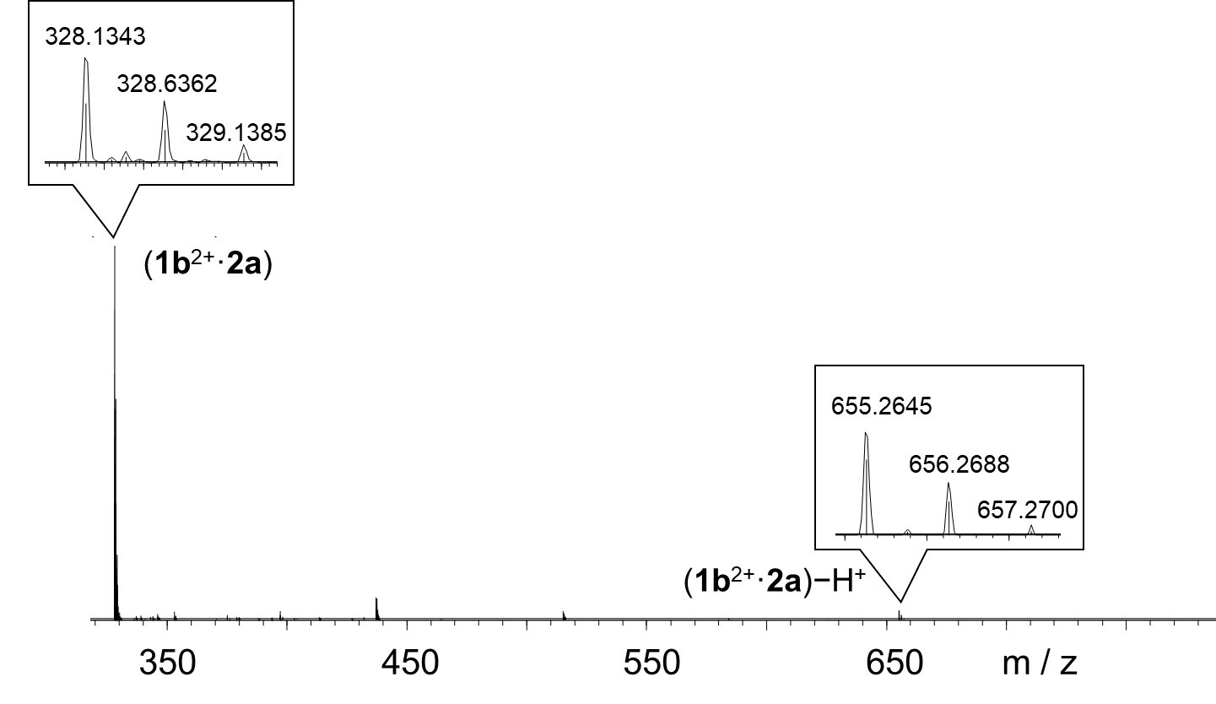
Figure S23. High-resolution LCMS-IT-TOF the reaction mixture by condensing a 1:1 mixture of 1b²⁺2Br─ (0.6 mM) and 2a (0.6 mM). The signals labeled in the spectrum correspond to molecular cations that contain two and one positive charges, respectively. m/z [(1b²⁺·2a)]²⁺ calculated for C₃₈H₃₆N₆O₅²⁺: 328.1368; found:328.1343. [(1b²⁺·2a) ─ H⁺]⁺ calculated for C₃₈H₃₅N₆O₅⁺: 655.2663; found 655.2688.

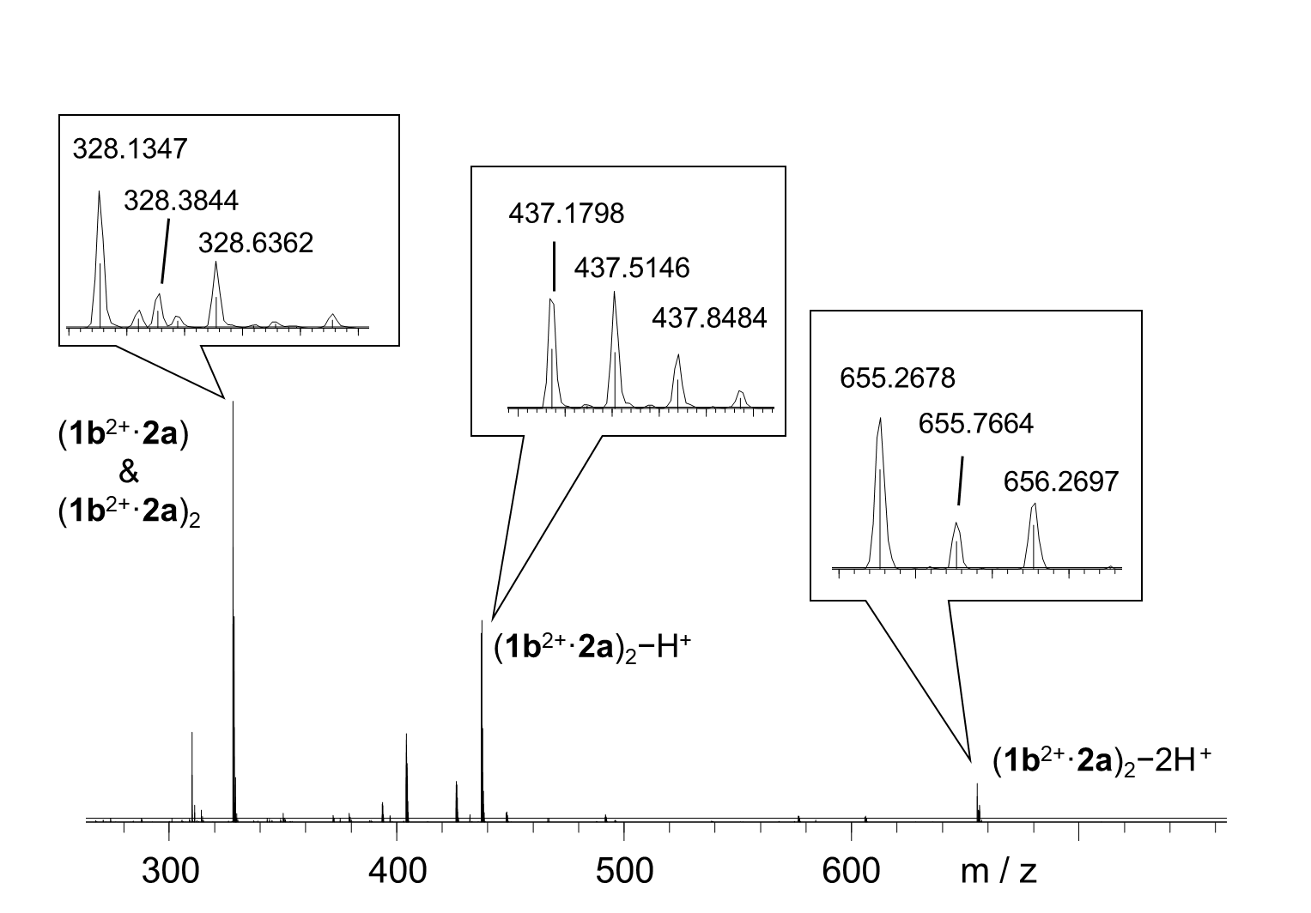
Figure S24. High-resolution LCMS-IT-TOF of the reaction mixture by condensing a 1:1 mixture of 1b²⁺2Br─ (4.5 mM) and 2a (4.5 mM). m/z [(1b²⁺·2a)₂ ─ H⁺]³⁺ calculated for C₇₆H₇₁N₁₂O₁₀³⁺: 437.1800; found: 437.1798. [(1b²⁺·2a)₂ ─ 2H⁺]²⁺ calculated for C₈₀H₇₄N₁₂O₁₀²⁺: 655.2663; found 655.2678.

The self-assembly products of condensing 1b²⁺·2Br─ and 2a in water are independent on the concentration of the reactants. Low concentration favors the formation of the ring (1b²⁺·2a), while higher concentration favors the catenane (1b²⁺·2a)₂, as inferred from the corresponding mass spectra in Figures S23-24.

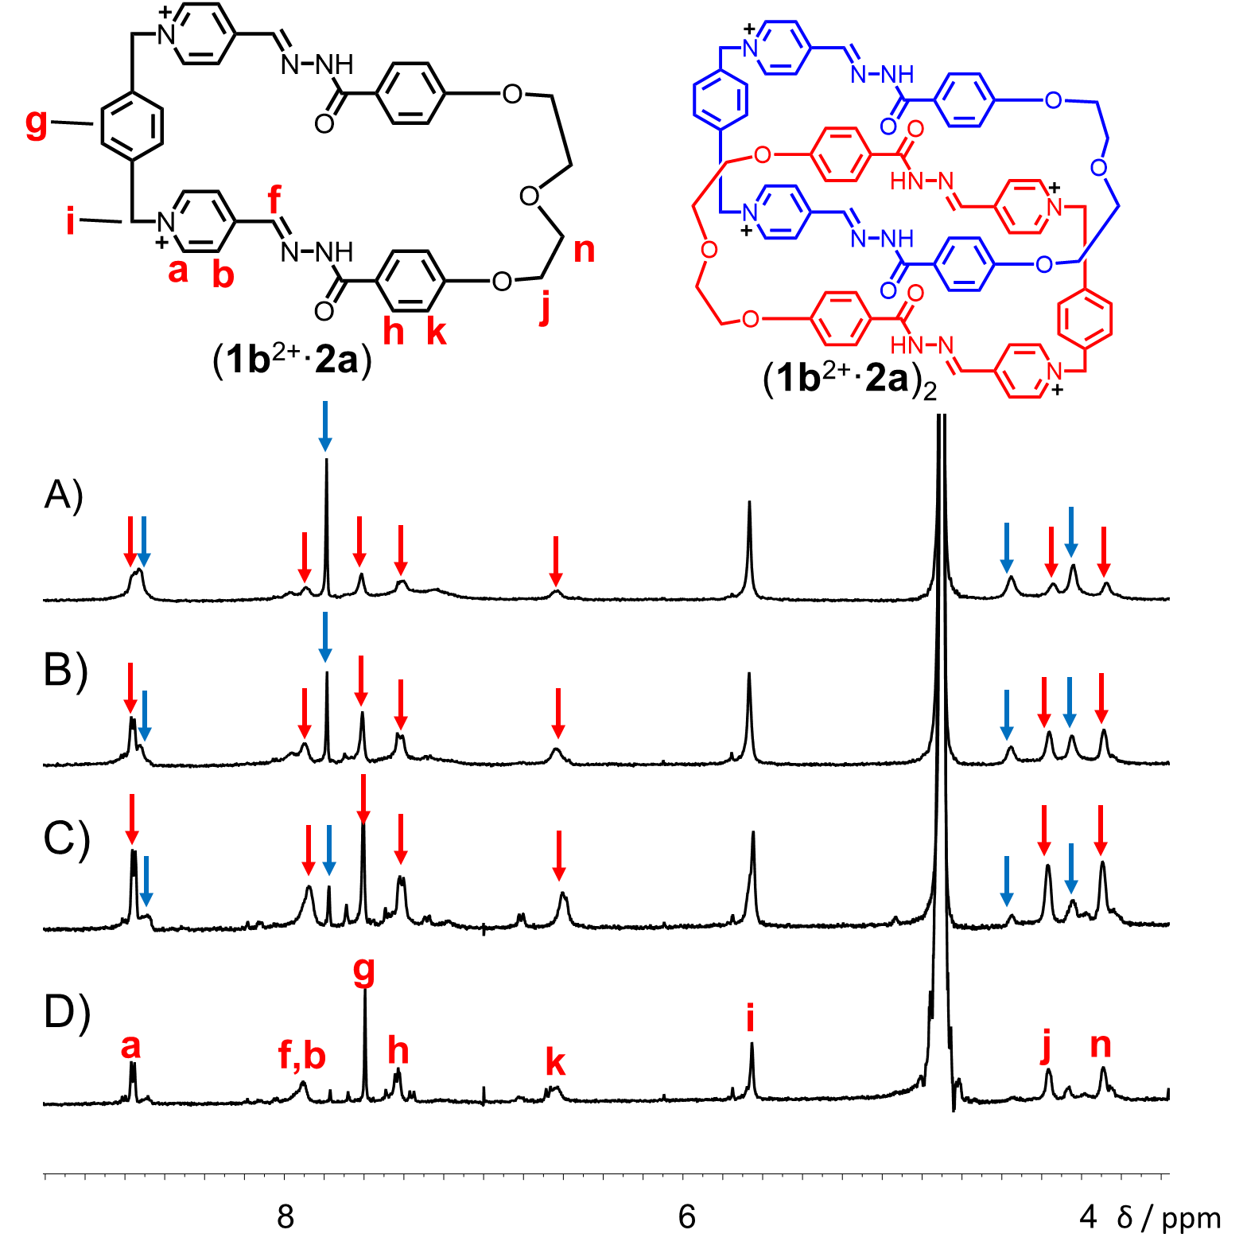
Figure S25. Partial ¹H NMR spectra of condensing a 1:1 mixture of 1b²⁺·2Br─ and 2a (600 MHz, D₂O, 298 K), when the concentration of 2a is A) 4.5 mM, B) 2.5 mM, C) 1.2 mM, D) 0.6 mM. The resonances of (1b²⁺·2a) and (1b²⁺·2a)₂ are marked with red arrows and blue arrows, respectively. Most of the resonances corresponding to (1b²⁺·2a)₂ are relatively broad. As a consequence, only a few of them are clearly observed in Figure S25A.

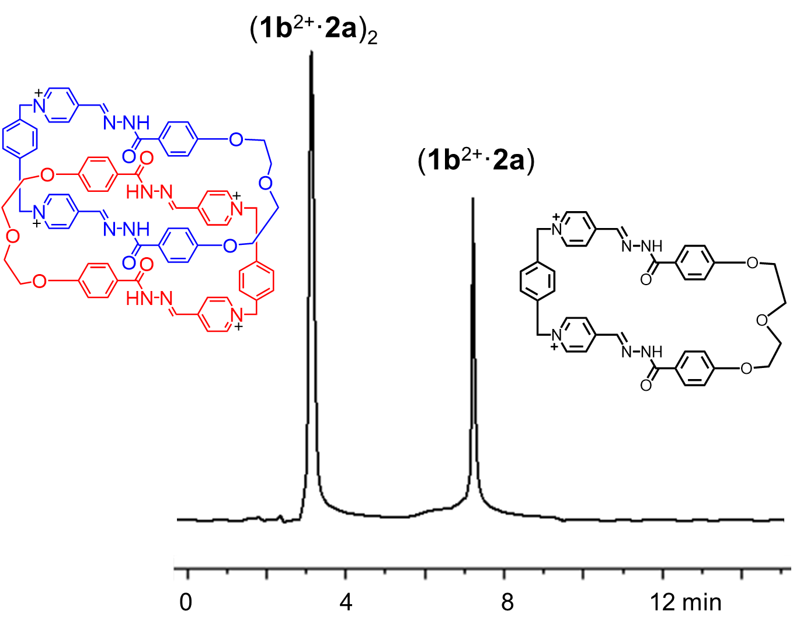
Figure S26 Reversed-phase HPLC analysis of the reaction mixture by condensing a 1:1 mixture of 1b²⁺2Br─ (4.5 mM) and 2a (4.5 mM). Charges are balanced by Br⁻ or Cl⁻ counteranions.
The analytical HPLC experiment was performed on an Agilent 1250 instrument equipped with a diode array detector and a InfintyLab Poroshell EC-C18 column (4.6 x 50 mm, 2.7 μm). The following acetonitrile /water (both containing 0.1% acetate acid) gradient was used. In the beginning, 1/9 acetonitrile/water was used as the fluent phase, followed by gradually increasing the acetonitrile content from 10% to 100% acetonitrile over the course of 15 min. The detection wavelength was 250 nm.
In the HPLC spectrum, it was observed that two products by condensing 1b²⁺ (4.5 mM) and 2a (4.5 mM) in water, two products namely the [2]catenane (1b²⁺·2a)₂ and macrocycle (1b²⁺·2a) were produced as the major products.

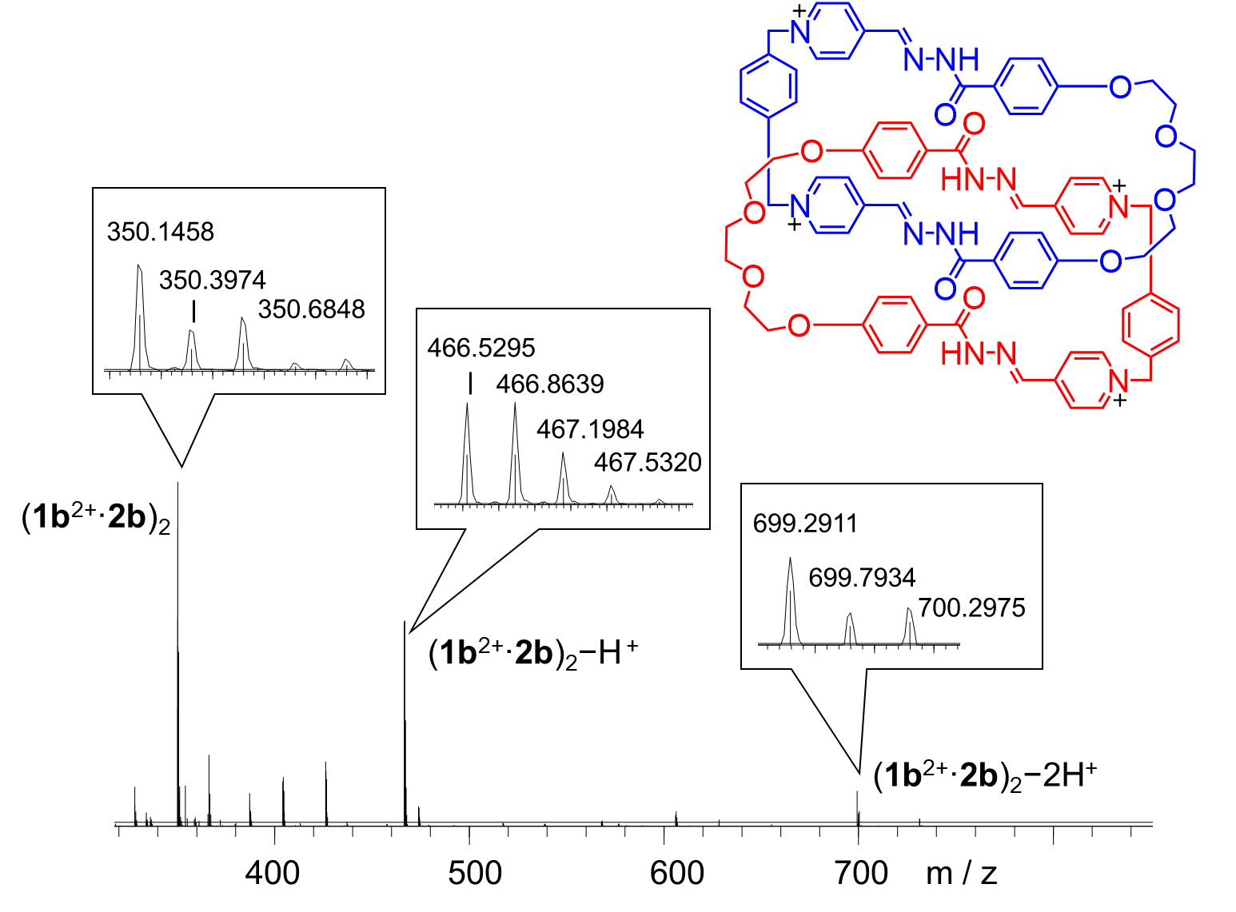
Figure S27. High-resolution LCMS-IT-TOF of (1b²⁺·2b)₂·4Cl─. The signals labeled in the spectrum correspond to molecular cations that contain four, three and two positive charges, respectively. m/z [(1b²⁺·2b)₂]⁴⁺ calculated for C₈₀H₈₀N₁₂O₁₂⁴⁺: 350.1499; found: 350.1458. [(1b²⁺·2b)₂ ─ H⁺]³⁺ calculated for C₈₀H₇₉N₁₂O₁₂³⁺: 466.5308; found: 466.5295. [(1b²⁺·2b)₂ ─ 2H⁺]²⁺ calculated for C₈₀H₇₈N₁₂O₁₂²⁺: 699.7942; found 699.7934.

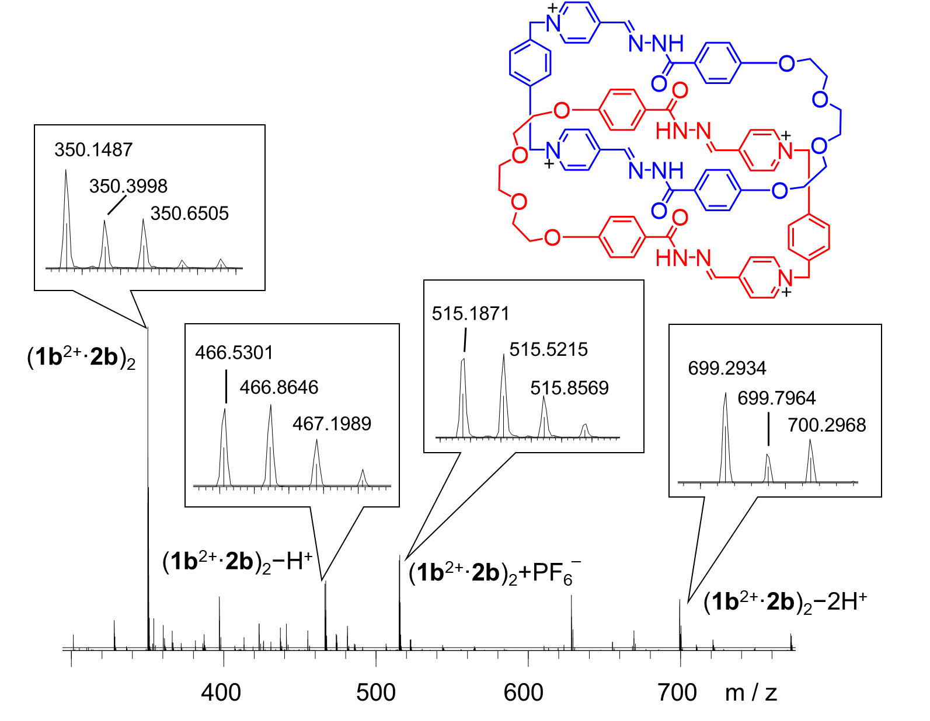
Figure S28. High-resolution LCMS-IT-TOF of (1b²⁺·2b)₂·4PF₆─. The signals labeled in the spectrum correspond to molecular cations that contain four, three and two positive charges, respectively. m/z [(1b²⁺·2b)₂]⁴⁺ calculated for C₈₀H₈₀N₁₂O₁₂⁴⁺: 350.1499; found: 350.1487. [(1b²⁺·2b)₂ ─ H⁺]³⁺ calculated for C₈₀H₇₉N₁₂O₁₂³⁺: 466.5308; found: 466.5301. [(1b²⁺·2b)₂+ PF₆─]³⁺ calculated for C₈₀H₈₀PF₆N₁₂O₁₂³⁺: 515.1881; found 515.1871. [(1b²⁺·2b)₂ ─ 2H⁺]²⁺ calculated for C₈₀H₇₈N₁₂O₁₂²⁺: 699.7942; found 699.7964.

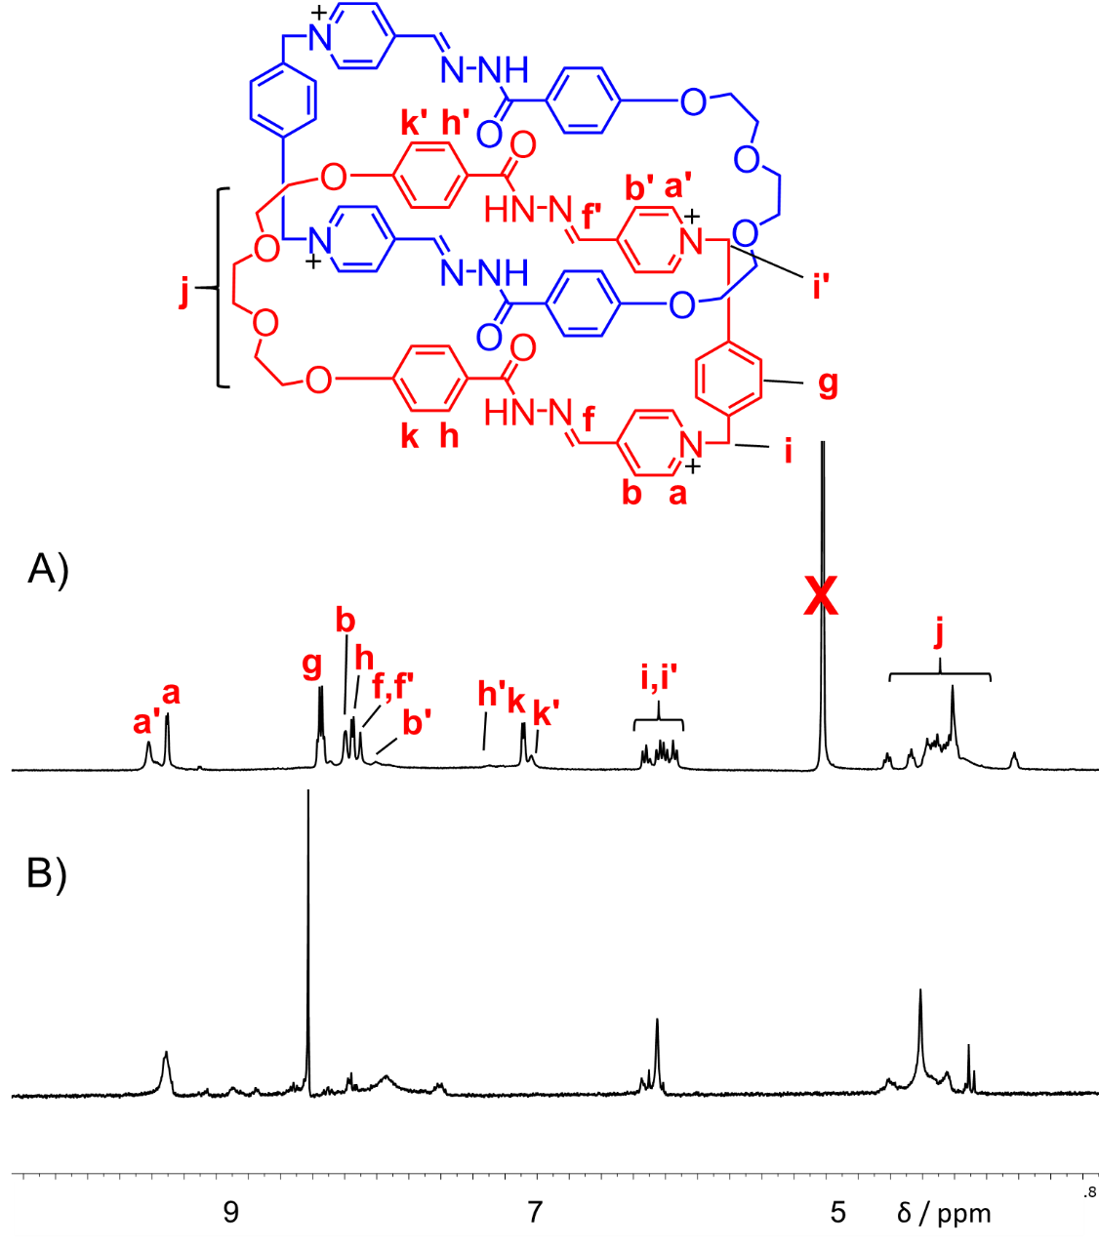
Figure S29. Partial ¹H NMR spectra of A) (1b²⁺·2b)₂·4Cl─ (600 MHz, D₂O, 298 K), B) (1b²⁺·2b)₂·4PF₆─ (500 MHz, CD₃CN, 298 K).

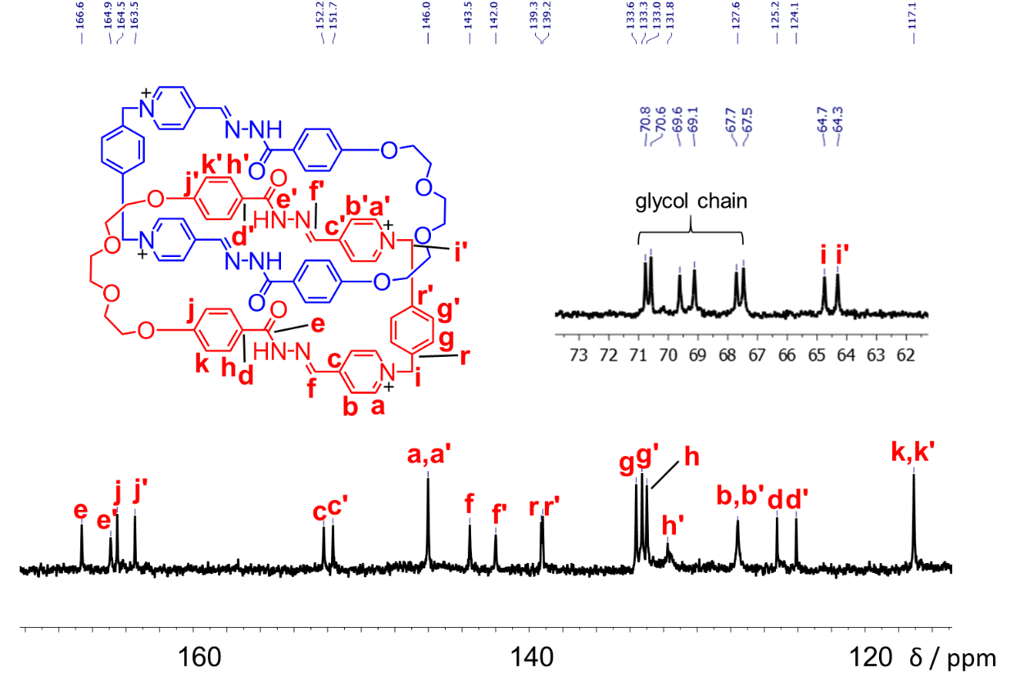
Figure S30. ¹³C NMR spectrum (150 M Hz, 298 K, D₂O:DMSO=2:1) of (1b²⁺·2b)₂·4Cl─.

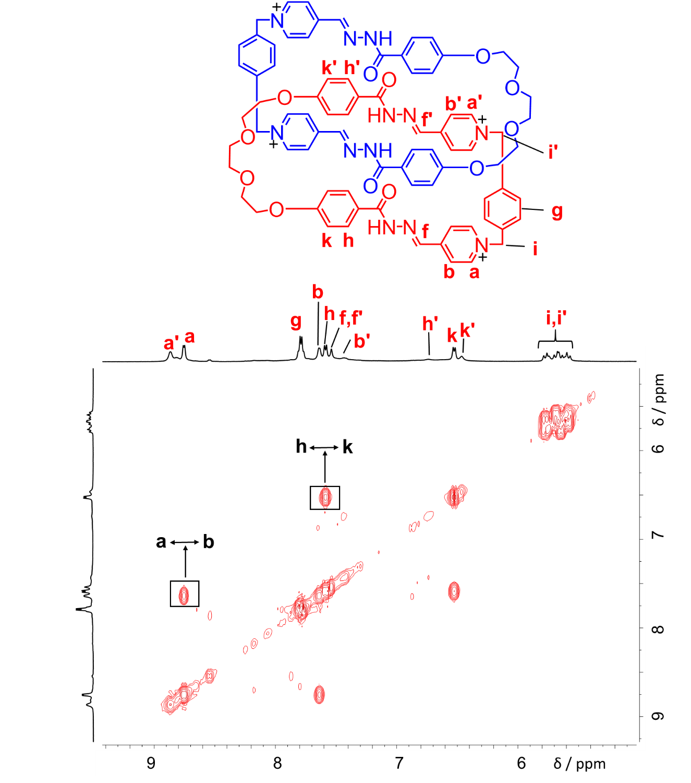
Figure S31. ¹H−¹H COSY spectrum (500 MHz, D₂O, 298 K) of (1b²⁺·2b)₂·4Cl─. Key correlation peaks are labeled in the spectrum.

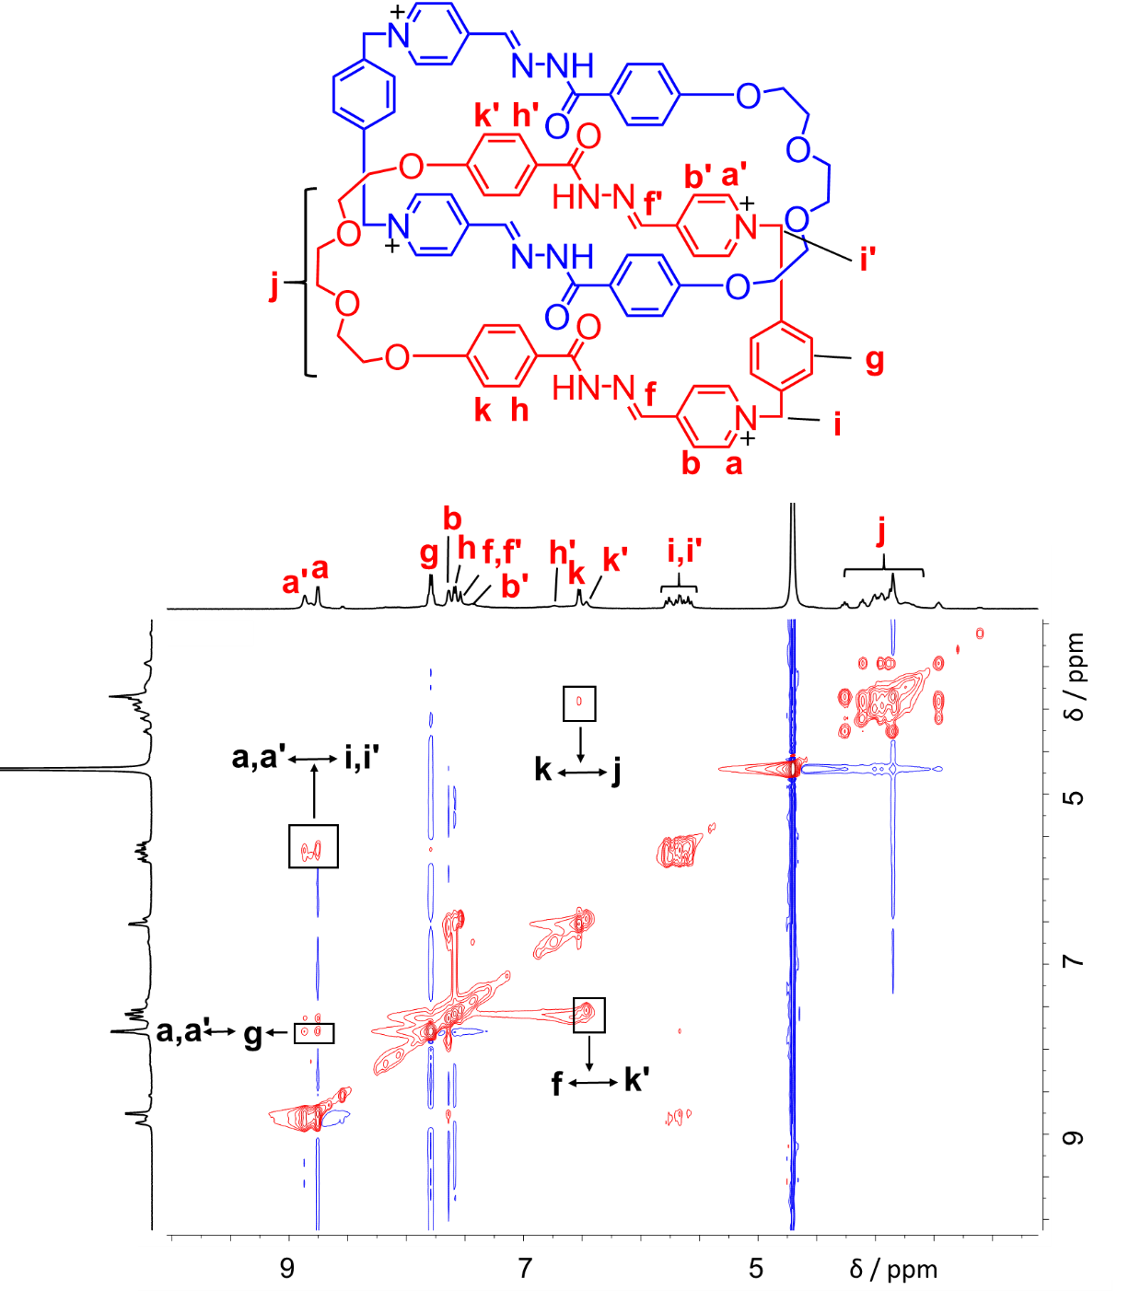
Figure S32. ¹H−¹H NOESY spectrum (500 MHz, D₂O, 298 K) of (1b²⁺·2b)₂·4Cl─. Key correlation peaks are labeled in the spectrum.

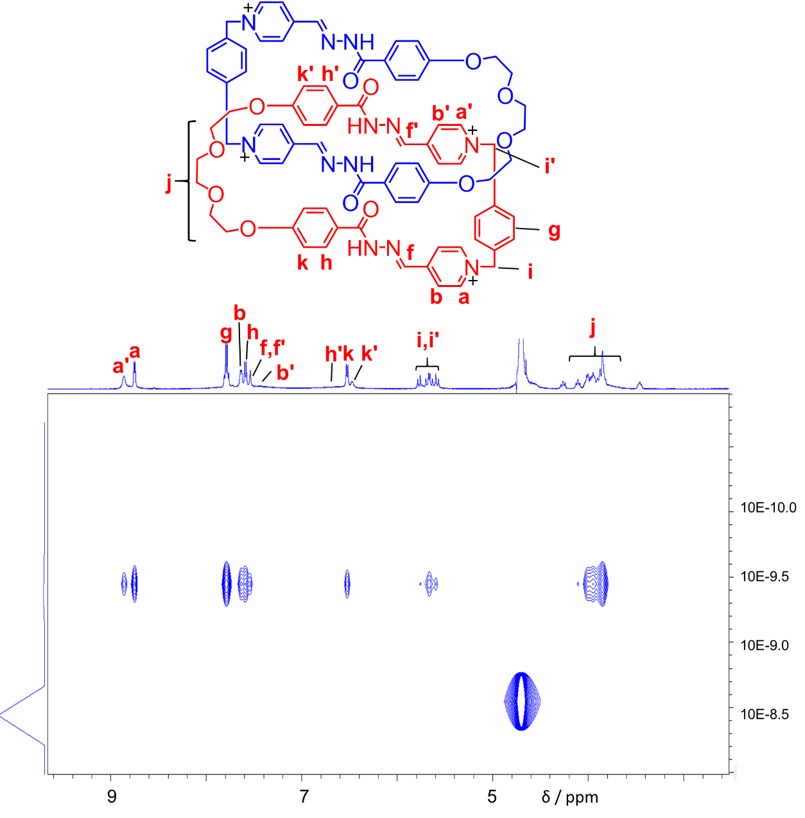
Figure S33. DOSY spectrum (500 MHz, D₂O, 298 K) of (1b²⁺·2b)₂·4Cl─.

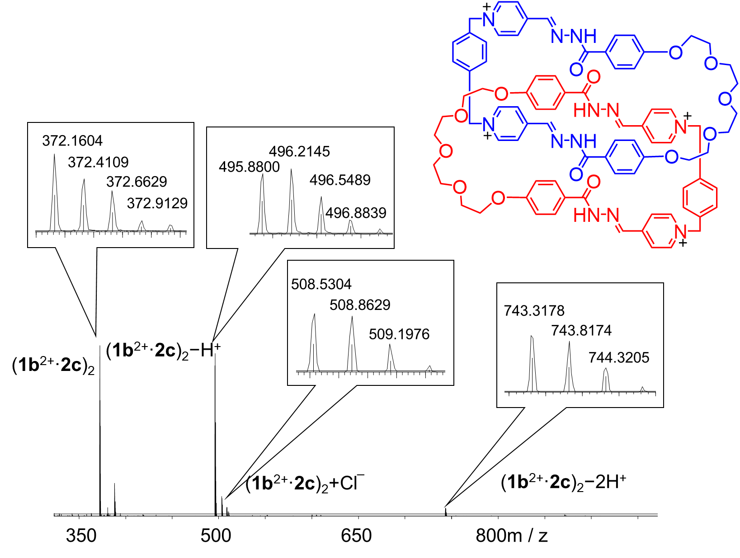
Figure S34. High-resolution LCMS-IT-TOF of (1b²⁺·2c)₂·4Cl─. The signals labeled in the spectrum correspond to molecular cations that contain four, three and two positive charges, respectively. m/z [(1b²⁺·2c)₂]⁴⁺ calculated for C₈₄H₈₈N₁₂O₁₄⁴⁺: 372.1630; found: 372.1604. [(1b²⁺·2c)₂ ─ H⁺]³⁺ calculated for C₈₄H₈₇N₁₂O₁₄³⁺: 495.8816; found: 495.8800. [(1b²⁺·2c)₂ + Cl─]³⁺ calculated for C₈₄H₈₈ClN₁₂O₁₄³⁺: 507.8738; found: 508.8629. [(1b²⁺·2c)₂ ─ 2H⁺]²⁺ calculated for C₈₄H₈₆N₁₂O₁₄²⁺: 743.3186; found 743.3178.

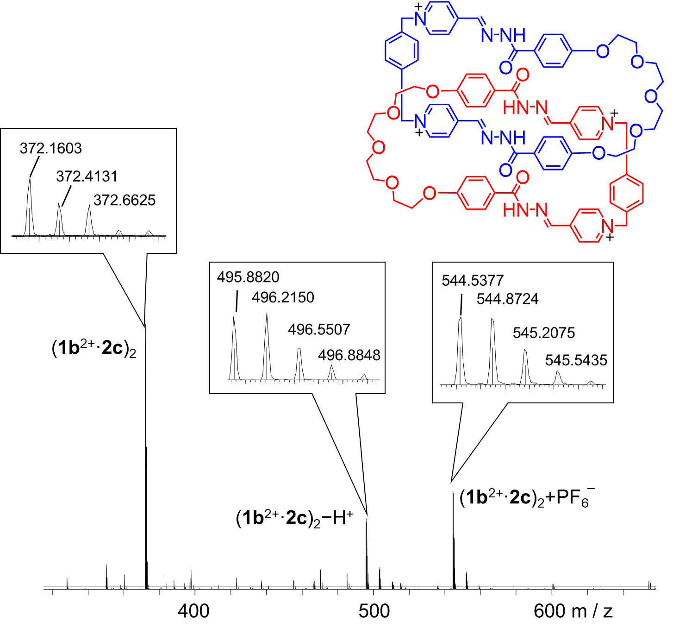
Figure S35. High-resolution LCMS-IT-TOF of (1b²⁺·2c)₂·4PF₆─. The signals labeled in the spectrum correspond to molecular cations that contain four and three positive charges, respectively. m/z [(1b²⁺·2c)₂]⁴⁺ calculated for C₈₄H₈₈N₁₂O₁₄⁴⁺: 372.1630; found: 372.1603. [(1b²⁺·2c)₂ ─ H⁺]³⁺ calculated for C₈₄H₈₇N₁₂O₁₄³⁺: 495.8816; found: 495.8820. [(1b²⁺·2c)₂ + PF₆⁺]³⁺ calculated for C₈₄H₈₈PF₆N₁₂O₁₄³⁺: 544.5389; found: 544.5377.

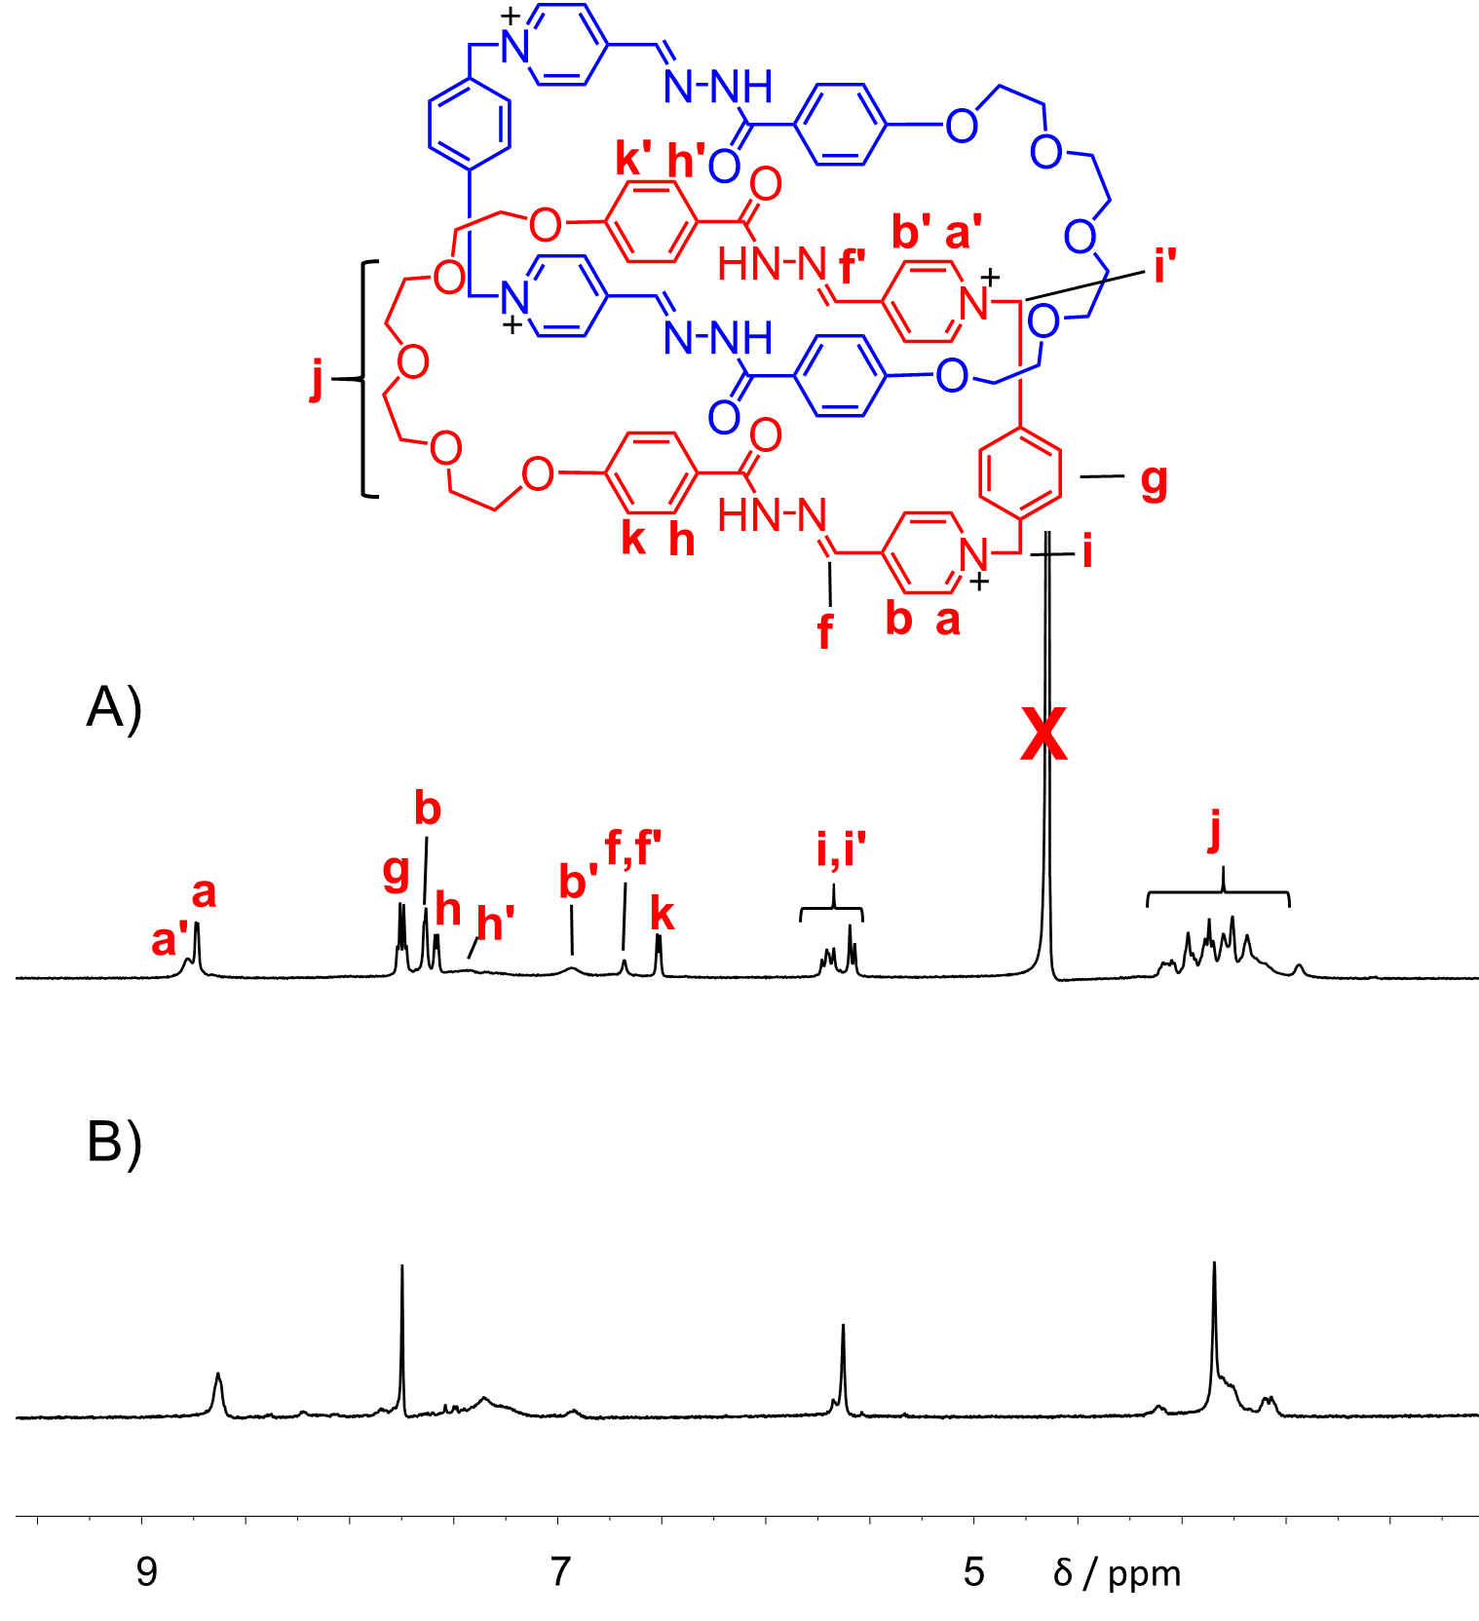
Figure S36. Partial ¹H NMR spectra of A) (1b²⁺·2c)₂·4Cl─ (600 MHz, D₂O, 298 K) and B (1b²⁺·2c)₂·4PF₆─ (500 MHz, CD₃CN, 298 K).
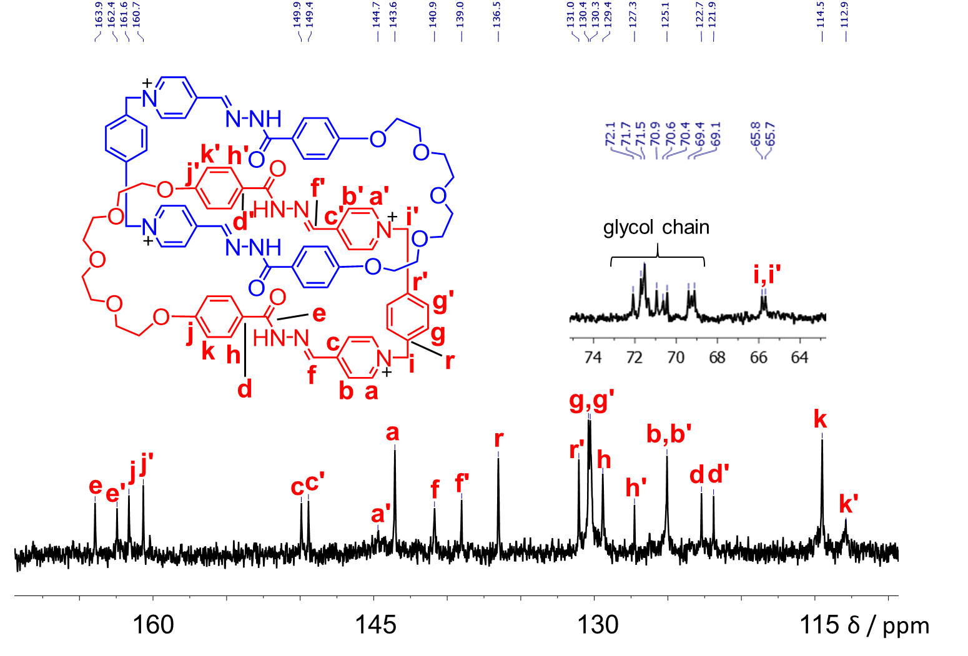
Figure S37. ¹³C NMR spectrum (125 M Hz, 298 K, D₂O:DMSO=4:3) of (1b²⁺·2c)₂·4Cl─.

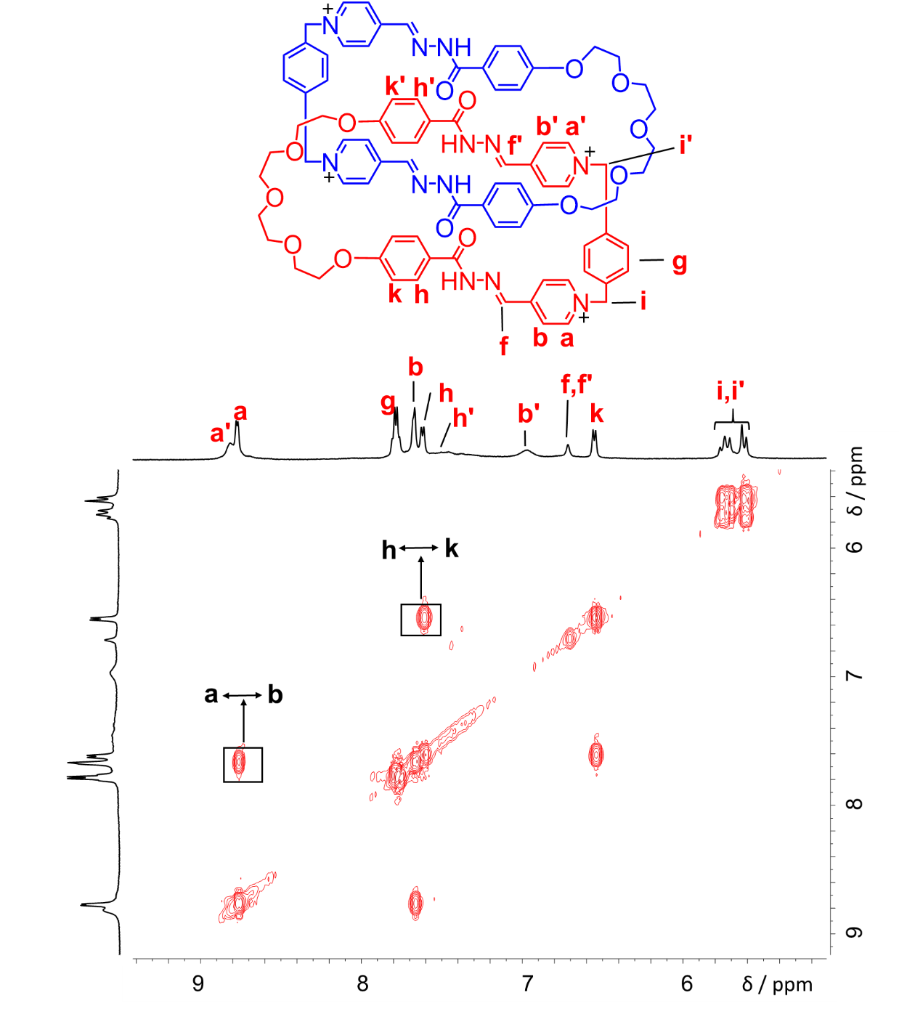
Figure S38. ¹H−¹H COSY spectrum (500 MHz, D₂O, 298 K) of (1b²⁺·2c)₂·4Cl─. Key correlation peaks are labeled in the spectrum.

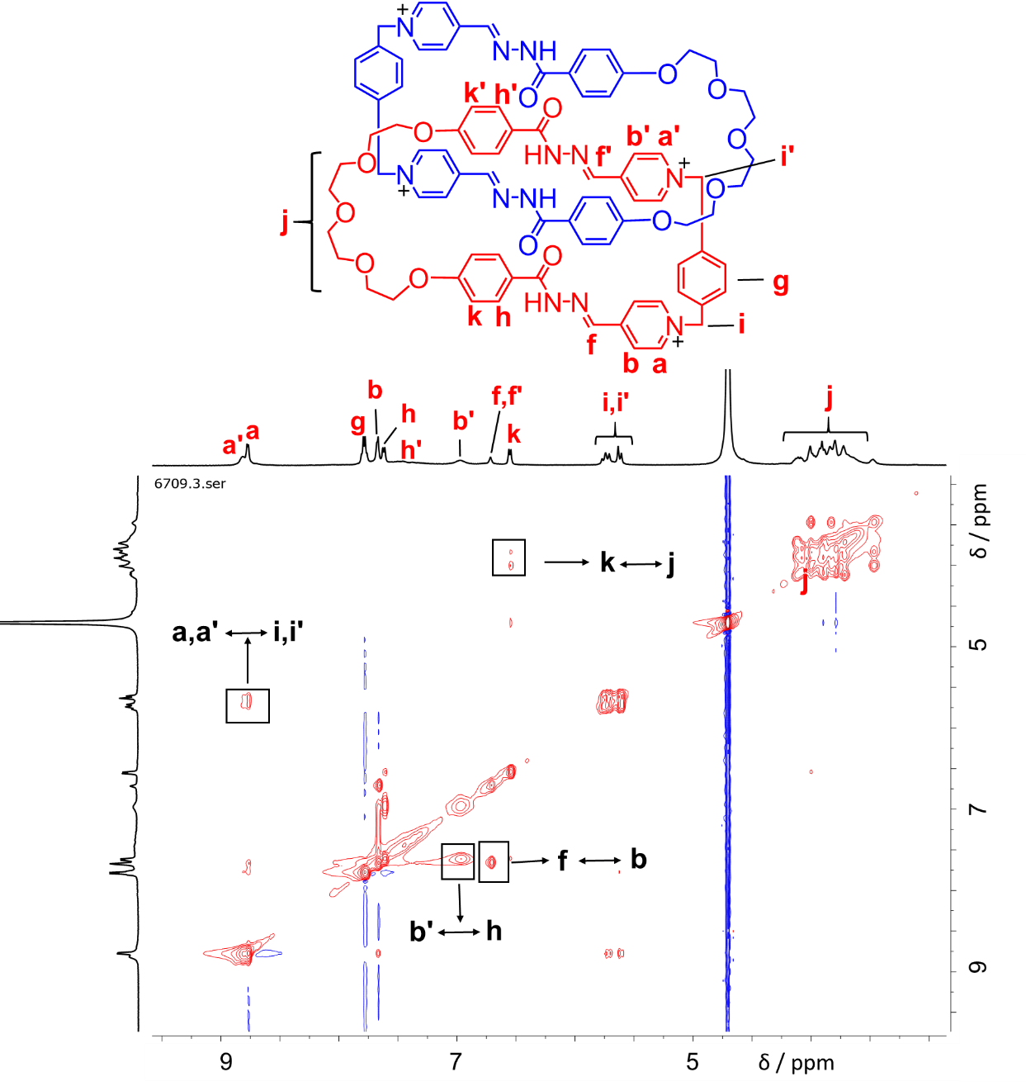
Figure S39. ¹H−¹H NOESY spectrum (500 MHz, D₂O, 298 K) of (1b²⁺·2c)₂·4Cl─. Key correlation peaks are labeled in the spectrum.

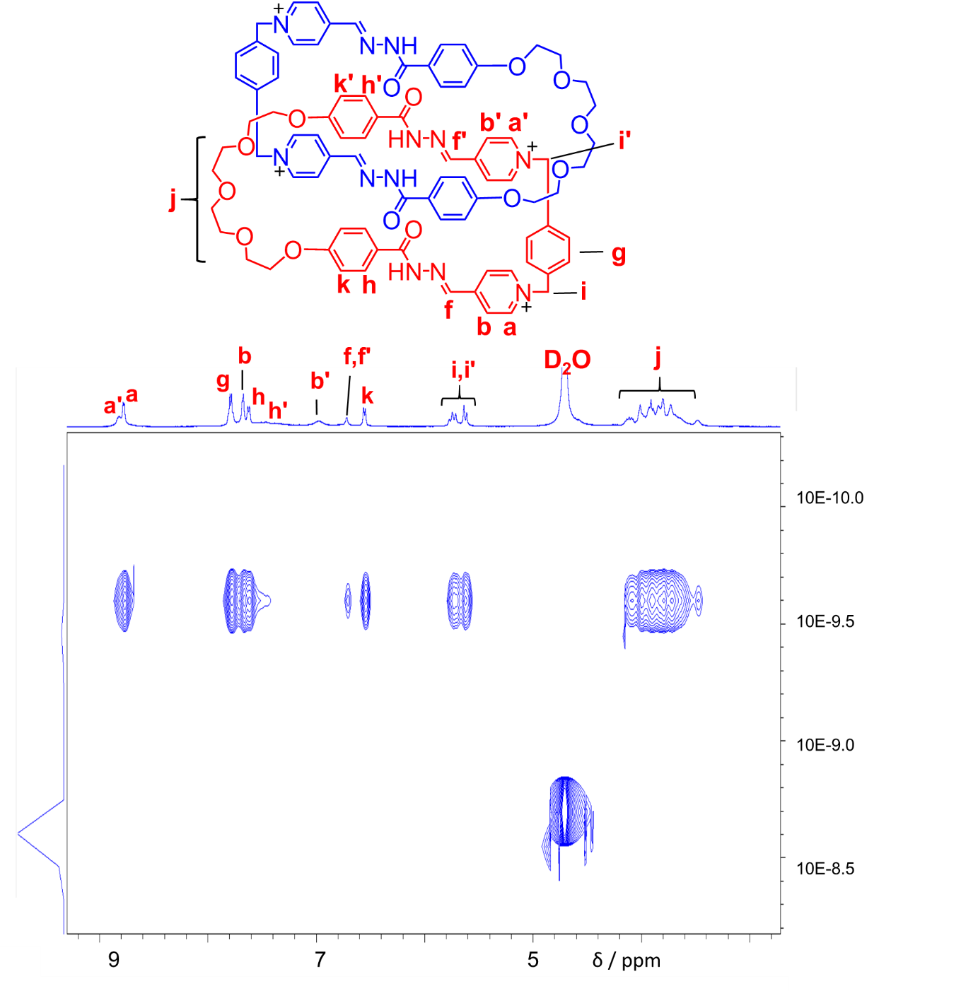
Figure S40. DOSY spectrum (500 MHz, D₂O, 298 K) of (1b²⁺·2c)₂·4Cl─.

5. Characterization of (1a²⁺·2e) by NMR and HRMS
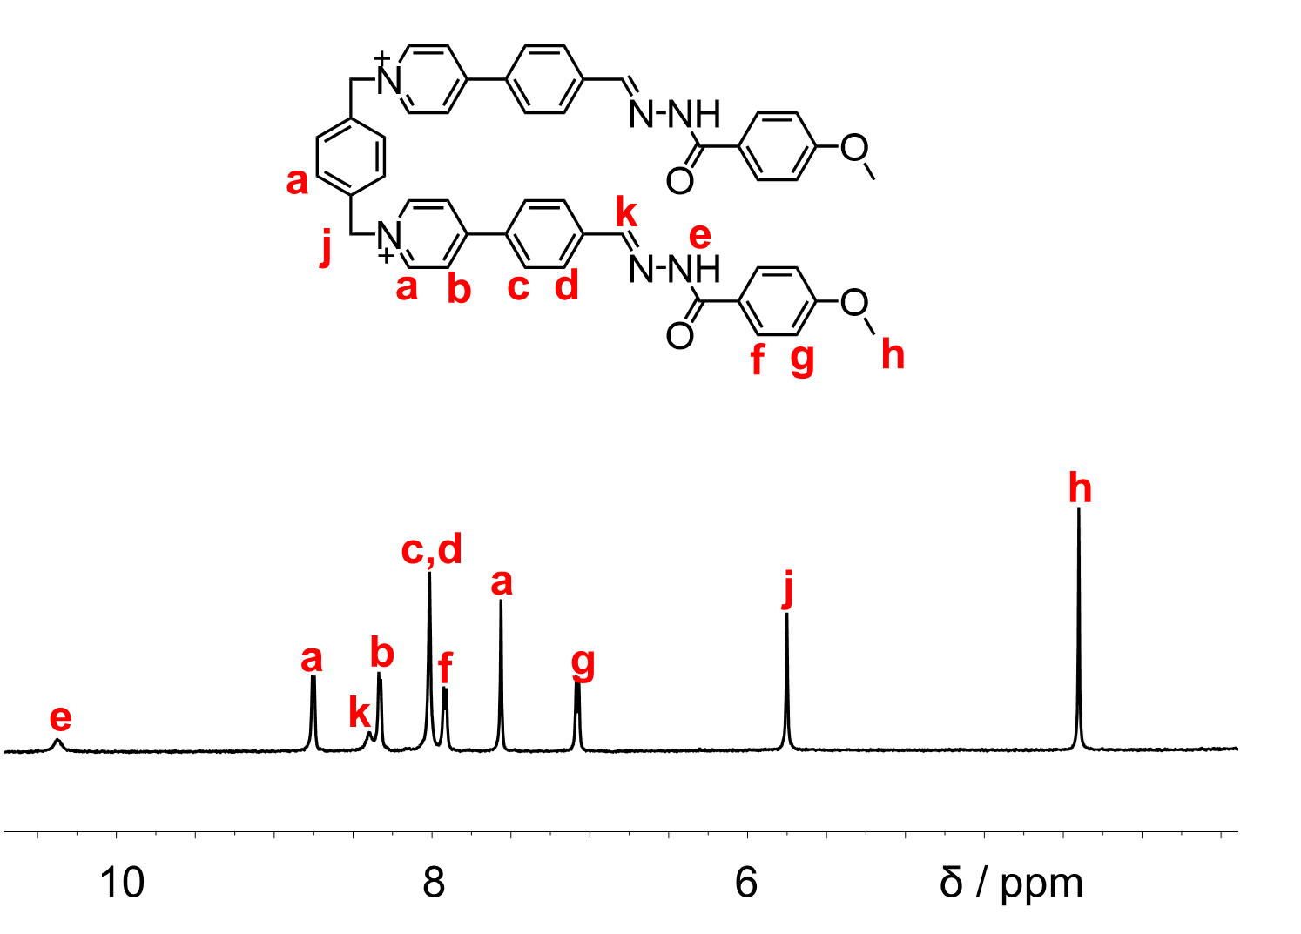
Figure S41. Partial ¹H NMR spectra of (1a²⁺·2e)·2PF₆─ (400 MHz, CD₃CN, 298 K).

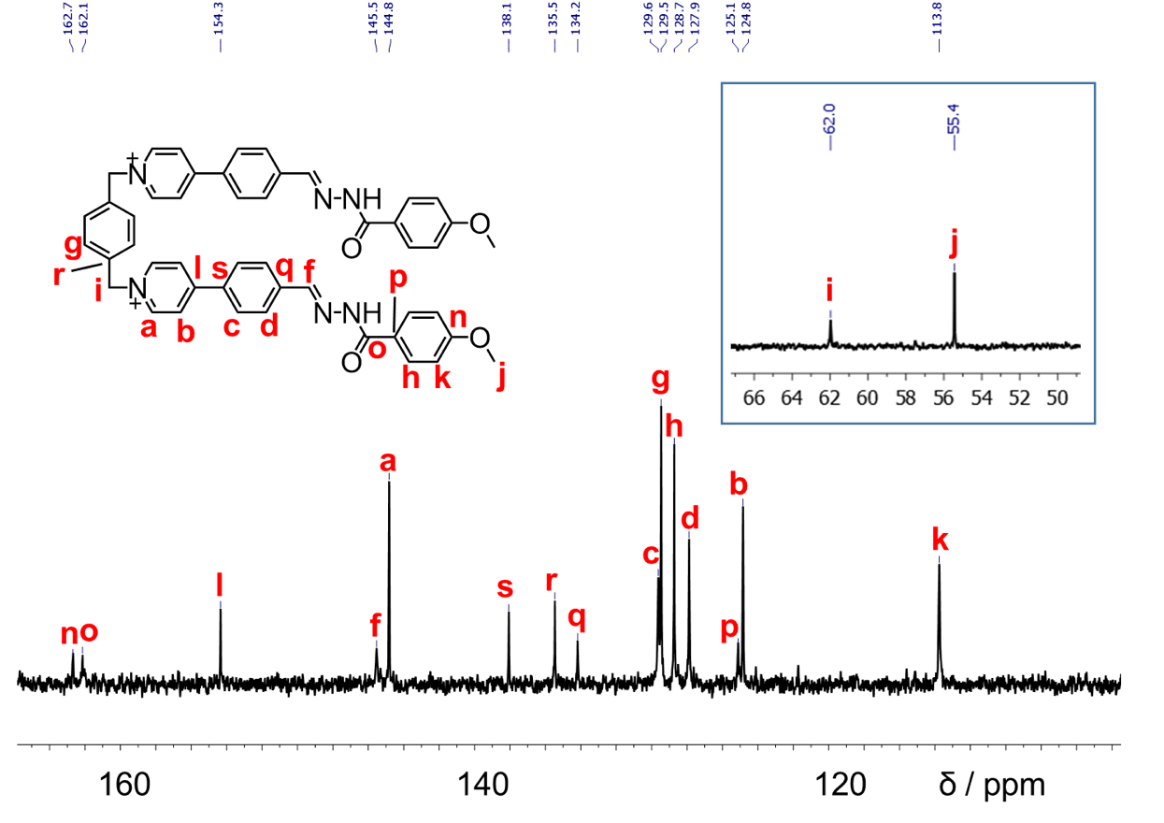
Figure S42. ¹³C NMR spectrum (125 M Hz, 298 K, DMSO) of (1a²⁺·2e)·2PF₆─.
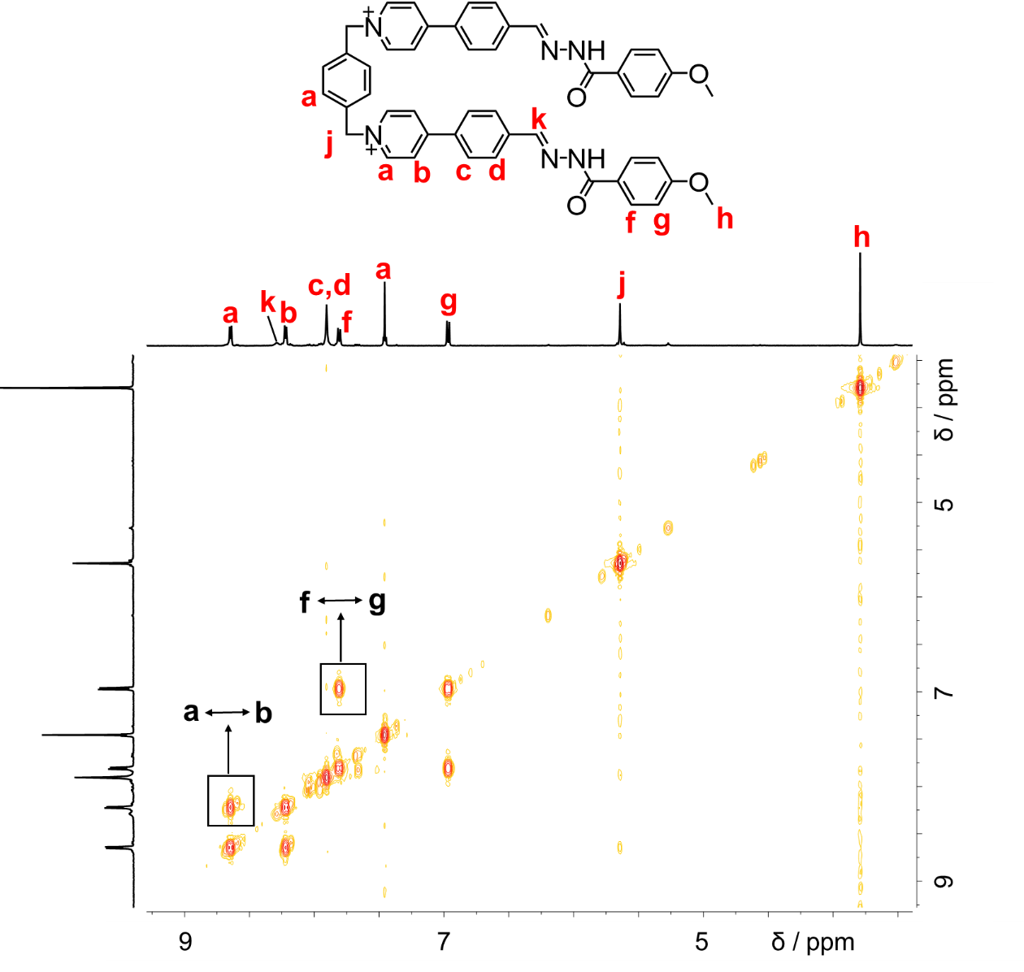
Figure S43. ¹H−¹H COSY spectrum (500 MHz, CD₃CN, 298 K) of (1a²⁺·2e)·2PF₆─. Key correlation peaks are labeled in the spectrum.
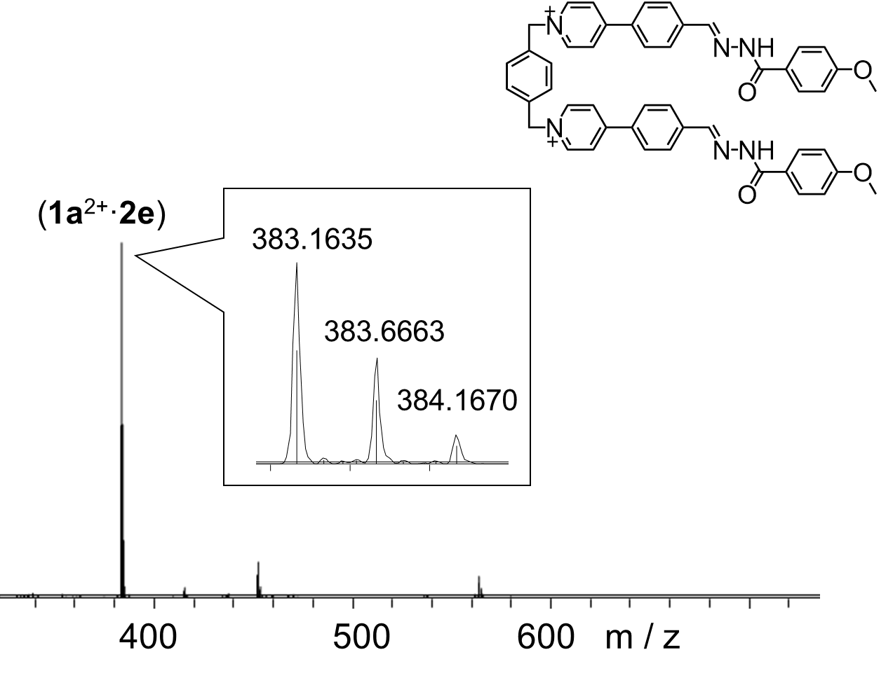
Figure S44. High-resolution LCMS-IT-TOF of (1a²⁺·2e)·2PF₆─. m/z [(1a²⁺·2e)]²⁺ calculated for C₄₈H₄₂N₆O₄²⁺: 383.1628; found: 383.1635.

6. Self-sorting Investigations
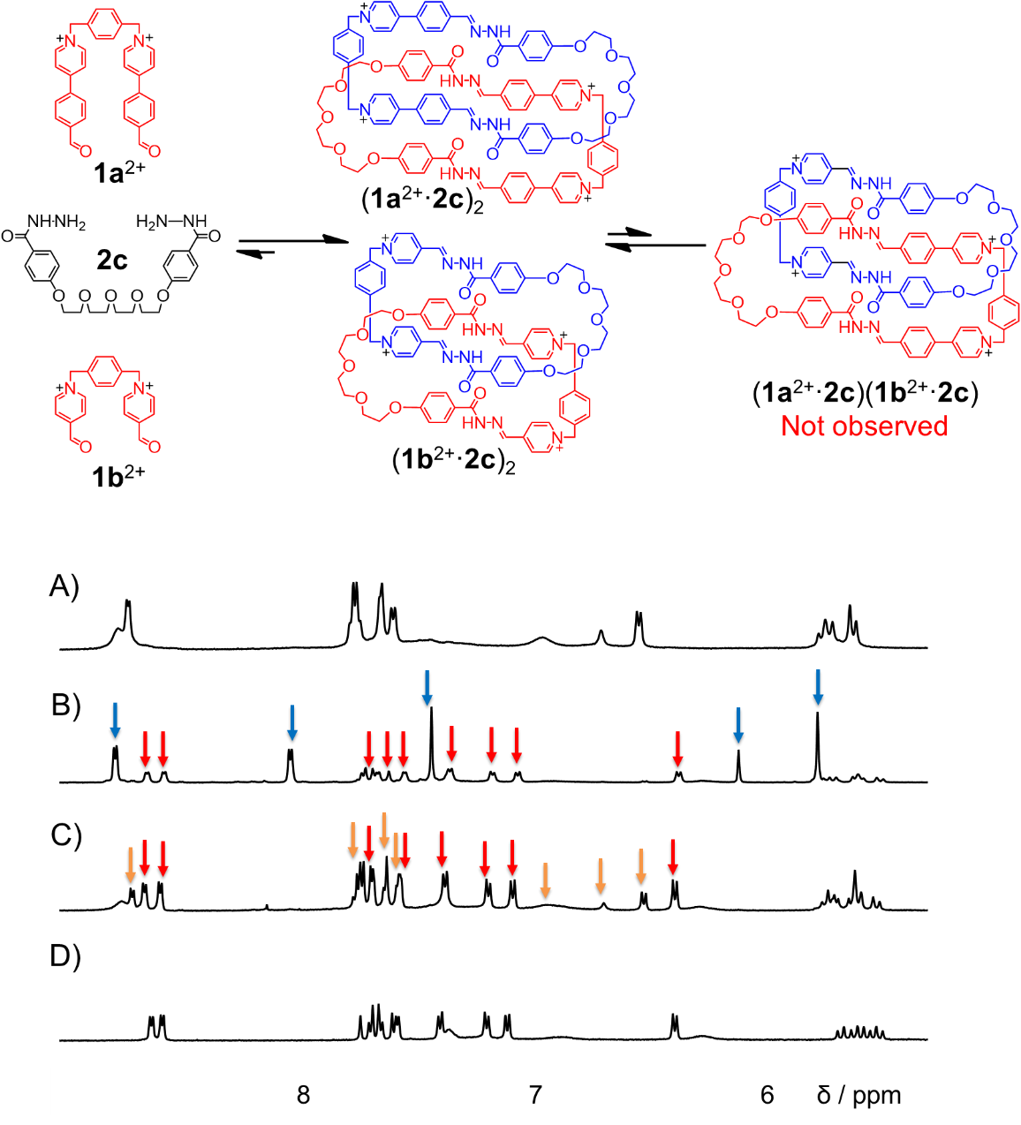
Figure S45. Partial ¹H NMR spectra (500 MHz, D₂O, 298 K) of A) (1b²⁺·2c)₂, B) a 1:1:1 reaction mixture of 1a²⁺·2Cl─, 1b²⁺·2Br─ and 2c, C) a 1:1:2 reaction mixture of 1a²⁺·2Cl─, 1b²⁺·2Br─ and 2c and D) (1a²⁺·2c)₂. The resonances of unreacted 1b²⁺, (1a²⁺·2c) and (1b²⁺·2c) are marked with blue arrows, red arrows and orange arrows, respectively.
When 1a²⁺·2Cl─, 1b²⁺·2Br─ and 2c were combined in D₂O in a 1:1:2 ratio, heating the mixture solution produced two catenanes, namely (1a²⁺·2c)₂ and (1b²⁺·2c)₂.as indicated by both ¹H NMR (Figure S45 C) and mass spectrum (Figure S46). The hybridized product, namely (1a²⁺·2c)(1b²⁺·2c) were barely observed. Each of these homo [2]catenanes, a macrocycle acts as the template to drive the formation of another. Or expressed in another way, a macrocycle is mechanically interlocked by another version of “itself”, each of which fully occupy the cavity of the other. As a consequence, the noncovalent driving forces, including hydrophobic effect, π-π interactions, CH-π interactions, as well as hydrogen bonding, are maximized. These effects favor the formation of homo [2] catenanes over their heteroleptic ones. When 1a²⁺·2Cl─, 1b²⁺·2Br─ and 2c were combined in D₂O in a 1:1:1 ratio, (1a²⁺·2c)₂ was self-assembled as the major product, leaving a large part of 1b²⁺ unreacted (Figure S45 B and Figure S47).

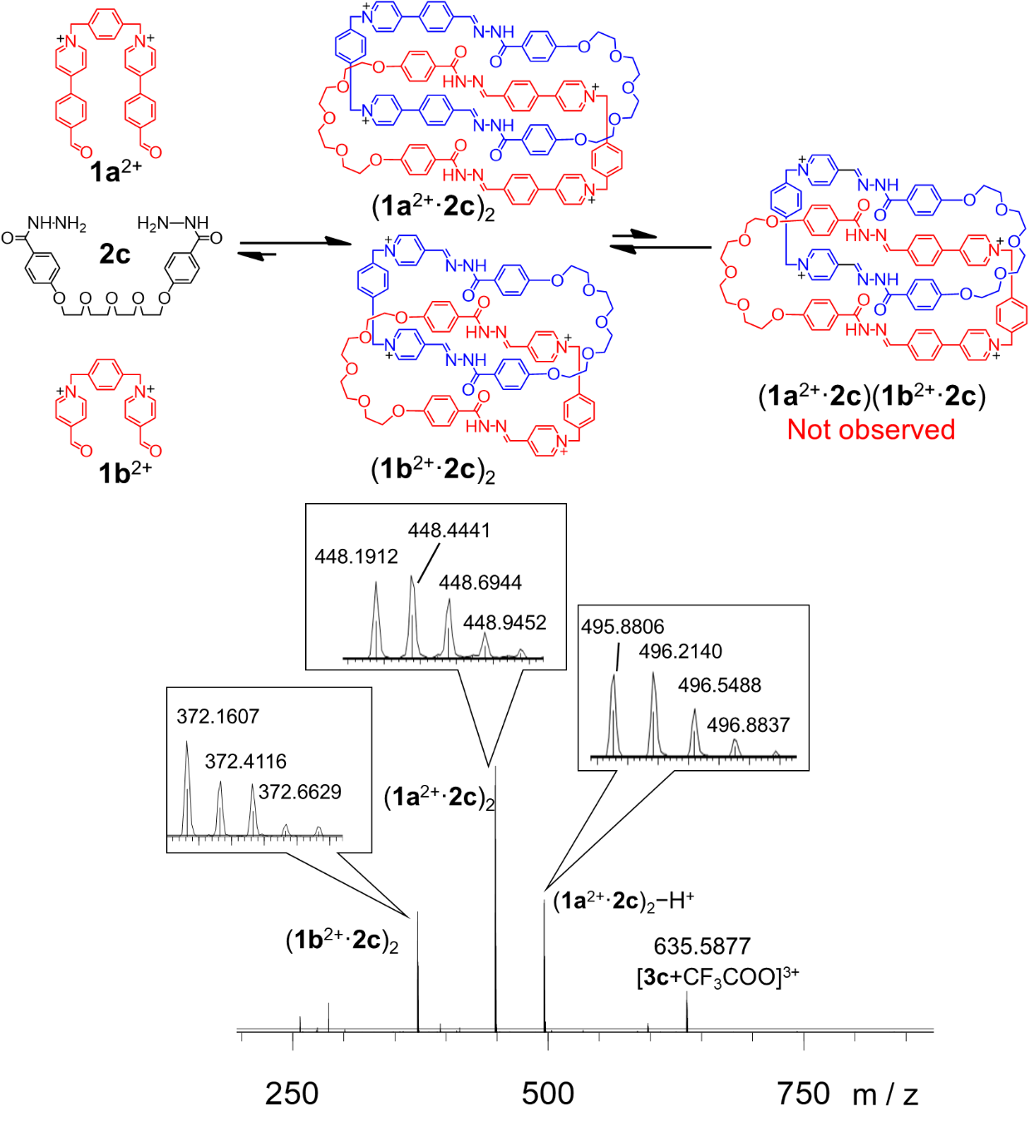
Figure S46. ESI-MS of a 1:1:2 reaction mixture of 1a²⁺·2Cl─, 1b²⁺·2Br─ and 2c .
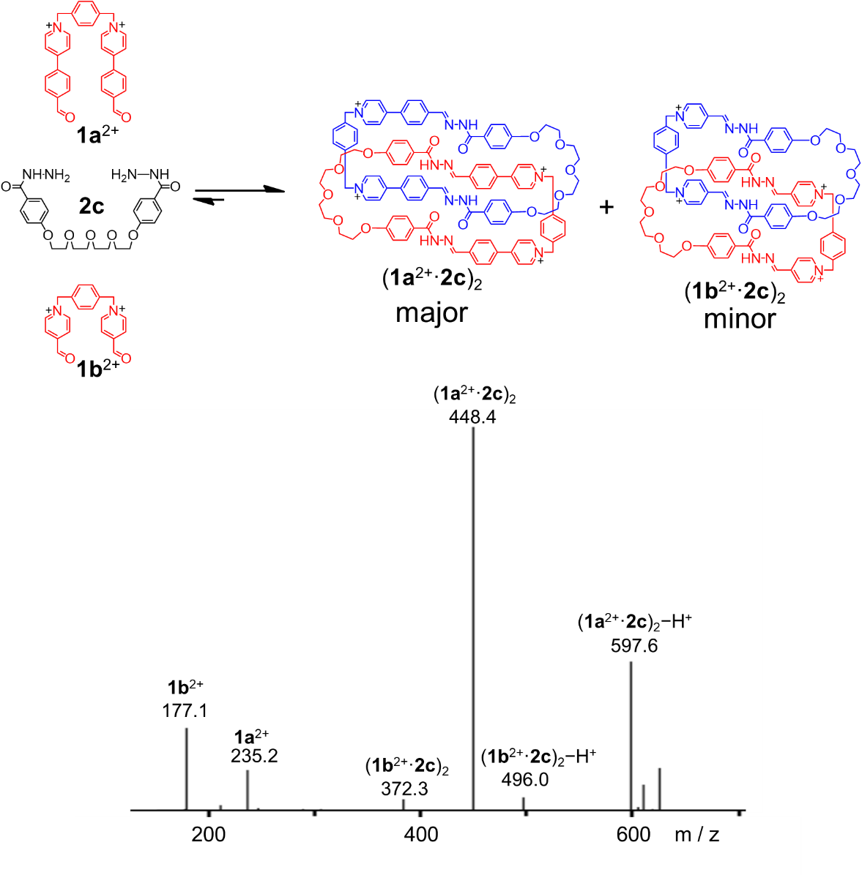
Figure S47. ESI-MS of a 1:1:1 reaction mixture of 1a²⁺·2Cl─, 1b²⁺·2Br─ and 2c. (1a²⁺·2c)₂ was self-assembled as the major product, leaving a large part of 1b²⁺ unreacted. Only trace amount of (1b²⁺·2c)₂ was observed as a minor product.

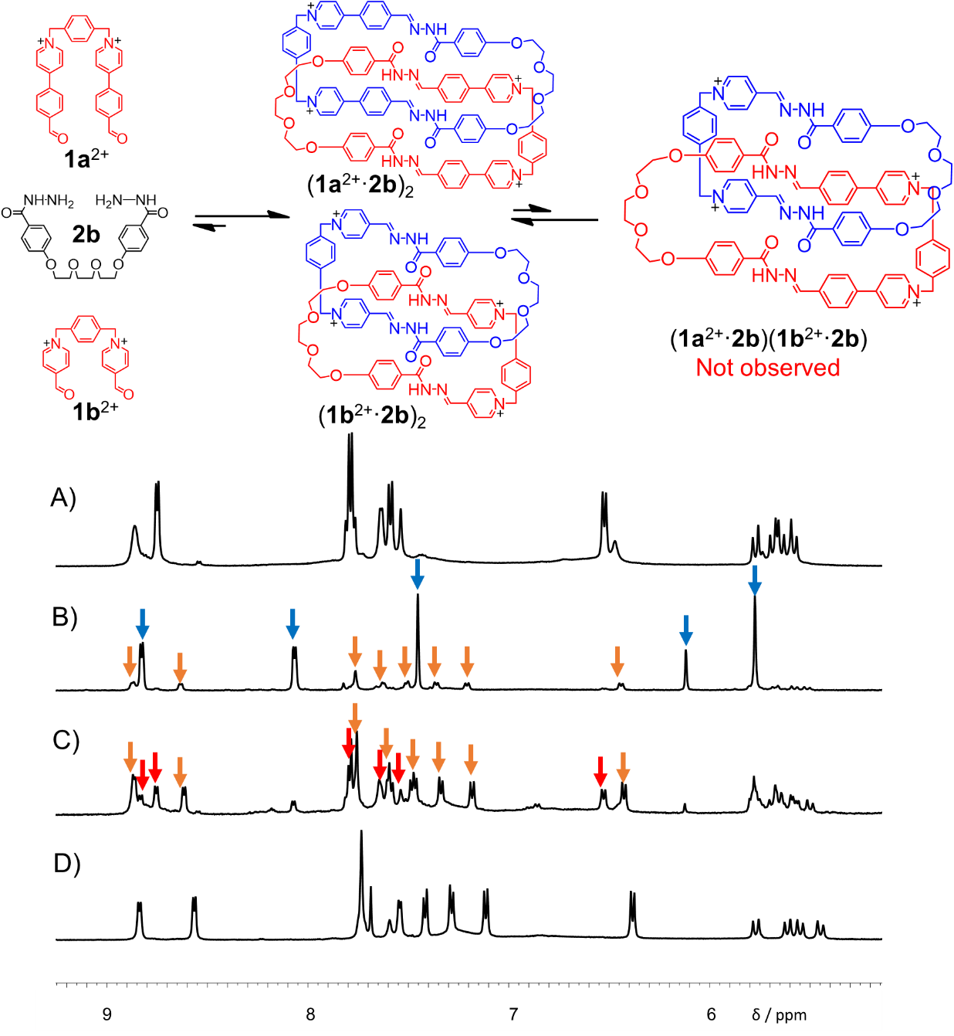
Figure S48. Partial ¹H NMR spectra (500 MHz, D₂O, 298 K) of A) (1b²⁺·2b)₂, B) a 1:1:1 reaction mixture of 1a²⁺·2Cl─, 1b²⁺·2Br─ and 2b, C) a 1:1:2 reaction mixture of 1a²⁺·2Cl─, 1b²⁺·2Br─ and 2b and D) (1a²⁺·2b)₂. The resonances of unreacted 1b²⁺, (1b²⁺·2b) and (1a²⁺·2b) are marked with blue arrows, red arrows and orange arrows, respectively.

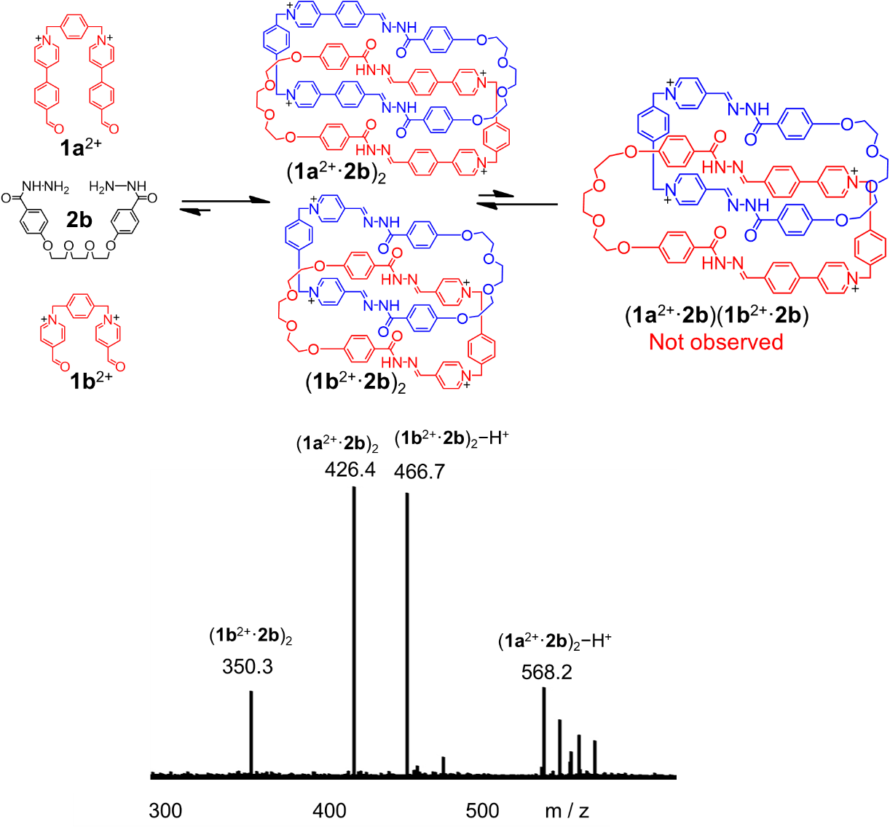
Figure S49. ESI-MS of a 1:1:2 reaction mixture of 1a²⁺·2Cl─, 1b²⁺·2Br─ and 2b.

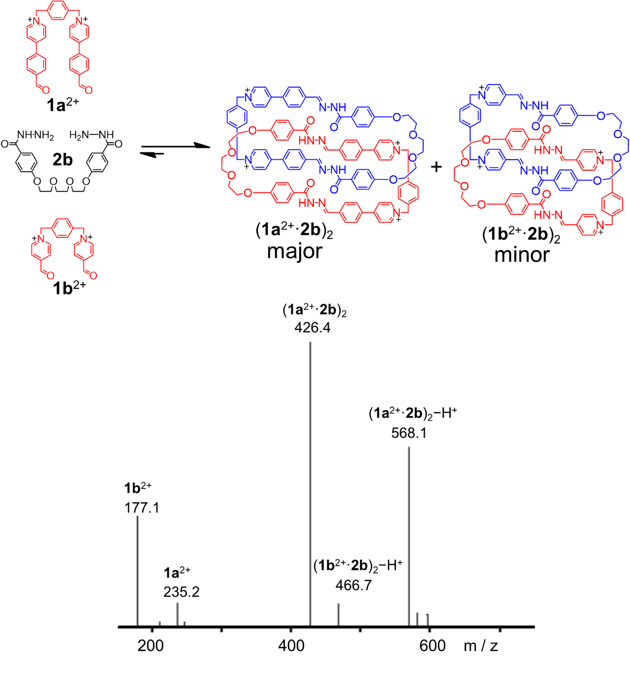
Figure S50. ESI-MS of a 1:1:1 reaction mixture of 1a²⁺·2Cl─, 1b²⁺·2Br─ and 2b. (1a²⁺·2b)₂ was self-assembled as the major product, leaving most of 1b²⁺ unreacted. Only trace amount of (1b²⁺·2b)₂ was observed as a minor product.

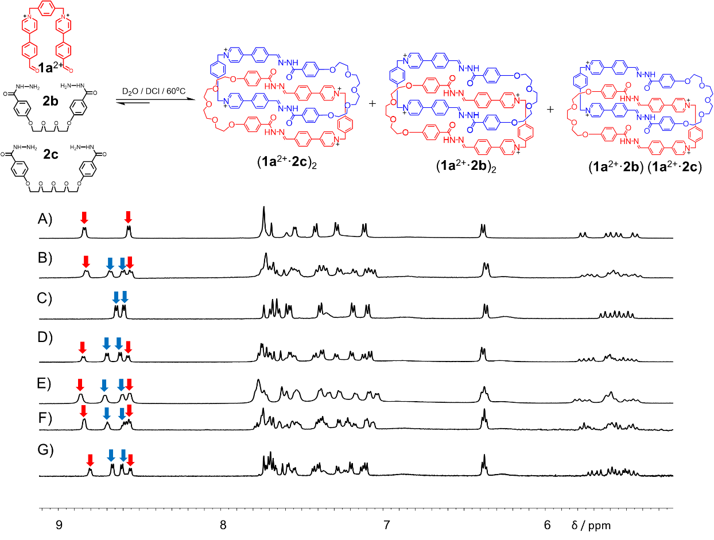
Figure S51. Partial ¹H NMR spectra (500 MHz, D₂O, 298 K) of A) (1a²⁺·2b)₂, B) a 2:1:1 reaction mixture of 1a²⁺·2Cl─, 2b and 2c, C) (1a²⁺·2c)₂, as well as a 1:1 mixture of the pre-synthesized [2]catenanes (1a²⁺·2b)₂ and (1a²⁺·2c)₂ at D) room temperature , E) heated at 60 ºC, and F) after adding catalytic amount of acid and G) after adding excessive amounts of acid. The resonances of (1a²⁺·2c)₂ and (1a²⁺·2b)₂ are marked with blue arrows and red arrows, respectively.
When 1a²⁺·2Cl─, 2b and 2c were combined in D₂O in a 2:1:1 ratio, heating the mixture solution produced two homo [2]catenanes, namely (1a²⁺·2c)₂ and (1a²⁺·2b)₂, and one hybrid [2]catenane, namely (1a²⁺·2c)(1a²⁺·2b), as indicated by mass spectrum (Figure S53). On account of the NMR signals are relatively similar, the peaks of the hybrid [2]catenane can not be clearly found (Figure S51 B). However, when catenanes (1a²⁺·2c)₂ and (1a²⁺·2b)₂ were mixed in water at room temperature, almost no hybrid product was observed after 8 h, as indicated by both ¹H NMR (Figure S51 D) and mass spectrum (Figure S54). Heating the mixture of these two catenanes led to the formation of (1a²⁺·2c)(1a²⁺·2b) slightly, as indicated by mass spectrum (Figure S55). (1a²⁺·2c)(1a²⁺·2b) was observed obviously by adding acid (Figures S56-57).
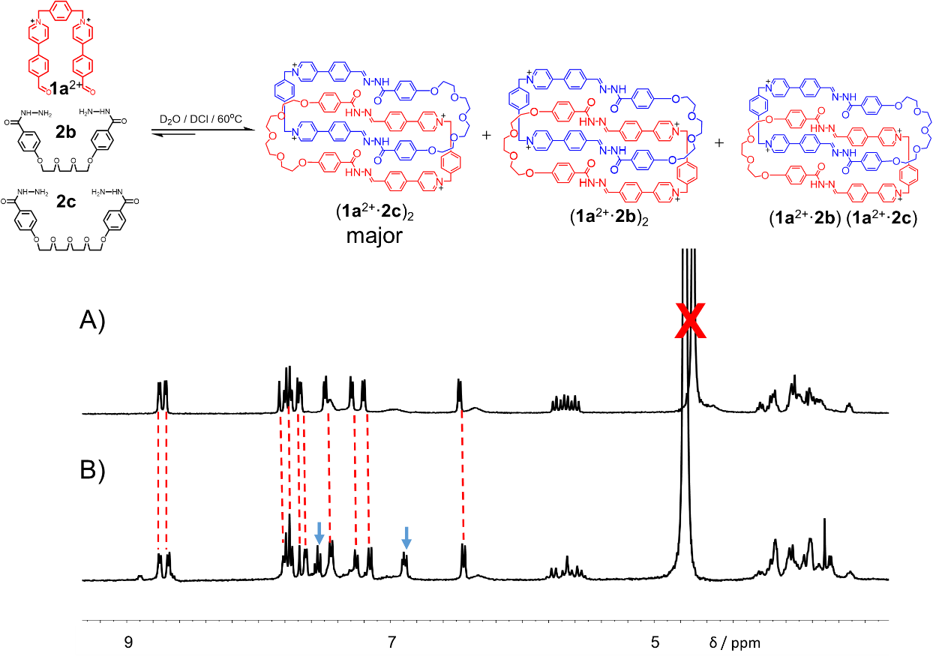
Figure S52. Partial ¹H NMR spectra (400 MHz, D₂O, 298 K) of A) (1a²⁺·2c)₂ and B) a 1:1:1 reaction mixture of 1a²⁺·2Cl─, 2b and 2c. The resonances of unreacted 2b are marked with blue arrows.
From the ¹H NMR spectra (Figure S52), we could observed that [2]catenane (1a²⁺·2c)₂ was produced as the major product by condensation of a 1:1:1 mixture of 1a²⁺·2Cl─, 2b and 2c. Other small amounts of products, namely (1a²⁺·2b)₂ and (1a²⁺·2c)(1a²⁺·2b), could not be found clearly in the the ¹H NMR spectrum (Figure S52 B) since their signals were quite weak. However, the ESI-MS experiment (Figure S58) verified the formation of (1a²⁺·2b)₂ and (1a²⁺·2c)(1a²⁺·2b) strongly.

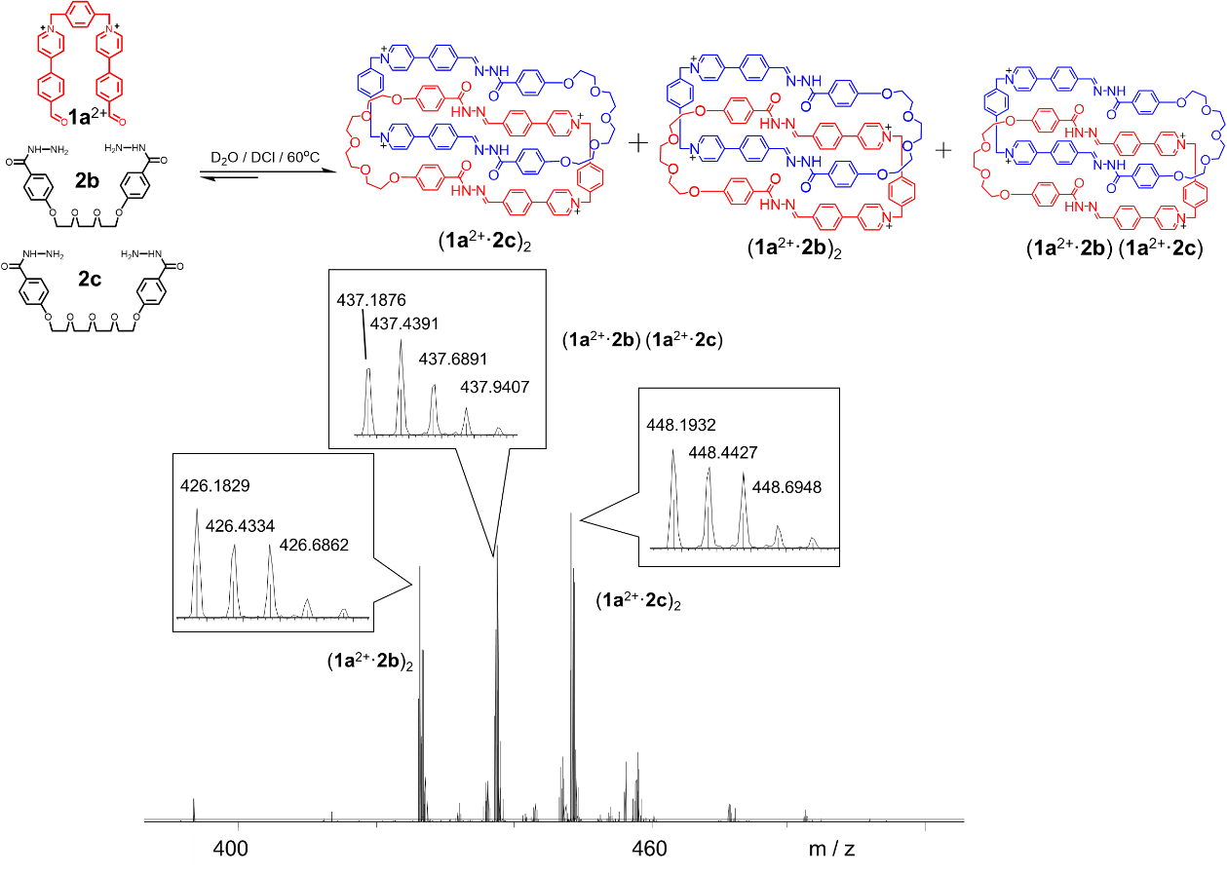
Figure S53. LCMS-IT-TOF spectrum of the self-assembled products of a 2:1:1 reaction mixture of 1a²⁺·2Cl─, 2b and 2c.

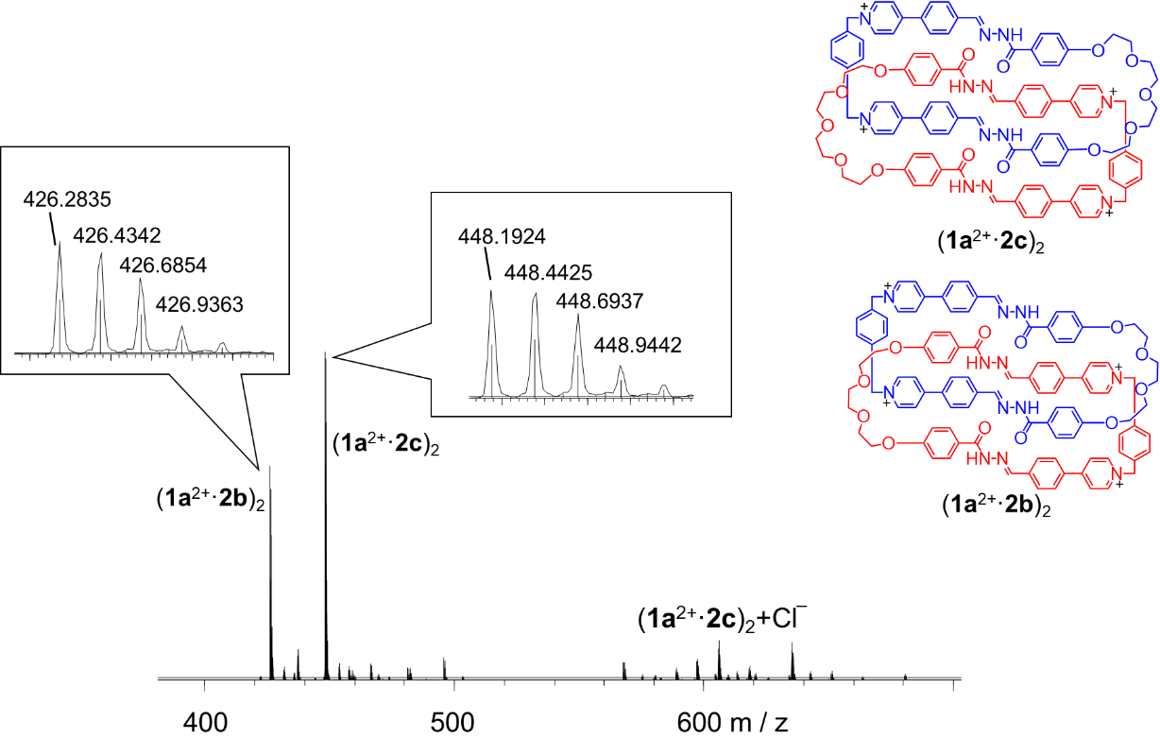
Figure S54. LCMS-IT-TOF spectrum of a 1:1 mixture of two catenanes (1a²⁺·2b)₂·4Cl─ and (1a²⁺·2c)₂·4Cl─ at room temperature for 12 h.

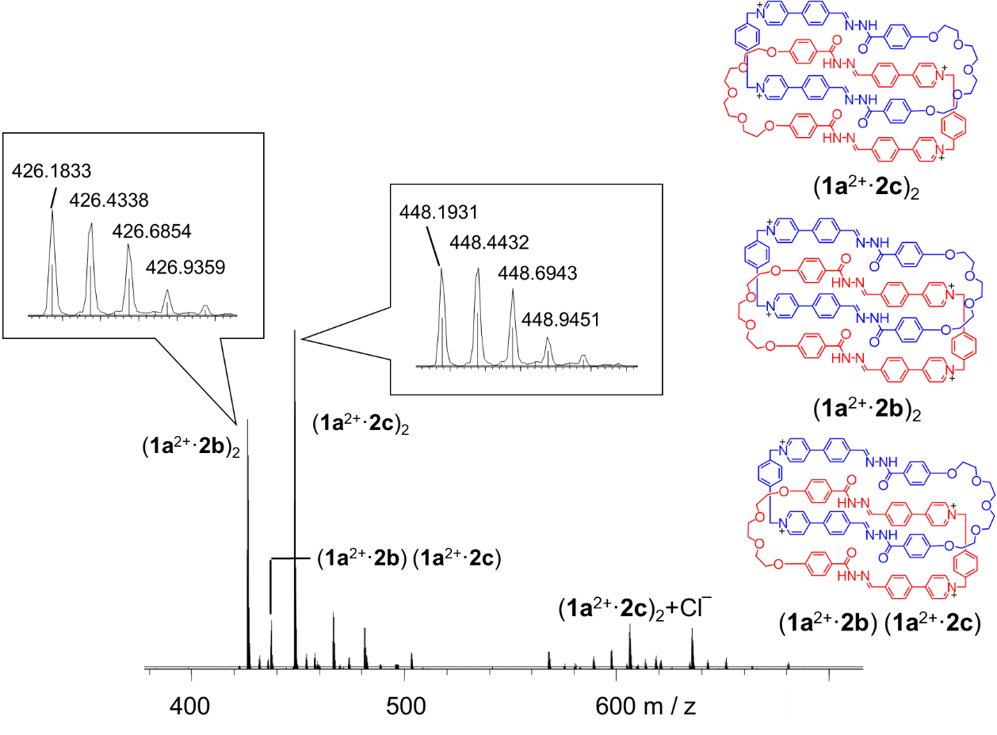
Figure S55. LCMS-IT-TOF spectrum of a 1:1 mixture of two catenanes (1a²⁺·2b)₂·4Cl─ and (1a²⁺·2c)₂·4Cl─ at 60 ºC for 12 h.

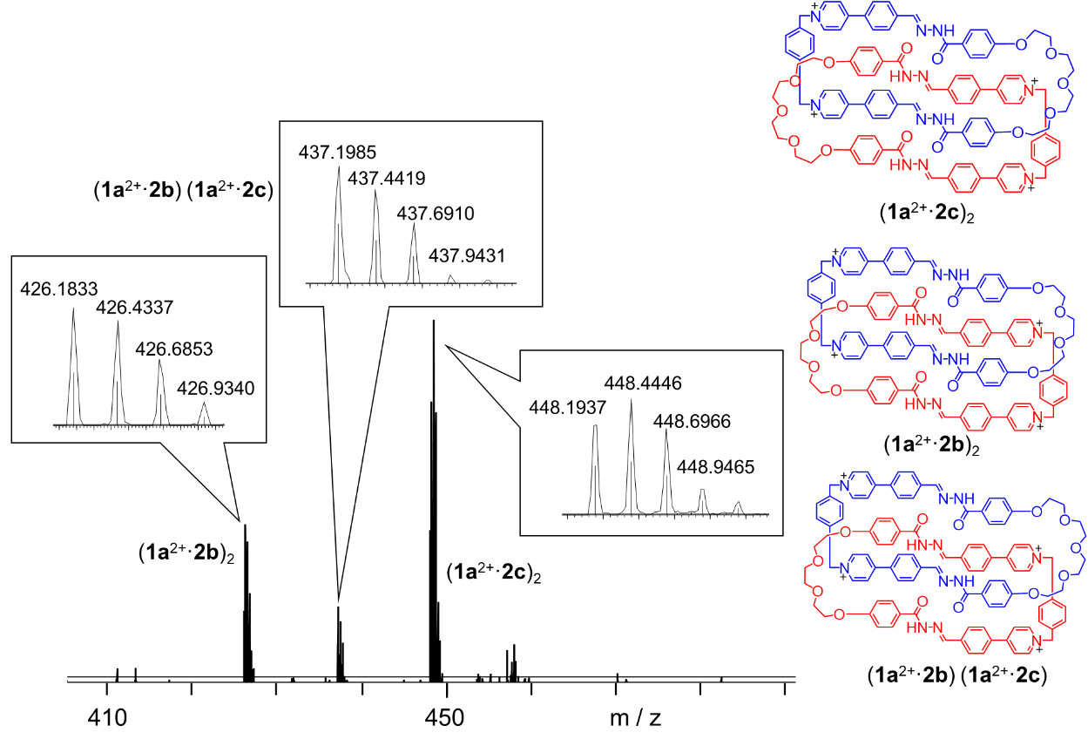
Figure S56. LCMS-IT-TOF spectrum of a 1:1 mixture of two catenanes (1a²⁺·2b)₂·4Cl─ and (1a²⁺·2c)₂·4Cl─ after adding catalytic amount of acid at 60 ºC for 12 h.

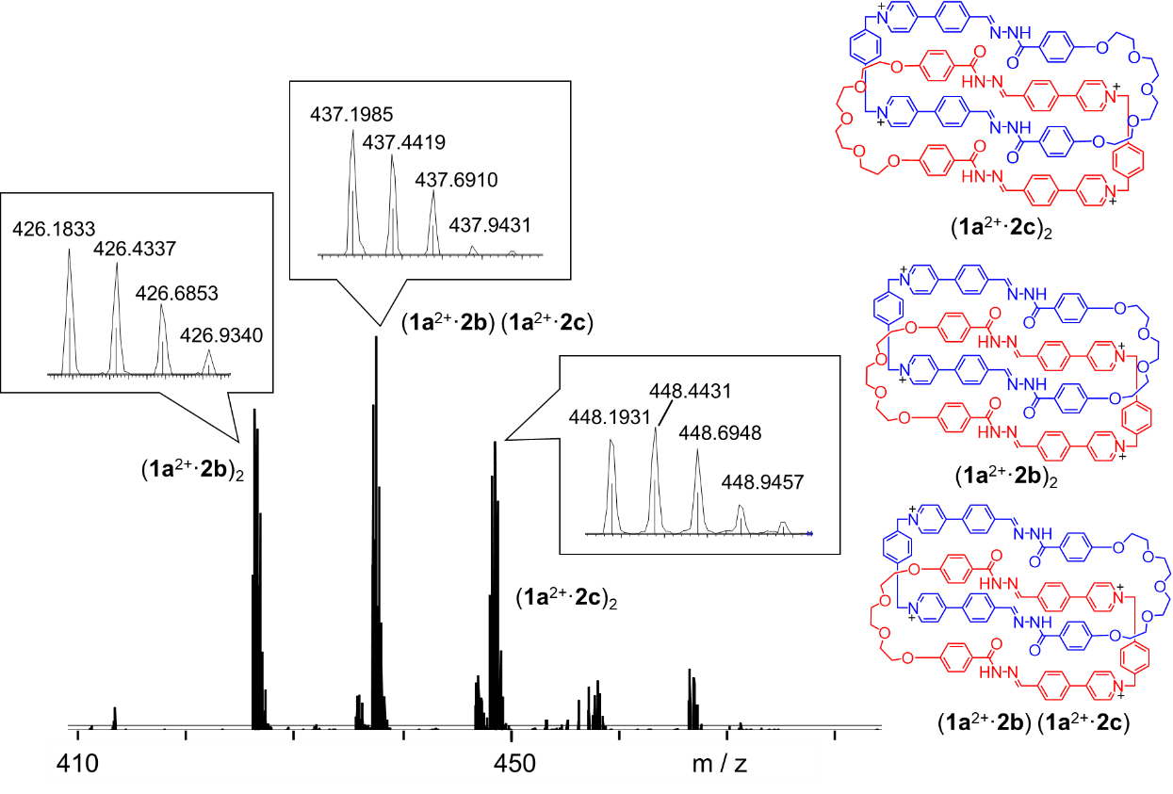
Figure S57. LCMS-IT-TOF spectrum of a 1:1 mixture of two catenanes (1a²⁺·2b)₂·4Cl─ and (1a²⁺·2c)₂·4Cl─ after adding excessive amount (0.05 mL) of DCl 12 h.

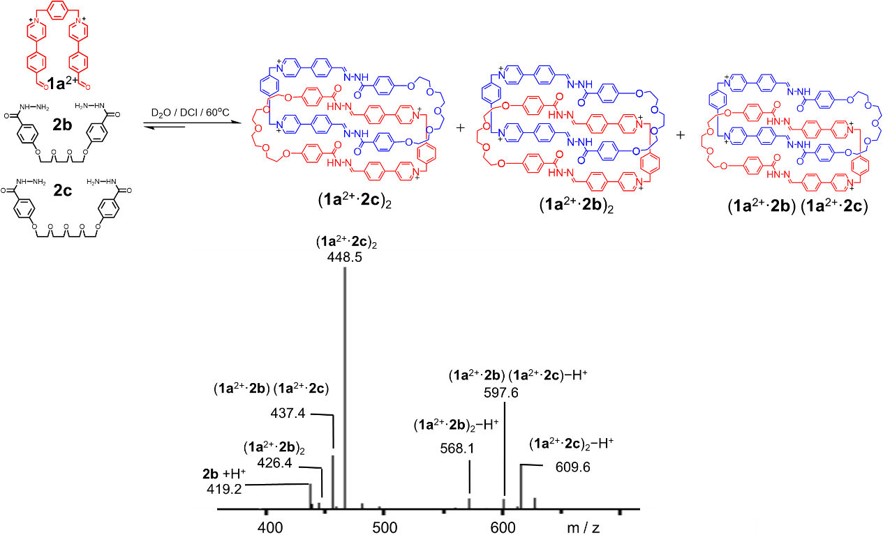
Figure S58. ESI-MS of a 1:1:1 reaction mixture of 1a²⁺·2Cl─, 2b and 2c. (1a²⁺·2c)₂ was self-assembled as the major product, leaving part of 2b unreacted. Only trace amount of (1a²⁺·2b)₂ and (1a²⁺·2b)(1a²⁺·2c) were observed as minor products.

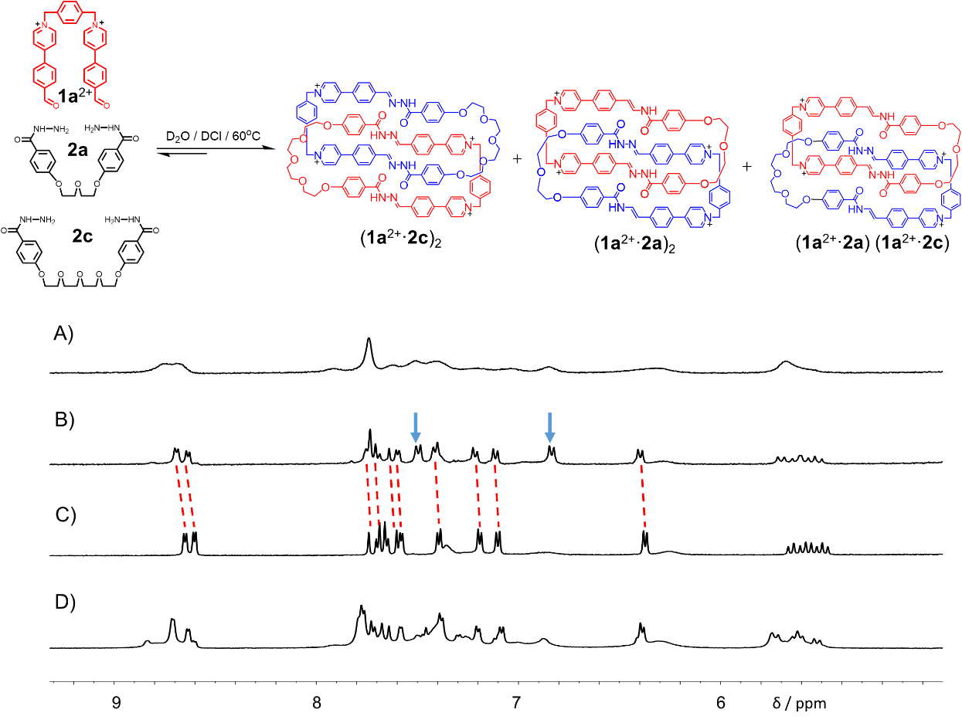
Figure S59. Partial ¹H NMR spectra (500 MHz, D₂O, 298 K) of A) (1a²⁺·2a)₂, B) a 1:1:1 reaction mixture of 1a²⁺·2Cl─, 2a and 2c, C) (1a²⁺·2c)₂ and D) a 2:1:1 reaction mixture of 1a²⁺·2Cl─, 2a and 2c. The resonances of unreacted 2a are marked with blue arrows.
When 1a²⁺·2Cl─, 2b and 2c were combined in D₂O in a 1:1:1 ratio, heating the mixture solution produced the homo [2]catenane (1a²⁺·2c)₂ as the major product (Figures S59 B and S61). When 1a²⁺·2Cl─, 2b and 2c were combined in D₂O in a 2:1:1 ratio, heating the mixture solution produced two homo [2]catenanes, namely (1a²⁺·2c)₂ and (1a²⁺·2a)₂, and one hybrid [2]catenane, namely (1a²⁺·2c)(1a²⁺·2a), as indicated by mass spectrum (Figure S60). On account of the NMR signals are relatively similar, the peaks of the hybrid [2]catenane can not be clearly found (Figure S59 D).

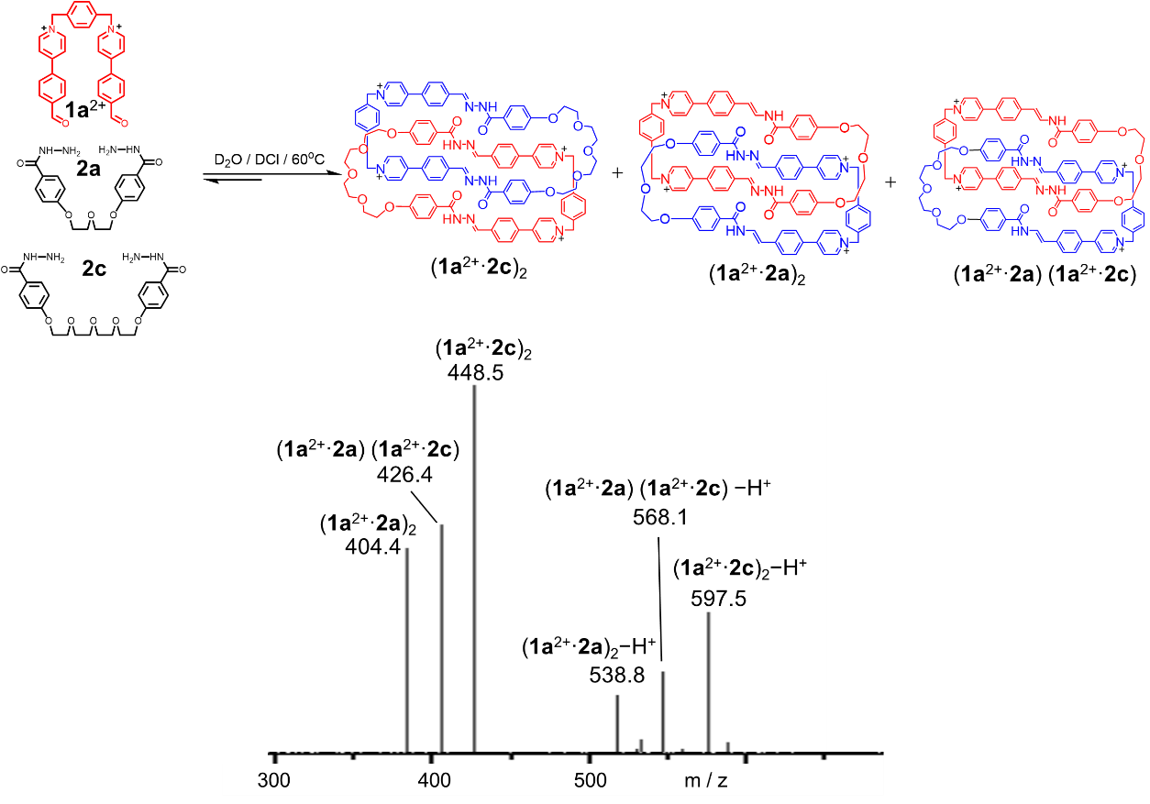
Figure S60. ESI-MS of a 2:1:1 reaction mixture of 1a²⁺·2Cl─, 2a and 2c.

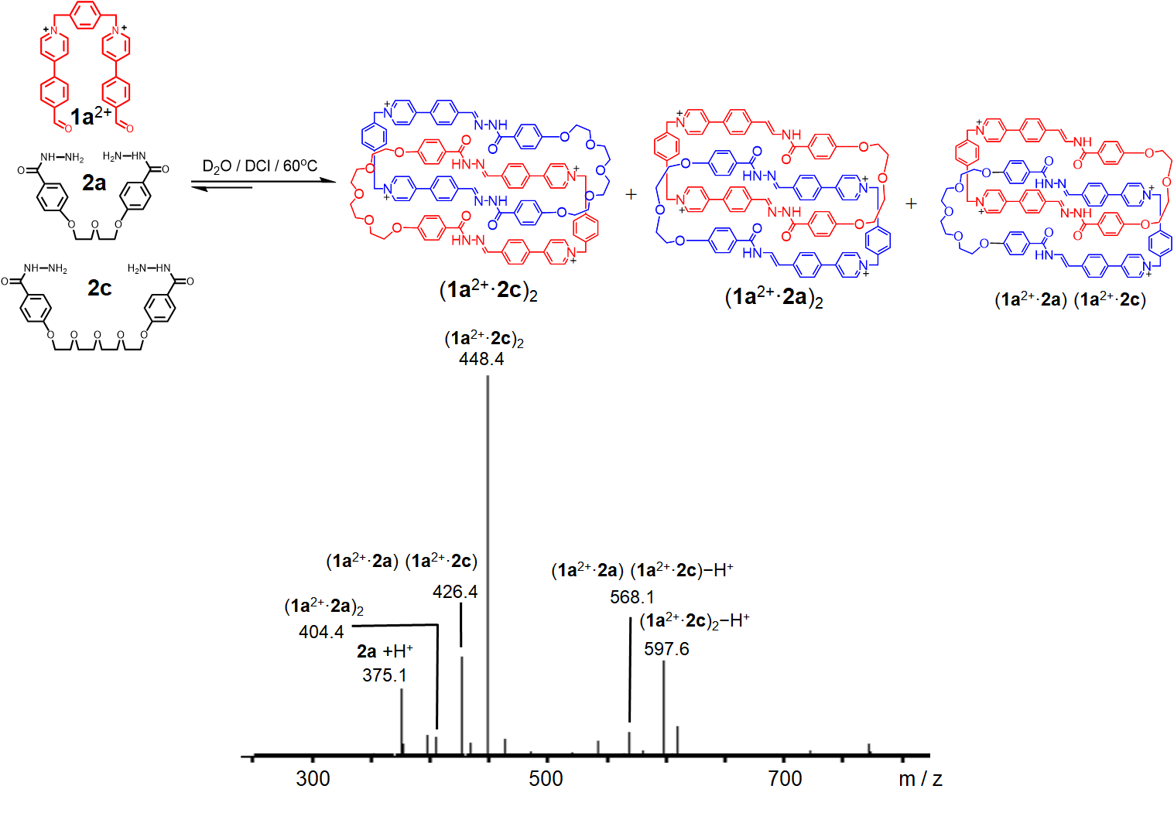
Figure S61. ESI-MS of a 1:1:1 reaction mixture of 1a²⁺·2Cl─, 2a and 2c. (1a²⁺·2c)₂ was self-assembled as the major product, leaving most of 2a unreacted. (1a²⁺·2a)₂ and (1a²⁺·2a)(1a²⁺·2c) were observed as minor products.

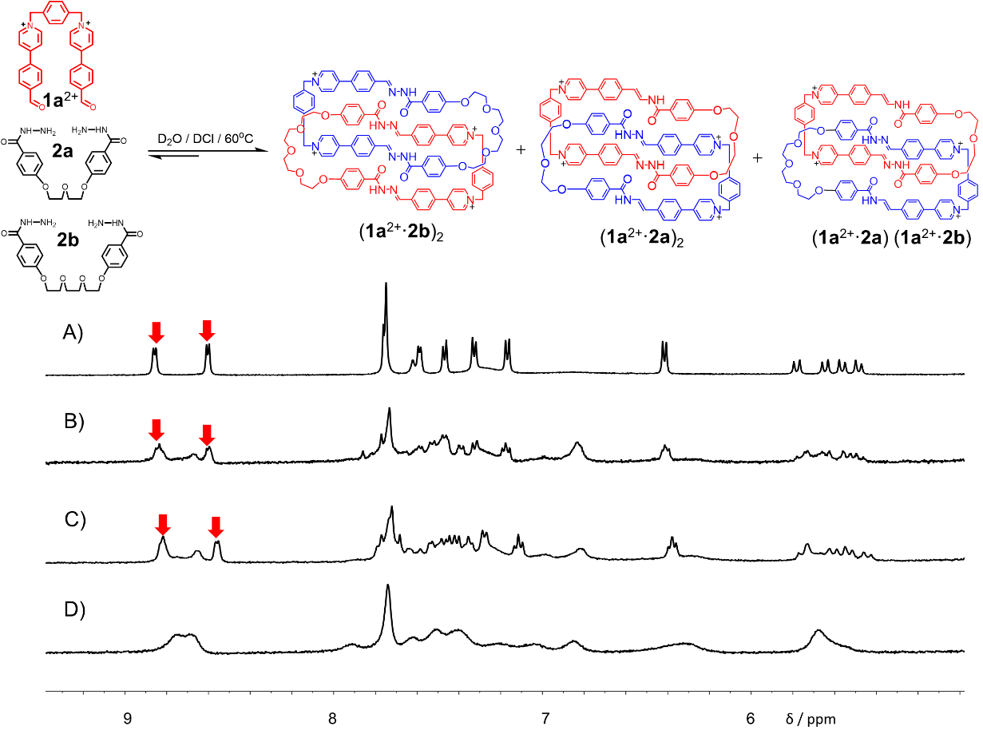
Figure S62. Partial ¹H NMR spectra (500 MHz, D₂O, 298 K) of A) (1a²⁺·2b)₂, B) a 1:1:1 reaction mixture of 1a²⁺·2Cl─, 2a and 2b, C) a 2:1:1 reaction mixture of 1a²⁺·2Cl─, 2a and 2b and D) (1a²⁺·2a)₂. The resonances of (1a²⁺·2b)₂ are marked with red arrows.

On account of the circumvolution motion of [2]catenanes (1a²⁺·2a)₂ and (1a²⁺·2a)(1a²⁺·2b) is quite fast, the peaks in the ¹H NMR spectra are relatively broad (Figure S62 B, C and D). However, the ESI-MS experiments (Figures S63-64) verified the formation of (1a²⁺·2a)₂ and (1a²⁺·2a)(1a²⁺·2b) strongly by condensation of either a 1:1:1 mixture or a 2:1:1 mixture of 1a²⁺·2Cl─, 2a and 2b.

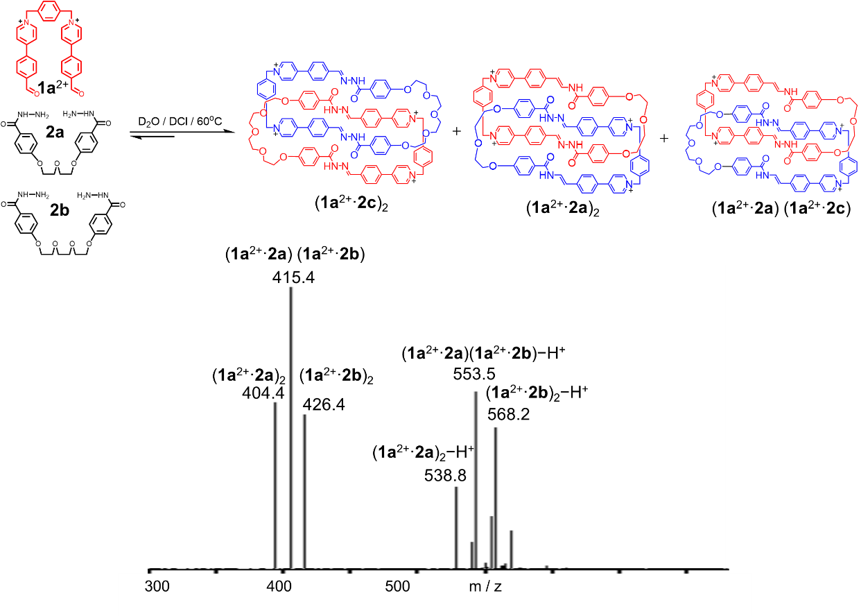
Figure S63. ESI-MS of a 2:1:1 reaction mixture of 1a²⁺·2Cl─, 2a and 2b.

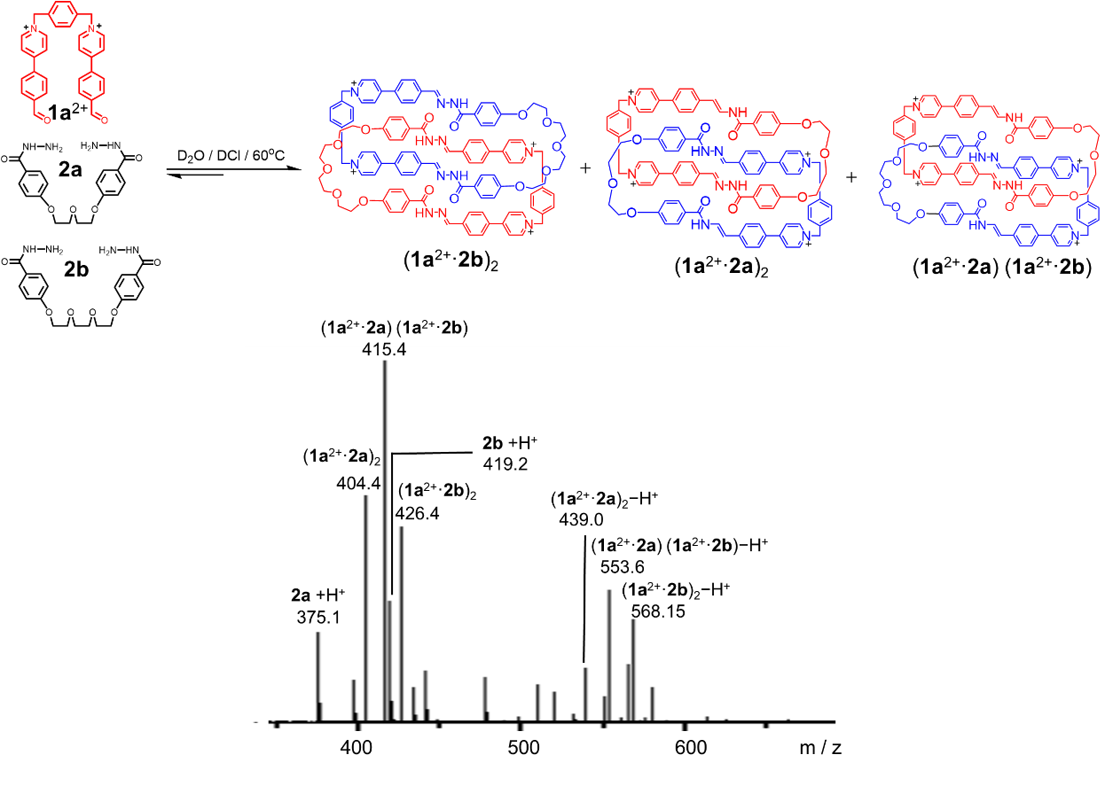
Figure S64. ESI-MS of a 1:1:1 reaction mixture of 1a²⁺·2Cl─, 2a and 2b.

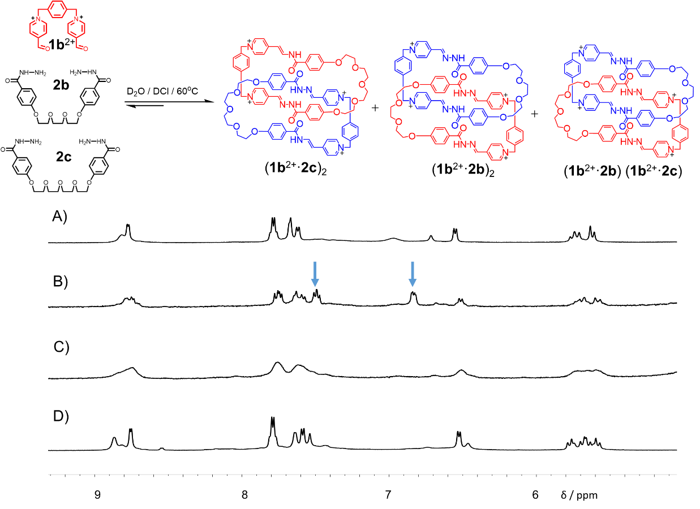
Figure S65. Partial ¹H NMR spectra (500 MHz, D₂O, 298 K) of A) (1b²⁺·2c)₂, B) a 1:1:1 reaction mixture of 1b²⁺·2Br─, 2b and 2c, C) a 2:1:1 reaction mixture of 1b²⁺·2Br─, 2b and 2c and D) (1b²⁺·2b)₂. The resonances of unreacted 2b are marked with blue arrows.

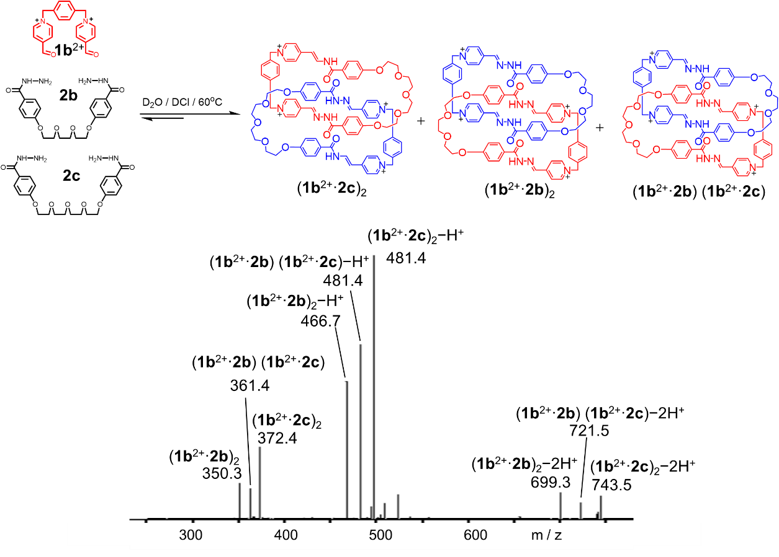
Figure S66. ESI-MS spectrum of a 2:1:1 reaction mixture of 1b²⁺·2Br─, 2b and 2c.

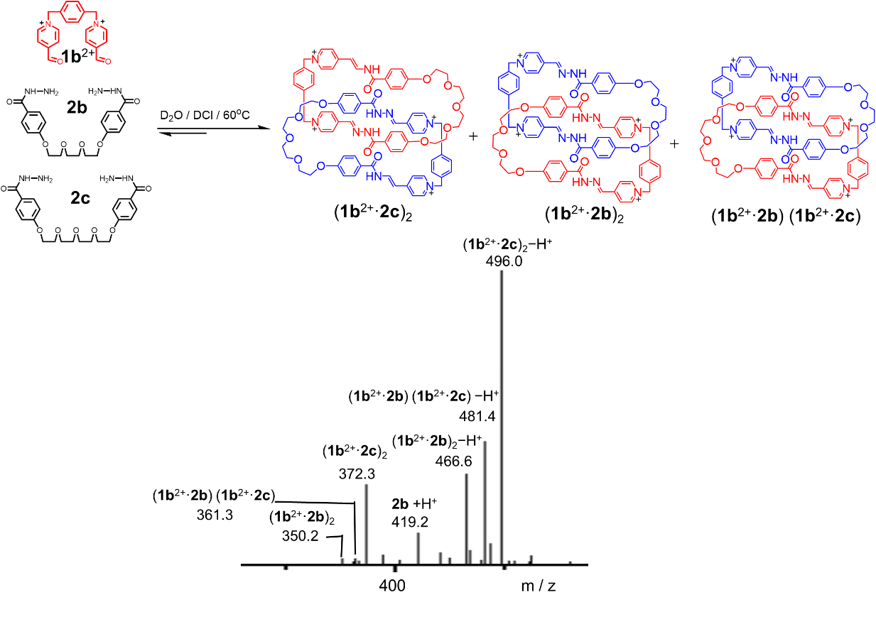
Figure S67. ESI-MS spectrum of a 1:1:1 reaction mixture of 1b²⁺·2Br─, 2b and 2c. (1b²⁺·2c)₂ was self-assembled as the major product, leaving most of 2b unreacted. (1b²⁺·2b)₂ and (1b²⁺·2b)(1b²⁺·2c) were observed as minor products.

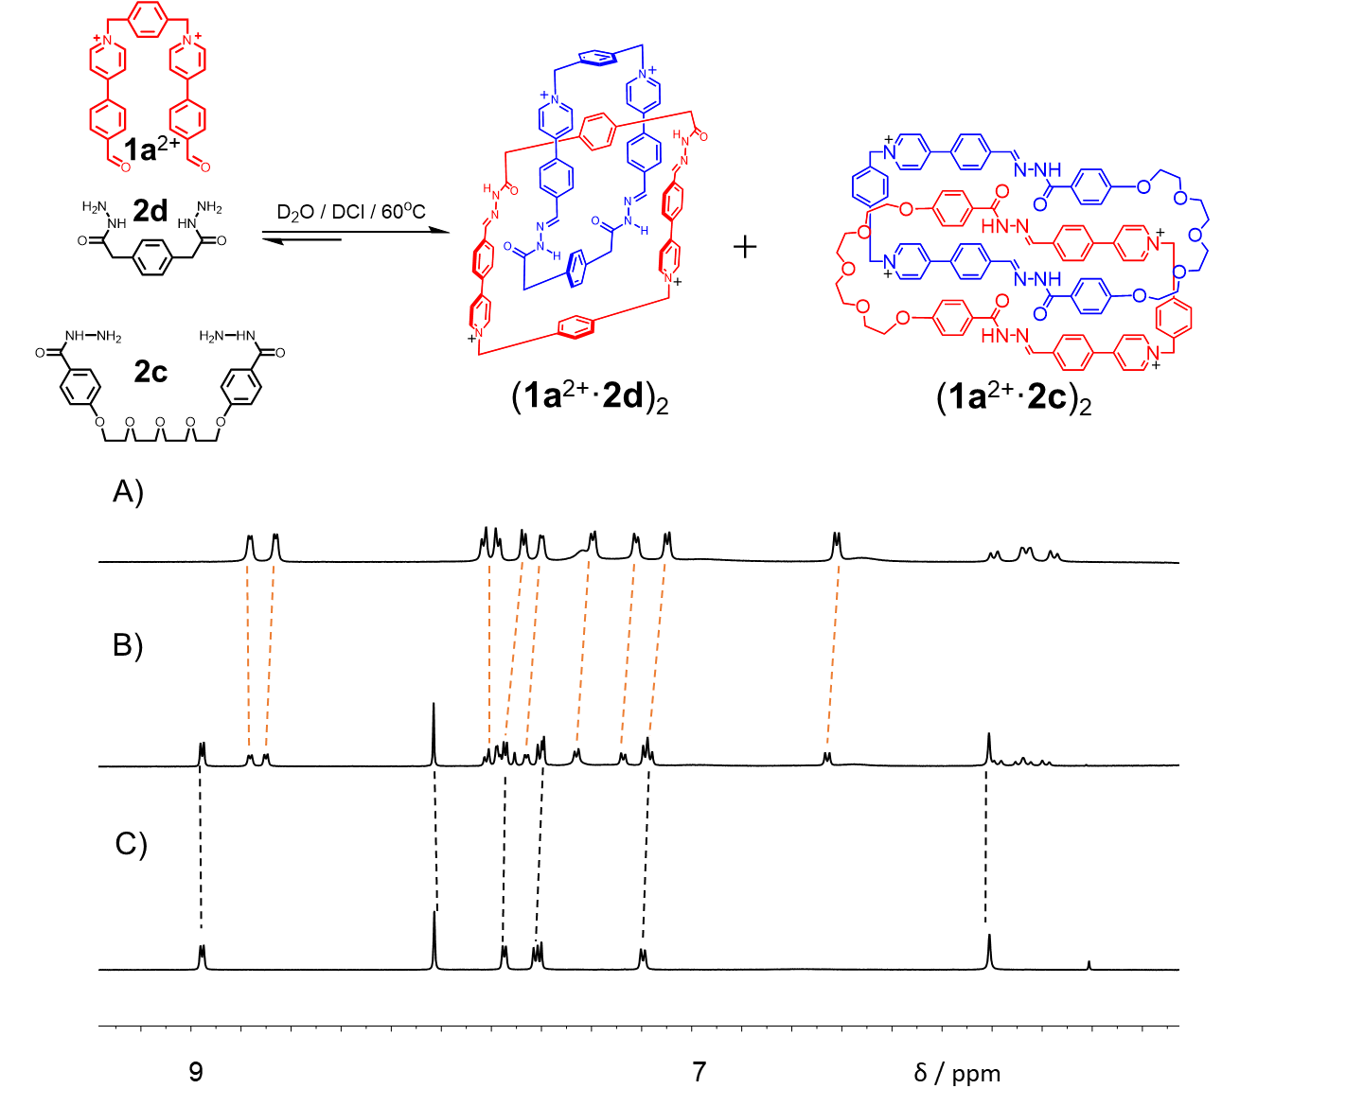
Figure S68. Partial ¹H NMR spectra (500 MHz, D₂O, 298 K) of A) (1a²⁺·2c)₂, B) a 2:1:1 reaction mixture of 1a²⁺·2Cl─, 2c and 2d, and C) (1a²⁺·2d)₂.

When 1a²⁺·2Cl─, 2c and 2d were combined in D₂O in a 2:1:1 ratio, heating the mixture solution produced two catenanes, namely (1a²⁺·2c)₂ and (1a²⁺·2d)₂ as indicated by both ¹H NMR (Figure S68 B) and mass spectrum (Figure S69). The hybridized product, namely (1a²⁺·2c)(1a²⁺·2d) were barely observed.

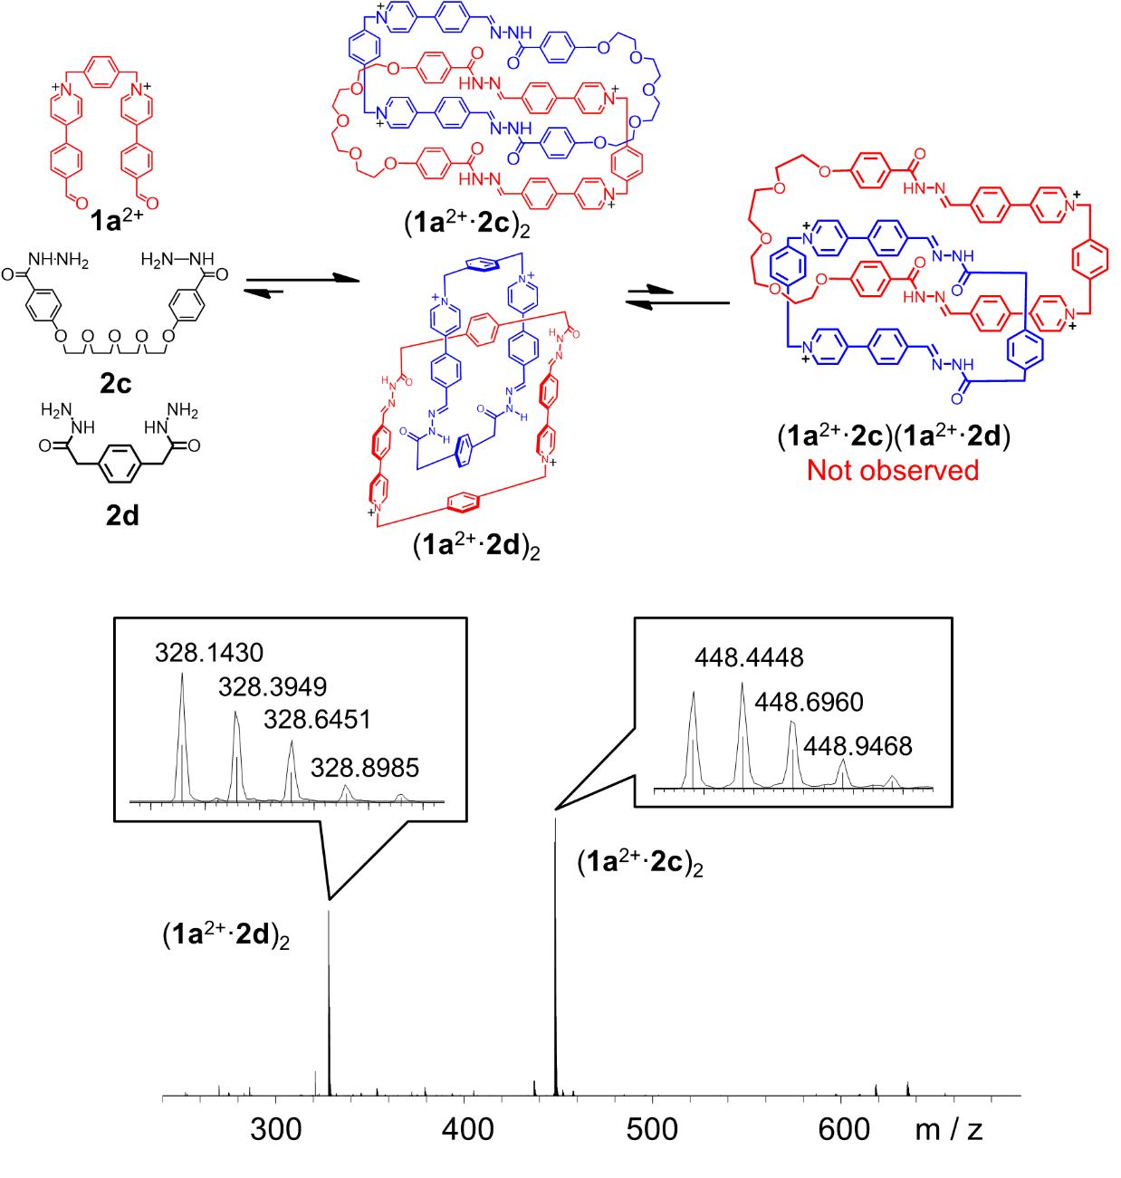
Figure S69. ESI-MS of a reaction mixture of 2:1:1 mixture of 1a²⁺·2Cl─, 2c and 2d.

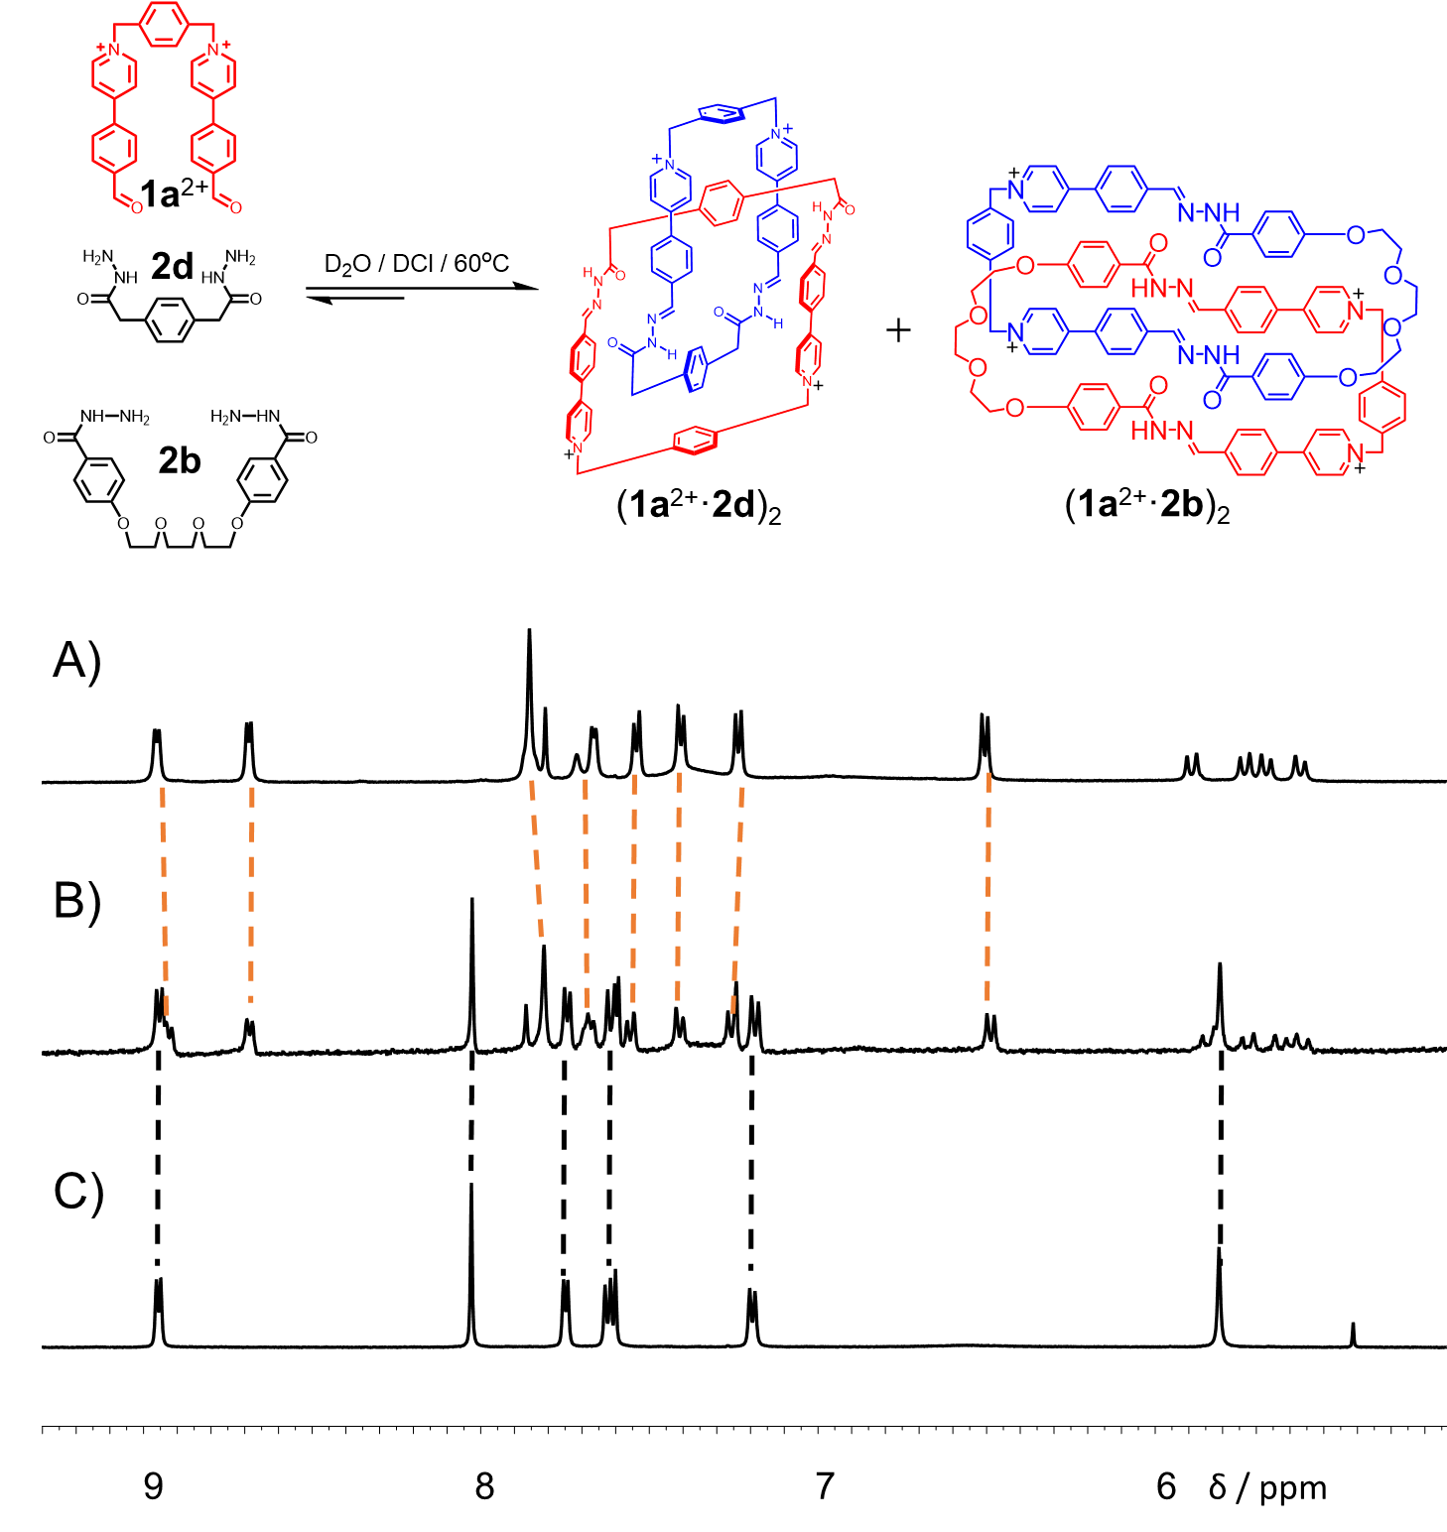
Figure S70. Partial ¹H NMR spectra (500 MHz, D₂O, 298 K) of A) (1a²⁺·2b)₂, B) a 2:1:1 reaction mixture of 1a²⁺·2Cl─, 2b and 2d, and C) (1a²⁺·2d)₂.

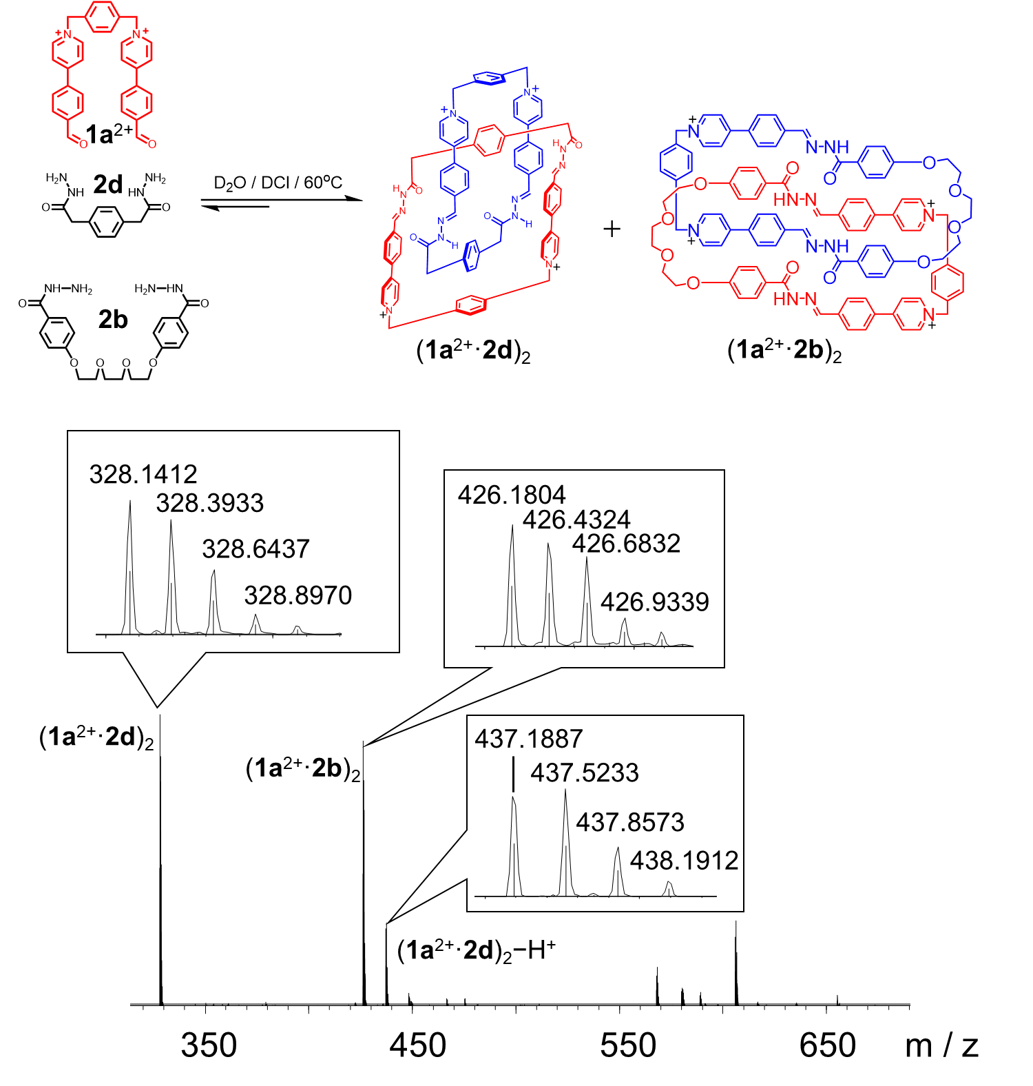
Figure S71. ESI-MS of a reaction mixture of 2:1:1 mixture of 1a²⁺·2Cl─, 2b and 2d.

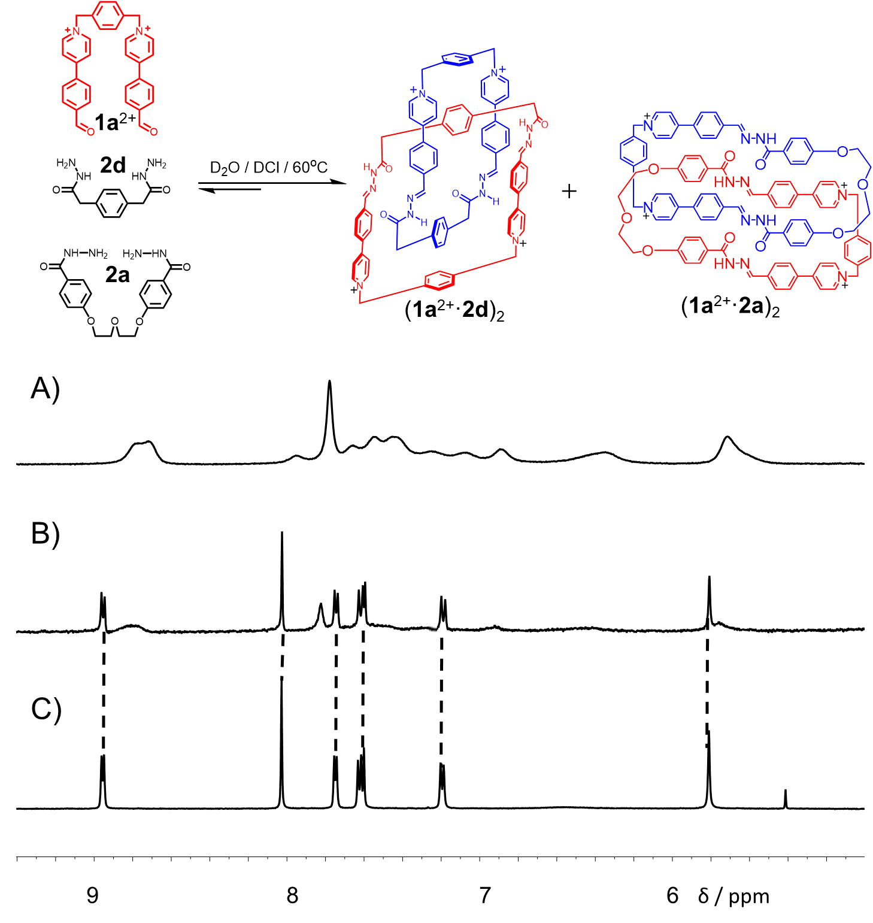
Figure S72. Partial ¹H NMR spectra (500 MHz, D₂O, 298 K) of A) (1a²⁺·2a)₂, B) a 2:1:1 reaction mixture of 1a²⁺·2Cl─, 2a and 2d, and C) (1a²⁺·2d)₂.

7. Yields of the [2]catenanes in Solutions
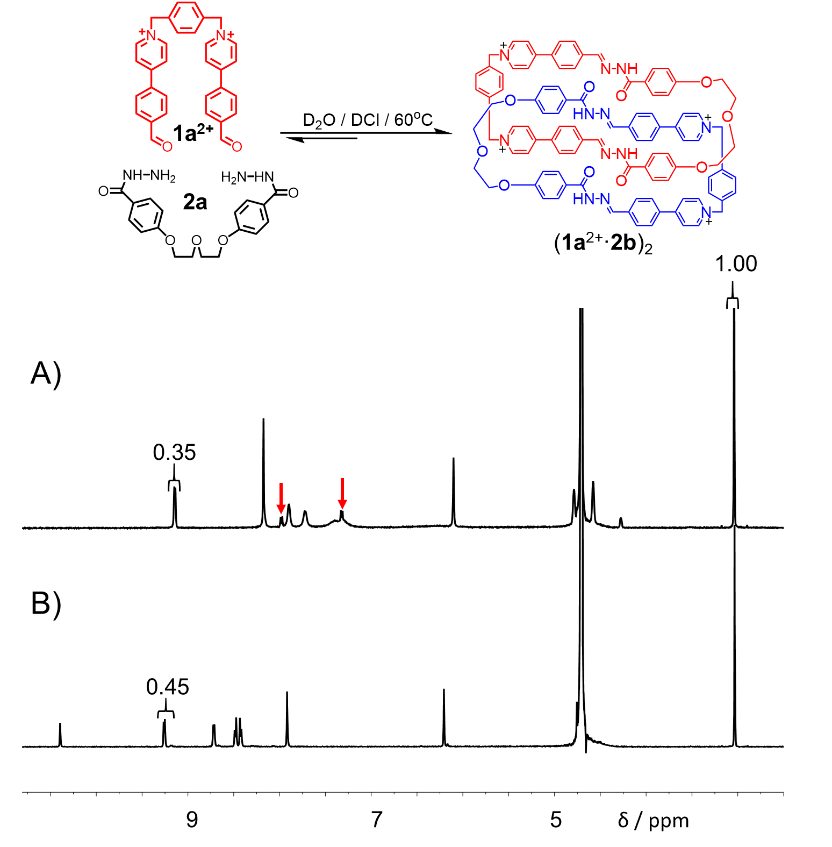
Figure S73. ¹H NMR spectra (500 MHz, D₂O, 333 K) of A) (1a²⁺·2a)₂·4Cl⁻ and B) 1a²⁺·2Cl⁻. The resonances of excess 2a are marked with red arrows.

We use ¹H NMR spectra to calculate the self-assembly yields by using DMSO with a fixed concentration as the internal standard. The integrated intensity of the resonance of internal standard was normalized to 1, allowing the concentration ratios of the catenanes relative to their corresponding aldehyde precursors to be calculated. For example, in the ¹H NMR spectra of 1a²⁺·2Cl⁻ and (1a²⁺·2a)₂·4Cl⁻, whose spectra were recorded before and after the reaction was allowed to proceed by adding 2a, the resonances of the hydrogens in pyridine α position integrated as 0.45 and 0.35, respectively, relative to the standard; the yield of (1a²⁺·2a)₂·4Cl⁻ was thus 78 % (0.35/0.45). Using this method, the NMR yields of (1a²⁺·2b)₂, (1a²⁺·2c)₂, (1b²⁺·2b)₂ and (1b²⁺·2c)₂ were calculated to be 73 % 94 %, 61 % and 94 %, respectively (Figures S74-77). These results indicated that 2c represents an ideal bishydrazide linker in catenation formation.

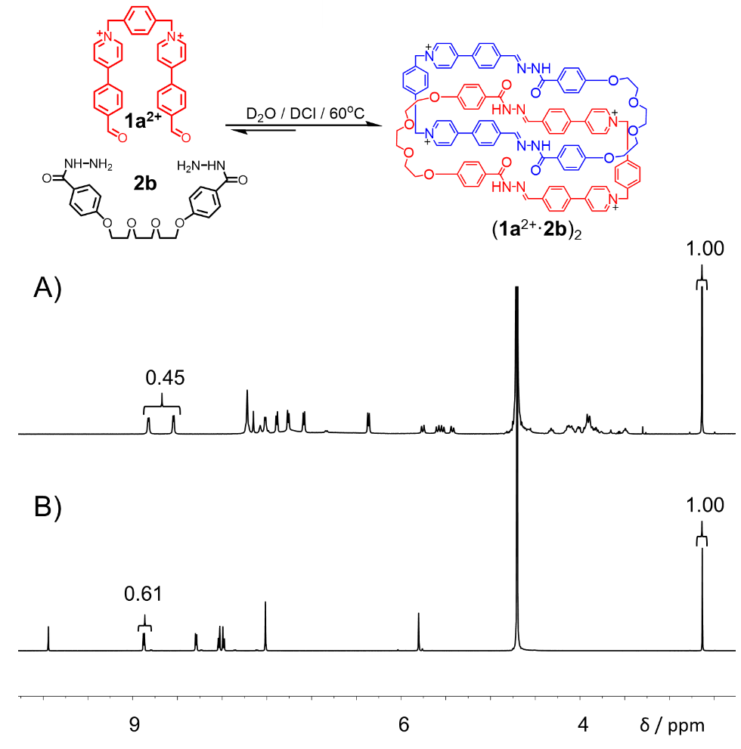
Figure S74. ¹H NMR spectra (500 MHz, D₂O, 298 K) of A) (1a²⁺·2b)₂ and B) 1a²⁺·2Cl⁻.

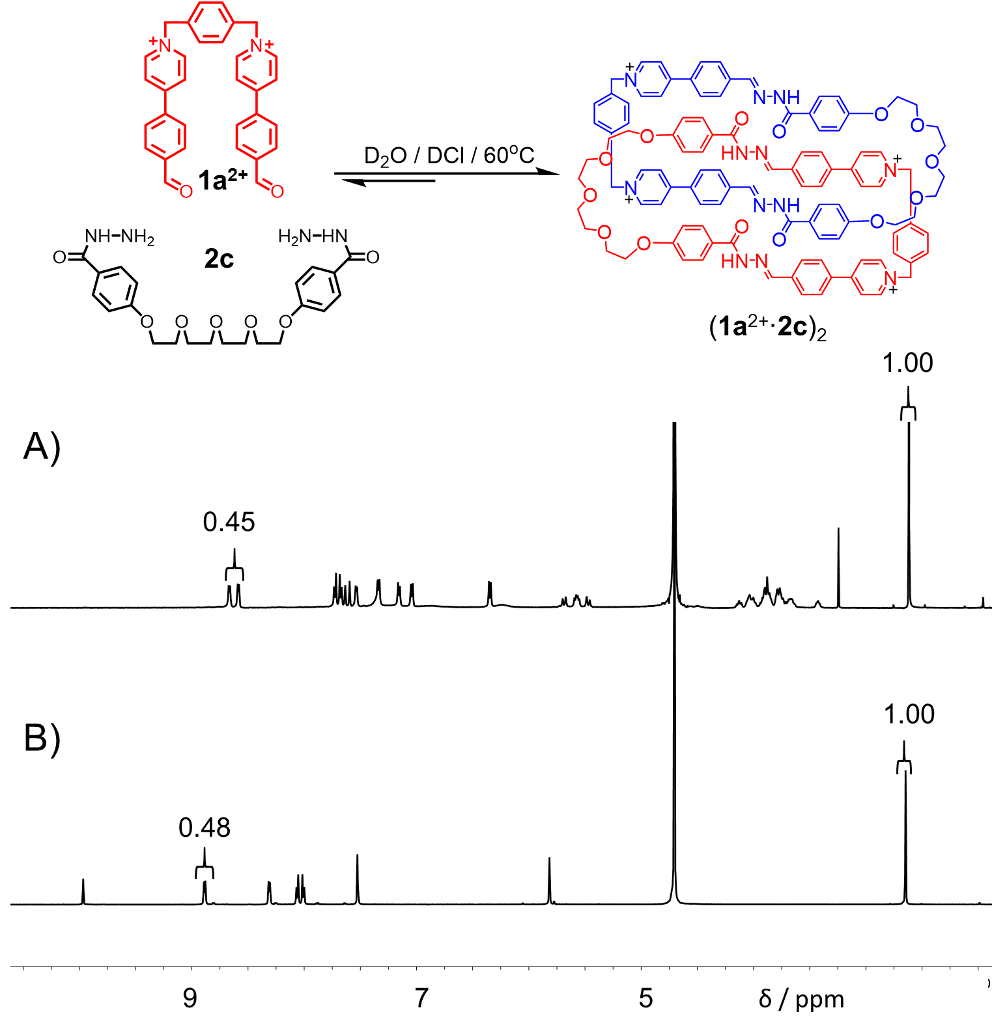
Figure S75. ¹H NMR spectra (500 MHz, D₂O, 298 K) of A) (1a²⁺·2c)₂ and B) 1a²⁺·2Cl⁻.
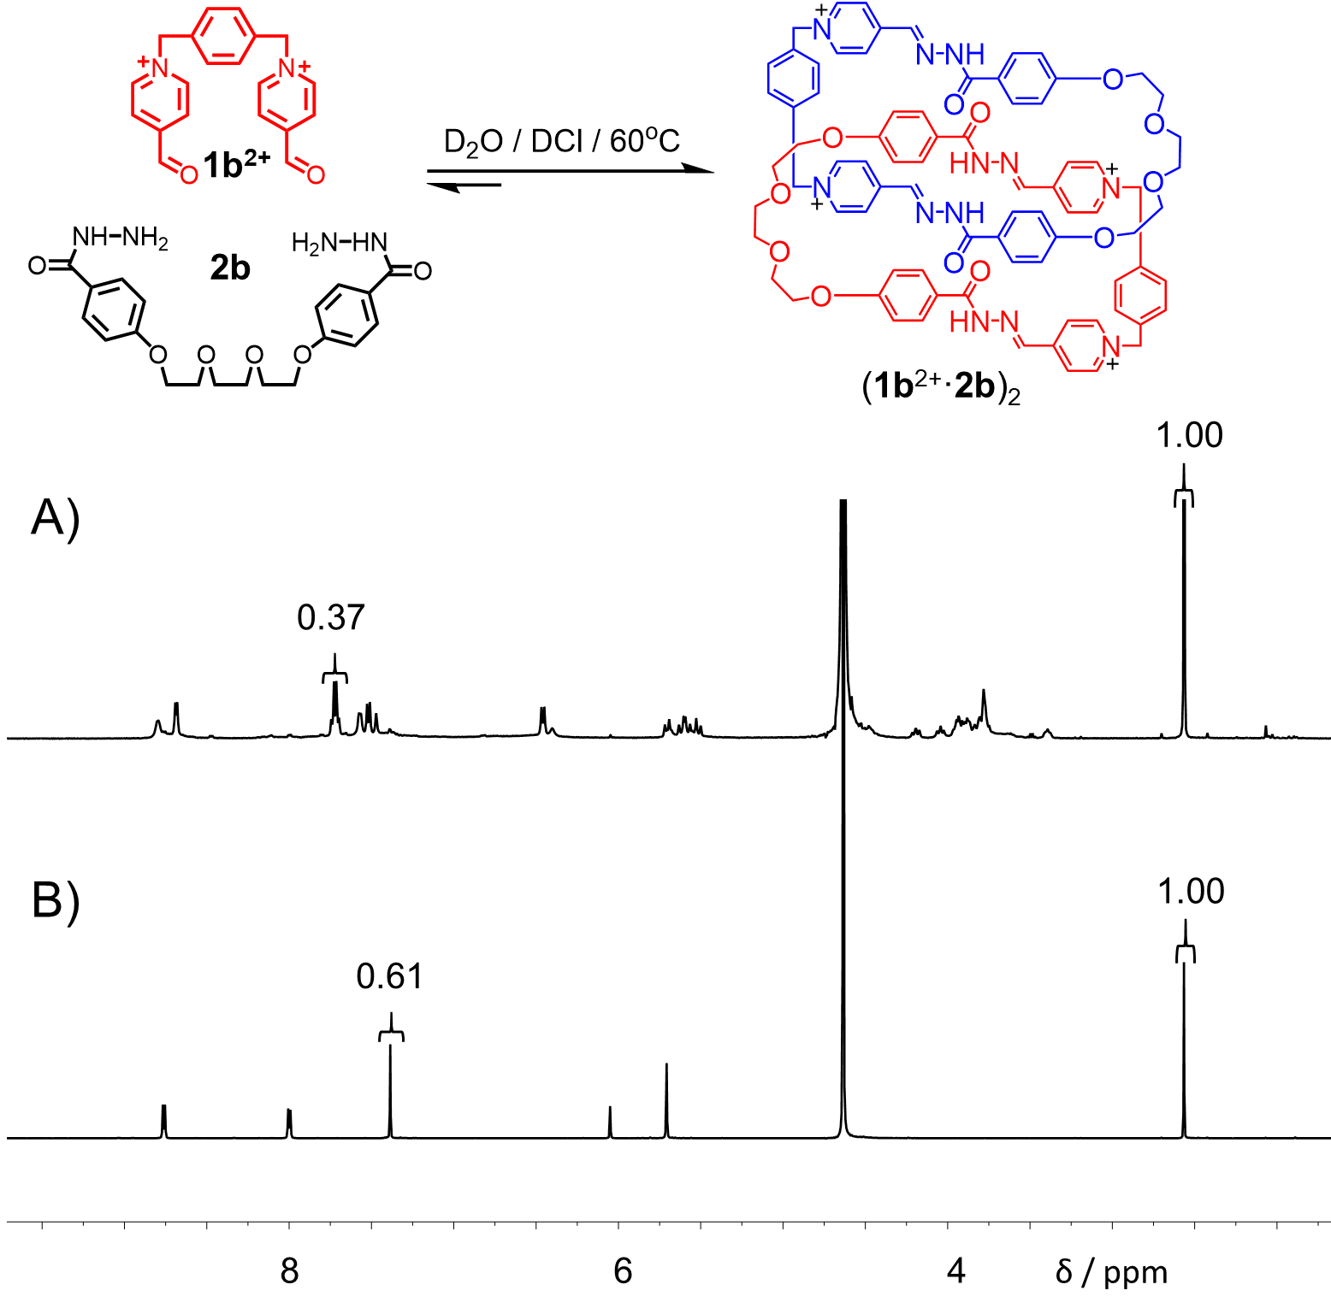
Figure S76. ¹H NMR spectra (500 MHz, D₂O, 298 K) of A) (1b²⁺·2b)₂ and B) 1b²⁺·2Br⁻.

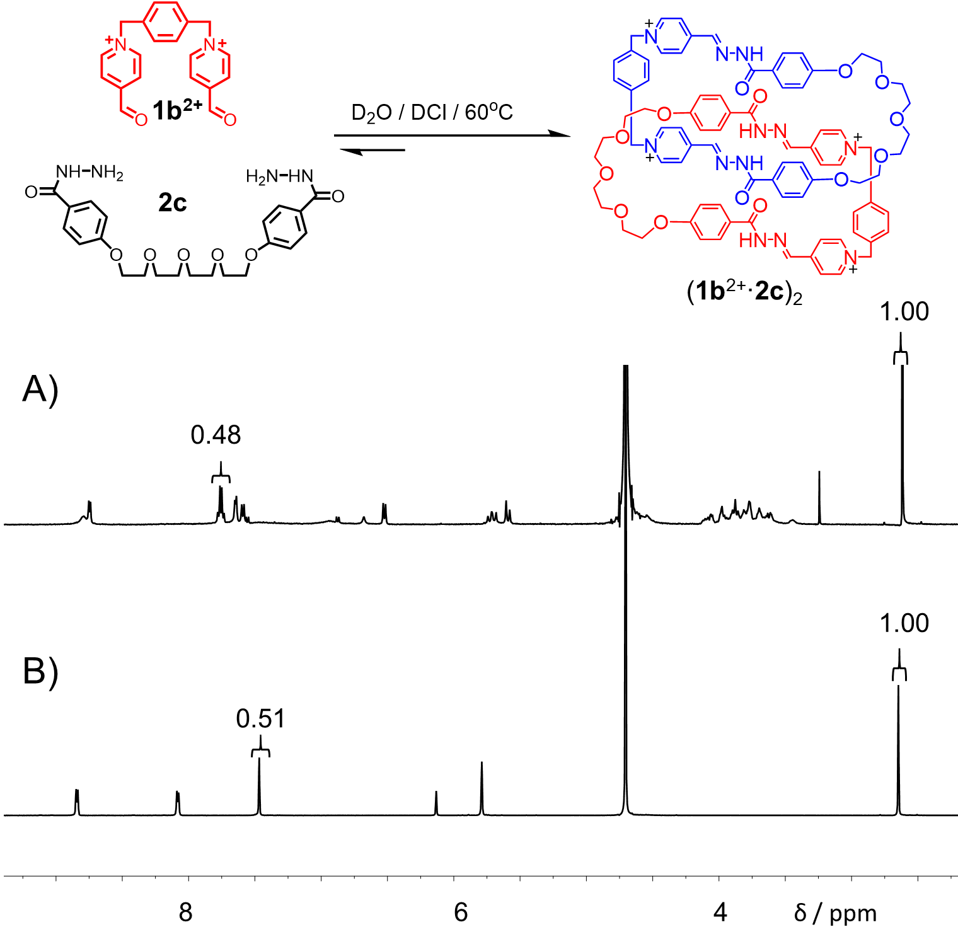
Figure S77. ¹H NMR spectra (500 MHz, D₂O, 298 K) of A) (1b²⁺·2c)₂ and B) 1b²⁺·2Br⁻.

8. Variable Temperature ¹H NMR Spectroscopy
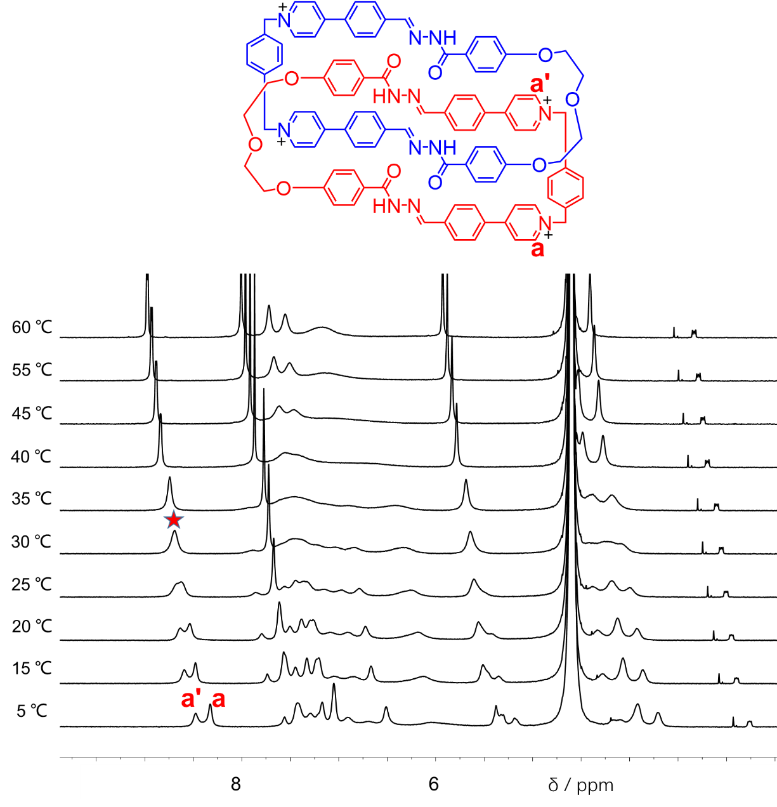
Figure S78. ¹H NMR spectra of (1a²⁺·2a)₂·4Cl─ at variable temperatures in D₂O (500 M Hz).
The rotational behavior of the [2]catenane (1a²⁺·2a)₂·4Cl─ was investigated using variable temperature (VT) ¹H NMR spectroscopy. The resonances associated with the proton a and a′ in (1a²⁺·2a)₂·4Cl─ undergo coalescence at temperature (Tc) of 303 K (Figure S78). However, ΔG cannot be accurately determined, given that even the solution was cooled to 5 ºC that is close to the frozen point of water, the resonances corresponding to a and a′ did not fully split. Further cooling might freeze the solvent.
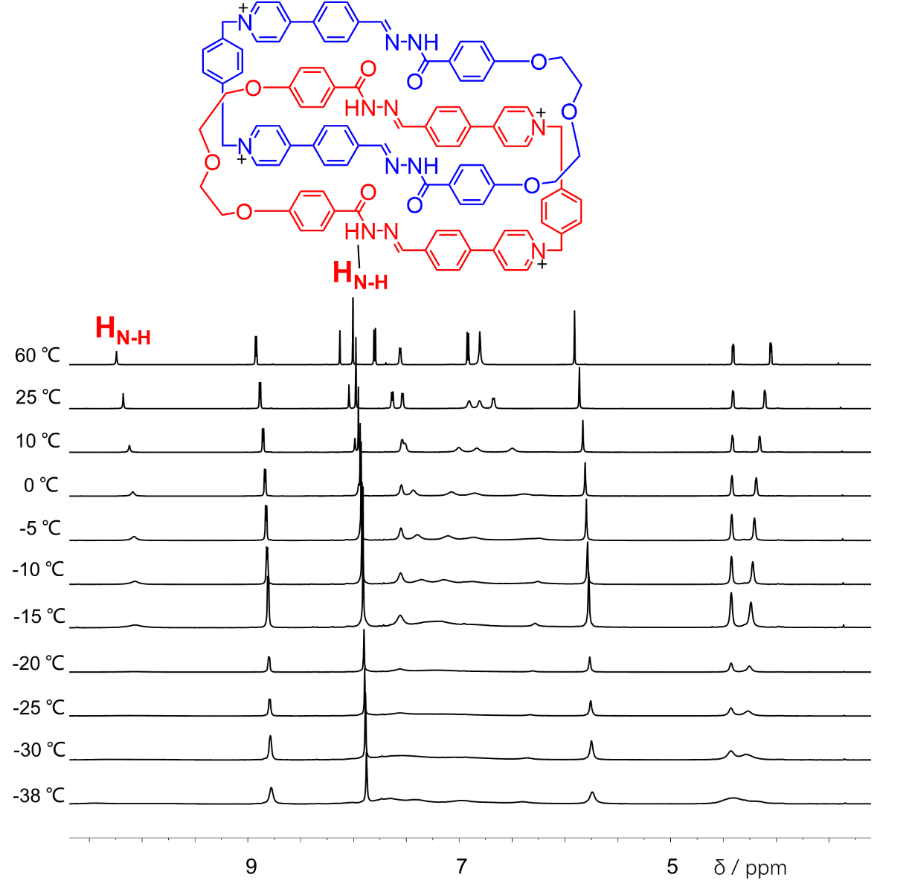
Figure S79. ¹H NMR spectra of (1a²⁺·2a)₂·4PF₆─ at variable temperatures in CD₃CN (600 M Hz).
Because the resonances did not fully split into two sets of peaks even at -38 ºC, a temperature that are close to the frozen points of solvent, namely CD₃CN, the rotational behavior of it could not be determined using variable temperature (VT) ¹H NMR spectroscopy .
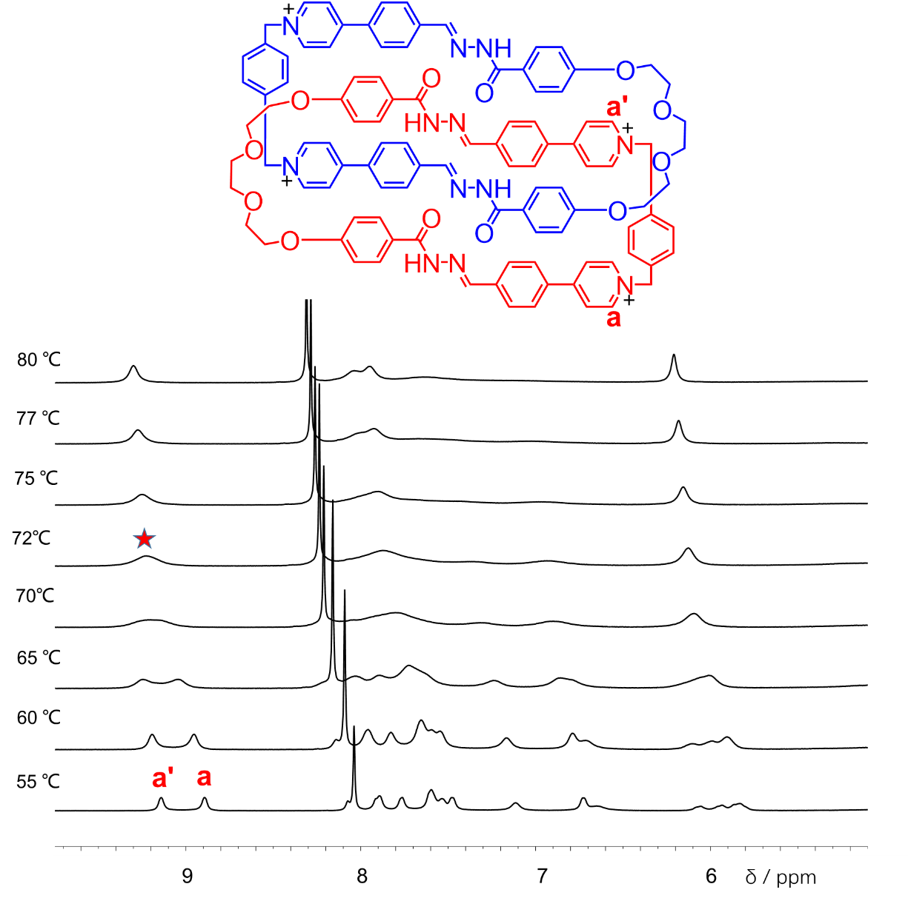
Figure S80. ¹H NMR spectra of (1a²⁺·2b)₂·4Cl─ at variable temperatures in D₂O (500 M Hz).
The resonances associated with the proton a and a' in (1a²⁺·2b)₂·4Cl─ undergo coalescence at temperature (Tc) of 345 K (Figure S80). Using Eyring equation, the energy barrier (ΔG) of circumvolution motion is determined to be 61.5 KJ·mol⁻¹.

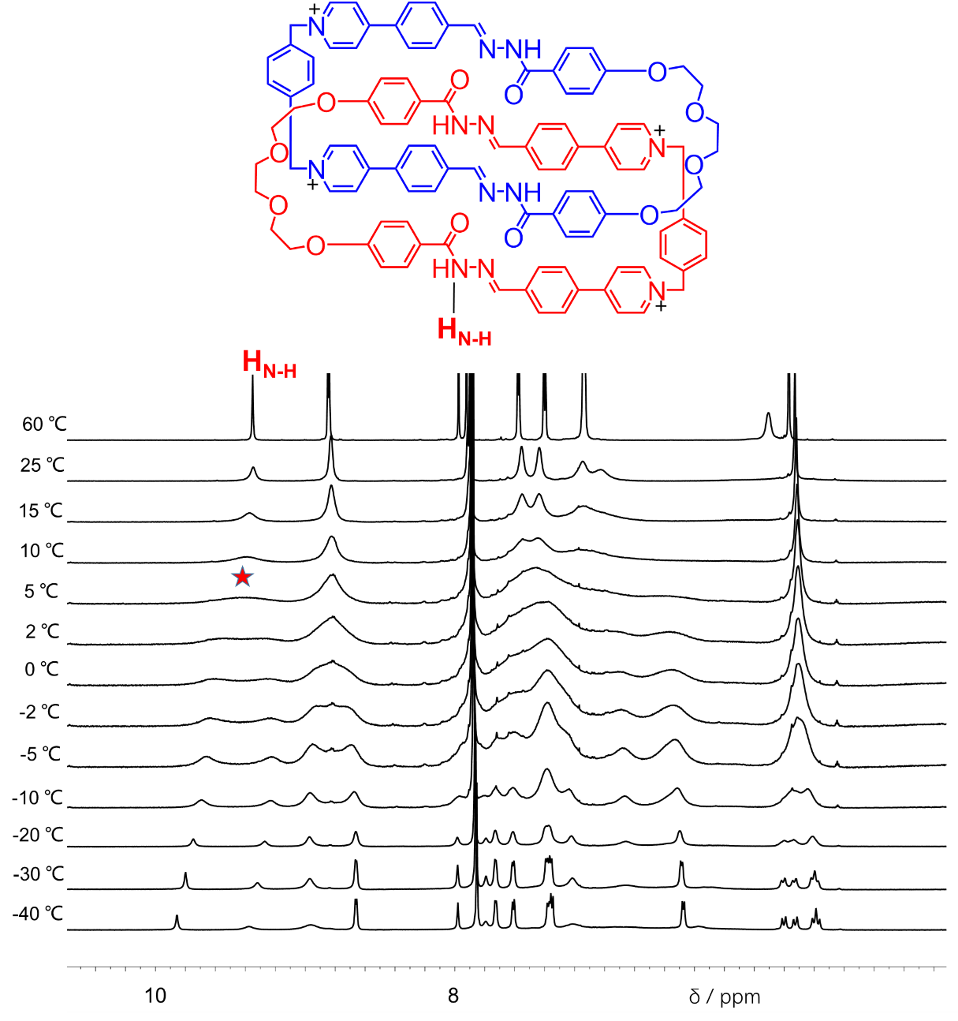
Figure S81. ¹H NMR spectra of (1a²⁺·2b)₂·4PF₆─ at variable temperatures in CD₃CN (600 M Hz).
The resonances associated with the protons H_{NH} in (1a²⁺·2b)₂·4PF₆─ undergo coalescence at temperature (Tc) of 278 K (Figure S81). Using Eyring equation, the energy barrier (ΔG) of circumvolution motion of (1a²⁺·2b)₂·4PF₆─ is determined to be 56.8 KJ·mol⁻¹.
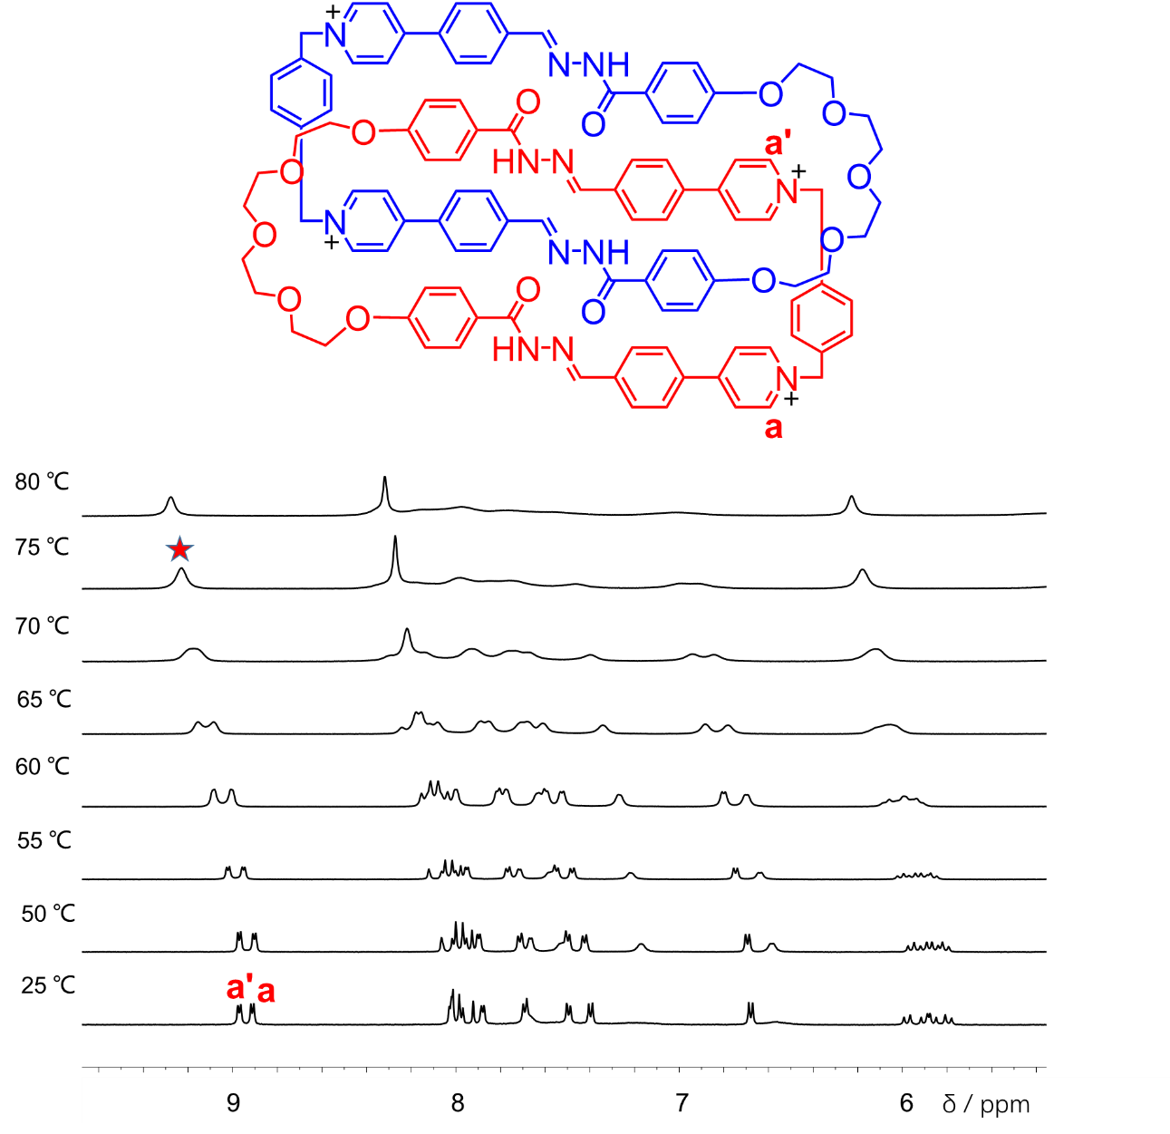
Figure S82. ¹H NMR spectra of (1a²⁺·2c)₂·4Cl─ at variable temperatures in D₂O (500 M Hz).
The resonances associated with the proton a and a' in (1a²⁺·2c)₂·4Cl─ undergo coalescence at temperature (Tc) of 348 K (Figure S82). Using Eyring equation, the energy barrier (ΔG) of circumvolution motion of (1a²⁺·2c)₂·4Cl─ is determined to be 62.4 KJ·mol⁻¹.

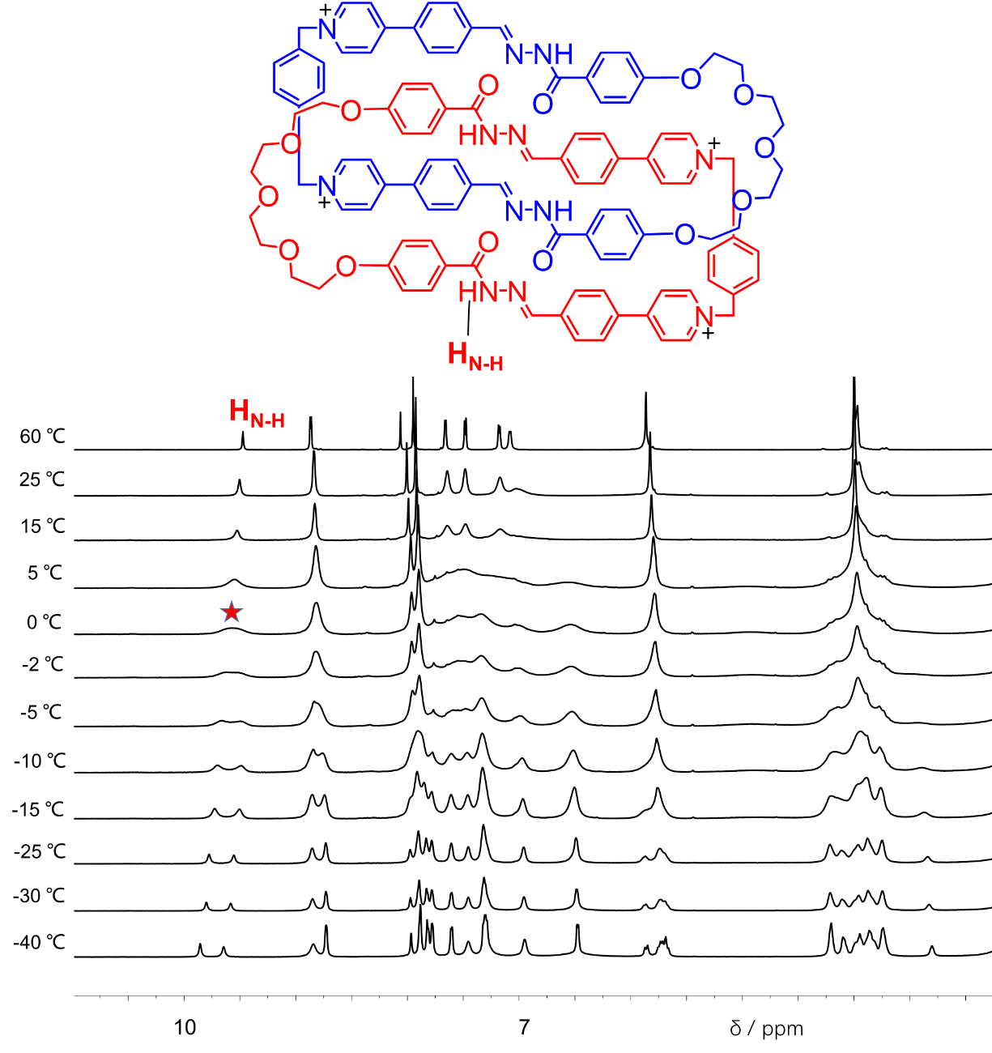
Figure S83. ¹H NMR spectra of (1a²⁺·2c)₂·4PF₆─ at variable temperatures in CD₃CN (600 M Hz).
The resonances associated with the protons H_{NH} in (1a²⁺·2c)₂·4PF₆─ undergo coalescence at temperature (Tc) of 273 K (Figure S83). Using Eyring equation, the energy barrier (ΔG) of circumvolution motion of (1a²⁺·2b)₂·4PF₆─ is determined to be 58.5 KJ·mol⁻¹.

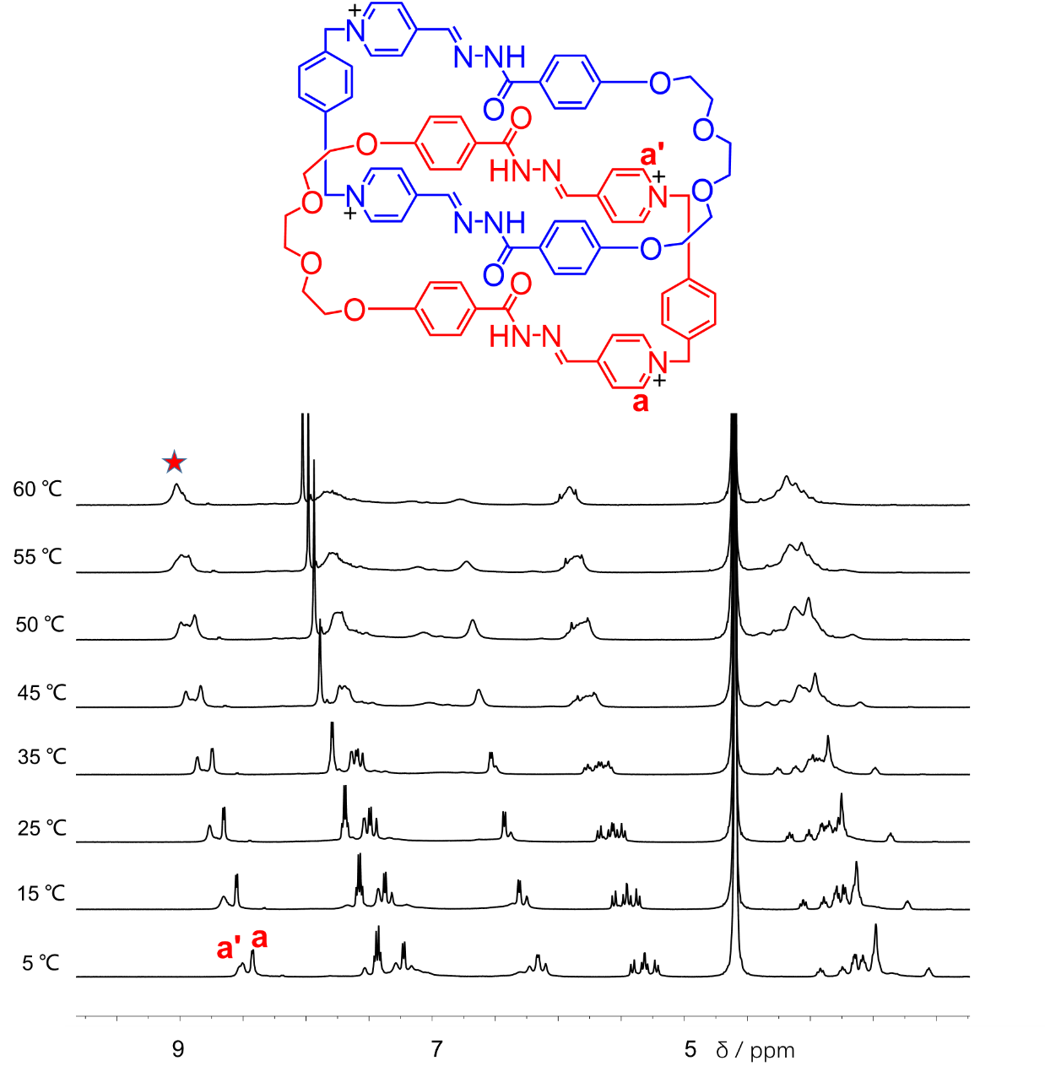
Figure S84. ¹H NMR spectra of (1b²⁺·2b)₂·4Cl─ at variable temperatures in D₂O (500 M Hz).
The resonances associated with the proton a and a' in (1b²⁺·2b)₂·4Cl─ undergo coalescence at temperature (Tc) of 333 K (Figure S84). Using Eyring equation, the energy barrier (ΔG) of circumvolution motion of (1b²⁺·2b)₂·4Cl─ is determined to be 61.1 KJ·mol⁻¹.

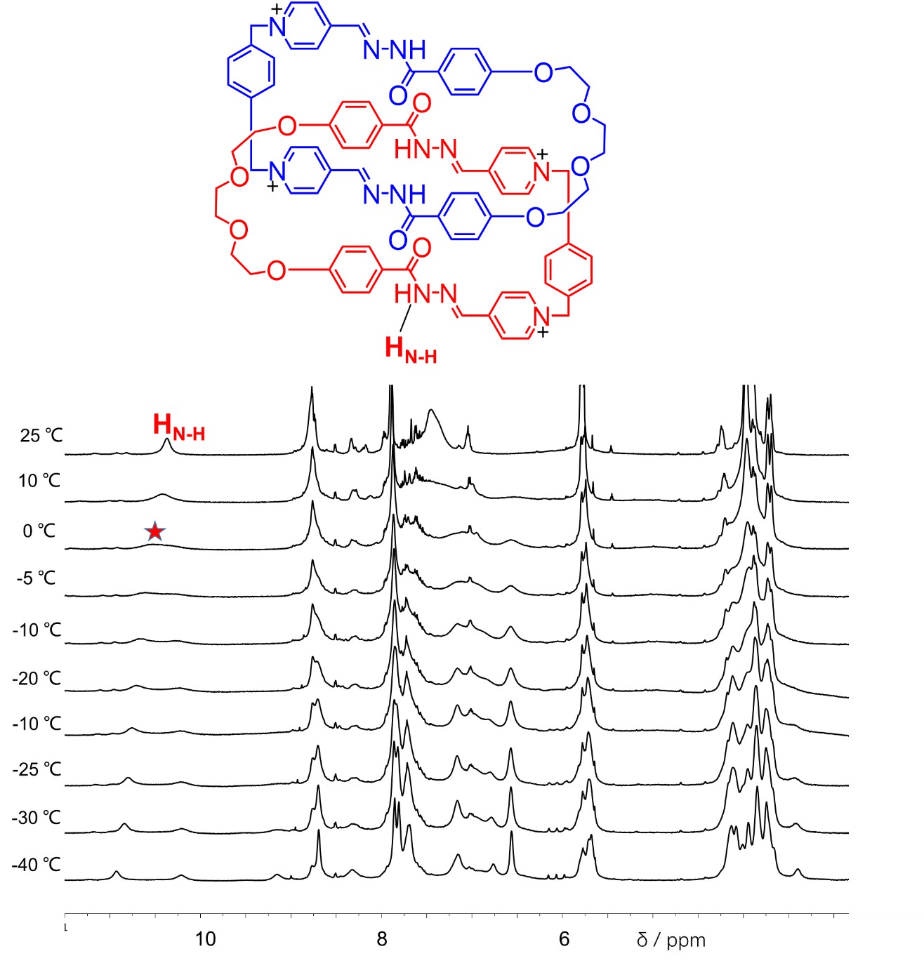
Figure S85. ¹H NMR spectra of (1b²⁺·2b)₂·4PF₆─ at variable temperatures in CD₃CN (600 M Hz).
The resonances associated with the proton H_{NH} in (1b²⁺·2b)₂·4PF₆─ undergo coalescence at temperature (Tc) of 273 K (Figure S85). Using Eyring equation, the energy barrier (ΔG) of circumvolution motion of (1b²⁺·2b)₂·4PF₆─ is determined to be 55.8 KJ·mol⁻¹.

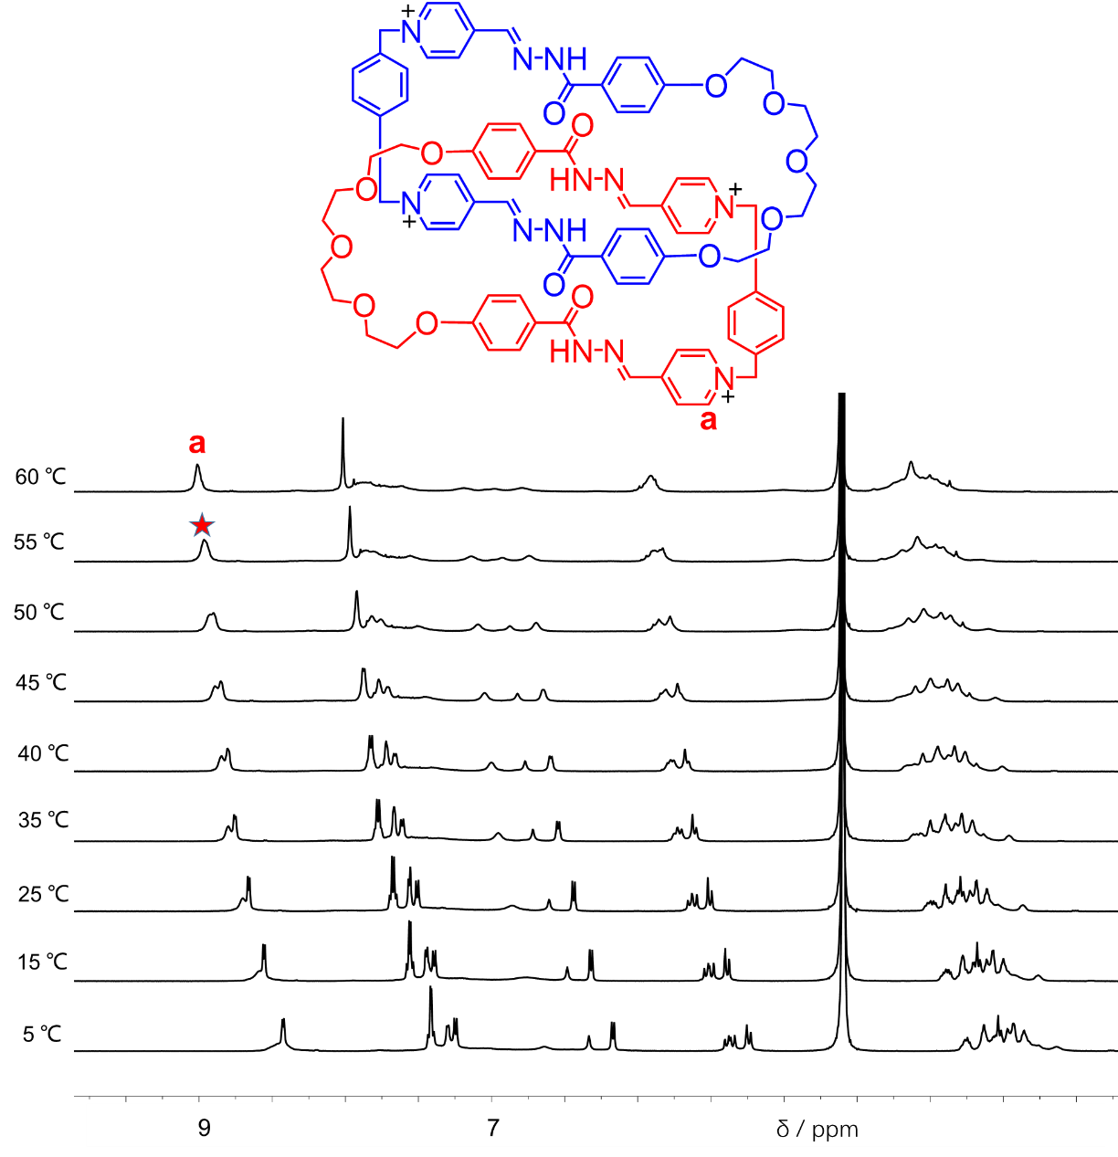
Figure S86. ¹H NMR spectra of (1b²⁺·2c)₂·4Cl─ at variable temperatures in D₂O (500 M Hz).
Because the resonances did not fully split into two sets of peaks even at the temperatures that are close to the frozen points of solvent namely water, the rotational behavior of (1b²⁺·2c)₂·4Cl─ could not be accurately determined using variable temperature (VT) ¹H NMR spectroscopy .

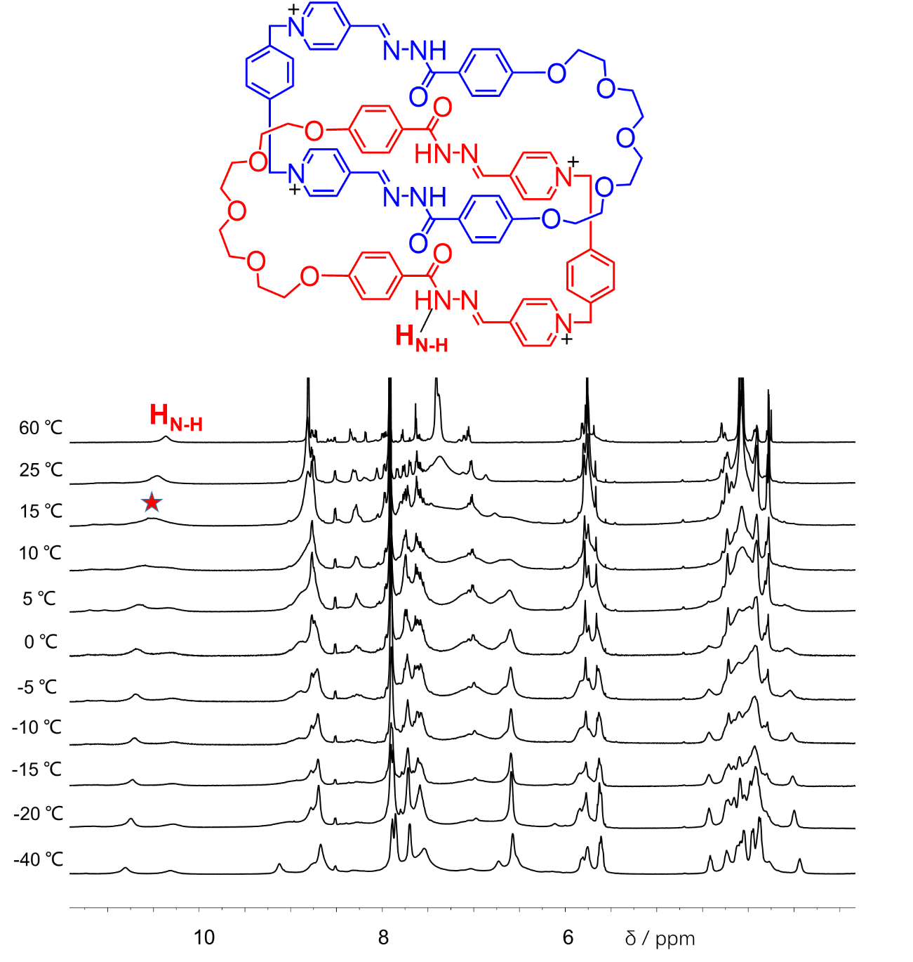
Figure S87. ¹H NMR spectra of (1b²⁺·2c)₂·4PF₆─ at variable temperatures in CD₃CN (600 M Hz).
The resonances associated with the proton H_{NH} in (1b²⁺·2c)₂·4PF₆─ undergo coalescence at temperatures (Tc) of 288 K (Figure S87). Using Eyring equation, the energy barrier (ΔG) of circumvolution motion of (1b²⁺·2c)₂·4PF₆─ is determined to be 56.7 KJ·mol⁻¹.

9. X-ray Crystallography
1) (1a²⁺·2c)₂·4Cl⁻
1.1) Methods
Single crystals of the [2]catenane (1a²⁺·2c)₂·4Cl⁻ was obtained by slow vapor diffusion of THF into their water solutions under room temperature. A suitable crystal was selected on a Bruker D8 Venture diffractometer. The crystal was kept at 170.0 K during data collection. Using Olex2 [1], the structure was solved with the ShelXT [2] structure solution program using Intrinsic Phasing and refined with the ShelXL [3] refinement package using Least Squares minimisation.
1.2) Crystal data
[C₁₀₈H₁₂₈C_{l4}N₁₂O₂₆] (M =2152.02 g/mol): monoclinic, space group P2_{1/c} (no. 14), a = 13.6939(9) Å, b = 19.0018(12) Å, c = 50.945(3) Å, β = 90.412(4)°, V = 13256.0(15) Å^{3,} Z = 4, T = 170.0 K, μ(GaKα) = 0.876 mm-1, Dcalc = 1.078 g/cm³, 122205 reflections measured (5.614° ≤ 2Θ ≤ 96.354°), 18873 unique (R_{int} = 0.1553, R_{sigma} = 0.1168) which were used in all calculations. The final R₁ was 0.1224 (I > 2σ(I)) and wR₂ was 0.3812 (all data). CCDC number:2014868

Table S2 Crystal data and structure refinement for (1a²⁺·2c)₂·4Cl⁻
Empirical formula | C₁₀₈H₁₂₈Cl₄N₁₂O₂₆
Formula weight | 2152.02
Temperature/K | 170.0
Crystal system | monoclinic
Space group | P2₁/c
a/Å | 13.6939(9)
b/Å | 19.0018(12)
c/Å | 50.945(3)
α/° | 90
β/° | 90.412(4)
γ/° | 90
Volume/Å³ | 13256.0(15)
Z | 4
ρ_{calc}g/cm³ | 1.078
μ/mm⁻¹ | 0.876
F(000) | 4544.0
Crystal size/mm³ | 0.05 × 0.02 × 0.015
Radiation | GaKα (λ = 1.34139)
2Θ range for data collection/° | 5.614 to 96.354
Index ranges | -15 ≤ h ≤ 15, -21 ≤ k ≤ 21, -56 ≤ l ≤ 49
Reflections collected | 122205
Independent reflections | 18873 [R_{int} = 0.1553, R_{sigma} = 0.1168]
Data/restraints/parameters | 18873/96/1414
Goodness-of-fit on F² | 1.086
Final R indexes [I>=2σ (I)] | R₁ = 0.1224, wR₂ = 0.3055
Final R indexes [all data] | R₁ = 0.2392, wR₂ = 0.3812
Largest diff. peak/hole / e Å⁻³ | 1.47/-0.61

1.3) Solid-state structure
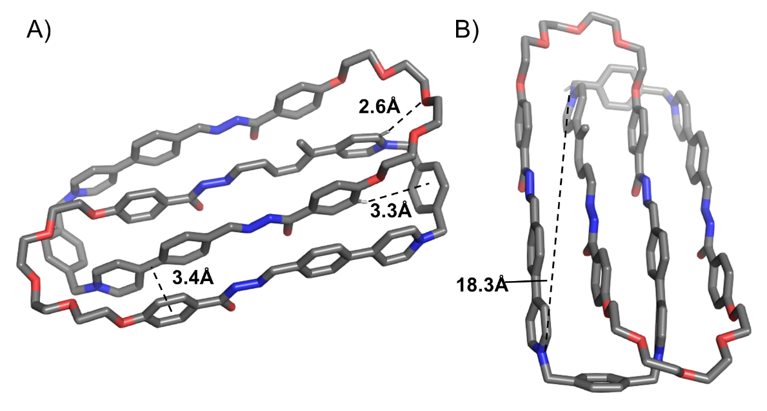
Figure S88. Different views of the solid-state structure of (1a²⁺·2c)₂·4Cl⁻. Counterions and solvent molecules are omitted for the sake of clarity.

2) (1b²⁺·2b)₂·4Cl⁻
2.1) Methods
Single crystals of the [2]catenane (1a²⁺·2c)₂·4Cl⁻ was obtained by slow vapor diffusion of THF into their water solutions under room temperature. A suitable crystal was selected on a Bruker D8 Venture diffractometer. The crystal was kept at 170.0 K during data collection. Using Olex2 [1], the structure was solved with the ShelXT [2] structure solution program using Intrinsic Phasing and refined with the ShelXL [3] refinement package using Least Squares minimisation.
2.2) Crystal data
[C₄₀H₅₅Cl₂N₆O_{13.5}] (M =1813.60 g/mol): monoclinic, space group C2/c (no. 15), a = 16.874(3) Å, b = 16.465(3) Å, c = 32.822(6) Å, β = 101.444(7)°, V = 8938(3) Å³, Z = 8, T = 169.96 K, μ(GaKα) = 1.234 mm-1, Dcalc = 1.348 g/cm³, 42917 reflections measured (6.59° ≤ 2Θ ≤ 110.244°), 8316 unique (R_{int} = 0.0809, R_{sigma} = 0.0583) which were used in all calculations. The final R₁ was 0.1036 (I > 2σ(I)) and wR₂ was 0.3358 (all data). CCDC number:2014867

Table S3 Crystal data and structure refinement for (1b²⁺·2b)₂·4Cl⁻
Empirical formula | C₄₀H₅₅Cl₂N₆O_{13.5}
Formula weight | 906.80
Temperature/K | 169.96
Crystal system | monoclinic
Space group | C2/c
a/Å | 16.874(3)
b/Å | 16.465(3)
c/Å | 32.822(6)
α/° | 90
β/° | 101.444(7)
γ/° | 90
Volume/Å³ | 8938(3)
Z | 8
ρ_{calc}g/cm³ | 1.348
μ/mm⁻¹ | 1.234
F(000) | 3832.0
Crystal size/mm³ | 0.07 × 0.06 × 0.05
Radiation | GaKα (λ = 1.34139)
2Θ range for data collection/° | 6.59 to 110.244
Index ranges | -19 ≤ h ≤ 20, -19 ≤ k ≤ 20, -26 ≤ l ≤ 40
Reflections collected | 42917
Independent reflections | 8316 [R_{int} = 0.0809, R_{sigma} = 0.0583]
Data/restraints/parameters | 8316/1/588
Goodness-of-fit on F² | 1.038
Final R indexes [I>=2σ (I)] | R₁ = 0.1036, wR₂ = 0.2964
Final R indexes [all data] | R₁ = 0.1435, wR₂ = 0.3358
Largest diff. peak/hole / e Å⁻³ | 1.40/-0.56
1.3) Solid-state structure
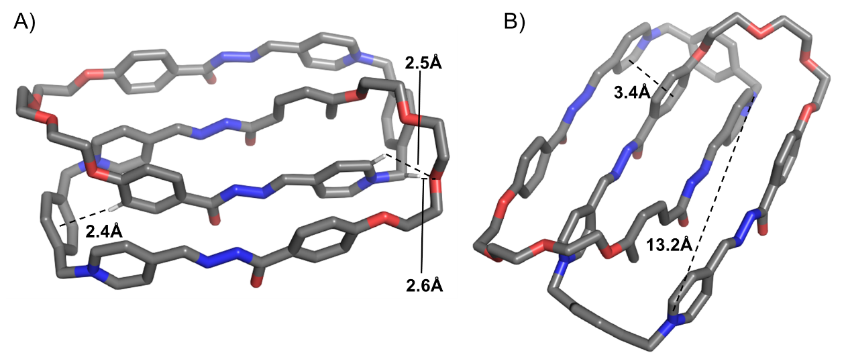
Figure S89. Different views of the solid-state structure of (1b²⁺·2b)₂·4Cl⁻. Counterions and solvent molecules are omitted for the sake of clarity.

3) (1b²⁺·2c)₂·4Cl⁻
3.1) Methods
Single crystals of the [2]catenane (1b²⁺·2c)₂·4Cl⁻ was obtained by slow vapor diffusion of THF into their water solutions under room temperature. A suitable crystal was selected on a Bruker D8 Venture diffractometer. The crystal was kept at 170.0 K during data collection. Using Olex2 [1], the structure was solved with the ShelXT [2] structure solution program using Intrinsic Phasing and refined with the ShelXL [3] refinement package using Least Squares minimisation.
3.2) Crystal data
[C₈₄H₉₈Cl₄N₁₂O₁₉] (M =1721.54 g/mol): triclinic, space group P-1 (no. 2), a = 9.3654(10) Å, b = 13.8586(15) Å, c = 35.902(4) Å, α = 99.729(8)°, β = 94.865(8)°, γ = 92.200(8)°, V = 4569.6(8) Å³, Z = 2, T = 169.99 K, μ(GaKα) = 1.150 mm-1, Dcalc = 1.251 g/cm³, 51045 reflections measured (5.638° ≤ 2Θ ≤ 111.154°), 17251 unique (Rint = 0.1783, Rsigma = 0.2119) which were used in all calculations. The final R₁ was 0.1552 (I > 2σ(I)) and wR₂ was 0.4060 (all data). CCDC number:2014869

Table S4 Crystal data and structure refinement for (1b²⁺·2c)₂·4Cl⁻
Empirical formula | C₈₄H₉₈Cl₄N₁₂O₁₉
Formula weight | 1721.54
Temperature/K | 169.99
Crystal system | triclinic
Space group | P-1
a/Å | 9.3654(10)
b/Å | 13.8586(15)
c/Å | 35.902(4)
α/° | 99.729(8)
β/° | 94.865(8)
γ/° | 92.200(8)
Volume/Å³ | 4569.6(8)
Z | 2
ρ_{calc}g/cm³ | 1.251
μ/mm⁻¹ | 1.150
F(000) | 1812.0
Crystal size/mm³ | 0.06 × 0.06 × 0.05
Radiation | GaKα (λ = 1.34139)
2Θ range for data collection/° | 5.638 to 111.154
Index ranges | -11 ≤ h ≤ 11, -16 ≤ k ≤ 15, -43 ≤ l ≤ 43
Reflections collected | 51045
Independent reflections | 17251 [R_{int} = 0.1783, R_{sigma} = 0.2119]
Data/restraints/parameters | 17251/0/1105
Goodness-of-fit on F² | 1.036
Final R indexes [I>=2σ (I)] | R₁ = 0.1552, wR₂ = 0.3253
Final R indexes [all data] | R₁ = 0.3211, wR₂ = 0.4060
Largest diff. peak/hole / e Å⁻³ | 1.58/-0.67
1.3) Solid-state structure
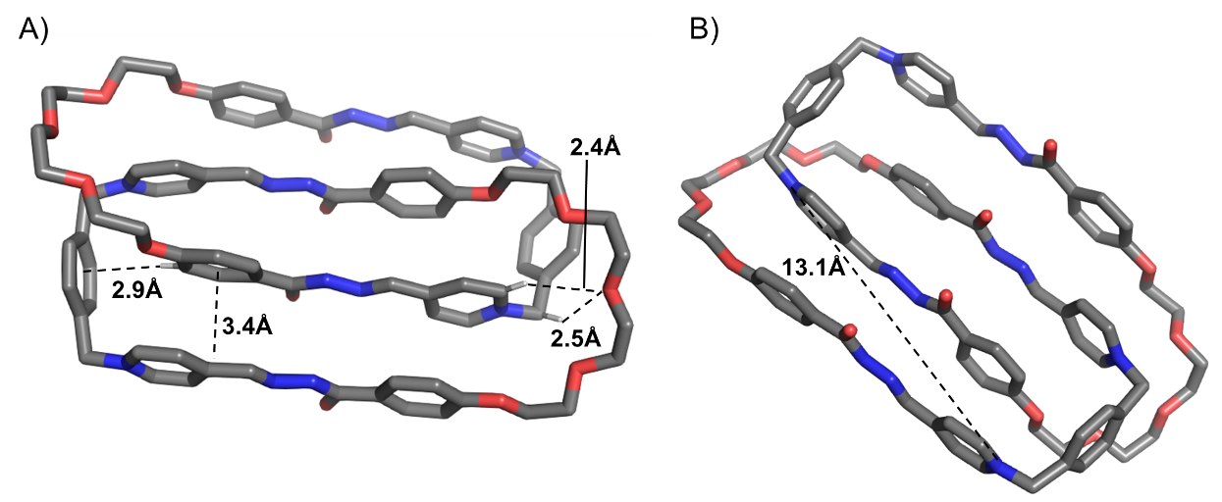
Figure S90. Different views of the solid-state structure of (1b²⁺·2c)₂·4Cl⁻. Counterions and solvent molecules are omitted for the sake of clarity.

10. UV−vis spectra
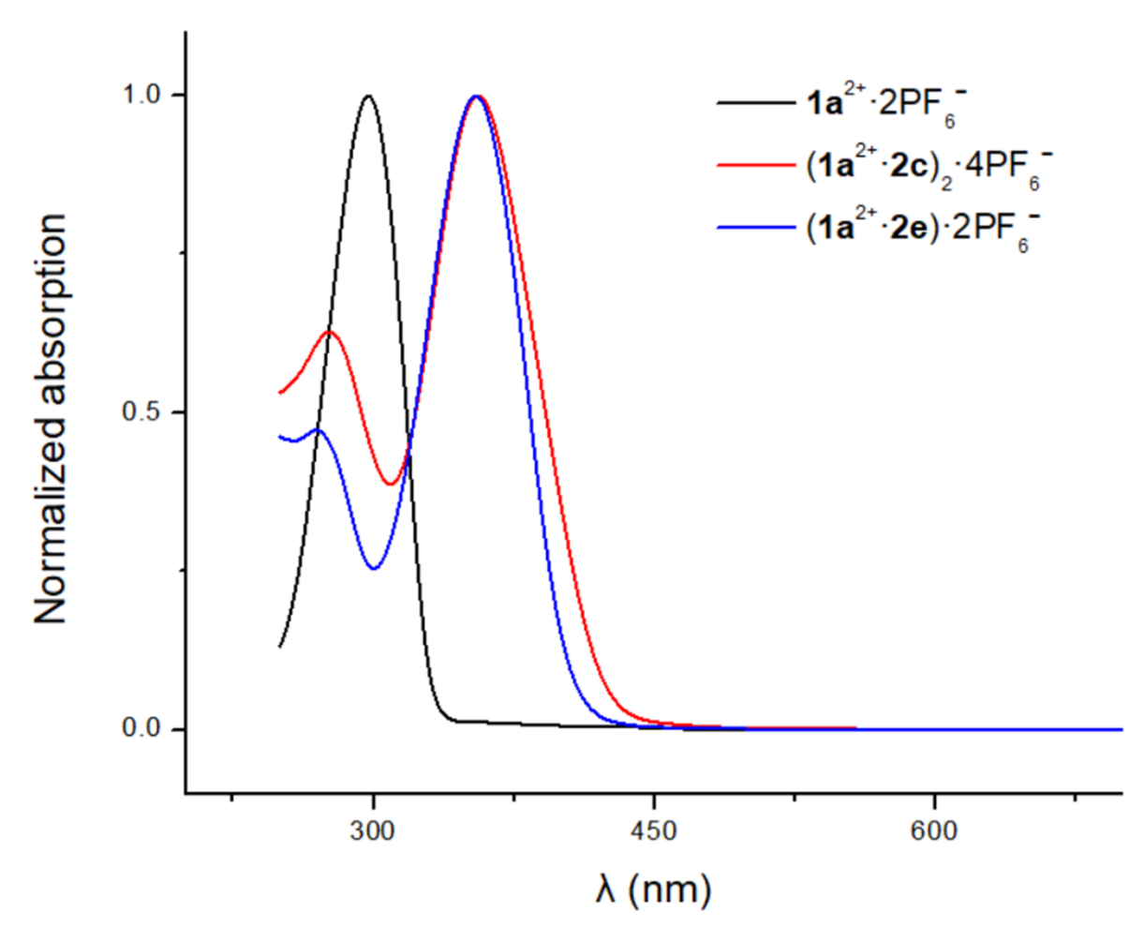
Figure S91. UV−vis spectra of 1a²⁺·2PF₆⁻ (20 μM, black), (1a²⁺·2c)₂·4PF₆⁻ (10 μM, red) and (1a²⁺·2e)·2PF₆⁻ (20 μM, blue) in CD₃CN.

11. References
1. Becker, F.; Klaiber, M.; Franzreb, M.; Bräse, S.; Lahann, J. On Demand Light-Degradable Polymers Based on 9,10-Dialkoxyanthracenes. Macromol. Rapid Commun. 41, 2000314 (2020).
2. Benito-Alifonso, D.; Richichi, B.; Baldoneschi, V.; Berry, M.; Fragai, M.; Salerno, G.; Galan, M. C.; Nativi, C. Quantum Dot-Based Probes for Labeling and Imaging of Cells that Express Matrix Metalloproteinases. ACS Omega 3, 9822−9826 (2018).

