Appendix
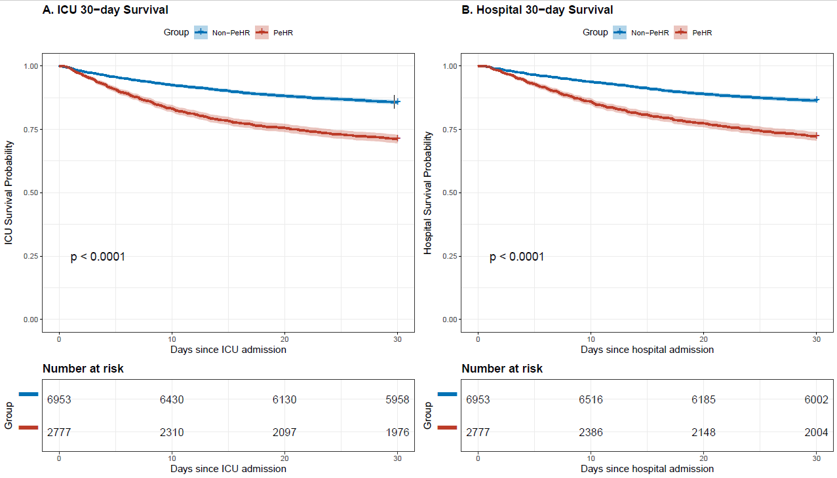
Supplementary Figure 1(30-day survival curve)
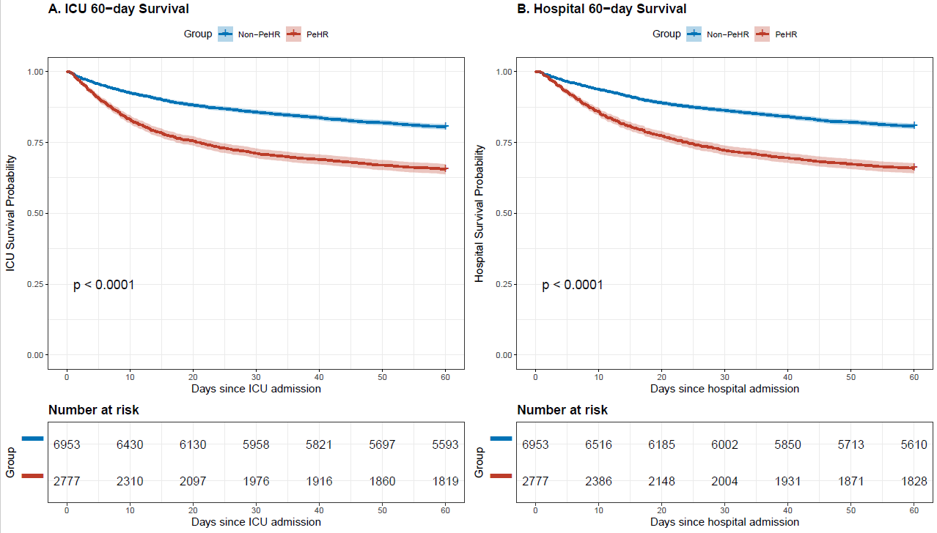
Supplementary Figure 2(60-day survival curve)

Supplementary Table 1 Univariate Logistic Regression
Characteristic | OR | 95% CI | p-value
Pehr
0 | — | —
1 | 1.29 | 1.18, 1.40 | <0.001
Gender
Female | — | —
Male | 1.37 | 1.26, 1.49 | <0.001
Admission_age | 1.01 | 1.01, 1.02 | <0.001
Race
White | — | —
Black | 0.69 | 0.60, 0.79 | <0.001
Asian | 0.91 | 0.69, 1.20 | 0.499
Other | 1.19 | 1.07, 1.32 | 0.002
Heart_rate | 1.00 | 1.00, 1.00 | 0.345
MBP | 1.00 | 0.99, 1.00 | <0.001
Resp_rate | 1.01 | 1.00, 1.02 | <0.001
Temperature | 0.91 | 0.87, 0.97 | 0.001
Spo₂ | 0.99 | 0.98, 1.00 | 0.012
BUN | 1.01 | 1.01, 1.01 | <0.001
Creatinine | 1.08 | 1.06, 1.11 | <0.001
Bicarbonate | 0.95 | 0.95, 0.96 | <0.001
Glucose | 1.00 | 1.00, 1.00 | <0.001
Calcium | 0.96 | 0.91, 1.01 | 0.112
Chloride | 0.99 | 0.99, 1.00 | 0.025
Potassium | 1.19 | 1.13, 1.25 | <0.001
Sodium | 0.99 | 0.98, 1.00 | 0.003
PT | 1.00 | 1.00, 1.01 | 0.217
PTT | 1.01 | 1.01, 1.01 | <0.001
INR | 1.02 | 0.98, 1.06 | 0.308
Platelet | 1.00 | 1.00, 1.00 | 0.077
WBC | 1.02 | 1.01, 1.03 | <0.001
Hemoglobin | 0.99 | 0.97, 1.00 | 0.102
Sofa Score | 1.07 | 1.05, 1.08 | <0.001
Aps iii Score | 1.02 | 1.01, 1.02 | <0.001
Saps ii Score | 1.03 | 1.03, 1.03 | <0.001
Mechanical Ventilation
No | — | —
Yes | 1.12 | 1.01, 1.24 | 0.025
CRRT
No | — | —
Yes | 2.55 | 1.92, 3.43 | <0.001
Vasopressor
No | — | —
Yes | 1.59 | 1.46, 1.72 | <0.001
Inotrope
No | — | —
Yes | 1.66 | 1.43, 1.93 | <0.001
Diuretic
No | — | —
Yes | 1.09 | 0.99, 1.19 | 0.066
β-blocker
No | — | —
Yes | 1.14 | 1.05, 1.25 | 0.002
Anticoagulant
No | — | —
Yes | 1.18 | 1.05, 1.32 | 0.007
Antiplatelet
No | — | —
Yes | 2.15 | 1.97, 2.35 | <0.001
Fluid Balance (24h) | 1.00 | 1.00, 1.00 | <0.001
AKI
No | — | —
Yes | 1.48 | 1.32, 1.65 | <0.001
Sepsis
No | — | —
Yes | 1.26 | 1.16, 1.37 | <0.001
Renal Disease
No | — | —
Yes | 1.37 | 1.26, 1.48 | <0.001
Diabetes
No | — | —
Yes | 1.41 | 1.30, 1.53 | <0.001
Malignant Cancer
No | — | —
Yes | 1.01 | 0.89, 1.15 | 0.874
Cerebrovascular Disease
No | — | —
Yes | 1.31 | 1.17, 1.47 | <0.001
Chronic Pulmonary Disease
No | — | —
Yes | 0.83 | 0.76, 0.90 | <0.001
Severe Liver Disease
No | — | —
Yes | 0.93 | 0.73, 1.18 | 0.556
Metastatic Solid Tumor
No | — | —
Yes | 0.93 | 0.75, 1.15 | 0.521
Anemia
No | — | —
Yes | 1.12 | 1.03, 1.22 | 0.005
Hypertension
No | — | —
Yes | 0.84 | 0.76, 0.93 | 0.001
Atrial Fibrillation
No | — | —
Yes | 0.91 | 0.84, 0.98 | 0.019

Supplementary Table 2 AIC Values for Sequential Logistic Regression Models Evaluating the Association Between PeHR and MACE
Model | N | AIC
M1 | 9730 | 13248.44569
M2 | 9730 | 12733.56388
M3 | 9730 | 12618.33623
M4 | 9730 | 12231.68077

Supplementary Table 3 Subgroup analysis
Subgroup | Level | Exposure | n (%) | OR (95% CI) | P | P for Interaction
Age Group | >=65 | pehr = 1 | 7566 (77.8%) | 1.41 (1.27, 1.56) | <0.001 | 0.010
Age Group | <65 | pehr = 1 | 2164 (22.2%) | 1.06 (0.88, 1.28) | 0.531
Gender | Female | pehr = 1 | 4254 (43.7%) | 1.35 (1.18, 1.54) | <0.001
Gender | Male | pehr = 1 | 5476 (56.3%) | 1.25 (1.11, 1.41) | <0.001 | 0.439
Hypertension | No | pehr = 1 | 7969 (81.9%) | 1.29 (1.17, 1.43) | <0.001 | 0.704
Hypertension | Yes | pehr = 1 | 1761 (18.1%) | 1.24 (1.00, 1.53) | 0.050
Atrial Fibrillation | No | pehr = 1 | 4443 (45.7%) | 1.27 (1.10, 1.46) | 0.001 | 0.566
Atrial Fibrillation | Yes | pehr = 1 | 5287 (54.3%) | 1.34 (1.19, 1.50) | <0.001
Diabetes | No | pehr = 1 | 5421 (55.7%) | 1.29 (1.14, 1.45) | <0.001 | 0.882
Diabetes | Yes | pehr = 1 | 4309 (44.3%) | 1.31 (1.14, 1.49) | <0.001
Chronic Pulmonary Disease | No | pehr = 1 | 6022 (61.9%) | 1.32 (1.18, 1.48) | <0.001 | 0.504
Chronic Pulmonary Disease | Yes | pehr = 1 | 3708 (38.1%) | 1.24 (1.08, 1.43) | 0.003
Severe Liver Disease | No | pehr = 1 | 9456 (97.2%) | 1.28 (1.17, 1.39) | <0.001 | 0.271
Severe Liver Disease | Yes | pehr = 1 | 274 (2.8%) | 1.71 (1.02, 2.89) | 0.042
Aki Flg | No | pehr = 1 | 1634 (16.8%) | 0.89 (0.67, 1.18) | 0.419
Aki Flg | Yes | pehr = 1 | 8096 (83.2%) | 1.29 (1.17, 1.42) | <0.001 | 0.013
Sepsis | No | pehr = 1 | 4469 (45.9%) | 0.89 (0.76, 1.04) | 0.131
Sepsis | Yes | pehr = 1 | 5261 (54.1%) | 1.48 (1.32, 1.66) | <0.001 | <0.001
Vasopressor Flag | No | pehr = 1 | 6015 (61.8%) | 0.99 (0.88, 1.12) | 0.899
Vasopressor Flag | Yes | pehr = 1 | 3715 (38.2%) | 1.51 (1.32, 1.73) | <0.001 | <0.001
Mechanical Ventilation Flag | No | pehr = 1 | 2031 (20.9%) | 1.50 (1.23, 1.83) | <0.001
Mechanical Ventilation Flag | Yes | pehr = 1 | 7699 (79.1%) | 1.23 (1.12, 1.36) | <0.001 | 0.086
Crrt Flag | No | pehr = 1 | 9527 (97.9%) | 1.28 (1.17, 1.40) | <0.001 | 0.764
Crrt Flag | Yes | pehr = 1 | 203 (2.1%) | 1.16 (0.65, 2.12) | 0.614

Supplementary Table 4 Missing number of variables
Variables | Missing number (%)
Albumin | 68.44
ALT | 49.16
Bilirubin | 48.75
AST | 48.60
Height | 47.15
Icu Survival | 46.46
Hosp Survival | 46.46
Post Icu Survival | 46.46
Post Hosp Survival | 46.46
Weight | 42.57
Lactate | 42.12
PTT | 13.29
INR | 12.62
PT | 12.62
Calcium | 6.89
Temperature | 4.15
WBC | 1.80
Hemoglobin | 1.79
Platelet | 1.77
Glucose | 1.55
Bicarbonate | 1.22
BUN | 1.21
Potassium | 1.21
Sodium | 1.20
Chloride | 1.17
Creatinine | 1.17
GCS | 0.32
Spo₂ | 0.21
Resp | 0.11
Heart | 0.08
MBP | 0.08
SOFA | 0.08
Insufficient | 0.01
Pehr | 0.01
Icu Outtime | 0.01

