Supplementary Information
Model Calibrating
In order to implement the modelling framework described in Methods, the unknown parameters, $β$, RCs and TCs, need to be estimated against the grain transport related observations. According to Liang et al. (2007), Chen et al. (2014) and National Railway Administration (2015), the average cost for road transport was about 0.5-0.6 Chinese yuan per ton-km (CNY/ton-km), and the average cost for rail and water transport were 0.15 CNY/ton-km and 0.04 CNY/ton-km before 2015. Thus the ${RC}^{RL}$ and ${RC}^{WT}$ were estimated as 0.25 and 0.10, respectively. $β$ is the parameter of distance impedance function; a higher $β$ would cause a lower average transport distance as it would reduce the preference for long-distance transport. The TCs and $β$ would jointly impact the average transport distance and market share of railway/waterway; however, the impacts of TCs on total ton-km of grain and the proportion of inter-provincial transport are quite limited. Results suggest that given any specific beta value, the percentage of grain transported by rail decreases and the average grain transport distance by rail increases with increasing TC. Higher TCs discourage the rail transport of grain, especially short-distance rail transport, thus leading to lower percentages and higher average distances of grain transport by rail (Fig S1).
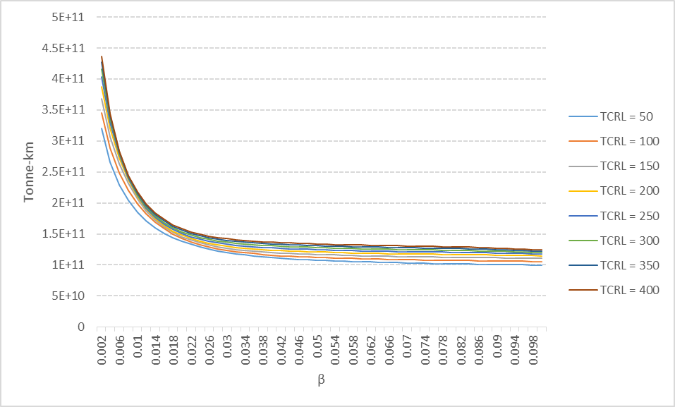 | 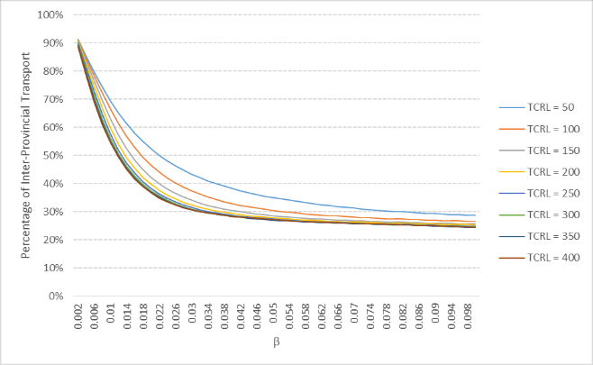
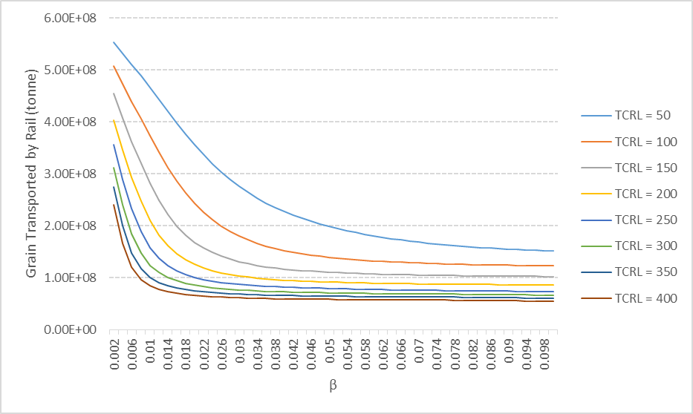 | 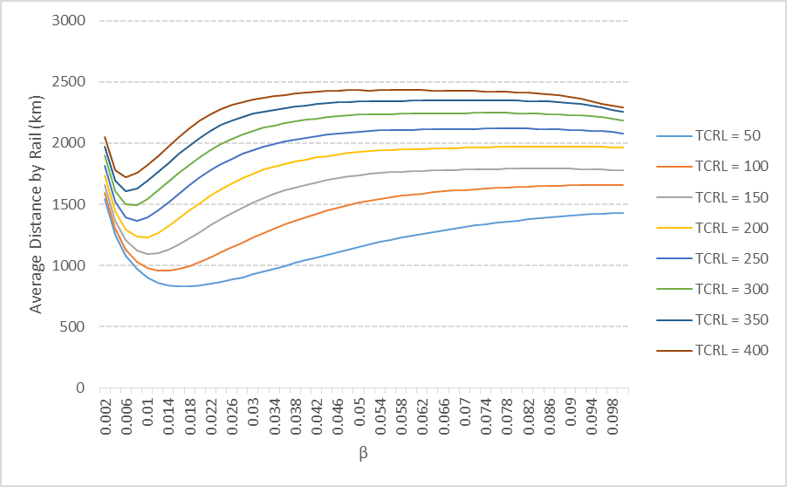
Figure S1 a) Change of total ton-km of grain transport by ${TC}^{RL}$and $β$, b) Change of proportion of inter-provincial flows by ${TC}^{RL}$and $β$, c) Change of market share of railway in grain transport by ${TC}^{RL}$ and $β$, and d) Change of average distance of rail transport by ${TC}^{RL}$ and $β$.

According to NBSC (2019) and National Development and Reform Commission (NDRC, 2017), the percentage of grain transport by rail dropped fast since 2009, although the capacity of Chinese railway has kept growing during the last decades. To catch the general trend, here we used the 5-year average value instead of the single observation in 2015 to calibrate the model; thus, the percentage of grain transported by rail was set as 13%, and the average distance by rail was set as 1800 km in the calibrating process. For waterway, 40% of inter-provincial transport of grain were transported by inland or coastal waterway, which was adopted to calibrate ${TC}^{WT}$.
In practice, we adopted the exhaustive searching approach to identify the best-fit TCs and $β$ values. By enumerate all possible TC and $β$ values, we ran the model with different TC-$β$ combinations and estimated the "percentage of grain by rail transport" and the "average transport distance by rail" based on different modelling results (Figure S1). By comparing the modelling results and the observed value from NBSC/NDRC, we obtained the best-fit ${TC}^{RL}$, ${TC}^{WT}$, which are 200km and 50km road distance equivalent, respectively, and the best-fit $β$ which is 0.07. We further obtained the scale of total inter-provincial flow and the market-share of the railway in the inter-provincial transport of grain to validate the model. Table S1 shows the relevant statistics from NBSC/NDRC against the modelling results. The relatively small error indicates that the modelling results are acceptable for further analysis.
Table S1 Key metrics for observed and modelled values
Statistics for 2015 | Observed | Modelled | Error（%）
Inter-Provincial Flow of Grain（million ton） | 165.00 | 168.03 | 1.81
% Inter-Provincial Flow of Grain by Railway | 50.00 | 51.68 | 3.36
% Inter-Provincial Flow of Grain by Waterway | 40.00 | 40.13 | 0.32
Total Grain Transport by Rail (million ton) | 87.71 | 87.48 | -0.26
Average Transport Distance by Rail (km) | 1795.89 | 1972.17 | 9.81

References
Anselin, L. (1995). Local indicators of spatial association—LISA. Geographical analysis, 27(2), 93-115.
Chen,Y., Yang, Y., Zhou. L. (2014) Discussion on Selection of Grain Logistic Modes in China, Railway Freight Transport 2014(11), 12-17, in Chinese
Liang, S, Liu, X., Meng, Z., Bai, S. (2007) Comprehensive Grain Transport Cost and Logistics Path Optimization in China, China Grain Economy 2007(4), 32-35, in Chinese
National Railway Administration (2015) National Development and Reform Commission on Adjusting Railway Freight Transport Prices Notice to further improve the price formation mechanism, 发改价格[2015]183号, http://www.nra.gov.cn/jgzf/flfg/gfxwj/zt/other/201701/t20170105_33361.shtml in Chinese
Wang, L., Li, C., Ying, Q., Cheng, X., Wang, X., Li, X. & Gong, P. (2012). China's urban expansion from 1990 to 2010 determined with satellite remote sensing. Chinese Science Bulletin, 57(22), 2802-2812.
Xu, X. and Lan, Y., 2017. Spatial and temporal patterns of carbon footprints of grain crops in China. Journal of Cleaner Production, 146, pp.218-227.
Yin, Fang, Sun, Zhanli, You, Liangzhi & Müller, Daniel (2018) Increasing concentration of major crops in China from 1980 to 2011, Journal of Land Use Science, 13:5, 480-493, DOI: 10.1080/1747423X.2019.156783
National Railway Administration (2015) National Development and Reform Commission on Adjusting Railway Freight Transport Prices Notice to further improve the price formation mechanism, 发改价格[2015]183号, http://www.nra.gov.cn/jgzf/flfg/gfxwj/zt/other/201701/t20170105_33361.shtml in Chinese
National Development and Reform Commission (2017) "13th Five-Year" Development Plan for Grain Logistics Industry, 发改经贸[2017]432号, http://www.gov.cn/xinwen/2017-03/10/5176120/files/6d1e09e27af4429abb950b24f6693819.pdf in Chinese
National Bureau of Statistics of China (2020), China Statistics Database, https://data.stats.gov.cn/english/easyquery.htm?cn=C01

