Supplementary table 1: Analytical validation report of the prototype Simoa™ immunoassay for CSF and plasma SNAP25 measurements on the Simoa HD-X platform.
Parameters | Results | Acceptance criteria
Measuring range | 0.02 – 25 pg/mL | -
Precision - repeatability  (Inter-run CV%) | CSF: 3.3%  Plasma: 4.1% | < 10%
Precision - reproducibility  (Inter-run CV%) | CSF: 4.4%  Plasma: 6.4% | < 10%
Sensitivity (LLOQ) | 0.0054 pg/mL | Concentration at which inter-run CV% > 20%
Minimal required dilution | CSF: DF 9  Plasma: DF 6 | -
Dilution factor used | CSF: DF 200  Plasma: DF 6 | -
Parallelism | CSF: 104%  Plasma: 89% | 80-120%
Spike-recovery | CSF: 94%  Plasma: 93% | 80-120%
Dilution linearity | CSF: 100%  Plasma: 102% | 85-115%
RV samples were sample diluent spiked with calibrator protein. Lower limit of quantification, LLOQ; upper limit of quantification, ULOQ; coefficient of variation, CV; run validation, RV; quality control, QC; dilution factor, DF; cerebrospinal fluid, CSF.

Supplementary table 2: Extended baseline demographic characteristics of the four cohorts.
SPIN Cohort | CU Aβ- | CU Aβ+ | MCI Aβ+ | AD dementia | P-value
n | 44 | 16 | 187 | 90 | -
Plasma pTau217 | 0.4 ± 0.1 ^{c,d} | N/A | 1.3 ± 0.7ª | 1.8 ± 0.9ª | <0.001
Plasma pTau181 | 18.1 ± 9.7 | 20.9 ± 20.0 | 20.7 ± 20.5 | 21.1 ± 10.4 | 0.810
Plasma NfL | 11.4 ± 5.6 ^{c,d} | 12.3 ± 3.1 ^{c,d} | 16.4 ± 9.1 ^{a,b} | 16.9 ± 8.1 ^{a,b} | 0.003
ADC | SCD Aβ- | SCD Aβ+ | MCI Aβ+ | AD dementia | P-value
n | 210 | 82 | 43 | 44 | -
Plasma pTau217 | 0.03 ± 0.01^{b,c,d} | 0.07 ± 0.04^{a,d} | 0.08 ± 0.04^{a,d} | 0.11 ± 0.06^{a,b,c} | <0.001
Plasma pTau181 | 18.4 ± 9.5^{b,c,d} | 28.5 ± 12.8 ª | 31.1± 20.1ª | 31.3 ± 14.2ª | <0.001
Plasma Aβ_{42/40} | 0.06 ± 0.01^{b,c,d} | 0.05 ± 0.01ª | 0.05 ± 0.01ª | 0.05 ± 0.01ª | <0.001
Plasma GFAP | 75.7 ± 37.5^{b,c,d} | 113.9 ± 53.8 ª | 111.4 ± 50.3 ª | 133.23 ± 59.03ª | <0.001
Plasma NfL | 12.4 ± 7.9 ^{b,c,d} | 17.5 ± 8.6 ª | 19.4 ± 12.5 ª | 20.2 ± 7.7 ª | 0.043
Twins Cohort | CU Aβ- | CU Aβ+ |  |  | P-value
n | 170 | 26 |  |  | -
Plasma pTau217 | 0.04 ± 0.02 | 0.08 ± 0.04 |  |  | <0.001
Plasma Aβ_{42/40} | 0.06 ± 0.01 | 0.05 ± 0.01 |  |  | 0.002
Plasma GFAP | 101.3 ± 47.8 | 171.8 ± 74.1 |  |  | <0.001
Plasma NfL | 16.2 ± 9.1 | 19.0 ± 10.7 |  |  | 0.244
Data represent the mean ± SD, n (%); SPIN Cohort: ªp <0.05 vs CU Aβ-, ^{b}p <0.05 vs CU Aβ+, ^{c}p <0.05 vs MCI Aβ+, ^{d}p <0.05 vs AD dementia. ADC: ªp <0.05 vs SCD Aβ-, ^{b}p <0.05 vs SCD Aβ+, ^{c}p <0.05 vs MCI Aβ+, ^{d}p <0.05 vs AD dementia. Biomarker concentrations are represented as pg/mL or as a ratio. Missing data: SPIN cohort- plasma pTau217 (n=271), plasma pTau181 (n=251), plasma NfL (n=188); ADC- plasma pTau217 (n=1), plasma pTau181 (n=218), plasma Aβ_{42/40} (n=1) . CU Aβ-: cognitively unimpaired amyloid negative, CU Aβ+: cognitively unimpaired amyloid positive, SCD Aβ-: subjective cognitive decline amyloid negative, SCD Aβ+: subjective cognitive decline amyloid positive, MCI Aβ+: mild cognitive impairment amyloid positive, AD dementia: Alzheimer’s disease type dementia, pTau217: phosphorylated tau 217, pTau181: phosphorylated tau 181, GFAP: glial fibrillary acidic protein, NfL: neurofilament light chain.

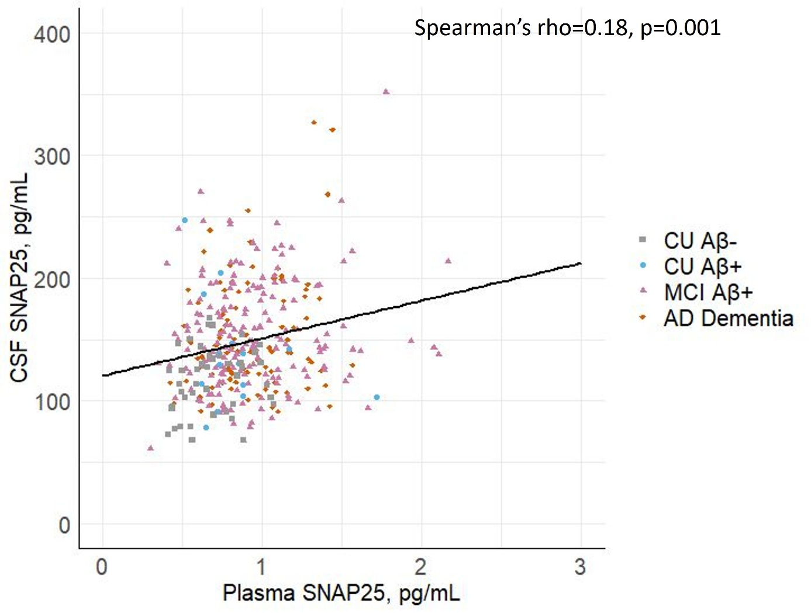
Supplementary figure 1: Scatterplot to visualize the correlation of CSF SNAP25 versus plasma SNAP25 in the SPIN cohort. CU Aβ-: cognitively unimpaired amyloid beta negative, CU Aβ+: cognitively unimpaired amyloid beta positive, MCI Aβ+: mild cognitive impairment amyloid beta positive, AD dementia: Alzheimer’s disease type dementia, SNAP25: synaptosomal-associated protein 25kDa.

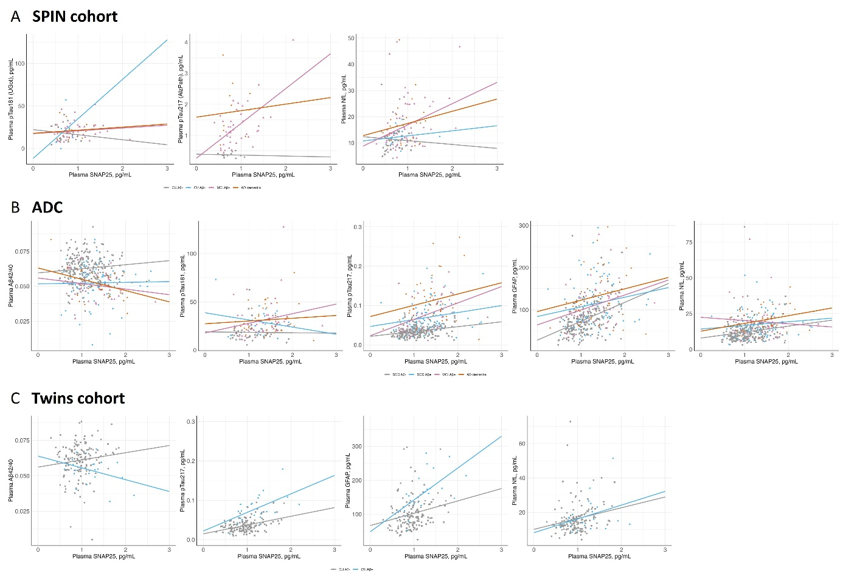
Supplementary figure 2: Scatterplot to visualize the correlation of plasma SNAP25 with other plasma biomarkers. A) SPIN cohort, B) ADC, C) Twins cohort. CU Aβ-: cognitively unimpaired amyloid beta negative, CU Aβ+: cognitively unimpaired amyloid beta positive, SCD Aβ-: subjective cognitive decline amyloid negative, SCD Aβ+: subjective cognitive decline amyloid positive, MCI Aβ+: mild cognitive impairment amyloid beta positive, AD dementia: Alzheimer’s disease type dementia, SNAP25: synaptosomal-associated protein 25kDa.

Supplementary table 3: Linear mixed models of cognitive performance (ADC-SCIENCe) , stratified by amyloid status.
Cognitive domain | Cognitive score measure | SCD Aβ- | SCD Aβ+ | p-value
Global cognition | Baseline  Longitudinal | 0.01 ± 0.04  0.02 ± 0.01 | 0.00 ± 0.09  -0.07 ± 0.02 | 0.867  0.000
Memory | Baseline  Longitudinal | 0.04 ± 0.05  0.01 ± 0.01 | -0.13 ± 0.11  -0.14 ± 0.03 | 0.081  0.000
Attention | Baseline  Longitudinal | 0.01 ± 0.06  0.01 ± 0.01 | 0.10 ± 0.13  -0.03 ± 0.02 | 0.444  0.008
Language | Baseline  Longitudinal | -0.03 ± 0.05  0.02 ± 0.01 | 0.07 ± 0.12  -0.07 ± 0.03 | 0.345  0.000
Executive functioning | Baseline  Longitudinal | 0.05 ± 0.05  0.02 ± 0.01 | 0.01 ± 0.12  -0.04 ± 0.02 | 0.729  0.000
The table presents baseline and longitudinal estimates for global cognition, memory, attention, language, and executive function. All models were adjusted for age, sex, and education, with values centered around the overall sample mean (age = 60.4 years; 59.4% male; education level = 5.6 Verhage scale). For both the SCD Aβ− and SCD Aβ+ groups, baseline estimates represent mean cognitive performance at study entry, and longitudinal estimates reflect the rate of change in performance over time (SD/year). P-values indicate differences between groups in baseline performance and longitudinal change.
Supplementary figure 3: Association between changes in plasma SNAP25 and cognitive performance over time in the ADC-SCIENCe cohort. These figures present linear mixed models of cognition over time in individuals with SCD (total cohort, Aβ-, Aβ+), stratified by plasma SNAP25 baseline values (A-C) or slopes (D-F) in tertiles. Plasma SNAP25 slopes and baseline values were adjusted for age, sex, and education. Cognitive domain scores are average z-scores of individual neuropsychological test results. SNAP25: synaptosomal-associated protein 25kDa.

Supplementary table 4: Cox regression model with predictive performance of plasma SNAP25 for clinical progression from SCD to MCI/ dementia
Biomarker | Condition | HR (95% CI) | Harrell’s C-index (95 CI) | Comparison with baseline biomarker
Demographics | Age, Sex, Baseline MMSE |  | 0.70 (0.564-0.814) | -
Plasma SNAP25 | Baseline | 1.94 (1.42 - 2.65)** | 0.80 (0.700-0.861) | -
Plasma SNAP25 | Baseline +  Slope | 1.67 (1.21 - 2.29)*  2.00 (1.38 - 2.89)** | 0.86 (0.790-0.912) | 0.06 (0.024 -0.136)
Plasma pTau217 | Baseline | 2.95 (2.05 - 4.26)** | 0.86 (0.782-0.920) | -
Plasma pTau217 | Baseline +  Slope | 1.48 (0.90 - 2.44)  4.27 (1.97 - 9.25)** | 0.90 (0.856-0.943) | 0.05 (0.007 -0.103)
Combined | Demographics + Baseline + Slope of (plasma SNAP25 & pTau217 | - | 0.92 (0.880-0.955) | -
The table presents the HR (95% CI) and Harrell’s C-index (95% CI) for plasma SNAP25 from Cox regression models that include (1) Demographics: demographics (age + sex + baseline MMSE), (2) Baseline: demographics + baseline biomarker, (3) Baseline + Slope: demographics + baseline and slope of biomarker (4) Combined: selected predictors from elastic net, which are demographics + baseline + slope of plasma SNAP25 and pTau217.

