The effect of SSRI/SNRI antidepressant treatment on the gut microbiota of patients with major depressive disorder
Eugenia Emile Natasha, MSc¹*, Danique Mulder MSc¹*, Leon Fehse MSc², Nils R. Winter PhD³, Lukas Fisch MSc³, Marius Welzel PhD², Corinna Bang PhD⁴, Susanne Meinert MSc^{3,5}, Kira Flinkenflügel MSc³, Tiana Borgers PhD³, Janik Goltermann PhD³, Elisabeth J. Leehr PhD³, Carsten Culmsee PhD^{6,7}, Frederike Stein PhD⁸, Florian Thomas-Odenthal PhD⁸, Paula Usemann MSc⁸, Lea Teutenberg MSc⁸, Igor Nenadic PhD⁸, Benjamin Straube PhD⁸, Nina Alexander PhD⁸, Hamidreza Jamalabadi PhD⁸, Andreas Jansen PhD⁸, Robert Nitsch MD PhD⁵, Andreas Lügering MD⁹, Andre Franke PhD⁴, Udo Dannlowski MD, PhD^{3,10}, Tilo Kircher MD^{6,8}, Dominik Heider PhD², Tim Hahn PhD³, Janna N. Vrijsen PhD^{1,11,12}, Philip van Eijndhoven MD PhD¹, Indira Tendolkar MD PhD¹, Andreas Reif MD^{13,14}, Sharmili Edwin Thanarajah MD^{13,14,15}, Silke Matura PhD¹³, Alejandro Arias Vasquez PhD¹#, Mirjam Bloemendaal PhD^{13,15}#^
Supplemental Online Content
Table of contents
1. Supplementary Methods 2
1.1. Study populations 2
1.2. ATC codes classification 4
1.3. Microbiota data acquisition and preprocessing 6
1.4. Description of covariates 7
eFigure 2. Sequencing batch effect in the MACS cohort 7
1.5. Sensitivity analyses 10
2. Supplementary Figures 11
eFigure 3. Distribution of treatment psychotropic medications 11
eFigure 4. Abundance distribution MDD-associated genera in the MACS cohort 12
eFigure 5. Abundance distribution of MDD-associated genera in the MIND-Set cohort 14
eFigure 6. Associations between genus abundance and MDD and SSRI/SNRI treatment 16
References 17

1. Supplementary Methods

1.1. Study populations
MACS
The Marburg-Münster Affective Cohort Study (MACS) is an observational, prospective, case-control study, conducted at the Department of Psychiatry and Psychotherapy at the University of Münster and University of Marburg, Germany. The study, described previously^{1,2}, aims to investigate underlying neurobiological and environmental risk factors for affective disorders. The cohort comprises patients with an acute or lifetime diagnosis of an affective disorder and a group of unaffected individuals who reported no history of any psychiatric disorders. Individuals aged 18–67 years, of Caucasian ancestry, receiving in- or outpatient treatment from participating local clinics in Marburg or Münster, or responding to newspaper advertisements, were recruited between 2014 and 2018. Study procedures were conducted at the Marburg University Hospital and Münster University Hospital. Psychiatric diagnoses, including an MDD diagnosis, were determined by trained clinicians using the Structural Clinical Interview for DSM-IV, axis 1 disorders (SCID-I). Individuals were included if they had an active or lifetime major depressive episode, with or without somatic or other psychiatric comorbidities. For the current project, patients without an affective disorder diagnosis were excluded (n=297). For a complete description of sample selection, see eFigure 1. Upon the completion of baseline participation, individuals were invited to participate in a non-mandatory follow-up examination after two years. The study received ethical approval from the Ethics Committees of the Medical Faculties, University of Marburg (07/14), and University of Münster (2014-422-b-S).

MIND-Set
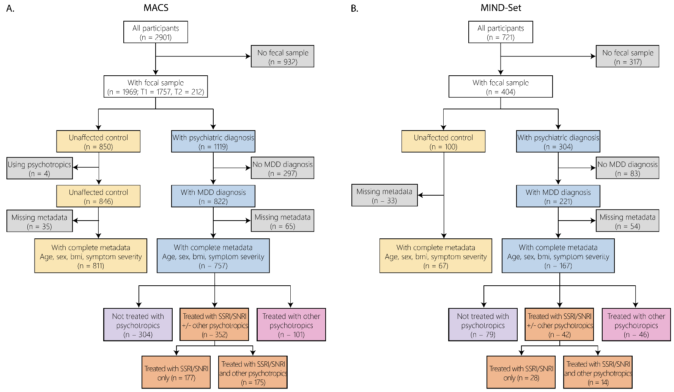
The Measuring Integrated Novel Dimensions in Neurodevelopmental and Stress-related Mental Disorders (MIND-Set) cohort³ was used as a replication cohort. The MIND-Set cohort is an observational, cross-sectional study, which aims to elucidate shared and specific mechanisms of stress-related and neurodevelopmental psychiatric disorders. Individuals aged 18 years and older were recruited through the Department of Psychiatry of the Radboud University Medical Center, Nijmegen, the Netherlands between 2016 and 2021. At the time of recruitment, participants were outpatients at the Department of Psychiatry of the Radboud University Medical Center. The SCID-I for mood and anxiety disorders was conducted by trained clinicians to confirm the MDD diagnosis, alongside other standardized instruments to assess the presence of other psychiatric and neurodevelopmental disorders (see Van Eijndhoven et al.³ for a description of all measurement instruments). Individuals were included if they fulfilled the criteria for a stress-related disorder (mood, anxiety or substance use disorders) and/or neurodevelopmental disorder (attention deficit/hyperactivity disorder (ADHD) or autism spectrum disorder (ASD)). For the current project, only individuals with an acute or lifetime diagnosis of MDD, with or without psychiatric comorbidities, were included. For a complete description of sample selection, see eFigure 1. A group of individuals free from psychiatric disorders was recruited from the local general population, screened via telephone interviews using the same diagnostic tools. Exclusion criteria comprised active psychotic disorders, IQ estimation < 70, sensorimotor disabilities, insufficient Dutch language comprehension, or taking antibiotics at the time of recruitment. The study received ethical approvals from the local medical ethics committee (NL55618.091.015).

eFigure 1: Flowchart for participant selection
Summary of the number of participants included/excluded in every step in the (A) MACS and (B) MIND-Set cohort. We selected participants based on several criteria: available fecal sample; MDD diagnosis for patients; available data about age, gender, BMI, and symptom severity; and not on any psychotropic medication for the unaffected controls.

1.2. ATC codes classification
A comprehensive overview of the medication classes along with their corresponding ATC codes and ATC classification

SSRIs/SNRIs
ATC Code | Name | Class_1 (N) | Class_2 (N0X) | Class_3 (N0XX) | Class_4 (N0XXX)
N06AB03 | fluoxetine | Nervous system | Psychoanaleptics | Antidepressants | SSRI
N06AB04 | citalopram | Nervous system | Psychoanaleptics | Antidepressants | SSRI
N06AB05 | paroxetine | Nervous system | Psychoanaleptics | Antidepressants | SSRI
N06AB06 | sertaline | Nervous system | Psychoanaleptics | Antidepressants | SSRI
N06AB10 | escitalopram | Nervous system | Psychoanaleptics | Antidepressants | SSRI
N06AX16 | venlafaxine | Nervous system | Psychoanaleptics | Antidepressants | Other antidepressants
N06AX17 | milnacipran | Nervous system | Psychoanaleptics | Antidepressants | Other antidepressants
N06AX21 | duloxetine | Nervous system | Psychoanaleptics | Antidepressants | Other antidepressants
N06AX26 | vortioxetine | Nervous system | Psychoanaleptics | Antidepressants | Other antidepressants

Other psychotropic medications
ATC Code | Name | Class_1 (N) | Class_2 (N0X) | Class_3 (N0XX) | Class_4 (N0XXX)
N05AN01 | lithium | Nervous system | Psycholeptics | Antipsychotics | Lithium
N05AX08 | risperidone | Nervous system | Psycholeptics | Antipsychotics | Other antipsychotics
N05AX12 | aripiprazole | Nervous system | Psycholeptics | Antipsychotics | Other antipsychotics
N05BA01 | diazepam | Nervous system | Psycholeptics | Anxiolytics | Benzodiazepine derivatives
N05BA04 | oxazepam | Nervous system | Psycholeptics | Anxiolytics | Benzodiazepine derivatives
N05BA06 | lorazepam | Nervous system | Psycholeptics | Anxiolytics | Benzodiazepine derivatives
N05BA12 | alprazolam | Nervous system | Psycholeptics | Anxiolytics | Benzodiazepine derivatives
N05BB01 | hydroxyzine | Nervous system | Psycholeptics | Anxiolytics | Diphenylmethane derivatives
N05CD02 | nitrazepam | Nervous system | Psycholeptics | Hypnotics and sedatives | Benzodiazepine derivatives
N05CD06 | lormetazepam | Nervous system | Psycholeptics | Hypnotics and sedatives | Benzodiazepine derivatives
N05CD07 | temazepam | Nervous system | Psycholeptics | Hypnotics and sedatives | Benzodiazepine derivatives
N05CF01 | zopiclone | Nervous system | Psycholeptics | Hypnotics and sedatives | Benzodiazepine related drugs
N05CF02 | zolpidem | Nervous system | Psycholeptics | Hypnotics and sedatives | Benzodiazepine related drugs
N05CH01 | melatonin | Nervous system | Psycholeptics | Hypnotics and sedatives | Melatonin receptor agonist
N05CM09 | Valeriane radix | Nervous system | Psycholeptics | Hypnotics and sedatives | Other hypnotics and sedatives
N06AA02 | imipramine | Nervous system | Psychoanaleptics | Antidepressants | Non-selective monoamine reuptake inhibitors
N06AA04 | clomipramine | Nervous system | Psychoanaleptics | Antidepressants | Non-selective monoamine reuptake inhibitors
N06AA09 | amitriptyline | Nervous system | Psychoanaleptics | Antidepressants | Non-selective monoamine reuptake inhibitors
N06AA10 | mortiptyline | Nervous system | Psychoanaleptics | Antidepressants | Non-selective monoamine reuptake inhibitors
N06AF04 | tranylcypromine | Nervous system | Psychoanaleptics | Antidepressants | Monoamine oxidase inhibitors, non-selective
N06AX05 | trazodone | Nervous system | Psychoanaleptics | Antidepressants | Other antidepressants
N06AX11 | mirtazapine | Nervous system | Psychoanaleptics | Antidepressants | Other antidepressants
N06AX12 | bupropion | Nervous system | Psychoanaleptics | Antidepressants | Other antidepressants
N06AX22 | agomelatine | Nervous system | Psychoanaleptics | Antidepressants | Other antidepressants
N06AX26 | vortioxetine | Nervous system | Psychoanaleptics | Antidepressants | Other antidepressants
N06BA02 | dexamphetamine | Nervous system | Psychoanaleptics | Psychostimulants, agents used for ADHD and nootropics | Centrally acting sympathomimetics
N06BA04 | methylphenidate | Nervous system | Psychoanaleptics | Psychostimulants, agents used for ADHD and nootropics | Centrally acting sympathomimetics
N06BA07 | modafinil | Nervous system | Psychoanaleptics | Psychostimulants, agents used for ADHD and nootropics | Centrally acting sympathomimetics

1.3. Microbiota data acquisition and preprocessing
The protocol for DNA extraction, sequencing and preprocessing has been described in detail elsewhere for MACS⁴ and MIND-Set⁵. In short, participants from the MACS cohort were asked to collect a fecal sample on the day of their baseline intake interview or within two weeks after . Baseline samples were used by default; if unavailable, the two-year follow-up samples were used along with corresponding clinical and questionnaire data. The DNA was extracted from the fecal samples, and the V1-V2 regions of the 16s rRNA gene were amplified using the 27F−308R primer pair. Sequencing was performed using the Illumina MiSeq v3 platform (2x300bp), carried out in two batches, with samples from different timepoints processed in separate batches. Sequencing yielded an average of 36,335 [4008 – 11,3711] paired-end reads per sample. Raw sequences were pre-processed using the Natrix pipeline⁶, which clustered the reads into OTUs before using the BLAST algorithm against the SILVA database for taxonomic assignment⁷. The resulting feature Table contained a total of 48,495 OTUs, corresponding to 636 genera.
For the MIND-Set cohort, all participants collected a fecal sample at home. DNA was extracted from the fecal samples, and the V4 region of the 16s rRNA gene was amplified using the 515F-806R primer pair. Sequencing was performed using the Illumina NovaSeq6000 platform (2x250bp) in one batch, yielding an average of 768,466 [226,130 –1,266,720] paired-end reads per sample. Raw sequences were pre-processed using the QIIME2-DADA2 pipeline^{8,9}, which inferred ASVs and then assigned taxonomy using a Naïve Bayes classifier pre-trained on the SILVA v138 reference database. The resulting feature Table contained a total of 21,078 ASVs, corresponding to 243 genera.

1.4. Description of covariates
Sequencing batch
We observed clustering based on the sequencing batch in the MACS cohort, reflected on an OTU/ASV-level unsupervised ordination plot (eFigure 2). The sequencing batch effects were no longer observed after agglomeration to genus level. The sequencing batch affected the number of detected OTUs (F=36.92, p < 0.001), hence we added the variable as a covariate in our analyses.

eFigure 2. Sequencing batch effect in the MACS cohort
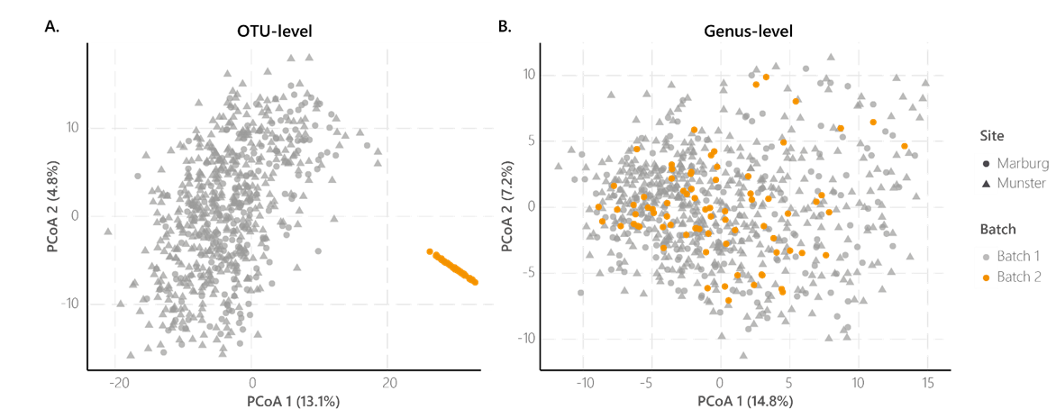
In the MACS cohort, unsupervised ordination (PCA on Aitchison distance) on OTU-level revealed a sequencing batch effect (A). After agglomeration to genus level, the sequencing batch effect disappeared (B). Since the batch affected the microbial community structure, we corrected for batch effect in all statistical models.

Sequencing depth
Sequencing depth, the number of sequencing reads after pre-processing using Natrix (MACS) or QIIME2-DADA2 (MIND-Set), was significantly associated with the number of microbial features in both the MACS (r=.23, p<.001) and MIND-Set (r=.09, p < .001) cohorts, and was therefore added as a covariate in the analyses
Depression symptom severity
All participants in the MACS cohort self-reported depression symptom severity using the Beck Depression Inventory (BDI-II)¹⁰. The BDI-II is a 21-item questionnaire that assesses the intensity of depressive symptoms over the past two weeks. Each item is scored on a scale from 0 to 3. Total scores range from 0 to 63, with scores of 0–13 indicating minimal depression, 14–19 mild depression, 20–28 moderate depression, and 29–63 severe depression.
All participants in the MIND-Set cohort self-reported depression symptom severity using the Inventory of Depressive Symptomatology (IDS-SR)¹¹. The IDS-SR is a 30-item questionnaire designed to assess the severity of depressive symptoms across various domains, including mood, sleep, appetite, and cognitive functioning. Each item is scored on a scale from 0 to 3. Total scores range from 0 to 84, with scores of 0-13 indicating no depression, 14-25 mild depression, 26-38 severe depression and 39-84 very severe depression.
There was a significant different in depression symptom severity between medication groups, with the SSRI/SNRI-treated group showing higher symptom levels compared to unmedicated group, in both MACS (F = 61.32, p < .001) and MINDSet (F = 14.68, p < 0.001). Therefore, all the models testing differences between medication groups were adjusted for symptom severity (BDI or IDS-SR).
Psychiatric comorbidities
The MACS cohort included only individuals with or without a comorbid anxiety disorder; thus, psychiatric comorbidities were coded as a binary variable indicating presence or absence of comorbid anxiety. For the MIND-Set cohort, psychiatric comorbidities were quantified by counting the number of the following diagnostic groups: Attention Deficit/Hyperactivity Disorder (ADHD), Autism Spectrum Disorder (ASD), Dysthymia, Bipolar Disorder, Generalized Anxiety Disorder (GAD), Panic Disorder, Post Traumatic Stress Disorder (PTSD) or Substance Use Disorder (SUD).
Remission status
MDD patients were categorized based on their remission status at study enrollment. In the MACS cohort, individuals meeting criteria for a current depressive episode were classified as 'active; , while those not currently meeting criteria were classified as ‘partially remitted’ (if in partial remission) or ‘remitted’ (if fully recovered from a past episode). In the MIND-Set cohort, patients with a current depressive episode were classified as ‘active’, and those without were classified as ‘remitted’.
Appetite change
Appetite change was assessed in the MACS cohort using item A3 from the Structured Interview Guide for the Hamilton Depression Rating Scale (SIGH-HAMD)¹²: “Has your appetite been greater than when you feel well or okay?” with response options ranging from 0 (no increase in appetite) to 3 (wants to eat much more than usual). Appetite change was not assessed in MINDSet.
Somatic comorbidity
The MACS cohort also comprised individuals with somatic diagnoses, including autoimmune diseases (n=7), gastrointestinal disorders (n=2), neurological and pain disorders (n=6), musculoskeletal disorder (n=2), respiratory diseases (n=3), and a history of cancer (n=4). This variable was encoded as a binary variable based on the presence or absence of any somatic disease.
Dietary factors (total fiber intake, total calorie intake, soft drink consumption)
Dietary components were evaluated using a validated German semiquantitative food frequency questionnaire (FFQ2), containing 101 items¹³. Participants reported how often they typically consumed one serving, illustrated in the questionnaire, during the past year. Response options ranged from “never” to “multiple times per day.” Individual dietary components were calculated by multiplying the reported frequency by the standard portion size listed in the FFQ2. Nutrient data were then used to estimate the total energy intake in kilocalories. Here, we adjust the analyses for 1) total fiber intake (in gram), total calorie intake (in kilojoules), and total soft drink consumption (as in ¹⁴).

1.5. Sensitivity analyses
Methods
To confirm the robustness of associations between SSRI/SNRI treatment and gut microbiota in MDD, we conducted sensitivity analyses. Both MACS and MIND-Set cohorts were analyzed for remission status. In MACS only, additional sensitivity analyses accounted for appetite changes, somatic comorbidities, and dietary factors (fiber, calorie, and soft drink intake). Sensitivity analyses were applied to all microbial features significantly linked to SSRI/SNRI use, using logistic and quantile regression models as in the stratified analysis, with the sensitivity factor included as an additional covariate.

2. Supplementary Figures

eFigure 3. Distribution of treatment psychotropic medications
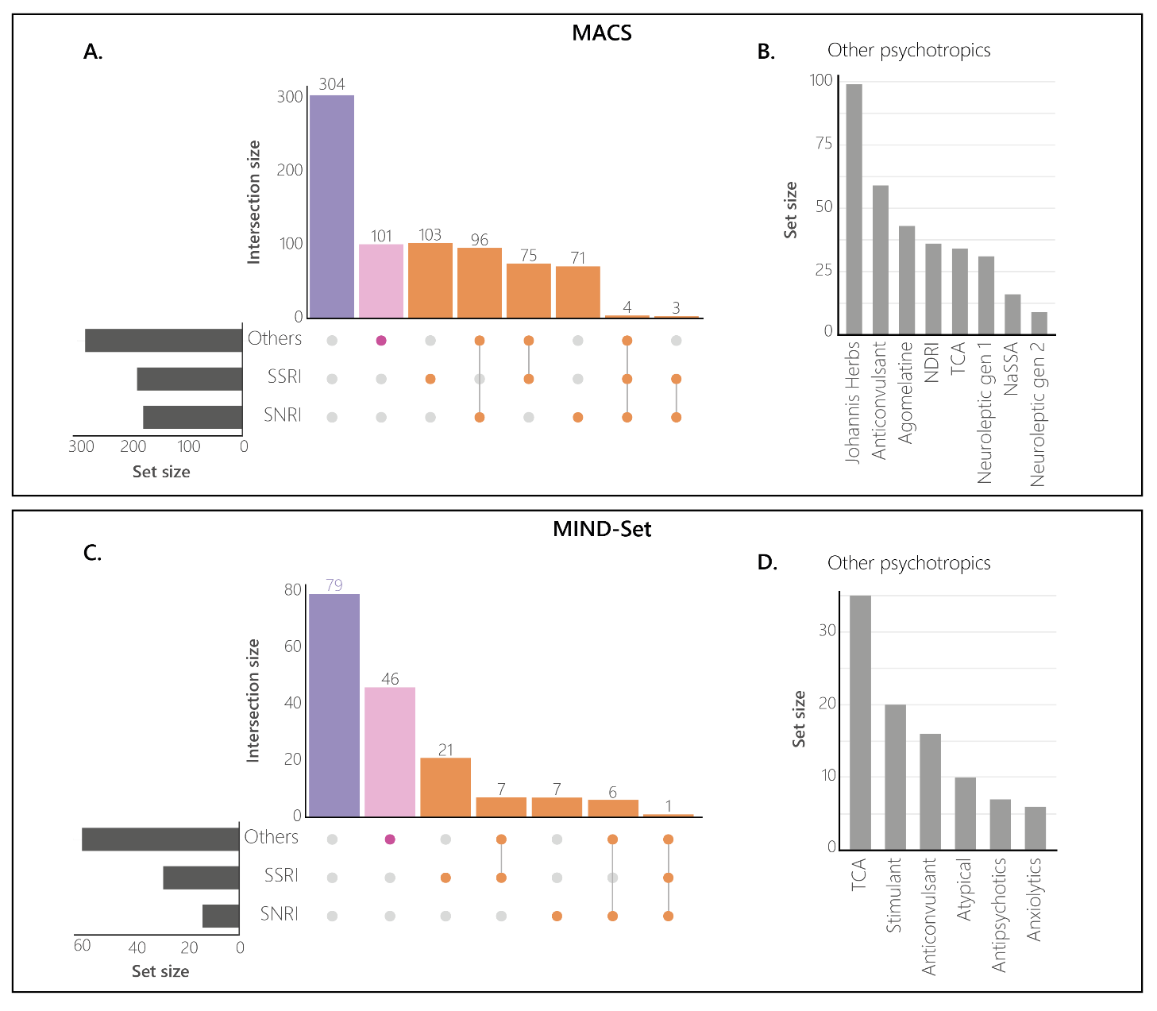
The distribution of medication use in the MACS (A) and MIND-Set (C) cohort together with corresponding groups: unmedicated in purple, SSRI/SRNRI (+/- other psychotropics) in orange and other psychotropics only in pink. The horizontal bars show the number of participants using each corresponding medication. The dots represent the combination of different types of medications. The vertical bars show the number of participants treated with this combination of medications. Panel (B) and (D) show the different medications non-SSRI/SNRI psychotropic medications for MACS and MIND-Set, respectively.

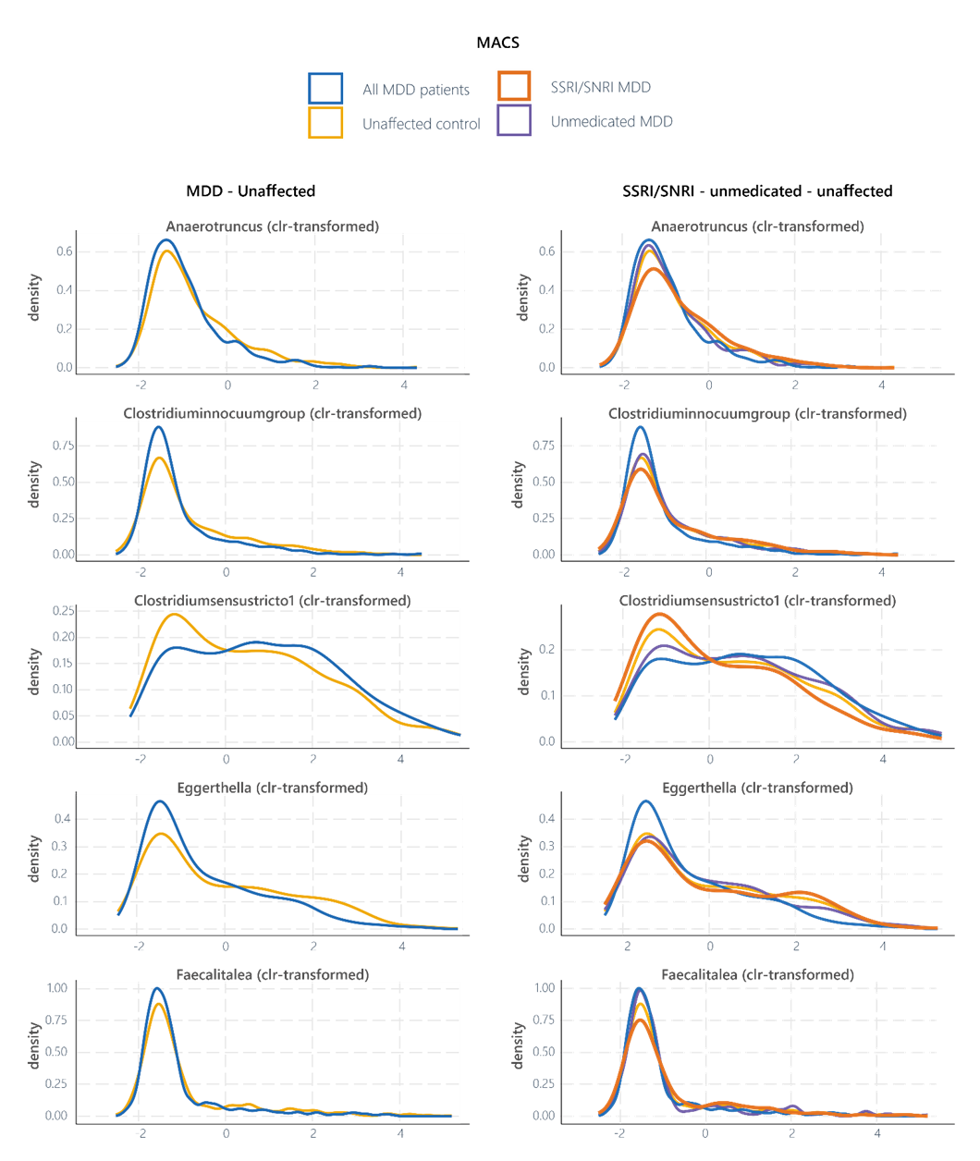
eFigure 4. Abundance distribution MDD-associated genera in the MACS cohort

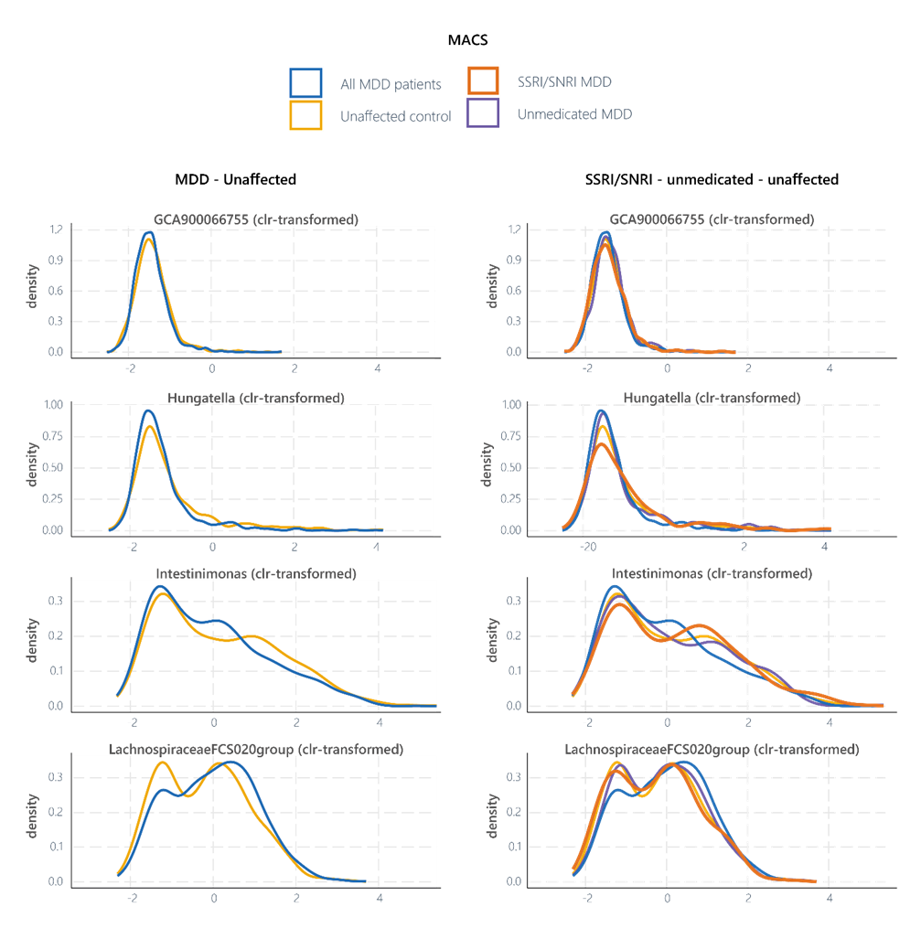

Density plots of centered log-ratio-transformed abundance of the nine MDD-associated bacterial genera for the unaffected controls (yellow), MDD (blue), SSRI/SNRI-treated MDD (orange) and unmedicated MDD (purple) groups in the MACS cohort

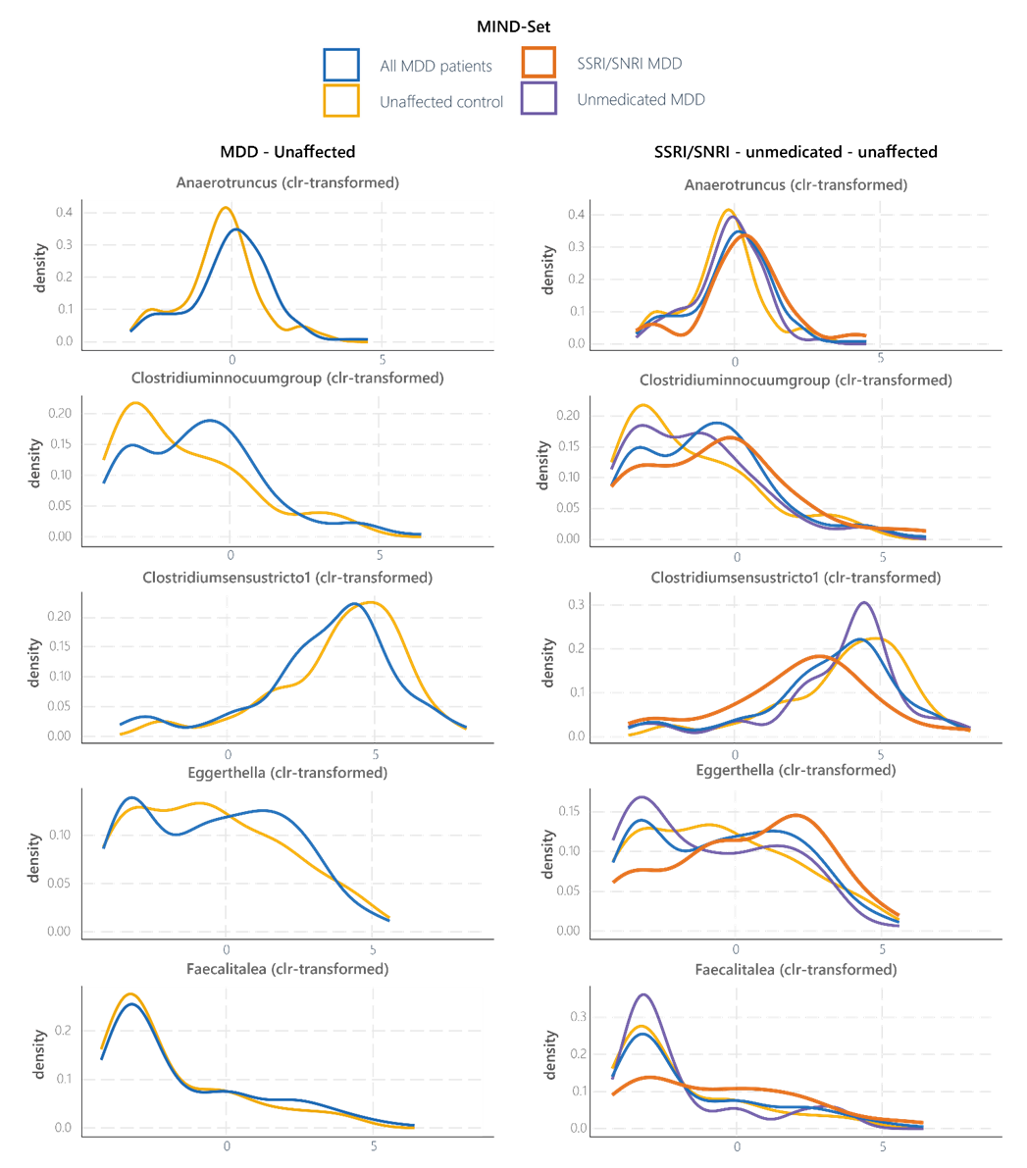
eFigure 5. Abundance distribution of MDD-associated genera in the MIND-Set cohort
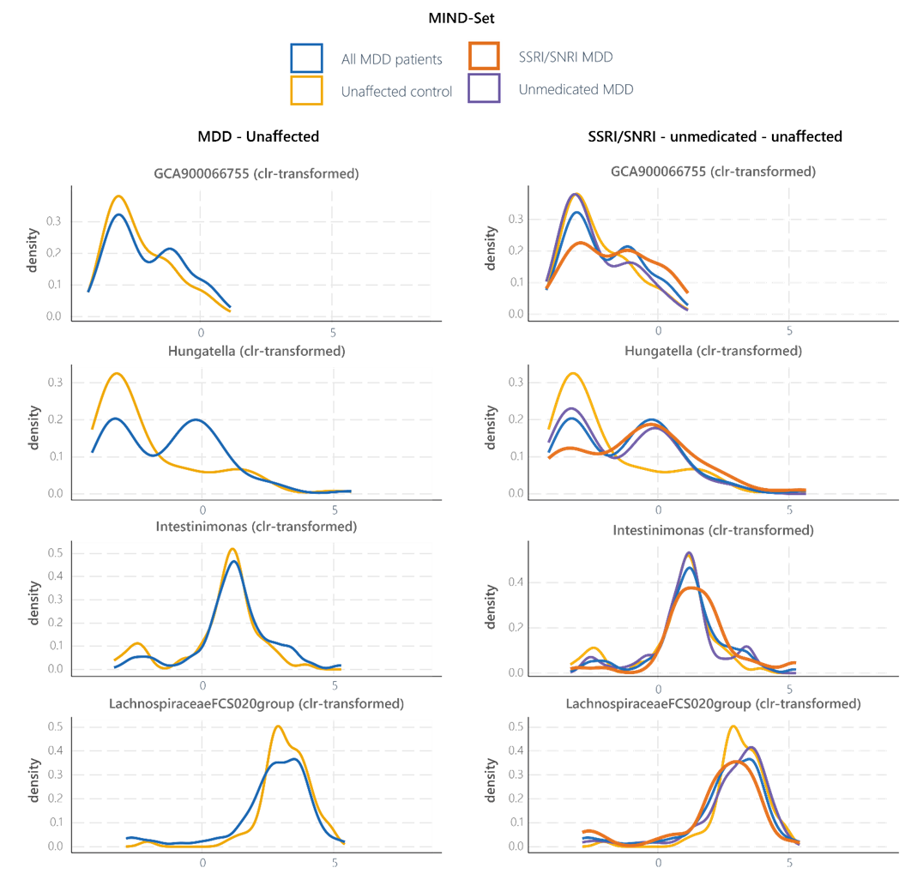

Density plots of centered log-ratio-transformed abundance of the nine MDD-associated bacterial genera for the unaffected (yellow), MDD (blue), SSRI/SNRI-treated MDD (orange) and unmedicated MDD (purple) groups in the MIND-Set cohort

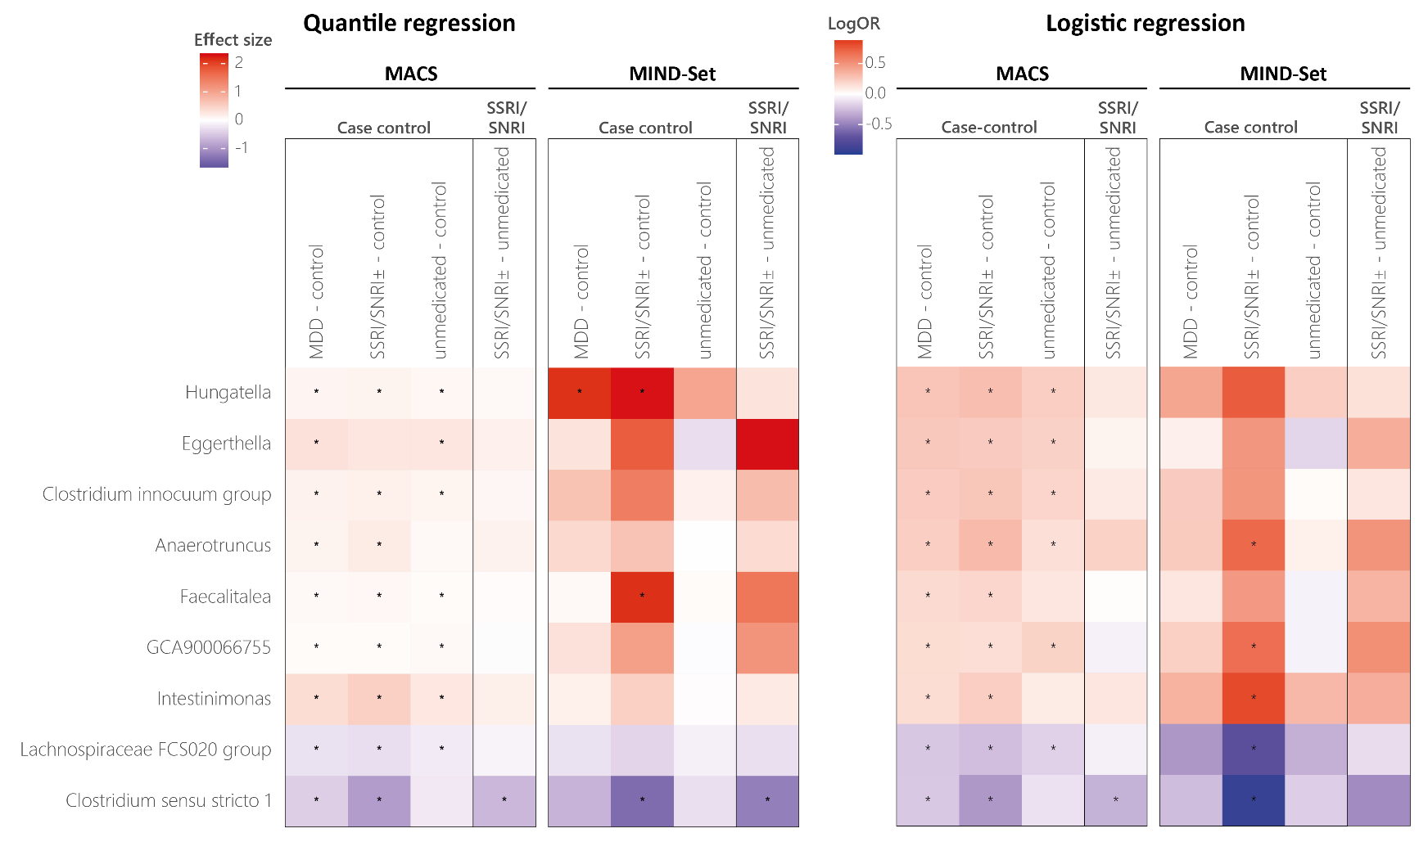
eFigure 6. Associations between genus abundance and MDD and SSRI/SNRI treatment

Heatmaps showing the beta coefficients (quantile regression, left) or logOR (logistic regression, right) of the group differences between the MDD (all, SSRI/SNRI, unmedicated) and unaffected control groups, and of the group differences between the SSRI/SNRI-treated and the unmedicated MDD groups. Higher beta coefficients/logOR (red) indicates a higher abundance in the first group of each comparison (i.e, the MDD groups in the case-control and the SSRI/SNRI group in the medication comparison).

References
1. Iovoli, F. et al. Exploring the complex interrelation between depressive symptoms, risk, and protective factors: A comprehensive network approach. J. Affect. Disord. 355, 12–21 (2024).
2. Vogelbacher, C. et al. The Marburg-Münster Affective Disorders Cohort Study (MACS): A quality assurance protocol for MR neuroimaging data. NeuroImage 172, 450–460 (2018).
3. van Eijndhoven, P. et al. Measuring Integrated Novel Dimensions in Neurodevelopmental and Stress-Related Mental Disorders (MIND-SET): Protocol for a Cross-sectional Comorbidity Study From a Research Domain Criteria Perspective. JMIRx Med 3, e31269 (2022).
4. Fehse, L. et al. From Gut to Brain: Evidence for a Causal Contribution of Gut-Microbiota to Major Depressive Disorder in Humans. Preprint at https://doi.org/10.1101/2024.12.05.24318549 (2024).
5. Mulder, D. et al. Gut microbiota composition links to variation in functional domains across psychiatric disorders. Brain. Behav. Immun. 120, 275–287 (2024).
6. Welzel, M. et al. Natrix: a Snakemake-based workflow for processing, clustering, and taxonomically assigning amplicon sequencing reads. BMC Bioinformatics 21, 526 (2020).
7. Quast, C. et al. The SILVA ribosomal RNA gene database project: improved data processing and web-based tools. Nucleic Acids Res. 41, D590–D596 (2012).
8. Bolyen, E. et al. Reproducible, interactive, scalable and extensible microbiome data science using QIIME 2. Nat. Biotechnol. 37, 852–857 (2019).
9. Callahan, B. J. et al. DADA2: High-resolution sample inference from Illumina amplicon data. Nat. Methods 13, 581–583 (2016).
10. Smarr, K. L. & Keefer, A. L. Measures of depression and depressive symptoms: Beck Depression Inventory‐II (BDI‐II), Center for Epidemiologic Studies Depression Scale (CES‐D), Geriatric Depression Scale (GDS), Hospital Anxiety and Depression Scale (HADS), and Patient Health Questionnaire‐9 (PHQ‐9). Arthritis Care Res. 63, (2011).
11. Van Eeden, W. A., Van Hemert, A. M., Carlier, I. V. E., Penninx, B. W. & Giltay, E. J. Severity, course trajectory, and within‐person variability of individual symptoms in patients with major depressive disorder. Acta Psychiatr. Scand. 139, 194–205 (2019).
12. Williams, J. B. W. A Structured Interview Guide for the Hamilton Depression Rating Scale. Arch. Gen. Psychiatry 45, 742 (1988).
13. Nöthlings, U., Hoffmann, K., Bergmann, M. M. & Boeing, H. Fitting Portion Sizes in a Self-Administered Food Frequency Questionnaire ,. J. Nutr. 137, 2781–2786 (2007).
14. Edwin Thanarajah, S. et al. Soft Drink Consumption and Depression Mediated by Gut Microbiome Alterations. JAMA Psychiatry 82, 1095 (2025).

