Genome-wide discovery, characterization, and validation of novel SSR markers in clove (Syzygium aromaticum) and their application in genetic analysis
Muhammed Azharudheen T.P.^{*+}, Muhammed Nissar V.A. ⁺, Anees K., Lijo Thomas, Rabisha V.P., Jayarajan K. and T.E. Sheeja
(ICAR-Indian Institute of Spices Research, Kozhikode, Kerala-673012, India)

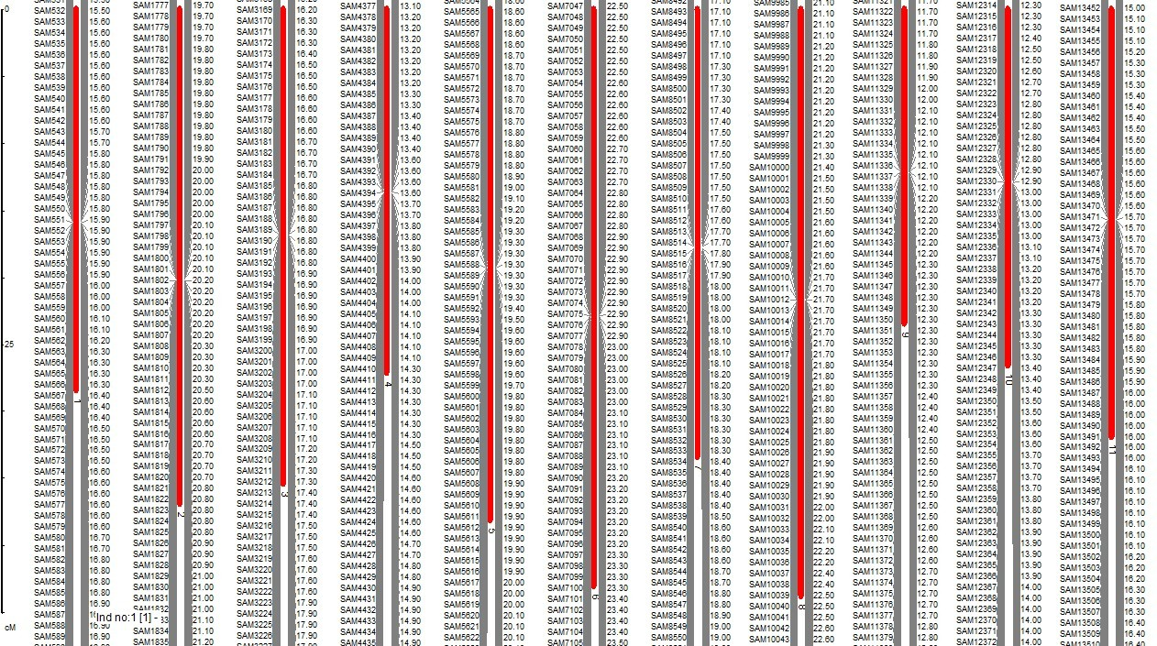
Supplementary Figure S1. A high density map of the genome-wide Class I and Class II SSR markers showing their physical positions on eleven chromosomes of clove.

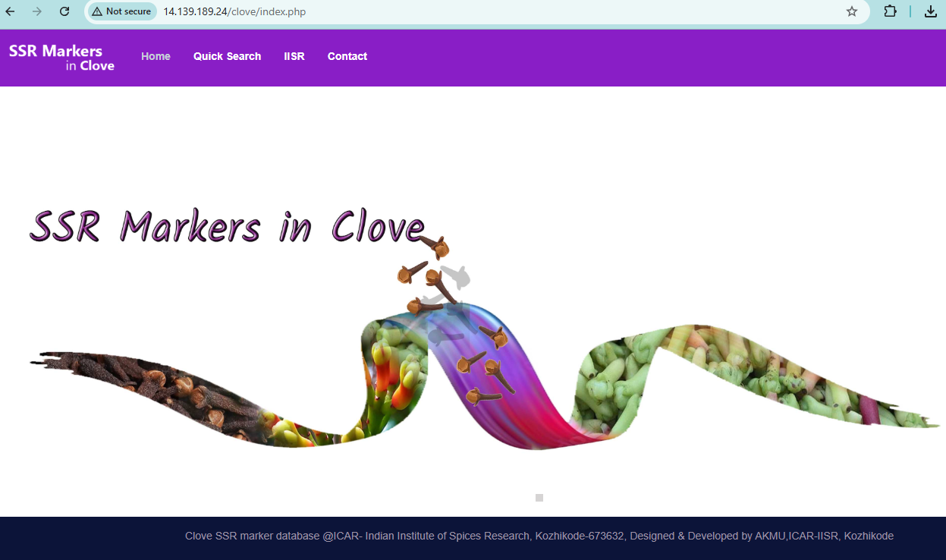
Supplementary Figure S2. The webpage of the SSR marker database developed in clove (http://14.139.189.24/clove/genes.php)

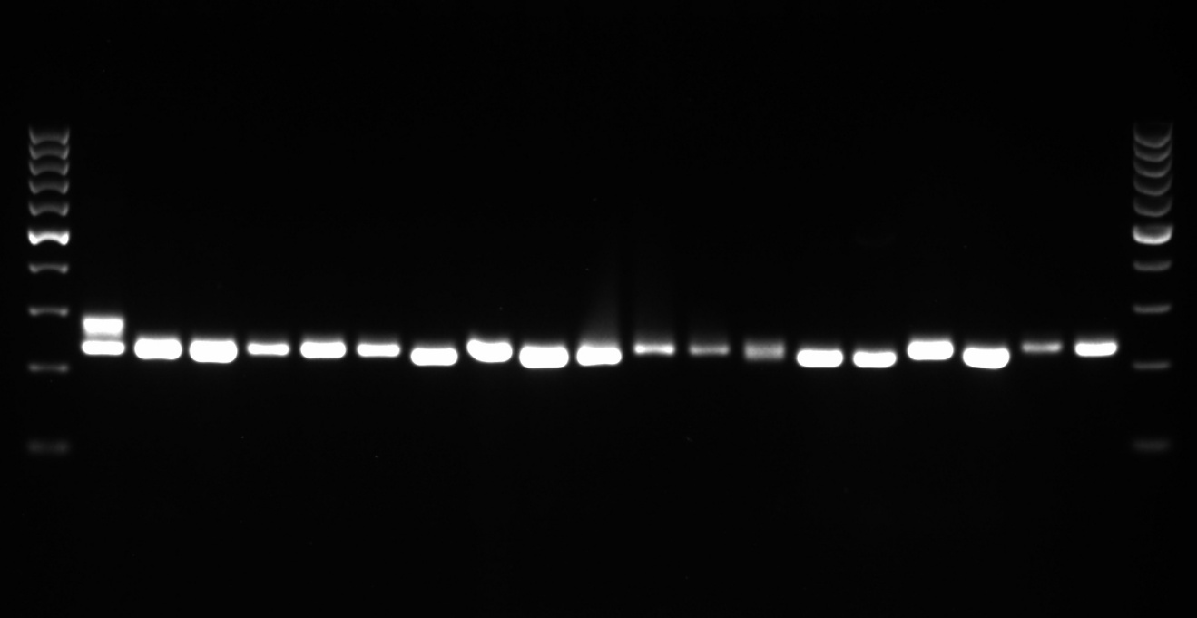
Supplementary Fig. S3. The Uncropped full length gel image of Fig. 4.

SaM 6173

SaM 3999
Supplementary Fig. S4. The Uncropped full length gel image of Fig. 7. The cropped area for each marker is indicated with an orange box.

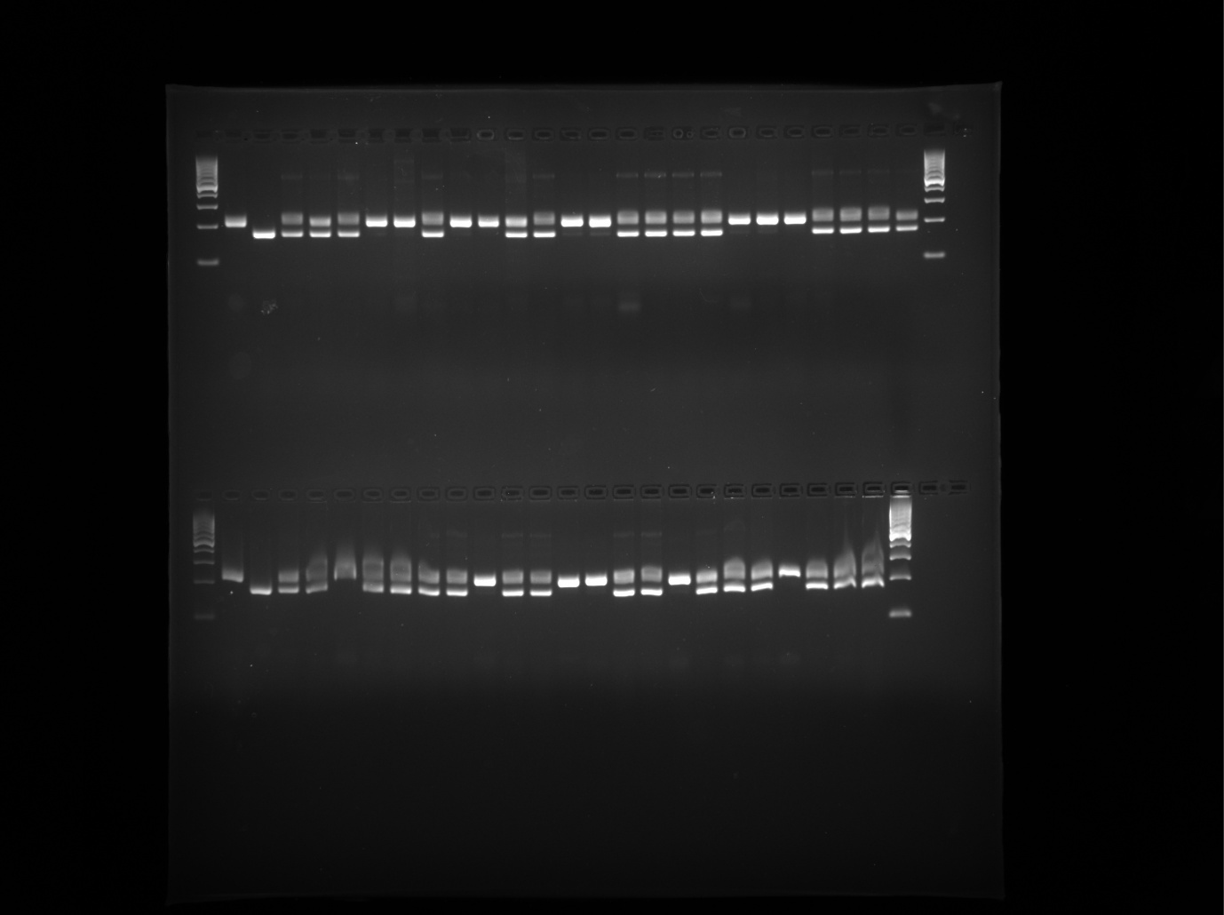
Supplementary Fig. S5. The Uncropped full length gel image of Fig. 8.

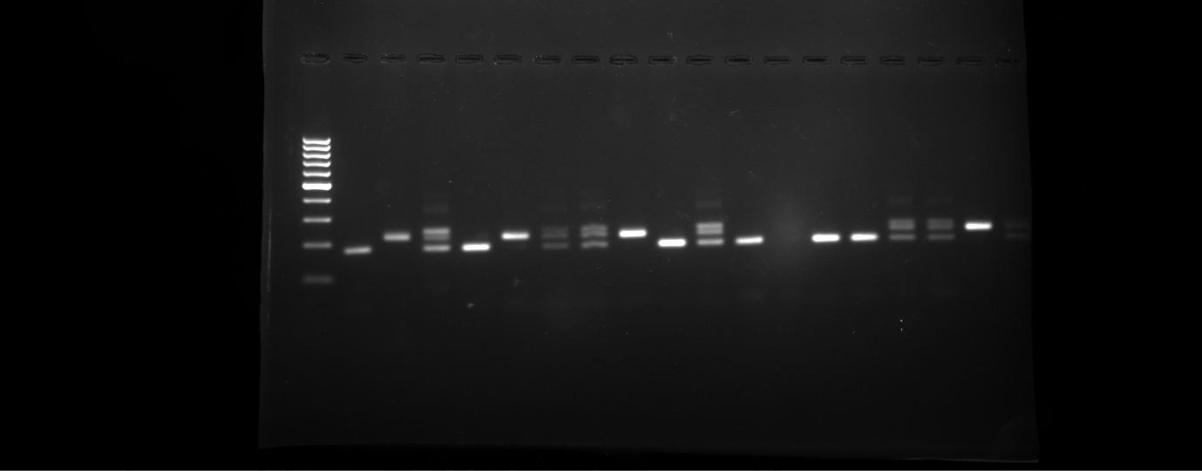
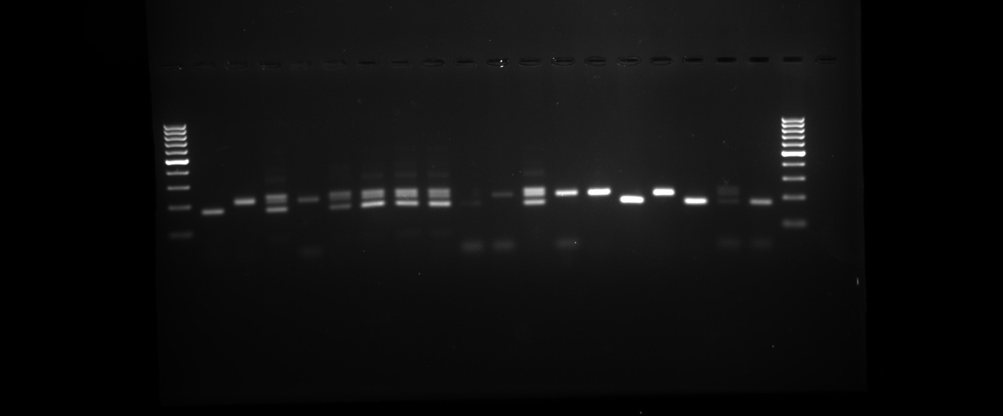

Supplementary Fig. S6. The Uncropped full length gel image of Fig. 9.

