Supplementary figures
amiR414e-mediated silencing of overlapping C1/C4 genes confers resistance to Cotton leaf curl Multan virus in Gossypium hirsutum cv. HS6
Molecular Biology Reports (Plant Molecular Biology)
Masnad Khan, Jawaid A. Khan*
Plant Virus Laboratory, Department of Biosciences, Jamia Millia Islamia, New Delhi-110025, India
*Corresponding author: jkhan1@jmi.ac.in

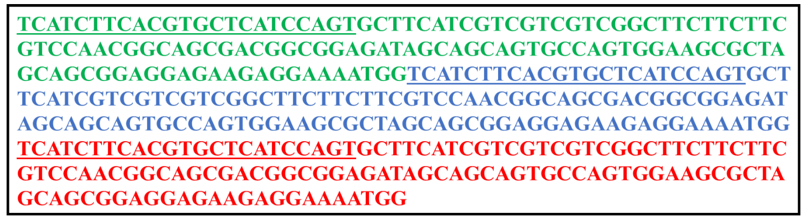
Supplementary Fig. S1 The nucleotide sequence of cotton-encoded pre-miR414e containing the amiR414e sequence is shown. Three tandem repeats of the pre-amiR414e sequence are highlighted in green, blue, and red, while the underlined sequences represent the designed amiR414e sequence.

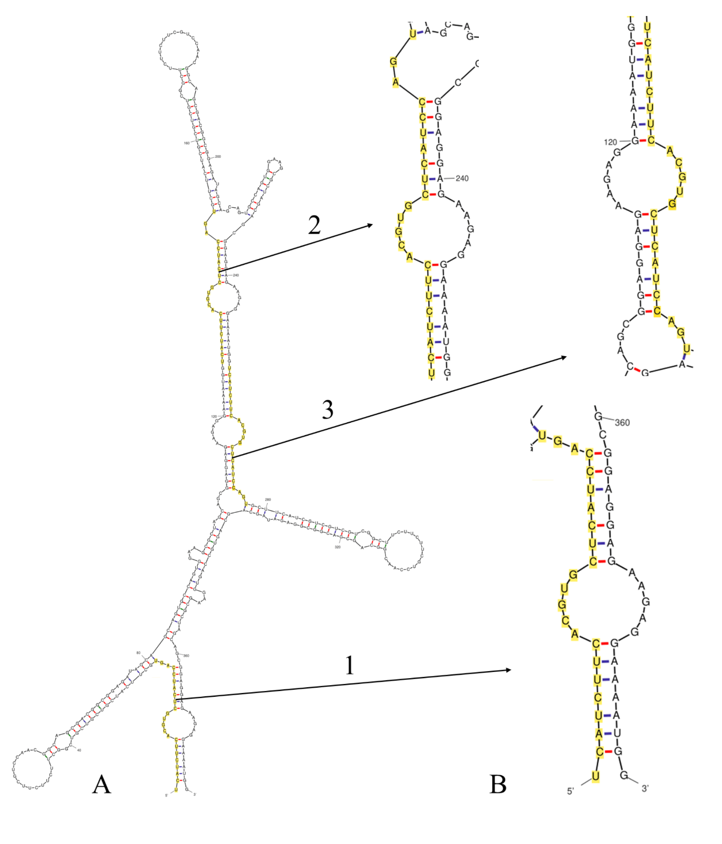
Supplementary Fig. S2 Predicted secondary structure of (A) pre-amiR414e sequence arranged in three tandem repeats, and (B) enlarged view of designed amiR414e sequence highlighted with yellow colour (5’- Repeat 1, 2 and 3 -3’).

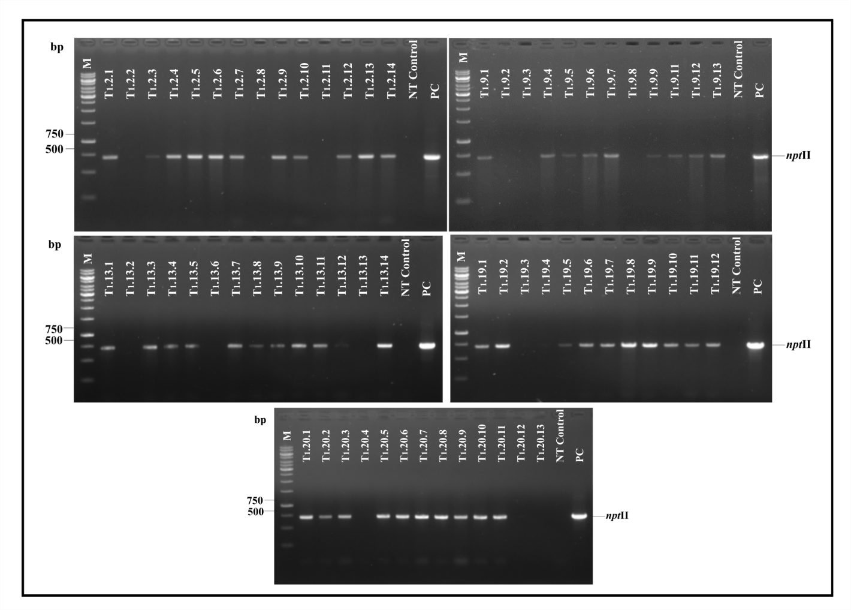
Supplementary Fig. S3 PCR-based amplification of transgene (nptII) in T₁ progeny plants of Gossypium hirsutum cv. HS6 plants. M denotes 1 kb DNA marker, NT control= non-transgenic control plant, PC= Positive control (pBI121 plasmid DNA) and bp= base pair.

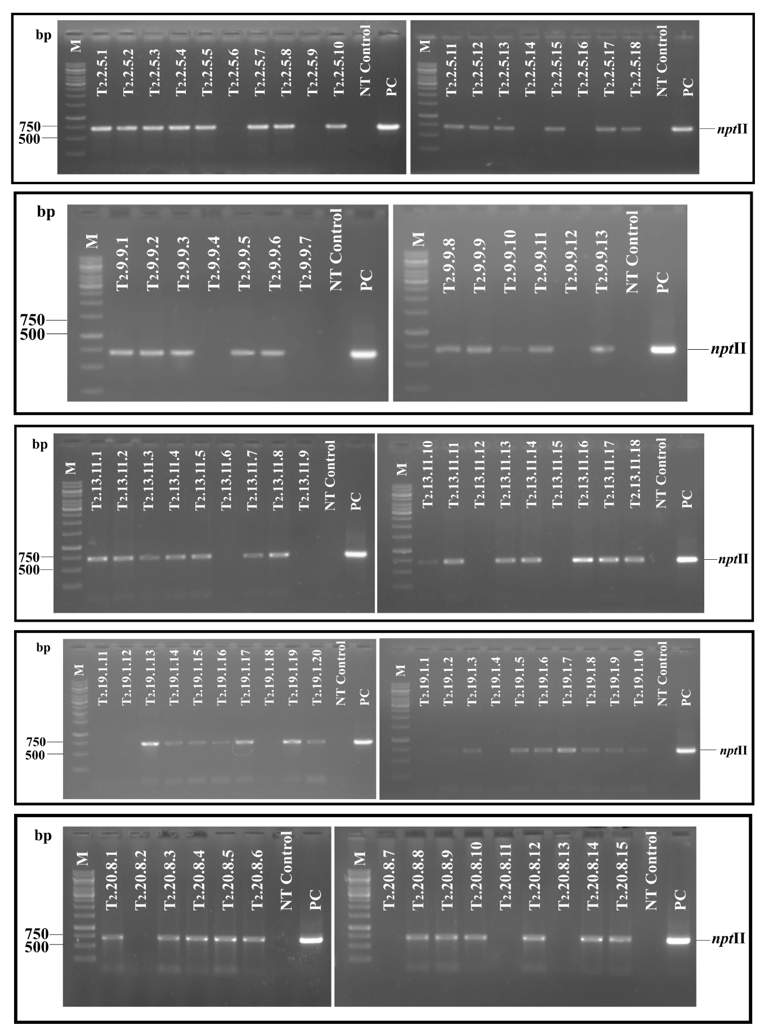
Supplementary Fig. S4 PCR-based amplification of transgene (nptII) in T₂ progeny plants of Gossypium hirsutum cv. HS6 plants. M denotes 1 kb DNA marker, NT control= non-transgenic control plant, PC= Positive control (pBI121 plasmid DNA) and bp= base pair.
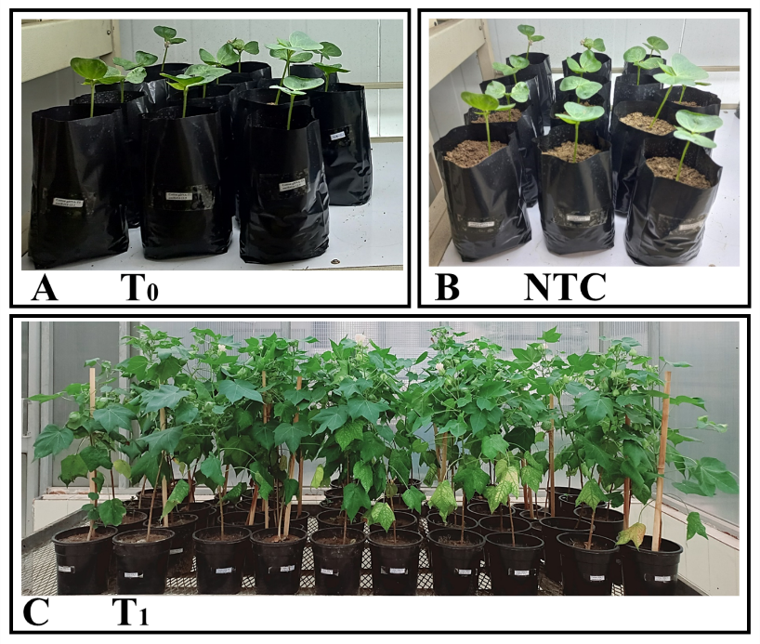
Supplementary Fig. S5 Transgenic T₁ Progeny plants of Gossypium hirsutum cv. HS6. Germinated seeds of (A) Transgenic T₀ lines, (B) Non-transgenic control plants, and (C) T1 progeny plants at their reproductive stage.

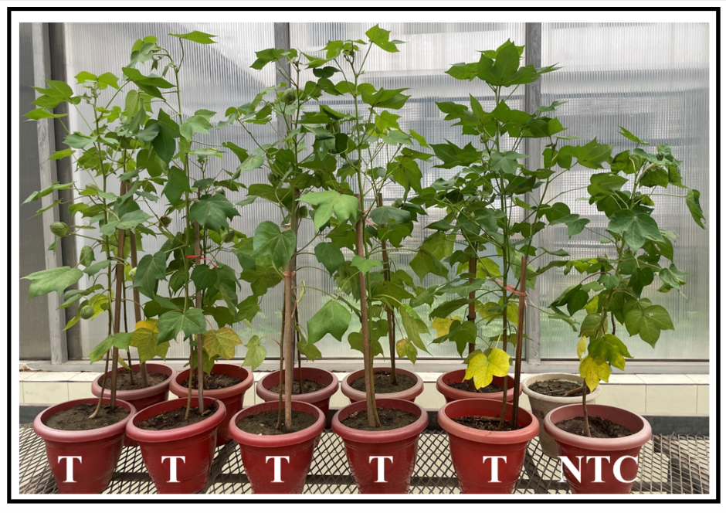
Supplementary Fig. S6 T₂ Progeny plants of Gossypium hirsutum cv. HS6 at their reproductive stage. T= Transgenic plants and NTC= non-transformed control plants.

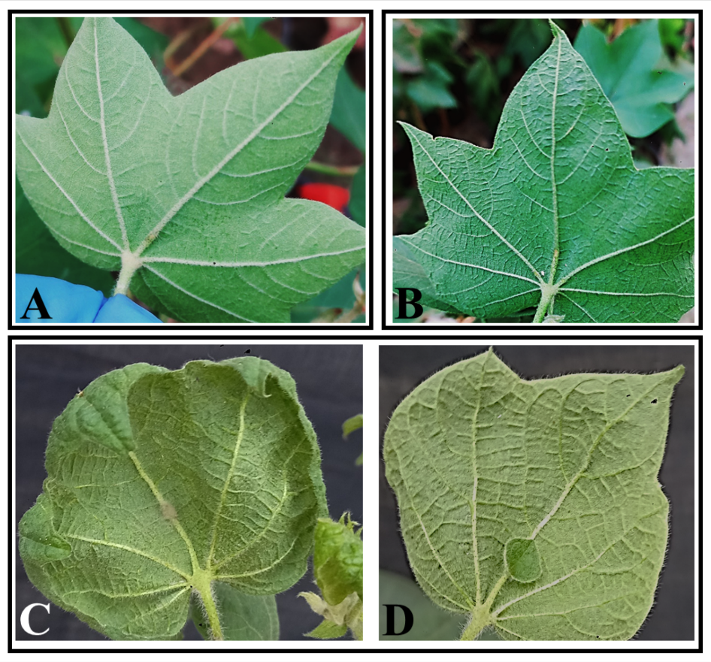
Supplementary Fig. S7 Appearance of cotton leaf curl disease (CLCuD) symptoms in transgenic (T₁) and NT control plants. (A) No CLCuD symptoms were observed on the leaves of the majority of transgenic T₁ plants. (B) Mild CLCuD symptoms, including vein thickening, were observed in a few transgenic plants, and (C-D) non-transgenic (NT) control plants developed severe CLCuD symptoms, including vein thickening, leaf curling, and enation, at 60 days post-inoculation.

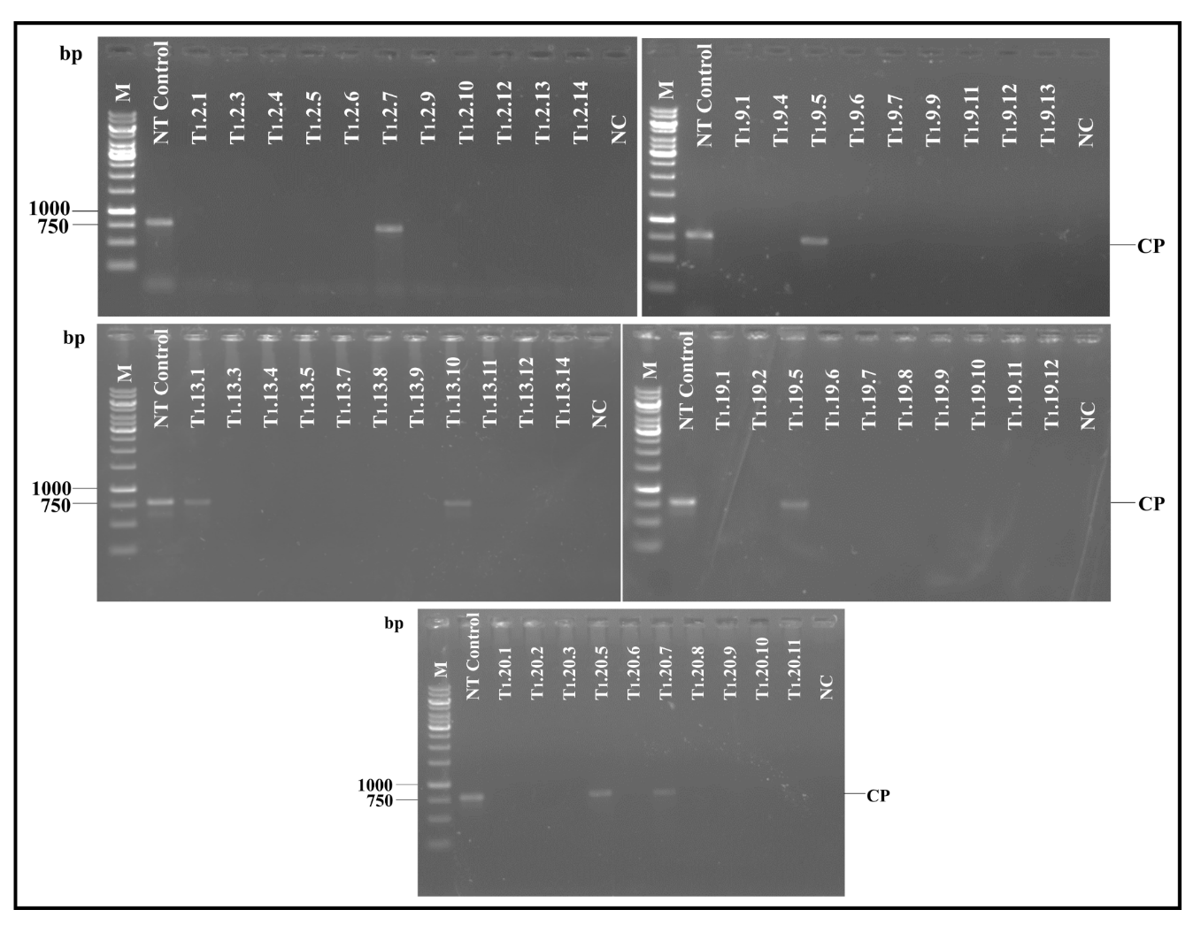
Supplementary Fig. S8 Detection of Cotton leaf curl Multan virus coat protein (CP) gene in transgenic T₁ plants of Gossypium hirsutum cv. HS6 using PCR. M is 1 kb DNA marker, NT control= non-transgenic control, and NC is Negative control (uninoculated plant genomic DNA used as template).

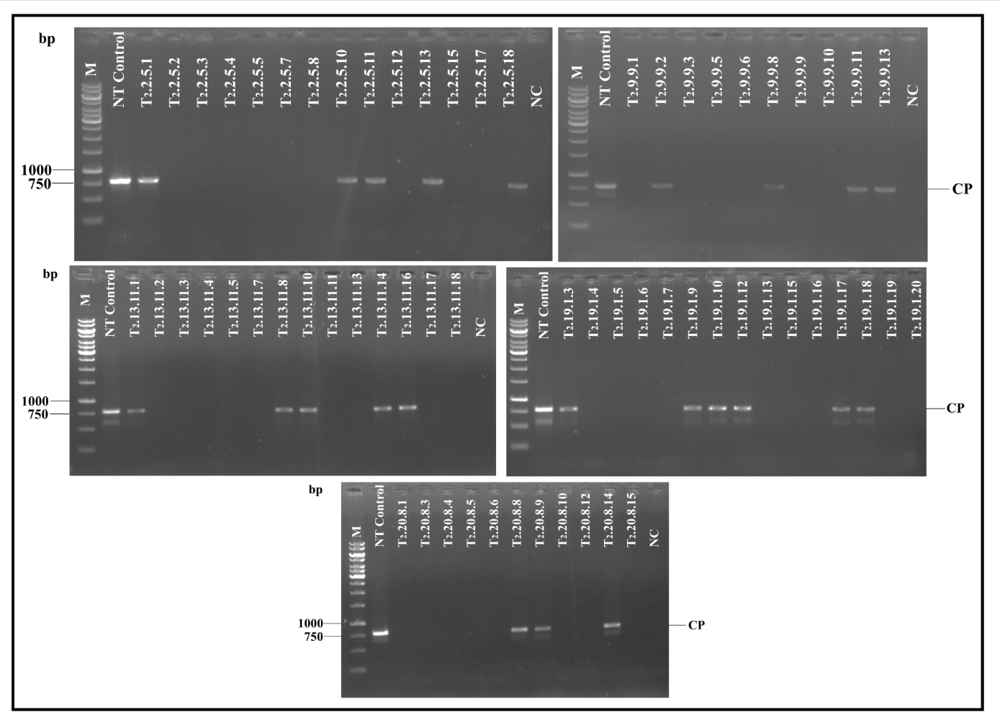
Supplementary Fig. S9 Detection of Cotton leaf curl Multan virus coat protein (CP) gene in transgenic T₂ plants of Gossypium hirsutum cv. HS6 using PCR. M is 1 kb DNA marker, NT control= non-transgenic control, and NC is Negative control (uninoculated plant genomic DNA used as template).

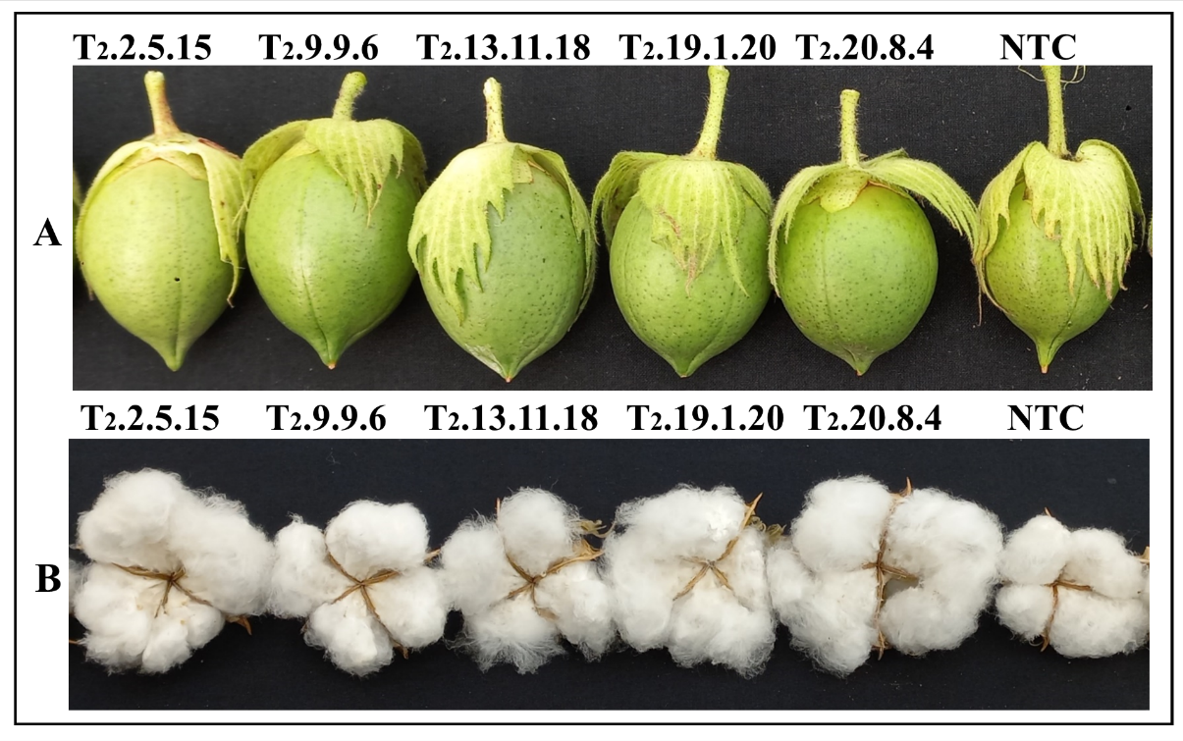
Supplementary Fig. S10 Phenotypic observations of (A) flower buds and (B) mature bolls were conducted on transgenic T₂ lines and non-transformed control (NTC) plants of Gossypium hirsutum cv. HS6.

