Extended Data Figures
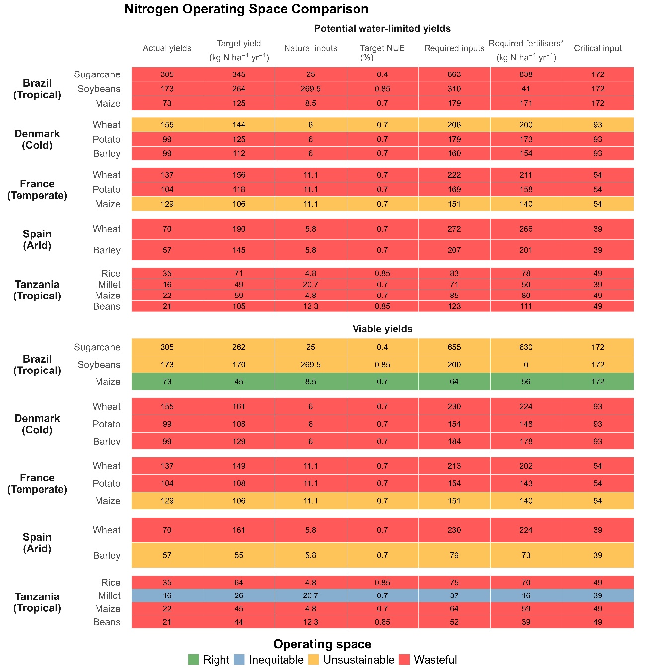
Extended Data Figure 1. Comparing N operating spaces based on potential and viable yield thresholds across representative crop-climate systems. Nitrogen input-yield configurations for selected national systems are shown relative to both water-limited potential yields (top panel) and the viable threshold (bottom panel). Each cell represents a crop-climate-country combination classified by operating space. Required fertilisers (*) correspond to both manure and synthetic fertiliser inputs.

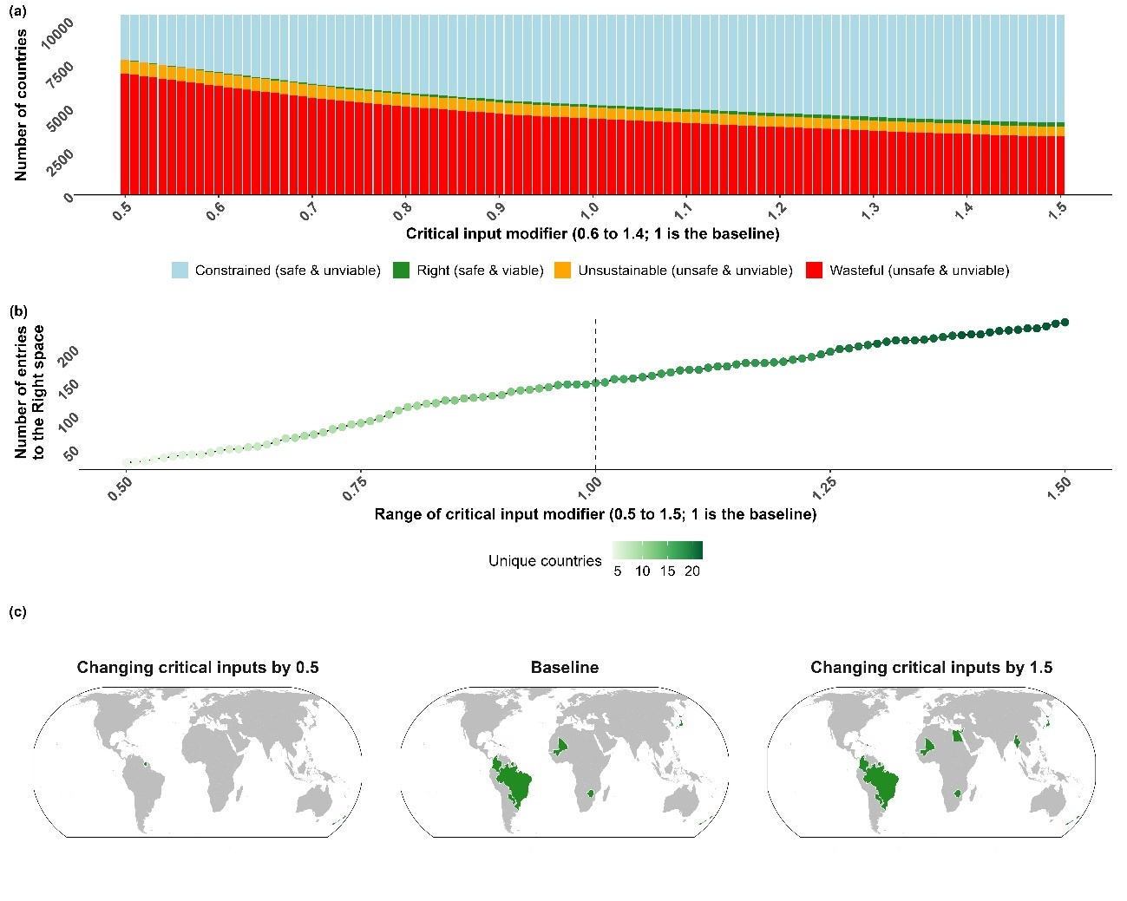
Extended Data Figure 2. Perturbations of the safe threshold. (a) Distribution of countries across the four operating spaces as the critical input is modified by ±50 %. (b) Number of unique country-year entries into the Right space across the range of modifiers, and (c) spatial examples for low (0.5x), baseline (1x), and high (1.5x) thresholds. While increasing critical inputs expands the Right space slightly, fewer than 5% of all country-years enter it even under generous assumptions.
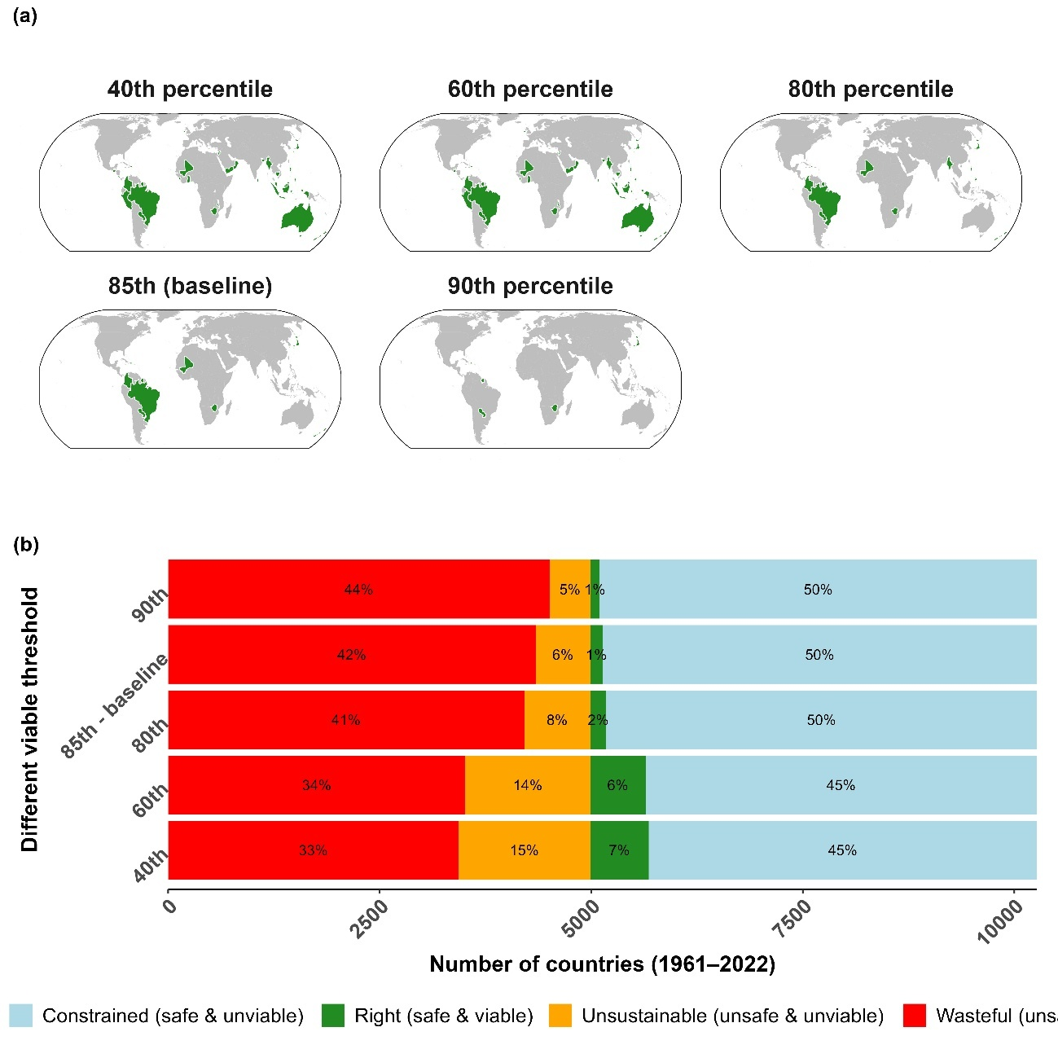
Extended Data Figure 3. Perturbation to the viable threshold. (a) Countries classified within the Right (safe & viable) space when viable N use is defined at different yield percentiles (40th-90th). (b) Global share of country-year combinations across the four operating spaces for each percentile definition. Results show that while the number of countries reaching the Right space changes slightly with percentile choice, the overall dominance of wasteful (unsafe & unviable) and constrained (safe & unviable) conditions remains consistent.

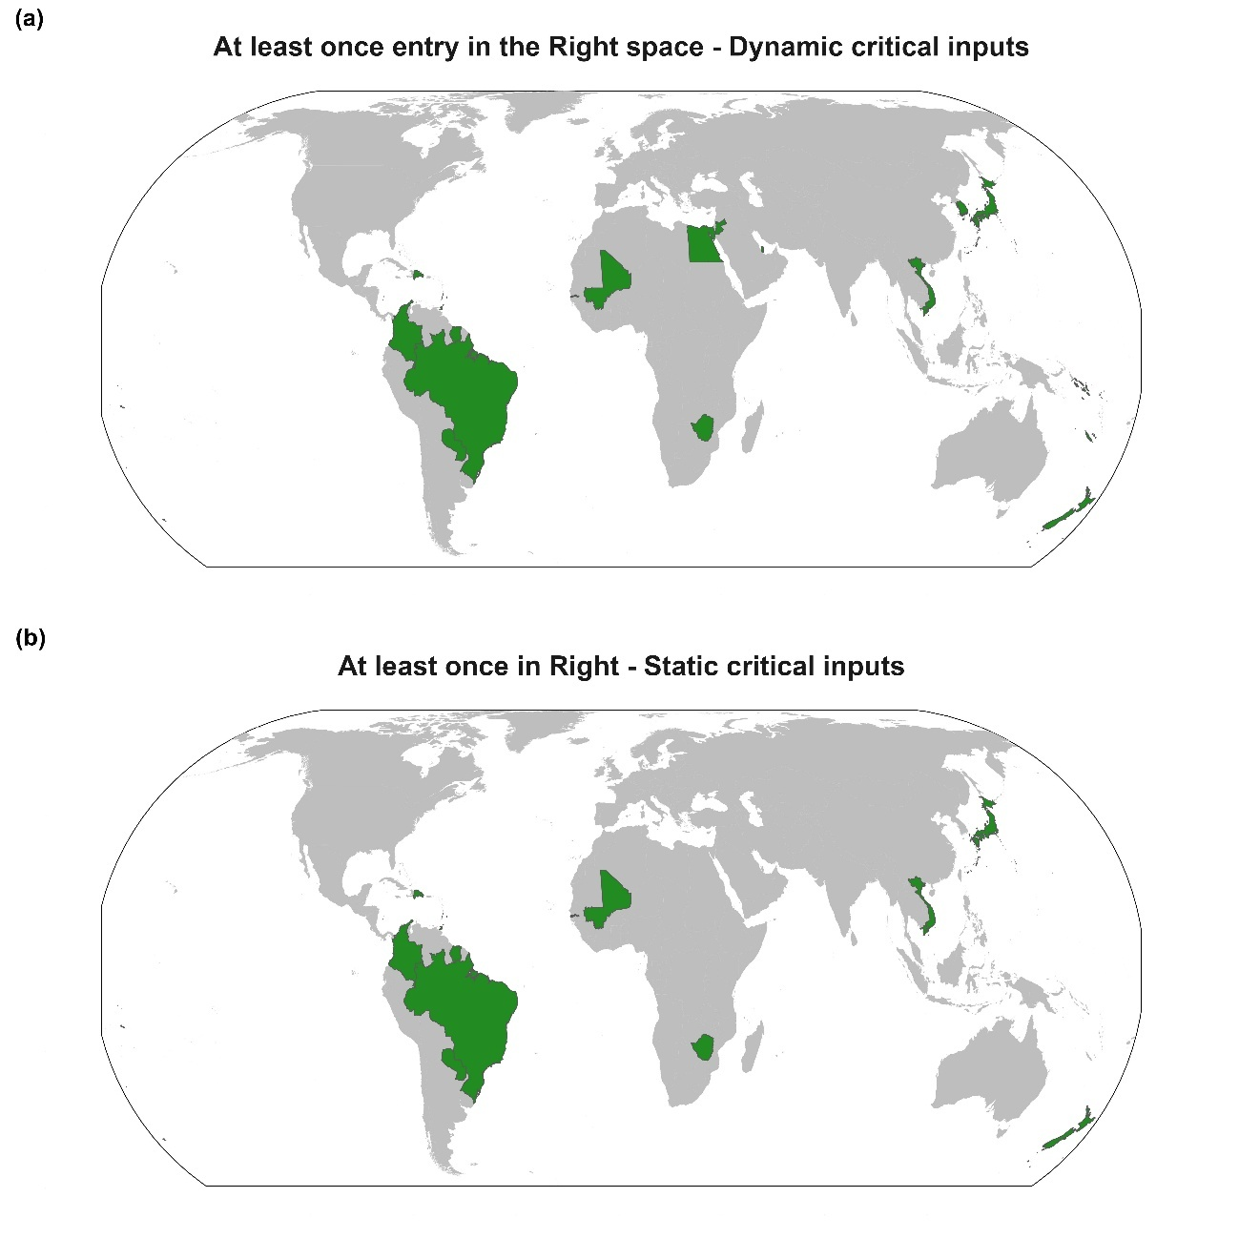
Extended Data Figure 4. Spatial variation, and differences, between using dynamic (a) and static (b) critical N inputs in classifying operating spaces for the period 1961-2022.
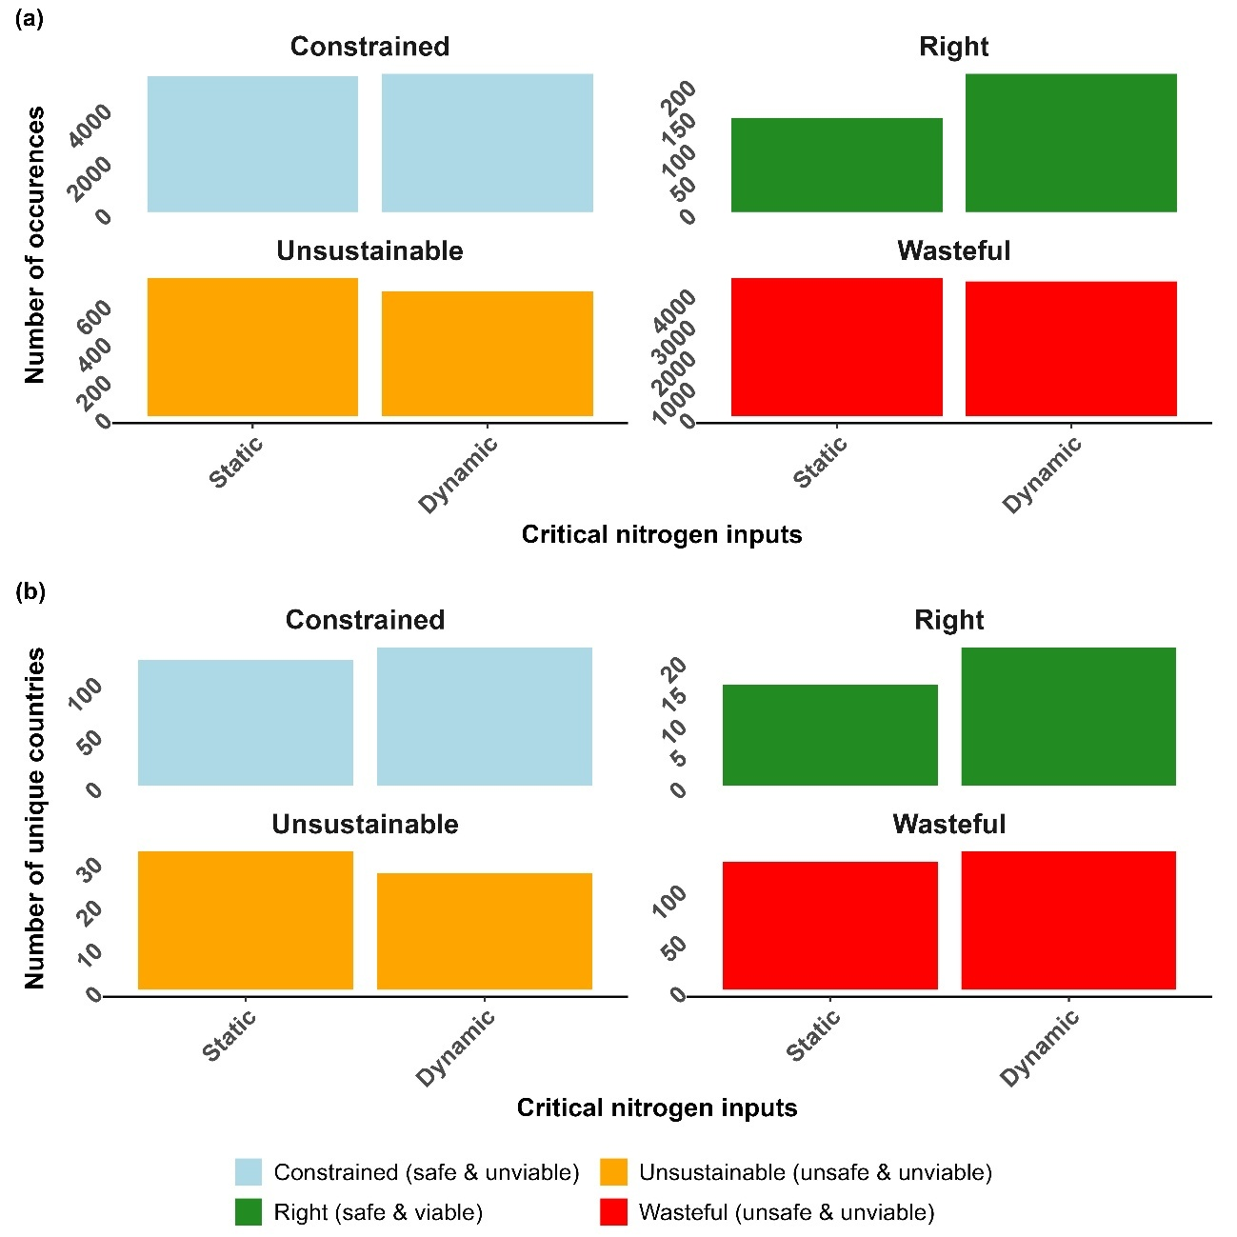
Extended Data Figure 5. Comparison of the number of total occurrences (a) and unique occurrences (b) in all four operating spaces between static and dynamic critical N inputs.

