Cropland is trapped outside a safe and agronomically viable nitrogen use
J Serra^{1,2,3}; M Quemada⁴; L Lassaletta⁴; GH Ros⁵; W De Vries⁵; C Treat²; J Rahimi^{2,6}; F Giannini-Kurina¹; M Graversgaard¹; Hans J.M. van Grinsven⁷; A Sanz-Cobeña⁴; MO Aderele²; T Dalgaard^{1,2}; K Butterbach-Bahl^{2,6}
¹ Department of Agroecology, Aarhus University, Blichers Allé 20, 8830, Tjele, Denmark
² Pioneer Center Land-CRAFT, Department of Agroecology, Aarhus University, Aarhus, Denmark
³ Forest Research Centre, Associate Laboratory TERRA, School of Agriculture, University of Lisbon, 1349-017, Lisbon, Portugal
⁴ CEIGRAM/ETSIAAB, Universidad Politécnica de Madrid, 28040, Madrid, Spain
⁵ Earth Systems and Global Change, Wageningen University and Research, Wageningen, the Netherlands
⁶ Institute of Meteorology and Climate Research, Atmospheric Environmental Research (IMK-IFU), Karlsruhe Institute of Technology (KIT), Garmisch-Partenkirchen, Germany
⁷ PBL Netherlands Environmental Assessment Agency, PO BOX 30314, 2500 GH, The Hague, the Netherlands

Supplementary Material

Supplementary methods

Viable N use
Here we define a viable N use in croplands (N_{up,floor}). This value represents the nitrogen yield required for cropland systems to contribute meaningfully to food production while remaining within biophysical boundaries. Unlike agronomic yield-gaps that compare actual to potential yields under optimal management, our threshold is empirically grounded: it is derived from the lower bound of nitrogen yields already achieved in comparable crop-climate systems. As such, it does not represent an aspirational target but an observed baseline of sufficiency below which systems are unlikely to meet food security needs, even if environmental boundaries are respected.
We estimated N_{up,floor} using the following steps:
- Crop-specific nitrogen yields. For each FAOSTAT crop category (n= 158 crops), nitrogen yields were derived from harvested yields multiplied by crop-specific nitrogen contents¹.
- Weighting by national crop composition and climate shares. For each country-year, harvested area shares of different crops (f_{crop}​) and the fractional distribution of cropland across Köppen-Geiger² climate zones (f_{climate}​). We aggregated each climate zone in functional groups (tropical, temperate, cold and arid). We combined f_{crop} and f_{climate} to generate weighted nitrogen yields:
$$N_{yield,weighted}=\sum{(N_{yield,crop}{∙f}_{crop}∙f_{climate})}$$
- Defining attainable distributions. For each crop-climate functional group (e.g., wheat in temperate zones, maize in arid zones), we constructed distributions of observed nitrogen yields across all countries and years (1961–2022). We then calculated the attainable range using the 85th percentile (80-90th), which captures yields regularly achieved without biasing towards extreme outliers. We calculated 5-year rolling windows to minimize annual variability.
- Aggregating to national productivity floors. For each country-year, the minimum achievable uptake floor was derived as the weighted aggregation of these crop-climate attainable quantiles.
- Integration with safe operating space framework. N_{up,floor} was applied as a dynamic constraint in the safe operating space: countries with nitrogen yields below N_{up,floor} were considered to operate in the “safe but unviable” zone, whereas those in exceedance entered the ideal safe operating space, provided they also respected environmental constraints.

Definition of crop categories
We grouped FAOSTAT crop items into 18 functional categories:
Rice – Rice.
Wheat – Wheat.
Maize – Maize (corn); Green maize.
Other cereals – Barley; Oats; Rye; Millet; Sorghum; Buckwheat; Quinoa; Fonio; Canary seed; Mixed grain; Triticale; Cereals n.e.c.
Soybeans – Soya beans.
Pulses – Beans, dry; Broad beans and horse beans, dry; Peas, dry; Chickpeas, dry; Cowpeas, dry; Pigeon peas, dry; Lentils, dry; Bambara beans, dry; Vetches; Lupins; Other pulses n.e.c.
Other oilcrops – Groundnuts; Sunflower seed; Rapeseed; Safflower seed; Sesame seed; Mustard seed; Poppy seed; Melonseed; Castor oil seed; Tung nuts; Jojoba seeds; Oil palm fruit; Coconuts, in shell; Linseed; Hempseed; Other oil seeds n.e.c.
Roots and tubers – Potatoes; Sweet potatoes; Cassava (roots and leaves); Yams; Taro; Yautia; Other starchy roots and tubers n.e.c.
Sugar crops – Sugarcane; Sugar beet; Other sugar crops n.e.c.
Vegetables – Tomatoes; Onions and shallots (dry and green); Cabbages; Lettuce and chicory; Spinach; Carrots and turnips; Okra; Pumpkins, squash and gourds; Cucumbers and gherkins; Eggplants; Chillies and peppers, green; Garlic; Leeks and other alliaceous vegetables; Beans and peas, green; Cauliflowers and broccoli; Artichokes; Asparagus; String beans; Other vegetables n.e.c.
Tropical fruits – Bananas; Plantains; Mangoes; Guavas; Mangosteens; Avocados; Pineapples; Dates; Papayas; Cashew apple; Other tropical fruits n.e.c.
Citrus fruits – Oranges; Mandarins and tangerines; Clementines; Lemons and limes; Pomelos and grapefruits; Other citrus fruits n.e.c.
Other fruits – Apples; Pears; Apricots; Cherries (sweet and sour); Peaches; Nectarines; Plums; Sloes; Strawberries; Raspberries; Gooseberries; Currants; Blueberries; Cranberries; Persimmons; Quinces; Figs; Kiwifruit; Melons (watermelons, cantaloupes and others); Locust beans (carobs); Other stone fruits; Other pome fruits; Other fruits n.e.c.
Grapes – Grapes.
Cotton – Seed cotton, unginned.
Olives – Olives.
Stimulants – Coffee, green; Cocoa beans; Tea leaves; Hop cones; Unmanufactured tobacco; Maté leaves.
Nuts – Cashew nuts; Almonds; Walnuts; Pistachios; Hazelnuts; Chestnuts; Sheanuts; Kola nuts; Areca nuts; Other nuts n.e.c.
Other crops – Fibre crops (flax; hemp; jute; kenaf; ramie; sisal; agave fibres; abaca; other fibres n.e.c.); Spices and condiments (pepper; dry chillies; vanilla; cinnamon; cloves; nutmeg; mace; cardamom; anise; badian; coriander; cumin; caraway; fennel; juniper berries; ginger; peppermint; spearmint; other spices n.e.c.); Specialty crops (natural rubber; chicory roots; kapok fruit; pyrethrum flowers; tallowtree seeds).

Benchmarking biophysical attainability of viable N use
Background inputs
Deposition for 2022 was collated from FAOSTAT, as well as non-symbiotic N fixation, which was set at 25 kg N ha⁻¹ yr⁻¹ for rice and sugarcane, respectively¹. Biological N fixation from soybeans in Brazil was sourced from ref³.
Converting yield potentials
We derived crop-specific water-limited yield potential⁴ (tonnes ha⁻¹ yr⁻¹). We then converted these into N yields by applying a N coefficient¹ and subsequently multiplied these by 80% to get the optimal point of the fertiliser-yield curve.

Multi-output random forests training for nitrogen inputs, yields and minimum achievable productivity
Overview
We developed a multi-output Random Forest (RF) model to jointly predict three key nitrogen cycle metrics: (1) nitrogen inputs, (2) nitrogen yields in cropland and (3) viable nitrogen yields. This multi-output approach captures correlations between targets and ensures physically consistent predictions across the nitrogen cascade.
Model architecture
Multi-Output Framework
Rather than training three independent models, we employed a multi-output regressor that simultaneously predicts all three targets:
f: X → (Input, Crop_Removal, N_att)
This joint prediction framework offers several advantages:
- Shared feature importance: Leverages common predictors (e.g., crop composition affects all three targets)
- Computational efficiency: Single model training instead of three separate models
- Consistent predictions: Ensures targets respond coherently to input changes
Random forest configuration
Base Estimator: Scikit-learn RandomForestRegressor wrapped in MultiOutputRegressor
Hyperparameters:
- Number of trees (n_estimators): 500
- Maximum depth: None (trees grown until pure leaves or min_samples_split reached)
- Minimum samples per split: 2
- Minimum samples per leaf: 1
- Maximum features per split: sqrt(n_features) ≈ 5 (out of 26 total features)
- Bootstrap sampling: True (with replacement)
- Random state: 123 (for reproducibility)
Why Random Forest?
- Handles non-linear relationships between crop composition and nitrogen metrics
- Robust to outliers and missing data
- Provides feature importance rankings
- No assumptions about data distribution
Input features
Crop Composition (19 features):
- Percentage of agricultural area for each crop type: wheat, maize, rice, other cereals, soybeans, other oilcrops, cotton, vegetables, other fruits, grapes, pulses, roots and tubers, nuts, sugar crops, citrus fruits, olives, other crops, stimulants, tropical fruits
Climate Zones (4 features):
- Fraction of country area in each Köppen-Geiger zone: Arid, Temperate, Cold, Tropical
Socioeconomic Indicators (2 features):
- GDP per capita (constant 2015 USD)
- Population (millions)
Temporal Feature (1 feature):
- Year (normalized)
Feature Preprocessing:
- All features standardized using StandardScaler (mean=0, std=1)
- Missing values filled with feature-wise median
- Crop percentages constrained to sum to 1.0
Target variables
Input (kg N ha⁻¹ yr⁻¹): Total nitrogen inputs applied per hectare of cropland
Crop_Removal (kg N ha⁻¹ yr⁻¹): Nitrogen yields per hectare of cropland
N_att (kg N ha⁻¹ yr⁻¹): Attainable productivity to obtain a viable production per hectare of cropland.
Training procedure
Data splitting
- Training set: 1961-2019 (n=8,271 country-year observations, 152 countries)
- Test set: 2020-2022 (n=464 observations, held-out for validation)
- Temporal split: Ensures model evaluated on future years, mimicking operational deployment
Synthetic data augmentation
To address severe class imbalance in operating space categories (baseline: 0.8% "Right", 5.4% "Unsustainable"), we tested synthetic minority oversampling:
Method: SMOTE-like interpolation between existing minority samples
- For each synthetic sample: randomly select two samples from target class, interpolate with α ~ U(0.3, 0.7), add 5% Gaussian noise
- Crop percentages normalized to sum to 1.0
Augmentation Scenarios Tested:
- No augmentation (baseline)
- Right only (5%, 10%)
- Unsustainable only (5%, 10%)
- Both classes (5%, 10%)
Results: Augmentation did not improve "Right" scenario predictions for future projections (0% across all models), but "Unsustainable" augmentation reduced "Wasteful" predictions by 15.8%. We report baseline (no augmentation) results as the most conservative approach.
Model training
Training: Data for 1961-2019
Testing: Data for 2020-2022
Model performance
Test set evaluation (2020-2022)
Input: R² of 0.88, RMSE of 34.3 kg N ha⁻¹ yr⁻¹, MAE of 16.5 kg N ha⁻¹ yr⁻¹ and bias of -1.7%
Crop_Removal: R² of 0.91, RMSE of 10.5 kg N ha⁻¹ yr⁻¹, MAE of 6.4 kg N ha⁻¹ yr⁻¹ and bias of -1.9%
N_att: R² of 0.96, RMSE of 6.4 kg N ha⁻¹ yr⁻¹, MAE of 5.1 kg N ha⁻¹ yr⁻¹ and bias of -4.5%
Feature importance
Top 10 most important features (mean decrease in impurity):
Share of sugar crops – 0.174 [crop composition]
Share of vegetables – 0.114 [crop composition]
GDP per capita – 0.112 [Socioeconomic]
Population – 0.056 [Socioeconomic]
Share of Roots & Tubers – 0.039 [Crop composition]
Share of cropland under Temperate climate – 0.038 [Climate]
Share of other fruits – 0.036 [Crop composition]
Share of cropland under Arid climate – 0.034 [Climate]
Share of pulses – 0.033 [Crop composition]
Share of tropical fruits – 0.032 [Crop composition]
Key Findings:
- Crop composition dominates (8 of top 10 features)
- Sugar crops and vegetables are strongest predictors (high N demand)
- GDP per capita is the most important non-crop feature (reflects fertilizer access)
- Year has moderate importance (captures temporal trends in intensification)

Generating plausible crop compositions under SSP-RCP scenarios
Overview
We developed a temporal Conditional Variational Autoencoder (CVAE) with Long Short-Term Memory (LSTM) layers to generate realistic future crop composition scenarios (2025-2100) conditioned on Shared Socioeconomic Pathway (SSP) and Representative Concentration Pathway (RCP) combinations. The LSTM-enhanced CVAE learns both the spatial distribution of crop compositions across countries and their temporal evolution patterns from historical data (1961-2019), enabling coherent multi-decadal projections.
Model architecture
Input features
The CVAE processes temporal sequences with:
- Crop Composition Sequences (19 dimensions × sequence length): Historical percentage of agricultural area allocated to each crop type (wheat, maize, rice, other cereals, soybeans, other oilcrops, cotton, vegetables, other fruits, grapes, pulses, roots and tubers, nuts, sugar crops, citrus fruits, olives, other crops, stimulants, tropical fruits)
- Conditional Variables (3 dimensions per timestep):
  - SSP-scenario (1-5): Socioeconomic development pathway
  - RCP-scenario (19, 26, 34, 45, 60, 70, 85): Climate forcing trajectory
  - Year (normalized): Temporal component
- Country Embedding (16 dimensions): Learned representation capturing country-specific agricultural characteristics
Network architecture
Country Embedding Layer:
- Embedding dimension: 16
- Captures country-specific agricultural patterns, climate zones, and policy contexts
- Trained end-to-end with the CVAE
Encoder (Temporal Pattern Recognition):
- LSTM layers: 2 layers, 128 hidden units per layer
- Input: Concatenated crop sequences + condition sequences + country embedding
- Dropout: 0.1 between LSTM layers for regularization
- Output: Final hidden state (128 dimensions)
- Latent space projection:
  - Mean (μ): Linear layer 128 → 32 dimensions
  - Log-variance (log σ²): Linear layer 128 → 32 dimensions
Decoder (Temporal Trajectory Generation):
- Condition Bottleneck: Linear layer reducing 3D conditions to 8D (prevents condition dominance)
- LSTM layers: 2 layers, 128 hidden units per layer
- Input: Concatenated latent vector (32D) + bottlenecked conditions (8D)
- State Initialization: Optionally inherits encoder's final LSTM states for continuity
- Dropout: 0.1 between LSTM layers
- Output projection: Linear layer 128 → 19 dimensions with softmax activation
Loss Function:
Total Loss = Reconstruction Loss + β × KL Divergence
Reconstruction Loss = MSE(X_true, X_reconstructed) across temporal sequences
KL Divergence = KL(q(z|X) || p(z)) where p(z) ~ N(0, I)
β = 0.5 (balancing parameter)
Temporal modelling with LSTM
The LSTM architecture provides several critical advantages:
- Sequential Dependencies: Captures year-to-year crop composition transitions (e.g., gradual shift from wheat to soybeans)
- Long-Term Memory: Retains information about multi-decadal trends (e.g., Green Revolution impacts)
- Temporal Coherence: Ensures future trajectories generated follow realistic transition patterns learned from 59 years of historical data
- State Continuity: Decoder can inherit encoder's LSTM states, maintain temporal consistency when projecting from historical to future periods
Sequence Processing:
- Historical sequences: 10-year windows (e.g., 2010-2019) used for training
- Future projections: Generated autoregressively for 2025-2100 (76 years)
- Temporal smoothing: 5-year moving average applied post-generation to further reduce noise
Training procedure
- Training Data: Historical crop composition sequences from 152 countries (1961-2019)
  - Total sequences: ~8,000 country-decade combinations
  - Sequence length: 10 years (sliding window)
- Validation Data: Held-out recent years (2020-2022, n=464 observations)
- Optimizer: Adam (learning rate = 0.001, β₁ = 0.9, β₂ = 0.999)
- Batch Size: 64 sequences
- Epochs: 200 with early stopping (patience = 20 epochs, monitored on validation KL divergence)
- Gradient Clipping: Max norm = 1.0 (prevents exploding gradients in LSTM)
- Framework: PyTorch 2.x with CUDA acceleration
Temporal consistency enforcement
Beyond LSTM's inherent temporal modeling, we applied additional smoothing:
Post-Generation Smoothing:
smoothed_trajectory[t] = (1/5) × Σ(trajectory[t-2:t+2])
This 5-year moving average filter removes high-frequency noise while preserving long-term trends, resulting in a temporal smoothness score of 0.999 (Table S1).

Scenario generation
Autoregressive projection
For each country-SSP-RCP combination:
- Initialize: Use final 10 years of historical data (2010-2019) as context
- Encode: Pass historical sequence through encoder LSTM to obtain latent representation z ~ N(μ, σ²)
- Sample: Draw 1000 latent vectors from learned distribution
- Decode: For each sample:
  - Condition on future SSP-RCP-year combinations (2025-2100)
  - Generate 76-year trajectory using decoder LSTM
  - Apply temporal smoothing
  - Enforce Σ(crops) = 1.0 constraint
- Aggregate: Average across 1000 samples for robust predictions
Total scenarios: 152 countries × 35 SSP-RCP combinations × 76 years × 1000 samples = 40,432,0000 trajectory points, aggregated to 17,024,000 unique country-SSP-RCP-year combinations.
Model validation
Reconstruction quality (Table S1)
We evaluated the LSTM-CVAE's ability to reconstruct held-out test sequences (2020-2022):
Kullback-Leibler (KL) Divergence:
KL(P||Q) = Σᵢ P(i) log(P(i)/Q(i))
Results: Mean KL divergence of 0.655 ± 0.376 demonstrates the LSTM encoder successfully captures both spatial crop distributions and temporal transition patterns (Table S1).
Temporal consistency (Table S1)
Smoothness Score:
Smoothness = 1 - (1/T) Σₜ ||xₜ₊₁ - xₜ||₁
A score of 0.999 indicates the LSTM decoder generates highly realistic temporal trajectories without abrupt, unrealistic year-to-year changes. This validates the LSTM's ability to learn and reproduce gradual agricultural transitions.
Diversity metrics (Table S1)
To ensure generated scenarios avoid unrealistic monoculture:
Maximum Concentration: For each scenario, we calculated the maximum crop percentage. Mean value of 27.0% indicates diverse compositions (Table S1).
Shannon Entropy:
H = -Σᵢ pᵢ log(pᵢ)
Mean entropy of 2.18 (out of maximum 2.94 for uniform distribution across 19 crops) indicates high diversity (Table S1).
Extreme Scenarios: Only 14 of 17,024 scenarios (0.08%) exceeded 70% concentration in a single crop, and none exceeded 90%, demonstrating the model avoids unrealistic monoculture (Table S1).
Crop-specific performance (Table S2)
Mean Absolute Error (MAE) was calculated for each crop type:
MAE = (1/n) Σⱼ |yⱼ - ŷⱼ|
Findings:
- Low-MAE crops (citrus, nuts, olives): Typically stable, minor crops with consistent historical patterns
- High-MAE crops (cereals, rice, maize): Major staple crops with high inter-annual variability and policy-driven changes
The overall mean crop-wise MAE of 4.6% demonstrates strong predictive accuracy across diverse crop types (Table S2).
Geographic performance
Country-specific KL divergence reveals (Table S3):
- Best performance: Countries with stable, diverse agricultural systems (e.g., Venezuela KL=0.170, Colombia KL=0.216, Tanzania KL=0.222)
- Challenging cases: Small island nations (Malta KL=2.638, Mauritius KL=1.623, Cape Verde KL=1.636) and arid regions (Djibouti KL=2.021) with limited training data and high historical variability
The model performs well across major agricultural producers (China KL=0.322, India KL=0.402), ensuring robust projections for globally significant regions (Table S3).
Model Limitations and Assumptions
- Historical Constraint: LSTM learns from 1961-2019 transition patterns; unprecedented future shifts may not be captured
- Sequence Length: 10-year training windows may not capture very long-term cycles (e.g., 30+ year policy shifts)
- Autoregressive Errors: Small errors in early projections (2025-2030) can compound over 76-year horizons
- LSTM Capacity: 128 hidden units may not fully capture all country-specific temporal dynamics
- Stationarity Assumption: Assumes future transition patterns follow historical statistical properties
Table S1. Conditional Variational Autoencoder (CVAE) Model Performance Metrics
Metric | Value | Interpretation
Reconstruction Quality (Test Set: 2020-2022)
Mean KL Divergence | 0.658 ± 0.375 | Excellent fit
Composition Sum Error (mean) | 5.42 × 10⁻⁸ | Near-perfect constraint
Composition Sum Error (max) | 2.38 × 10⁻⁷
Mean Crop-wise MAE | 1.76% | Very good accuracy
Temporal Consistency
Temporal Smoothness Score | 0.999 | Excellent
Diversity Metrics (SSP-RCP Scenarios)
Mean Maximum Concentration | 27.0% | High diversity
Median Maximum Concentration | 25.6%
95th Percentile Concentration | 40.6%
99th Percentile Concentration | 48.9%
Scenarios >70% Concentration | <0.1% | Minimal monoculture
Scenarios >90% Concentration | 0% | None
Mean Shannon Entropy | 2.2 | High diversity
Model Output Statistics
Total Scenarios Generated | 1702400
Countries | 152
SSP Pathways | 5
RCP Scenarios | 7
Temporal Coverage | 2025-2100
Samples per SSP-RCP-Country | 100

Table S2. Crop-Specific Reconstruction Performance (Mean Absolute Error)
Crop Type | MAE | Performance
Best Performing
Citrus Fruits | 0.013 (1.3%) | Excellent
Nuts | 0.014 (1.4%) | Excellent
Other Crops | 0.017 (1.7%) | Excellent
Grapes | 0.019 (1.9%) | Very good
Moderate Performance
Cotton | 0.026 (2.6%) | Good
Other Fruits | 0.026 (2.6%) | Good
Olives | 0.032 (3.2%) | Good
Soybeans | 0.032 (3.2%) | Good
Challenging Crops
Maize | 0.084 (8.4%) | Moderate
Rice | 0.087 (8.7%) | Moderate
Other Cereals | 0.103 (10.3%) | Moderate

Table S3. Country-Specific Model Performance (Selected Examples)
Country | ISO3 | Mean KL Divergence | Performance Category
Best Performers
Venezuela | VEN | 0.170 | Excellent
Kyrgyzstan | KGZ | 0.185 | Excellent
Colombia | COL | 0.216 | Excellent
Tanzania | TZA | 0.222 | Excellent
Poland | POL | 0.231 | Excellent
Moderate Performers
China | CHN | 0.011 | Excellent
India | IND | 0.137 | Excellent
United States | USA | 0.09 | Excellent
Brazil | BRA | 0.06 | Excellent
Challenging Countries
Mauritius | MUS | 1.623 | Limited data
Cape Verde | CPV | 1.636 | Limited data
South Korea | KOR | 1.643 | Complex system
Djibouti | DJI | 2.021 | Arid climate
Malta | MLT | 2.638 | Small island
Note: KL Divergence measures the difference between predicted and actual crop composition distributions (lower is better). MAE = Mean Absolute Error. Test set comprises 464 country-year observations from 2020-2022. Challenging countries typically represent small island nations or arid regions with limited or highly variable agricultural data.

Future projections of nitrogen operating spaces
Overview
We applied the trained multi-output Random Forest model to 1.7 million CVAE-generated crop composition scenarios to predict nitrogen inputs, crop removal, and NUE attainment under 35 SSP-RCP combinations across 152 countries for 2025-2100.
Input Data Sources
Crop Composition Scenarios
Source: LSTM-CVAE generated trajectories (see Generating plausible crop compositions under SSP-RCP scenarios Supplementary Methods section)
Structure:
- Countries: 152
- SSP scenarios: 5 (SSP1, SSP2, SSP3, SSP4, SSP5)
- RCP scenarios: 7 (1.9, 2.6, 3.4, 4.5, 6.0, 7.0, 8.5)
- Years: 76 (2025-2100, annual)
- Samples per combination: 100 (ensemble sampling)
- Total scenarios: 17,024,000 unique country-SSP-RCP-year combinations
Crop features (19): Percentage of agricultural area for wheat, maize, rice, other cereals, soybeans, other oilcrops, cotton, vegetables, other fruits, grapes, pulses, roots and tubers, nuts, sugar crops, citrus fruits, olives, other crops, stimulants, tropical fruits
Socioeconomic Projections
Source: SSP Database (https://data.ece.iiasa.ac.at/ssp/#/workspaces/200)
Variables:
- GDP per capita: Country-specific projections (constant 2015 USD) for each SSP pathway
- Population: Country-specific projections (millions) for each SSP pathway
Temporal resolution: 5-year intervals (2025, 2030, ..., 2100)
Missing data handling:
- Countries without SSP projections: filled with regional averages
- Missing years: linear interpolation between available data points
Cropland
Source: Ref ⁵
Variables:
- Cropland: Number of pixels inside a country at 5-year intervals (2025-2100)
Climate Zone Data
Source: Ref ²
Variables:
- Arid: Fraction of country area in arid zones (BWh, BWk, BSh, BSk)
- Temperate: Fraction in temperate zones (Csa, Csb, Cfa, Cfb, Cfc)
- Cold: Fraction in cold zones (Dfa, Dfb, Dfc, Dfd, Dsa, Dsb, Dsc, Dwa, Dwb, Dwc, Dwd)
- Tropical: Fraction in tropical zones (Af, Am, Aw, As)
Assumption: Climate zones held constant at 2000-2020 values for 2025-2040, at 2041-2070 values for 2040-2070 and at 2071-2099 for 2075-2100.
Temporal Feature
Year: Normalized to [0, 1] range
- Training range: 1961-2019 (mapped to 0.0-0.58)
- Projection range: 2025-2100 (mapped to 0.64-1.0)
This allows the model to extrapolate temporal trends (e.g., intensification, efficiency gains) learned from historical data.
Data merging and processing
Merging pipeline
Step 1: Load CVAE crop compositions (1702400 scenarios)
Step 2: Load SSP-RCP socioeconomic projections (19811 country-scenario-year combinations)
Step 3: Add functional climate zones in cropland
Step 4: Merge steps 1-3 based on (ISO3, scenario, year)
Step 5: Add normalized year feature
Step 6: 1757900 complete scenarios (some countries have scenario data but no CVAE crops)
Missing Value Handling
Missing socioeconomic data (25,100 scenarios):
- GDP per capita: Filled with country-specific median from available years
- Population: Filled with country-specific median from available years
- Climate zones: Filled with country-specific values
Missing crop compositions:
- Scenarios with SSP-RCP data but no CVAE crops were excluded from predictions (55,500 scenarios)
Feature Preparation
Feature vector construction:
X = [
# Crop composition (19 features)
percentage_wheat, percentage_maize, ..., percentage_tropical_fruits,
# Climate zones (4 features)
Arid, Temperate, Cold, Tropical,
# Socioeconomic (2 features)
gdp_capita, population,
# Temporal (1 feature)
year_normalized
]
Total features: 26
Preprocessing steps:
- Fill missing values with feature-wise median from training data
- Standardize using training set StandardScaler (mean=0, std=1)
- Verify crop percentages sum to 1.0 (±0.001 tolerance)
Derived metrics calculation
Nitrogen use efficiency (NUE)
NUE = Crop_Removal / Input * 100
Range: 0-Inf [values > 90% indicate soil nitrogen depletion, while <50% indicate risk of nitrogen pollution]
Nitrogen surplus
Nitrogen surplus = Input – Crop_Removal
Range: -Inf,+Inf [positive values indicate excess of nitrogen, an useful environmental loss proxy; negative values may indicate soil nitrogen mining]
Operating Space Classification
Using country-specific critical thresholds (nin_crit, from a separate analysis):
is_safe = (Input < nin_crit)
is_just = (Crop_Removal >= N_att)
if is_safe and is_just:
operating_space = "Right" # Safe + Just
elif is_safe and not is_just:
operating_space = "Constrained" # Safe + Not Just
elif not is_safe and is_just:
operating_space = "Unsustainable" # Unsafe + Just
else:
operating_space = "Wasteful" # Unsafe + Not Just

Supplementary Results

Illustrating crop composition generation under different scenarios
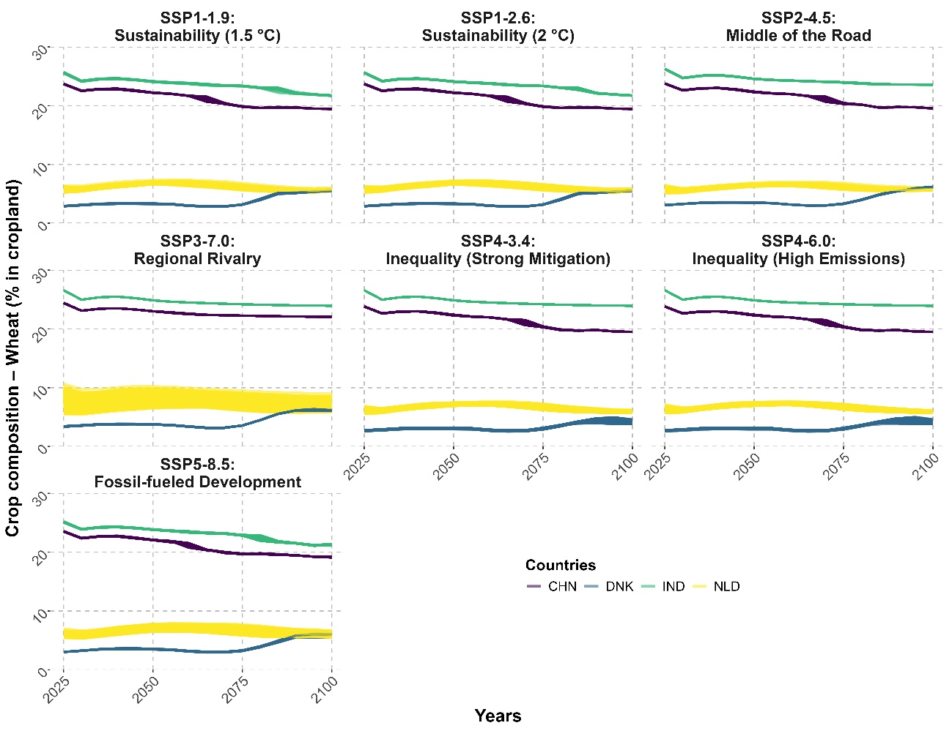
Figure S1. Illustrating the generated crop compositions (n=1000) for different countries under different SSP-RCP scenarios for Wheat.

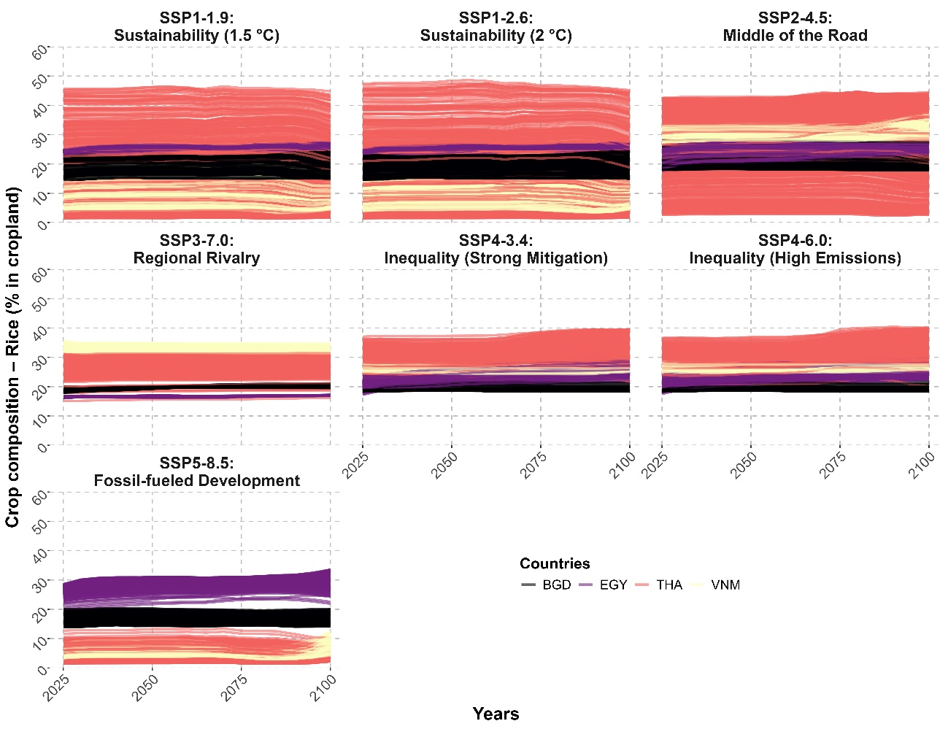
Figure S2. Illustrating the generated crop compositions (n=1000) for different countries under different SSP-RCP scenarios for Rice.

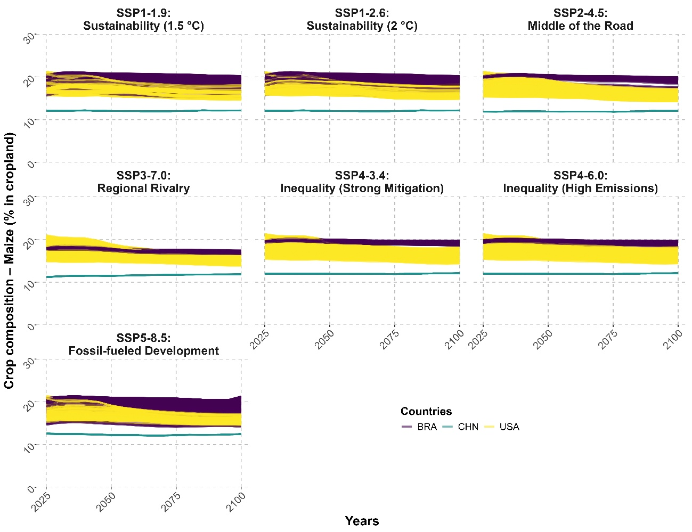
Figure S3. Illustrating the generated crop compositions (n=1000) for different countries under different SSP-RCP scenarios for Maize.
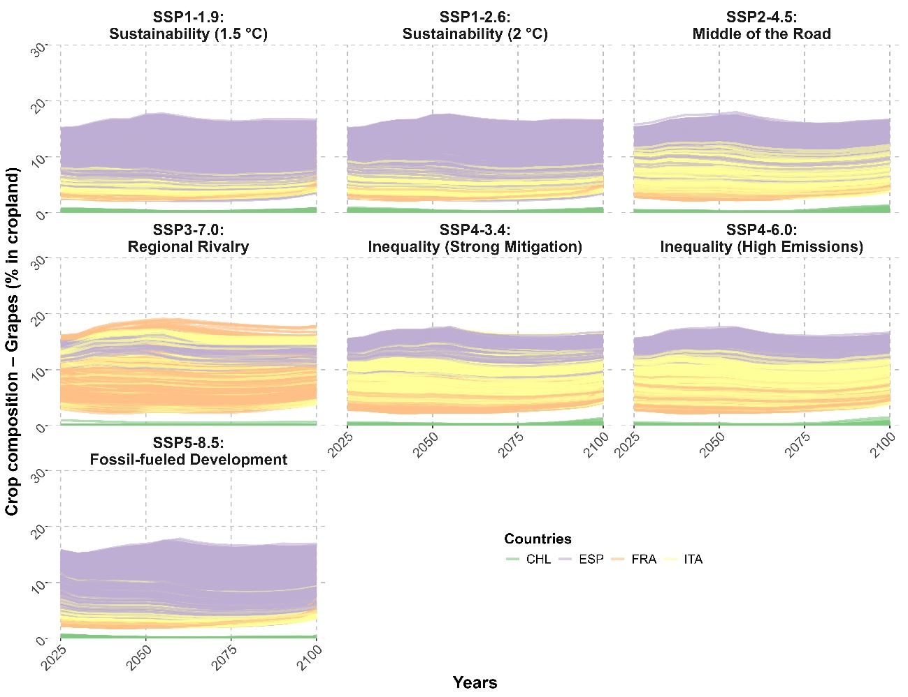
Figure S4. Illustrating the generated crop compositions (n=1000) for different countries under different SSP-RCP scenarios for Grapes.

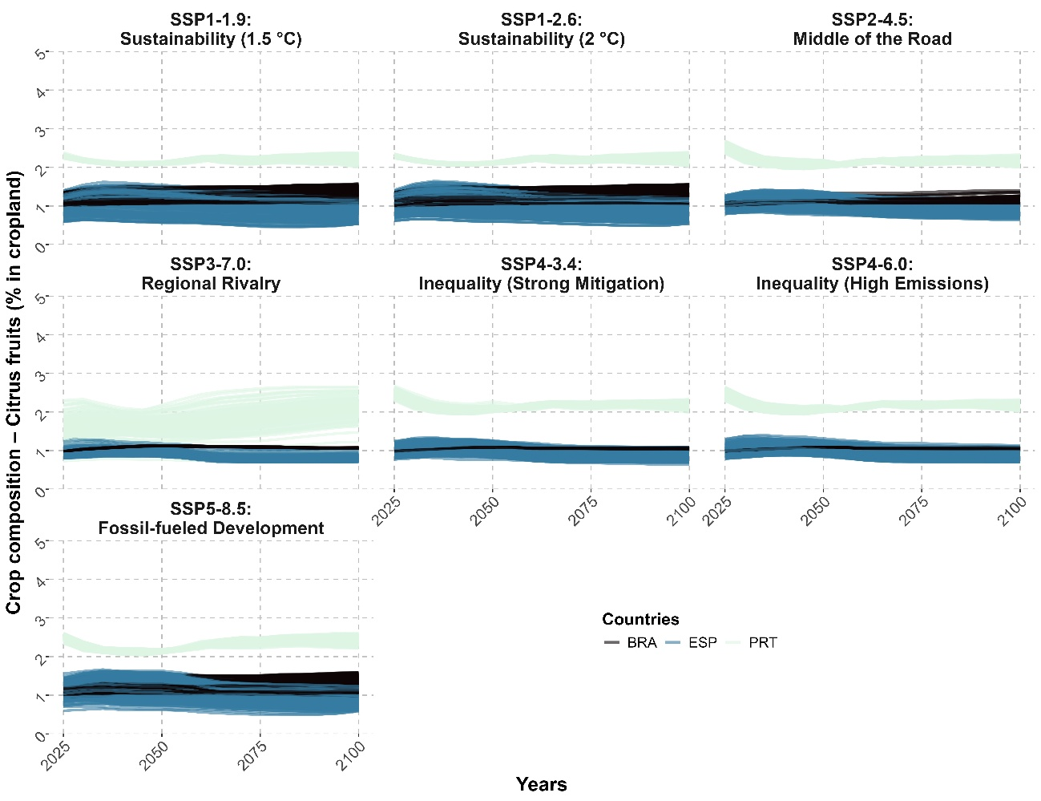
Figure S5. Illustrating the generated crop compositions (n=1000) for different countries under different SSP-RCP scenarios for Citrus fruits.

Predictions of nitrogen inputs, yields and viable productivity threshold in cropland under scenarios

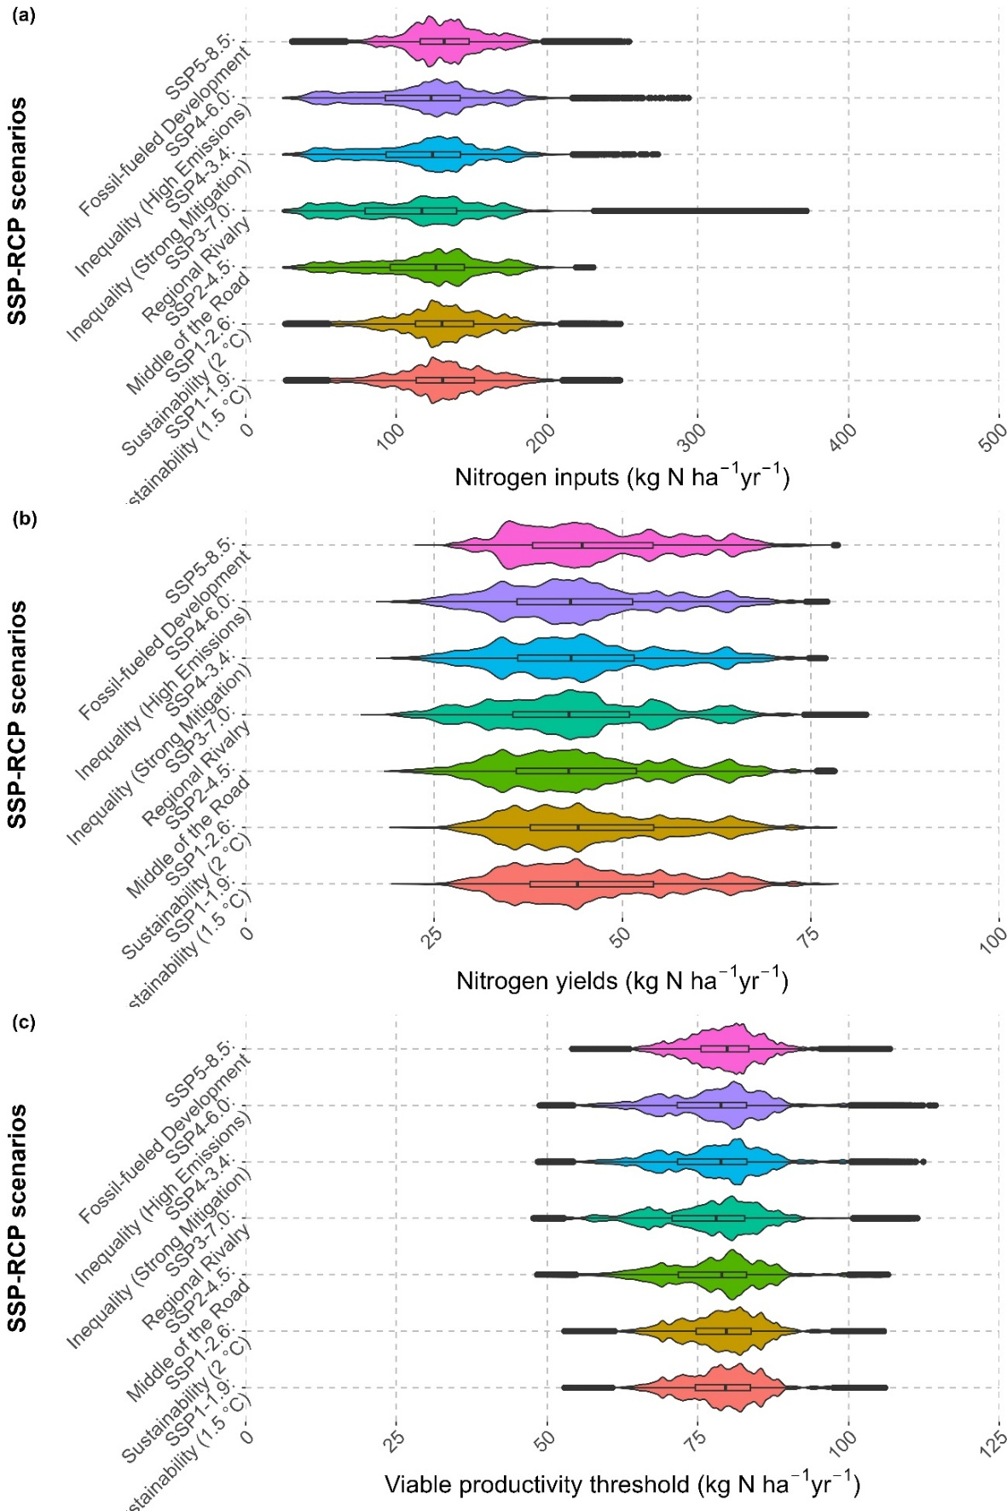
Figure S6. Variation in total N inputs (a), N yields (b) and viable productivity threshold (c), predicted for different crop compositions under SSP-RCP scenarios for all countries between 2025-2100 at 5-year intervals.

Future scenarios remain locked out of the Right space, even under augmented learning
Despite targeted efforts to improve the representation of sustainable nitrogen use patterns through data augmentation, no scenarios across any model configuration resulted in countries entering the Right space. This absence persisted across all 17 million projected futures, indicating that the plausible crop compositions and socio-climatic conditions anticipated under SSP-RCP pathways are structurally misaligned with the conditions required for safe and just nitrogen use.
Model behaviour varied markedly depending on the type of augmentation applied (Table S4). Upsampling countries historically in the Right space alone consistently worsened outcomes, increasing the share of Wasteful scenarios from 96% in the baseline to 98% (Table S5). This suggests that the model learned Right patterns from historical data that simply do not generalize to future cropping configurations, highlighting a fundamental incompatibility between past sustainable regimes and projected agronomic futures.
In contrast, augmenting the Unsustainable class led to substantial improvements, reducing the share of Wasteful outcomes by up to 16 percentage points. The best performance was achieved when both classes were upsampled by 10%, lowering the Wasteful share to 81%, with most reclassifications falling into the Unsustainable space. These results indicate that, under plausible future conditions, agricultural systems are more likely to reach high-input, high-uptake regimes (Unsustainable) than to simultaneously respect environmental boundaries and meet productivity thresholds (Right). In effect, Unsustainable becomes the ceiling of feasibility, while the Right space remains structurally out of reach.
This outcome highlights how machine learning cannot generate sustainable outcomes where future systemic conditions do not support them. The persistent absence of Right scenarios, despite explicit training to recognise them, reflects deeper constraints within the projected development trajectories. As operationalized here, sustainable nitrogen use is not only rare, but currently implausible without transformational shifts in cropping systems, infrastructure, and governance.

Table S4. Model performance with baseline (no augmentation) and different combination of augmentation of Right-Unsustainable in the training set.
Model | Input R² | Crop_Removal R² | N_att R²
Baseline (no augmentation) | 0.89 | 0.94 | 0.98
Right 5% | 0.89 | 0.93 | 0.98
Right 10% | 0.89 | 0.94 | 0.98
Unsustainable 5% | 0.886 | 0.919 | 0.968
Unsustainable 10% | 0.892 | 0.918 | 0.970
Both 5% | 0.90 | 0.94 | 0.98
Both 10% | 0.92 | 0.94 | 0.98

Table S5. Experimental testing of the effect of augmenting the training data for countries that have operated in the Right and Unsustainable spaces, and their impact on the share of countries in all operating spaces.
Model | Right  (%) | Constrained (%) | Unsustainable (%) | Wasteful  (%)
Baseline | 0 | 3.1 | 0.0 | 96.9
Right 5% | 0 | 1.4 | 0.0 | 98.6
Right 10% | 0 | 1.3 | 0.4 | 98.3
Unsustainable  5% | 0 | 0.8 | 14.4 | 84.8
Unsustainable 10% | 0 | 0.5 | 14.6 | 84.9
Both 5% | 0 | 0.8 | 13.1 | 86.1
Both 10% | 0 | 0.4 | 16.5 | 83.1

Methodological stepwise diagram
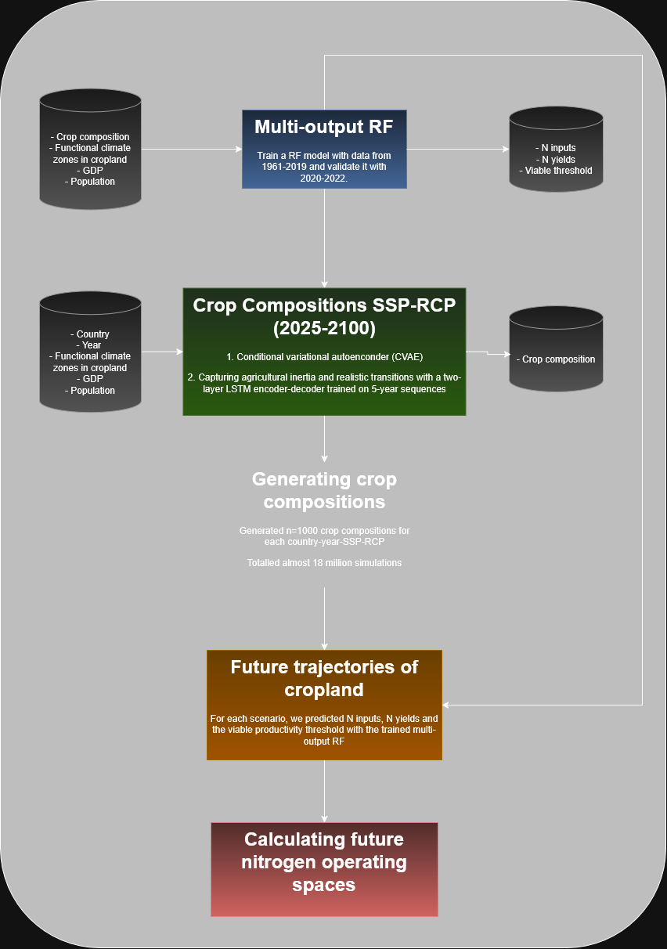
Figure S7. Conceptual diagram for the scenario analysis.

