Supplementary Information for
Economic and environmental spillovers decrease the benefits of upscaling biochemicals and biobased plastics in the European Union

Contents

A. Model definition 2
B. Introducing biochemicals and biobased plastics in a GE framework 6
C. Supplementary Tables and Figures 8
References 16

A. Model definition
We used the Modular Applied General Equilibrium Tool (MAGNET) for our analysis. MAGNET is a multi-regional, multi-sectoral applied computable general equilibrium (CGE) model. It is an advanced recursive dynamic version of the Global Trade Analysis Project (GTAP) model (Corong et al. 2017) which has been extended to allow integrated assessments focussing mainly on food and biomass production. As a CGE model, MAGNET solves through adjusting prices such that all markets for factors (land, labour, capital, natural resources) and commodities (good and services) simultaneously clear. Producers (one for each sector-region combination) respond to changing prices for inputs (factors and intermediates) based on profit maximization. With constant returns to scale production producers operate under zero-profit conditions. Representative private households (one for each region) respond to changing incomes earned with factor sales and changing prices of commodities for consumption based on utility maximization limited by the household’s income constraint. International trade flows are modelled bilaterally between all regions with regional sourcing of imports governed by the Armington assumption which allows two-way trade flows. Figure S1 outlines the structure of MAGNET with the interactions between production, trade, and consumption.
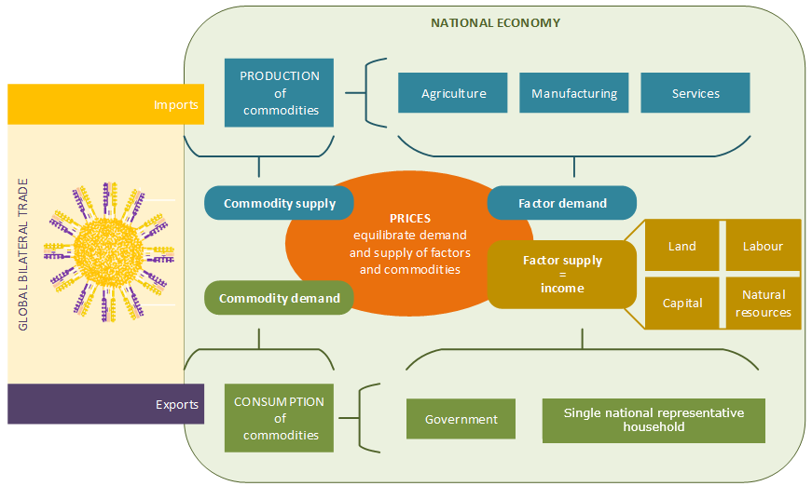

Figure S1. Schematic outline of the structure of MAGNET and the circular flow of money and commodities through the global economy. Additional information on the MAGNET model is available in Wouter et al. (2014) and at www.magnet-model.eu
With its’ modular structure, the MAGNET contains a series of switches for (de)activating a series of specialist modules to tailor the model to the study focus at hand. Given the medium-term time frame of the study, a recursive-dynamic variant is activated to capture investment, capital- accumulation and structural change over time. Moreover, to improve the representation of competing biomass uses (food, feed, energy, materials), bioeconomy policies are modelled (i.e., common agricultural policy bio-energy policy) and a waste generation, processing and treatment module is activated. In addition, to capture activity specific technologies and market rigidities in the agricultural and related biomass sectors, the model captures key input-nest combinations for crops (i.e., fertiliser vs land) and livestock (i.e., substitutability between animal feed types) activities; agricultural land transfer between different activities; labour and capital factor rigidities between agricultural and non-agricultural sectors; sustainable limits on available land and agricultural and forestry residue supplies. The model aggregation adopted for this study involves 30 regions (Table S1), each comprising 84 production sectors (Table S2) producing 104 commodities (Table S3). The European Union (EU27) is represented at member state level, while other countries are reported in aggregate regions. The whole bioeconomy comprehends 75 produced commodities and is represented as explicitly as possible given the data provided by the GTAP 11 database (Aguiar et al. 2023).
Table S1. Regional aggregation.
Model Region | Description | Countries
Austria | Austria | Austria
BelgLux | Belgium-Luxemburg | Belgium, Luxemburg
Bulgaria | Bulgaria | Bulgaria
Croatia | Croatia | Croatia
Czechia | Czechia | Czechia
Denmark | Denmark | Denmark
Estonia | Estonia | Estonia
Finland | Finland | Finland
France | France | France
Germany | Germany | Germany
GreCypMlt | Greece-Cyprus-Malta | Greece, Cyprus, Malta
Hungary | Hungary | Hungary
Ireland | Ireland | Ireland
Italy | Italy | Italy
Latvia | Latvia | Latvia
Lithuania | Lithuania | Lithuania
Netherlands | Netherlands | Netherlands
Poland | Poland | Poland
Portugal | Portugal | Portugal
Romania | Romania | Romania
Slovakia | Slovakia | Slovakia
Slovenia | Slovenia | Slovenia
Spain | Spain | Spain
Sweden | Sweden | Sweden
Ukraine | Ukraine | Ukraine
UK | United Kingdom | United Kingdom
EurCandid | EU Enlargement candidates countries | Albania, Serbia, Rest of Eastern Europe, Rest of Europe, Georgia
REUROPE | Rest of Europe (non-EU) | Switzerland, Norway, Rest of EFTA, Belarus, Russian Federation, Armenia, Azerbaijan, Turkey
MERCOSUR | MERCOSUR | Argentina, Brazil, Paraguay, Uruguay
ROW | Rest of the World | Australia, New Zealand, Rest of Oceania, China, Hong Kong, Japan, Korea, Mongolia, Taiwan, Rest of East Asia, Brunei Darussalam, Cambodia, Indonesia, Lao People's Democratic Republic, Malaysia, Philippines, Singapore, Thailand, Viet Nam, Rest of Southeast Asia, Afghanistan, Bangladesh, India, Nepal, Pakistan, Sri Lanka, Rest of South Asia, Canada, United States of America, Mexico, Rest of North America, Bolivia, Chile, Colombia, Ecuador, Peru, Venezuela, Rest of South America, Costa Rica, Guatemala, Honduras, Nicaragua, Panama, El Salvador, Rest of Central America, Dominican Republic, Haiti, Jamaica, Puerto Rico, Trinidad and Tobago, Caribbean, Kazakhstan, Kyrgyzstan, Tajikistan, Uzbekistan, Rest of Former Soviet Union, Bahrain, Iran Islamic Republic of, Iraq, Israel, Jordan, Kuwait, Lebanon, Oman, State of Palestine, Qatar, Saudi Arabia, Syria, United Arab Emirates, Rest of Western Asia, Algeria, Egypt, Morocco, Tunisia, Rest of North Africa, Benin, Burkina Faso, Cameroon, Cote d'Ivoire, Ghana, Guinea, Mali, Niger, Nigeria, Senegal, Togo, Rest of Western Africa, Central African Republic, Chad, Congo, Congo the Democratic Republic, Equatorial Guinea, Gabon, South Central Africa, Comoros, Ethiopia, Kenya, Madagascar, Malawi, Mauritius, Mozambique, Rwanda, Sudan, Tanzania, Uganda, Zambia, Zimbabwe, Rest of Eastern Africa, Botswana, Eswatini, Namibia, South Africa, Rest of South African Customs, Rest of the World

Table S2. Sectoral aggregation.
Sector in the model | Description | Sector in the model | Description
pdr | paddy rice | constr | construction
wht | wheat | rpp | rubbers and plastics
gro | other cereals | bioch | bio/based chemicals
veg | vegetable crops | bioph | bio/based pharmaceuticals
fruit | fruits | biopl | bio/based plastics
nuts | nuts | biog | bioethanol fuel
roots | roots and tubers | biod | biodiesel
pulses | pulse crops | bf2nd | ligno crops liquid biofuels
osd | oilseeds | bioe | bioelectricity
c_b | sugar beet and cane | residues | residue blender
ocrops | other crops | pellets | pellets
bfctl | beef cattle | plan | energy crops
ctl | other ruminant cattle | bkero | bio-kerosene
pltry | poultry | kero | kerosene (blender)
pigpls | pigs and other animals | bioh | bio heat
rmk | raw milk | heat | heat non-bio
frs | forestry | Bgas | bio gas
fishing | fishing | WCR | Waste collection rest
pest | pesticides | WCG | Waste collection green
fert | fertilisers | WCGP | Waste collection glass and plastic
seaweed | seaweed | comp | compositing
feed | feed | incin | incineration
coa | coal | landf | landfill
oil | crude oil | recy | recycling
gas | gas | ely | electricity blender
bfcmt | beef cattle meat | ely_c | electricity from coal
cmt | other cattle meat | ely_g | electricity from gas
poum | poultry meat | ely_n | electricity from nuclear
omt | porl and other animal meat | ely_h | electricity from hydroelectric
dairy | dairy | ely_w | electricity from wind and solar
vegoil | vegetable oils and fats | gas_dist | gas distribution
ricepro | processed rice | p_c | petroleum sector
sugarpro | processed sugar | metalprod | metal products
fishp | processed fish | omanu | other manufacturing
cvol | crude vegetable oil | airtrans | air transport
ofood | other food processing | otrans | other transport
bevtobac | beverages and tobacco | foodserv | food services and accomodation
texplus | textiles, wearing app etc. | trade | trade services
wood | wood products | recreat | recreation services
pap | paper and publishing | edu | education services
chm | chemicals | oserv | other services
omanu_furn | includes wood furniture | constr | construction
bph | pharmaceuticals | rpp | rubbers and plastics

Table S3. Commodities in the model
Type | Description
Arable and horticulture (12) | Paddy rice; wheat; other grains; vegetables; fruits; nuts; roots; pulses; oilseeds; raw sugar; other crops; crude vegetable oil
Livestock, meat and fish (11) | beef cattle; other extensive livestock; poultry; other intensive livestock; raw milk; beef; other red meat; poultry meat; other white meat; dairy products; processed fish products
Fertilisers and pesticides (8) | fertiliser; biowaste; manure from five animal activities; pesticides
Dedicated animal feeds (5) | 1st generation bioethanol by-product distillers dried grains and soluble; crude vegetable oil by-product oilcake; animal feed; sugar molasses; fish meal
Other food and beverages (5) | sugar processing; rice processing; vegetable oils and fats, other food; beverages and tobacco
Other bio-based activities (6) | fishing; forestry; wood; furniture products; paper products; textiles & clothing & leather products
Bio-chemicals (3) | bio-based chemicals; bio-based pharmaceuticals; bio-based plastics
Bio-mass supply (14) | energy crops; residues; pellets; three by-product residue commodities from cereals; five by-product residues from horticulture; by-product residues from oilseeds; by-product residues from other crops; by-product residues from forestry
Liquid bio-based energy (5) | biodiesel; bioethanol; advanced generation thermochemical technology biofuel; advanced generation biochemical technology biofuel; bio-kerosene
Renewable electricity and heat generation (6) | hydroelectricity; solar and wind; bioelectricity; biowaste electricity; bioheat; biogas
Fossil fuels and other energy markets (10) | crude oil; petroleum; gas; gas distribution; coal; coal-fired electricity; gas-fired electricity; nuclear electricity; kerosene; heat
Municipal waste collection and recycling (7) | waste collection green waste; waste collection of glass and plastic; waste collection grey waste; landfill; incineration; composting; recycling
Other markets (12) | construction; chemicals; pharmaceuticals; plastics and rubbers; metal products; other manufacturing; aviation; other transport; food services; retail and wholesale trade; recreation; other services

B. Introducing biochemicals and biobased plastics in a GE framework
Following the work of Philippidis et al. (2023), the MAGNET database has been enhanced to strip out from the three ‘parent’ chemical sectors of chemicals (GTAP code chm), pharmaceuticals (GTAP code bph) and rubbers and plastics (GTAP code rpp), three biobased offspring industries for chemicals (code biochm), pharmaceuticals (code biopha) and plastics (code biopla). As a first step, an ‘input-based’ approach (Kuosmanen et al., 2020) is used to estimate the top-down biobased share of the relevant biobased industry (e.g., biochm), from its corresponding parent (e.g., chm). A pre-defined series of inputs (i.e., primary agriculture, food, fishing, forestry, feeds, residues, biowaste, solid and liquid biobased energies, seaweed, manure, sugar syrups) are treated as entirely of biological origin. The collective value share of these biological origin inputs (at purchaser’s prices – including taxes) in each activity (i.e., primary, secondary and tertiary) gives an estimated biobased share for all industries in all of the regions in the Social Accounting Matrix (SAM). These activity-specific biobased share values (0 ≤ share ≤ 1) are then mapped to their respective commodities (of both domestic and imported origin). Finally, to estimate the biochemical share in each of the three parent chemical sectors in all regions, the biobased commodity shares are multiplied by the transaction value of each commodity input and divided by the total value of all inputs. This gives a ‘weighted’ biobased share of the three ‘offspring’ biobased chemical industries in the three ‘parent’ composite chemical industries, for all of the 160 regions of the model.
These biobased shares provide a ‘first-round’ SAM based estimate of the bio-based chemical industry column targets (i.e., turnover totals) in all regions. In the case of the EU27 regions, however, bio-based chemicals, pharmaceuticals and plastics turnover estimates are taken directly from the JRC Bioeconomy Monitoring System Dashboard. With total turnover estimates and assuming zero (economic) profits, the next step is to apportion the turnover totals into equivalent total cost amounts by different concepts (i.e., capital, labour, energy, biomass, ‘other’). The approach here follows that of Philippidis et al. (2023) in that cost share estimates (0 ≤ share ≤ 1) from Spekreijse et al. (2021) are reconciled with ‘other’ cost estimates from the parent chemical sectors in the SAM.
With the lack of comprehensive trade-data to support the splitting of existing parent chemicals trade transaction flows, no attempt is made to split these trade data. Instead, total chemicals production (using MAGNET/GTAP codes ‘chm’, ‘bph’, ‘rpp’) is modelled as a two-industry, single-commodity industry in the MAKE matrix of the SAM. This means that while the biobased and fossil-based industries run side-by-side, their output is aggregated into a single commodity called ‘chm’, ‘bph’ or ‘rpp’. In the aggregation process, a non-zero parameter is defined to indicate the degree of differentiation or “transformation elasticity” between fossil and biobased technologies. Given the heterogeneity of technological paths within each bio-based industry and the geographical coverage of the model, a transformation elasticity of 0.5 is chosen in all regions.
In the case of the biochemical module, in addition to the sector splits, a bio-based chemicals have specific nest structures to accommodate key substitutability between capital, labor, energy and food-based and non-food-based feedstock pathways (Figure S2). In the upper nest an elasticity of 0.2 is assumed which supports the assumption of very moderate technological structural input changes between value added-energy-biomass inputs and remaining material and services inputs over longer term time frames. The value-added nest uses the same elasticities as those from GTAP (in the corresponding three parent chemical sectors). Capital is also assumed inelastically substitutable with biomass to capture how recursive dynamic capital accumulation effects, impact upon biomass saving in nascent biotechnologies (with an assumed elasticity of substitution of 0.1). Since bio-based chemicals are assumed to employ electricity and gas (not coal, oil or petroleum), the structure and elasticity assumptions follow those in the energy nests of the GTAP-E model (Burniaux and Truong, 2002). An assumed ‘elastic’ value of three is assumed for the substitution between food-based and non-food biomass usage. This ‘elastic’ estimate is implemented, in part, to encourage sufficient non-food-based biomass uptake in response to relative price signals. The food-based biomass nest is of a highly heterogeneous nature (animal biomass (fats, lactose, etc.), sugar, starch, oil based) resulting in an assumed lower substitution elasticity value. In the non-food-based nest, a high elasticity response is assumed to characterize the uptake of different types of nascent non-food bio-feedstock pathways (consisting of processed ethanol from non-food biomass pathways and woody biomass).

Figure S2. Nesting structure for bio-chemical activities in MAGNET.

C. Supplementary Tables and Figures

Table S4. Cost of policy by country and scenario in billion US dollars and relative to national GDP in 2040.
 |  | BIOPL_LINEAR_LTECH |  |  | BIOPL_LINEAR_HTECH
 |  | Policy costs (1000 million US dollars) | GDP (1000 million US dollars) | Share of policy costs in GDP (%) | Policy costs (1000 million US dollars) | GDP (1000 million US dollars) | Share of policy costs in GDP (%)
Austria |  | 3519 | 562440 | 0.63 | 2638 | 563291 | 0.47
BelgLux |  | 12303 | 813585 | 1.51 | 8841 | 816701 | 1.08
Bulgaria |  | 610 | 99611 | 0.61 | 416 | 99804 | 0.42
Croatia |  | 365 | 103769 | 0.35 | 291 | 103862 | 0.28
Czechia |  | 1146 | 312763 | 0.37 | 765 | 313185 | 0.24
Denmark |  | 1498 | 503309 | 0.30 | 1172 | 503637 | 0.23
Estonia |  | 185 | 51700 | 0.36 | 142 | 51726 | 0.27
Finland |  | 909 | 376600 | 0.24 | 709 | 376699 | 0.19
France |  | 13876 | 3620424 | 0.38 | 10071 | 3623893 | 0.28
Germany |  | 23377 | 4734677 | 0.49 | 15573 | 4741035 | 0.33
GreCypMlt |  | 902 | 363621 | 0.25 | 657 | 363831 | 0.18
Hungary |  | 646 | 253787 | 0.25 | 443 | 253996 | 0.17
Ireland |  | 24731 | 751215 | 3.29 | 20387 | 756092 | 2.70
Italy |  | 9158 | 2346351 | 0.39 | 6357 | 2349171 | 0.27
Latvia |  | 115 | 56883 | 0.20 | 102 | 56855 | 0.18
Lithuania |  | 462 | 93497 | 0.49 | 377 | 93556 | 0.40
Netherlands |  | 7822 | 1205370 | 0.65 | 6318 | 1206804 | 0.52
Poland |  | 4963 | 979244 | 0.51 | 3469 | 980481 | 0.35
Portugal |  | 1613 | 325798 | 0.50 | 1253 | 326201 | 0.38
Romania |  | 532 | 381594 | 0.14 | 353 | 381653 | 0.09
Slovakia |  | 1386 | 163486 | 0.85 | 1094 | 163798 | 0.67
Slovenia |  | 573 | 85872 | 0.67 | 348 | 86061 | 0.40
Spain |  | 9824 | 1876589 | 0.52 | 7706 | 1879036 | 0.41
Sweden |  | 2192 | 769679 | 0.28 | 1544 | 770286 | 0.20
EU27 |  | 122707 | 20831864 | 0.59 | 91026 | 20861654 | 0.44

 | BIOPL_CIRCULAR_LTECH |  |  | BIOPL_CIRCULAR_HTECH
 | Policy costs (1000 million US dollars) | GDP (1000 million US dollars) | Share of policy costs in GDP (%) | Policy costs (1000 million US dollars) | GDP (1000 million US dollars) | Share of policy costs in GDP (%)
Austria | 5051 | 559907 | 0.90 | 4099 | 561012 | 0.73
BelgLux | 20637 | 800596 | 2.58 | 16473 | 804638 | 2.05
Bulgaria | 704 | 99491 | 0.71 | 510 | 99701 | 0.51
Croatia | 609 | 103477 | 0.59 | 522 | 103597 | 0.50
Czechia | 1215 | 312774 | 0.39 | 828 | 313171 | 0.26
Denmark | 2654 | 501931 | 0.53 | 2242 | 502425 | 0.45
Estonia | 245 | 51512 | 0.48 | 204 | 51539 | 0.40
Finland | 1248 | 376377 | 0.33 | 1035 | 376484 | 0.27
France | 28743 | 3605484 | 0.80 | 23355 | 3611642 | 0.65
Germany | 34432 | 4722152 | 0.73 | 25431 | 4730026 | 0.54
GreCypMlt | 1220 | 362702 | 0.34 | 1050 | 362984 | 0.29
Hungary | 956 | 253407 | 0.38 | 732 | 253679 | 0.29
Ireland | 24899 | 750621 | 3.32 | 20501 | 755603 | 2.71
Italy | 14717 | 2339737 | 0.63 | 11705 | 2343206 | 0.50
Latvia | 182 | 56834 | 0.32 | 165 | 56793 | 0.29
Lithuania | 942 | 92945 | 1.01 | 820 | 93027 | 0.88
Netherlands | 14421 | 1192709 | 1.21 | 12682 | 1194655 | 1.06
Poland | 5854 | 978325 | 0.60 | 4316 | 979735 | 0.44
Portugal | 2087 | 325293 | 0.64 | 1711 | 325769 | 0.53
Romania | 877 | 381660 | 0.23 | 665 | 381697 | 0.17
Slovakia | 2441 | 161879 | 1.51 | 2113 | 162270 | 1.30
Slovenia | 574 | 85890 | 0.67 | 349 | 86056 | 0.41
Spain | 15087 | 1870210 | 0.81 | 12819 | 1873454 | 0.68
Sweden | 2738 | 769122 | 0.36 | 2050 | 769773 | 0.27
EU27 | 182533 | 20755035 | 0.88 | 146377 | 20792936 | 0.70

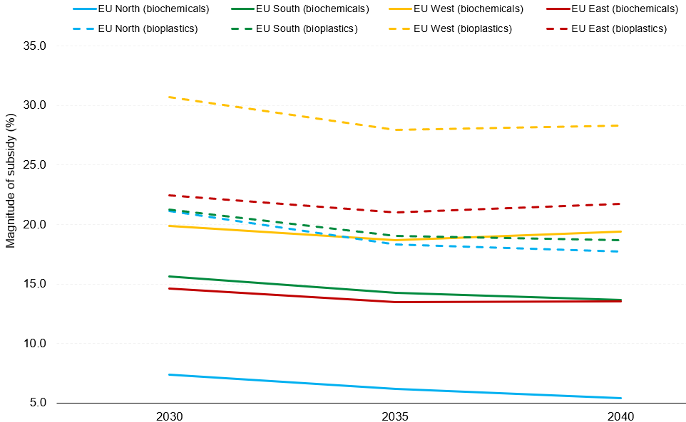
Figure S3. Magnitude of subsidies needed to reach a 15% share of biochemicals and biobased plastic within total chemical and plastic production by EU27 regions across the investigated timeframe.

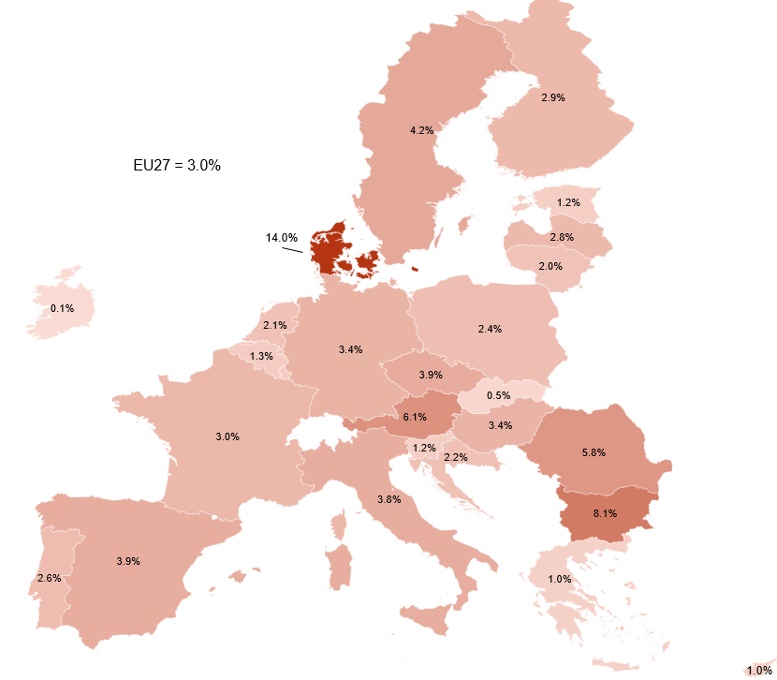
Figure S4. Share (%) of value-added from biochemicals and biobased plastics sectors in total value-added of chemicals and plastics sectors in the Business-as-Usual baseline scenario in 2040.

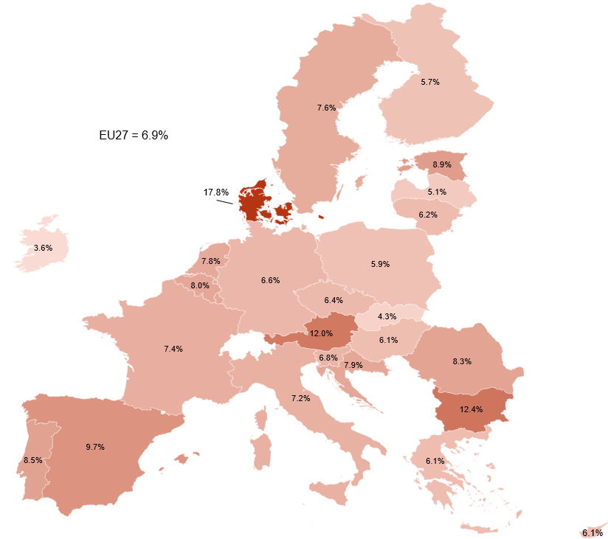
Figure S5. Share (%) of value-added from biochemicals and biobased plastics sectors in total value-added of chemicals and plastics sectors in the low technology (L_TECH) LINEAR and CIRCULAR scenarios in 2040.

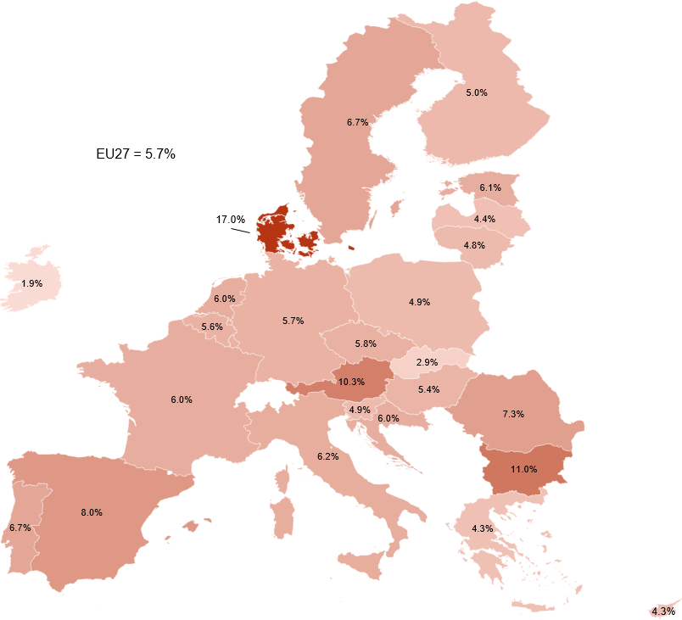
Figure S6. Share (%) of value-added from biochemicals and biobased plastics sectors in total value-added of chemicals and plastics sectors in the high technology (H_TECH) LINEAR and CIRCULAR scenarios in 2040.

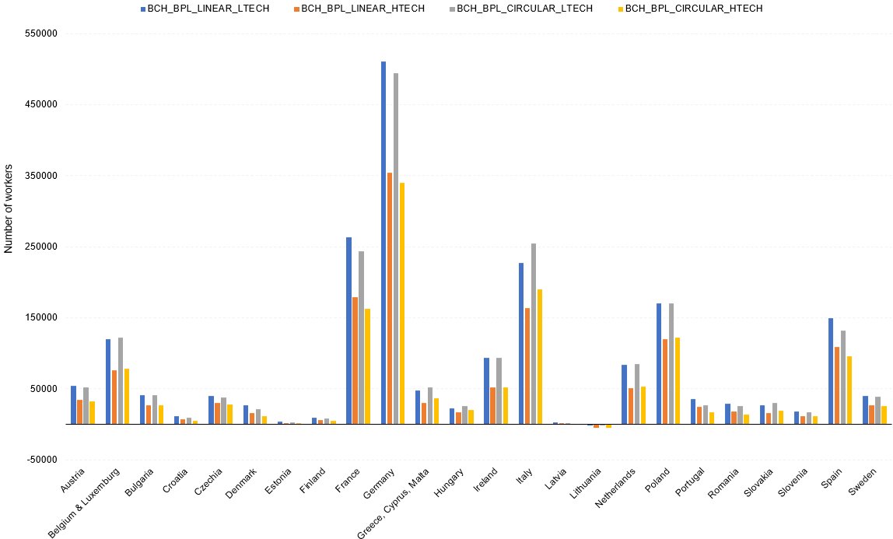
Figure S7. Number of workers in the bioeconomy (excluding the food system) across scenario with respect to the Business-as-Usual baseline scenario in 2040.

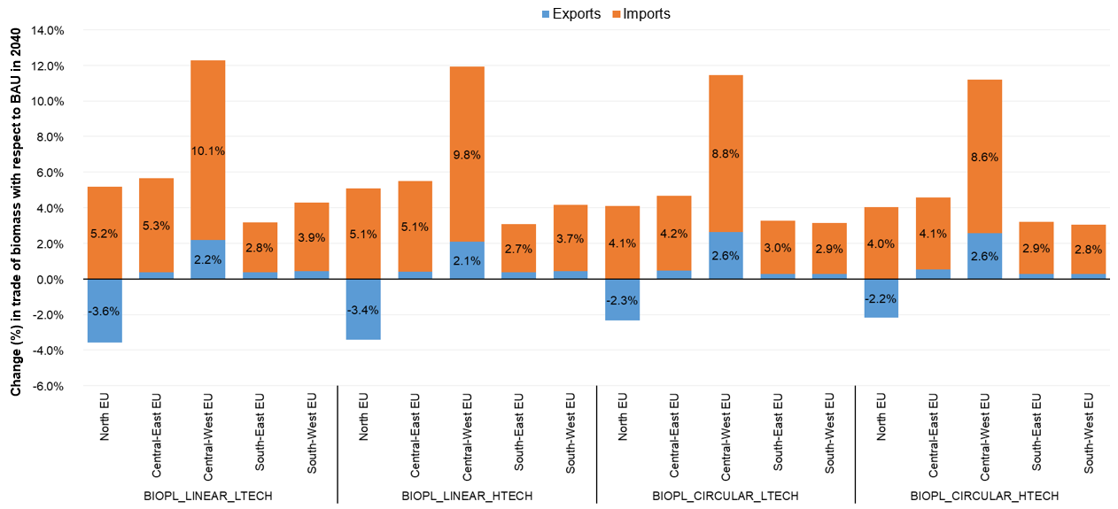
Figure S8. Change (%) in trade of biomass by EU27 regions across scenarios with respect to BAU in 2040.
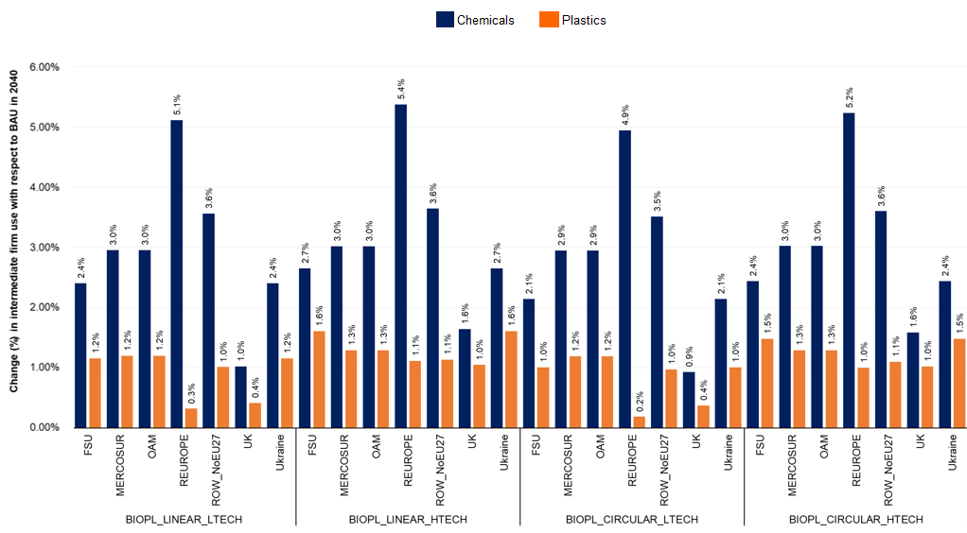
Figure S9. Change (%) in the use of chemical and plastics products (fossil-based and biobased) by firms in non-EU27 regions across scenarios with respect to BAU in 2040. FSU=Former Soviet Union; OAM=Other Latin America; REUROPE=Rest of Europe.

References

Aguiar, A., Chepeliev, M., Corong, E., & Mensbrugghe, D. van der. (2023). The Global Trade Analysis Project (GTAP) Data Base: Version 11. Journal of Global Economic Analysis, 7(2), Article 2. https://doi.org/10.21642/JGEA.070201AF
Corong, E.L., Hertel, T.W., McDougall, R., Tsigas, M.E., van der Mensbrugghe, D., (2017). The Standard GTAP Model, Version 7. Journal of Global Economic Analysis, 1, 1-119.
Burniaux, J.M., Truong, T.P., 2002. Gtap-e: An energy -environmental version of the gtap model. GTAP Technical Paper No. 16. Center for Global Trade Analysis.
Kuosmanen, T., Kuosmanen, N., El Meligi, A., Tevecia, R., Gurria Albusac, P., Iost, S., M’barek, R. (2020). How big is the bioeconomy? Reflections from an economic perspective EUR 30167 EN. (publications Office of the European Union ed., Vol. SBN 978-92-76-17858-3, pp. 49) JRC, Luxembourg (2020)
Philippidis, G., M’barek, R., Urban-Boysen, K., van Zeist, W.J. (2023) Exploring economy-wide sustainable conditions for EU bio-chemical activities, Ecological Economics, 210, doi.org/10.1016/j.ecolecon.2023.107857
Spekreijse, J., Vikla, K., Vis, M., Boysen-Urban, K., Philippidis, G., & M’barek, R. (2021). Bio-based value chains for chemicals, plastics and pharmaceuticals, EUR 30653 EN Publications Office of the European Union, Luxembourg, 10.2760/712499 ISBN 978-92-76-32459-1. JRC124141
Woltjer, G., & Kuiper, M. (2014). The MAGNET Model: Module description. 148.

Source: https://knowledge4policy.ec.europa.eu/visualisation/eu-bioeconomy-monitoring-system-dashboards_en
See Table 1 in Philippidis et al. (2023) (open access).
The use of residues, pellets, energy crops and waste (from composting) in biochemicals is via (i) a representative thermochemical technology based on the gasification of lignocellulose biomass and Fischer-Tropsch fuel synthesis and (ii) a representative bio-based chemical technology employing hydrolysis of lignocellulose biomass and fermentation of sugars to ethanol.

