(Table 1)
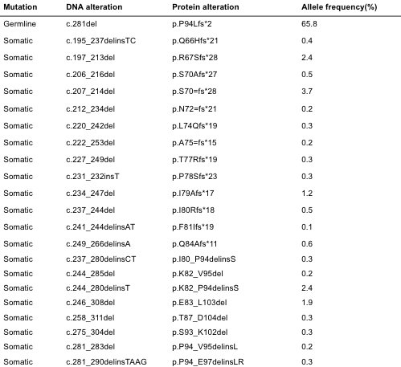

(Table 2)
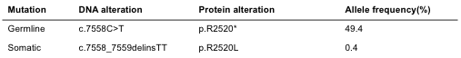

(Table 3)
