Supplementary Figures:
Figure S1: Boxplots of DNA methylation levels of ASCL1 and LHX8 (log2-transformed ΔCq ratios; y-axis) in HPV-positive cervical samples (A-B, n=264) relative to reference gene ACTB according to cervical disease categories (x-axis). Boxplots show medians with lower and upper quartiles and range whickers. A P-value, after Bonferroni correction for multiple testing of 0.0125 was considered to be significant. Abbreviations: ns: non-significant, CIN: cervical intraepithelial neoplasia (CIN) grade 1-3; CNTRL: women with no dysplasia or CIN1 (≤CIN1), CIN2: CIN grade 2, CIN3: CIN grade 3, AIS: adenocarcinoma in situ. CC: cervical cancer.
A ASCL1  p<0.001  p<0.001  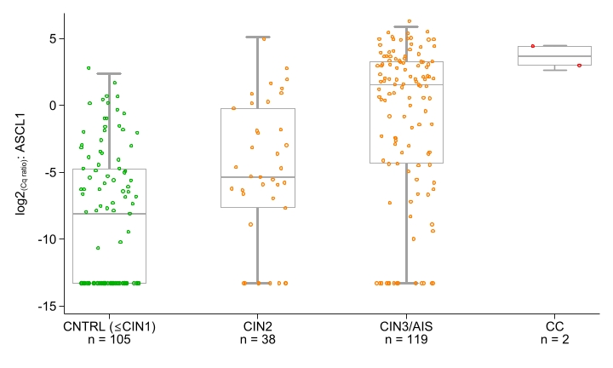  p<0.001  P<0.001 | B LHX8  p<0.001  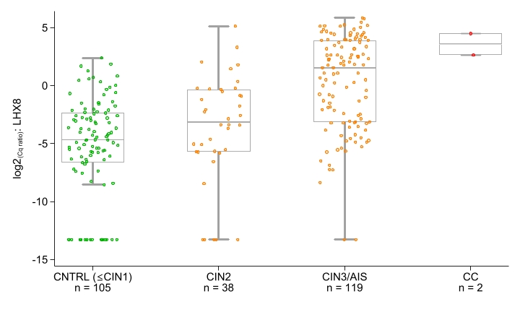  ns  p<0.001  p<0.001

Figure S2: Conditional scatterplots illustrating the DNA methylation levels (log2-transformed ΔCq ratios; y-axis) for ASCL1 (Figure A) and LHX8 (Figure B) for paired HPV-positive first-void urine (FVU) and cervical samples (CS) (n=264) stratified by histological endpoints. CIN: cervical intraepithelial neoplasia, grade 1-3; CNTRL: women with no dysplasia or CIN1 (≤ CIN1), CIN2: CIN grade 2, CIN3: CIN grade 3, AIS: adenocarcinoma in situ. CC: cervical cancer. P-value: testing for differences in median DNA methylation levels between paired sample types.
A | CNTRL (n=105) | CIN2 (n=38) | CIN3/AIS (n=119)  p<0.001 | Cancers (n=2)  p<0.001
 | p<0.001  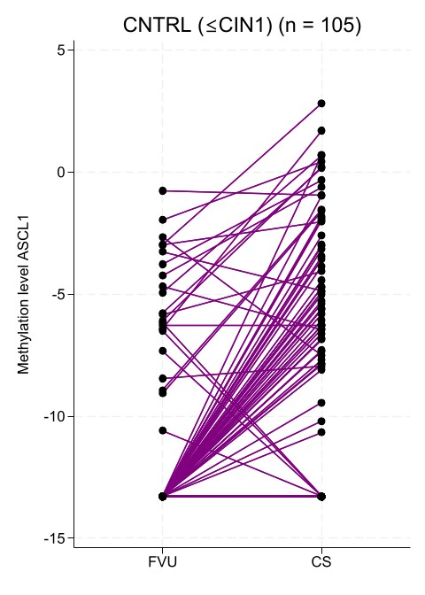 | p<0.001  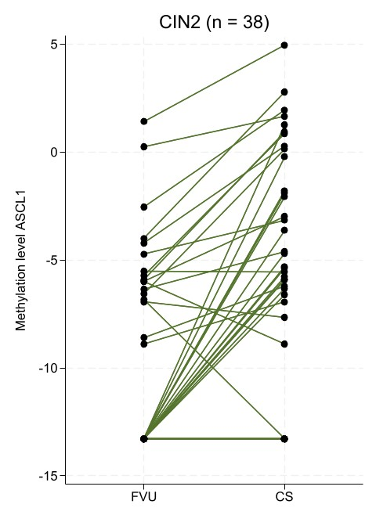 | 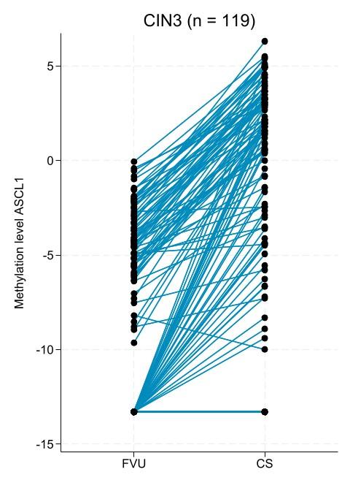 | 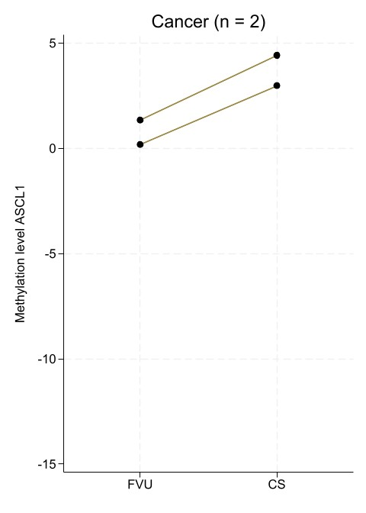
B | p<0.001  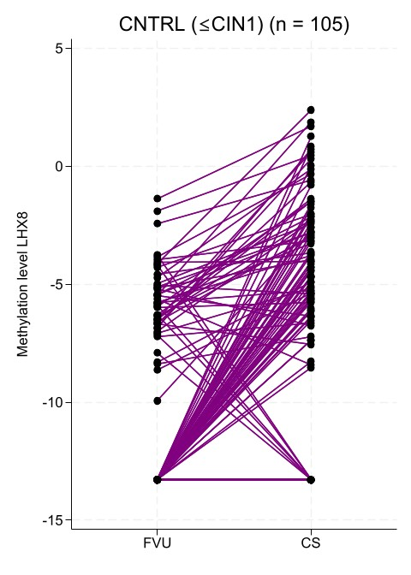 | p<0.001 | p<0.001 | p<0.001  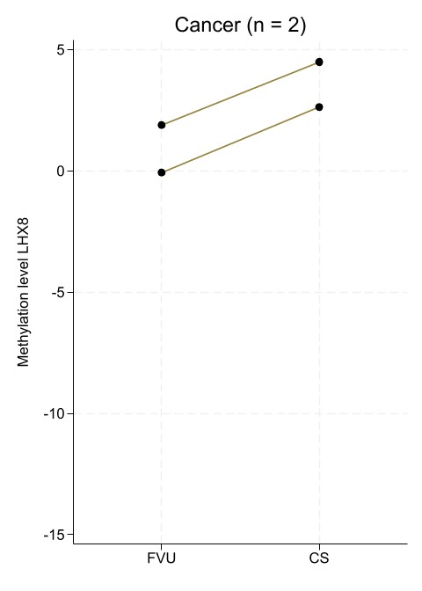

Figure S3: ROC curves illustrating the performance of the ASCL1/LHX8 DNA methylation marker panel in paired HPV-positive cervical (A-B) and first-void urine (C-D) samples to discern CIN3+ vs ≤CIN1 (n=226) and CIN2+ vs ≤CIN1 (n=264). Receiver Operating Characteristic (ROC) curves and corresponding area under the curves (AUCs) with 95% CIs are shown. CIN: Cervical Intraepithelial Neoplasia (CIN), grade 1 to 3. CNTRL: women with no dysplasia or CIN grade 1 (≤ CIN1). CIN3+: CIN grade 3, AIS: adenocarcinoma in situ, and cancer. CIN2+: CIN grade 2, CIN3, AIS, and Cancer.
A ASCL1/LHX8 | B ASCL1/LHX8
Cervical samples  CNTRL (≤CIN1) vs CIN3+  AUC: 0.84  95% CI: 0.79-0.89 | Cervical samples  CNTRL (≤CIN1) vs CIN2+  AUC: 0.80  95% CI: 0.75-0.85

C ASCL1/LHX8 | D ASCL1/LHX8
First-void urine  CNTRL (≤CIN1) vs CIN3+  AUC: 0.75  95% CI: 0.69-0.82 | First-void urine  CNTRL (≤CIN1) vs CIN2+  AUC: 0.73  95% CI: 0.67-0.79

Figure S4: ASCL1/LHX8 methylation positivity in relation to HPV genotypes detected in HPV-positive first-void samples and cervical disease categories. CIN: cervical intraepithelial neoplasia, grade 1-3; CNTRL: women with no dysplasia or CIN1, CIN2: CIN grade 2, CIN3+: CIN3, adenocarcinoma in situ, and cancer. Multiple HPV infections were counted as separate attributions. HPV: human papillomavirus, CIN cervical intraepithelial neoplasia, N total number of samples, CI confidence interval. *) ASCL1/LHX8 methylation positivity threshold in first-void urine was set at predefined 70% specificity for ≤CIN1 as defined by Van Keer et al (in revision). **) Other alpha-7/9 types: HPV31, 33, 35, 39, 45, 52, 58, 59, and 68. ***)Non-alpha-7/9 types: HPV51, 56, and 66.
CNTRL (n=123) |  |  | CIN2 (n=38) |  |  | CIN3+ (n=125)
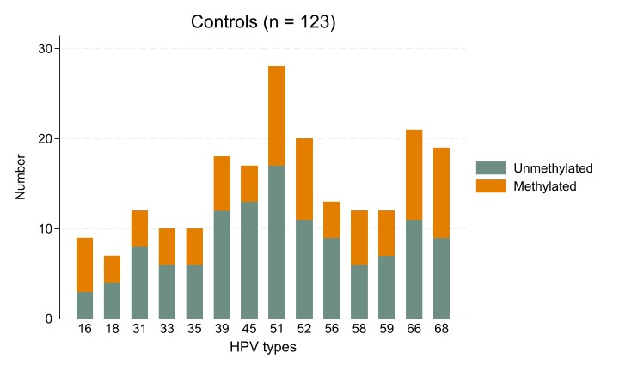 |  |  | 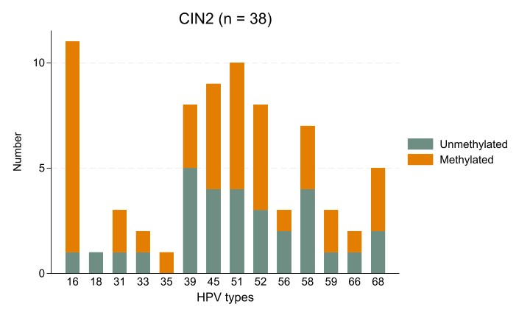 |  |  | 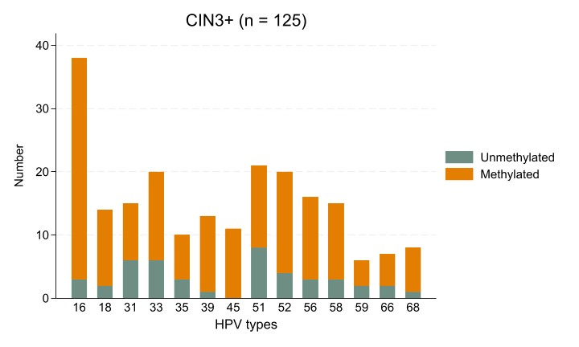
 | CNTRL |  |  | CIN2 |  |  | CIN3+
 | N | ASCL1/LHX8 methylation positivity* %, (95% CI) |  | N | ASCL1/LHX8 methylation positivity* %, (95% CI) |  | N | ASCL1/LHX8 methylation positivity* %, (95% CI)
HPV16/18 | 14 | 57.1 (29.0-82.3) |  | 12 | 83.3 (51.6-98.0) |  | 51 | 90.2 (78.6-96.7)
Other alpha- 7/9** | 89 | 39.3 (29.1-50.3) |  | 25 | 60.0 (38.7-78.9) |  | 85 | 76.5 (66.0-84.9)
Non-Other alpha- 7/9*** | 52 | 40.4 (27.0-54.9) |  | 14 | 57.1 (28.9-82.3) |  | 37 | 70.3 (53.0-84.1)

