Supplementary Materials
Enhancing bioactivity of Chlorella vulgaris through enzymatic pretreatment and lactic acid fermentation
Hakki Bilgin¹, Shahana Aboobacker¹, Aušra Šipailienė¹, Vaida Kitrytė-Syrpa¹, and Michail Syrpas^{1*}

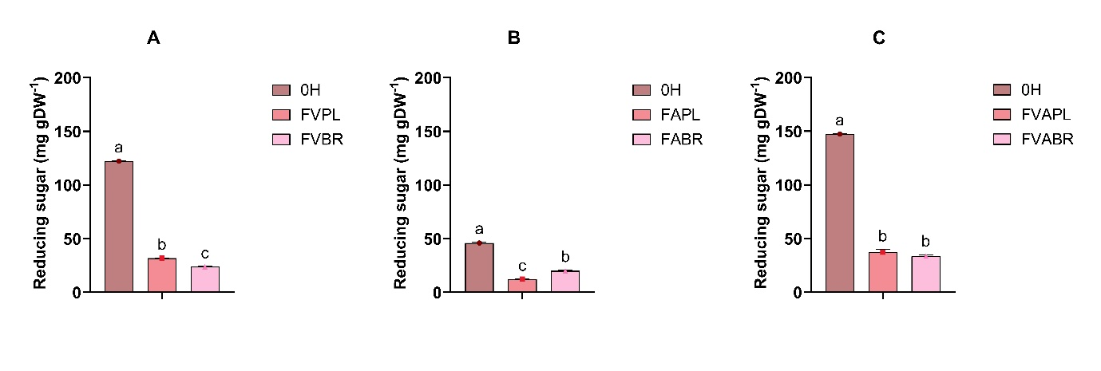
Figure S 1Reducing sugar (A-C) concentration after fermentation with L. plantarum (PL) and L. brevis (BR). (UF: unfermented; F: fermented; VC, VPL, VBR: viscozyme treated control, fermented by L. plantarum and L. brevis, respectively; AC, APL, ABR: alcalase treated control, fermented by L. plantarum and L. brevis, respectively; VAC, VAPL, VABR: combined enzyme treated control, fermented by L. plantarum and L. brevis, respectively). Bars represent means ± SD. Different letters indicate statistically significant differences (P < 0.05) (n = 3).

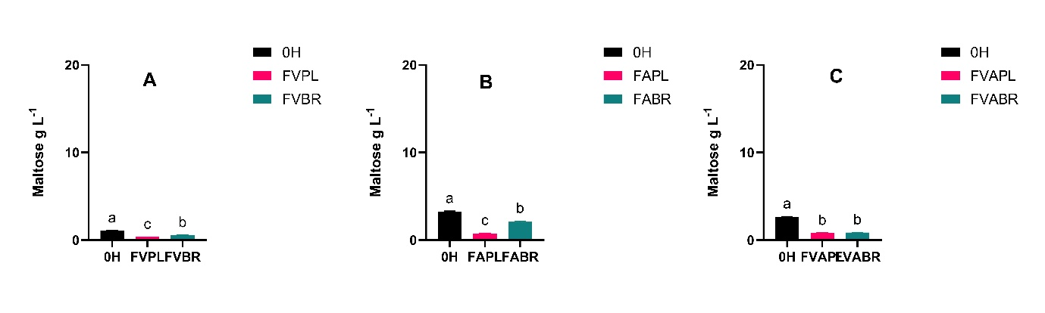
Figure S 2. Maltose concentration (A-C) after fermentation with L. plantarum (PL) and L. brevis (BR). (UF: unfermented; F: fermented; VC, VPL, VBR: viscozyme treated control, fermented by L. plantarum and L. brevis, respectively; AC, APL, ABR: alcalase treated control, fermented by L. plantarum and L. brevis, respectively; VAC, VAPL, VABR: combined enzyme treated control, fermented by L. plantarum and L. brevis, respectively). Bars represent means ± SD. Different letters indicate statistically significant differences (P < 0.05) (n = 3).

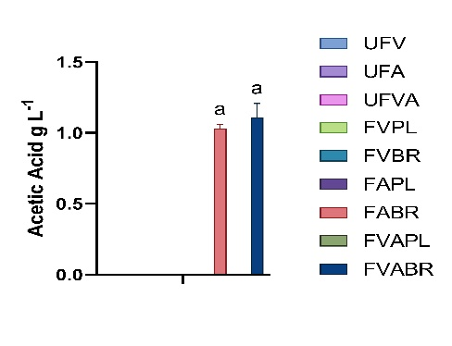
Figure S 3 Acetic acid concentration after fermentation with L. plantarum (PL) and L. brevis (BR). (UF: unfermented; F: fermented; VC, VPL, VBR: viscozyme treated control, fermented by L. plantarum and L. brevis, respectively; AC, APL, ABR: alcalase treated control, fermented by L. plantarum and L. brevis, respectively; VAC, VAPL, VABR: combined enzyme treated control, fermented by L. plantarum and L. brevis, respectively). Bars represent means ± SD. Different letters indicate statistically significant

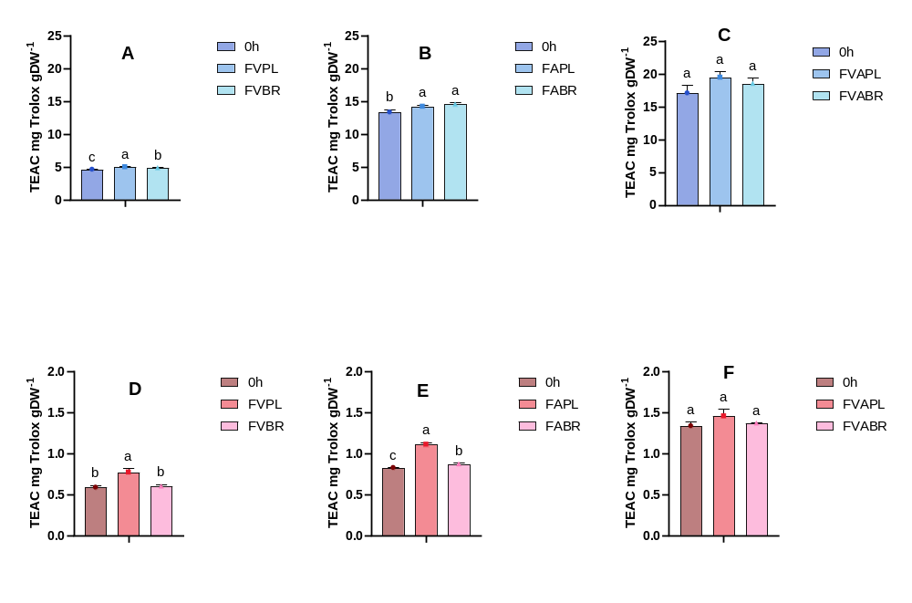
Fig. S 4. In vitro antioxidant capacity of C. vulgaris as evaluated by the ABTS (A-C), and DPPH (D-F) assay concentration after fermentation with L. plantarum (PL) and L. brevis (BR). (UF: unfermented; F: fermented; VC, VPL, VBR: viscozyme treated control, fermented by L. plantarum and L. brevis, respectively; AC, APL, ABR: alcalase treated control, fermented by L. plantarum and L. brevis, respectively; VAC, VAPL, VABR: combined enzyme treated control, fermented by L. plantarum and L. brevis, respectively). Bars represent means ± SD. Different letters indicate statistically significant differences (P < 0.05(n = 3).

