Supplementary Materials
A Schiff Base-Functionalized Triphenylamine Fluorescent Probe for Selective and Sensitive Detection of Cu²⁺ in Aqueous Media
Long Liuª, Jiayi Chenª,Meijun Chenª, Wen Huangª, Xiang Liaoª, Hanqing Wu*ª, Jingshui Xu*ª

ª Guangdong Provincial Key Laboratory of Petrochemical Equipment Fault Diagnosis, School of School of Materials Science and Engineering, Guangdong University of Petrochemical Technology, Maoming, Guangdong 525000, China.
Phone:+8619042711051
Email: LL0116@gdupt.edu.cn

1. Materials and methods
All chemical reagents and solvents (analytical grade and spectroscopic grade) used in this study were purchased from commercial sources and used as received without further purification. Fourier transform infrared (FT-IR) spectra were recorded on a Bruker (Germany) SEWERE ALPHA-T spectrometer, with samples prepared as KBr pellets. ¹H NMR and ¹³C NMR spectra were measured on an AVANCE 400 MHz NMR spectrometer. UV-vis absorption spectra were obtained using a Shimadzu UV-2550 spectrophotometer. Fluorescence spectra were recorded on a Hitachi F-4700 fluorescence spectrophotometer (Japan). Mass spectrometry data were acquired using a Waters UPLC/Xevo G2-XS Q-TOF LC/MS spectrometer.

2. General information
Ultrapure water was used to prepare stock solutions (1 × 10⁻³ M) of various metal ions, including Al³⁺, Zn²⁺, Ba²⁺, Ca²⁺, Cd²⁺, Co²⁺, Cr³⁺, Cu²⁺, Fe²⁺, Fe³⁺, Hg²⁺, K⁺, Mg²⁺, Mn²⁺, Na⁺, Pb²⁺, Ni²⁺, and Ag⁺. The stock solution of probe TPA-OPD (1 × 10⁻³ M) was prepared in DMSO. Prior to measuring UV–vis absorption and fluorescence spectra, this stock solution was diluted into the mixed solvent H₂O/DMSO (95:5, v/v) to yield a final concentration of 10⁻⁵ M. For fluorescence spectral measurements, the excitation wavelength was set at 370 nm, and both excitation and emission slit widths were fixed at 10 nm.

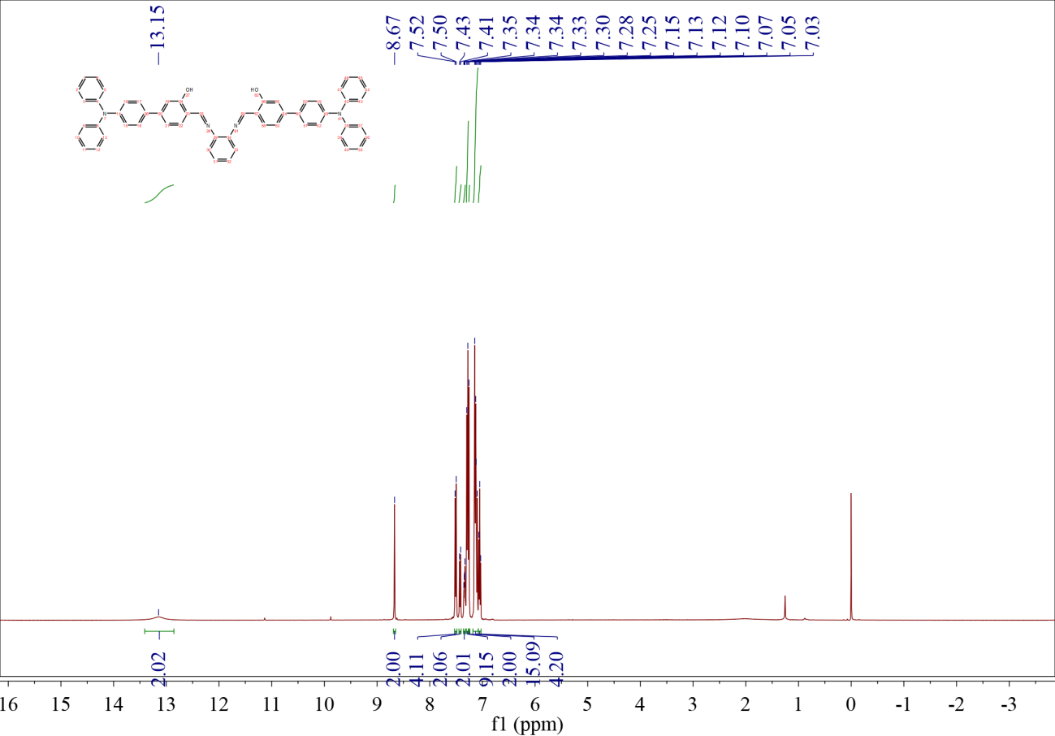
Fig. S1 ¹H NMR of compound TPA-OPD

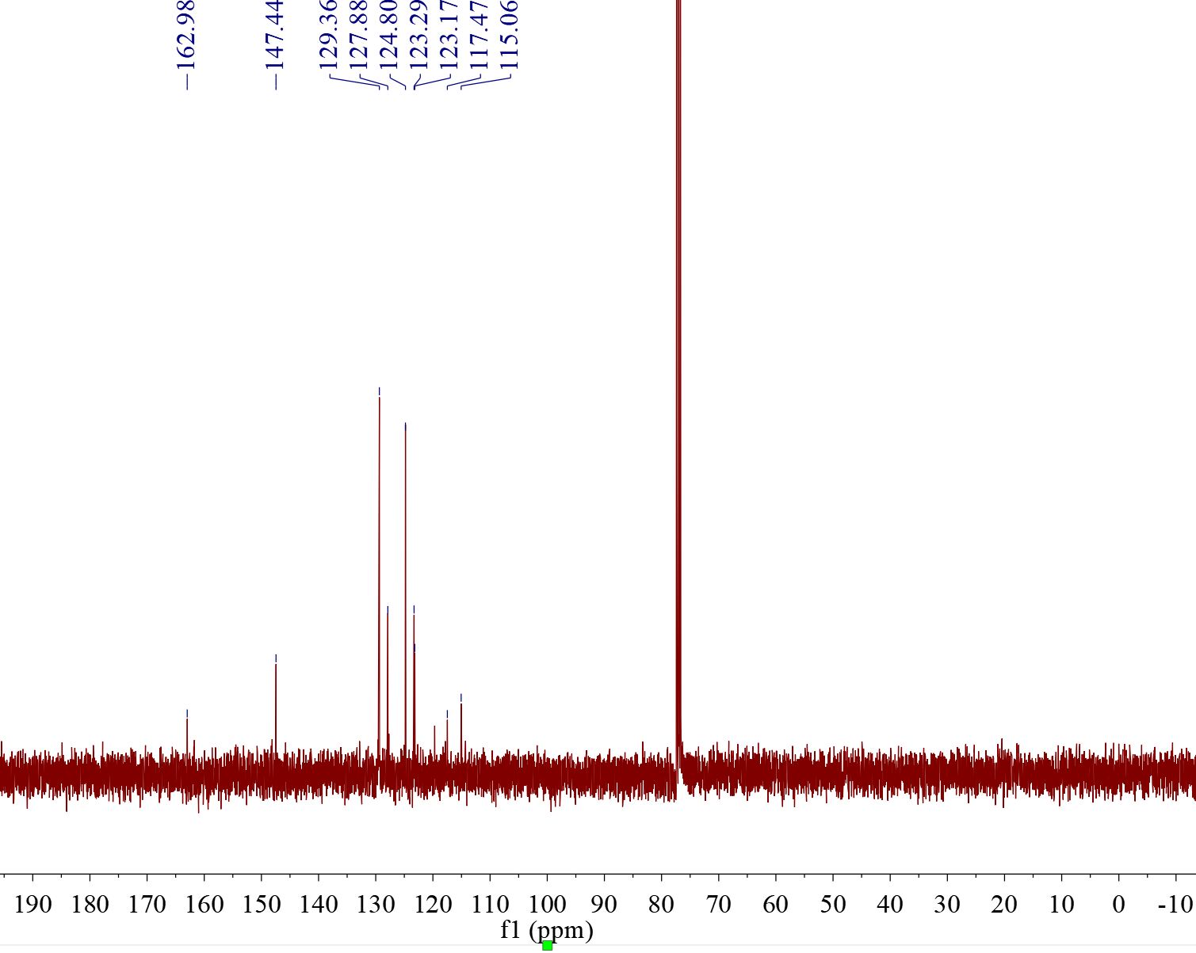
Fig. S2 ¹³C NMR of compound TPA-OPD

Fig. S3 MALDI-TOF-MS spectrum of TPA-OPD.

Fig. S4 UV-Vis absorption spectra of TPA-OPD in different solvents (1.0×10⁻⁵ M)
Fig. S5 The UV-Vis absorption spectra of TPA-OPD in DMSO-H₂O mixed solvent (1.0 × 10⁻⁵ M).

Fig. S6 MALDI-TOF-MS spectrum of TPA-OPD + Cu²⁺.
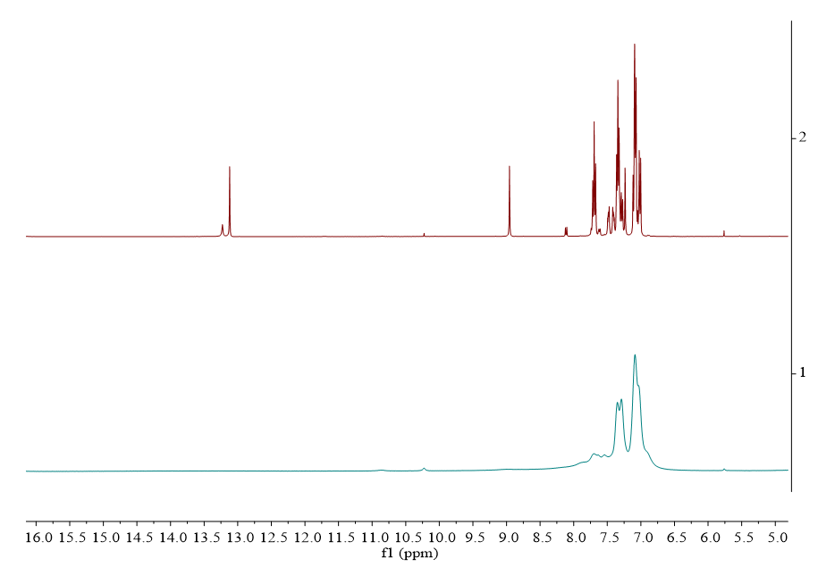
Fig. S7 ¹H NMR of compound TPA-OPD and TPA-OPD + Cu²⁺.

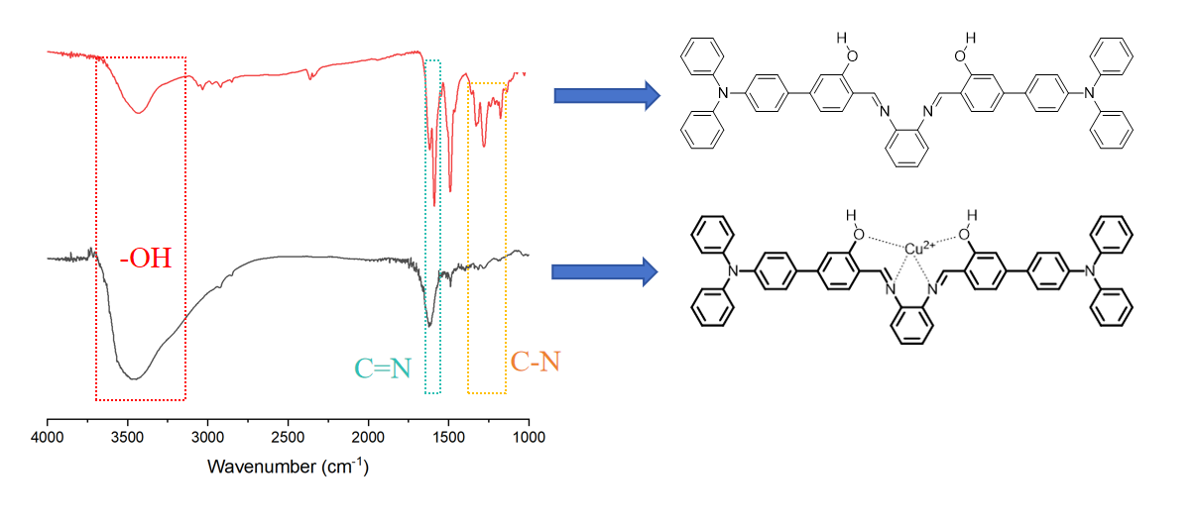
Fig. S8 FT-IR of compound TPA-OPD and TPA-OPD + Cu²⁺

Fig. S9 Schematic illustration of the chelation mechanism between TPA-OPD and Cu²⁺

Table S1 Comparison of LOD value for sensing Cu²⁺.
Sensor | Emission wavelength (nm) | LOD | Reference
 | 560 | 0.228 μM | Spectrochim. Acta A: Mol. Biomol. Spectrosc., 2024, 314, 124175.
 | 506 | 0.1 μM | Luminescence, 2024, 39(8), e4857.
 | 578/448 | 0.18 μM | Bioorganic Chemistry, 2023, 139, 106733.
 | 585 | 0.38 µM | Chemosensors, 2022, 10(10): 382-382
 | 575 | 33.0 nM | Spectrochimica Acta Part A: Molecular and Biomolecular Spectroscopy, 2024, 325: 125154-125154
 | 645 | 2.37 μM | Analytica Chimica Acta, 2023, 1276: 341602-341602
 | 531 | 0.43 μM | Journal of Hazardous Materials, 2024, 467: 133735-133735
 | 534 | 40.6 nM | Journal of Hazardous Materials, 2023, 465: 133192-133192
 | 790/825 | 1.4 µM | Spectrochimica Acta Part A: Molecular and Biomolecular Spectroscopy, 2024, 325: 125115-125115
 | 487 | 0.308 µM | Dyes and Pigments, 2022, 210: 110943-110943
 | 434 | 0.429 µM | Spectrochimica Acta Part A: Molecular and Biomolecular Spectroscopy, 2024, 304: 123291-123291
 | 455 | 0.77 µM | Journal of Photochemistry and Photobiology A: Chemistry, 2021, 415: 113318-113318
 | 529 | 85 nM | New Journal of Chemistry, 2022, 46(47): 22525-22532
 | 546 | 0.29 µM | Journal of Photochemistry and Photobiology A: Chemistry, 2021, 423: 113593-113593
 | 548 | 20.47nM | Our work

