Title: Seal tightly and store in a cool dry place: Exploring soil phosphorus storage in a subtropical treatment wetland.
Running Header: Wetland soil storage
Paul Julian II^{1,2}, Todd Z. Osborne^{2,3} and Vimala D. Nair³
¹ Sanibel-Captiva Conservation Foundation, Sanibel, FL 33957
*Corresponding Author: pjulian@sccf.org; ORCID: 0000-0002-7617-1354
² Whitney Marine Lab for Marine Bioscience, University of Florida, St. Augustine, Florida, 32080
³ University of Florida, Soil and Water Sciences Department, Gainesville, FL, 32611

Supplemental Information
Figure S1. Relationship between water extracted total dissolved phosphorus (TDP) and calculated oxalate extractable phosphorus saturation ratio (PSR) for iron and aluminum PSR (PSR_{FeAl, Ox}) for stormwater treatment area 2 flow-ways 1 and 3 (STA-2 FW1 and FW3, respectively). Change-point, as determined by segment regression, are identified by the vertical dashed line.

Figure S2. Scree plot for principal component analysis ordination presented in Fig. 5.

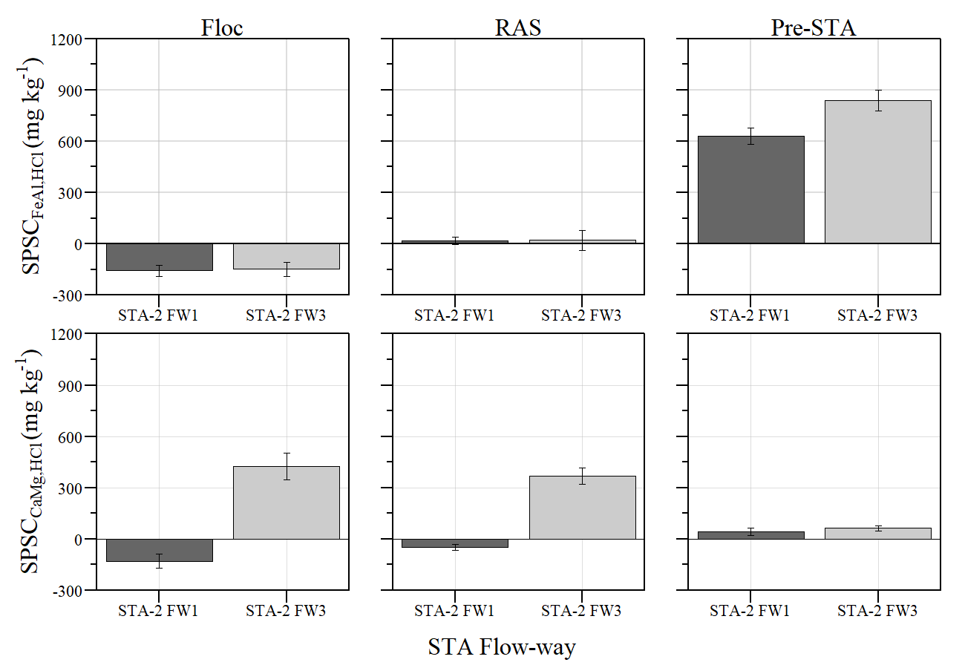
Figure S3. Mean (± standard error) soil phosphorus storage capacity (SPSC) by stormwater treatment area (STA) flow-way (FW) for SPSC_{FeAl} (top) and SPSC_{CaMg} (bottom).

Figure S4. Soil phosphorus storage capacity (SPSC) relative to distance downstream by stormwater treatment area (STA) flow-way (FW) and soil fraction for SPSC_{FeAl} (top) and SPSC_{CaMg} (bottom).

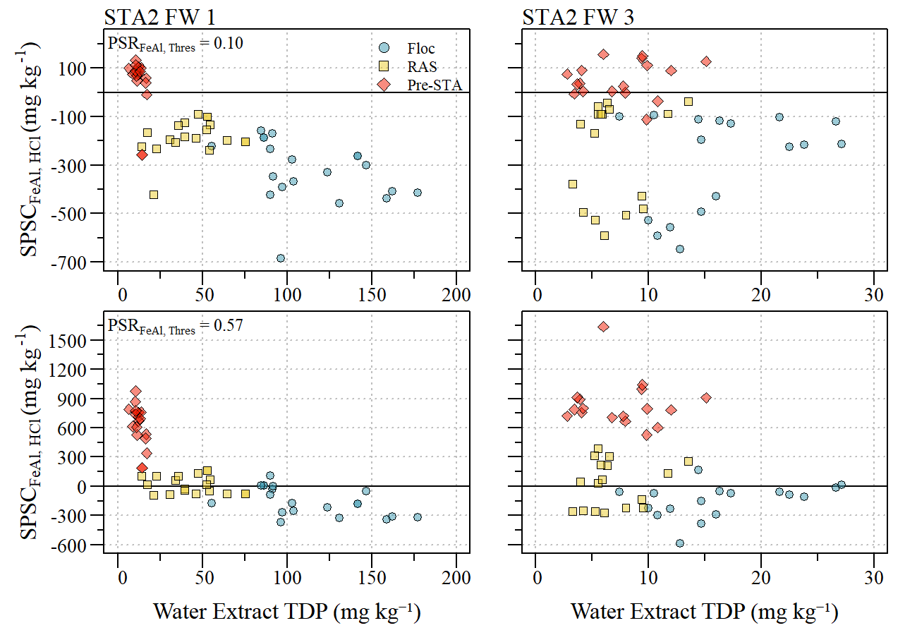
Figure S5. Comparison of iron and alumnim soil phosphorus storage capacity (SPSC_{FeAl, HCl}) estimated using literature reported PSR_{FeAl, Thres} (0.10; (Nair and Harris 2014) and segmented regression estimated value (0.57; this study) relative to water extractable total dissolved phosphorus (TDP) between stormwater treatment area flow-ways (STA FW) and soil fraction (Floc, RAS and Pre-STA).

Table S1. Summary statistics for parameters used in this study from samples collected along flow-ways 1 and 3 within Stormwater Treatment Area-2. Summary statistics expressed as mean ± standard error (sample size). Matrices include flocculent material (floc), recently accreted soil (RAS) and pre-STA soil (Pre-STA).
 |  |  | Mean ± SE (N)
Soil Depth | Parameter | units | STA2 FW1 | STA2 FW3
Floc | BD | g cm⁻³ | 0.04 ± 0.00(20) | 0.15 ± 0.01(17)
Floc | pH | SU | 7.52 ± 0.03(20) | 7.59 ± 0.05(17)
Floc | LOI | % | 74.2 ± 2.9(20) | 21.5 ± 1.8(17)
Floc | TP | mg kg⁻¹ | 1719.7 ± 106.7(20) | 697.3 ± 67.8(17)
Floc | TN | g kg⁻¹ | 33.2 ± 0.9(20) | 11.5 ± 0.7(17)
Floc | TC | g kg⁻¹ | 412.9 ± 12.7(20) | 193.5 ± 7.6(17)
Floc | TFe | mg kg⁻¹ | 1270.6 ± 225.3(20) | 945.0 ± 186.5(17)
Floc | TMg | mg kg⁻¹ | 5470.6 ± 339.8(20) | 8958.6 ± 186.7(17)
Floc | TCa | g kg⁻¹ | 93.4 ± 11.9(20) | 288.5 ± 7.1(17)
Floc | TAl | mg kg⁻¹ | 907.5 ± 198.9(20) | 762.2 ± 165.1(17)
Floc | TDP_{H₁O} | mg kg⁻¹ | 113.0 ± 7.3(20) | 16.4 ± 1.4(17)
Floc | P_{Ox} | mg kg⁻¹ | 405.7 ± 35.2(20) | 248.9 ± 33.6(17)
Floc | PSR_{FeAl} | ratio | 1.27 ± 0.14(20) | 1.41 ± 0.26(17)
Floc | PSR_{CaMg} | ratio | 0.005 ± 0.002(20) | 0.002 ± 0.003(17)
Floc | SPSC_{FeAl} | mg kg⁻¹ | -157.9 ± 31.9(20) | -148.5 ± 42.3(17)
Floc | SPSC_{CaMg} | mg kg⁻¹ | -129.4 ± 39.9(20) | 424.5 ± 78.5(17)
RAS | BD | g cm⁻³ | 0.07 ± 0.00(19) | 0.26 ± 0.02(17)
RAS | pH | SU | 7.67 ± 0.02(19) | 7.72 ± 0.02(17)
RAS | LOI | % | 79.7 ± 1.9(19) | 30.1 ± 2.8(17)
RAS | TP | mg kg⁻¹ | 1085.6 ± 43.0(19) | 596.9 ± 49.4(17)
RAS | TN | g kg⁻¹ | 30.1 ± 0.9(19) | 12.2 ± 0.9(17)
RAS | TC | g kg⁻¹ | 436.9 ± 10.7(19) | 232.2 ± 13.6(17)
RAS | TFe | mg kg⁻¹ | 1502.5 ± 185.9(19) | 1467.5 ± 132.1(17)
RAS | TMg | mg kg⁻¹ | 4407.8 ± 256.2(19) | 8231.6 ± 193.4(17)
RAS | TCa | g kg⁻¹ | 73.6 ± 7.8(19) | 258.4 ± 9.5(17)
RAS | TAl | mg kg⁻¹ | 876.8 ± 152.5(19) | 1189.2 ± 130.6(17)
RAS | TDP_{H₁O} | mg kg⁻¹ | 43.8 ± 4.1(19) | 6.8 ± 0.7(17)
RAS | P_{Ox} | mg kg⁻¹ | 166.5 ± 13.0(19) | 191.7 ± 24.7(17)
RAS | PSR_{FeAl} | ratio | 0.59 ± 0.05(19) | 0.59 ± 0.10(17)
RAS | PSR_{CaMg} | ratio | 0.004 ± 0.002(19) | 0.001 ± 0.001(17)
RAS | SPSC_{FeAl} | mg kg⁻¹ | 17.3 ± 21.2(19) | 20.4 ± 57.7(17)
RAS | SPSC_{CaMg} | mg kg⁻¹ | -46.9 ± 16.8(19) | 367.6 ± 49.1(17)

Table S1 continued
 |  |  | Mean ± SE (N)
Soil Depth | Parameter | units | STA2 FW1 | STA2 FW3
Pre-STA | BD | g cm⁻³ | 0.16 ± 0.01(19) | 0.31 ± 0.01(17)
Pre-STA | pH | SU | 7.44 ± 0.03(19) | 7.50 ± 0.02(17)
Pre-STA | LOI | % | 85.3 ± 0.4(19) | 79.3 ± 0.9(17)
Pre-STA | TP | mg kg⁻¹ | 415.1 ± 18.4(19) | 412.1 ± 16.8(17)
Pre-STA | TN | g kg⁻¹ | 30.6 ± 0.5(19) | 28.3 ± 0.5(17)
Pre-STA | TC | g kg⁻¹ | 478.7 ± 2.5(19) | 473.5 ± 3.7(17)
Pre-STA | TFe | mg kg⁻¹ | 2073.6 ± 86.5(19) | 2470.5 ± 110.1(17)
Pre-STA | TMg | mg kg⁻¹ | 4517.1 ± 123.2(19) | 5204.1 ± 192.3(17)
Pre-STA | TCa | g kg⁻¹ | 46.9 ± 1.5(19) | 65.5 ± 2.9(17)
Pre-STA | TAl | mg kg⁻¹ | 1824.2 ± 113.6(19) | 2012.2 ± 136.3(17)
Pre-STA | TDP_{H₁O} | mg kg⁻¹ | 12.4 ± 0.6(19) | 7.5 ± 0.9(17)
Pre-STA | P_{Ox} | mg kg⁻¹ | 73.1 ± 22.7(19) | 70.1 ± 8.5(17)
Pre-STA | PSR_{FeAl} | ratio | 0.08 ± 0.02(19) | 0.07 ± 0.01(17)
Pre-STA | PSR_{CaMg} | ratio | 0.002 ± 0.002(19) | 0.002 ± 0.001(17)
Pre-STA | SPSC_{FeAl} | mg kg⁻¹ | 631.0 ± 48.6(19) | 838.2 ± 59.5(17)
Pre-STA | SPSC_{CaMg} | mg kg⁻¹ | 42.1 ± 21.8(19) | 64.3 ± 15.1(17)

