Supplementary Material

Supplementary I: Mathematical Description of the Cost–Benefit Analysis (CBA) Simulation Model

1. Overview

This tool estimates the monetary and time savings from adopting mediation, rather than litigation, in medical malpractice disputes. The model uses stochastic simulation to account for uncertainty in costs, durations, and the gradual uptake of mediation. All parameters are user-defined and the model is implemented as a Monte Carlo simulation, generating distributions of possible outcomes.

2. Key Model Components

2.1. Triangular Distributions for Cost and Time Inputs

For each simulation run, the costs and durations for mediation and litigation are sampled from triangular distributions (one for each parameter). The input for these distributions is user-defined through the specification of the expected minimum (a), most probable (m), and maximum (b) value:

$$X\sim Trinagular\left(a,m, b\right)$$

2.2. Modeling the Uptake of Mediation: Sigmoid Function

A gradual adoption curve over time is defined. The proportion of cases entering mediation in each year is modeled by a sigmoid function, specifically:

$$p_{med}\left(t\right)=L_{low}+\frac{L_{up}-L_{low}}{1+e^{\left(-k\left(t-x_{0}\right)\right)}}$$

where:
$t$: Year, from 1 to the simulation maximum year
$L_{low}$: Initial uptake at year 1
$L_{up}$: Final uptake at the simulation maximum year
$x_{0}$: Midpoint of the time horizon set to ${L_{up}}/2$
$k$: Steepness parameter that controls the speed of uptake

At each year t the number of cases resolved by mediation is:

$$N_{med}\left(t\right)=N_{total}{×p}_{med}\left(t\right)$$

and the remainder that proceeds to trial is:

$$N_{trial}\left(t\right)=N_{total}-N_{med}$$

3. Simulation Logic

The following steps are performed for each simulation run, repeated n times (the default is set to 1000):

For each year t = 1, 2, …, T:
- Sample costs and times for mediation and trial from their respective triangular distributions.
- Calculate Per-Year Monetary Saving as: $S_{money}\left(t\right)={\left(C_{trial}-C_{med}\right)N}_{med}\left(t\right)$
- Calculate Per-Year Time Saving as: $S_{time}\left(t\right)={\left(M_{trial}-M_{med}\right)N}_{med}\left(t\right)$
- Apply Discounting (for monetary savings): $NPV\left(t\right)=\frac{S_{money}\left(t\right)}{{(1+r)}^{t}}$
- Store all per-year values for each run.

4. Output and Uncertainty Quantification

For each year, and for totals across the simulation horizon, we report
- the mean (expected) monetary savings with associated 95% credible intervals (empirical quantiles: 2.5th and 97.5th percentiles across simulation runs)
- the mean (expected) time savings with associated 95% credible intervals (empirical quantiles: 2.5th and 97.5th percentiles across simulation runs)
- The overall savings in money and court years for the entire projection period given the user specified expected total number of cases per year.

- Notation Table
Symbol | Description
$$a,m, b$$ | Minimum, mode, maximum for triangular distribution
T | Total years simulated
$$N_{total}$$ | Total cases per year
$$N_{total}$$ | Cases resolved by mediation
$$N_{total}$$ | Cases going to trial
$$p_{med}\left(t\right)$$ | Proportion entering mediation at year t
$$C_{med}$$ | Cost per mediated case (sampled)
$$C_{med}$$ | Cost per tried case (sampled)
$$M_{trial}$$ | Time per mediated case in months (sampled)
$$M_{trial}$$ | Time per tried case in months (sampled)
r | Discount rate

Supplementary II

Middle-income results

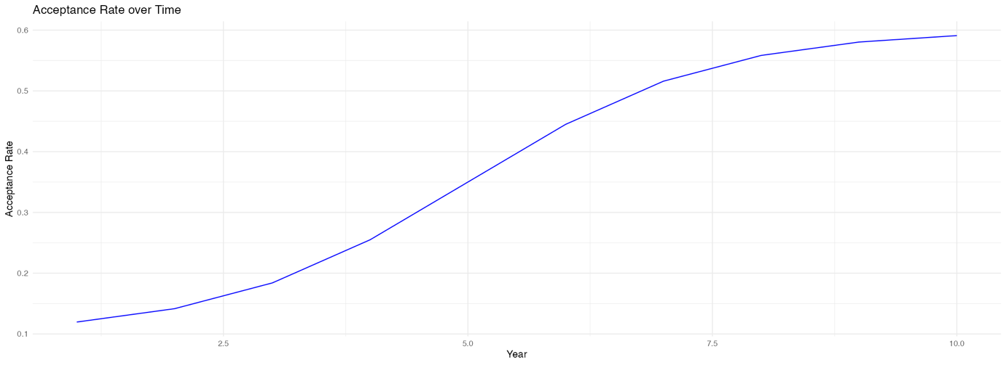

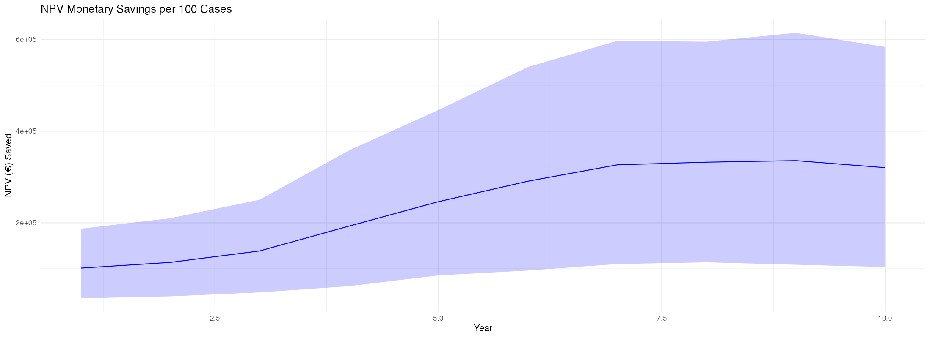
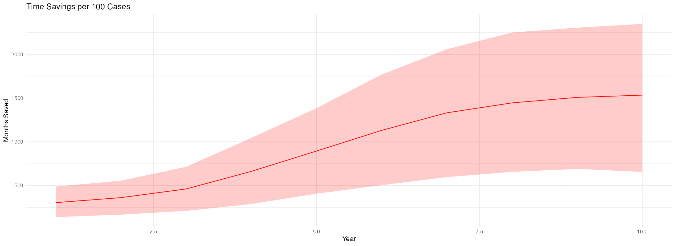

Year | Mediations | Trials | Monetary Savings (95% Cis) | Time Savings (95% Cis)
1 | 12 | 88 | 101366 (35514 -187246 ) |  | 304 (139 -487 )
2 | 14 | 86 | 113830 (39809 -210081 ) |  | 362 (167 -556 )
3 | 18 | 82 | 138808 (48476 -250491 ) |  | 461 (210 -714 )
4 | 26 | 74 | 192901 (62023 -357882 ) |  | 662 (289 -1045 )
5 | 35 | 65 | 246093 (85485 -445948 ) |  | 894 (407 -1385 )
6 | 44 | 56 | 290669 (96187 -539397 ) |  | 1130 (504 -1769 )
7 | 52 | 48 | 326457 (110230 -596747 ) |  | 1331 (597 -2059 )
8 | 56 | 44 | 332286 (114038 -594940 ) |  | 1445 (656 -2250 )
9 | 58 | 42 | 335693 (108769 -614145 ) |  | 1508 (690 -2305 )
10 | 59 | 41 | 320305 (103696 -583548 ) |  | 1534 (656 -2348 )
Total | 374 | 626 | 2398407 (1803804 -3071176 ) |  | 9631 (7655 -11777)

Low-Income results
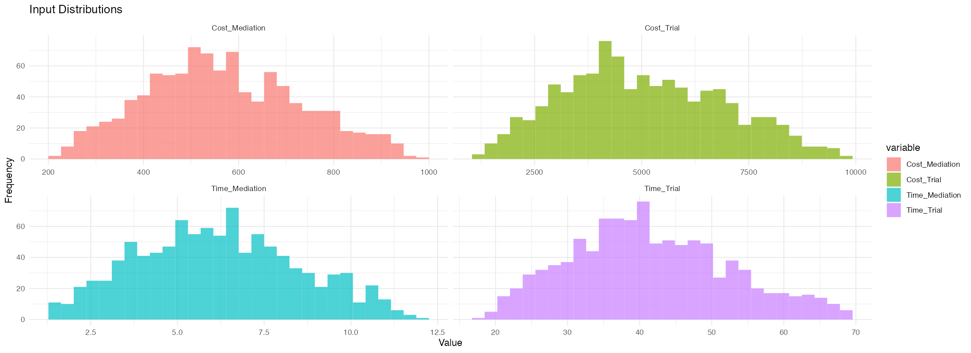

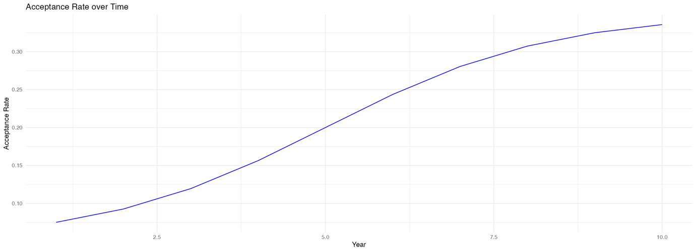

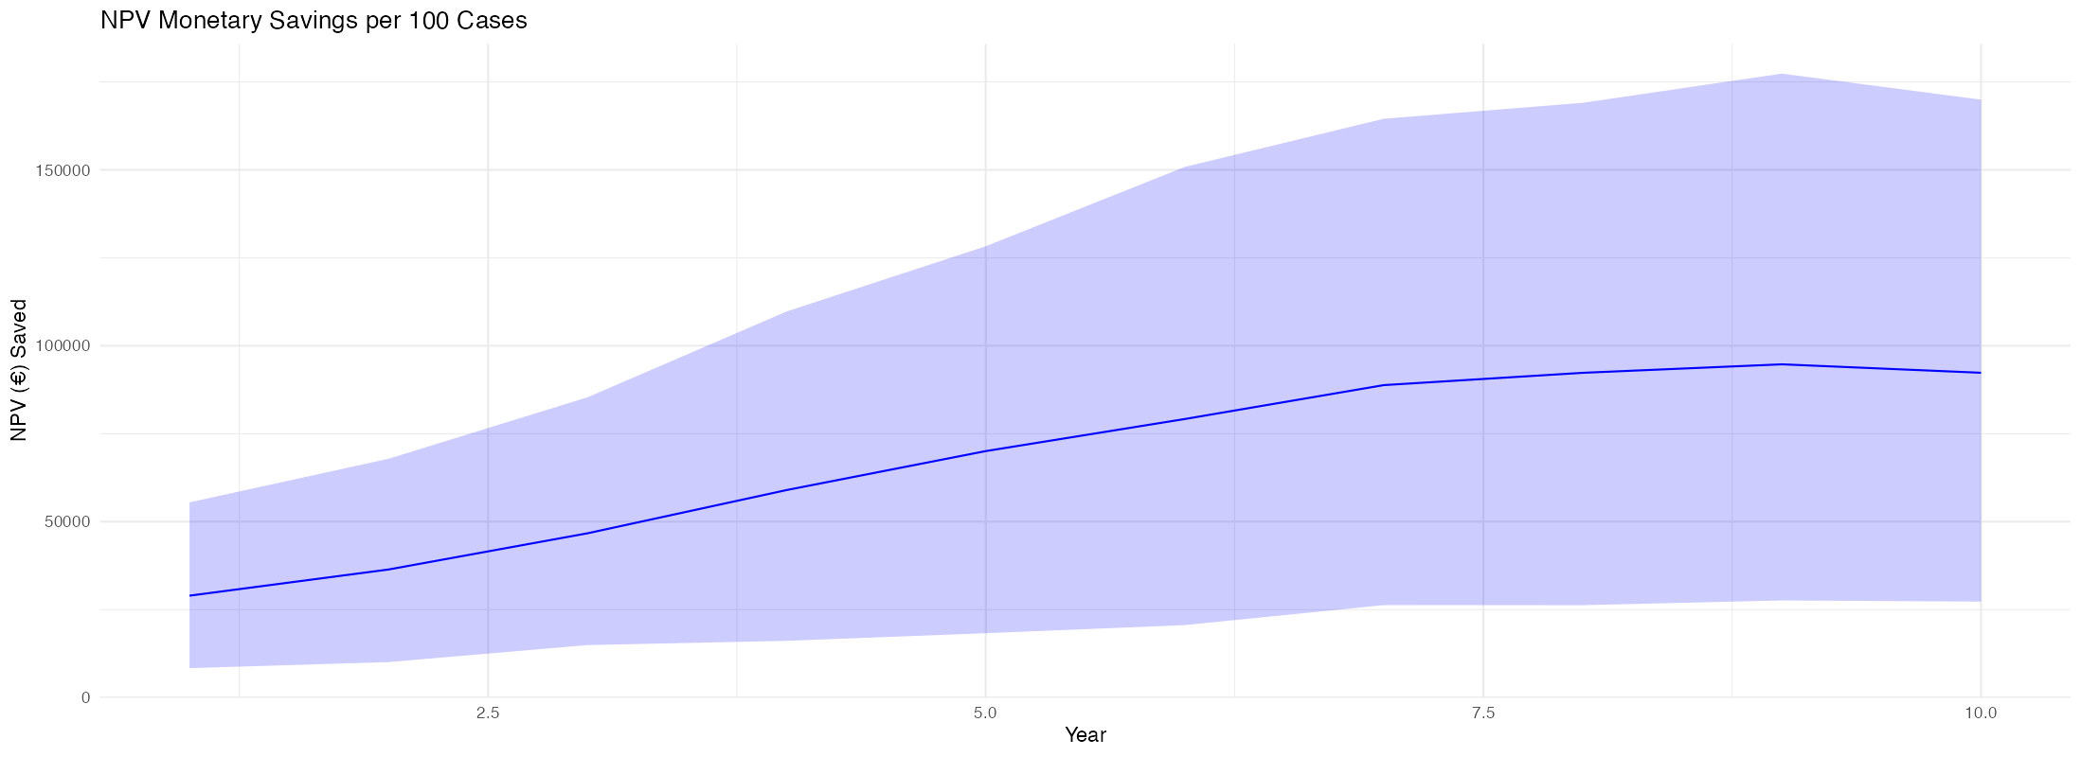

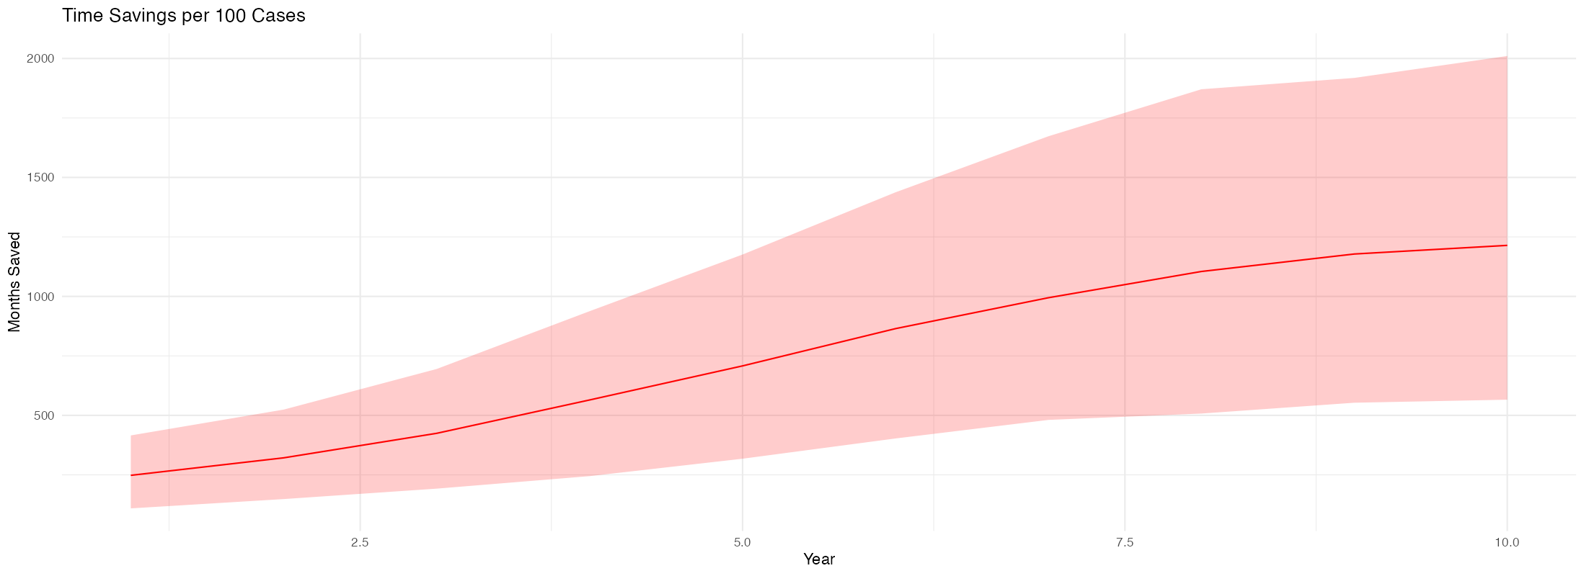

Year | Mediations | Trials | Monetary Savings (95% Cis) | Time Savings (95% Cis)
1 | 7 | 93 | 28968 (8367 -55486 ) | 248 (109 -416 )
2 | 9 | 91 | 36408 (10087 -67878 ) | 321 (148 -524 )
3 | 12 | 88 | 46704 (14924 -85362 ) | 425 (192 -695 )
4 | 16 | 84 | 58991 (16126 -109746 ) | 565 (245 -938 )
5 | 20 | 80 | 70062 (18296 -128282 ) | 708 (318 -1176 )
6 | 24 | 76 | 79179 (20602 -150833 ) | 865 (403 -1437 )
7 | 28 | 72 | 88818 (26282 -164527 ) | 994 (481 -1673 )
8 | 31 | 69 | 92313 (26265 -169066 ) | 1105 (508 -1871 )
9 | 33 | 67 | 94726 (27609 -177357 ) | 1178 (553 -1918 )
10 | 34 | 66 | 92325 (27274 -169955 ) | 1214 (566 -2010 )
Total | 214 | 786 | 688494 (484402 -885915 ) | 7623 (6070 -9355)

