Supplementary Information

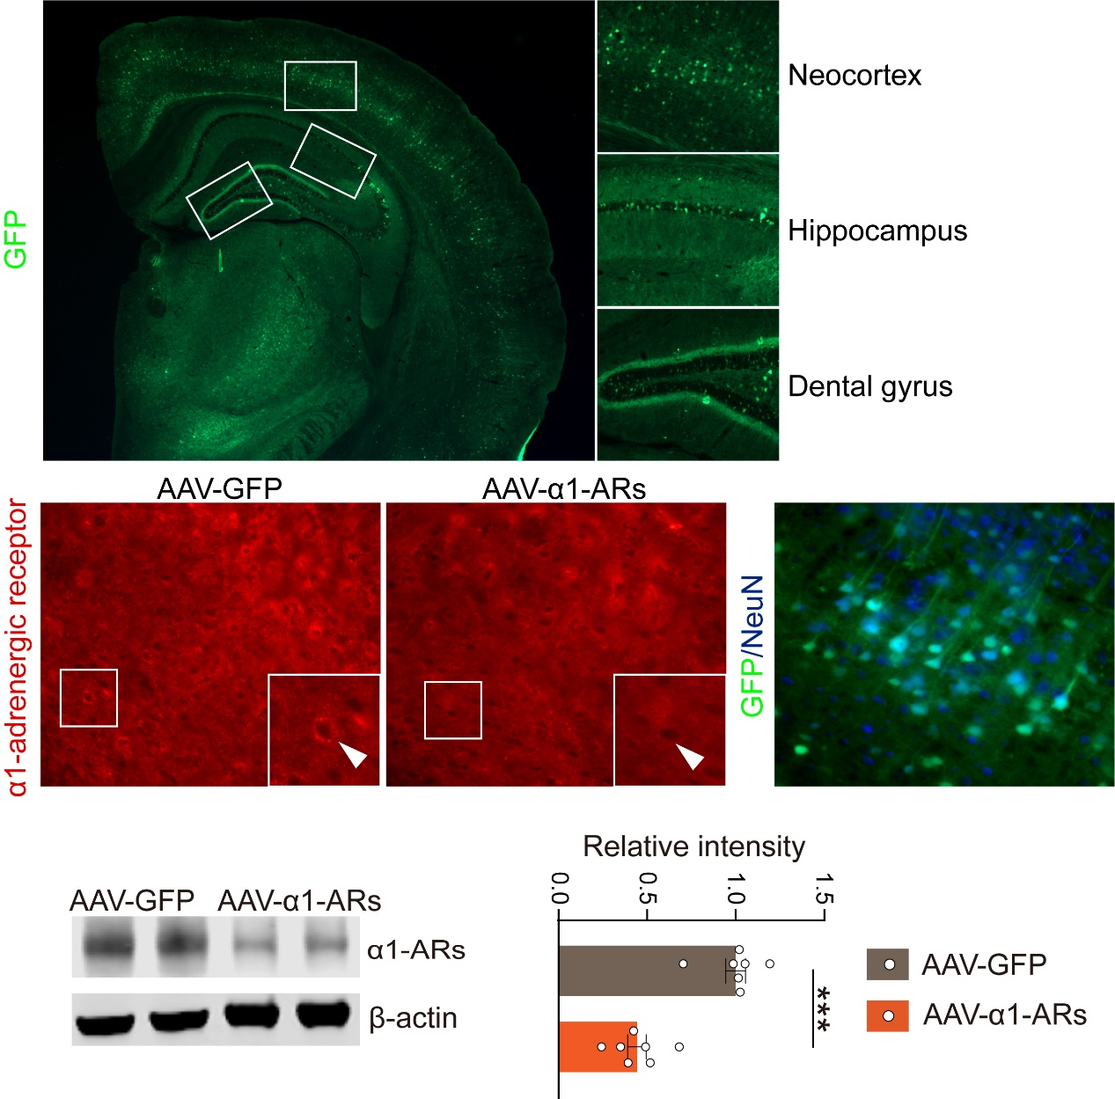
Figure S1. The representive immunostainign images and quantification of expression of α1-α1-ARs s in brain. n=8 per group; *** indicates P<0.001. Data are represented as mean ± SEMs.
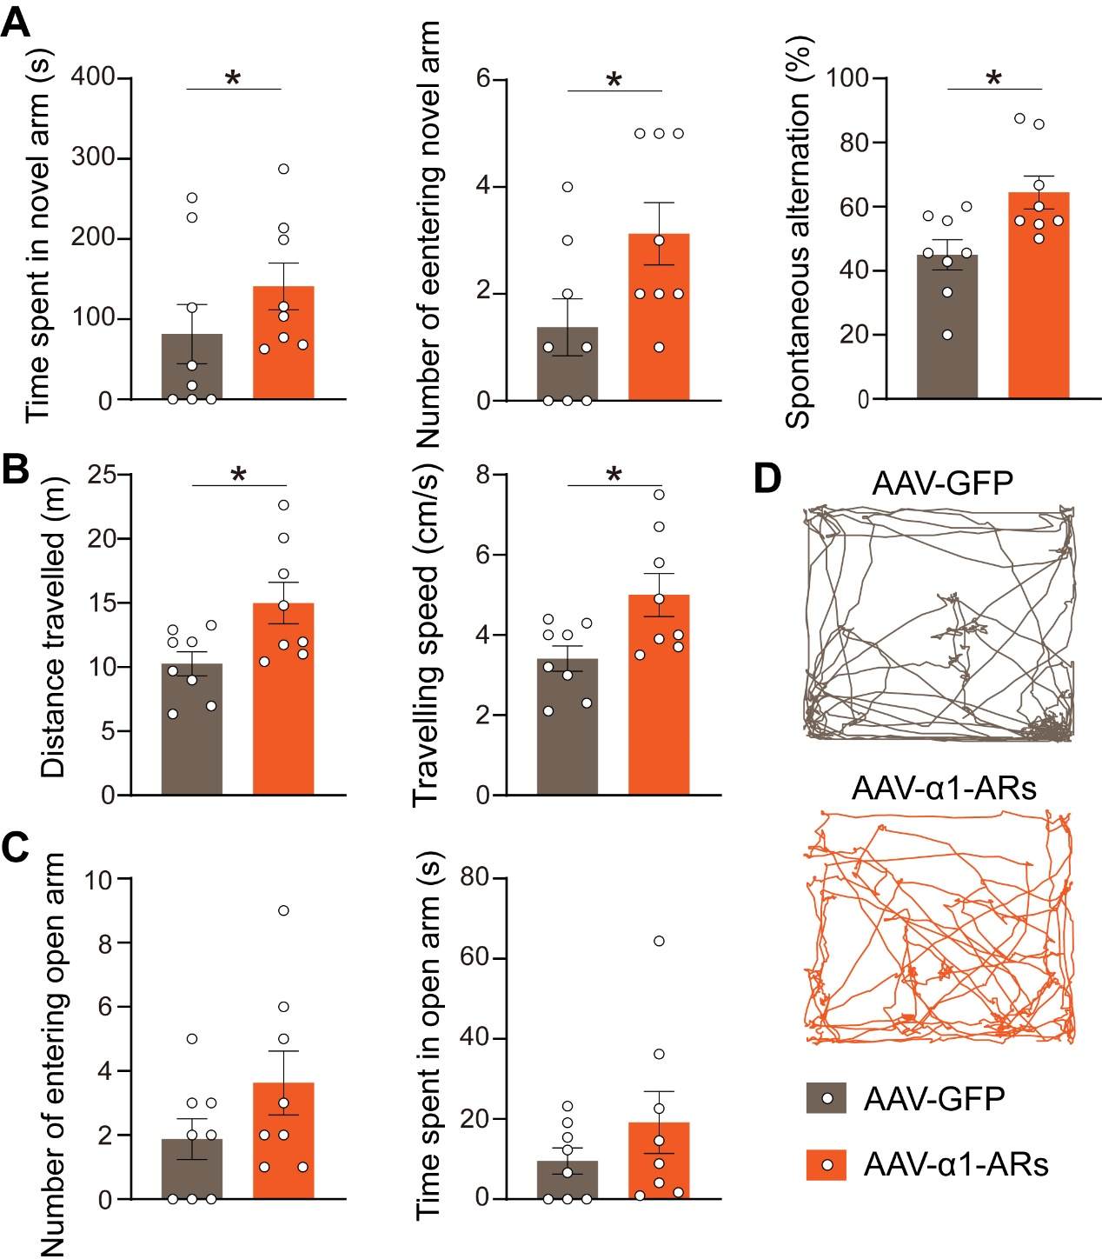
Figure S2. Knockdown of α1-ARs improved behaviour deficits in AD mice. A. Percentage of entries into the novel arm, percentage of time spent in the novel arm and spontaneous alterations in the Y maze test. B. Distance travelled and travelling speed in the open-field test. C. The number of entering and time spent in open arm in the Elevated Plus Maze test. D. Representative tracking images in the open-field test. n=8 per group; * indicates P<0.05. Data are represented as mean ± SEMs.

