Supplementary material
Species-Specific Growth Models Inform Sustainable Management of Rhizophora mangle in the Colombian Caribbean
Wetlands Ecology and Management
David Valderrama¹, Jaime Polanía¹, Valeria Aguiar¹, Sergio Orrego¹
¹ Departamento de Ciencias Forestales, Universidad Nacional de Colombia, sede Medellín, Carrera 65 No 59A – 110, Medellín, Colombia
Corresponding author: David Valderrama
E-mail address: dvalderramaca@unal.edu.co

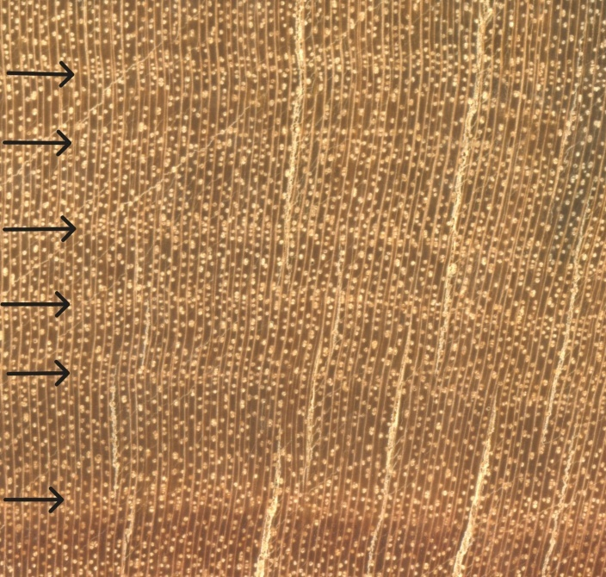
Fig. S1. Macroscopic aspect of Rhizophora mangle growth rings from a sampled tree’s cross-section. Black arrows indicate ring boundaries.
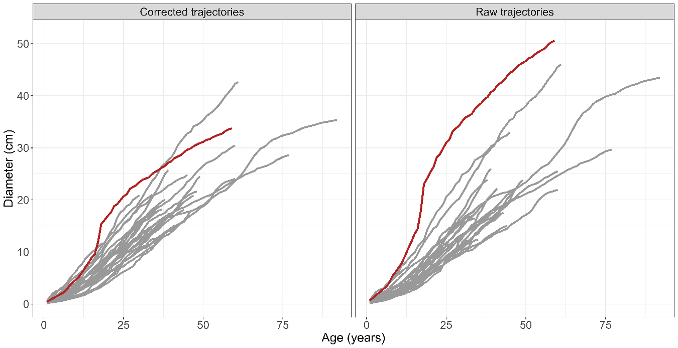
Fig. S2. Cumulative diameter growth trajectories of Rhizophora mangle population in Cispatá bay, based on tree-ring measurements. The left panel shows trajectories considering an eccentricity correction factor, while the right panel presents uncorrected (raw) cumulative diameter increments. The red trajectory highlights sample Z6-r2 which had a significant overestimation of growth before considering growth eccentricity.

Table S1. Ring-width measurements (raw and corrected), estimated age, and decay classification of Rhizophora mangle samples in Cispatá bay.
ID | radii | Raw diameter | Corrected diameter | Age | Decay class
cs1 | 1 | 32.00 | 28.59 | 77 | 3
cs1 | 2 | 29.67 | 28.59 | 77 | 3
d1 | 1 | 16.46 | 14.45 | 34 | 3
d1 | 2 | 12.70 | 14.45 | 34 | 3
d2 | 1 | 21.93 | 24.02 | 60 | 1
d2 | 2 | 30.45 | 24.02 | 60 | 1
d3 | 1 | 22.19 | 20.82 | 47 | 4
d4 | 1 | 23.84 | 19.98 | 48 | 3
d4 | 2 | 24.56 | 19.98 | 48 | 3
d5 | 1 | 24.97 | 25.69 | 39 | 2
d5 | 2 | 25.99 | 25.69 | 39 | 2
d6 | 1 | 26.48 | 30.47 | 60 | 1
d6 | 2 | 25.52 | 30.47 | 60 | 1
f1 | 1 | 22.17 | 15.07 | 41 | 2
f1 | 2 | 13.49 | 15.07 | 41 | 2
f2 | 1 | 12.39 | 12.59 | 35 | 1
f2 | 2 | 16.41 | 12.59 | 35 | 1
f3 | 1 | 19.40 | 18.13 | 37 | 1
f3 | 2 | 18.66 | 18.13 | 37 | 1
f4 | 1 | 11.89 | 16.43 | 32 | 2
f4 | 2 | 13.03 | 16.43 | 32 | 2
f5 | 1 | 20.62 | 21.61 | 48 | 4
f6 | 1 | 15.00 | 18.06 | 44 | 1
f6 | 2 | 17.15 | 18.06 | 44 | 1
f7 | 1 | 32.98 | 24.79 | 45 | 4
R1 | 1 |  |  |  | 5
r2 | 1 | 38.71 | 42.63 | 61 | 3
r2 | 2 | 45.97 | 42.63 | 61 | 3
r3 | 1 |  |  |  | 5
r4 | 1 | 18.01 | 17.97 | 35 | 3
r4 | 2 | 16.85 | 17.97 | 35 | 3
r5 | 1 | 45.34 | 35.34 | 92 | 3
r5 | 2 | 43.47 | 35.34 | 92 | 3
z1 | 1 | 16.57 | 16.63 | 38 | 1
z1 | 2 | 19.62 | 16.63 | 38 | 1
z2 | 1 | 17.53 | 15.49 | 43 | 1
z2 | 2 | 17.31 | 15.49 | 43 | 1
z3 | 1 | 23.83 | 24.5 | 49 | 1
z3 | 2 | 26.40 | 24.5 | 49 | 1
z4 | 1 | 19.14 | 17.87 | 46 | 3
z4 | 2 | 21.31 | 17.87 | 46 | 3
z5 | 1 | 17.74 | 21.02 | 34 | 1
z5 | 2 | 17.90 | 21.02 | 34 | 1
z6 | 1 | 39.02 | 33.74 | 59 | 3
z6 | 2 | 50.58 | 33.74 | 59 | 3
zf1 | 1 | 14.78 | 20.86 | 30 | 1
zf1 | 2 | 16.19 | 20.86 | 30 | 1
- no decay, (2) minor decay, (3) moderate decay, (4) advance decay, and (5) severe decay. Only one radius was analyzed for samples with advanced decay. Samples with severe decay were excluded from the analysis (red)

Table S2. Estimated random parameters of the von Bertalanffy’s diameter growth model and maximum mean diameter (A_{MAX}) for sampled trees of Rhizophora mangle in Cispatá bay.
ID | $$η$$ | $$m$$ | A_{MAX}
cs1_r2 | 0.37 | 0.55 | 33.42
d1_r1 | 0.36 | 0.58 | 38.12
d2_r1 | 0.32 | 0.59 | 34.57
d3_r1 | 0.33 | 0.61 | 43.35
d4_r1 | 0.37 | 0.59 | 45.52
d5_r2 | 0.38 | 0.61 | 60.94
d6_r2 | 0.39 | 0.56 | 40.08
f1_r1 | 0.31 | 0.63 | 41.12
f2_r1 | 0.32 | 0.60 | 33.76
f3_r1 | 0.39 | 0.55 | 35.98
f4_r2 | 0.38 | 0.58 | 43.01
f5_r1 | 0.38 | 0.54 | 32.91
f6_r1 | 0.35 | 0.57 | 33.66
f7_r1 | 0.46 | 0.50 | 35.81
r2_r2 | 0.41 | 0.58 | 55.56
r4_r1 | 0.41 | 0.54 | 37.76
r5_r2 | 0.33 | 0.61 | 39.85
z1_r1 | 0.36 | 0.57 | 36.37
z2_r1 | 0.32 | 0.58 | 32.05
z3_r1 | 0.33 | 0.63 | 50.51
z4_r2 | 0.31 | 0.63 | 40.70
z5_r2 | 0.44 | 0.53 | 40.14
z6_r2 | 0.53 | 0.48 | 39.37
zf1_r2 | 0.48 | 0.50 | 39.26
$η$ and $m$ represent the photosynthesis parameters in the equation. A_{max}: maximum mean diameter or model’s asymptote

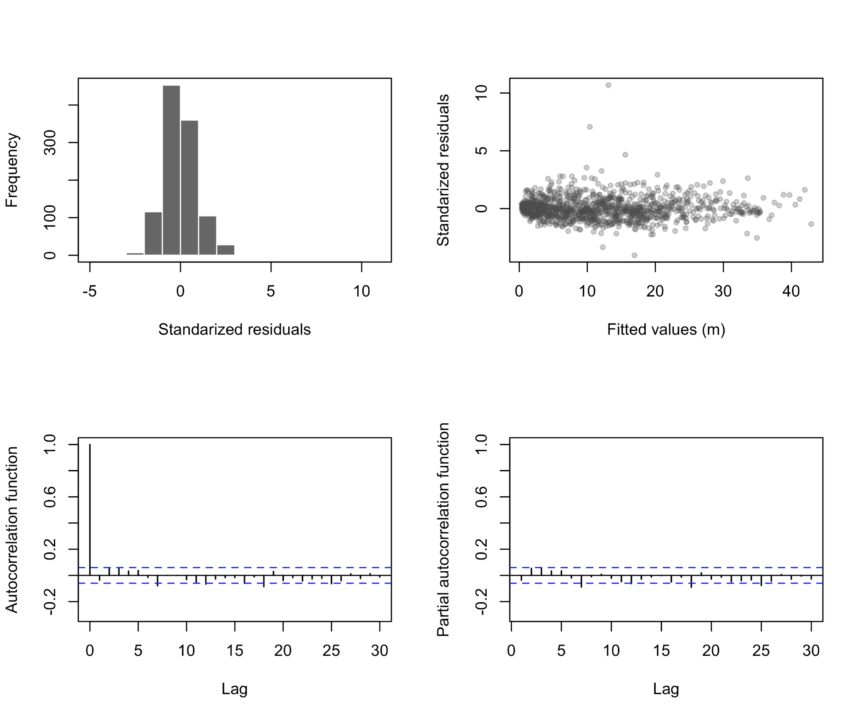
Fig. S3. Diagnostic plots for the von Bertalanffy diameter growth model fitted to Rhizophora mangle in Cispatá Bay: histogram of residuals (upper-left panel), standardized residuals versus fitted diameter values (upper-right panel), autocorrelation function (bottom-left panel), and partial autocorrelation function (bottom-right panel), after accounting for autocorrelation.

Table S3. Performance of the Michaelis-Menten diameter-height model fitted to Rhizophora mangle in Cispatá bay using different combinations of random parameters. The selected model is highlighted in bold.
Random parameters | AIC | BIC | logLik
$α$ | 14210.5 | 14247.9 | -7099.3
$β$ | 14134.5 | 14171.9 | -7061.3
$α+β$ | 14072.2 | 14134.6 | -7026.1

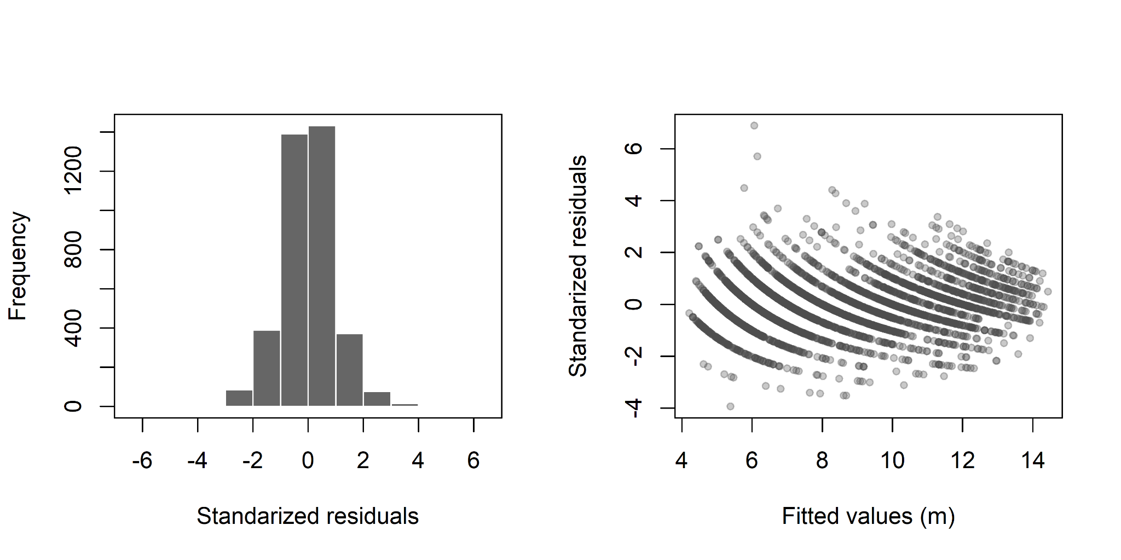
Fig. S4. Frequency histograms to test the normality of the residuals (left panel), and Standardized residuals versus fitted height values (right panel) for the Michaelis-Menten diameter-height model fitted to Rhizophora mangle in Cispatá bay

