Generating Vectorial Optical Fields via Surface-Wave-Excited Complex-Amplitude Metasurfaces
Xiangyu Jin^{1,3#}, Yu He^{2,3#}, Jianru Li^{1,3}, Xiaoya Nie^{1,3}, Shuai Du^{1,3}, Yufei Song^{2,3}, Haoyu Luo^{1,3}, Muhan Liu^{1,3}, Shaojie Ma^{1,3}, Qiong He^{2,3}, Lei Zhou^{2,3*}, Zhuo Wang^{3,4*}, Shulin Sun^{1,3*}

¹Shanghai Engineering Research Centre of Ultra Precision Optical Manufacturing, Department of Optical Science and Engineering, College of Future Information Technology, Fudan University, Shanghai 200433, China
²State Key Laboratory of Surface Physics and Key Laboratory of Micro and Nano Photonic Structures (Ministry of Education), Fudan University, Shanghai 200433, China
³Shanghai Key Laboratory of Metasurfaces for Light Manipulation, 200433 Shanghai, China
⁴Shanghai Frontiers Science Research Base of Intelligent Optoelectronics and Perception, Institute of Optoelectronics, Fudan University, Shanghai 200433, China.

Keywords: Complex amplitude; Vectorial holography; On-chip metasurface; Terahertz; Surface wave

Outlines
S1. Fabrication process of proposed terahertz metasurface sample 3
S2. Design and characterization of the terahertz meta-coupler for exciting surface wave 4
S3. Terahertz time-domain near-field spectroscopy system 5
S4. Dual focal beams with arbitrary intensity and polarization states 6
S5. Comparison between the traditional GS and modified GS algorithm 7
S6. MSE comparison of phase-only and complex-amplitude holography 9
S7. Phase distribution of target plane in phase-only and complex-amplitude holography 9
S8. Broadband performance of complex amplitude hologram generations 10
S9. Discretized complex-amplitude vectorial holography 10

S1. Fabrication process of proposed terahertz metasurface sample
The fabrication of the THz sample consists of three main stages: (i) preparation of the meta-coupler for SW excitation, (ii) fabrication of the plasmonic metal and meta-decoupler for transporting and decoupling SW, and (iii) substrate alignment and bonding. As illustrated in Fig. S1(a), the sample is realized on a 55-μm-thick quartz substrate, which is first patterned by photolithography (MA6), followed by the deposition of a 100-nm-thick gold film using magnetron sputtering (DE500). A standard lift-off process with acetone was then employed to remove the excess metal and retain the designed patterns. Subsequently, aligned photolithography was performed on the backside of the same substrate, followed by additional thin-film deposition and lift-off steps. The resulting SW-excitation MS is shown in Fig. S1(b). For the SW-decoupling MS, a second 55-μm-thick quartz substrate was processed via photolithography and thin-film deposition to create the meta-decoupler and plasmonic metal sample, as shown in Fig. S1(c). Finally, the two quartz substrates were carefully aligned and bonded together with UV adhesive, yielding the complete THz MS device.
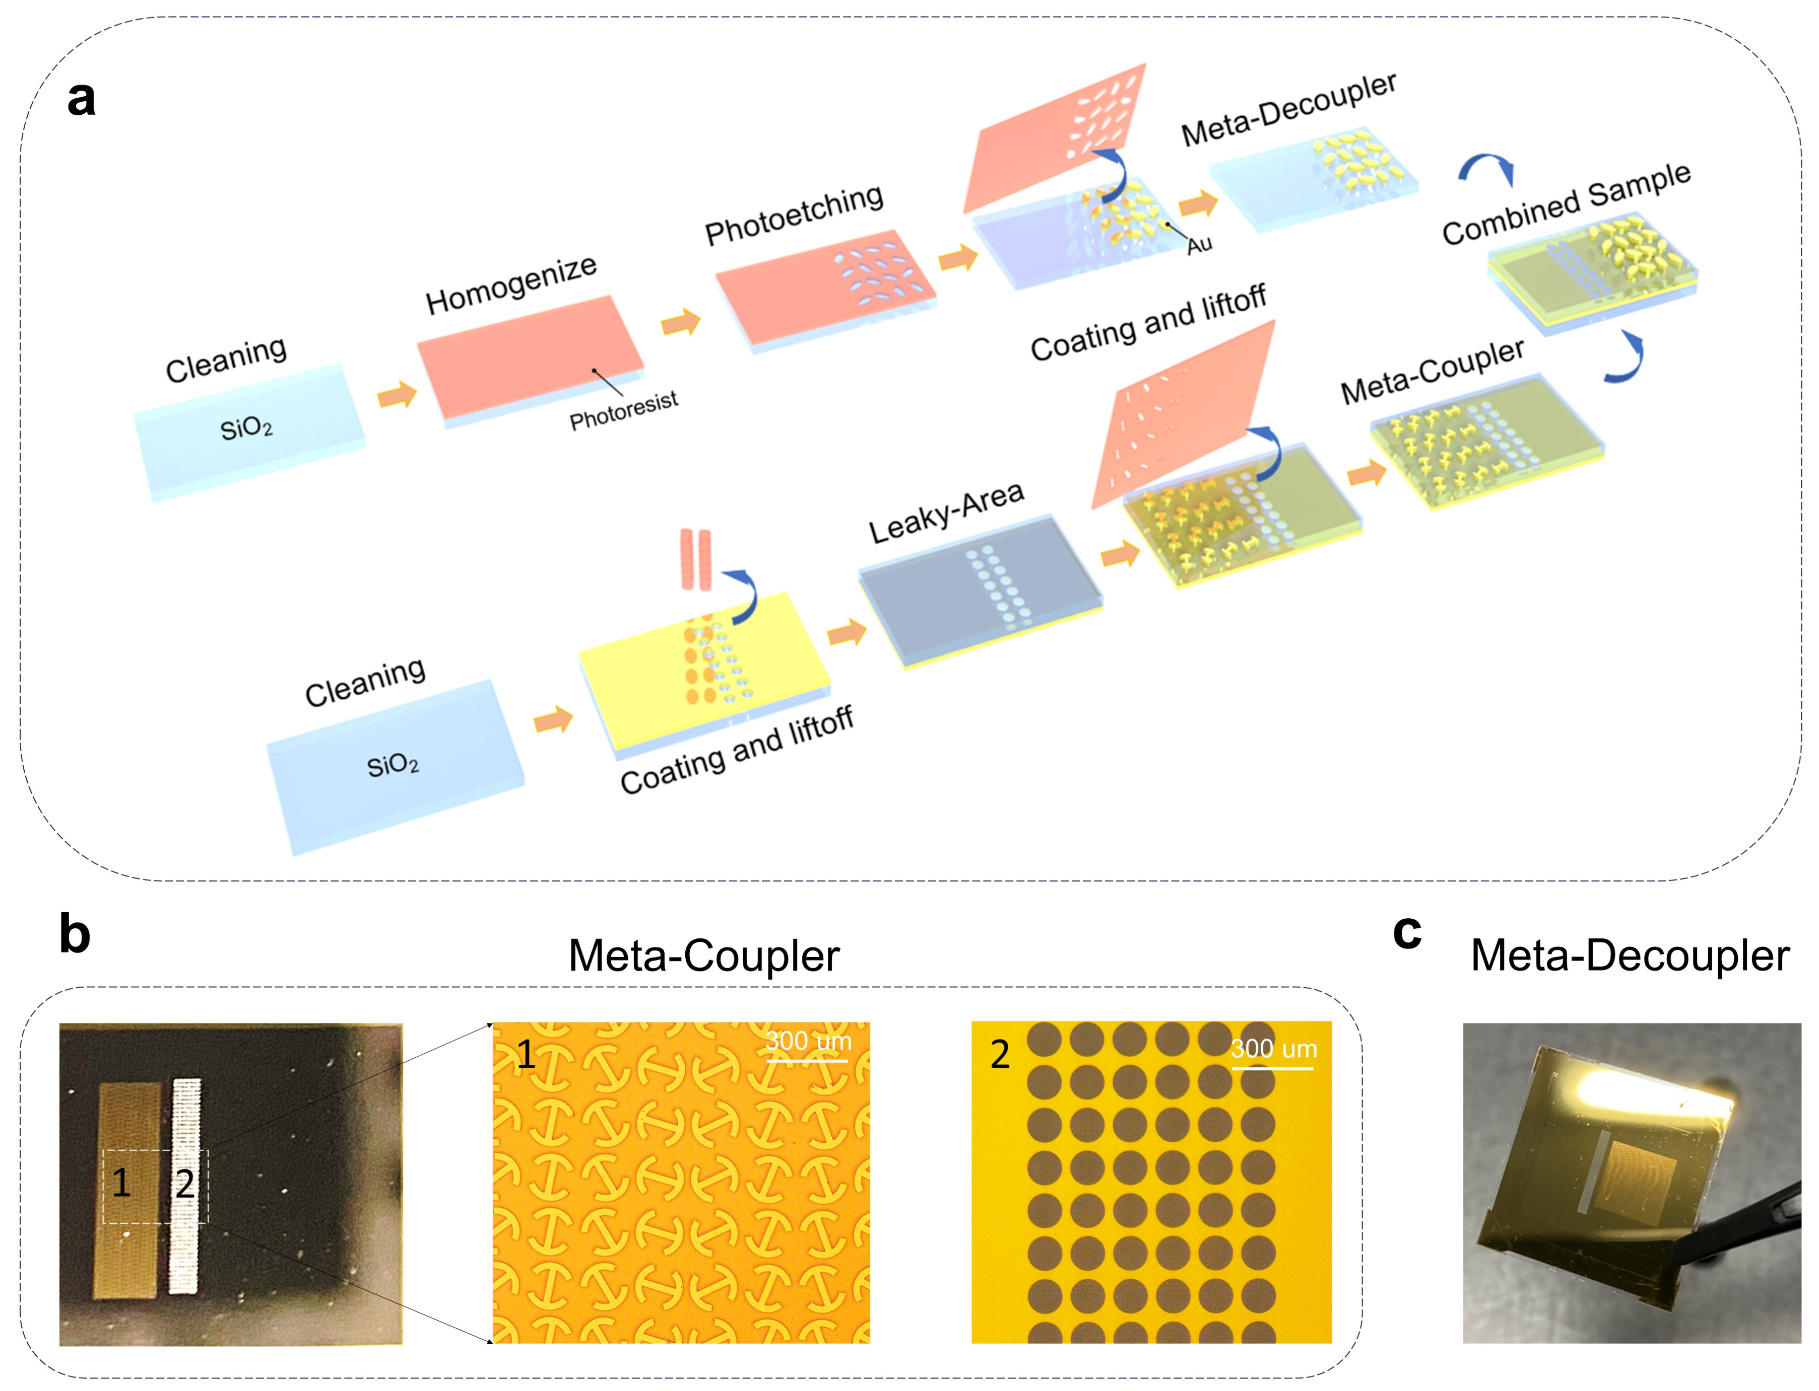
FIG. S1. Fabrication process of the whole sample, consisting of a SW meta-coupler, plasmonic metal and SW meta-decoupler. (a) Fabrication process of the whole sample. (b-c) Meta-coupler and Meta-decoupler of fabricated sample.

S2. Design and characterization of the terahertz meta-coupler for exciting surface wave
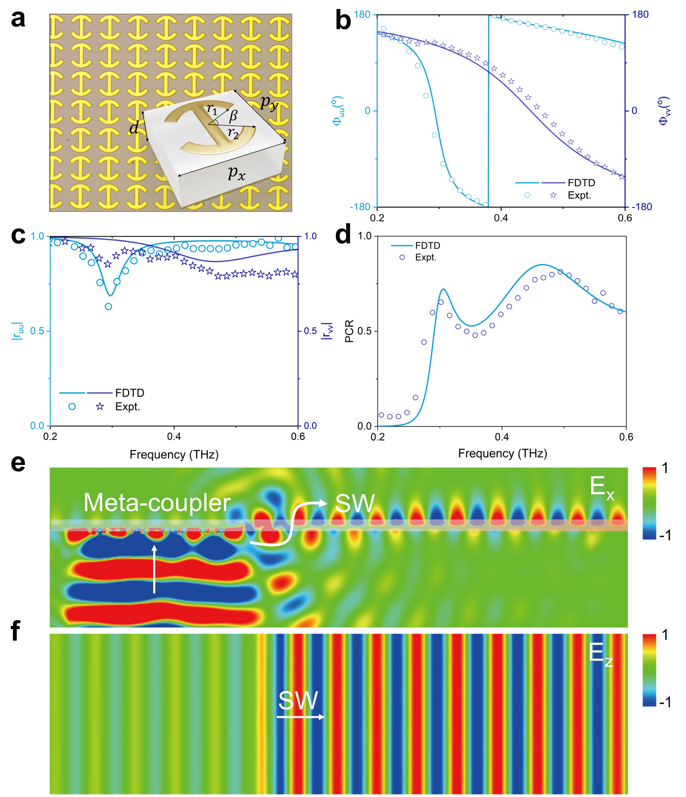
FIG. S2. Characterization of the meta-coupler for launching SW on the plasmonic metal. (a) Picture of the fabricated PB meta-atoms composed of curved I-shaped metallic microstructures as the top layer and a metallic thin film as the bottom layer, separated by a 55-$μ$m thick dielectric spacer ($ε_{r}=3.9+0.001i$). Here, inset figure shows the geometry of the meta-atom with the parameters of $p_{x}=p_{y}=160 μm$, $d=55 μm$, $r_{1}=70 μm$ $r_{2}=50 μm$, $β={60}^{°}$. (b-d) Spectra of reflection phase (${ Φ}_{uu}$ and ${ Φ}_{vv}$), reflection amplitude (${|r}_{uu}|$ and $|r_{vv}|$) and polarization conversion ratio ($PCR$) of the periodic PB meta-atoms shown in (a), which are obtained by simulations and experiments. (e, f) Simulated E_{x} and E_{z} distributions inside the meta-coupler for SW excitation on the xoz plane (y = 0 mm) and the xoy plane at (z= 0 mm). Here, we use PB meta-coupler to convert the PW into SW from the bottom side. Then, the generated SW would gradually leak to the top side of the plasmonic metal through the hole structure ($r=60 um$), thereby preventing the overlapping between the incident PW in the bottom free space and the radiated PW in the upper free space

S3. Terahertz time-domain near-field spectroscopy system
A broadband terahertz beam is emitted from the laser and then first expanded and collimated using a lens. After that, its polarization state is converted to circular polarization via the combination of a linear polarizer (LP) and a half-wave plate (HWP). The free-space circular beam is then coupled into surface waves by the meta-coupler and then decoupled back to the desired structured light by the metasurace (MS). Finally, the waves emitted by the MS are detected using a terahertz probe.
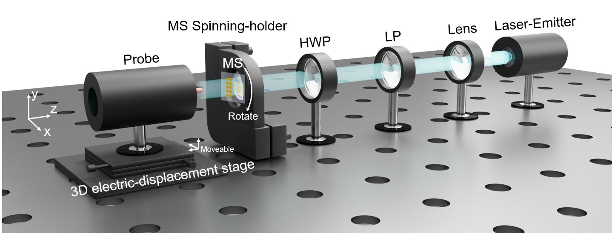
FIG. S3. Schematic diagram of the near-field measurement setup for mapping the electric field pattern (including ampltidue and phase) emitted by the SW-excited metasurfaces.

S4. Dual focal beams with arbitrary intensity and polarization states
$${\tilde{E}}_{odd}^{+}\left(x,y\right)={(A}_{1}^{+}e^{iφ_{1}^{+}\left(x,y\right)}+A_{2}^{+}e^{iφ_{1}^{+}\left(x,y\right)})e^{-iφ_{sw}^{+}}$$
$${\tilde{E}}_{even}^{-}\left(x,y\right)={(A}_{1}^{-}e^{iφ_{1}^{-}\left(x,y\right)}e^{i∆φ_{1}}+A_{2}^{-}e^{iφ_{1}^{-}\left(x,y\right)}e^{i∆φ_{2}})e^{-iφ_{sw}^{-}}$$
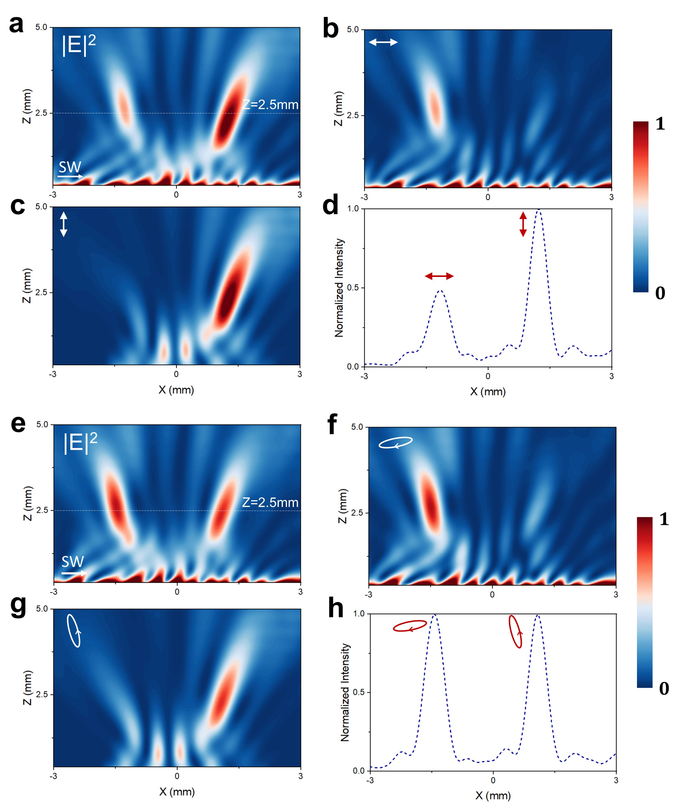
FIG. S4. Dual focus beams with arbitrary intensity and polarization states generated by the on-chip metasurface. (a-d) Dual focus beams generation with different intensities (0.5:1) and orthogonal linear polarizations (TM-, TE-linear polarizations). Here, we set$A_{1}^{+}/A_{2}^{+}=1/\sqrt{2}$, $A_{1}^{-}/A_{2}^{-}=1/\sqrt{2}$, $∆φ_{1}=0$, $∆φ_{2}=π$ to achieve this goal. (e-h) Dual focus beams generation with same intensities but different elliptical polarizations. Here, we set$A_{2}^{+}/A_{1}^{+}=1/\sqrt{2}$, $A_{2}^{-}/A_{1}^{-}=\sqrt{2}/1$, $∆φ_{1}=0$, $∆φ_{2}=π$ in our MS design.

S5. Comparison between the traditional GS and modified GS algorithm
The traditional Gerchberg–Saxton (GS) algorithm is the phase retrivial method for designing the MS to achieve the desired complex wavefront distribuiton in the image plane. As shown in Fig. S6(a), we start by defining the target holographic image on the image plane. Its amplitude distribution is derived from that of the target holographic image, while its phase profile is randomly initialized. The algorithm then iteratively performs forward and inverse Fourier transforms between the MS and image planes. During each iteration, while the phase information on the MS plane is reserved in the structural design, the amplitude information, which exhibits the inhomogneous spatial distribution, have to be uniformaly set to be unit due to the lack of degree of freedom in the design of most metaholograms. Eventually, we can obtian the phase information to design the phase-only (PO) MS. However, the quality of the reconstructed holograpic image by such a PO MS is degraded.
In this work, we propose a modified weighted complex-amplitude (CA) GS algorithm for generating vectorial holography through simultaneously and independently controlling both phase and amplitude of LCP and RCP fields radiated by the MS. As shown in the flowchart in Fig. S6(b), the algorithm starts by generating a target field “F” on the image plane with a randomly initialized phase distribution. The iteration performs Fresnel diffraction from the MS plane to the image plane, where the amplitude is replaced with the desired target image “F”. To accelerate the convergence of our method, weighting factors $w_{n}$are introduced to assign different importance to various regions of the light field. The weight for the $n^{th}$ iteration is defined as:
$$A_{n}=A_{n-1}×w_{n-1}$$
$w_{n}={|A}_{design}/A_{n}|×w_{n-1}$.
Here, $A_{n}$ is the $n^{th}$amplitude distribution on the image plane, and $A_{design}$is the amplitude of target holographic image. Additionally, we can arbitrarily manipulate the phase distribution on the imaging plane to make it either uniform or imhomogeneous. Unlike the traditional GS algorithm, the amplitude distribuition will be also iteratively updated instead of be always set to be unit during each loop.The iteration process will contineously run until the Mean Squared Error (MSE) of both the amplitude and phase distributions of the target image reach the threshold. In the end, the iteration process terminates, yielding the final complex amplitude distributions on the MS plane. Meanwhile, to avoid the iterative algorithm from dropping to the local minimum solution, optimization steps are often introduced using a gradient descent algorithm or genetic algorithm.
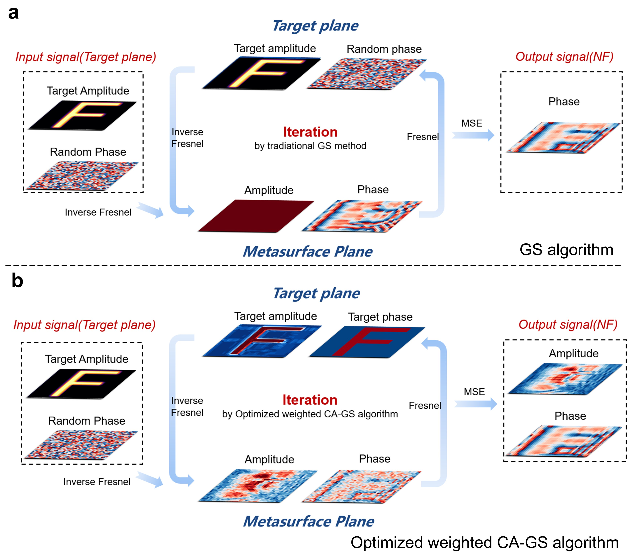
FIG. S5. Comparison between two GS algorithms. (a) Flowchart of the traditional GS algorithm for generating scalar phase-only holography. (b) Flowchart of the modified complex amplitude GS algorithm for generating complex-amplitude vectorial holography.

S6. MSE comparison of phase-only and complex-amplitude holography
Mean Squared Error (MSE) is widely utilized to evaluate the quality of a generated image, which is defined as:
$$MSE=\frac{1}{MN}\sum_{i=1}^{M}{\sum_{j=1}^{N}{{\left[I\left(i,j\right)-K(i,j)\right]}^{2}}}$$
Here, M and N represent the numbers of collected pixels in the image plane along two orthogonal directions. $I​(i, j)$ and $K\left(i, j\right)$ represent the complex amplitude (amplitude and phase) distribution of the pre-designed target image and the ultimate generated image with desired phase at the position labeled as $(i,j)$ on the target plane. The formula confirms the difference between the theoretical design (amplitude and phase) and the practical realization of the holography.

S7. Phase distribution of target plane in phase-only and complex-amplitude holography
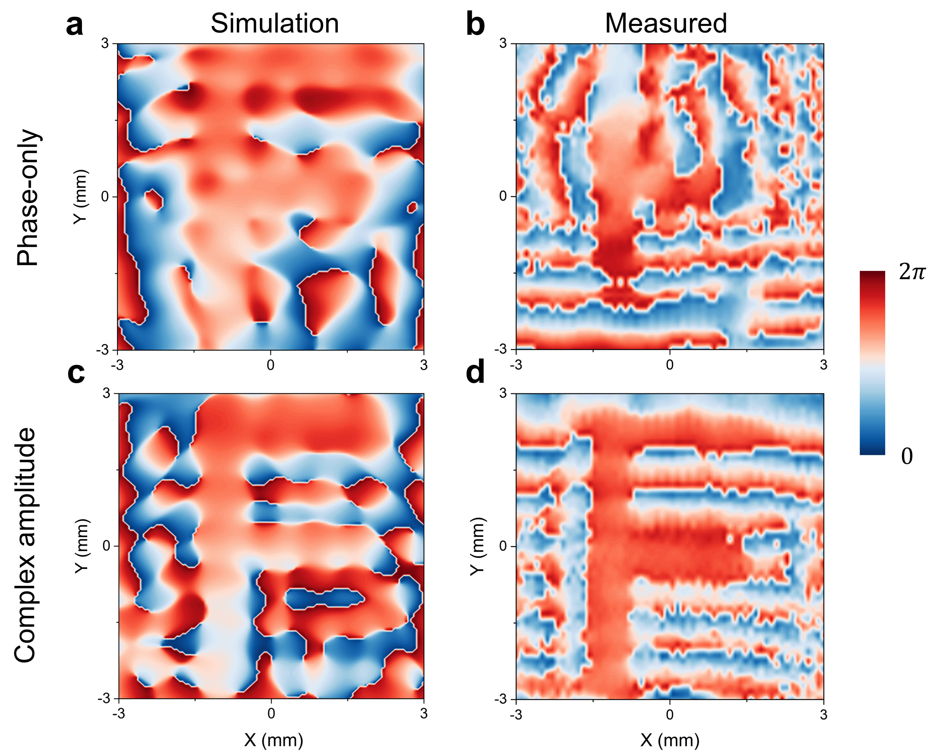
FIG. S7. Phase distribution of target image plane ($z=1.5 mm$) in phase-only (PO) and complex-amplitude (CA) holography at 0.4 THz. (a-d) Simulated and measured phase distributions of PO (a, b) and CA holography (c, d) at target plane by the designed MS under SW excitation.

S8. Broadband performance of complex amplitude hologram generations
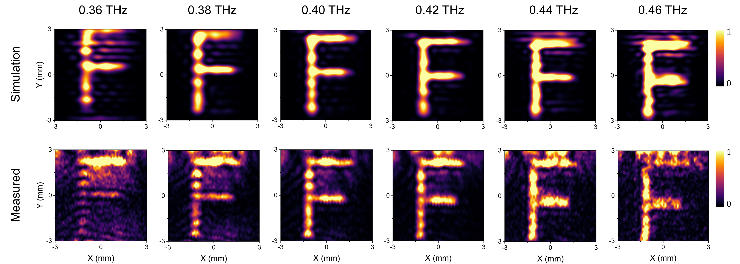
FIG. S8. Simulated and measured $\left|E_{x}^{2}\right|$ distribution of the generated hologram at target image plane by the designed MS under SW excitation at 0.36-0.46 THz.

S9. Discretized complex-amplitude vectorial holography
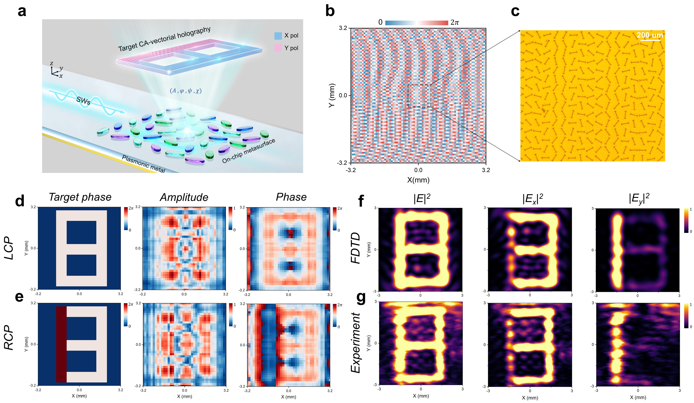
FIG. S9. The discretized complex amplitude vectorial holography generated by a on-chip composite MS under SW excitation using the proposed modified two-loop optimization algorithm. (a) Schematic of complex amplitude hologram generation with discretized linear polarizations by on-chip MS under SW excitation using the proposed two-loop optimization algorithm. (b-c) The orientation angle distribution of the entire MS and part image of the fabricated MS sample. (d-e) Amplitude and phase distribution of LCP and RCP components generated by on-chip MS. (f-g) Simulated and measured field intensities (${|E|}^{2},{|E_{x}|}^{2}, {|E_{y}|}^{2}$) of the discretized CA vectorial hologram in $xoy$plane $(z=1.5 mm$) generated by the MS under SW excitation. Here, the frequency is chosen as 0.4 THz.

