Supporting Information for
N-Bordered Rylene Arches via Programmable Curved π-Extension
Table of Contents
1. Materials and Measurements S2
2. Molecular Design and Synthetic Details S2
3. X-ray Crystal Structures S5
4. Theoretical Calculations S8
5. ¹H and ¹³C NMR Spectra S13
6. References S24

1. Materials and Measurements
All chemicals and solvents were purchased from J&K, Bide Pharmatech and Aladin used as received unless otherwise stated. All superdry solvents were purchased from J&K for directly use. All deuterated solvents were purchased from Cambridge Isotope Laboratories. Flash column chromatography was performed using silica gel (Greagent, 200-300 mesh) to purified crude products.
The ¹H and ¹³C NMR spectra were measured on JEOL JNM-ECZ400, JEOL JNM-ECZL500G and One Instrument Quantum-I Plus (600 MHz) spectrometers at different temperatures. High resolution mass spectra (HRMS) were determined on a SolariX 7.0T Fourier transform ion cyclotron resonance mass spectrometer. The UV-vis absorption spectra data were documented by a Shimadzu UV-3600i Plus spectrophotometer. Fluorescence measurements and absolute quantum yields were measured by using an integrating sphere on an Edinburgh Instruments Fluorescence Spectrometer FLS1000 fluorimeter.
Cyclic voltammetry (CV) was performed with a CHI610E electrochemical workstation using glassy carbon discs as the working electrode, Pt wire as the counter electrode, Ag/AgCl electrode as the reference electrode at a scanning rate of 50 V/s. 0.1 M Tetrabutylammonium hexafluorophosphate (TBAPF6) dissolved in superdry o-DCB was employed as the supporting electrolyte. CV experiment was carried out under argon atmosphere The plot includes the signal of the ferrocene as an internal potential marker. Superdry o-DCB was purchased from J&K Seal.
Single crystals data collections were performed on a RIGAKU XtaLAB Synergy-DW rotating anode X-ray diffractometer with Hybrid Photon Counting (HPC) X-ray detector and graphite mono-chromated CuKα radiation (λ = 1.54184). All calculations were performed using the SHELXL and the crystal structure crystallographic software package. Using Olex2, the crystal structure were solved with the ShelXT and refined with the ShelXL-2019/2 refinement package.

2. Molecular Design and Synthetic Details
Figure S1. Attempts to synthesize N-bordered rylenes.
Compound 1 and 2 were synthesized according to reported literature¹ and prepared up to 10 gram-scale in this article.
2-2Br: A 2 L Schlenk flask was charged with 3 (2.4 g, 3.4 mmol), NBS (1.52 g, 8.5 mmol) and 1,2-dichloroethane (1.2 L) and the mixture was stirred at 50 ºC for 16 h under argon. The cooled mixture was extracted with H₂O and CH₂Cl₂, dried with Na₂SO₄ and concentrated by rotary evaporation and purified by recrystallizing through petroleum ether to obtain 2-2Br as a yellow solid (2.15 g, 85% yield).
3: A 350 mL Schlenk flask was charged with 2-2Br (2.15 g, 2.5 mmol), (Bpin)₂ (3.17 g, 12.5 mmol), Pd(dppf)Cl₂ (275 mg, 0.38 mmol), AcOK (1.47g, 15 mmol) and super dry 1,4-dioxane (100 mL) under argon. The mixture was heated to 90 ºC with vigorous stirring for 36 h. The cooled mixture was extracted with H₂O and CH₂Cl₂, dried with Na₂SO₄ and was purified by column chromatography on silica gel, eluted with petroleum ether/CH₂Cl₂=7:1 then petroleum ether/CH₂Cl₂=4:1, then recrystallized through methanol to afford 3 (mixture of two isomers) as a yellow solid (1.12 g, 60% yield). ¹H NMR of the mixture(1 : 1.2) (THF-d₈, 400 MHz, 285 K): δ = 8.82 (d, J = 7.2 Hz, 2H), 8.77 (d, J = 7.2 Hz, 2.4H), 8.47 (s; s, 4+4.8H), 8.41 (s, 2H), 8.39 (s, 2.4H), 8.12(d; d, J = 7.2 Hz, 2+2.4H), 7.87 (d, J = 7.2 Hz, 2.4H), 7.85 (d, J = 7.2 Hz, 2H), 1.41(s; s, 24+28.8H). ¹³C NMR (THF-d₈, 400 MHz, 285 K): δ = 141.61, 141.50, 139.97, 139.80, 139.12, 133.84, 133.51, 133.17, 130.90, 129.56, 129.03, 127.97, 126.93, 126.48, 124.70, 121.99, 113.08, 112.98, 83.75, 83.71, 24.91. MS (MALDI-FTICR): [M]⁺ calcd for C₄₈H₃₆B₂F₁₂N₂O₄: 954.2679, found 954.2670.
4: A 350 mL Schlenk flask was charged with 3 (954 mg, 1 mmol), 1,8-dibromo-4,5-di-n-butyl-naphthalenedicarboxylate (1.12 g, 2.3 mmol), Pd₂(dba)₃ (183 mg, 0.2 mmol), Pcy₃ (224mg, 0.8 mmol), K₂CO₃(1.66g, 12 mmol) and super dry o-xylene (100 mL) under argon. The mixture was heated to 145 ºC with vigorous stirring for 36 h. The cooled mixture was purified by column chromatography on silica gel, eluted with CH₂Cl₂/EA=500:1 then recrystallized through methanol to afford 4 as a slate blue solid (740 mg, 55% yield). ¹H NMR (THF-d₈, 400 MHz, 345 K): δ = 8.25 (s, 4H), 8.18 (s, 2H), 7.95 (d, J = 7.6 Hz, 4H), 7.88 (s, 4H), 7.86 (d, J = 8 Hz, 4H), 4.30 (t, J = 6.7 Hz, 8H), 1.77 (dq, J = 8.5, 6.8 Hz, 8H), 1.50 (m, 8H), 0.99 (t, J = 7.4 Hz, 12H). ¹³C NMR (THF-d₈, 400 MHz, 345 K): δ = 167.71, 144.50, 134.96, 133.85, 133.51, 132.89, 130.67, 130.32, 130.04, 128.19, 124.54, 119.90, 107.91, 64.44, 30.78, 19.17, 13.08. MS (MALDI-FTICR): [M]⁺ calcd for C₇₆H₅₄F₁₂N₂O₈: 1350.3683, found 1350.3679.
5: A 100 mL Schlenk flask was charged with 4 (326 mg, 0.24 mmol), KOH (337 mg, 6 mmol), and tert-butanol (39 mL) under argon. The mixture was stirred at 85 ºC for 12 h. After cooling to room temperature, 75mL 1M hydrochloric acid was added at 0 ºC and stirred for 10 min, then the precipitate was collected by vacuum filtration. 23mL acetic acid was added to the filtrated solid stirring for 3h before 30ml water was added to the mixture, then the precipitate was collected by vacuum filtration to get purplish gray solids as an intermediate for directly use. A 100 mL Schlenk flask was charged with the intermediate (109 mg, 0.1 mmol), 1-phenylethylamine (103 μL, 0.8 mmol), imidazole (1.8g), and catalytic amount of zinc acetate under argon. The mixture was stirred at 140 ºC for 12 h. After cooling to room temperature, 5mL 1M hydrochloric acid was added and stirred, then the precipitate was collected by vacuum filtration. The mixture was purified by column chromatography on silica gel, eluted with CH₂Cl₂, then recrystallized through methanol to afford 5 as a blue-violet solid (90 mg, 70% yield). ¹H NMR (C₂D₂Cl₄, 500 MHz, 373 K): δ = 8.51 (d, J = 8.0 Hz, 4H), 8.27 (d, J = 8.0 Hz, 4H), 8.23 (s, 4H), 8.14 (s, 4H), 8.10 (s, 2H), 7.53 (d, J = 8.0 Hz, 4H), 7.33 (t, J = 7.7 Hz, 4H), 7.23 (t, J = 7.3 Hz, 2H), 6.48 (q, J = 7.1 Hz, 2H), 2.05 (d, J = 7.1 Hz, 6H). ¹³C NMR (C₂D₂Cl₄, 500 MHz, 373 K): δ = 163.39, 141.28, 137.06, 134.48, 132.74, 131.36, 130.66, 128.23, 127.53, 126.92, 124.21, 122.76, 120.57, 108.68, 50.98, 16.86. MS (MALDI-FTICR): [M]⁺ calcd for C₇₆H₃₆F₁₂N₄O₄: 1296.2550, found 1296.2581.
6: A 500 mL flask was charged with 4 (820 mg, 0.54 mmol) and dissolved in CH₂Cl₂ (170 mL), then tert-Butyl nitrite (1.8 mL, 13 mmol) was added. The mixture was stirred at room temperature for 4.5 h. The mixture was purified by flash chromatography on silica gel with CH₂Cl₂ then recrystallized through methanol to afford 6 as a violet solid (920 mg, 99% yield). ¹H NMR (CD₂Cl₂, 500 MHz, 285 K): δ = 8.31 (s, 4H), 8.14 (s, 4H), 8.10 (s, 6H), 4.29 (q, J = 6.4 Hz, 8H), 1.74 (p, J = 6.9 Hz, 8H), 1.44 (m, 8H), 0.95 (t, J = 7.4 Hz, 12H). ¹³C NMR (CD₂Cl₂, 500 MHz, 285 K): δ = 166.11, 146.39, 144.70, 139.22, 131.06, 130.33, 129.65, 126.91, 126.79, 124.35, 121.73, 113.76, 66.28, 30.52, 19.21, 13.53. MS (MALDI-FTICR): [M]⁺ calcd for C₇₆H₅₀F₁₂N₆O₁₆: 1530.3086, found 1530.3079.
7: A 350 mL Schlenk flask was charged with 6 (923 mg, 0.6 mmol), PPh₃ (4.43 g, 16.8 mmol) and super dry 1,2-dichlorobenzene (92 mL) under argon. The mixture was stirred at 160 ºC for 12 h. The cooled mixture was purified by column chromatography on silica gel, eluted with CH₂Cl₂/EA=200:1 then CH₂Cl₂/EA=50:1, then recrystallized through petroleum ether to afford 7 as a brick red solid (440 mg, 60% yield). ¹H NMR (THF-d₈, 500 MHz, 285 K): δ = 9.96 (s, 4H), 8.46 (s, 4H), 8.32 (s, 2H), 7.70 (s, 4H), 4.10 (qd, J = 6.6, 2.4 Hz, 8H), 1.57 (qq, J = 7.4, 3.7 Hz, 8H), 1.37 – 1.24 (m, 8H), 0.82 (td, J = 7.4, 2.3 Hz, 12H). ¹³C NMR (THF-d₈, 600 MHz, 285 K): δ = 167.96, 142.22, 138.99, 137.97, 137.68, 133.45, 133.23, 132.90, 130.35, 129.12, 128.71, 126.47, 124.28, 122.47, 121.49, 119.72, 116.27, 63.89, 30.67, 19.10, 13.03. MS (MALDI-FTICR): [M]⁺ calcd for C₇₆H₅₀F₁₂N₆O₈: 1402.3493, found 1402.3481.
8: A 350 mL Schlenk flask was charged with 7 (480 mg, 0.34 mmol), 1-bromobutane (1 mL, 5.5 mmol), K₂CO₃ (383mg, 2.7 mmol) and super dry N,N-dimethylformamide (48 mL) under argon. The mixture was stirred at 120 ºC for 12 h. The cooled mixture was extracted with H₂O and EA and purified by column chromatography on silica gel, eluted with CH₂Cl₂ then CH₂Cl₂/EA=100:1, then recrystallized through methanol to afford 8 as a brick red solid (440 mg, 60% yield). ¹H NMR (C₂D₂Cl₄, 500 MHz, 278 K): 8.45 (s, 4H), 8.11 (s, 2H), 7.85 (s, 4H), 4.17 (d, J = 25.6 Hz, 8H), 3.75 (s, 4H), 3.34 (s, 4H), 1.94 (d, J = 37.5 Hz, 8H), 1.32 (q, J = 7.2 Hz, 8H), 1.21 (s, 16H), 0.86 (q, J = 8.4 Hz, 24H). ¹³C NMR (THF-d₈, 400 MHz, 298 K): 168.20, 145.07, 140.55, 139.07, 137.83, 133.64, 133.30, 132.25, 130.14, 129.88, 129.10, 128.74, 128.22, 127.78, 124.38, 121.66, 120.13, 116.21. MS (MALDI-FTICR): [M]⁺ calcd for C₉₂H₈₂F₁₂N₆O₈: 1626.5997, found 1626.5987.
9: A 100 mL Schlenk flask was charged with 8 (244 mg, 0.15 mmol), KOH (427 mg, 7.6 mmol), and tert-butanol (24 mL) under argon. The mixture was stirred at 85 ºC for 12 h. After cooling to room temperature, 50mL 1M hydrochloric acid was added at 0 ºC and stirred for 10 min, then the precipitate was collected by vacuum filtration. 15mL acetic acid was added to the filtrated solid stirring for 3h before 30ml water was added to the mixture, then the precipitate was collected by vacuum filtration to get purplish gray solids as intermediate for directly use. A 100 mL Schlenk flask was charged with intermediate (198 mg, 0.145 mmol), 1-phenylethylamine (113 μL, 0.87 mmol), imidazole (3.2g), and catalytic amount of zinc acetate under argon. The mixture was stirred at 140 ºC for 12 h. After cooling to room temperature, 10mL 1M hydrochloric acid was added and stirred, then the precipitate was collected by vacuum filtration. The mixture was purified by column chromatography on silica gel, eluted with petroleum ether/CH₂Cl₂=1:3, then recrystallized through methanol to afford 9 as an purple-gray solid (155 mg, 68% yield). ¹H NMR (C₂D₂Cl₄, 500 MHz, 328 K): 8.51 (s, 4H), 8.30 (s, 4H), 8.22 (s, 2H), 7.33 (s, 4H), 7.19 (s, 4H), 7.15 (d, J = 6.5 Hz, 2H), 6.48 (d, J = 6.9 Hz, 2H), 3.85 (s, 4H), 3.45 (s, 4H), 2.04 (d, J = 28.0 Hz, 8H), 1.99 (s, 6H), 1.28 (s, 8H), 0.92 (s, 12H). ¹³C NMR (THF-d₈, 400 MHz, 298 K): 164.24, 144.72, 141.89, 141.65, 140.42, 139.89, 133.86, 132.63, 131.20, 130.96, 129.65, 129.23, 128.37, 127.41, 126.94, 125.98, 124.48, 122.06, 116.80, 116.65, 49.84, 47.88, 40.55, 34.28, 19.93, 15.77, 12.97. MS (MALDI-FTICR): [M]⁺ calcd for C₉₂H₆₄F₁₂N₈O₄: 1572.4853, found 1572.4842.

3. X-ray Crystal Structures
Single crystals suitable for X-ray analysis were grown at room temperature by slow evaporation of methanol into chloroform and chlorobenzene mixed solution for 7 and methanol into dichloromethane and chlorobenzene mixed solution for 9@C60. Crystallographic data have been deposited with the Cambridge Crystallographic Data Centre as supplementary publication on CCDC No. 2504268 for 7 and 2504270 for 9@C60, the crystallographic data were summarized below.

Table S1. Crystallographic data for 7 and 9@C60.
Compound | 7 | 9@C60
Empirical formula | C_{77.5}H_{51.5}Cl_{4.5}F₁₂N₆O₈ | C₁₅₄H₇₂F₁₂N₈O₆
Formula weight | 1582.27 | 2358.19
T (K) | 105(8) | 100(2)
Crystal system | orthorhombic | triclinic
Space group | Fdd2 | P-1
a (Å) | 43.8664(7) | 13.56940(10)
b (Å) | 27.2131(4) | 15.60780(10)
c (Å) | 22.9748(3) | 24.9813(2)
α (º) | 90 | 102.6500(10)
β (º) | 90 | 92.2140(10)
γ (º) | 90 | 100.5210(10)
V (Å³) | 27426.0(7) | 5058.46(7)
Z | 16 | 2
Dcalc (g/cm³) | 1.533 | 1.548
μ (mm⁻¹) | 2.598 | 0.912
F (000) | 12912.0 | 2416.0
Crystal size (mm³) | 0.3×0.05×0.05 | 0.25×0.10×0.08
Radiation | CuKα (λ = 1.54184) | CuKα (λ = 1.54184)
2Θ range for data collection/° | 5.422 to 152.366 | 5.918 to 152.978
Index ranges | -54≤h≤52, -33≤k≤34,  -28≤l≤26 | -16≤h≤16, -19≤k≤19,  -30≤l≤30
Reflns collected | 24960 | 183474
Indep reflns / R_{int} | 10623[R_{int} =0.0297, R_{sigma} =0.0309] | 20310[R_{int} =0.0359, R_{sigma} = 0.0176]
Data/restraints/parameters | 10623/88/1020 | 20310/707/1680
Goodness-of-fit on F² | 1.043 | 1.008
R1, wR2 [I>=2σ(I)] | 0.0601, 0.1708 | 0.1187, 0.2404
R1, wR2 [all data] | 0.0637, 0.1748 | 0.1308, 0.2463
CCDC No. | 2504268 | 2504270
Figure S2. Crystal structure of 7 in the unit cell. (a) Side view and (b) Top view. Ellipsoids are drawn at 50% probability level. Hydrogen atoms and disordered solvents are omitted for clarity.
Figure S3. Crystal structure of 9@C₆₀ in the unit cell. (a) Side view and (b) Top view. Ellipsoids are drawn at 50% probability level. Hydrogen atoms and disordered solvents are omitted for clarity.
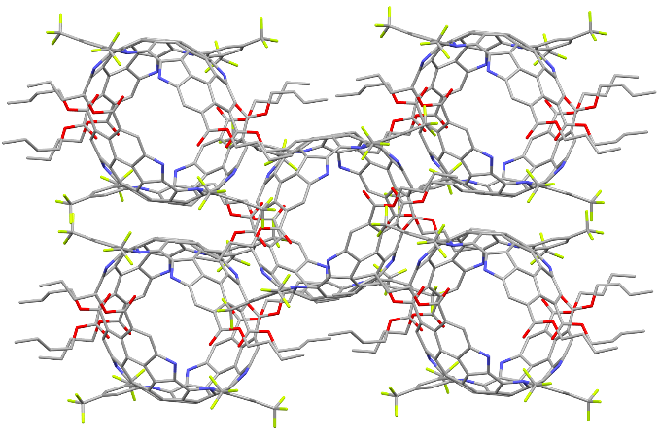
Figure S4. Molecular arrangements of 7 along the a axis. Hydrogen atoms and disordered solvents are omitted for clarity.
Figure S5. Molecular arrangements of 9@C₆₀. Hydrogen atoms are omitted for clarity.
Figure S6. Observed POAV angles of 2¹ and 7 in crystal structures.
Figure S7. Absorption (a) and fluorescence (b) titration and fittings (c) of 9 with different ratios of C₆₀ measured in toluene at room temperature. The dashed lines in (c) serve as guides for the eye. The concentration of 9 was 10 μM.

4. Theoretical Calculations
The density functional theory (DFT) and time-dependent DFT (TD-DFT) calculations were performed using the Gaussian 16 software package². The geometries were optimized with the B3LYP functional method³⁻⁵ including Grimme's D3 dispersion correction with Becke-Johnson damping (D3BJ)^{6,7} and 6-31G(d) basis set^{8,9}. The long alkyl chains of the compounds were reduced to methyl groups. The optimized structures and transition state (TS) where confirmed by harmonic frequency calculations (model 5, model 7, and model 9). For TS optimization, the long alkyl chains of the compounds were reduced to hydrogen atoms. Single point energy calculations were carried out with the M06-2X functional method¹⁰ and def2-TZVP basis set¹¹. Isosurface maps of various real space functions were rendered by means of Visual Molecular Dynamics (VMD) software based on the files exported by Multiwfn^{12,13}.
The UV-vis absorption spectra were calculated using the TDDFT linear response method and taken into account the solvent used during experiments (toluene) through the self-consistent reaction field (SCRF) method using the polarizable continuum model (PCM)¹⁴ and the UFF atomic radii model (i.e., explicit hydrogens). For each molecule, the lowest 100 states were computed at the optimized geometry. The calculated line spectra are represented by applying Gaussian broadening with a full width at half maximum (FWHM) of 0.15 eV for UV-vis spectra. The UV-vis spectra was generated by Multiwfn 3.8.
NICS(1)_{zz} values¹⁵ were calculated at the B3LYP-D3(BJ)/6-311G(d)¹⁶ level of theory, and analyzed with Multiwfn 3.8. AICD plotwas calculated by using the method developed by Herges¹⁷. The strain energy was computed using the corresponding isodesmic reactions,^{18,19} in line with the methodology established by G. N. Sastry and U. D. Priyakumar for evaluating buckybowl strain energy.^{20,21}
Figure S8. Geometry optimizations of the ground states of model (a) 2 (b) 5 (c) 7 and (d) 9 by side view at the B3LYP/6-31G(d) level of theory.
Figure S9. View of molecular orbitals of model 5.
Figure S10. View of molecular orbitals of model 9.
Figure S11. Theoretical UV-vis absorption curves for the models (a) 5 and (b) 9 B3LYP/6-311G(d) TDDFT line spectrum calculations and Gaussian line shape with line broadening of 0.15 eV (FWHM).

Figure S12. View of inversion process of 5.
Figure S13. View of inversion process of 9.

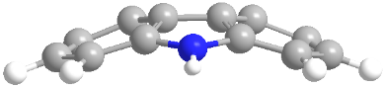
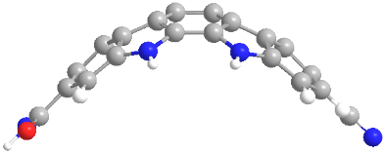
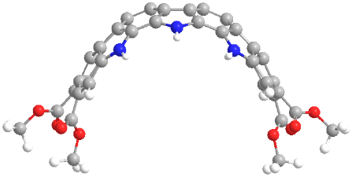
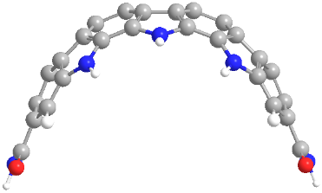
Figure S14. Calculation of the strain energy of N-embedded rylenes based on isodesmic reactions. The strain energy accumulates gradually with the increasing number of embedded pyrrole pentagons.
Figure S15. Calculated NICS values of (a) QDI, (b) 5 and (c) 9 in average NICS(1)_{zz}. Calculated AICD plot of (d) QDI (e) 5 and (f) 9 with clockwise current in red and anti-clockwise current in blue.

Table S2. Calculated photophysical property data of the ground state of model 5 and 9 at the B3LYP/6-311G(d,p) level.
Comp. | Excited  States | Energy  [eV] | Wavelength  [nm] | Oscillator  Strength | Transition | Weight  [%]
5 | S₀→S₁ | 1.6707 | 742.11 | 1.72380 | H → L | 100
5 | S₀→S₂ | 2.2622 | 548.07 | 0.02040 | H → L+1 | 89.4
 |  |  |  |  | H-2 → L | 9.6
5 | S₀→S₃ | 2.3756 | 521.91 | 0.13650 | H-1 → L | 97.2
5 | S₀→S₄ | 2.6115 | 474.76 | 0.05930 | H-2 → L | 89.4
 |  |  |  |  | H → L+1 | 9.5
5 | S₀→S₅ | 2.7695 | 447.68 | 0.00020 | H → L+2 | 92.8
9 | S₀→S₁ | 1.9205 | 645.58 | 0.90860 | H → L | 99.1
9 | S₀→S₂ | 2.2523 | 550.48 | 0.18670 | H-1 → L | 96.6
9 | S₀→S₃ | 2.3705 | 523.03 | 0.01120 | H → L+3 | 56.1
 |  |  |  |  | H → L+1 | 37.9
 |  |  |  |  | H → L+2 | 5.2
9 | S₀→S₄ | 2.3956 | 517.55 | 0.05260 | H → L+2 | 89.9
 |  |  |  |  | H → L+3 | 8.4
9 | S₀→S₅ | 2.4709 | 501.78 | 0.14610 | H → L+1 | 58.9
 |  |  |  |  | H → L+3 | 33.7
Table S3. Frontier molecular orbital energies.
Comp | E_{LUMO}  [eV] | E_{HOMO}  [eV]
5 | -3.40 | -5.31
9 | -2.63 | -4.87

5. ¹H and ¹³C NMR Spectra
Figure S16. VT-¹H NMR (500 MHz) spectrum of compound 5 in THF-d₈.
Figure S17. VT-¹H NMR (500 MHz) spectrum of compound 9 in C₂D₂Cl₄.
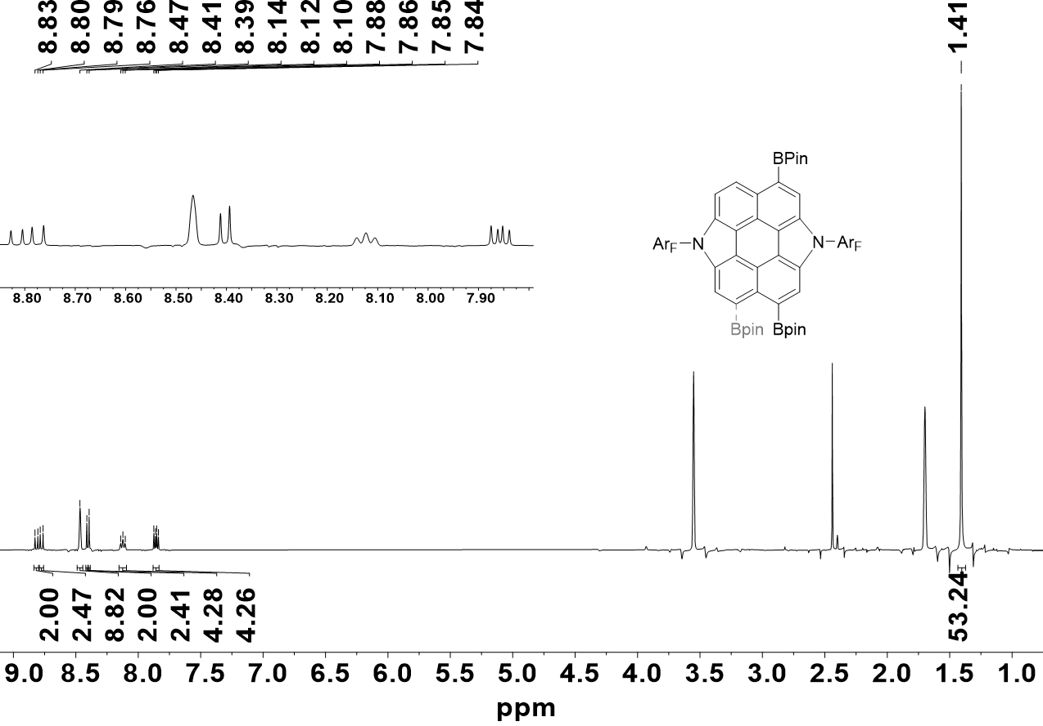
Figure S18. ¹H NMR spectrum of 3 (THF-d₈, 400 MHz, 285 K).
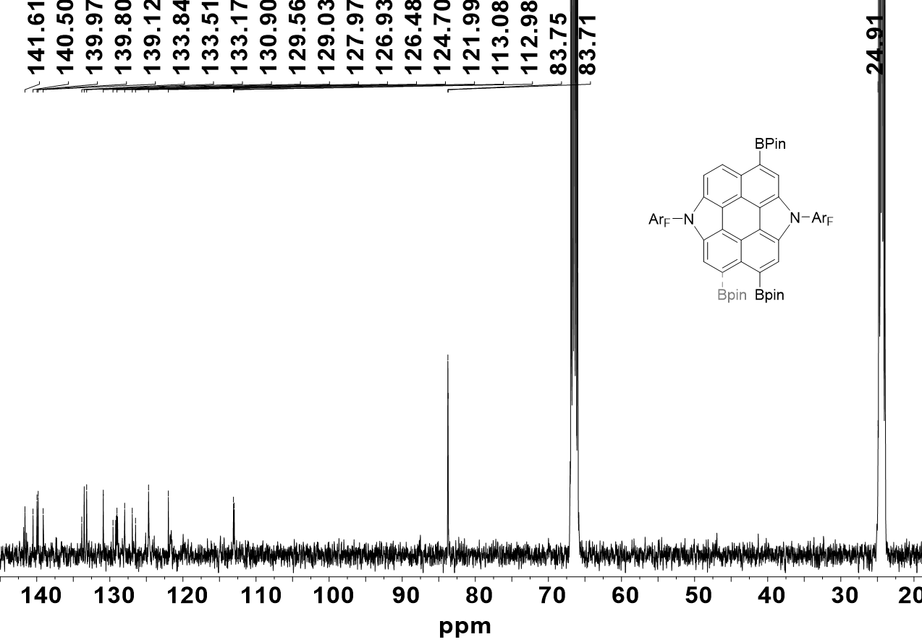
Figure S19. ¹³C NMR spectrum of 3 (THF-d₈, 400 MHz, 285 K).
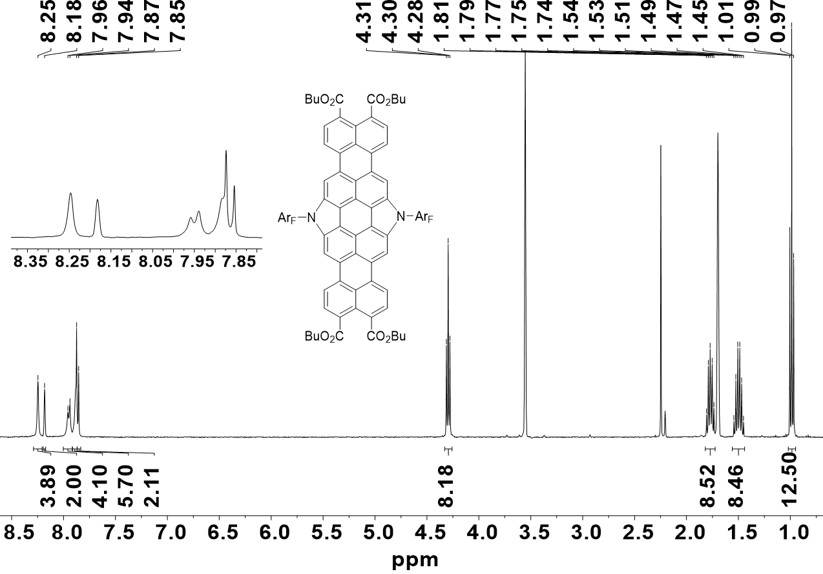
Figure S20. ¹H NMR spectrum of 4 (THF-d₈, 400 MHz, 345 K).

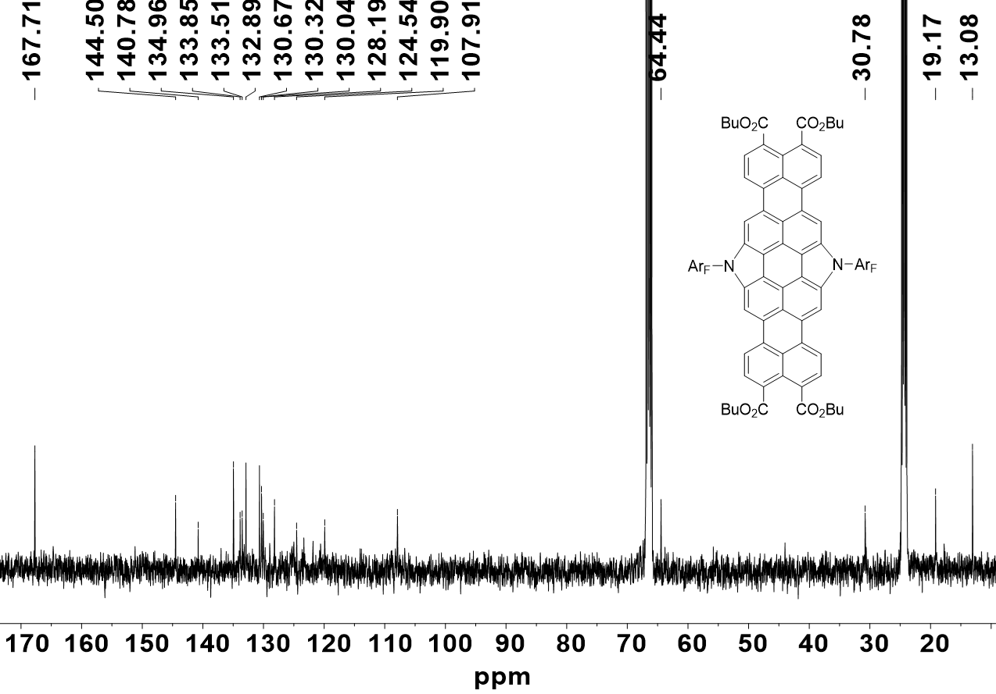
Figure S21. ¹³C NMR spectrum of 4 (THF-d₈, 400 MHz, 345 K).
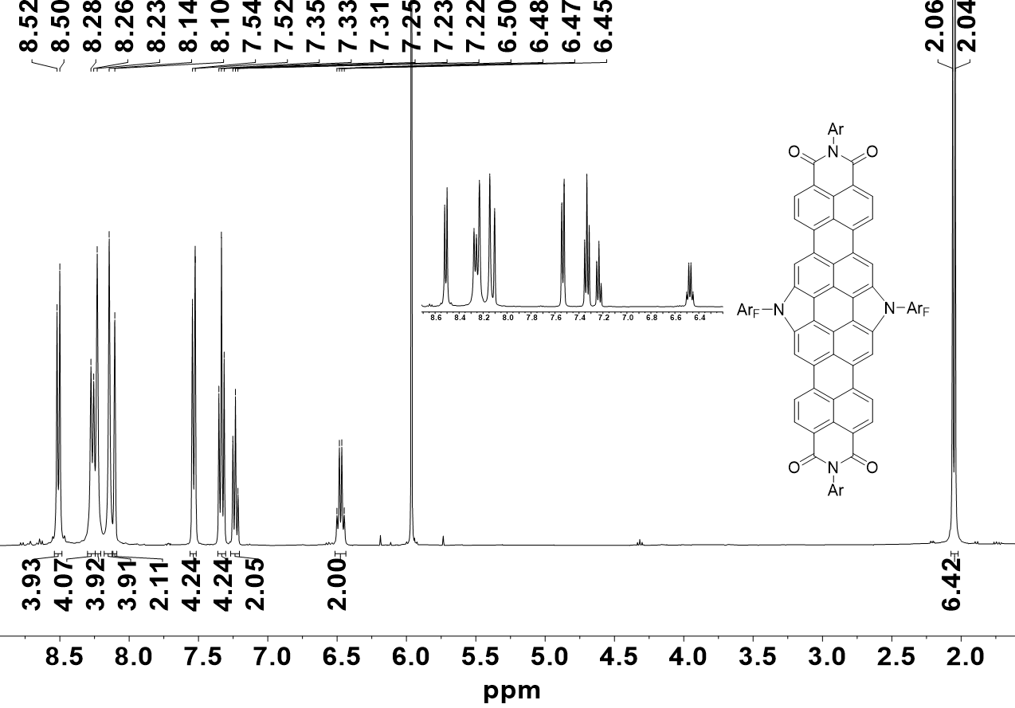
Figure S22. ¹H NMR spectrum of 5 (C₂D₂Cl₄, 400 MHz, 373 K).
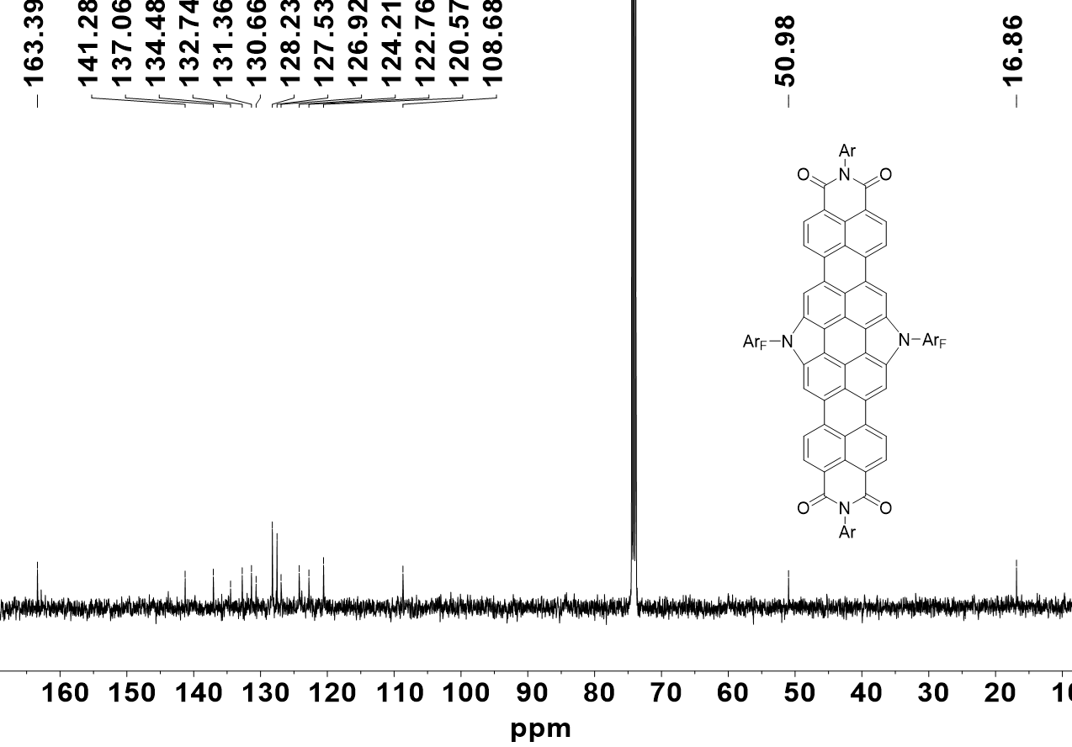
Figure S23. ¹³C NMR spectrum of 5 (C₂D₂Cl₄, 400 MHz, 373 K).
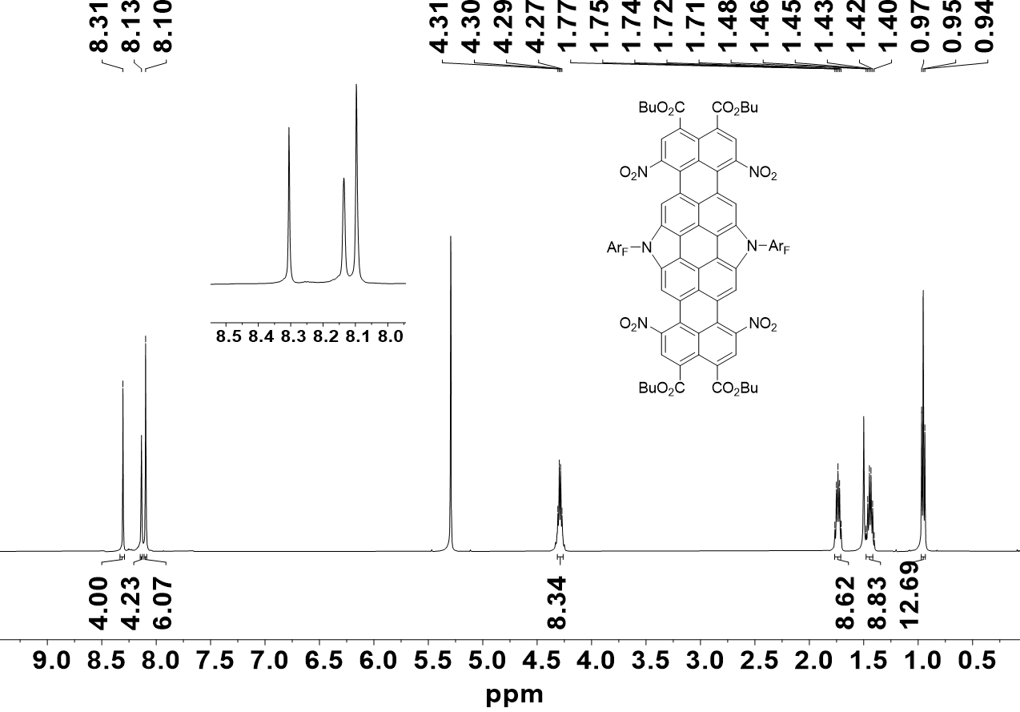
Figure S24. ¹H NMR spectrum of 6 (CD₂Cl₂, 500 MHz, 285 K).

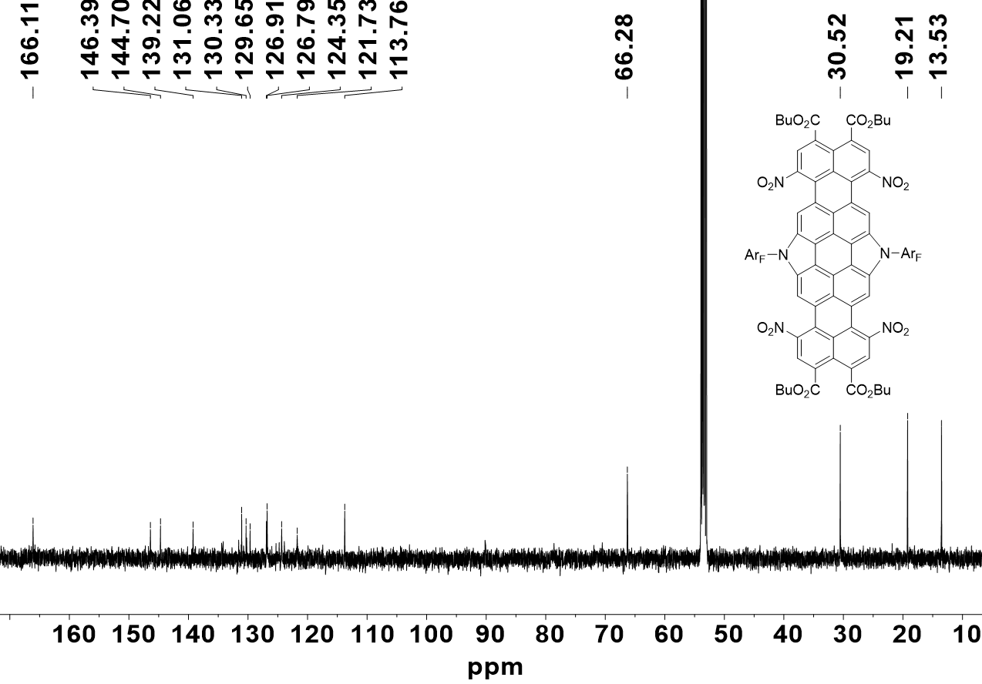
Figure S25. ¹³C NMR spectrum of 6 (CD₂Cl₂, 500 MHz, 285 K).
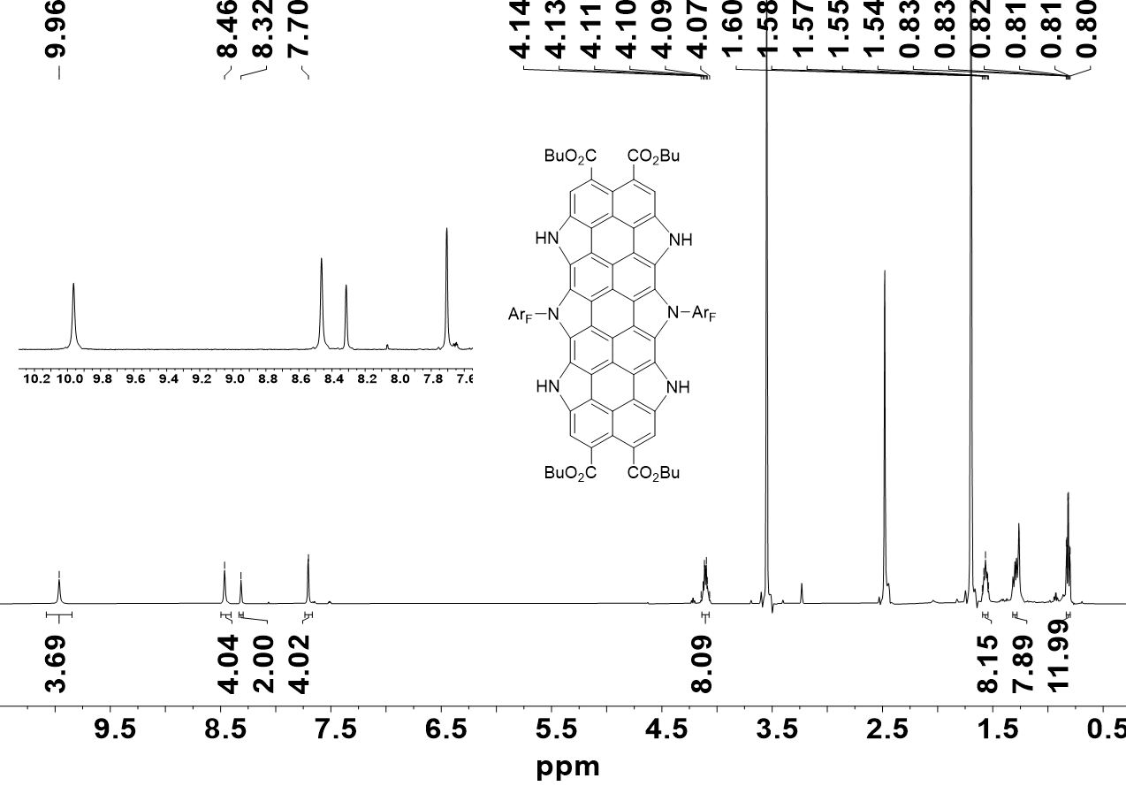
Figure S26. ¹H NMR spectrum of 7 (THF-d₈, 500 MHz, 285 K).

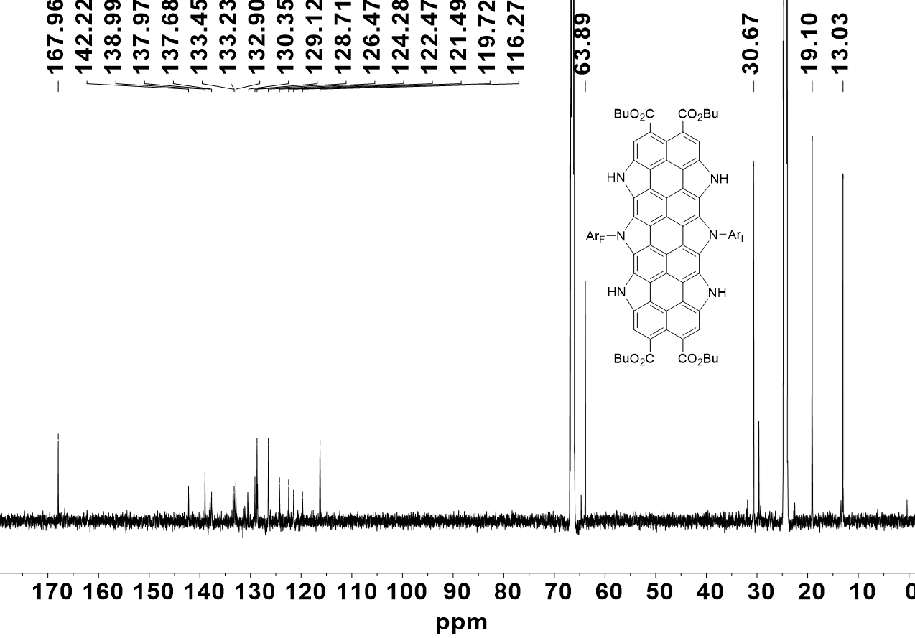
Figure S27. ¹³C NMR spectrum of 7 (THF-d₈, 600 MHz, 285 K).
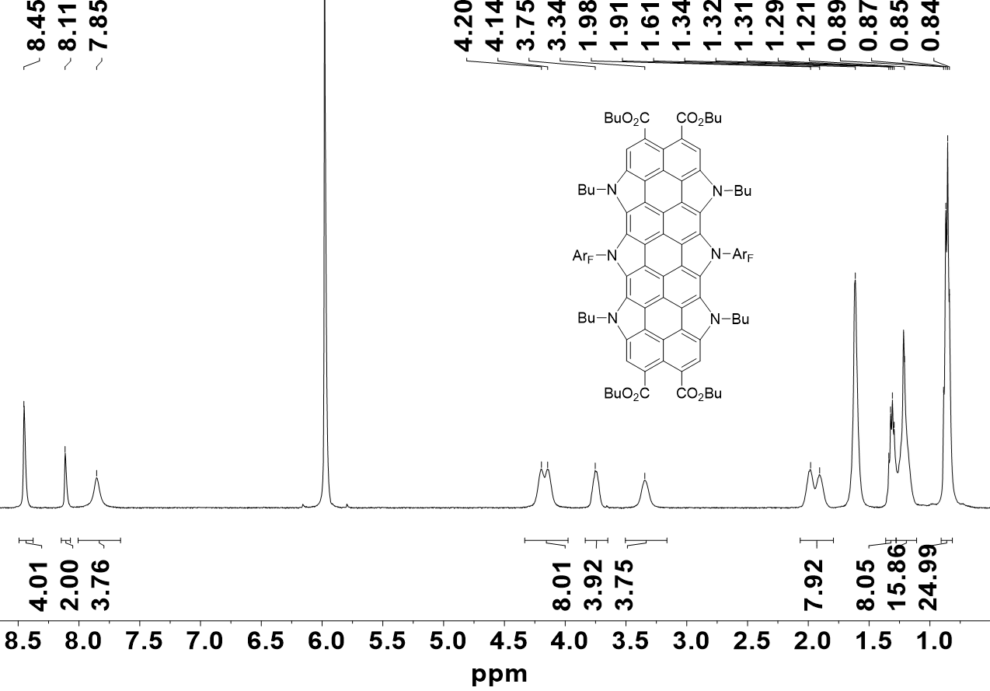
Figure S28. ¹H NMR spectrum of 8 (C₂D₂Cl₄, 500 MHz, 278 K).

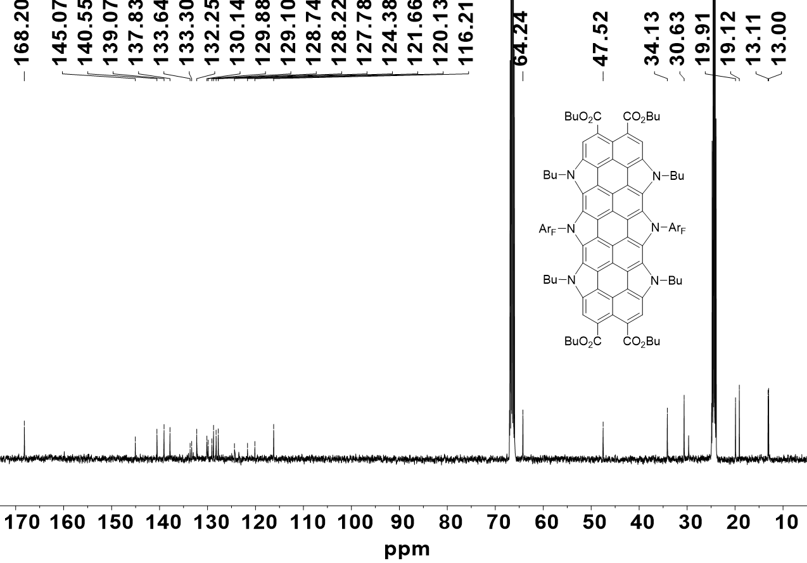
Figure S29. ¹³C NMR spectrum of 8 (THF-d₈, 400 MHz, 298 K)
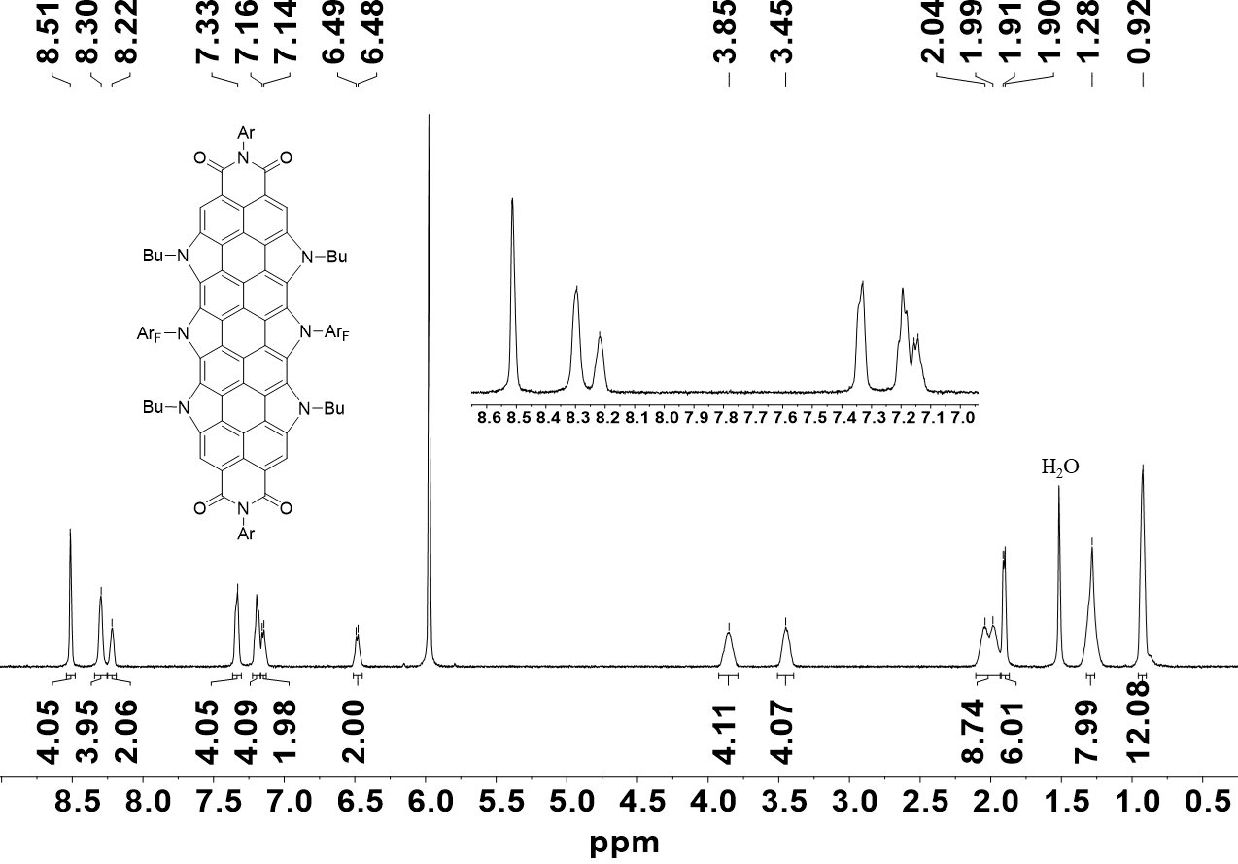
Figure S30. ¹H NMR spectrum of 9 (C₂D₂Cl₄, 500 MHz, 328 K).
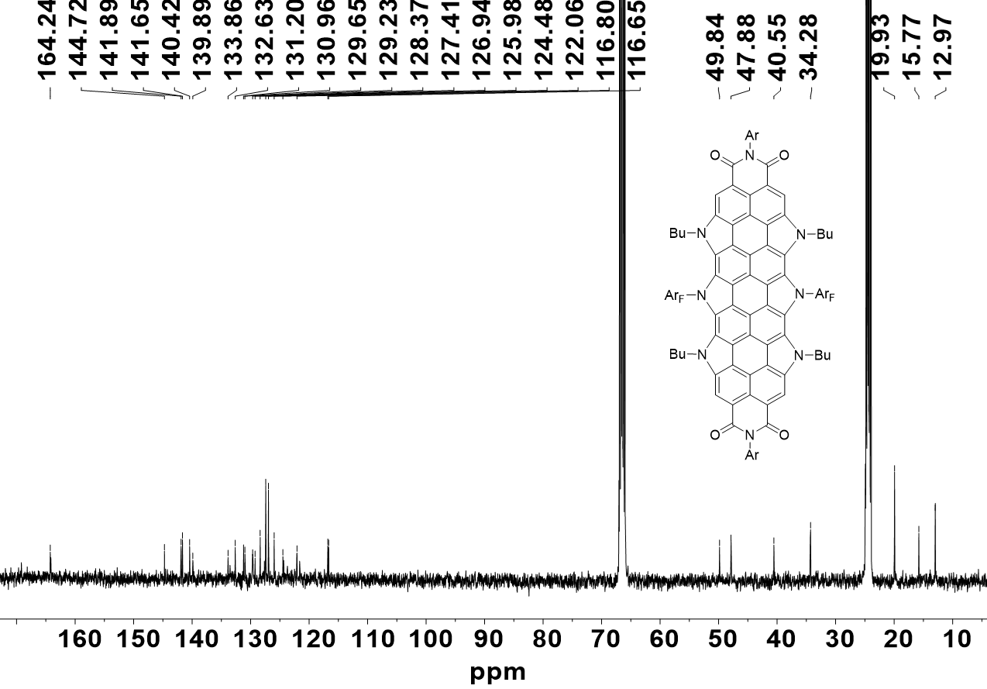
Figure S31. ¹³C NMR spectrum of 9 (THF-d₈, 400 MHz, 285 K).

8. Mass Spectra
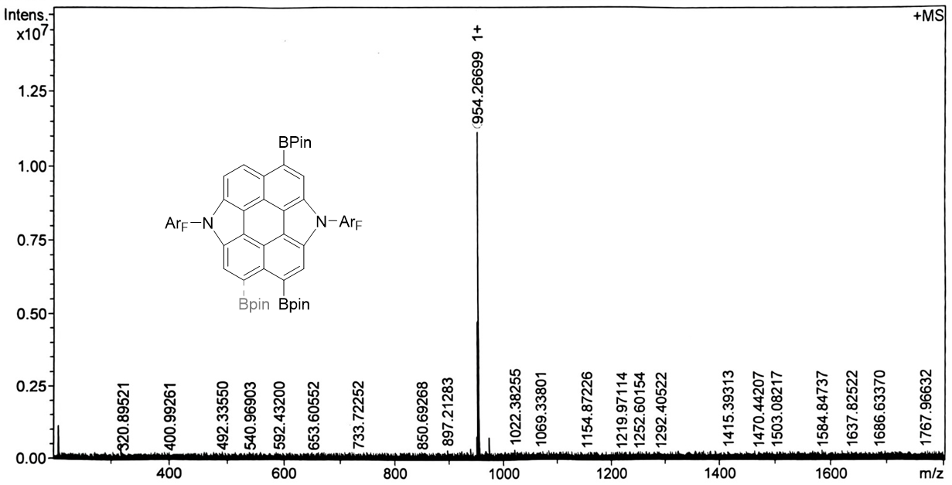
Figure S32. Mass spectrum (MALDI-FTICR) of 3.
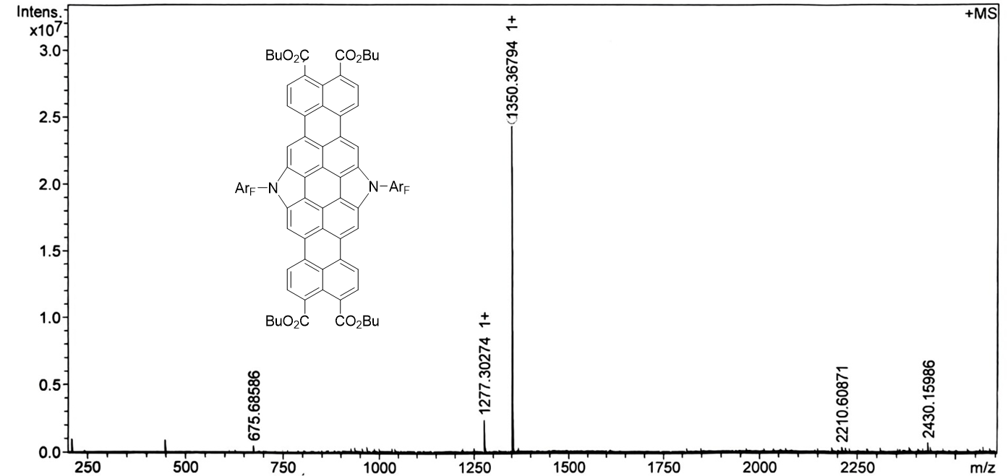
Figure S33. Mass spectrum (MALDI-FTICR) of 4.
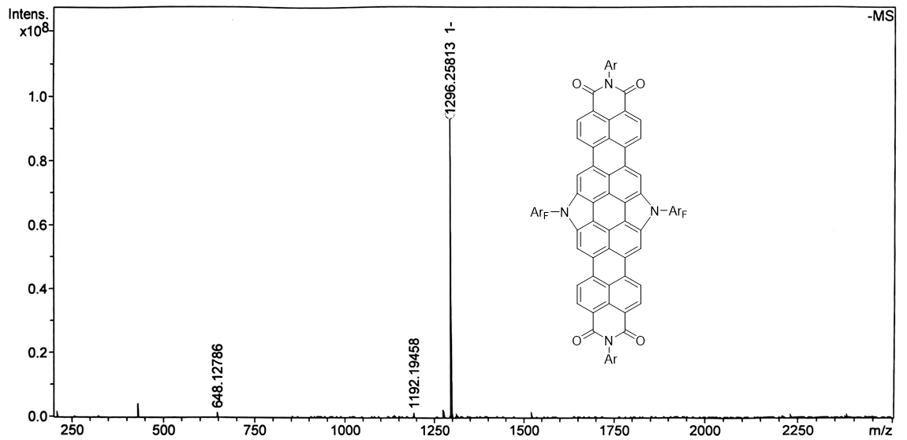
Figure S34. Mass spectrum (MALDI-FTICR) of 5.
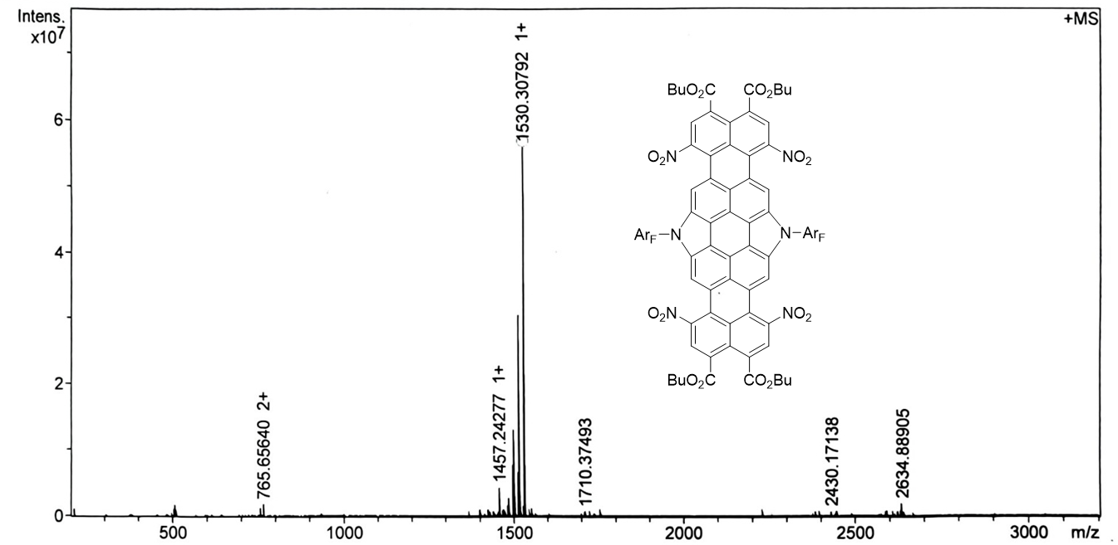
Figure S35. Mass spectrum (MALDI-FTICR) of 6.
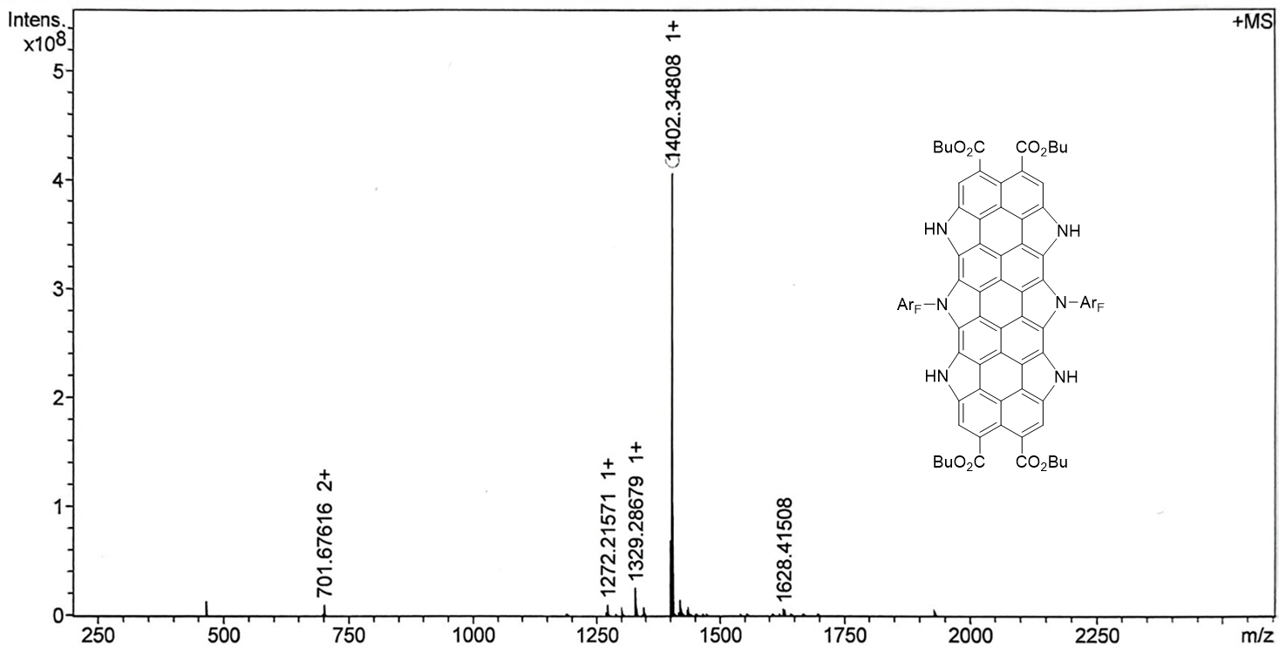
Figure S36. Mass spectrum (MALDI-FTICR) of 7.
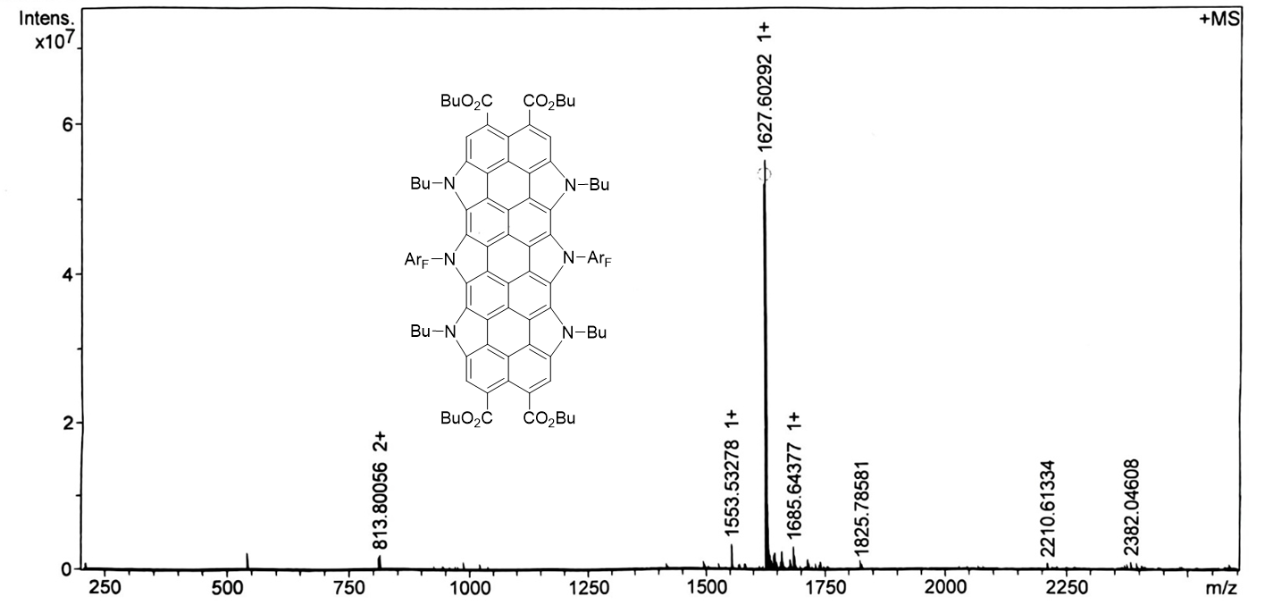
Figure S37. Mass spectrum (MALDI-FTICR) of 8.
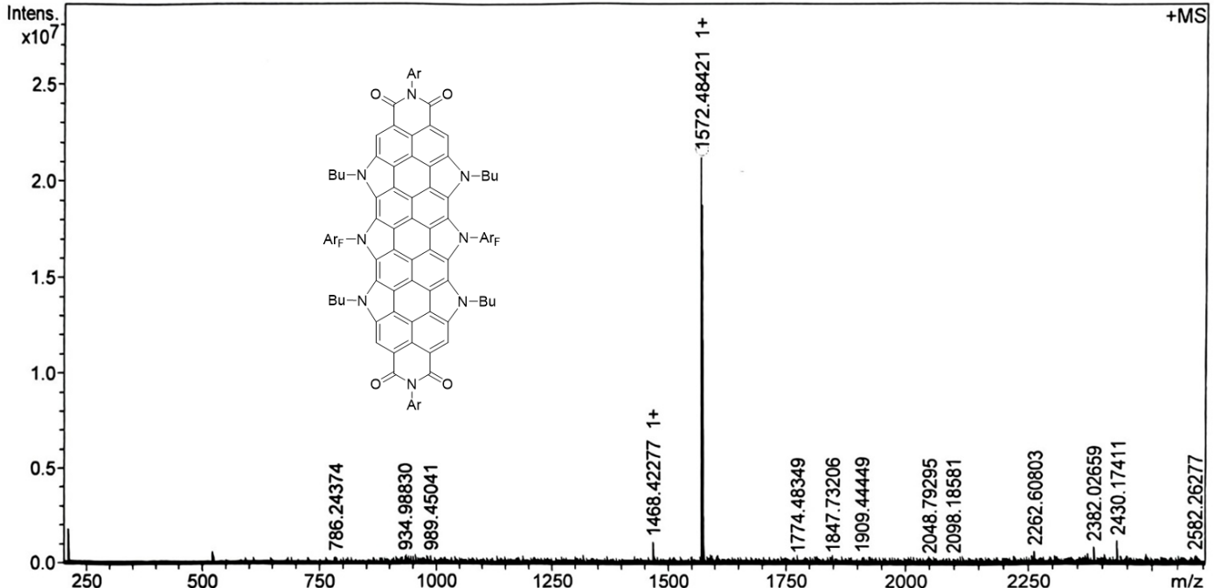
Figure S38. Mass spectrum (MALDI-FTICR) of 9.

6. References
- Qiu, S., Chen, K., Deng, Z., Jin, X., Li, Z., Liu, G., Zhang L., Jiang W., Chen T.-T., Liu J.& Wang, Z. N-Doped Nonalternant Molecular Bowl/Saddle Hybrids. Angew. Chem. Int. Ed. e202516881 (2025).
- Frisch, M. J.; Trucks, G. W.; Schlegel, H. B.; Scuseria, G. E.; Robb, M. A.; Cheeseman, J. R.; Scalmani, G.; Barone, V.; Petersson, G. A.; Nakatsuji, H.; Li, X.; Caricato, M.; Marenich, A. V.; Bloino, J.; Janesko, B. G.; Gomperts, R.; Men-nucci, B.; Hratchian, H. P.; Ortiz ,J. V.; Izmaylov, A. F.; Sonnenberg, J. L.; Williams-Young, D.; Ding, F.; Lipparini, F.; Egidi, F.; Goings, J.; Peng, B.; Petrone, A.; Henderson, T.; Ranasinghe, D.; Zakrzewski, V. G.; Gao, J.; Rega, N.; Zheng, G.; Liang, W.; Hada, M.; Ehara, M.; Toyota, K.; Fukuda, R.; Hasegawa, J.; Ishida, M.; Nakajima, T.; Honda, Y.; Kitao, O.; Nakai, H.; Vreven, T.; Throssell, K.; Montgomery, J. A.; Peralta, J. E.; Ogliaro, F.; Bearpark, M. J.; Heyd ,J. J.; Brothers, E. N.; Kudin, K. N.; Staroverov, V. N.; Keith, T. A.; Kobayashi, R.; Normand, J.; Raghavachari, K.; Rendell, A. P.; Burant, J. C.; Iyengar, S. S.; Tomasi, J.; Cossi, M.; Millam, J. M.; Klene, M.; Adamo, C.; Cammi, R.; Ochterski, J. W.; Martin, R. L.; Morokuma, K.; Farkas, O.; Foresman, J. B.; Fox, D. J. Gaussian, Inc., Wallingford CT, 2016.
- Becke, A. D. Density-functional thermochemistry. III. The role of exact exchange. J. Chem. Phys. 98, 5648-5652 (1993).
- Lee, C., Yang, W. & Parr, R. G. Development of the colle-salvetti correlation-energy formula into a functional of the electron density. Phys. Rev. B 37, 785-789 (1988).
- Stephens P. J., Devlin F. J., Chabalowski C. F., Frisch M. J. Ab Initio Calculation of Vibrational Absorption and Circular Dichroism Spectra Using Density Functional Force Fields. J. Phys. Chem. 98, 45, 11623-11627 (1994)
- Grimme S., Antony J., Ehrlich S., Krieg H. A consistent and accurate ab initio parametrization of density functional dispersion correction (DFT-D) for the 94 elements H-Pu. J. Chem. Phys. 132, 154104 (2010).
- Grimme S., Ehrlich S., Goerigk L. Effect of the Damping Function in Dispersion CorrectedDensity Functional Theory. J. Comput. Chem. 32, 1456–1465 (2011).
- Ditchfield R., Hehre W. J., Pople J. A. Self-Consistent Molecular-Orbital Methods. IX. An Extended Gaussian-Type Basis for Molecular-Orbital Studies of Organic Molecules. J. Chem. Phys. 54, 724 (1971).
- Hariharan P. C., Pople J. A. The influence of polarization functions on molecular orbital hydrogenation energies. Theor. Chim. Acta 28, 213 (1973).
- Zhao Y. Truhlar D. G., The M06 suite of density functionals for main group thermochemistry, thermochemical kinetics, noncovalent interactions, excited states, and transition elements: two new functionals and systematic testing of four M06-class functionals and 12 other functionals. Theor. Chem. Acc. 120, 215-241 (2008).
- Weigend F. Accurate Coulomb-fitting basis sets for H to Rn. Phys. Chem. Chem. Phys. 8, 1057-1065 (2006).
- Lu T., Chen F. Multiwfn: A Multifunctional Wavefunction Analyzer. J. Comput. Chem. 33, 580-592 (2012).
- Lu T. A comprehensive electron wavefunction analysis toolbox for chemists, Multiwfn. J. Chem. Phys. 161, 082503 (2024).
- Tomasi J., Mennucci B., Cammi R. Quantum Mechanical Continuum Solvation Models. Chem. Rev. 105, 2999-3093 (2005).
- Fallah-Bagher-Shaidaei H., Wannere C. S., Corminboeuf C., Puchta R., Schleyer P. v. R. Org. Lett. 8, 863-866 (2006).
- Krishnan R., Binkley J. S., Seeger R., Pople J. A. Self-consistent molecular orbital methods. XX. A basis set for correlated wave functions. J. Chem. Phys. 72, 650 (1980).
- Geuenich D., Hess K., Köhler F., Herges R. Anisotropy of the Induced Current Density (ACID), a General Method To Quantify and Visualize Electronic Delocalization. Chem. Rev. 105, 3758-3772 (2005).
- Ponomarev D. A., Takhistov V. V. What are Isodesmic Reactions? J. Chem. Edu. 74, 201 (1997).
- Hehre W. J., Ditchfield R., Radom L., Pople J. A. Molecular orbital theory of the electronic structure of organic compounds.V. Molecular theory of bond separation. J. Am. Chem. Soc. 92, 4796-4801 (1970).
- Priyakumar U. D., Sastry G. N. First ab Initio and Density Functional Study on the Structure, Bowl-to-Bowl Inversion Barrier, and Vibrational Spectra of the Elusive C_{3v}-Symmetric Buckybowl: Sumanene, C₂₁H₁₂. J. Phys. Chem. A 105, 4488-4494 (2001).
- Priyakumar U. D., Sastry G. N. Heterobuckybowls: A Theoretical Study on the Structure, Bowl-to-Bowl Inversion Barrier, Bond Length Alternation, Structure-Inversion Barrier Relationship, Stability, and Synthetic Feasibility. J. Org. Chem. 66, 6523-6530 (2001).

