Supplementary information
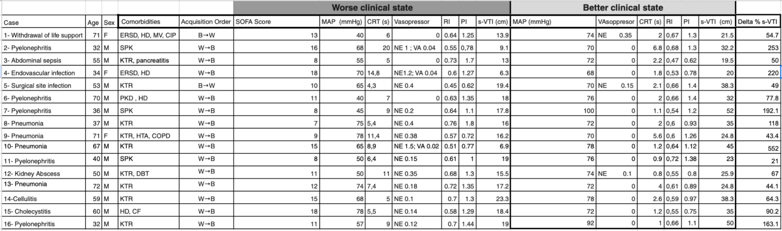
Table 1. Abbreviations:
ESRD, end-stage renal disease; HD, hemodialysis; MV, mechanical ventilation; CIP, critical-illness polyneuropathy; KTR, kidney transplant recipient; SPK, simultaneous pancreas–kidney (transplant) recipient ; PKD, polycystic kidney disease; NE, norepinephrine; MAP, mean arterial pressure; s-VTI, splenic velocity–time integral; CRT, capillary refill time; RI, resistive index; PI, pulsatility index. Acquisition order: W→B, sampling chronology worse→better; B→W, better→worse. Units: NE in μg/kg/min; MAP in mmHg; s-VTI in cm; CRT in s.
SOFA score corresponds to the worst clinical state for each patient

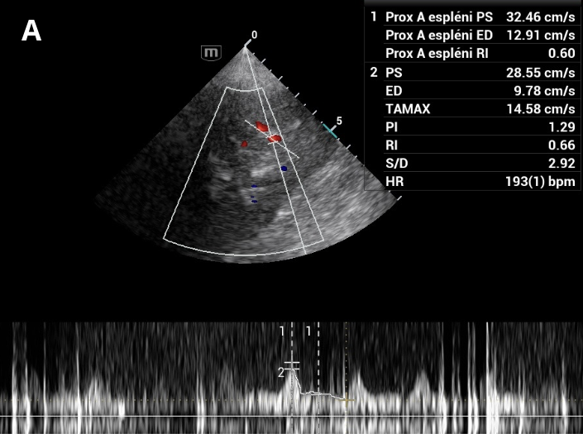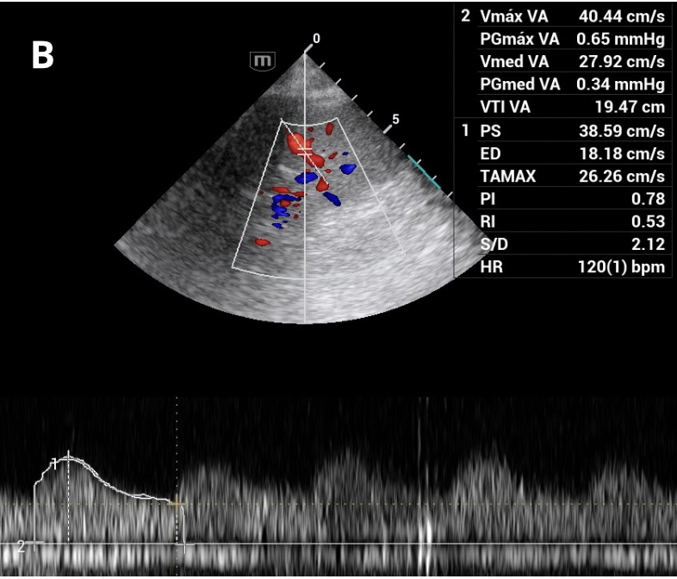
Splenic Doppler waveforms obtained in the same patient ( case 4) during two clinical states. (A) VTI = 6.28 cm, RI = 0.60, PI 1.29. (B) VTI = 19.47 cm, RI = 0.47, PI 0.78. The increase in VTI indicates improved splenic perfusion when measured in the same intraparenchymal branch, as VTI reflects the integrated forward velocity and remains relatively stable if the insonation angle and sampling site are consistent.

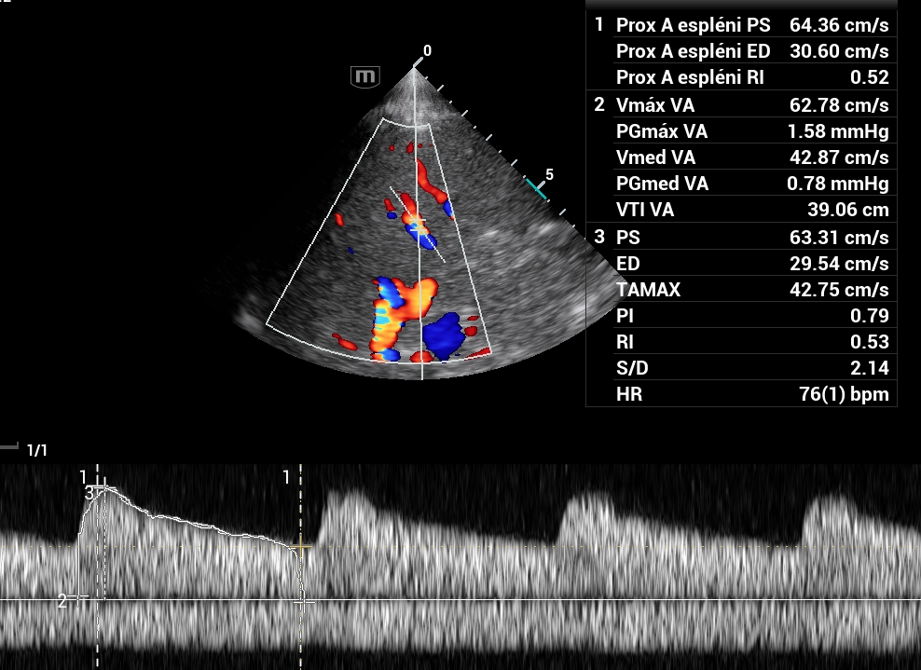
Splenic pulsed‑wave Doppler in a healthy volunteer (control) demonstrating VTI 39 cm, RI 0.52, and PI 0.79.

