Longitudinal changes in gut microbiota across reproductive states in wild baboons.

Southworth, C.A.^{1*}, Barrios, L.^{2,3}, Dasari, M.D.⁴, Gesquiere, L.R.⁵, Gilbert, J.A⁸., Alberts, S.C.^{5,6,7}, Tung, J.^{5,6,9,10,11}, Archie, E.A.¹

¹Department of Biological Sciences, University of Notre Dame, Notre Dame, IN, USA
²Biomedical Engineering Program, University of Colorado, Boulder, CO, USA
³Interdisciplinary Quantitative Biology Program, BioFrontiers Institute, University of Colorado, Boulder, CO, USA
⁴California Academy of Sciences, San Francisco, CA, USA
⁵Department of Biology, ⁶Department of Evolutionary Anthropology, and ⁷Population Research Institute, Duke University, Durham, NC, USA
⁸Scripps Institution of Oceanography, University of California San Diego, La Jolla, USA
⁹Department of Primate Behavior and Evolution, Max Planck Institute for Evolutionary Anthropology, Leipzig, Germany
¹⁰Faculty of Life Sciences, Institute of Biology, Leipzig University, Leipzig, Germany
¹¹Canadian Institute for Advanced Research, Toronto, ON, Canada

*Corresponding author (chelsea.southworth2@gmail.com)
Table of Contents
Figure S1. Baboon gut microbiota do not cluster by reproductive state in ordination analysis. 2
Figure S2. Few gut microbial ASVs differ in abundance between PPA and ovarian cycling. 3
Figure S3. Gut microbiota in the first three months of PPA are distinct from later PPA. 4
Figure S4. Gut microbial changes are small across ovarian cycle phases. 5
Figure S5. Reproductive state explains more variation in microbiota composition within individuals, compared to across all samples. 6

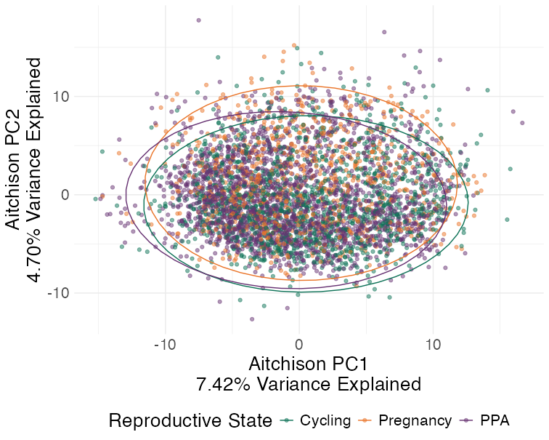
Figure S1. Baboon gut microbiota do not cluster by reproductive state in ordination analysis. Plot of the first two principal components (PCs) of an Aitchison distance matrix for all 4,462 samples. Each point is an individual fecal sample colored by reproductive state. Reproductive state explained 1.46% of the variation between samples (ANOVA on RDA; DF = 2, R² = 0.0146, F = 33.31, p=0.001; Table S2).

Figure S2. Few gut microbial ASVs differ in abundance between PPA and ovarian cycling. Volcano plot showing the effect of PPA compared to ovarian cycling on the abundances of the 401 ASVs present in at least 20% of samples. Each point represents an individual ASV and the color of each point represents the ASV’s assigned phyla. Points above the horizontal red line are statistically significant associations (q<0.05). Points to the left or right of the vertical red lines have relatively large fold changes of ≥1.5 or ≤-1.5. Model results used to generate this table are found in table S4.

Figure S3. Gut microbiota in the first three months of PPA are distinct from later PPA. (A) ASV richness as a function of the period of PPA. ASV richness is significantly higher during early PPA than later periods of PPA (Table S5). (B-E) Volcano plots showing the effect of three to six months in PPA (B), six to nine months in PPA (C), nine months in PPA to infant weaning (D), and one month to cycling resumption (E) compared to zero to three months in PPA on the abundances of the 401 bacterial ASVs. Each point represents an individual ASV and the color of each point represents the ASV’s assigned phylum. Points above the horizontal red line are statistically significant (q<0.05). Points to the left or right of the vertical red lines have fold changes of ≥1.5 or ≤-1.5. Model results used to generate panels B-E are in Table S8.

Figure S4. Gut microbial changes are small across ovarian cycle phases. (A) ASV richness as a function of ovarian cycle phase. ASV richness does not significantly differ between phases (Table S5). (B-D) Volcano plots showing the effect of the menstrual (B), follicular (C), and luteal (D) phases compared to the peri-ovulatory phase on the abundances of the 401 bacterial ASVs. Each point represents an individual ASV and the color of each point represents the ASV’s assigned phyla. Points above the horizontal red line are statistically significant (q<0.05). Points to the left or right of the vertical red lines have fold changes of ≥1.5 or ≤-1.5. Model results used to generate panels B-D are in Table S9.

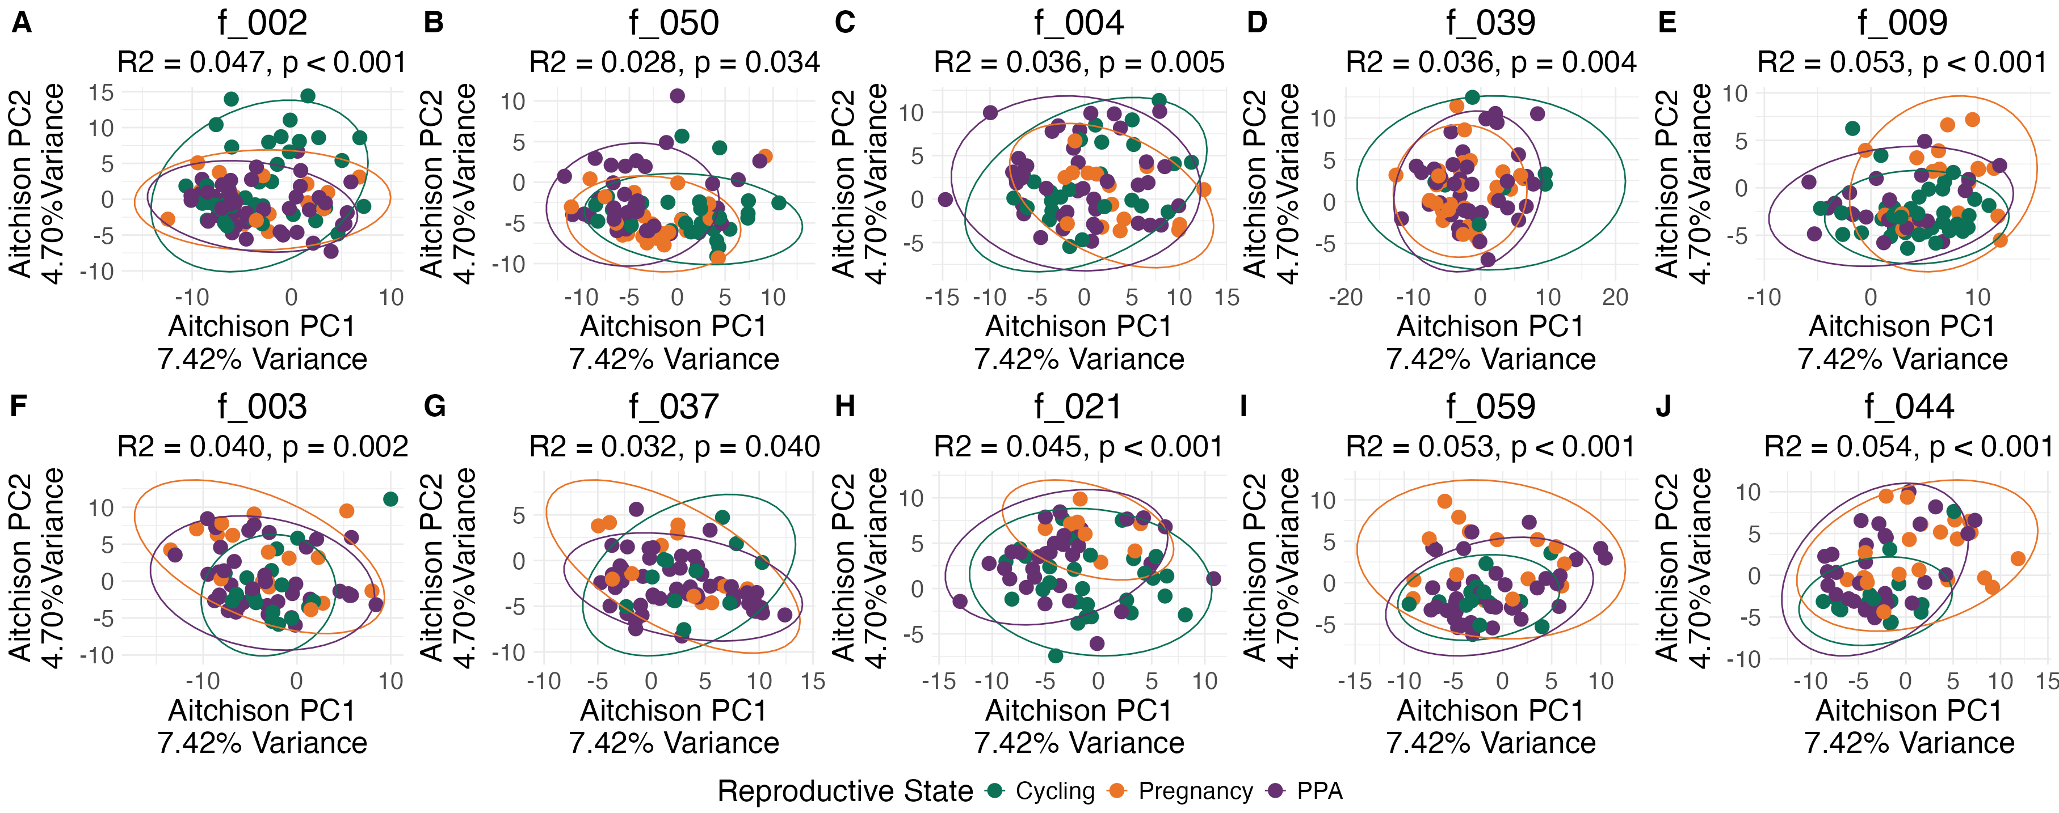

Figure S5. Reproductive state explains more variation in microbiota composition within individuals, compared to across all samples. Each plot shows the first two principal components of Aitchison distances between samples within an individual female (female ID is indicated by a unique code above each plot). Each point represents one sample and points are colored by reproductive state. R² and p-values are from ANOVAs on the Redundancy Analysis (RDA) for each female in Table S10.

