Supplementary Methods

1. Data Sourcing and Deduplication
The initial abstract corpus was generated by querying three major bibliographic databases: Web of Science (WoS), Scopus, and PubMed on August 14, 2025.
Final Search Query: The search string was designed to capture fungal endophyte research broadly. The exact Boolean query used was: TITLE-ABS-KEY(("fungal endophyte" OR "fungal endophytes" OR "endophytic fungus" OR "endophytic fungi" OR "latent fungus" OR "latent fungi" OR "systemic fungus" OR "systemic fungi" OR "internal fungi" OR "resident fungi" OR "seed-borne fungi" OR "seed-transmitted fungi" OR "dark septate endophyte" OR "dark septate fungi" OR "DSE fungi") AND (plant* OR moss* OR bryophyte* OR liverwort* OR hornwort* OR fern* OR lycophyte* OR pteridophyte* OR tree* OR forest* OR shrub* OR grass* OR graminoid* OR herb* OR crop* OR seedling* OR sapling* OR seed* OR root* OR leaf* OR foliage OR shoot* OR stem* OR twig* OR rhizome* OR thallus OR frond* OR algae OR "green alga*" OR macroalga* OR "red alga*" OR "brown alga*" OR hydrophyte* OR kelp OR seaweed* OR seagrass* OR cyanobacteria OR cyanobiont* OR photobiont* OR lichen*)) AND DOCTYPE(ar)
This process yielded a combined dataset of 41,154 abstracts from the three sources (WoS: 14,855; Scopus: 15,426; PubMed: 10,873). This corpus was subjected to a rigorous, multi-stage deduplication pipeline (Supp. Table 1):
- Standardization of column names (e.g., Title, Abstract, DOI) across sources.
- Deduplication by DOI, reducing the set to 23,321 abstracts.
- Deduplication by normalized (to lowercase) abstract text, reducing the set to 23,007 abstracts.
- Filtering to include “Article” document types only, reducing the set to 22,587 abstracts.
- Final deduplication by normalized (to lowercase) title, resulting in the 21,891 abstract dataset that was fed into the ML pipeline. To ensure our training data was representative of this full corpus, we compared the publication year distributions of the manually curated training set against the full dataset (Supp. Fig. 7). This confirmed that our training data was not temporally biased.

Curation Stage | Initial Records ($N$) | Final Records ($N$) | Records Removed ($ΔN$) | Rationale
1. Initial Combination & Abstract Filter | 41,154 (WoS: 14,855; Scopus: 15,426; PubMed: 10,873) | 40,776 | 378 | Removed records with missing or empty abstracts.
2. DOI Deduplication | 40,776 | 23,321 | 17,455 | Most stringent match; prioritized WoS/Scopus/PubMed record.
3. Abstract Text Deduplication | 23,321 | 23,007 | 314 | Normalized text match for records without DOIs.
4. Document Type Filter | 23,007 | 22,587 | 420 | Restricted analysis to Article types only.
5. Title Deduplication (Final Corpus) | 22,587 | 21,891 | 696 | Final check using normalized title text.

Supplementary Table 1: Corpus assembly statistics, representing how many abstracts were removed in every step of the dataset creation pipeline.

2. ML Classification Pipeline
The 21,891 abstracts were processed by a two-stage machine learning pipeline. To ensure the models could distinguish true biological claims from ambiguous statements, this training set included not only clear ‘Presence’ and ‘Absence’ examples, but also ‘Both’ (mixed results, n=117) and ‘Other’ (irrelevant/ambiguous, n=180) classes. We employed synthetic data augmentation to balance these classes and compensate for the extreme rarity of ‘Absence’ claims in the literature.
- Relevance Classification: The first stage classifier filtered the corpus for scope. We defined ‘Irrelevant’ as any abstract that failed to meet our inclusion criteria for primary fungal endophyte ecology. Specifically, the ‘Irrelevant’ class included: (1) secondary literature (reviews, perspectives, book chapters); (2) studies focused exclusively on bacterial, viral, or insect symbionts; (3) research on mycorrhizae lacking a distinct endophyte component; and (4) purely agronomic or chemical studies (e.g., bioprospecting assays) that did not report host or fungal taxonomic data.
The initial relevance classification stage used a regularized logistic regression (glmnet) to filter the corpus of 21,891 abstracts for primary literature relevant to fungal endophytes. Using 5-fold cross-validation on the manually curated training set, the model achieved an Overall Accuracy of 0.895 and a Sensitivity (Recall) for the ‘Relevant’ class of 0.976. This high sensitivity was critical to ensure the first filter retained the vast majority of true endophyte-focused studies, preventing the loss of relevant data from the corpus before the final analysis. The Specificity (correctly identifying ‘Irrelevant’ abstracts) was 0.674, which is an acceptable trade-off for maximizing the recall of the primary, ‘Relevant’ literature. This step resulted in 19,447 abstracts classified as relevant, from the original full dataset of 21,891 abstracts.
- Presence/Absence Classification: The training dataset for the second stage consisted of 505 relevant abstracts (80% split). The class distribution for the “Absence” category was initially critically low (n=1 verified true absence). To enable model training, we first performed text-based data augmentation by generating synthetic abstracts representing plausible absence claims (93 via large language models), raising the “Absence” class count to 94.
Despite this augmentation, the dataset remained imbalanced (Presence: 411, Absence: 94). To fully mitigate classification bias toward the dominant Presence class, we subsequently applied the Synthetic Minority Oversampling Technique (SMOTE; ³⁷) to the feature vectors (Document-Term Matrix). This resulted in a final, perfectly balanced training set of 822 abstracts (411 for each class).
The models were trained on a Document-Term Matrix (DTM) composed of 7,492 unique features (unigrams and bigrams) extracted from the abstract text. The large-scale application to the full corpus involved creating a sparse DTM with 120,245 features, which was processed in 1,000-document chunks and employed sparse matrix techniques (e.g., unigram sparsity of 99.1%) for memory efficiency.
This corpus was classified using a custom-weighted ensemble of a glmnet model and a linear-kernel Support Vector Machine (svmLinear; ³⁸). As documented in our model testing, this ensemble allowed us to prioritize absence detection. The final model applied a weight of 0.6 to the SVM’s “Presence” prediction and 0.8 to the glmnet “Absence” prediction. All models were validated using 5-fold cross-validation. Two distinct models were trained and cross-validated on the balanced dataset: Support Vector Machine with a Linear Kernel (svmLinear) and Regularized Logistic Regression (glmnet; ³⁸). The svmLinear model demonstrated superior ability to detect studies reporting fungal presence, achieving a Presence Recall of 0.980 (Sensitivity). Conversely, the glmnet model achieved a superior Absence Recall of 0.913 (Specificity). To optimize performance for the rare Absence class while retaining high confidence in Presence classification, we implemented a weighted probability ensemble.
This approach ensures that a high probability of Absence from the glmnet model, which excels at this detection, is strongly favored, thus creating a high-confidence screening tool for our critical class of interest^{10,11}. The optimized threshold for the combined ensemble achieved an Overall Accuracy of 0.872 with a Presence Recall of 0.882 and an Absence Recall of 0.826 on the test set.

3. Ubiquity Statement Analysis
To quantify the status of the ‘ubiquity paradigm,’ we computationally screened the 19,119 relevant and non-mycorrhizal abstracts for explicit statements of ubiquity (e.g., ‘endophytes are ubiquitous’). This analysis found that only 38 abstracts (0.2%) contained such a claim. This scarcity confirms that ubiquity functions as a silent axiom in the primary literature: it is almost never treated as a novel result to be reported in an abstract, but rather as an established premise typically reserved for the introduction sections of full texts.

4. Computational Optimization & Pipeline
The pipeline was engineered for high-throughput and robust processing of large text datasets.
- Error Handling: The pipeline featured a robust error handling system, including “safe execution wrappers” and data recovery from backups, to prevent catastrophic failures during long-running processes.
- Memory Optimization: We employed memory-efficient techniques, such as chunked processing of large files (1,000-document batches), data structure optimization (e.g., converting strings to factors), and aggressive garbage collection, to ensure the pipeline could run on standard hardware.
- Optimized Lookups: We used hash-table optimization and pre-computed lookup tables for O(1) (instant) lookups of species names.
- Bloom Filters: We implemented DuckDB-based Bloom filters for probabilistic pre-filtering³⁹, which allowed the pipeline to instantly reject 80-90% of non-matching taxonomic strings, dramatically reducing expensive validation queries.

5. Modular Extraction Pipeline
The data extraction pipeline was built as a series of modular, independent components.
The extraction components demonstrated high fidelity, successfully detecting plant and fungal species in 82.2% (15,940) of the 19,119 relevant abstracts and plant tissue information in 75.5% of abstracts.
- Species & Mycorrhizal Extraction: The first component extracted all plant and fungal taxonomic names and classified fungi for mycorrhizal status (Supp. Fig. 3).
- Mycorrhizal-Only Filtering: A dedicated algorithm assessed abstracts and flagged those containing only mycorrhizal fungi for exclusion. Starting with 19,447 unique abstracts (the full relevant corpus input into the presence/absence DTM creation), we systematically removed abstracts that reported mycorrhizal associations to avoid confounding the endophytic signal. This involved a multi-step filter targeting rows classified as is_mycorrhizal or belonging to the phylum Glomeromycota. This rigorous filtering resulted in the final corpus of 19,199 relevant, abstracts excluding those solely focused on mycorrhizae used for all subsequent analyses.
- Component Extraction: Subsequent components ran on the filtered abstract list to extract research methods (e.g., culture, molecular), plant tissues (e.g., stem, leaf, bark, root) (Supp. Fig. 6), and geographic locations.
- Final Aggregation: A final script merged the outputs from all components into a single comprehensive dataset.

6. Pipeline Visualization
Visualization: All data visualizations were generated in R using ggplot2, employing custom, colorblind-friendly palettes and themes to ensure accessibility and consistency^{40,41}.

7. Code Reproducibility
The codebase includes a comprehensive framework to ensure validation and reproducibility, including scripts to generate representative test subsets and “quick start” test scripts to automatically execute the entire pipeline on these subsets.

8. Detailed Validation Protocols
- Extraction Validation Suite: The data extraction components were validated using a comprehensive, automated test suite (test_extract_species.R) that evaluated “core functionality, accuracy, performance, and robustness.” The pipeline achieved a weighted “Overall score” of 91.4%, passing all 10 test categories.
- Manual Classification Validation: We validated our ML classification in two ways. First, we manually reviewed all ‘Absence’ candidates. Second, to estimate the ‘Absence’ False Negative Rate (i.e., ‘Absence’ abstracts misclassified as ‘Presence’), we manually reviewed a stratified random sample of 77 abstracts that the model had classified as ‘Presence’. This review confirmed that 0 of the 77 abstracts were genuine ‘Absence’ cases, supporting the robustness of our primary finding.

9. Detailed Absence Validation Results
The high-sensitivity screening pipeline identified 102 candidate abstracts for manual validation (89 from the ML model, 12 from the string search, 1 from training). Manual expert review of these 102 abstracts yielded the following:
- 46 ‘Presence’: Simple false positives (the abstract only reported presence but was incorrectly flagged as ‘Absence’ by the model).
- 15 ‘Both’: Abstracts that reported mixed results (e.g., presence in leaves, absence in roots). These are considered ‘Presence’ at the taxon level.
- 40 ‘Irrelevant’: Abstracts irrelevant to this study (e.g., bacterial endophytes).
- 1 ‘Absence’: A single study-level report of non-detection¹⁶. This validation confirmed zero verifiable taxon-level absences in the corpus.

Supplementary Figures
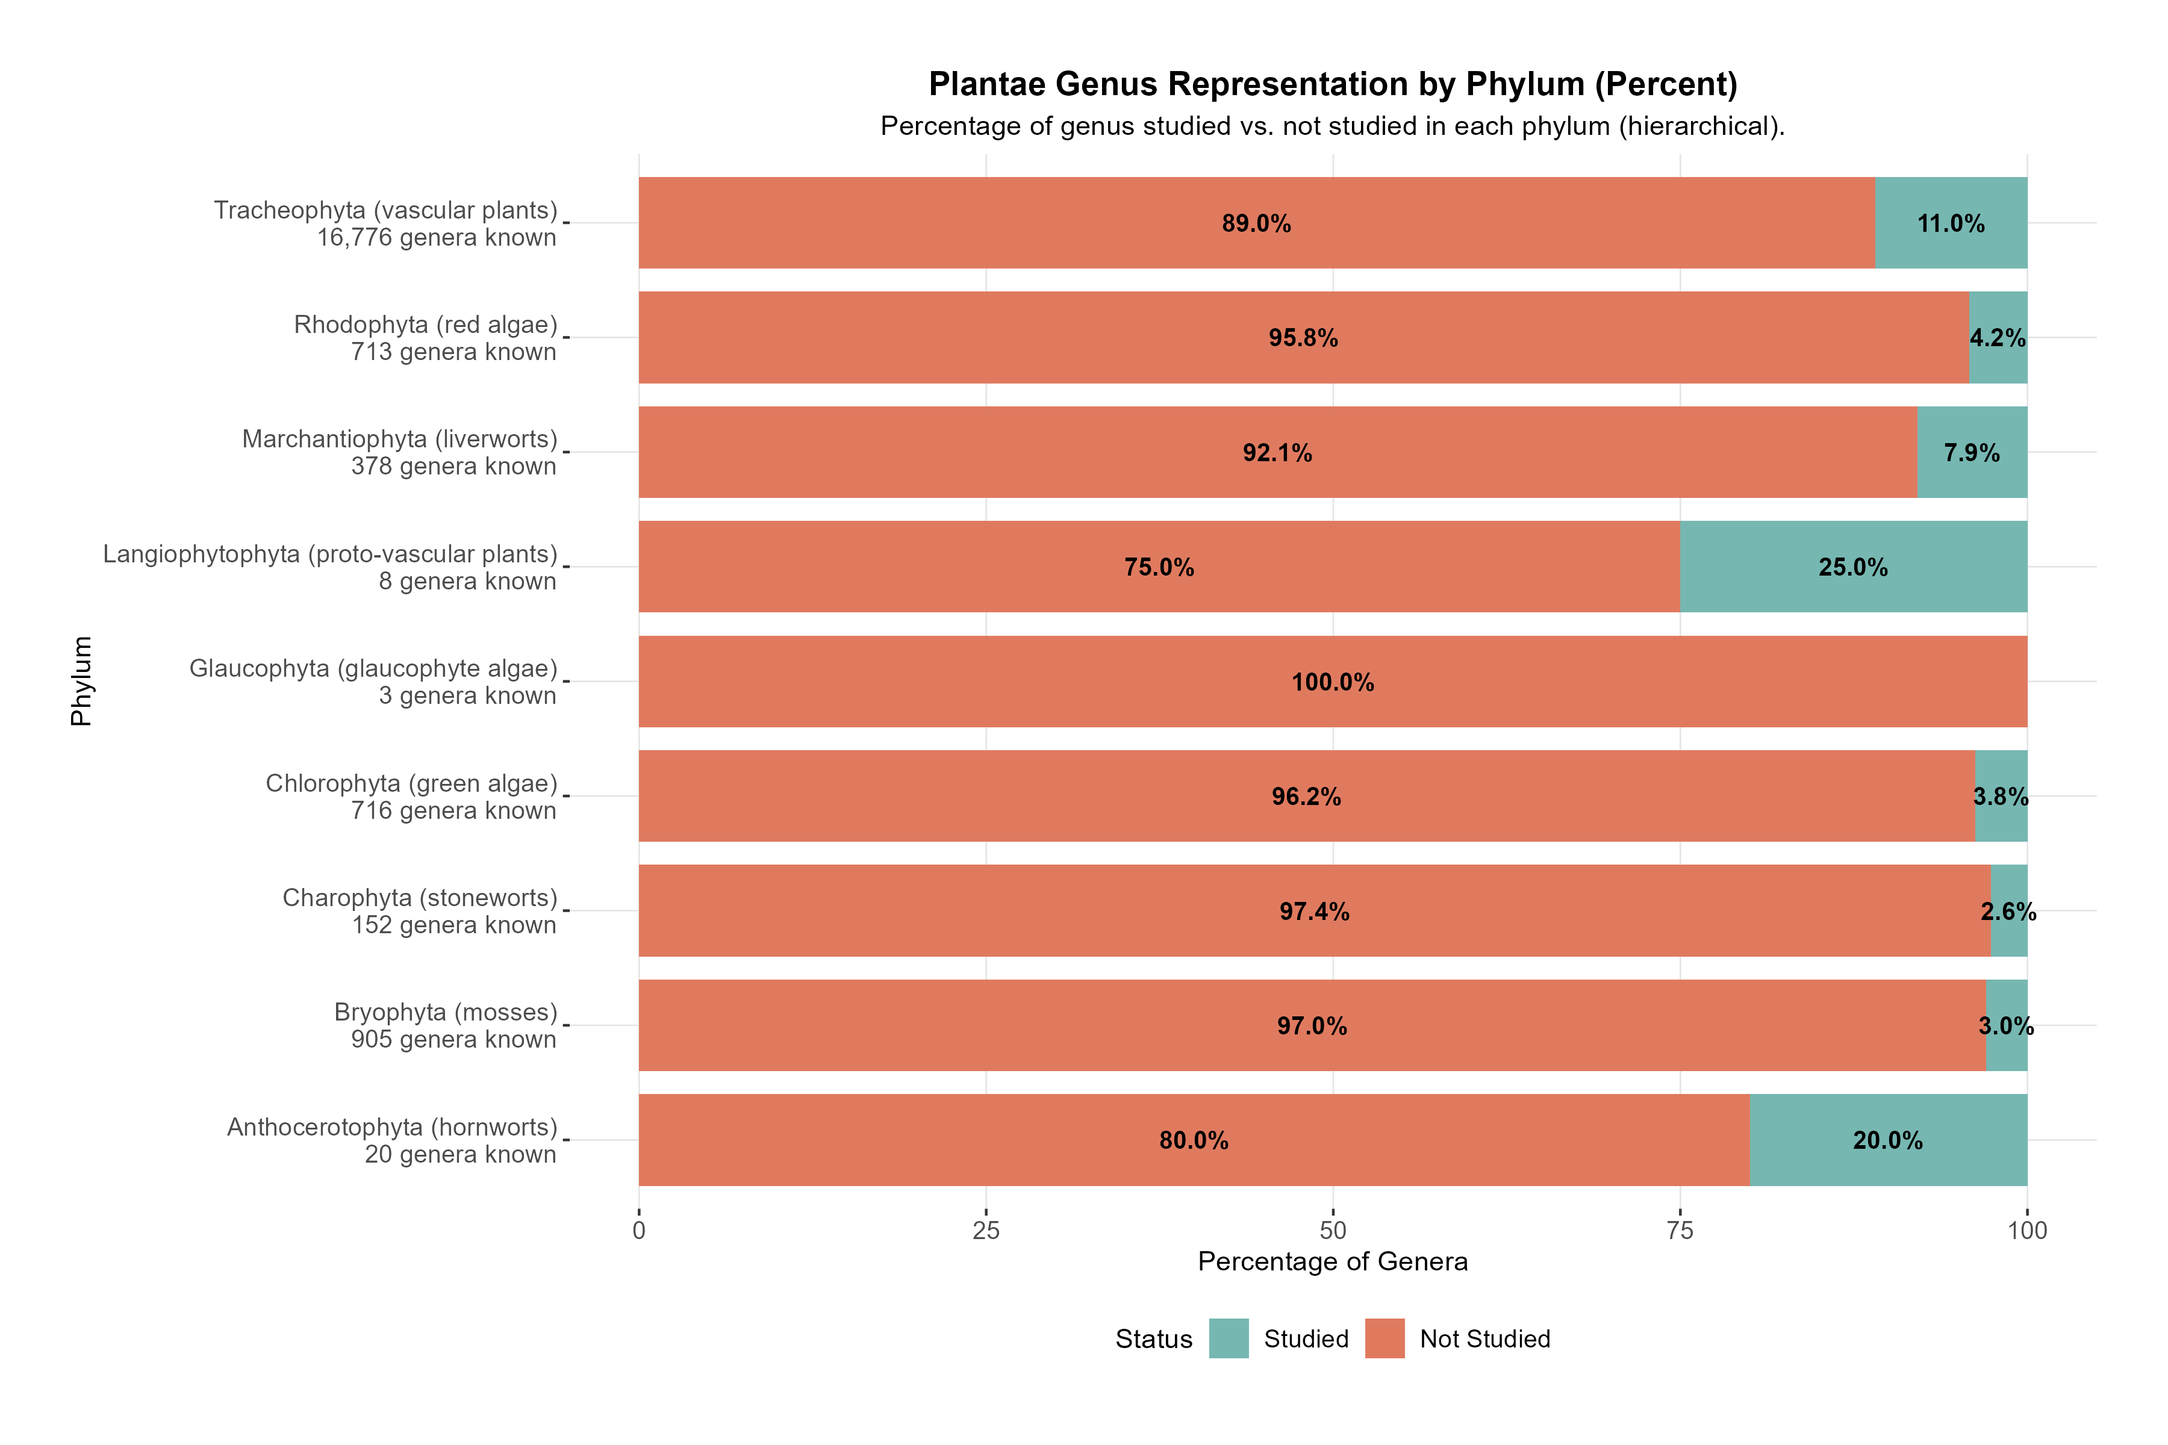
Supp. Fig. 1: Genus representation by plant phylum. Proportion of described genera represented in the corpus, broken down by plant phylum.
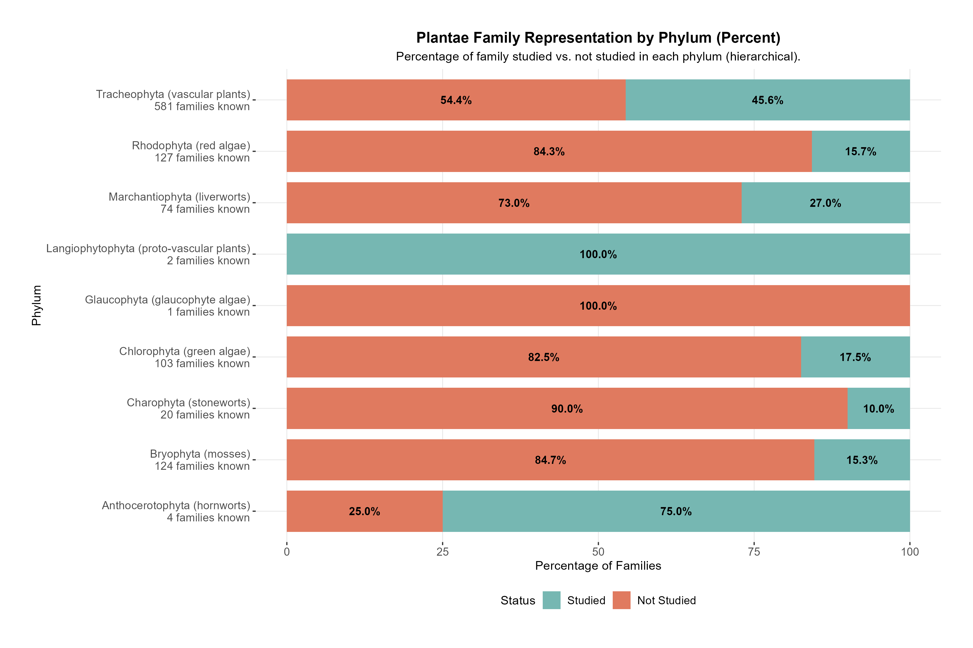
Supp. Fig. 2: Family representation by phylum (plants). Proportion of described families represented in the corpus, by plant phylum.
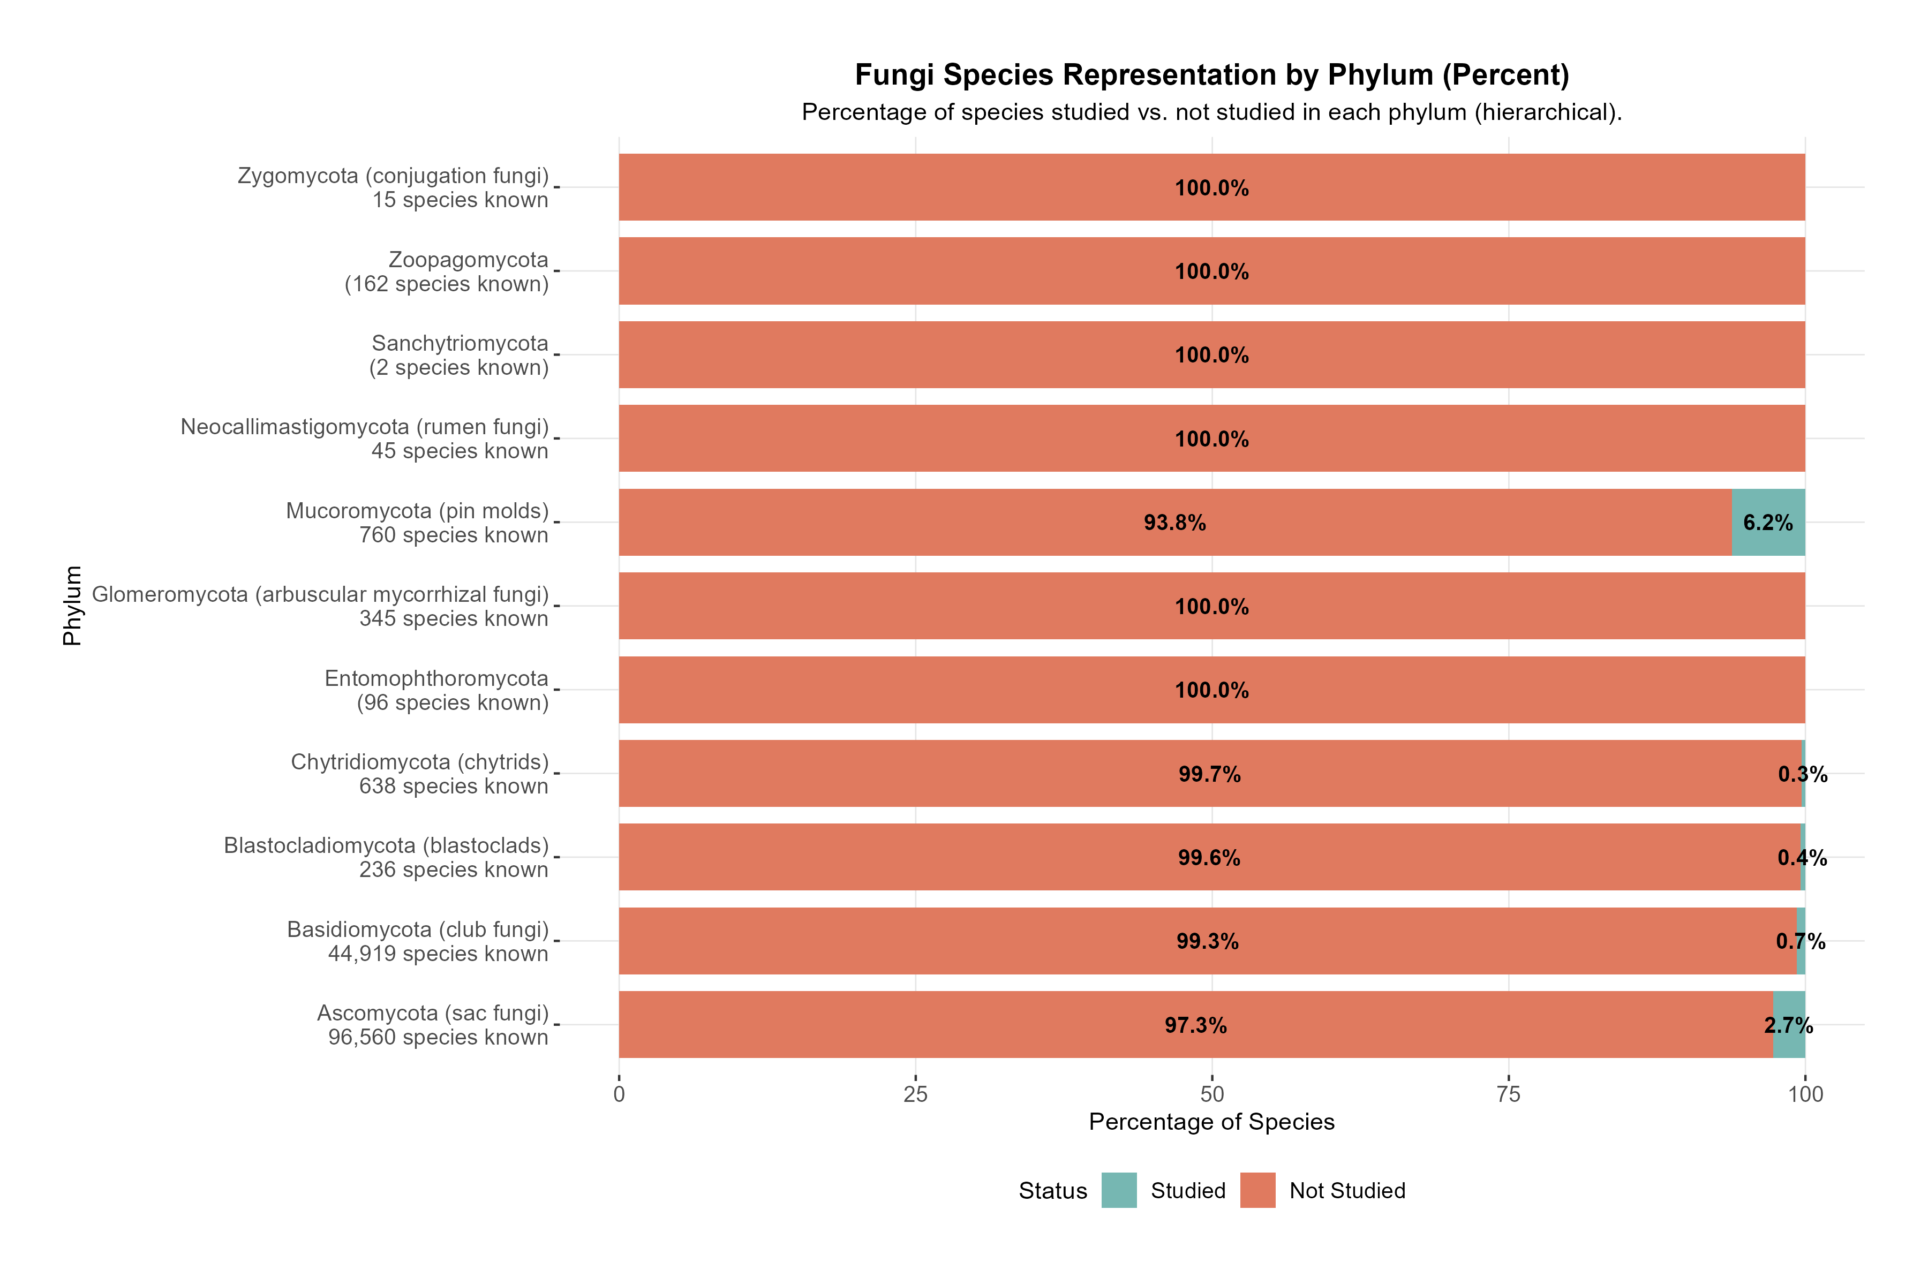
Supp. Fig. 3: Fungal species representation by phylum. Bars represent the percentage of described species within each fungal phylum detected in the 19,119-abstract corpus. Note: The phylum Glomeromycota is included here for taxonomic completeness but displays 0% coverage because all abstracts focusing on arbuscular mycorrhizal fungi were methodologically excluded to distinguish endophytes from mycorrhizal fungi.

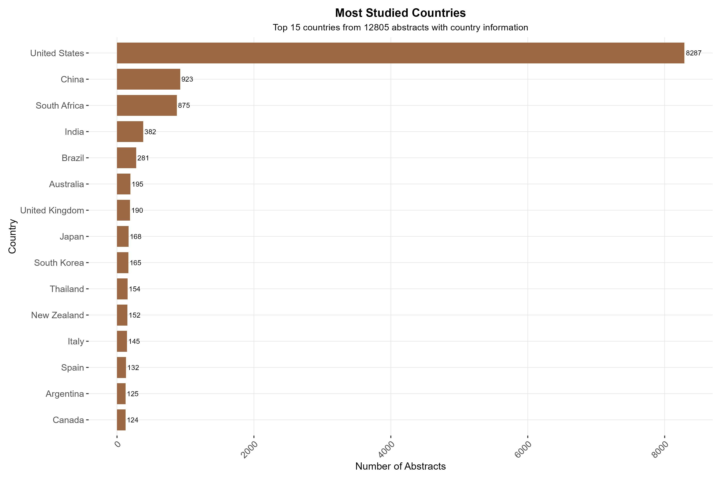
Supp. Fig. 4: Top countries by study count. Bar plot of the top 20 countries by number of geographically coded studies; United States, China, South Africa, India, and Brazil are highest.
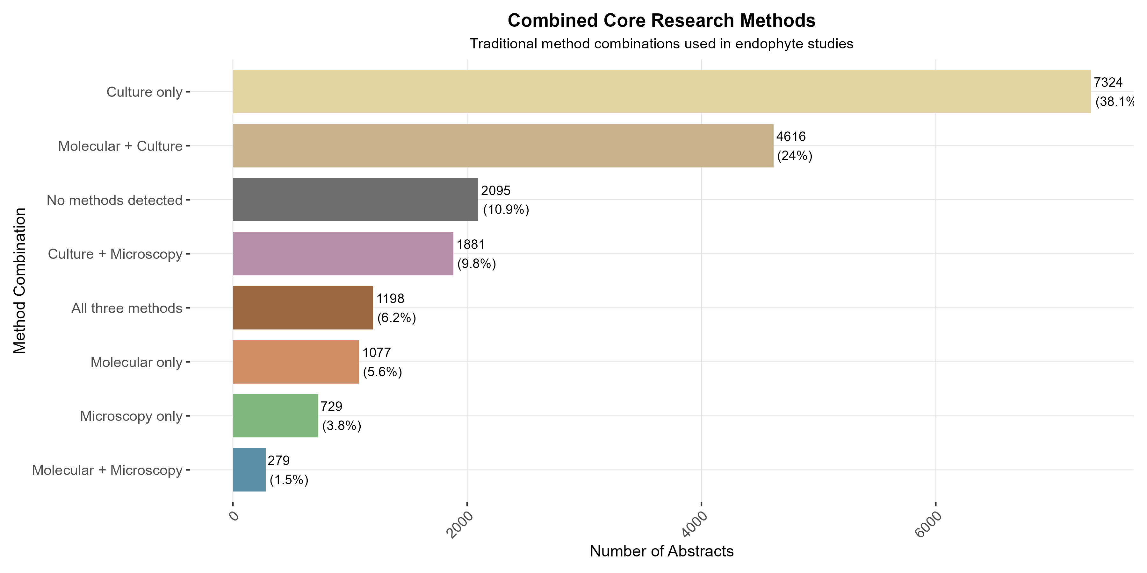
Supp. Fig. 5: Combined detection methods overview. Relative and absolute counts of method types (molecular, culture-based, microscopy/visual) across studies that reported methods.
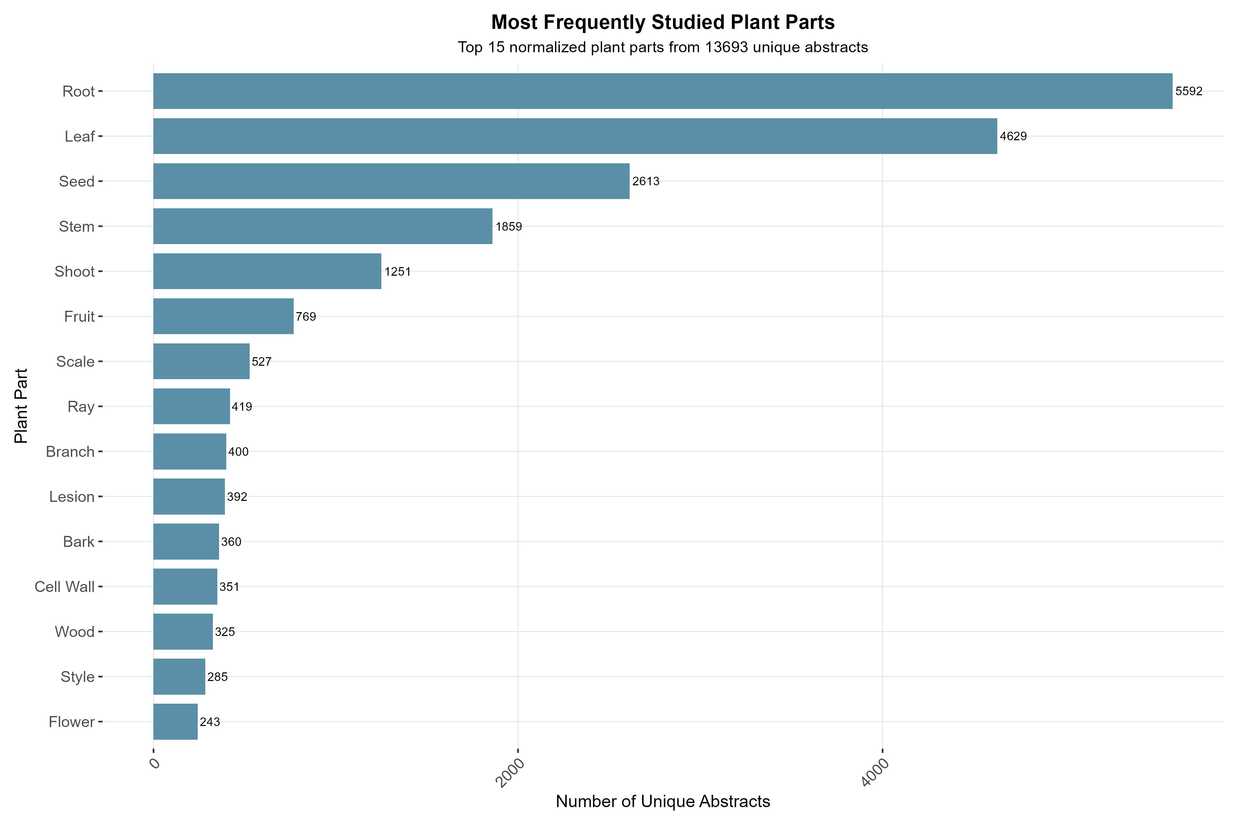
Supp. Fig. 6: Plant tissue frequency in the dataset. Frequency distribution of plant parts (leaf, root, stem, etc.) reported across the 19,119 relevant-abstract corpus.

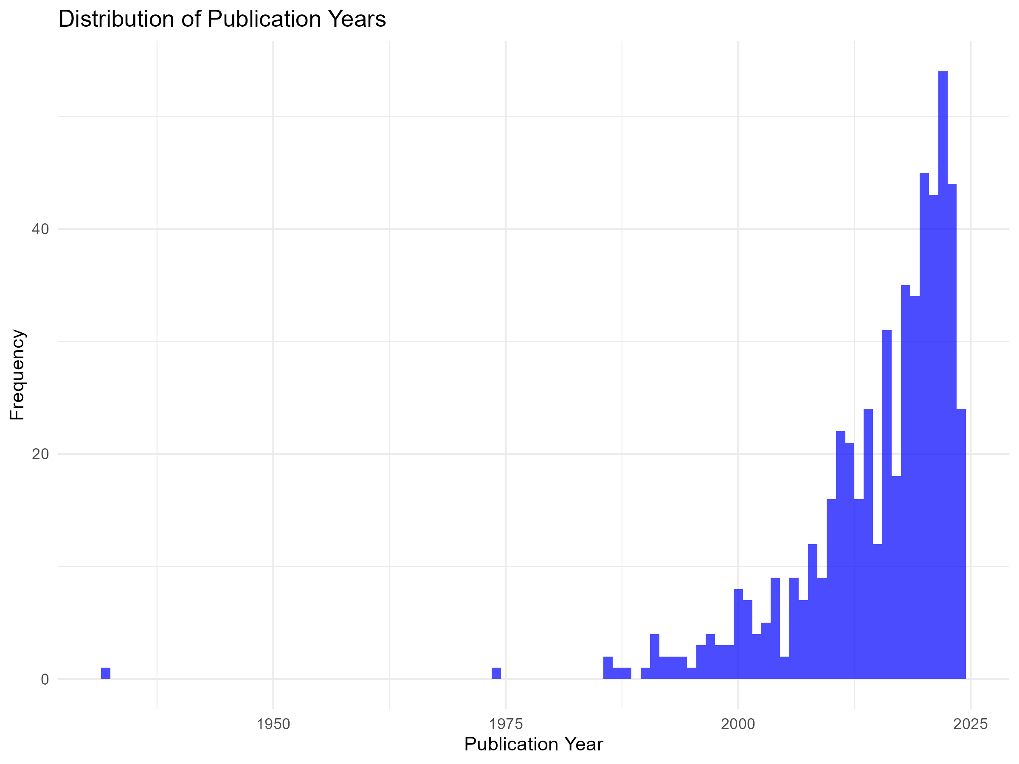
Supp. Fig. 7: Distribution of publication years in the training dataset.

