Supplemental file

Table S1. The limit of detection (LOD, in ng/mL) for urinary phthalate metabolites (NHANES 2007–2016).
Table S2. Spearman rank correlation matrix for urinary phthalate metabolites concentrations (μg/mmol Cr) measured in the adolescents (N=1,650), NHANES 2007-2016.
Table S3. Association between log-transformed phthalate metabolites and indicators of liver function for adolescents aged 12-19 years old in NHANES 2007-2016 (N=1,650).
Table S4. The sensitivity analysis of the association between log-transformed phthalate metabolites and indicators of liver function in NHANES 2007-2016.
Table S5. Posterior inclusion probabilities (PIPs), using Bayesian kernel machine regression (BKMR) model (N=1,650), NHANES 2007–2016.

Table S1. The limit of detection (LOD, in ng/mL) for urinary phthalate metabolites (NHANES 2007–2016).
Analyte | 2007-2008 | 2009-2010 | 2011-2012 | 2013-2014 | 2015-2016
MCNP | 0.5 | 0.2 | 0.2 | 0.2 | 0.2
MCOP | 0.7 | 0.2 | 0.2 | 0.3 | 0.3
MECPP | 0.5 | 0.2 | 0.2 | 0.4 | 0.4
MnBP | 0.6 | 0.4 | 0.4 | 0.4 | 0.4
MCPP | 0.2 | 0.2 | 0.2 | 0.4 | 0.4
MEP | 0.462 | 0.462 | 0.6 | 1.2 | 1.2
MEHHP | 0.7 | 0.2 | 0.2 | 0.4 | 0.4
MEHP | 1.1 | 0.5 | 0.5 | 0.8 | 0.8
MiBP | 0.3 | 0.2 | 0.2 | 0.8 | 0.8
MEOHP | 1.848 | 0.2 | 0.2 | 0.2 | 0.2
MBzP | 0.216 | 0.216 | 0.3 | 0.3 | 0.3

Table S2 Spearman rank correlation matrix for urinary phthalate metabolites concentrations (μg/mmol Cr) measured in the adolescents (N=1,650), NHANES 2007-2016.
 | ∑DEHPª | MCNP | MCOP | MnBP | MCPP | MEP | MiBP | MBzP
∑DEHPª | 1
MCNP | 0.319** | 1
MCOP | 0.216** | 0.625** | 1
MnBP | 0.497** | 0.095** | 0.046 | 1
MCPP | 0.529** | 0.541** | 0.622** | 0.356** | 1
MEP | 0.283** | 0.052** | -0.045 | 0.325** | 0.167** | 1
MiBP | 0.315** | 0.077** | 0.107** | 0.607** | 0.195** | 0.220** | 1
MBzP | 0.397** | 0.062** | 0.081** | 0.585** | 0.309** | 0.182** | 0.393** | 1
** P< 0.05

Table S3.Association between log-transformed phthalate metabolites and indicators of liver function for adolescents aged 12-19 years old in NHANES 2007-2016 (N=1,650).
 | β (95% CI) | P value | P _{FDR}
ALT
∑DEHPª | 0.0059 (-0.0076 0.0194) | 0.660 | 0.856
MCNP | 0.0160 (0.0020, 0.0300) | 0.254 | 0.660
MCOP | -0.0037 (-0.0179, 0.0105) | 0.796 | 0.906
MnBP | -0.0085 (-0.0277, 0.0107) | 0.658 | 0.856
MCPP | -0.0121 (-0.0266, 0.0024) | 0.404 | 0.725
MEP | 0.0023 (-0.0069, 0.0115) | 0.807 | 0.906
MiBP | 0.0107 (-0.0110, 0.0324) | 0.623 | 0.856
MBzP | 0.0136 (-0.0039, 0.0311) | 0.436 | 0.725
AST
∑DEHPª | 0.0047 (-0.0047, 0.0141) | 0.612 | 0.856
MCNP | 0.0002 (-0.0106, 0.0110) | 0.958 | 0.986
MCOP | -0.0119 (-0.221, -0.0017) | 0.245 | 0.660
MnBP | -0.0009 (-0.0174, 0.0156) | 0.954 | 0.986
MCPP | 0.0004 (-0.0102, 0.0110) | 0.973 | 0.986
MEP | 0.0047 (-0.0017, 0.0111) | 0.459 | 0.734
MiBP | 0.0312 (0.0060, 0.0564) | 0.216 | 0.658
MBzP | -0.0039 (-0.0186, 0.0108) | 0.791 | 0.906
GGT
∑DEHPª | -0.0058 (-0.0214, 0.0098) | 0.707 | 0.856
MCNP | 0.0264 (0.0079, 0.0449) | 0.153 | 0.576
MCOP | -0.0083 (-0.0237, 0.0071) | 0.589 | 0.856
MnBP | 0.0445 (0.0225, 0.0665) | 0.044 | 0.256
MCPP | -0.0315 (-0.0468, -0.0162) | 0.040 | 0.256
MEP | 0.0097 (-0.0002, 0.0196) | 0.327 | 0.722
MiBP | -0.0170 (-0.0360, -0.0020) | 0.370 | 0.725
MBzP | -0.0003 (-0.0161, 0.0155) | 0.986 | 0.986
ALP
∑DEHPª | 0.0133 (-0.028, 0.0294) | 0.409 | 0.725
MCNP | 0.0130 (-0.039, 0.0299) | 0.442 | 0.725
MCOP | -0.0158 (-0.0293, -0.0023) | 0.243 | 0.660
MnBP | -0.0133 (-0.0368, 0.0102) | 0.573 | 0.856
MCPP | -0.0067 (-0.0238, 0.0104) | 0.694 | 0.856
MEP | -0.0014 (-0.0118, 0.0090) | 0.894 | 0.954
MiBP | 0.0331 (0.0111, 0.0551) | 0.132 | 0.552
MBzP | 0.0056 (-0.0109, 0.0221) | 0.734 | 0.870
TBIL
∑DEHPª | -0.0169 (-0.0334, 0.0004) | 0.308 | 0.704
MCNP | 0.0199 (0.0006, 0.0392) | 0.303 | 0.704
MCOP | -0.0582 (-0.0726, -0.0438) | <0.001 | 0.001
MnBP | 0.0375 (0.0132, 0.0618) | 0.124 | 0.552
MCPP | 0.0640 (0.0443, 0.0837) | 0.001 | 0.011
MEP | 0.0161 (0.0043, 0.0279) | 0.175 | 0.603
MiBP | -0.0600 (-0.0804, -0.0396) | 0.003 | 0.024
MBzP | 0.0142 (-0.0019, 0.0303) | 0.378 | 0.725
ALB
∑DEHPª | -0.0107 (-0.0132, -0.0082) | <0.001 | 0.001
MCNP | -0.0013 (-0.0039, 0.0013) | 0.623 | 0.856
MCOP | -0.0091 (-0.0114, -0.0068) | <0.001 | 0.001
MnBP | -0.0035 (-0.0066, -0.0004) | 0.268 | 0.660
MCPP | 0.0084 (0.0060, 0.0109) | 0.0004 | 0.005
MEP | -0.0046 (-0.0061, -0.0031) | 0.002 | 0.018
MiBP | 0.0011 (-0.0019, 0.0041) | 0.709 | 0.856
MBzP | -0.0033 (-0.0059, -0.0007) | 0.208 | 0.658
TP
∑DEHPª | -0.0027 (-0.0047, -0.0007) | 0.179 | 0.603
MCNP | 0.0004 (-0.0020, 0.0028) | 0.879 | 0.954
MCOP | -0.0082 (-0.0101, -0.0063) | <0.001 | 0.001
MnBP | -0.0067 (-0.0095, -0.0039) | 0.019 | 0.135
MCPP | 0.0010 (-0.0015, 0.0035) | 0.697 | 0.856
MEP | 0.0014 (-0.0003, 0.0031) | 0.420 | 0.725
MiBP | 0.0024 (-0.0003, 0.0051) | 0.374 | 0.725
MBzP | -0.0016 (-0.0037, 0.0005) | 0.430 | 0.725
AST/ALT
∑DEHPª | -0.0012 (-0.0101, 0.0077) | 0.893 | 0.954
MCNP | -0.0158 (-0.0264, -0.0052) | 0.138 | 0.552
MCOP | -0.0082 (-0.0174, 0.0010) | 0.373 | 0.725
MnBP | 0.0076 (-0.0067, 0.0219) | 0.596 | 0.856
MCPP | 0.0124 (0.0014, 0.0234) | 0.260 | 0.660
MEP | 0.0025 (-0.0040, 0.0090) | 0.706 | 0.856
MiBP | 0.0206 (0.0074, 0.0338) | 0.120 | 0.552
MBzP | -0.0175 (-0.0279, -0.0071) | 0.092 | 0.491
ª ΣDEHP indicates the creatinine corrected molar sum of DEHP metabolites including: MECPP, MEHHP, MEHP, and MEOHP (expressed as MEHP, molecular weight 278).
P _{FDR} is the P value adjusted by the method of Benjamini-Hochberg false discovery rate (FDR) correction to adjust for multiple testing.
All models were adjusted for poverty income ratio (≤1/>1), BMI (<25/25-30/≥30), age (12-14/15-17/18-19 years), gender(male/female), race/ethnicity (Mexican American/Other Hispanic/Non-Hispanic White/Non-Hispanic Black/Other Race), education (Less than high school/ High School graduate or GED/ More than High), and physical activity (inactive/active).

Table S4.The sensitivity analysis of the association between log-transformed phthalate metabolites and indicators of liver function in NHANES 2007-2016.
Liver function index/ Phthalate metabolites | β (95% CI)
Liver function index/ Phthalate metabolites | Female(N=767) | Male(N=883)
ALT
∑DEHPª | 0.0033 (-0.0160, 0.0226) | -0.0024 (-0.0217, 0.0169)
MCNP | 0.0152 (-0.0041, 0.0345) | 0.0175 (-0.0031, 0.0381)
MCOP | -0.0019 (-0.0246, 0.0208) | -0.0086 (-0.0257, 0.0085)
MnBP | -0.0308 (-0.0539, -0.0077) | 0.0165 (-0.0134, 0.0464)
MCPP | -0.0058 (-0.0307, 0.0191) | -0.0096 (-0.0272, 0.0080)
MEP | 0.0088 (-0.0034, 0.0210) | -0.0047 (-0.0182, 0.0088)
MiBP | 0.0214 (0.0017, 0.0417) | 0.0152 (-0.0218, 0.0522)
MBzP | 0.0165 (-0.0093, 0.0423) | 0.0104 (-0.0127, 0.0335)
AST
∑DEHPª | -0.0057 (-0.0194, 0.0080) | 0.0126 (-0.0011, 0.0263)
MCNP | 0.0031 (-0.0117, 0.0179) | -0.0018 (-0.0186, 0.0150)
MCOP | -0.0189 (-0.0343, -0.0035) | -0.0073 (-0.0209, 0.0063)
MnBP | -0.0082 (-0.0248, 0.0084) | 0.0093 (-0.0192, 0.0378)
MCPP | 0.0115 (-0.0054, 0.0284) | -0.0070 (-0.0200, 0.0060)
MEP | 0.0022 (-0.0066, 0.0110) | 0.0067 (-0.0026, 0.0160)
MiBP | 0.0262 (0.0097, 0.0427) | 0.0418 (-0.0041, 0.0877)
MBzP | 0.0053 (-0.0123, 0.0229) | -0.0109 (-0.0335, 0.0117)
GGT
∑DEHPª | 0.0053 (-0.0180, 0.0286) | -0.0246 (-0.0435, -0.0057)
MCNP | 0.0025 (-0.0255, 0.0305) | 0.0479 (0.0238, 0.0720)
MCOP | 0.0162 (-0.0094, 0.0418) | -0.0300 (-0.0475, -0.0125)
MnBP | 0.0197 (-0.0099, 0.0493) | 0.0724 (0.0430, 0.1018)
MCPP | -0.0403 (-0.0637, -0.0169) | -0.0194 (-0.0400, 0.0012)
MEP | 0.0158 (0.0036, 0.0280) | 0.0035 (-0.0110, 0.0180)
MiBP | 0.0196 (-0.0078, 0.0470) | -0.0462 (-0.0702, -0.0222)
MBzP | -0.0213 (-0.0470, 0.0044) | 0.0155 (-0.0035, 0.0345)
ALP
∑DEHPª | -0.0030 (-0.0314, 0.0254) | 0.0343 (0.0168, 0.0518)
MCNP | -0.0107 (-0.0358, 0.0144) | 0.0239 (0.0012, 0.0466)
MCOP | -0.0320 (-0.0549, -0.0091) | 0.0120 (-0.0047, 0.0287)
MnBP | -0.0726 (-0.1196, -0.0256) | 0.0329 (0.0124, 0.0534)
MCPP | 0.0194 (-0.0080, 0.0468) | -0.0292 (-0.0502, -0.0082)
MEP | 0.0160 (-0.0008, 0.0328) | -0.0202 (-0.0327, -0.0077)
MiBP | 0.0568 (0.0160, 0.0976) | 0.0071 (-0.0139, 0.0281)
MBzP | 0.0215 (-0.0045, 0.0475) | 0.0016 (-0.0171, 0.0203)
TBIL
∑DEHPª | -0.0326 (-0.0564, -0.0088) | 0.0001 (-0.0218, 0.0220)
MCNP | 0.0408 (0.0115, 0.0701) | 0.0067 (-0.0172, 0.0306)
MCOP | -0.0678 (-0.0882, -0.0474) | -0.0525 (-0.0723, -0.0327)
MnBP | 0.0563 (0.0245, 0.0881) | 0.0324 (0.0024, 0.0624)
MCPP | 0.527 (0.0209, 0.0845) | 0.0693 (0.0434, 0.0952)
MEP | 0.0084 (-0.0097, 0.0265) | 0.0229 (0.0078, 0.0380)
MiBP | -0.0319 (-0.0592, -0.0046) | -0.0811 (-0.1095, -0.0527)
MBzP | 0.0079 (-0.0134, 0.0292) | 0.0147 (-0.0068, 0.0362)
ALB
∑DEHPª | -0.0152 (-0.0186,-0.0118) | -0.0049 (-0.0077, -0.0021)
MCNP | 0.0038 (0, 0.0076) | -0.0053 (-0.0083, -0.0023)
MCOP | -0.0158 (-0.0196, -0.0120) | -0.0047 (-0.0070, -0.0024)
MnBP | -0.0052 (-0.0100, -0.0004) | -0.0007 (-0.0041, 0.0027)
MCPP | 0.0157 (0.0118, 0.0196) | 0.0034 (0.0009, 0.0059)
MEP | -0.0052 (-0.0074, -0.0030) | -0.0032 (-0.0052, -0.0012)
MiBP | 0.0061 (0.0018, 0.0104) | -0.0008 (-0.0044, 0.0028)
MBzP | -0.0033 (-0.0073, 0.0007) | -0.0041 (-0.0068, -0.0014)
TP
∑DEHPª | -0.0050 (-0.0078, -0.0022) | -0.0005 (-0.0035, 0.0025)
MCNP | -0.0022 (-0.0053, 0.0009) | 0.0031 (-0.0005, 0.0067)
MCOP | -0.0120 (-0.0150, -0.0090) | -0.0065 (-0.0090, -0.0040)
MnBP | -0.0048 (-0.0093, -0.0003) | -0.0068 (-0.0102, -0.0034)
MCPP | 0.0081 (0.0042, 0.0120) | -0.0033 (-0.0062, -0.0004)
MEP | 0.0004 (-0.0020, 0.0028) | 0.0023 (-0.0001, 0.0047)
MiBP | 0.0034 (-0.0004, 0.0072) | 0.0024 (-0.0012, 0.0060)
MBzP | -0.0054 (-0.0085, -0.0023) | 0.0003 (-0.0023, 0.0029)
AST/ALT
∑DEHPª | -0.0090 (-0.0206, 0.0026) | 0.0150 (0.0017, 0.0283)
MCNP | -0.0121 (-0.0254, 0.0012) | -0.0193 (-0.0358, -0.0028)
MCOP | -0.0170 (-0.0299, -0.0059) | 0.0013 (-0.0111, 0.0137)
MnBP | 0.0226 (0.0060, 0.0392) | -0.0071 (-0.0290, 0.0148)
MCPP | 0.0173 (0.0015, 0.0331) | 0.0026 (-0.0129, 0.0181)
MEP | -0.0066 (-0.0147, 0.0015) | 0.0114 (0.0017, 0.0211)
MiBP | 0.0048 (-0.0090, 0.0186) | 0.0266 (0.0036, 0.0496)
MBzP | -0.0113 (-0.0261, 0.0035) | -0.0213 (-0.0356, -0.0070)
ª ΣDEHP indicates the creatinine corrected molar sum of DEHP metabolites including: MECPP, MEHHP, MEHP, and MEOHP (expressed as MEHP, molecular weight 278).
All models were adjusted for poverty income ratio (≤1/>1), BMI (<25/25-30/≥30), age (12-14/15-17/18-19 years), race/ethnicity (Mexican American/Other Hispanic/Non-Hispanic White/Non-Hispanic Black/Other Race), education (Less than high school/ High School graduate or GED/ More than High), and physical activity (inactive/active).

Table S5. Posterior inclusion probabilities (PIPs), using Bayesian kernel machine regression (BKMR) model (N=1,650), NHANES 2007–2016.
Analyte | ALT | AST | GGT | ALP | TBIL | ALB | TP | AST/ALT
∑DEHPª | 0.0012 | 0 | 0.0002 | 0.0362 | 0.1598 | 1 | 0 | 0.0114
MCNP | 0.0144 | 0 | 0.0092 | 0 | 0.173 | 0 | 0 | 0.0682
MCOP | 0 | 0 | 0.02 | 0 | 0.6434 | 0 | 0 | 0.0768
MnBP | 0 | 0.0342 | 0.0048 | 0.2006 | 0.9584 | 0 | 0 | 0.0148
MCPP | 0 | 0 | 0.0212 | 0 | 0.522 | 0 | 1 | 0.0032
MEP | 0.028 | 0.003 | 0.0266 | 0.0026 | 0.7476 | 0 | 0 | 0.0602
MiBP | 0 | 0.0036 | 0 | 0.2718 | 0.9692 | 0 | 0 | 0.0432
MBzP | 0.0032 | 0.003 | 0.0044 | 0.2546 | 0.1306 | 0 | 0 | 0.0566
ª ΣDEHP indicates the creatinine corrected molar sum of DEHP metabolites including: MECPP, MEHHP, MEHP, and MEOHP (expressed as MEHP, molecular weight 278).

Figure S1. Flowchart of population included in our final analysis (N=1650), NHANES 2007-2016.
Unweighted survey sample size 2007-2016 NHANES: n=50588
Unweighted survey sample size aged 12-19 years old: n=6598
Excluded (n=934):
Missing hepatitis B core antibody records (n=900)
Serologically positive for hepatitis B virus or hepatitis C virus (n=34)
Participants included:
n=1854

- Excluded (n=43990): Under 12 or over 19 years old

Excluded (n=3810): Missing liver function test or phthalate records

Participants for the current study:
n=1650

Excluded (n=6): TBIL test value of 0
Excluded (n=198): Missing PIR, BMI, or PA records

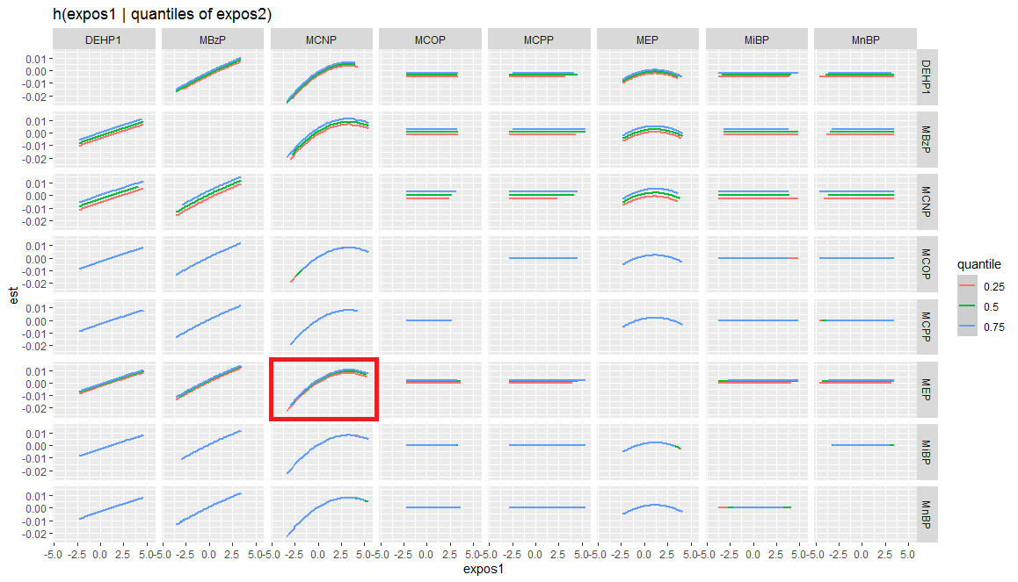
Figure S2. Bivariate exposure–response functions for alanine aminotransferase (ALT) and each of the exposure1 chemicals when exposure2 chemicals were at their 25th (red line), 50th (green line), and 75th (blue line) percentile, and other chemicals were fixed at their median levels. In the top left corner, for example, the exposure–response functions of log-transformed MBzP and ALT were conducted when log-transformed DEHP was fixed at the 25th, 50th, or 75th percentile, and the other urinary phthalate metabolites were fixed at their median levels. As the concentration of DEHP increases from the 25th to the 75th percentile, the positive slope of MBzP tends to be steep, indicating that there may be a positive interaction between MBzP and DEHP in the association with ALT. The results show that the two variables in the red box (exposure 1 and exposure 2) may have an interactive effect on ALT. If the three lines (red, green and blue) are approximately coincident or parallel, this indicates that there may be no interaction between urine phthalate metabolites on ALT.

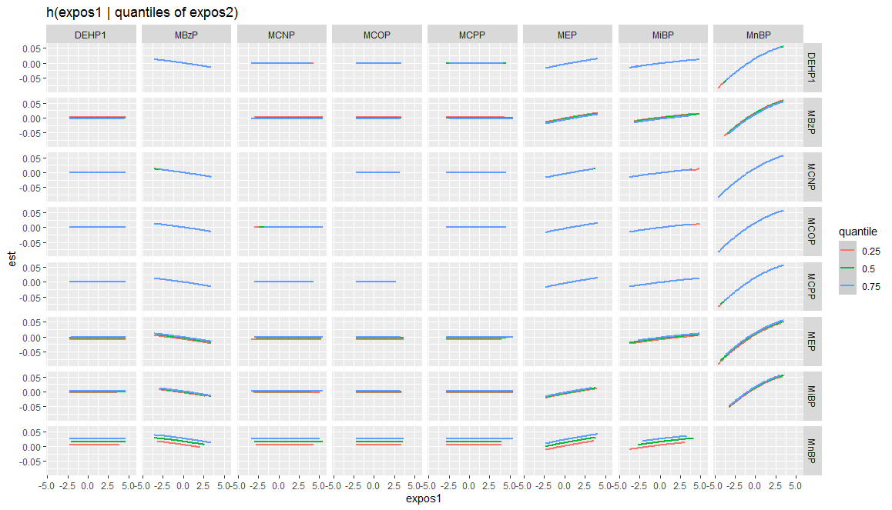
Figure S3. Bivariate exposure–response functions for alanine aminotransferase (AST) and each of the exposure1 chemicals when exposure2 chemicals were at their 25th (red line), 50th (green line), and 75th (blue line) percentile, and other chemicals were fixed at their median levels. The results show that the three lines (red, green and blue) are approximately coincident or parallel, this indicates that there may be no interaction between urine phthalate metabolites on AST.

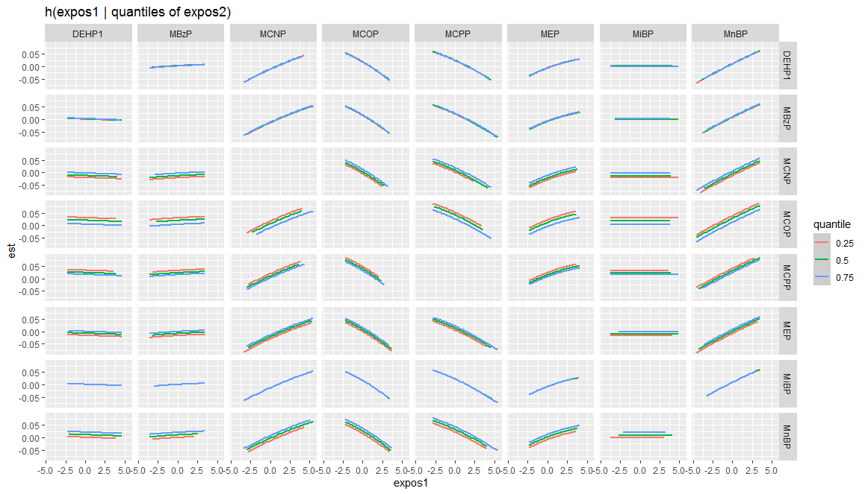
Figure S4. Bivariate exposure–response functions for alanine aminotransferase (GCT) and each of the exposure1 chemicals when exposure2 chemicals were at their 25th (red line), 50th (green line), and 75th (blue line) percentile, and other chemicals were fixed at their median levels. The results show that the three lines (red, green and blue) are approximately coincident or parallel, this indicates that there may be no interaction between urine phthalate metabolites on GCT.

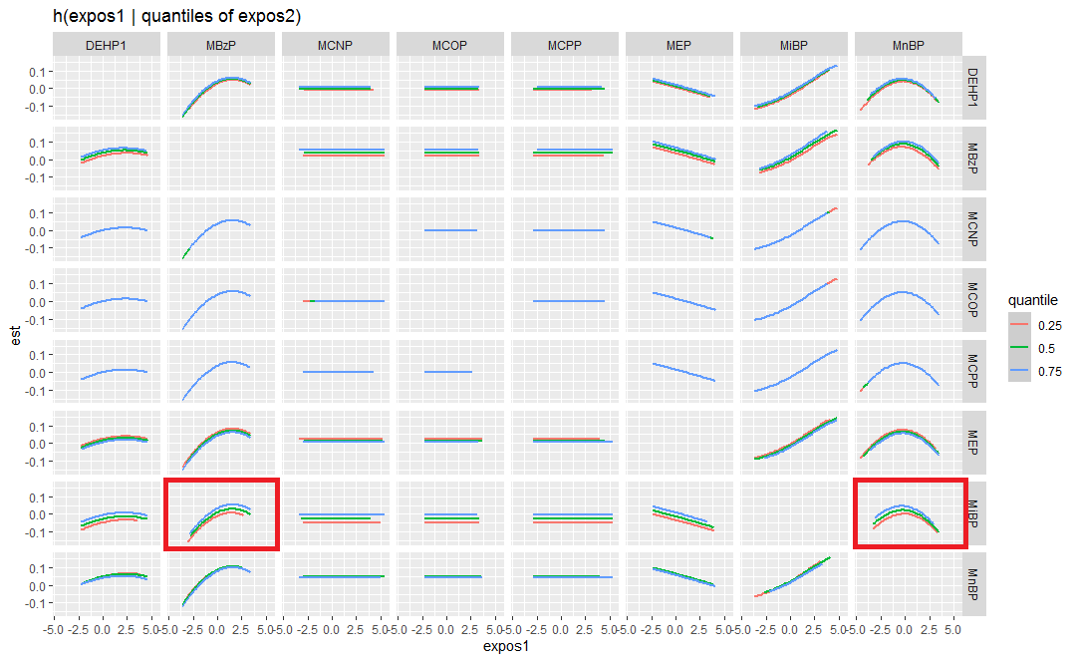
Figure S5. Bivariate exposure–response functions for alanine aminotransferase (ALP) and each of the exposure1 chemicals when exposure2 chemicals were at their 25th (red line), 50th (green line), and 75th (blue line) percentile, and other chemicals were fixed at their median levels. The results show that the two variables in the red box (exposure 1 and exposure 2) may have an interactive effect on ALP. If the three lines (red, green and blue) are approximately coincident or parallel, this indicates that there may be no interaction between urine phthalate metabolites on ALP.

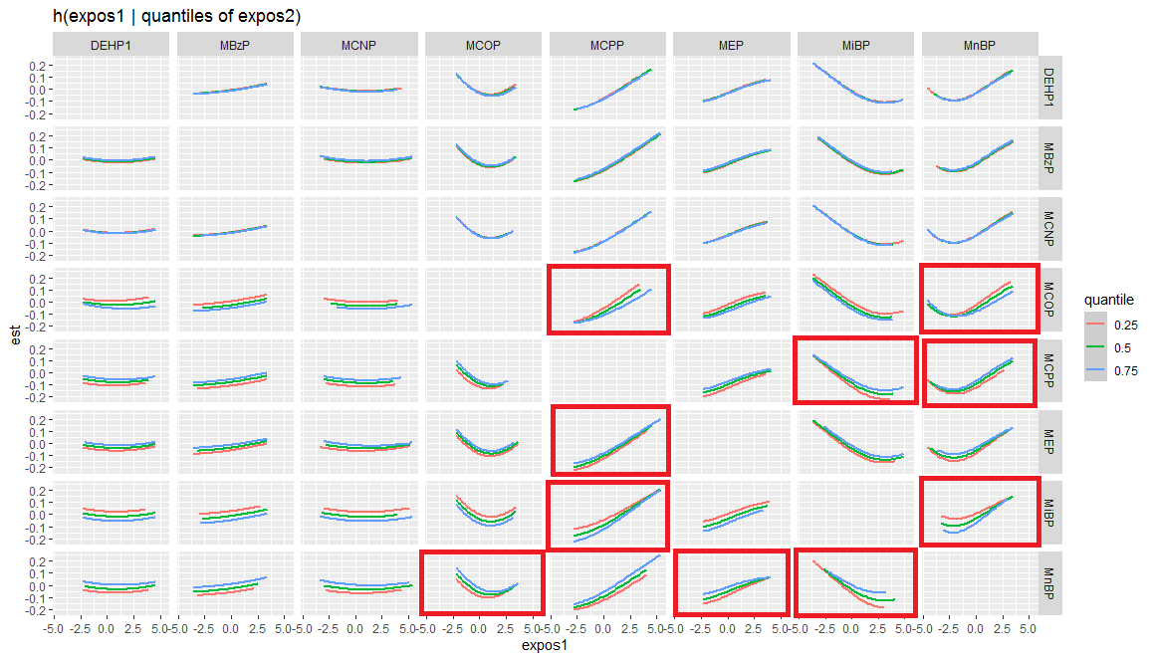
Figure S6. Bivariate exposure–response functions for alanine aminotransferase (TBIL) and each of the exposure1 chemicals when exposure2 chemicals were at their 25th (red line), 50th (green line), and 75th (blue line) percentile, and other chemicals were fixed at their median levels. The results show that the two variables in the red box (exposure 1 and exposure 2) may have an interactive effect on TBIL. If the three lines (red, green and blue) are approximately coincident or parallel, this indicates that there may be no interaction between urine phthalate metabolites on TBIL.

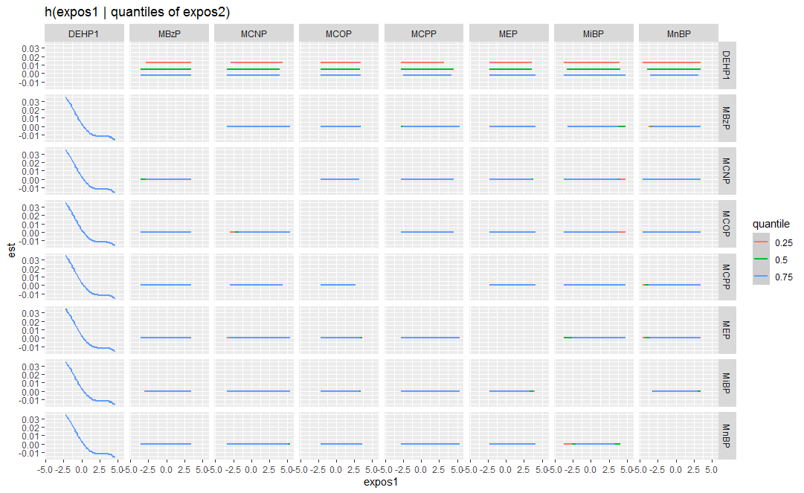
Figure S7.Bivariate exposure–response functions for albumin (ALB) and each of the exposure1 chemicals when exposure2 chemicals were at their 25th (red line), 50th (green line), and 75th (blue line) percentile, and other chemicals were fixed at their median levels. The results show that the three lines (red, green and blue) are approximately coincident or parallel, this indicates that there may be no interaction between urine phthalate metabolites on ALB.

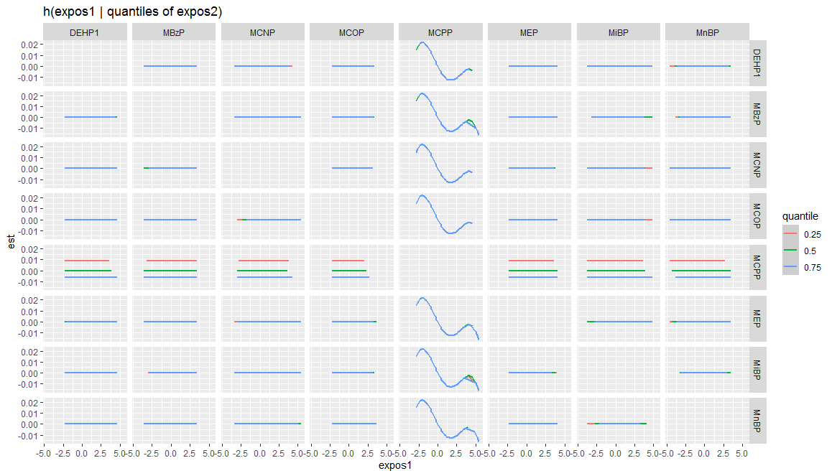
Figure S8. Bivariate exposure–response functions for albumin (TP) and each of the exposure1 chemicals when exposure2 chemicals were at their 25th (red line), 50th (green line), and 75th (blue line) percentile, and other chemicals were fixed at their median levels. The results show that the three lines (red, green and blue) are approximately coincident or parallel, this indicates that there may be no interaction between urine phthalate metabolites on TP.

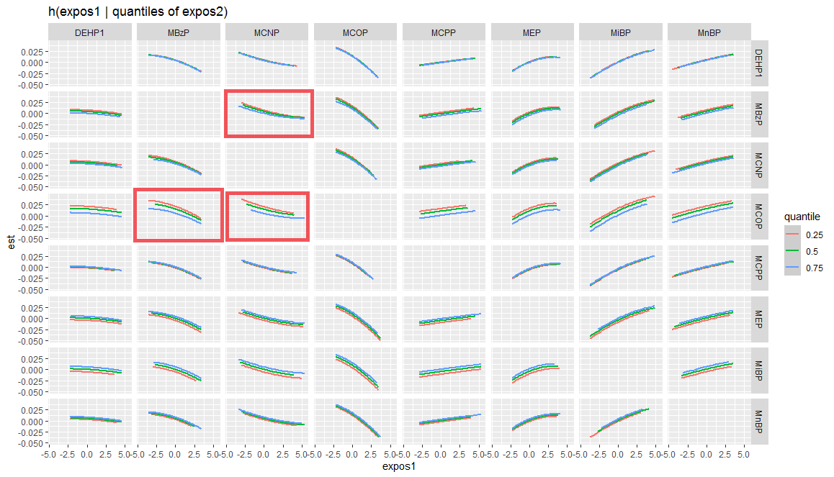
Figure S9. Bivariate exposure–response functions for AST/ALT and each of the exposure1 chemicals when exposure2 chemicals were at their 25th (red line), 50th (green line), and 75th (blue line) percentile, and other chemicals were fixed at their median levels. The results show that the three lines (red, green and blue) are approximately coincident or parallel, this indicates that there may be no interaction between urine phthalate metabolites on AST/ALT.

