SUPPLEMENTARY MATERIALS

S1 Table. Morphological descriptors, units, and abbreviations
Plant part | Descriptor | Units/Categories | Abbreviation | Recording Stage/Interval | No.
Vine | Seed germination percentage | % | SGP | At planting | 1
 | Length of the vine | cm | LV | Weekly | 2
 | No. of nodes | Count | NN | Weekly | 3
 | Vigor of the vine | 1: weak; 2: low; 3: medium; 4: high | VV | Weekly | 4
 | No. of leaves | Count | NL | Weekly | 5
 | No. of days to start vining | Count | NDSV | One time | 6
 | No. of days to start flowering | Count | NDSFl | One time | 7
 | No. of days to start fruiting | Count | NDSFr | One time | 8
 | Leaf area at flowering | cm² (of five selected leaves separately) | LAF | At flowering  One time | 9
 | Estimated leaf area at flowering | cm² (no. of leaves × area of the mean leaf selected) | ELAF | At flowering  One time | 10
 | Density of leaves at flowering stage | No. of leaves/cm (no. of leaves / length of the vine) | DLF | At flowering  One time | 11
 | Relative greenness of the foliage at flowering | 1: yellowish; 2: yellowish green; 3: green | RGFF | At flowering  One time | 12
 | Branching intensity of vine at flowering | 1: weak; 2: intermediate; 3: high | BIV | At flowering  One time | 13
 | Shape of the leaf blade | entire; lightly lobed; intermediately lobed | SLB | Weekly | 14
 | Leaf margin | smooth; serrate | LM | Weekly | 15
 | Hairiness of stem | low; intermediate; high | HS | Weekly | 16
 | Sex expression | Monoecious, andromonoecious | SE | After flowering  Weekly | 17
 | No. of tendrils at flowering | Count | NTF | At flowering  One time | 18
 | Branching intensity of tendril | 1: weak; 2: intermediate; 3: high | BIT | At flowering  One time | 19
 | Total length of tendril | cm (of five selected tendrils separately) | TLT | At flowering  One time | 20
 | Nature of climbing/crawling | 1: weak; 2: intermediate; 3: high | NC | At flowering  One time | 21
 | Overall disease resistance | 1: susceptible; 2: intermediate; 3: resistant | ODR | Weekly | 22
 | Overall insect pest resistance | 1: susceptible; 2: intermediate; 3: resistant | OIPR | Weekly | 23
Flower | No. of staminate flowers | Count | NSF | After flowering  Weekly | 24
 | No. of pistillate flowers | Count | NPF | After flowering  Weekly | 25
 | No. of hermaphrodite flowers | Count | NHF | After flowering  Weekly | 26
 | Ratio of no. of staminate flowers: no. of pistillate flowers: no. of hermaphrodite flowers | Ratio (count) | NSF:NPF:NHF | After flowering  Weekly | 27
 | No. of stigma in staminate flowers | Count | NSSF | After flowering  Weekly | 28
 | No. of stigma in pistillate flowers | Count | NSPF | After flowering  Weekly | 29
 | Ovary shape of pistillate flowers | 1: round; 2: ovular | OSPF | After flowering  Weekly | 30
 | Ovary size of pistillate flowers | mm or 1,2,3 rank | OSiPF | After flowering  Weekly | 31
 | No. of stigma in hermaphrodite flowers | count | NSHF | After flowering  Weekly | 32
 | Ovary shape of hermaphrodite flowers | 1: round; 2: ovular | OSHF | After flowering  Weekly | 33
 | Ovary size of hermaphrodite flowers | mm or 1,2,3 rank | OSiHF | After flowering  Weekly | 34
 | Type of hermaphrode flowers | 1: hypogynous; 2: epigynous | THF | After flowering  Weekly | 35
 | Fragrance of the flower | 1: no special fragrance; 2: fragrant; 3: highly fragrant | FF | After flowering  Weekly | 36
 | Brightness of the flowers | 1: pale yellow; 2: yellow; 3: bright yellow | BF | After flowering  Weekly | 37
Fruit | Skin (epidermis) undergoes color transformation at maturity | 0: absent; 1: present | SCTM | At fruiting  One time | 38
 | Fruit color at maturity | White, Yellow, Orange, Brown, Pale-green, Dark-green, Mosaic, any other color class | FCM | At fruiting  One time | 39
 | Wrinkled skin | Wrinkled, Non-wrinkled | WS | At fruiting  One time | 40
 | Abscission of peduncle | Non-slip, half-slip, slip | AP | At fruiting  One time | 41
 | Texture of fruit skin | Smooth, Moderately rough; Rough | TFS | At fruiting  One time | 42
 | Fruit shape at maturity | Round, Ovular, Elliptical, Pyriform, Oblong, Cylindrical oblong, Square Oblong, Boxy, Conical, Irregular | FSM | At fruiting  One time | 43
 | Fruit flesh color at maturity | White, Light Green, Green, Light orange, Greenish Orange, Orange | FFCM | At fruiting  One time | 44
 | Fruit length | cm | FL | At fruiting  At least 5 selected mature fruits | 45
 | Fruit diameter | cm | FD | At fruiting  At least 5 selected mature fruits | 46
 | Fruit perimeter (LS) | cm | FPLS | At fruiting  At least 5 selected mature fruits | 47
 | Fruit perimeter (CS) | cm | FPCS | At fruiting  At least 5 selected mature fruits | 48
 | Blossom scar diameter | mm | BCD | At fruiting  At least 5 selected mature fruits | 49
 | Fruit flesh perimeter (LS) | cm | FFPLS | At fruiting  At least 5 selected mature fruits | 50
 | Fruit flesh perimeter (CS) | cm | FFPCS | At fruiting  At least 5 selected mature fruits | 51
 | Fruit flesh thickness (Mean) | cm | FFT | At fruiting  At least 5 selected mature fruits | 52
 | Fruit weight | G | FW | At fruiting  All mature fruits | 53
 | No. of fruits per vine | Count | NFrV | At fruiting – Weekly | 54
 | No. of fruits dropped | Count | NFrD | At fruiting – Weekly | 55
 | Fruit density | g/l | FDe | At fruiting  At least 5 selected mature fruits | 56
 | Fruit yield of the vine | Kg | FYV | At fruiting  One time | 57
 | Texture of flesh | Crispy, Intermediate, Soft | TF | At fruiting  At least 5 selected mature fruits | 58
 | Juiciness of flesh | 1: none; 2: intermediate; 3: juicy | JF | At fruiting  At least 5 selected mature fruits | 59
 | Flesh weight | G | FlW | At fruiting  At least 5 selected mature fruits | 60
 | Seed and pit weight of the fruit | G | SPWF | At fruiting  At least 5 selected mature fruits | 61
 | Net flesh weight | G | NFW | At fruiting  At least 5 selected mature fruits | 62
 | Peel weight | g (of five selected fruits) | PW | At fruiting  At least 5 selected mature fruits | 63
 | Net flesh weight without peel | g (of the same five selected fruits for PW) | NFWP | At fruiting  At least 5 selected mature fruits | 64
 | No. fruits needed per 1 kg of net flesh with peel | Count | - | At fruiting  At least 5 selected mature fruits | 65
 | No. fruits needed per 1 kg of net flesh without peel | Count | - | At fruiting  At least 5 selected mature fruits | 66
Seed | Seed length | cm | SL | At fruiting  Y selected mature seeds | 67
 | Seed width | cm | SW | At fruiting  Y selected mature seeds | 68
 | Seed index | - (length/width) | SI | At fruiting  Y selected mature seeds | 69
 | Seed thickness | mm | ST | At fruiting  Y selected mature seeds | 70
 | Thousand-Seed weight | g | TSW | At fruiting  One time | 71
 | Seed color | White, light yellow, yellow | SC | At fruiting  Y selected mature seeds | 72
 | Time to sediment/submerge in distilled water | Mins. | TSDW | At fruiting  One time | 73
 | Friability of seeds under 1000 r. p. m rotation. | Rpm Surface erosion, cracking and breakable. | FS | At fruiting  One time | 74
 | Hardness of seeds in 100N force. | N Crushing, breaking (Unit) | HS | At fruiting  One time | 75
 | Germination percentage of newly produced seeds | % | GPNPS | At fruiting  One time | 76

Vegetative characters | Epicotyl color | 1. Light green 2. Green 3. Green-purple 4. Purple 5. Other | EC | At fruiting  Y selected mature seeds | 77
 | Hypocotyl colour | 1. Light green 2. Green 3. Green-purple 4. Purple 5. Other | HC | At fruiting  Y selected mature seeds | 78
 | Hypocotyl length | 1.Short 2. Medium 3.Long | HL | At fruiting  Y selected mature seeds | 79
 | Hypocotyl pubescence | 1.Absent 2.Present | HP | At fruiting  Y selected mature seeds | 80
 | Cotyledon bitterness | 1.Poor 2. Intermediate 3. Vigorous | CB | At fruiting  Y selected mature seeds | 81
 | Plant growth rate | 1.Low 2.Medium 3.High | PG | at flowering One time | 82
 | Plant size | 1.Small (<1 m3) 2.Intermediate (1-3 m3) 3.Large (>3 m3) | PSi | at flowering One time | 83
Stem characters | Stem colour | 1. Yellow 2. Light green 3. Green 4. Dark-green 5. Other | SCl | at flowering One time | 84
Branch characters | Primary branch length | 1. Short 2. Intermediate 3. Long | PBL | At flowering one time | 85
Root characters | Root length | 1.Short 2. Intermediate 3. Long | RL | at fruiting One time | 86
 | Root branching | 1.Poor 2. Intermediate 3.High | RBr | at flowering One time | 87
Leaf characters | Central leaf lobe shape | 1.Broadly ovate  2. Shallowly oblong  3. Narrowly oblong  4. Elliptic (rarely)  5. Other | CLL | At flowering One time | 88
 | Central leaf lobe secondary lobation | 1.Entire  2.Pinnatifid | CLLS | At flowering One time | 89
 | Leaf pubescence density – adaxial | 1.Sparse  2. Intermediate  3. Dense | LPD | At flowering One time | 90
 | Leaf pubescence type | 1.Soft  2. Intermediate  3. Hard | LPT | At flowering One time | 91
 | Leaf colour | 1.Light green  2. Green  3.Dark green  4.Variable  5.Other | LCl | One time At flowering | 92
 | Leaf glossiness | 1.Glossy  2. Intermediate  3. Dull | LGl | At flowering One time | 93
 | Prominence of leaf vein | 1.Absent  2.Present | PLV | At flowering One time | 94
 | Leaf size | 1.Small (approx. <40 cm2)  2. Intermediate (approx. 40-70 cm2)  3.Large (approx. >70 cm2) | LSZ | At flowering One time | 95
 | Leaf petiole length | 1.Short (approx. 3 cm)  2. Medium (approx. 10 cm)  3. Long (approx. 15 cm) | LPtL | At flowering One time | 96
 | Leaf petiole hairiness | 1.Sparsely hispid  2. Hispid  3. Hispidulous  4. Retrorse strigose  5. Lanate (rarely)  6. Other | LPH | At flowering One time | 97
 | Leaf petiole colour | 1.Light green  2. Green  3. Dark green  4. Green-purple  5. Other | LPCl | One time At flowering | 98
 | Leaf persistence | 1.Low  2. Moderate  3.High | LPer | Recorded when 80% of the fruits have reached maturity | 99
 | Leaf senescence | 1.Slight visual senescence 2. Moderate senescence 3. Conspicuous concurrent senescence | LSen | Recorded when 80% of the fruits reach maturity | 100
Sex type | Earliness of male flower | 1.Early  2. Intermediate  3. Late | EMFl | To be observed on main stem at first fruit set. | 101
 | Earliness of female flower | 1.Early  2. Intermediate  3. Late | EFF | To be observed on main stem at first fruit set | 102
 | Flower bud size | 1.Small  2.Medium  3.Large | FBz | At flowering one time | 103
 | Flower size | 1.Small  2.Medium  3.Large | FlSz | At flowering one time | 104
 | Flower color | 1.White-yellow  2. Yellow-cream  3. Yellow  4. Dark-yellow  5. Orange (common)  6. Green  7. Other | FlClo | At flowering one time | 105
 | Sepal size | 1.Small (normal)  2 Leaf like | SeSz | At flowering one time | 106
Fruit characteristics | Fruit shape | 1.Globular (round)  2. Flattened  3. Oblate  4. Elliptical  5. Pyriform (pear-like)  6. Ovate  7. Acorn  8. Elongate  9. Scallop (like a scallop shell)  10. Other | FrSh | At fruit ripening | 107
 | Fruit size | 1.Very small (<100 g)  2. Very small to small (approx. 200 g)  3. Small (approx. 450 g) 4. Small to intermediate (approx. 800 g)  5. Intermediate (approx. 1200 g)  6.Intermediate to large (approx. 1600 g)  7.Large (approx. 2000 g) 8. Large to very large (approx. 2600 g)  9.Very large (>3000 g) | FrSz | At fruit ripening | 108
 | Time of maturity | 1.Early (<70 days)  2. Intermediate (70-90 days)  3. Late (91-110 days) 4.Very late (>110 days) | ToM | At fruit ripening | 109
 | Primary colour of immature fruit | 1.Light green  2. Intermediate  3.Dark green | PClI | At fruiting | 110
 | Fruit skin glossiness | 1.Dull  2. Intermediate  3.Glossy | FSGl | At fruit ripening | 111
 | Secondary skin colour pattern | 0.No secondary skin colour  1. Speckled (spots <0.5 cm)  2. Spotted, blotchy (spots >0.5 cm)  3.Striped (bands that run from peduncle to blossom scar)  4. Short streaked (elongated marks that are continuous from one end the other and <4 cm in length  5. Long streaked (as 4 but >4 cm)6. Other | SSCl | At fruit ripening | 112
 | Fruit surface | 1.Smooth  2. Grainy  3. Finely wrinkled  4. Deeply wrinkled  5. Shallowly wavy  6.Rare warts  7.Numerous warts  8. Lightly corked/netted 9. Heavily corked/netted 10. Sutures  99 Other | FSur | At fruit ripening | 113
 | Fruit skin hairiness | 1.Very short (velvet, peach like)  2. Intermediate  3. Long (>1 cm) | FSHr | At fruit ripening | 114
 | Diameter of peduncle | 1.Small  2. Intermediate  3. Larg | DoP | At fruit ripening | 115
 | Fruit abscission | 1.Abscises when ripe  2. Abscises when over-ripe | FrAb | At fruit ripening | 116
 | Separation of peduncle from fruit | 1.Easy  2. Intermediate  3. Difficult | SoPFr | At fruit ripening | 117
 | Fruit splitting/cracking frequency | 1.Low  2. Intermediate  3.High | FSpl | At fruit ripening | 118
 | Fruit storage ability | 1.Low (approx. 1 week) 2. Intermediate (approx. 1 month)  3. High (approx. 3 months) | FStA | After ripening | 119
 | Skin hardness on fruit | 1.Soft  2. Intermediate  3. Hard | SHFr | After ripening | 120
 | Flesh acidity | 1.Low acidity  2. Intermediate  3.High acidity | FlAc | After ripening | 121
 | Separation of seed and placenta from flesh | 1.Easy  2. Intermediate 3.Difficult | SSPFl | After ripening | 122
 | Bitterness of immature fruit | 1.Low  2. Intermediate  3.High | BiIF | At fruiting | 123
 | External aroma | 0.Absent  1.Present | EAro | After ripening | 124
 | Internal aroma | 0.Absent  1.Present | IAro | After ripening | 125
 | Leaf shape | 1.Entire  2.Trilobate  3 Pentalobate  4 3-palmately lobed  5 5-palmately lobed  99 Other | LSha | At flowering one time | 126
 | Leaf outline | 3 Shallow  5 Intermediate  7 Deep | LeOu | At flowering one time | 127
 | Central leaf lobe shape | 1Broadly ovate  2 Shallowly oblong  3 Narrowly oblong  4 Elliptic (rarely)  99 Other | CLLSh | At flowering one time | 128
 | Central leaf lobe secondary lobation | 0 Entire 1Pinnatifid | CLLSL | At flowering one time | 129
 | Leaf margin dentation | 3 Weak  5 Intermediate  7 Strong | LMD | At flowering one time | 130
 | Leaf margin undulation | 3 Weak  5 Intermediate  7 Strong | LMUn | At flowering one time | 131
 | Leaf pubescence density – adaxial | 3 Sparse  5 Intermediate  7 Dense | LPDA | At flowering one time | 132
 | Leaf pubescence density – abaxial | 3 Sparse  5 Intermediate  7 Dense | LPDAb | At flowering one time | 133
 | Pubescence on leaf margin | 3 Sparse  5 Intermediate  7 Dense | PbLM | At flowering one time | 134
 | Leaf pubescence type | 3 Soft  5 Intermediate  7 Hard | LPbT | At flowering one time | 135
 | Leaf blade blistering | 3Weak  5 Intermediate  7 Strong | LBBl | At flowering one time | 136
 | Leaf colour | 1 Light green  2 Green  3Dark green  4Variable  99 Other | LeCl | At flowering one time | 137
 | Leaf glossiness | 3 Glossy  5 Intermediate  7 Dull | LeGl | At flowering one time | 138
 | Prominence of leaf vein | 0 Absent  1 Present | PLV | At flowering one time | 139
 | Pigmentation of leaf vein | 0 Absent  1Present | PiLV | At flowering one time | 140
 | Leaf size | 1 Small (approx. <40 cm2)  2 Intermediate (approx. 40-70 cm2)  3.Large (approx. >70 cm2) | LSZ | At flowering one time | 141
 | Leaf ratio | l/w | LRO | At flowering one time | 142
 | Leaf petiole length | 3 Short (approx. 3 cm)  5 Medium (approx. 10 cm)  7 Long | LPLe | At flowering one time | 143
 | Leaf petiole hairiness | 1.Sparsely hispid  2. Hispid  3.Hispidulous  4.Retrorse strigose  5. Lanate (rarely)  99. Other | LPHr | At flowering one time | 144
 | Leaf petiole colour | 1 Light green  2 Green  3 Dark green  4 Green-purple  99 Other | LPCol | At flowering one time | 145
 | Leaf petiole attitude | 1 Erect  2 Semi-erect  3. Horizontal | LPAt | At flowering one time | 146
 | Leaf tendrils | 1 Short  2.Medium  3 Long  99 Other | LfT | At flowering one time | 147
 | Mean length of standard petal |  | MLSP | At flowering one time | 148
 | Mean width of standard petal |  | MWSP | At flowering one time | 149
 | Ovary shape | 1Flat  2 Round  3 Long  4Very long | OvSh | At flowering one time | 150

Site | Season | T mean_C | Rainfall_mm | VPD_kPa |  | RH_percent
Cheddikulam | Maha | 26.37 | 1187.4 | 0.942 | 72.6
Cheddikulam | Yala | 26.82 | 2218.5 | 1.306 | 63
Homagama | Maha | 24.87 | 3481.8 | 0.526 | 83.3
Homagama | Yala | 25.23 | 3384.3 | 0.748 | 76.6
Tissamaharama | Maha | 27.16 | 1038.6 | 1.063 | 70.5
Tissamaharama | Yala | 27.74 | 2045.4 | 1.492 | 60
S2 Table. Site environmental data. Monthly environmental variables (Tmax, Tmin, Tmean, rainfall, relative humidity, vapor pressure deficit) for the three experimental sites (Tissamaharama — Dry zone; Cheddikulam — Dry–Intermediate; Homagama — Wet zone) were compiled for the period January 2020–December 2022. Where on-site continuous meteorological records were not available, monthly values were reconstructed using regional climate normals and adjusted for inter-annual variability to reflect plausible site-specific conditions during Yala (Apr–Sep) and Maha (Oct–Mar) seasons. Vapor pressure deficit (VPD) was calculated from monthly mean temperature and relative humidity using the Tetens formula. The full site-by-site dataset and plots are provided in the Supplementary Material.

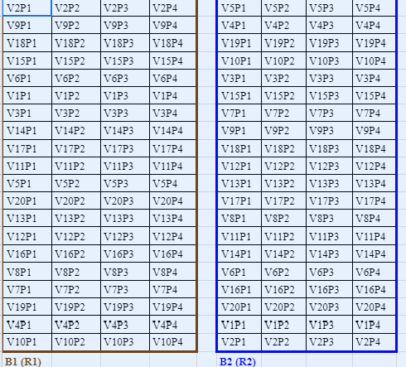
S1 Figure: Field planting layout. 20 Genotypes (G), two replicates (B or R), and four plants (P) per replicate are shown here. All (9 C. melo and 11 C. sativus) genotypes were assessed together.

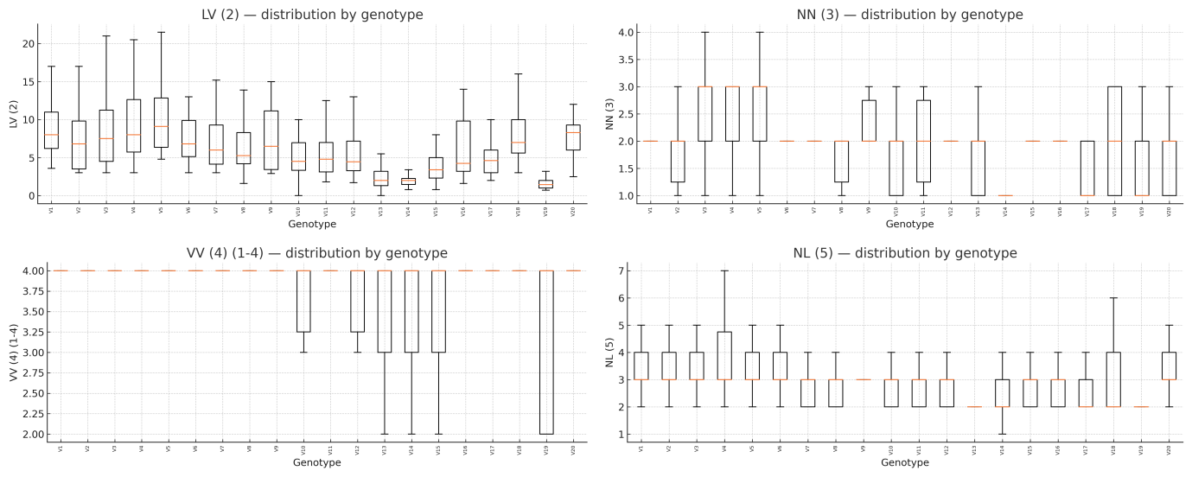

S2 Figure. Boxplots of early growth traits across 20 Cucumis genotypes (genotype-level distributions across all plants and seasons). Traits shown are: LV (2), NN (3), VV (4) (1–4), and NL (5). Boxes show median and interquartile range; whiskers indicate 1.5× IQR. Data pooled from three locations and two seasons (2020–2022).

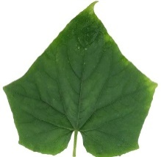
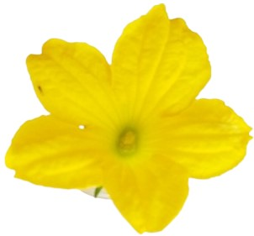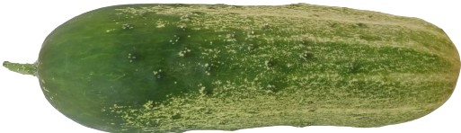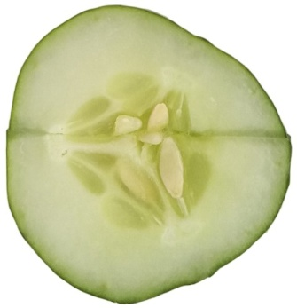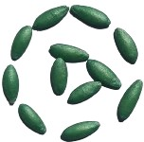
A1 B1 C1 D1 E1

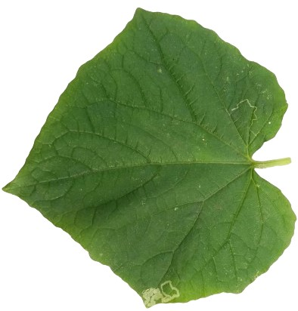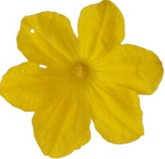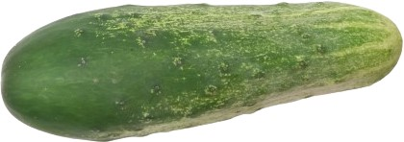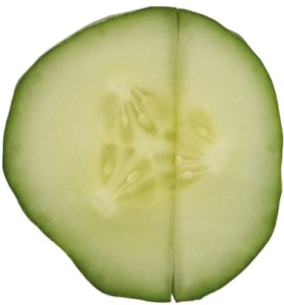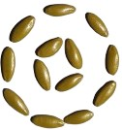
A2 B2 C2 D2 E2

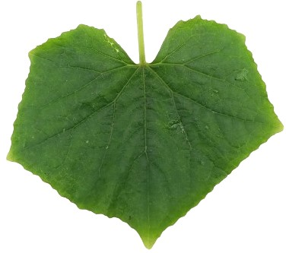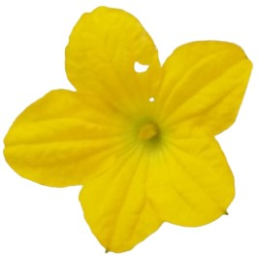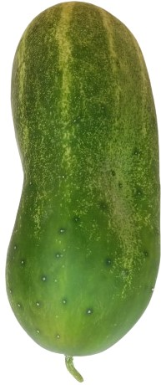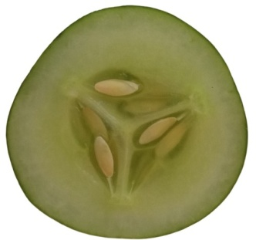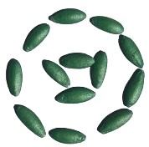
A3 B3 C3 D3 E3

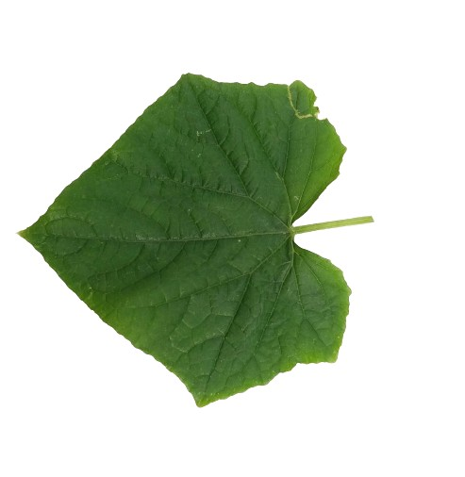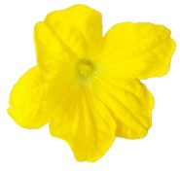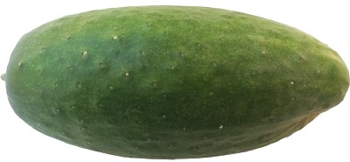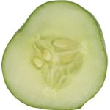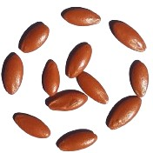
A4 B4 C4 D4 E4

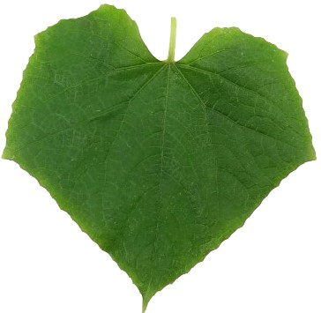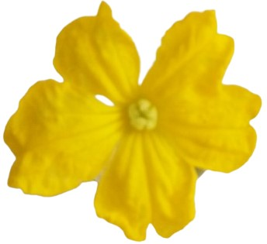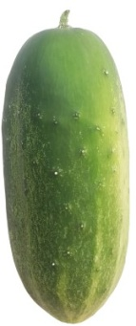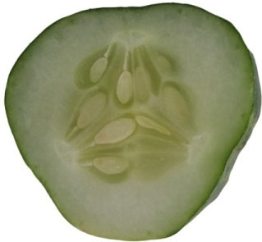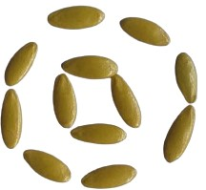
A5 B5 C5 D5 E5

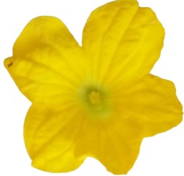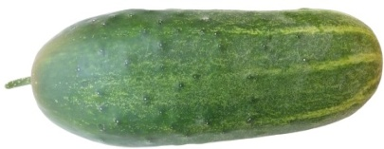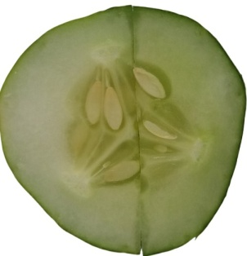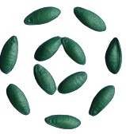
A6 B6 C6 D6 E6

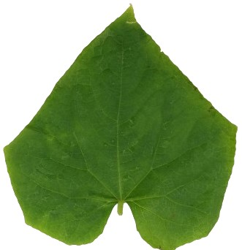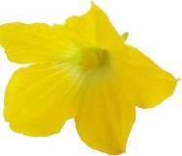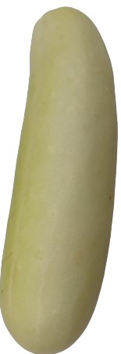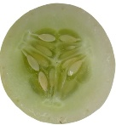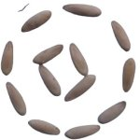
A7 B7 C7 D7 E7
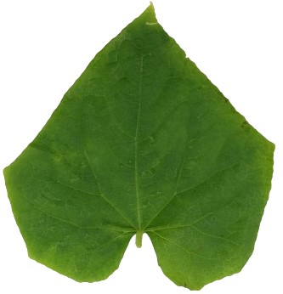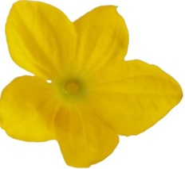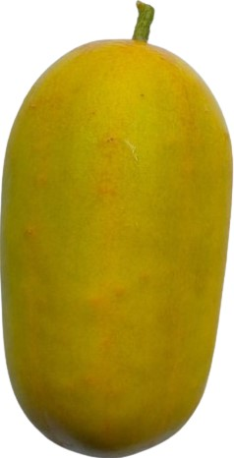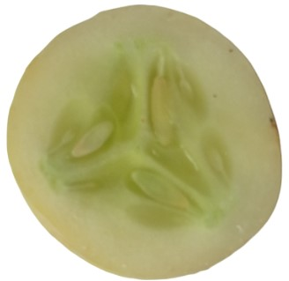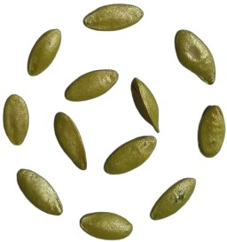
A8 B8 C8 D8 E8

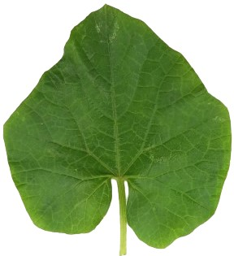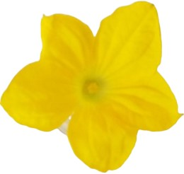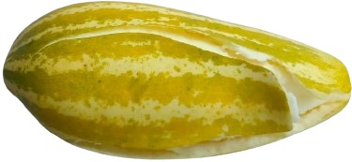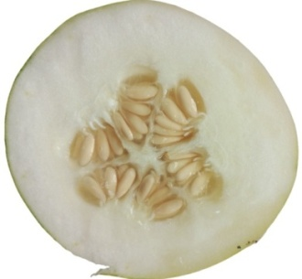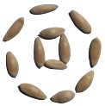

A9 B9 C9 D9 E9

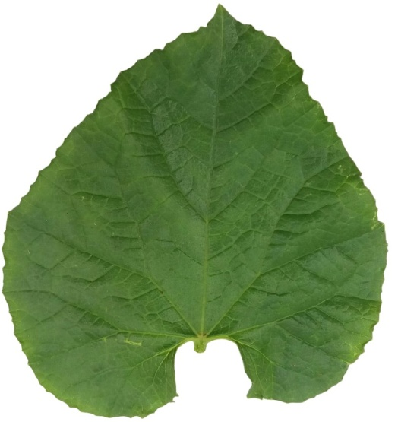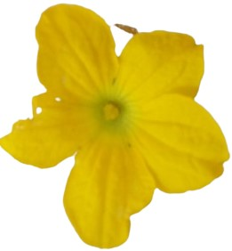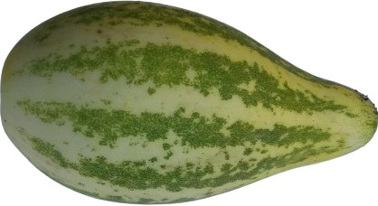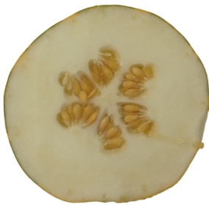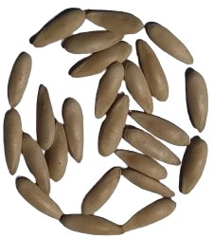

A10 B10 C10 D10 E10

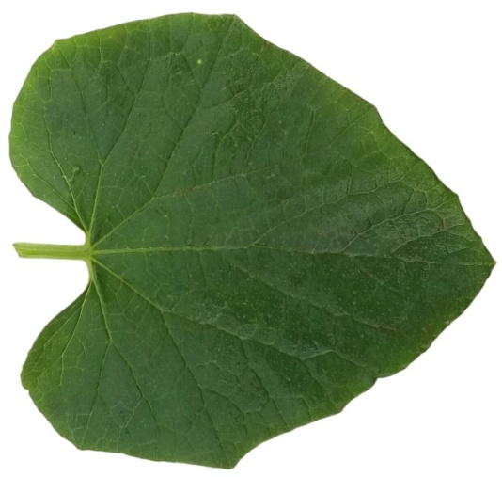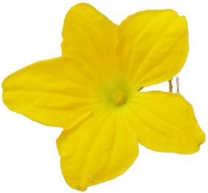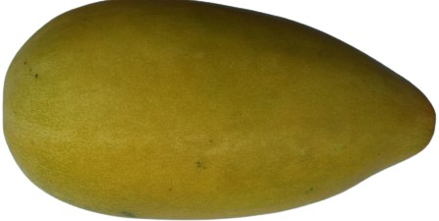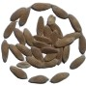

A11 B11 C11 D11 E11

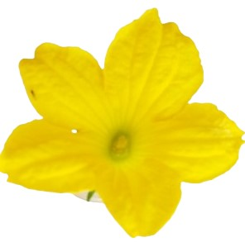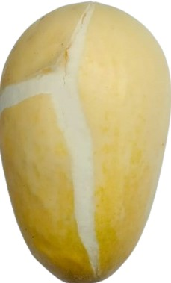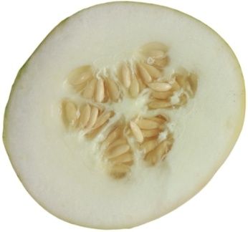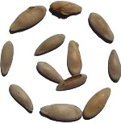

A12 B12 C12 D12 E12

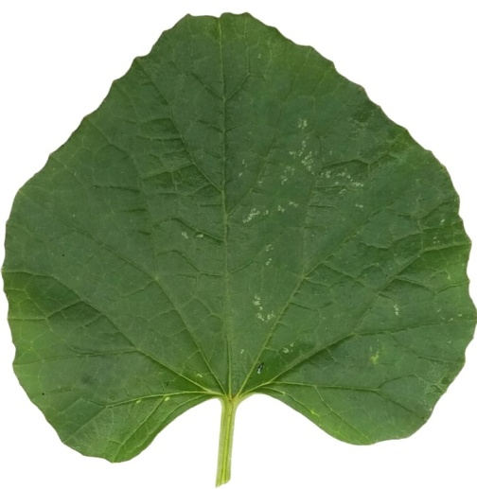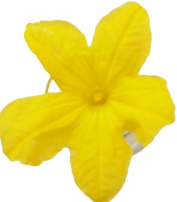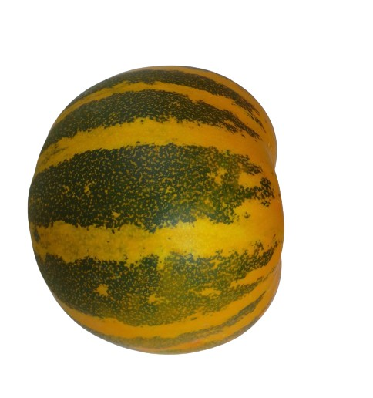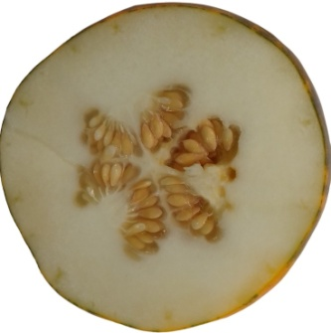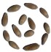

A13 B13 C13 D13 E13

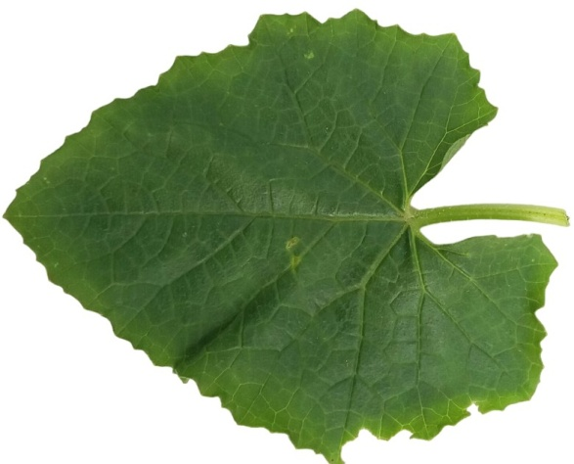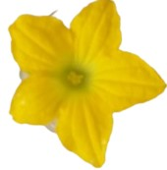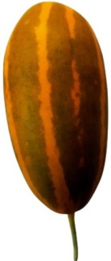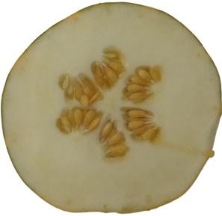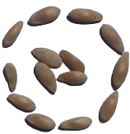

A14 B14 C14 D14 E14

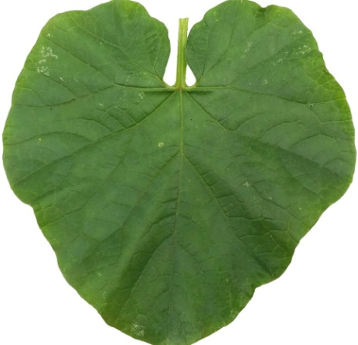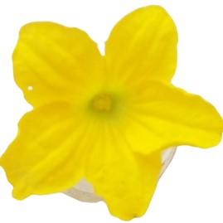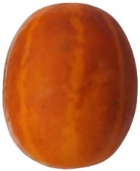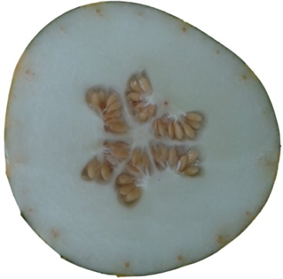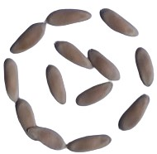

A15 B15 C15 D15 E15

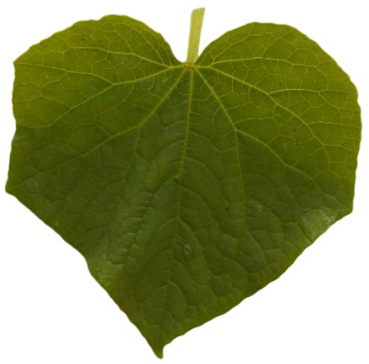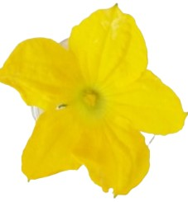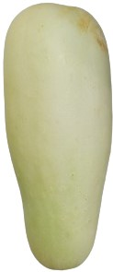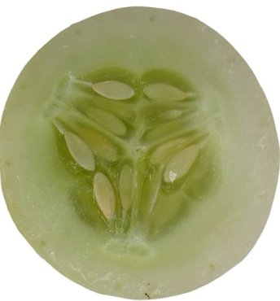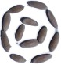

A16 B16 C16 D16 E16

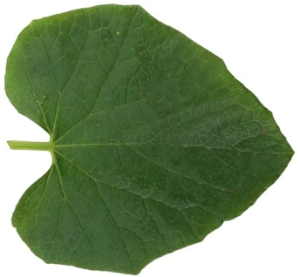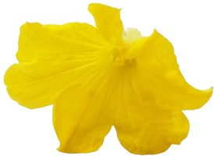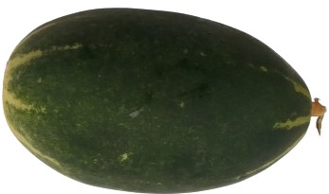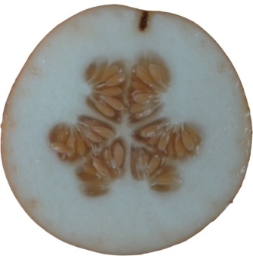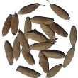
A17 B17 C17 D17 E17

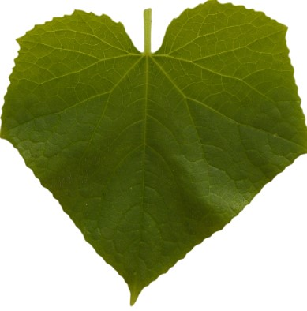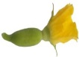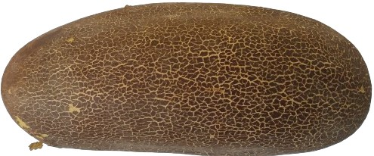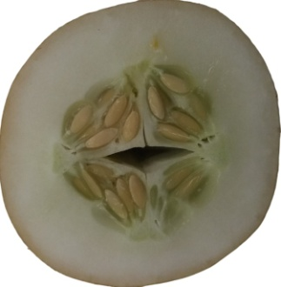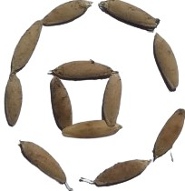

A18 B18 C18 D18 E18

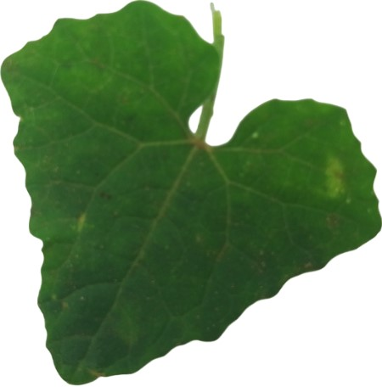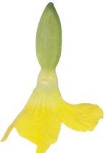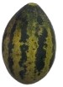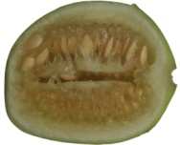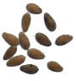

A19 B19 C19 D19 E19

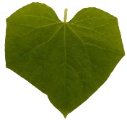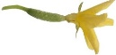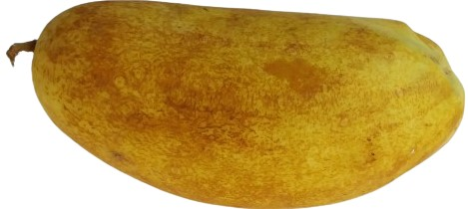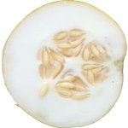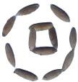

A20 B20 C20 D20 E20
S3 Figure. Additional fruit/leaf/flower macro photographs. Morphological variation of the reproductive parts (A: leaves; B: flowers; C: fruits appearance; D: cross sections of fruits; E: seeds). The numbers 1–20 indicate Sassy; Wealthy; Fiesty; Ajex; Chandani; Treasure; KW; LY58; GSG; GSS; YSS; WSM; MK; DK; SK; DP; LYV; TH; GK; THW.

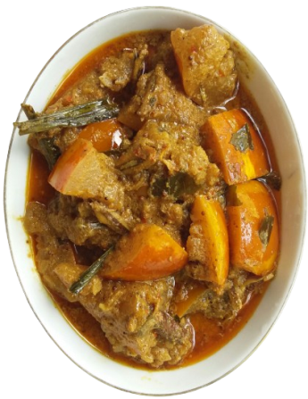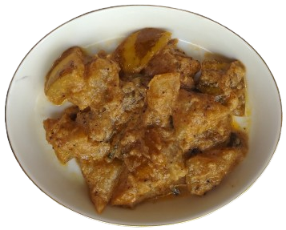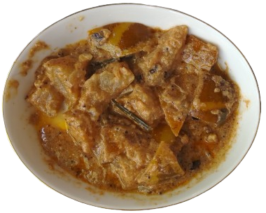
MK DK SK
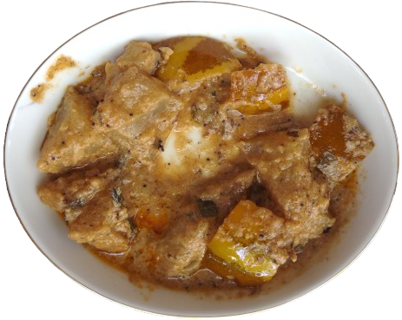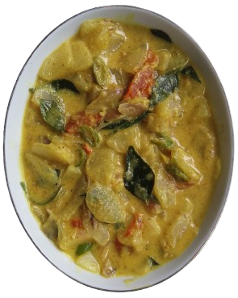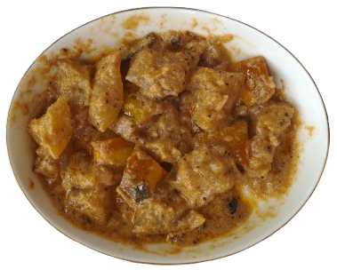
LYV TH THW
S4 Figure. Plate: Culinary preparations subjected to taste panel and subsequent association analyses between sensory parameters and six cooking Cucumis varieties.

GSS
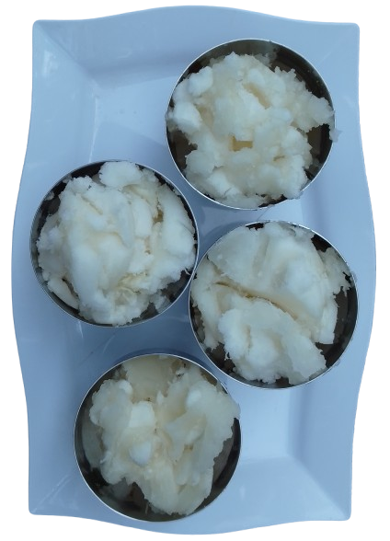
GSG
WSM
YSS

S5 Figure. Fruit salad preparations subjected to taste panel and subsequent association analyses between sensory parameters and Cucumis melo L. fruit verities.

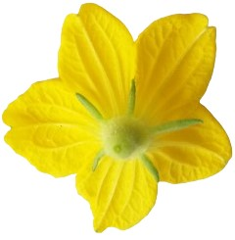 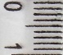1cm 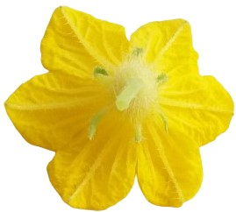
a b a b
Sassy Wealthy

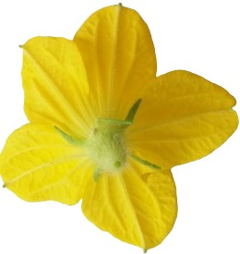 1cm 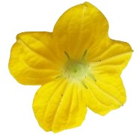
a b a b
Fiesty Ajex

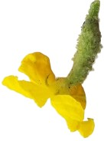 1cm 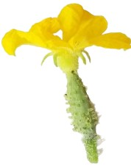
a b a b
Chandani Treasure

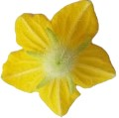 1cm 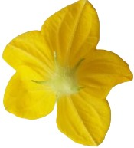
a b a b
KW LY58

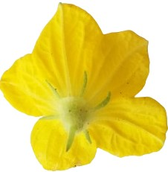 1cm 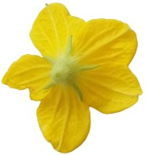
a b a b
GSG GSS

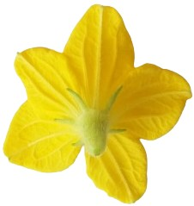 1cm 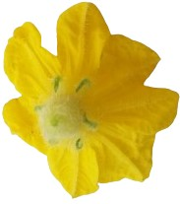

a b a b
YSS WSM
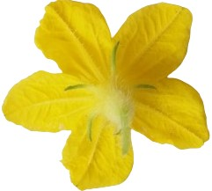 1cm 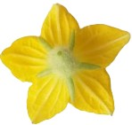
a b a b
MK DK

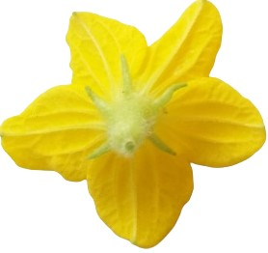 1cm 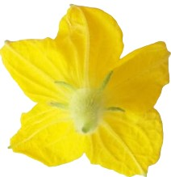
a b a b
SK DP

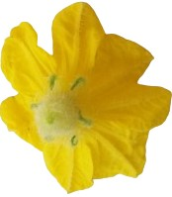 1cm 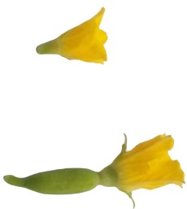
a b a b
LYV TH

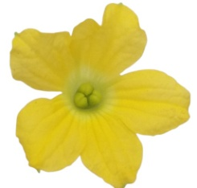 1cm 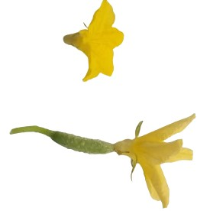
a b a b
GK THW

S6-1. The front (a) and back side (b) view of Cucumis flowers
Sassy Wealthy Fiesty
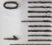1cm

Ajex Chandani Treasure
KW LY58 GSG
1cm

GSS YSS WSM

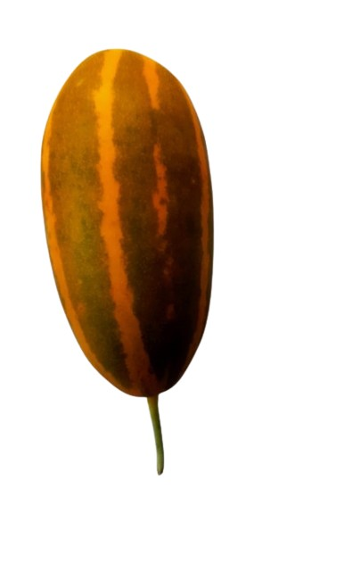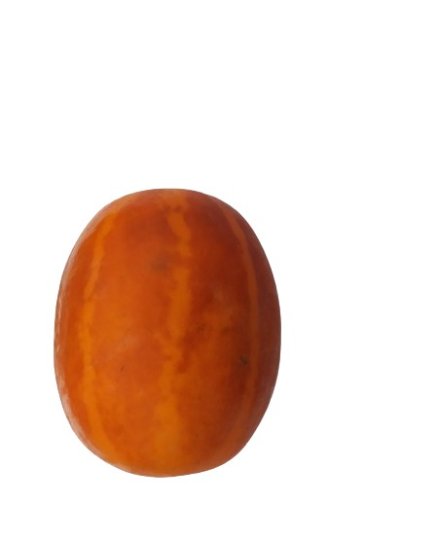
MK DK SK

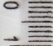1cm

DP LYV TH
1cm

GK THW

S6-2. Fruits shapes of Cucumis varieties

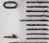1cm

Sassy Wealthy Fiesty Ajex

1cm

Chandani Treasure KW LY58

GSG GSS YSS WSM

MK DK SK DP
LYV TH GK THW

S6-3. Seeds shape of Cucumis varieties

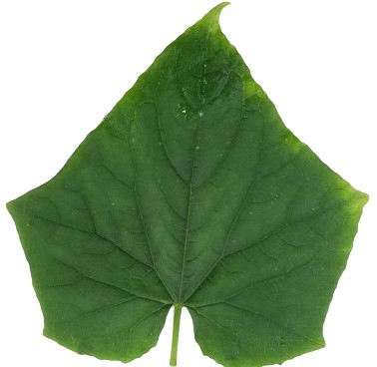 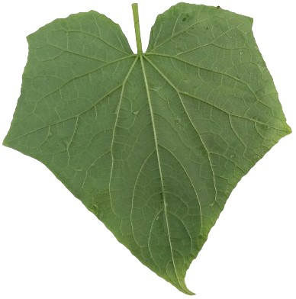 1cm 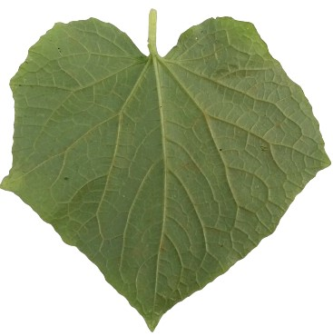
a b a b
Sassy Wealthy
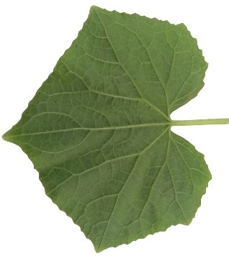 1cm 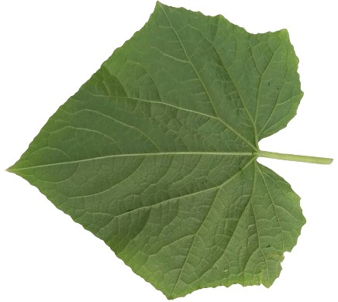
a b a b
Fiesty ajex
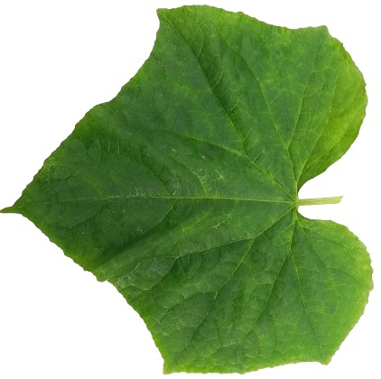 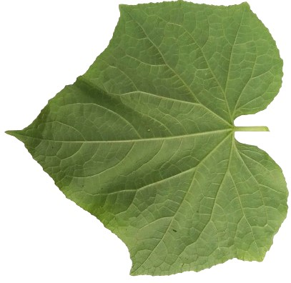 1cm 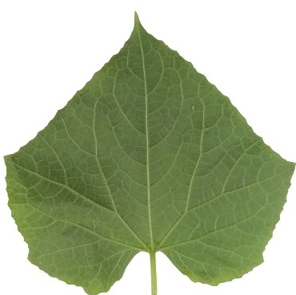
a b a b
Chandani Treasure

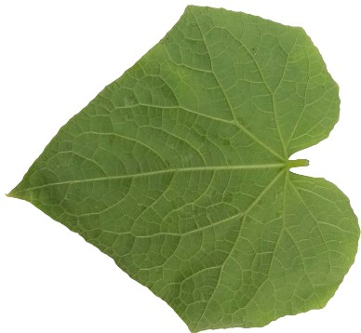 1cm 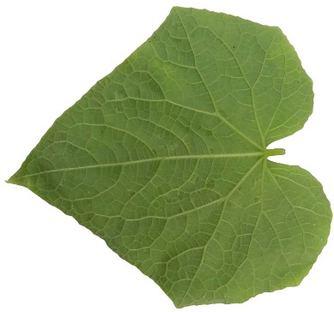
a b a b
KW LY58

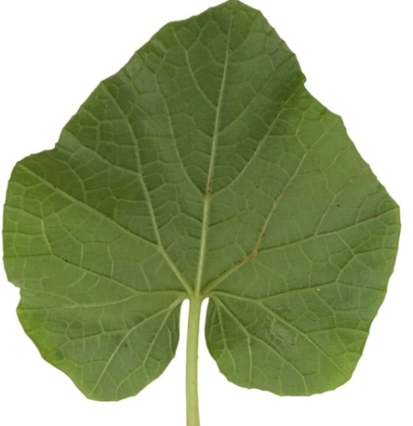 1cm 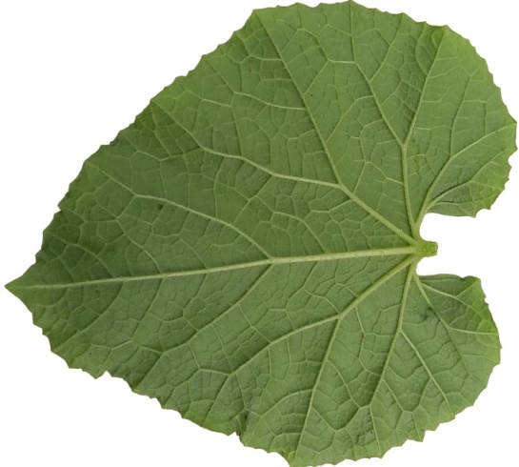
a b a b
GSG GSS

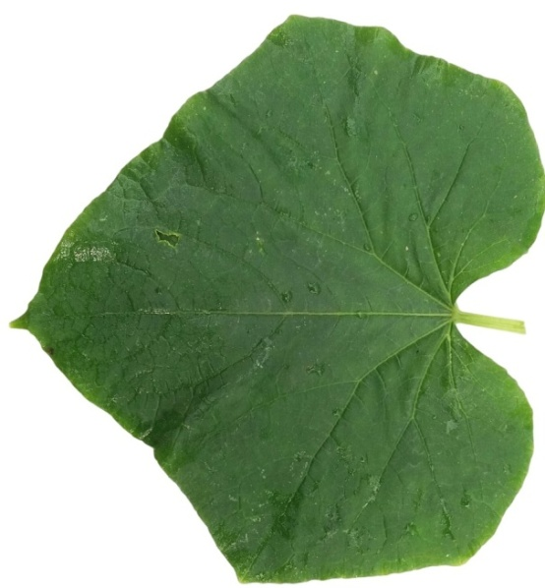 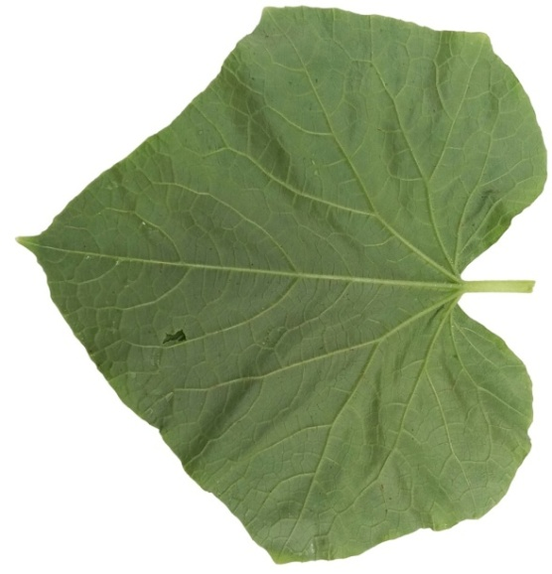 1cm 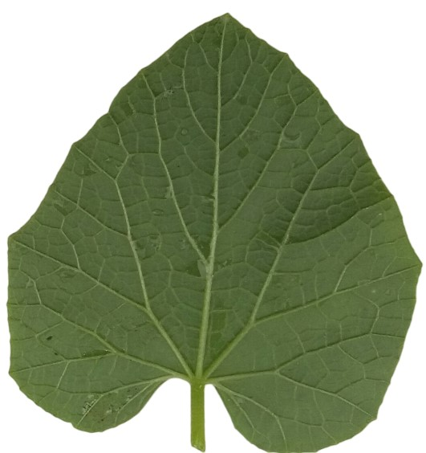
A b a b
YSS WSM

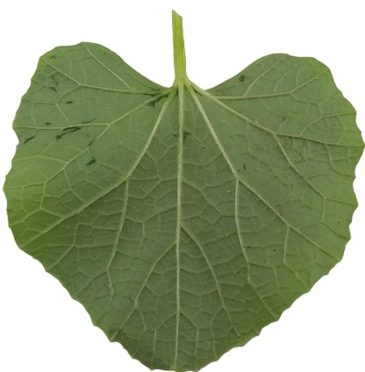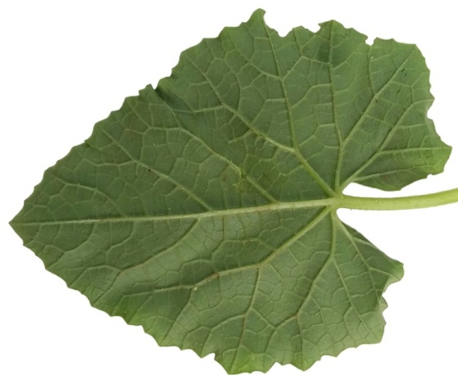
a b 1cm a b
MK DK

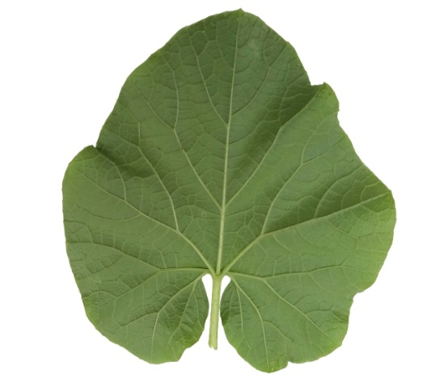 1cm 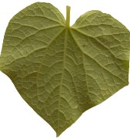
a b a b
SK DP

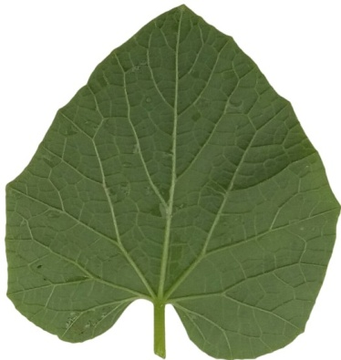 1cm 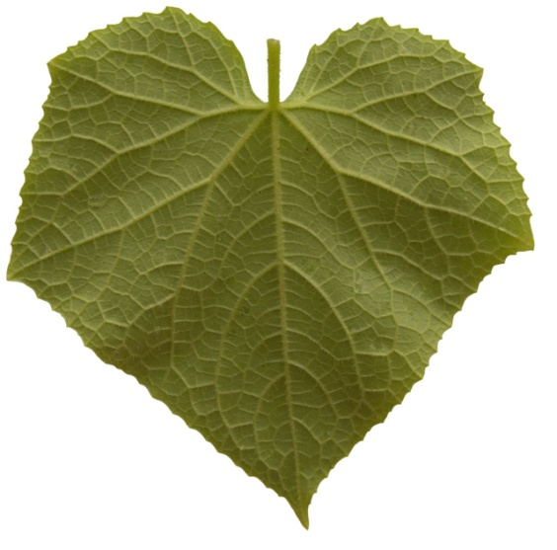
a b a b
LYV TH

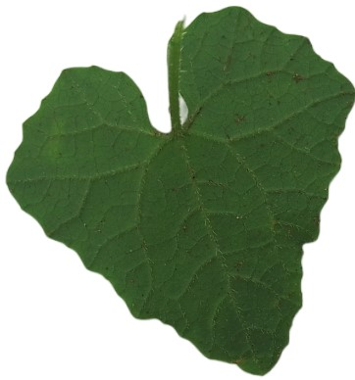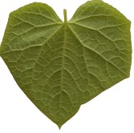
a b a b
GK THW

S6-4. The front (a) and back side (b) view of Cucumis leaves

S6 Figure. Additional flower/fruit/seed/leaf macro photographs (with a scale). Morphological variation of the reproductive parts.

